**Troubleshooting**

**Scenario**

In this lab, you will learn how to monitor and debug desktop flows.

**High-level lab objectives**

* Monitor desktop flows
* Debug desktop flows
* Add retry to desktop flow

**Exercise #1: Monitor flows**

In this exercise, you will monitor desktop flows.

**Task #1: Monitor desktop flows**

1. Navigate to <https://make.powerautomate.com/> and make sure you are in your dev environment.
2. Click on **More** and select **Discover all**.

[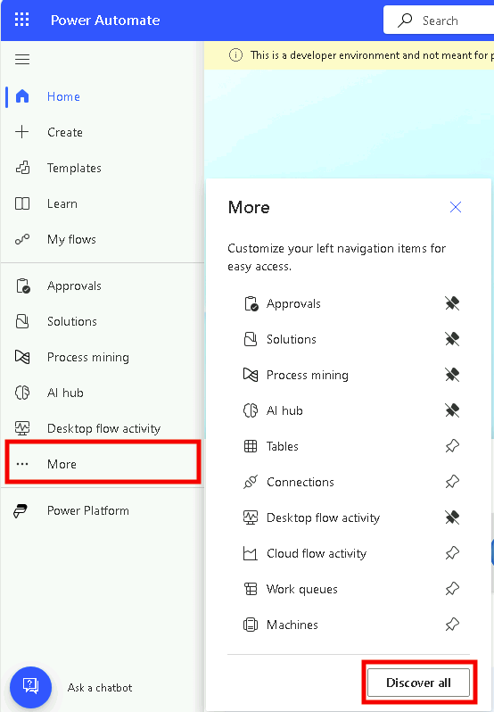](https://github.com/MicrosoftLearning/PL-500T00-Microsoft-Power-Automate-RPA-Developer/blob/master/Instructions/L06/media/image1.png)

1. Under **Monitor** select **Desktop flow runs**.

[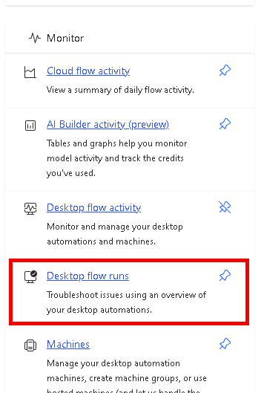](https://github.com/MicrosoftLearning/PL-500T00-Microsoft-Power-Automate-RPA-Developer/blob/master/Instructions/L06/media/image35.png)

1. If you don’t see anything, make sure you are in your Dev environment.
2. Turn on **Auto refresh**.

[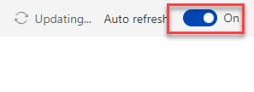](https://github.com/MicrosoftLearning/PL-500T00-Microsoft-Power-Automate-RPA-Developer/blob/master/Instructions/L06/media/image2.png)

1. Click on the ellipses of one the **Woodgrove Funding Manager Draw** run and select **See parent flow run**.

[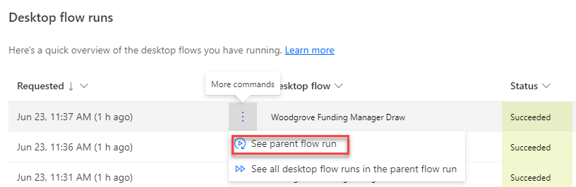](https://github.com/MicrosoftLearning/PL-500T00-Microsoft-Power-Automate-RPA-Developer/blob/master/Instructions/L06/media/image3.png)

1. You should see the parent cloud flow run (CF Manage Woodgrove Funding Process).

[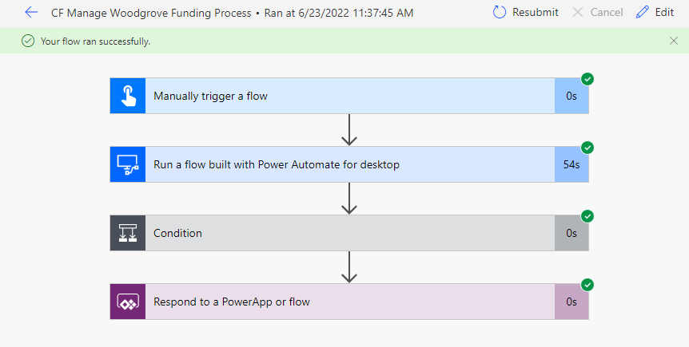](https://github.com/MicrosoftLearning/PL-500T00-Microsoft-Power-Automate-RPA-Developer/blob/master/Instructions/L06/media/image4.png)

1. Click on the browser back button.
2. Click to open the **Woodgrove Funding Manager Draw** run.

[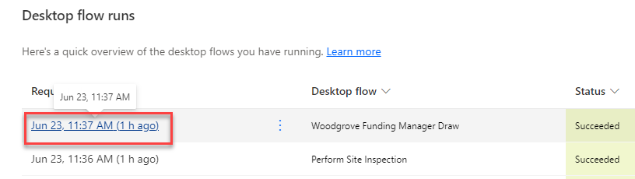](https://github.com/MicrosoftLearning/PL-500T00-Microsoft-Power-Automate-RPA-Developer/blob/master/Instructions/L06/media/image5.png)

1. You should see all the actions in the flow run.

[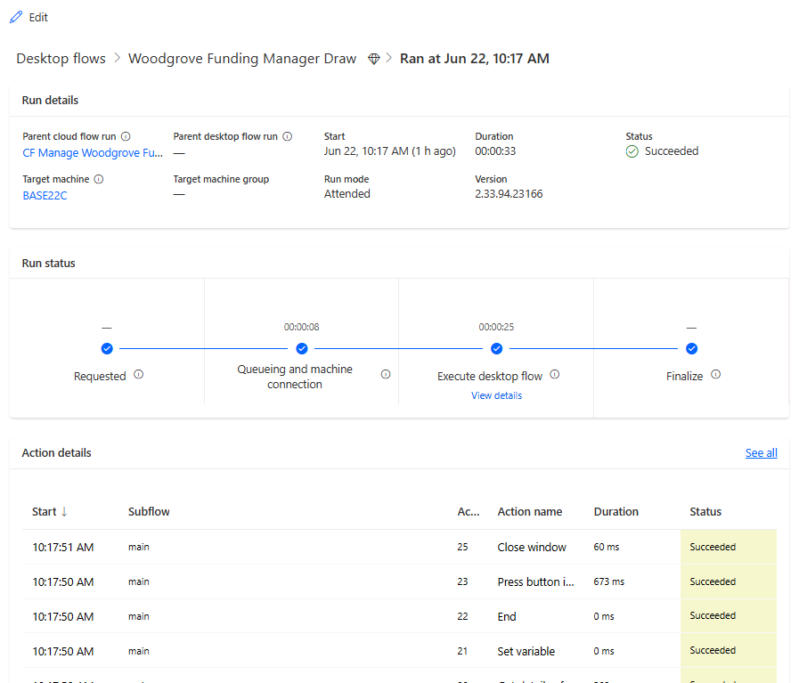](https://github.com/MicrosoftLearning/PL-500T00-Microsoft-Power-Automate-RPA-Developer/blob/master/Instructions/L06/media/image6.png)

1. Click on the start timestamp to open the **Set variable** action.

[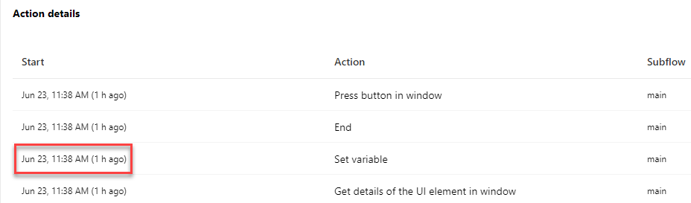](https://github.com/MicrosoftLearning/PL-500T00-Microsoft-Power-Automate-RPA-Developer/blob/master/Instructions/L06/media/image7.png)

1. Go to the **Action Details** pane and click **See output details**.

[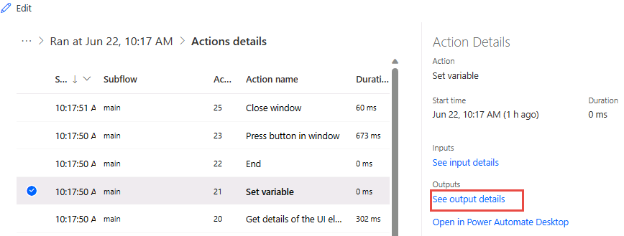](https://github.com/MicrosoftLearning/PL-500T00-Microsoft-Power-Automate-RPA-Developer/blob/master/Instructions/L06/media/image8.png)

1. You should see details of the variable.

[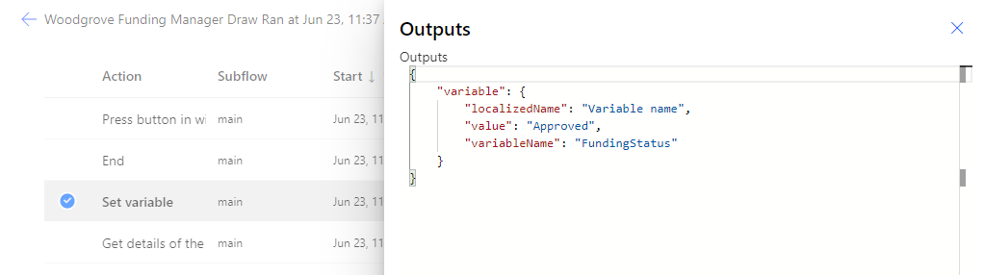](https://github.com/MicrosoftLearning/PL-500T00-Microsoft-Power-Automate-RPA-Developer/blob/master/Instructions/L06/media/image9.png)

1. Close the **Outputs** pane.
2. You may wish to review the other actions.

**Task #2: Flow monitor**

1. Launch **Power Automate for desktop**, make sure your dev environment is selected.
2. Click **Settings**.

[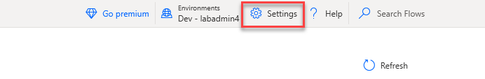](https://github.com/MicrosoftLearning/PL-500T00-Microsoft-Power-Automate-RPA-Developer/blob/master/Instructions/L06/media/image10.png)

1. Click on the **Monitoring/Notifications** dropdown, select **Flow monitoring window**, and click **Save**.

[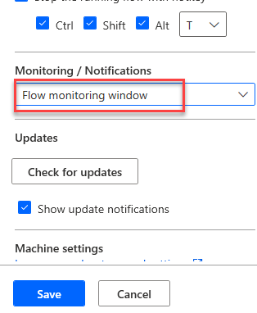](https://github.com/MicrosoftLearning/PL-500T00-Microsoft-Power-Automate-RPA-Developer/blob/master/Instructions/L06/media/image11.png)

1. Close the **Settings** pane.
2. Run the **Perform Site Inspection**.

[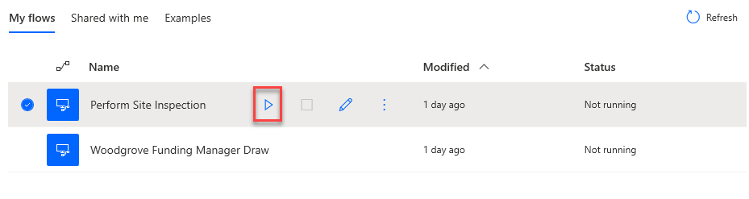](https://github.com/MicrosoftLearning/PL-500T00-Microsoft-Power-Automate-RPA-Developer/blob/master/Instructions/L06/media/image12.png)

1. Click **OK**.

[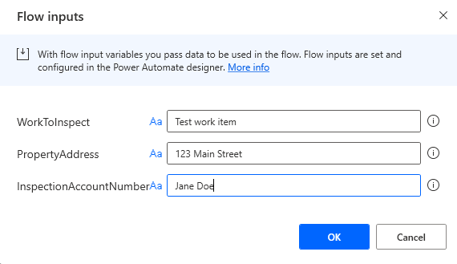](https://github.com/MicrosoftLearning/PL-500T00-Microsoft-Power-Automate-RPA-Developer/blob/master/Instructions/L06/media/image13.png)

1. Notice the monitor. Click **Pause**.

[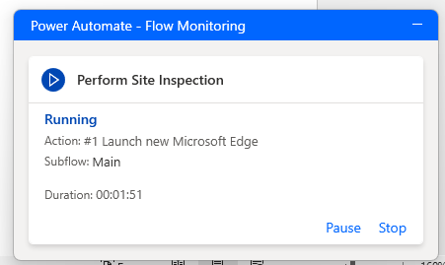](https://github.com/MicrosoftLearning/PL-500T00-Microsoft-Power-Automate-RPA-Developer/blob/master/Instructions/L06/media/image14.png)

1. The flow should pause. Click **Resume**.

[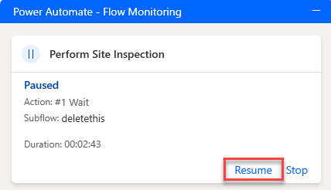](https://github.com/MicrosoftLearning/PL-500T00-Microsoft-Power-Automate-RPA-Developer/blob/master/Instructions/L06/media/image15.png)

1. Click **Stop**. The flow should stop, and the monitor should disappear.

**Exercise #2: Debug flows**

**Task #1: Debug flow**

1. Go to Power Automate desktop flow and run the **Perform Site Inspection** flow again.
2. Enter **456 Main Street** for Address and click **OK**.

[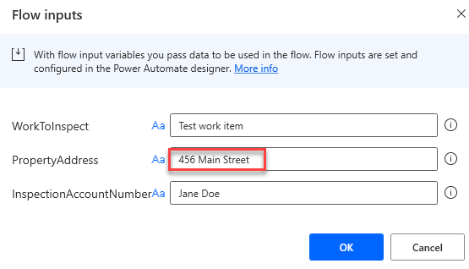](https://github.com/MicrosoftLearning/PL-500T00-Microsoft-Power-Automate-RPA-Developer/blob/master/Instructions/L06/media/image16.png)

1. Wait for the flow to finish running.
2. The flow should fail, and you should see an error in the notification.

[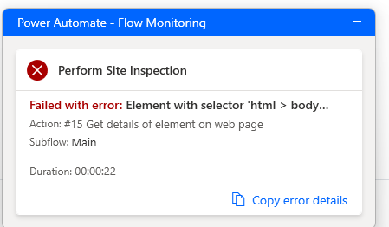](https://github.com/MicrosoftLearning/PL-500T00-Microsoft-Power-Automate-RPA-Developer/blob/master/Instructions/L06/media/image17.png)

1. Click **Edit** flow.

[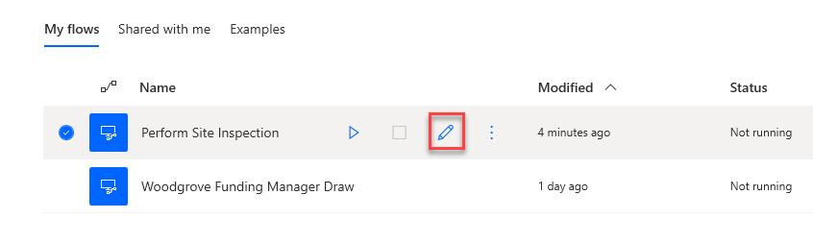](https://github.com/MicrosoftLearning/PL-500T00-Microsoft-Power-Automate-RPA-Developer/blob/master/Instructions/L06/media/image18.png)

1. Add a breakpoint on the first press button action. Clicking to the left of the line number will add a breakpoint.

[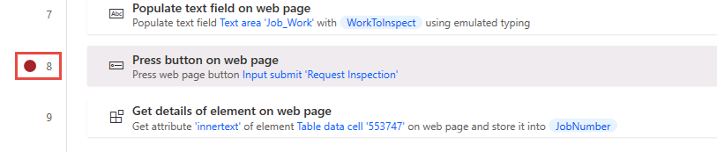](https://github.com/MicrosoftLearning/PL-500T00-Microsoft-Power-Automate-RPA-Developer/blob/master/Instructions/L06/media/image19.png)

1. Edit the property address variable and change the default value to **456 Main Street**.
2. Click **Run**.
3. The flow will pause when the breakpoint is hit. Click **Run next action**.

[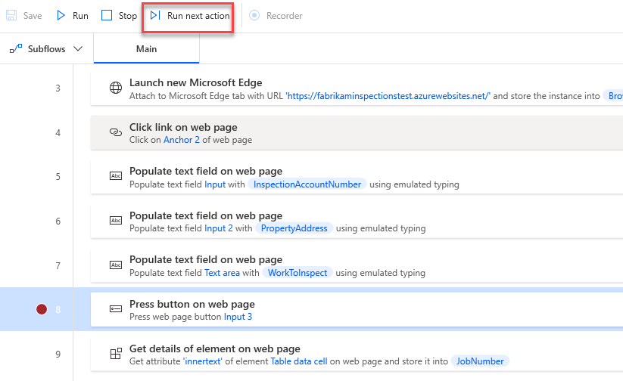](https://github.com/MicrosoftLearning/PL-500T00-Microsoft-Power-Automate-RPA-Developer/blob/master/Instructions/L06/media/image20.png)

1. The flow should advance to the next action and pause again. Click **Run next action** again.
2. Click **Run next action** until the flow fails.

[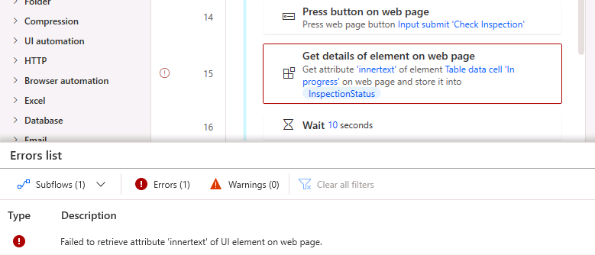](https://github.com/MicrosoftLearning/PL-500T00-Microsoft-Power-Automate-RPA-Developer/blob/master/Instructions/L06/media/image21.png)

**Task #2: Add retry**

1. Click **Subflows** and select + New subflow.

[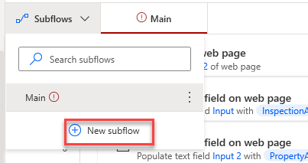](https://github.com/MicrosoftLearning/PL-500T00-Microsoft-Power-Automate-RPA-Developer/blob/master/Instructions/L06/media/image22.png)

1. Enter **WaitFlow** for name and click **Save**.
2. Go to the **Actions** pane, search for **wait** and double click on the **Wait** action.

[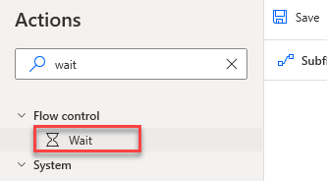](https://github.com/MicrosoftLearning/PL-500T00-Microsoft-Power-Automate-RPA-Developer/blob/master/Instructions/L06/media/image23.png)

1. Enter **60** and click **Save**.

[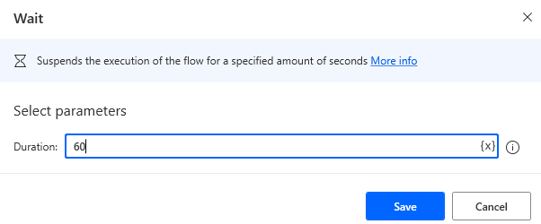](https://github.com/MicrosoftLearning/PL-500T00-Microsoft-Power-Automate-RPA-Developer/blob/master/Instructions/L06/media/image24.png)

1. The subflow should now have one wait action. Select the **Main** tab.

[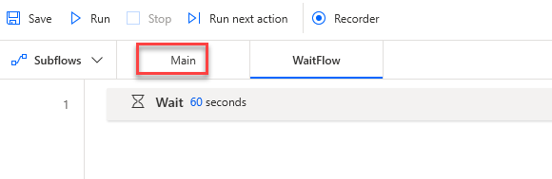](https://github.com/MicrosoftLearning/PL-500T00-Microsoft-Power-Automate-RPA-Developer/blob/master/Instructions/L06/media/image25.png)

1. Go to the **Actions** pane, search for **error**, drag **On block error** action, and place it after the **Get details of element on web page** for the **JobNumber** action.

[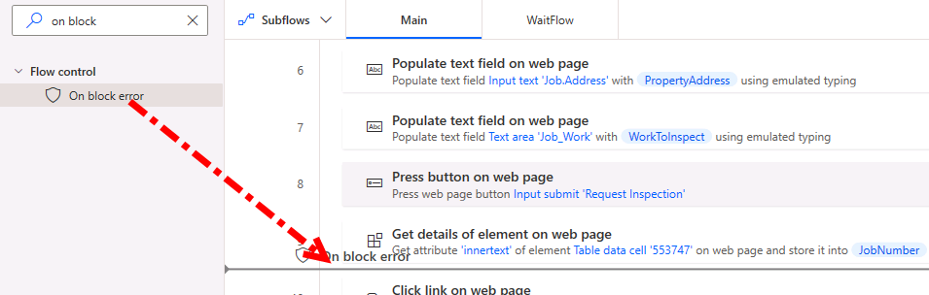](https://github.com/MicrosoftLearning/PL-500T00-Microsoft-Power-Automate-RPA-Developer/blob/master/Instructions/L06/media/image26.png)

1. Enter **RetryOnError** for Name, click **+ New rule**, and select **Run subflow**.

[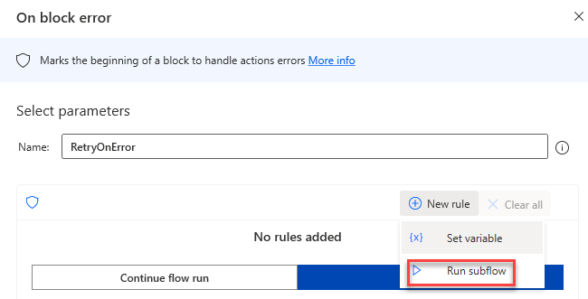](https://github.com/MicrosoftLearning/PL-500T00-Microsoft-Power-Automate-RPA-Developer/blob/master/Instructions/L06/media/image27.png)

1. Select the **WaitFlow** you created and click **Continue flow run**.

[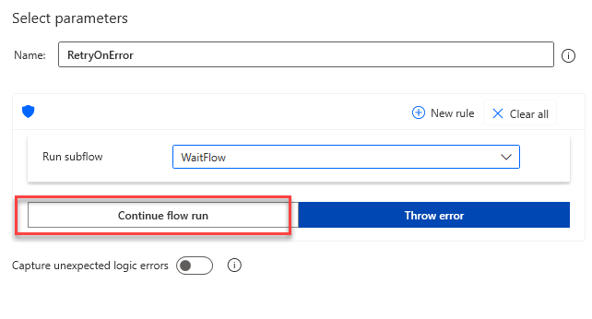](https://github.com/MicrosoftLearning/PL-500T00-Microsoft-Power-Automate-RPA-Developer/blob/master/Instructions/L06/media/image28.png)

1. Select **Go to beginning of block** for Exception handling mode and click **Save**.

[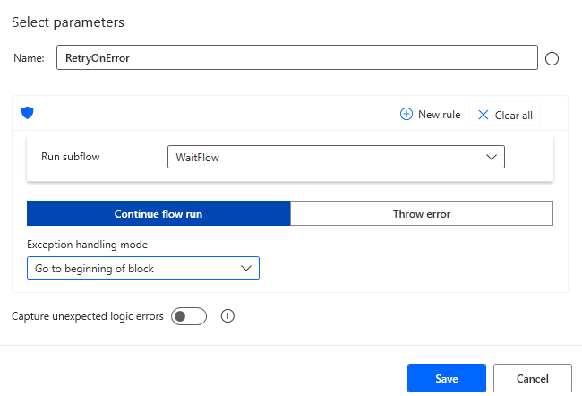](https://github.com/MicrosoftLearning/PL-500T00-Microsoft-Power-Automate-RPA-Developer/blob/master/Instructions/L06/media/image29.png)

1. Click to select the action below the error block.

[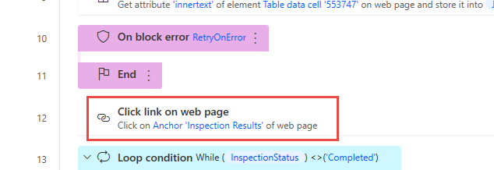](https://github.com/MicrosoftLearning/PL-500T00-Microsoft-Power-Automate-RPA-Developer/blob/master/Instructions/L06/media/image30.png)

1. Hold the **[SHIFT]** and click to select the **End** loop action.

[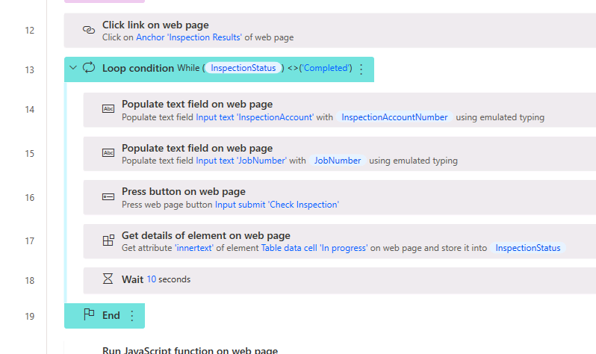](https://github.com/MicrosoftLearning/PL-500T00-Microsoft-Power-Automate-RPA-Developer/blob/master/Instructions/L06/media/image31.png)

1. Drag all the selected actions and drop them inside the error block.
2. The **On block error** action should now look like the image below.

[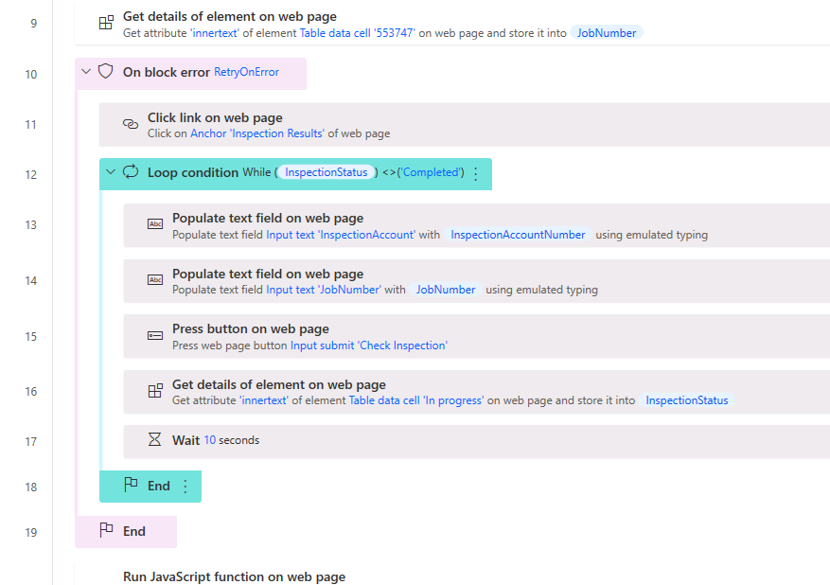](https://github.com/MicrosoftLearning/PL-500T00-Microsoft-Power-Automate-RPA-Developer/blob/master/Instructions/L06/media/image32.png)

1. Click **Save** and wait for the flow to be saved.

**Task #3: Test**

1. Remove the breakpoint and Click **Run**.
2. The flow will switch to the subflow if error occurs.

[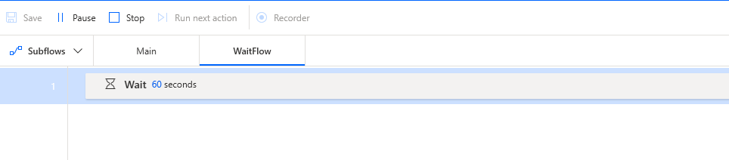](https://github.com/MicrosoftLearning/PL-500T00-Microsoft-Power-Automate-RPA-Developer/blob/master/Instructions/L06/media/image33.png)

1. The flow will go back to the main flow after **60** seconds.
2. The process should complete successfully.

[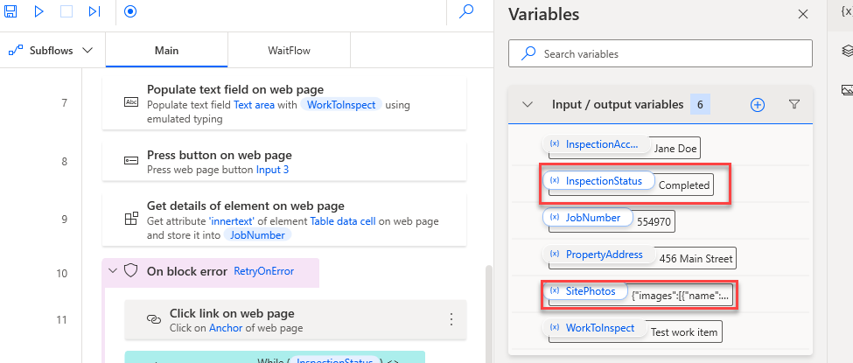](https://github.com/MicrosoftLearning/PL-500T00-Microsoft-Power-Automate-RPA-Developer/blob/master/Instructions/L06/media/image34.png)