**EDA on Students Performance dataset**

**Exploratory Data Analysis (EDA)** is a critical phase in data analysis where you systematically examine and summarize data to gain insights and identify patterns. It involves visualization of data through graphs and charts and calculating summary statistics.

Our dataset is Students_Performance dataset, some features about is Students_Performance dataset are:-

* It contains 1000 rows and 8 columns.
* Its features or variables are gender, race/ethnicity, parental level of education, lunch, test preparation course, math score, reading score, writing score.

We ensure that our dataset do not contain any missing value and duplicate records that can cause unnecessary hinderance in our analysis.

**This project aims to conduct Exploratory Data Analysis (EDA) to understand how various factors impact students' performance, specifically their test scores. The factors of interest include Gender, Ethnicity, Parental Level of Education, Lunch, and Test Preparation Course.**

At First, we tried to know the distribution of students and some of their features for our analysis.

1. **Distribution of gender among students.**

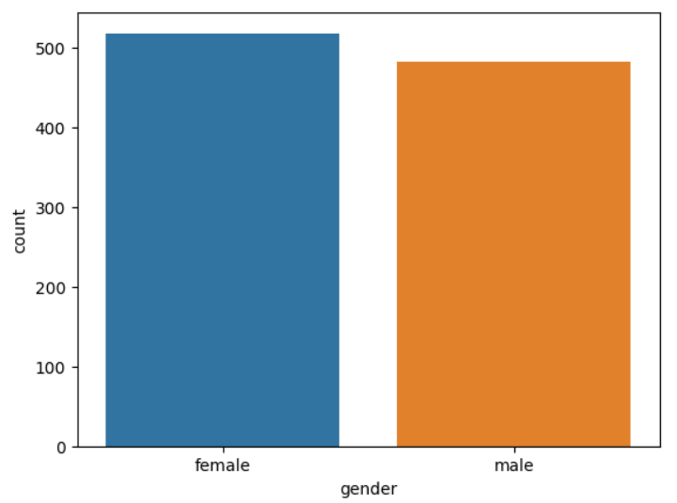

**Females are more in numbers than males.**

1. **Distribution of ethnicity among students.**

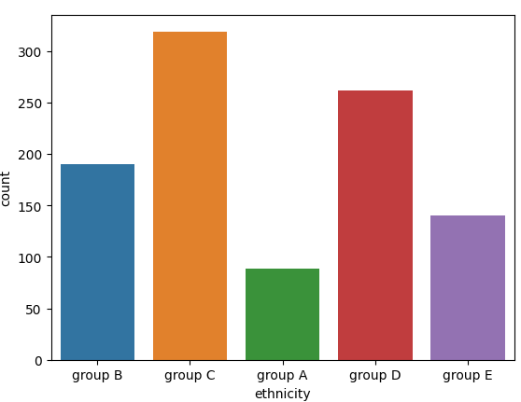

**Maximum students are in group C and minimum students are in group A.**

1. **Distribution of ethnicity among students.**

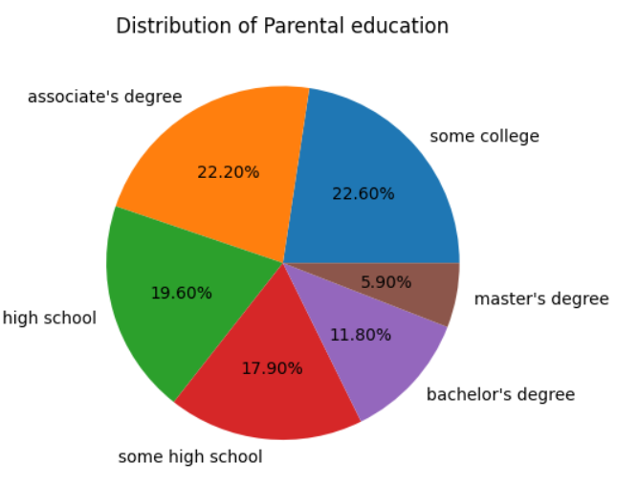

**Parental level of education decreases with the increasing educational level**. It can be observed that very few no. of parents had master’s degree and more had their bachelor’s and associate’s degree and significant no. of parents are involved in high school .

Now, our analysis will shift its focus towards students performance depending upon various features or variables.

**Gender-Related Trends in Academics**

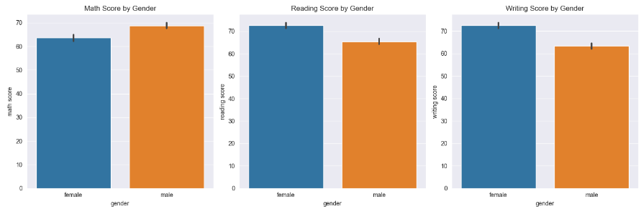

Females tend to score less marks in **maths** as compared to males but they are performing better in **writing and reading**, indicating that while females excel in language-oriented subjects, there is room for improvement in mathematics performance and vice-versa for males.

**Impact of Lunch Choices on academics**

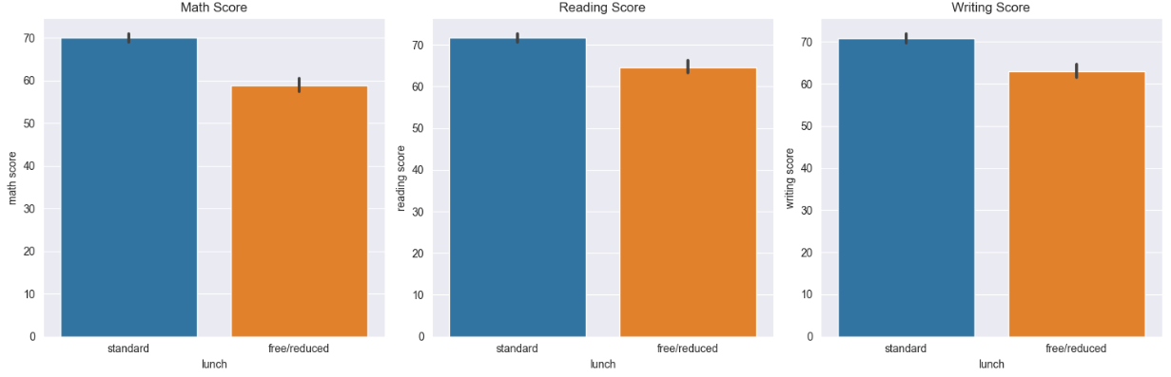

A noteworthy observation is seen when considering the type of lunch students have. Specifically**, students who took standard lunch consistently performs stronger in academics across all subjects in comparison to students who have taken the free/reduced lunch option**. This observation underscores the potential impact of nutrition and access to meals on student achievement in academics.

**Impact of Educational Background and Ethnicity**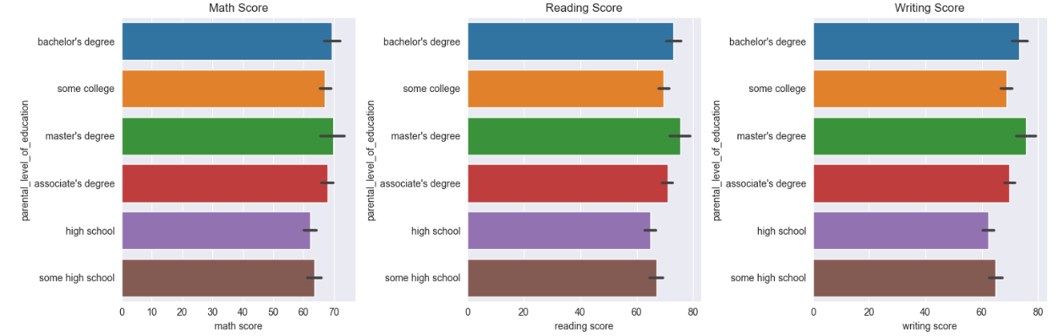

**On an average, students scores better whose parents holds Bachelor’s and Master’s degree** than the students whose parents scores do not have that much good qualifications. There is not any vast difference in the score but this significant difference can’t be neglected.

**More insight trend**

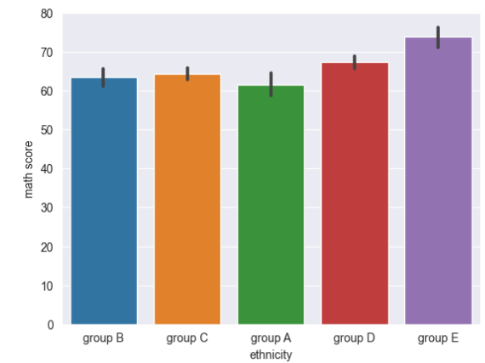 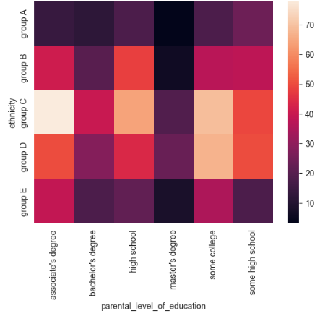

Notably, students of **Group E ethnicity consistently outperformed all other ethnic groups**, with Group D ranking second in terms of academic performance.

Our heatmap visualization revealed an intresting relationship between ethnicity and parental level of education.Specifically, ethnic groups C, D, and E tend to have parents with higher educational qualifications, potentially contributing to **improved academic performance**. Conversely, ethnic groups A and B have a higher representation of parents with lower educational levels, which **may influence their students' performance**.

**Impact of Test preparation course on academics**

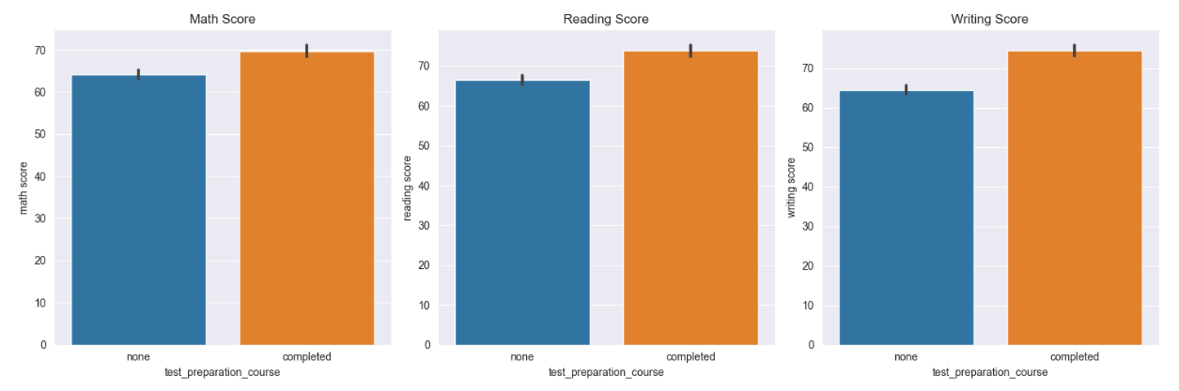

A consistent pattern emerges when considering whether students have completed a test preparation course. Notably**, students who have undertaken the test preparation course consistently demonstrate stronger academic performance compared to students who have not**. This finding underscores the positive impact of test preparation courses on student achievement, suggesting that such programs contribute to improved academic outcomes.