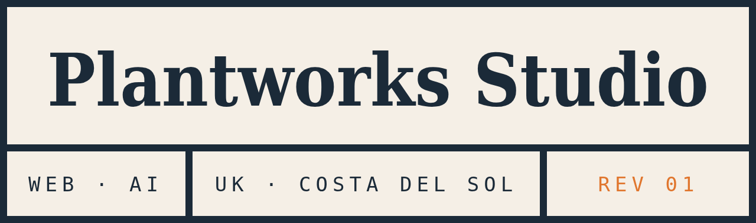 | Plantworks Studio Ltd  Company no. [00000000]  Registered office: [registered office address, UK]  info@plantworksstudio.com  plantworksstudio.com

PROPOSAL
A new website for
[Client business name]
Prepared for [Contact name] · [dd Month yyyy] · Valid for 30 days
What we heard
From our conversation on
- [The business in one line: what it does, who for, where.]
- [The problem with the current site or the reason for a new one.]
- [What the site must do: bookings, enquiries, menus, listings, be found in Spanish and English.]
What we’ll build
A fast, hand-built site designed around your brand, not a template. Pages in both English and Spanish, each pair linked so Google shows the right language to the right person.
Page | What it does
Home | [The pitch, opening hours, one clear action: book / call / enquire]
[Menu / Services / Listings] | [Laid out properly, easy to update, with prices]
[About / The story] | [Why this business is different, in its own voice]
Contact | [Form that reaches your inbox, WhatsApp, map, directions]
[Further pages] | [Up to eight in total]
Included in every build
- Design around your brand, built by hand, tested like equipment before hand-over
- English and Spanish with correct hreflang, structured data and sitemap, so both versions rank
- Mobile-first, loads in under a second, hosted on a global network at near-zero cost
- On-page SEO and Google Business Profile setup
- Domain and hosting connected, HTTPS on, two rounds of revisions, native-speaker proofread of Spanish copy
- You own everything: files, domain, accounts. No monthly platform fee
Timeline
When | What happens
Day 1 | Brief agreed, deposit received, we start
Week 1 | First working version on a private link, on your real content
Week 2 | Two rounds of changes. Spanish copy to a native speaker for proofing
Week 3 | Domain connected, HTTPS on, Google told it exists. Live
Price
Item | List price | This proposal
Multi-page bilingual website, up to eight pages | €1,500 | [€1,200]
[Take payments online — optional] | €150 | [€150]
Care plan — hosting, updates, monthly check. Optional, cancel any month | €40 / month | €40 / month
Care Plus — Care plus your Google listing managed. Optional | €75 / month | €75 / month
Launch offer: [This is one of the first five multi-page sites at €1,200 instead of €1,500, in return for a Google review at launch and permission to show the site in our portfolio.]
Prices exclude VAT or IVA. Half on brief, half on launch. Photography, copywriting and any paid third-party service at cost.
What we need from you
- Logo and any brand colours, or the sign and we’ll match it
- Text you already have: menus, service lists, prices, opening hours, the story. Rough is fine, photos of notes are fine
- Photos, if you have them. If not, see below
- Access to the domain if you already own one, or we register one for you
- One person who can say yes
Next step
Reply to this email or WhatsApp with “yes” and we’ll send the deposit invoice and a date for the brief. Questions welcome. info@plantworksstudio.com · +34 722 676 631

Plantworks Studio Ltd · plantworksstudio.com

