TABLE OF CONTENTS

S. No. Topic Page No.

1 Introduction 9-14

1.1 Introduction 9

1.2 Problem Statement 10

1.3 Objectives 10

1.4 Methodology 11-13

1.5 Organisation of the report 14

2. Literary Survey 15-29

3. System Development 31-35

3.1 Computational Analysis

3.1.1 Drowsiness Detection Design 31-33

3.1 .2 Developing Image Processing 33-35

4 References

**ABSTRACT**

A computer vision based thoughts have been used for the creation of a Drowsy Driver Detection System. The little camera has been utilized by framework that concentrates straight towards the essence of driver and checks the driver's eyes with a particular ultimate objective to perceive weakness. A notice sign is issued to alert the driver, in such circumstance when exhaustion is perceived. The framework oversees using information picked up for the picture to find the facial tourist spots, which gets the area where the eyes of an individual may exist. On the off chance that the eyes of driver are discovered close for a specific measure of casings, the proposed framework accept that the driver is falling asleep and an alarm of caution has been issued. The structure can work just when the eyes are found, and works in encompassing lighting conditions too

**CHAPTER 1**

**INTRODUCTION**

* 1. **Introduction**

Driver exhaustion is a noteworthy factor in countless mishaps. Late measurements gauge that yearly 1,200 passings and 76,000 wounds can be credited to fatigue related crashes Driver drowsiness and fatigue is a major factor which results into numerous vehicle accidents. Developing and maintaining technologies which can efficiently detect or prevent drowsiness at the wheel and alert the driver before am mishap is a major challenge in the field of accident prevention systems. Because of the dangerous that drowsiness can cause on the roads some methods need to be developed for preventing counteracting its effects. With the advent of modern technology and real time scanning systems using cameras we can prevent major mishaps on the road by alerting car driver who is feeling drowsy through a drowsiness detection system The point of this undertaking is to build up a prototype drowsiness detection system. The spotlight will be put on planning a framework that will precisely monitor the open or shut condition of the driver's eyes continuously. By monitoring the eyes, it is believed that the symptoms of driver fatigue can be detected early enough to avoid a car accident. Detection of fatigue involves the observation of eye movements and blink patterns in a sequence of images of a face

**1.2 Problem Statement**

Designing a prototype Drowsiness Detection System which will focus on continuously and accurately monitoring the state of the driver’s eyes in real time to check whether they are open or closed for more than a given period of time

**1.3 Objectives**

Driver drowsiness detection is a car safety technology which spares the life of the driver by avoiding mishaps when the driver is getting languid.

• The primary goal is to initially plan a framework to distinguish driver's sluggishness by persistently checking retina of the eye.

• The framework works disregarding driver wearing displays and in different lighting conditions.

• To caution the driver on the identification of laziness by utilizing ringer or alert.

• Speed of the vehicle can be reduced.

• Traffic management can be maintained by reducing the accidents.

**1.4Methodology**

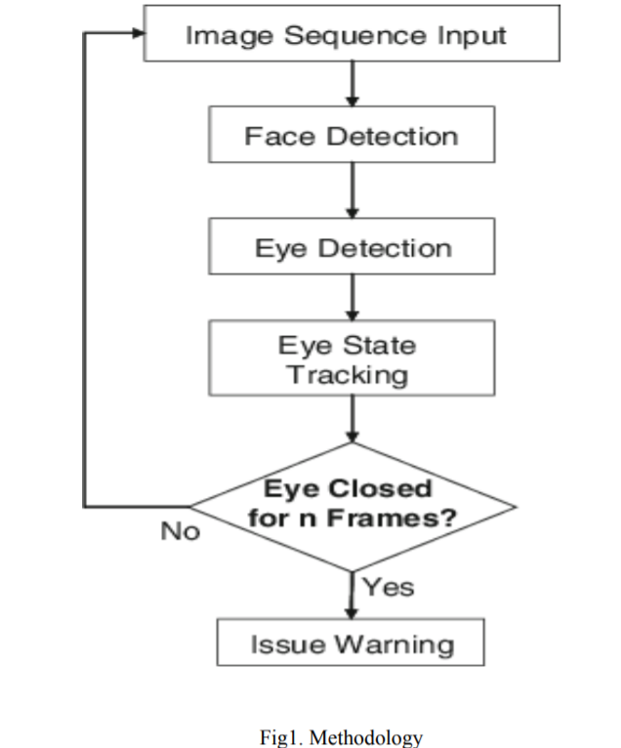

**1.5 Organization of the report**

The report is divide into five chapters. Chapter 1 is a brief introduction about the project. It tells about the Objectives and Methodology of the project. Chapter 2 is a in depth analysis of all the Research Papers and Documents that were used in making of this project. Chapter 3 is an experimental analysis of how the project will be working when put under various test case scenarios.

**CHAPTER 2**

**LITERATURE SURVEY**

This part presents the literature survey of drowsiness detection approaches. According to the Survey on Driver Fatigue-Drowsiness Detection System, the detection system includes the processes of face image extraction, yawning tendency, blink of eyes detection, eye area extraction etc.

There are many experiments done with OpenCv for android also which is available for cheap smartphones as well. Other experiments conducted have resulted in utmost accuracy when camera were placed at different locations.

OpenCv is predominantly a technique for real time image processing which has free of cost implementations on latest computer vision algorithms. It has all required computer vision algorithms

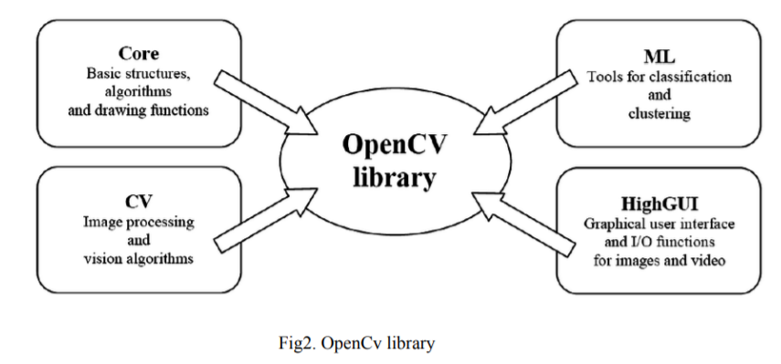

Through analysis bestowed during this paper, we have a tendency to developed associate nonintrusive image laptop vision framework for timespan checking of a driver's cautiousness. To begin with, the obligatory equipment and imaging calculations square measure created to at the same time remove various viewable signs that for the most part describe an individual's dimension of weariness. At that point, a probabilistic structure is developed to demonstrate weakness, that reliably joins totally extraordinary obvious signals and in this manner the applicable talk data to supply a tough and steady weariness file. These obvious signals portray palpebra movement, gaze, head movement, and facial highlights. The most pieces of the framework incorporate an equipment framework for the timeframe obtaining of video photos of the main impetus and differed PC vision calculations and their PC code.

Validation of this study has 2 parts in it. The first one involved the accuracy (of the computer vision algorithms / techniques) validation. Then the second involved the validation of the fatigue parameters that were computed in defining the extent of the fatigue.

The outcomes of the study showed that the prototype is efficient, dependable and accurate as well in detecting the drowsiness of the driver. All this was done in realtime and represents non-intrusive fatigue monitoring.

In another study which they tried developing similar fatigue detection system, the algorithm they proposed was designed to get the facial parts that include eyes and lips. For reducing the search areas in the provided input images, the algorithm extract the skin pixels as well which tells a lot about the possibilities that what all an algorithm can include in order to compute the drowsiness of the driver.

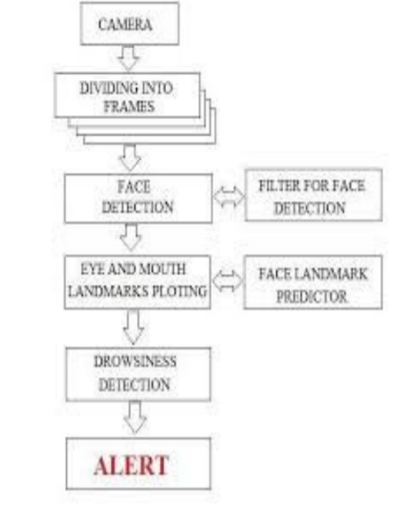

Fig3.overview of survey

**CHAPTER-3**

**SYSTEM DEVELOPMENT**

**3.1 Computational Analysis Matching**

Dashboard mounted camera is used to monitor the eyes of the driver in real time to detect drowsiness

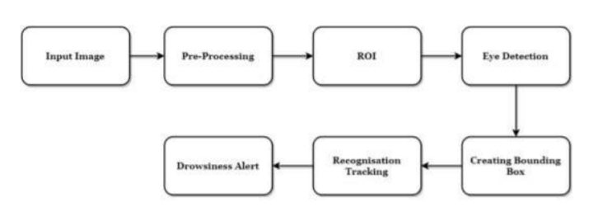

Fig 4:Architecture of Drowsyness Detection

**3.1.1 Drowsiness Detection Design:** A camera is setup that looks for faces in the input video stream and monitors frames of faces. In the event that a face is identified, facial milestone identification is connected and the eye district is removed from the edges of the video stream.

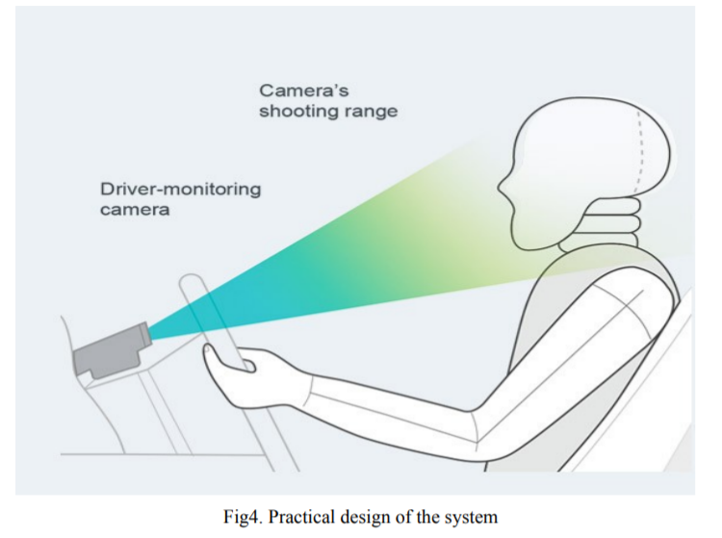

**3.1.2 Developing Image Processing solutions using OpenCV & dlib**

OpenCV was developed keeping image processing in mind. Every function and data struct of OpenCV concerns itself with an Image Processing library. Comparatively, Matlab is hugely of generic use & slow. Any usefulness can be accomplished by methods for tool kits in OpenCV, it might be money related tool compartments or explicit DNA tool stash

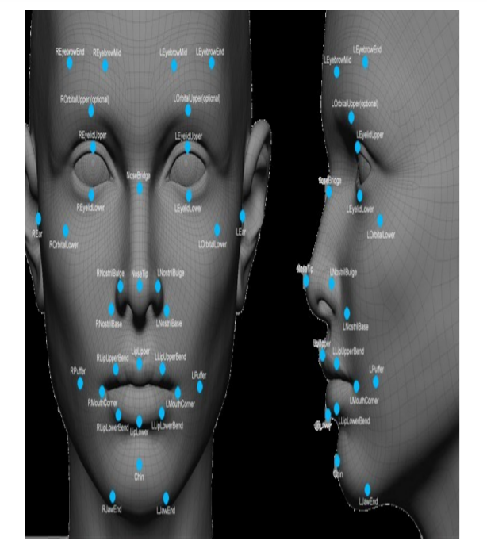

Fig5. Facial landmarks by opencv

**REFERENCES**

[1] Manu, B. N. 2016. Facial features monitoring for real time drowsiness detection. 2016 12th International Conference on Innovations in Information Technology (IIT).

[2] Alshaqaqi, B., Baquhaizel, A. S., Amine Ouis, M. E., Boumehed, M., Ouamri, A., & Keche, M. 2013. Driver drowsiness detection system. 2013 28th International Workshop on Systems, Signal Processing and Their Applications (WoSSPA).

[3] Baek, J. W., Han, B.-G., Kim, K.-J., Chung, Y.-S., & Lee, S.-I. 2018. Real-Time Drowsiness Detection Algorithm for Driver State Monitoring Systems. 2018 Tenth International Conference on Ubiquitous and Future Networks (ICUFN).

[4] You, F., Li, X., Gong, Y., Wang, H., & Li, H. 2019. A Real-time Driving Drowsiness Detection Algorithm with Individual Differences Consideration. IEEE Access, vol. 7, pp. 179396-179408.

[5] Dasgupta, A., Rahman, D., & Routray, A. 2018. A Smartphone-Based Drowsiness Detection and Warning System for Automotive Drivers. IEEE Transactions on Intelligent Transportation Systems, 1–10.

[6] Eraldo, B., Quispe, G., Chavez-Arias, H., Raymundo-Ibanez, C., & Dominguez, F. 2019. Design of a control and monitoring system to reduce traffic accidents due to drowsiness through image processing. 2019 IEEE 39th Central America and Panama Convention (CONCAPAN XXXIX).

[7] Lashkov, I., Kashevnik, A., Shilov, N., Parfenov, V., & Shabaev, A. 2019. Driver Dangerous State Detection Based on OpenCV & Dlib Libraries Using Mobile Video Processing. 2019 IEEE International Conference on Computational Science and Engineering (CSE) and IEEE International Conference on Embedded and Ubiquitous Computing (EUC).

[8] Zhang, S., & Wang, X. 2013. Human detection and object tracking based on Histograms of Oriented Gradients. 2013 Ninth International Conference on Natural Computation (ICNC).

[9] Kamran, M., Mannan, M., & Jeong, Y. 2019. Drowsiness, Fatigue and Poor Sleep’s Causes and Detection: A Comprehensive Study. IEEE Access, vol. 7, pp. 167172-167186.

[10] Zhang, W., Cheng, B., & Lin, Y. 2012. Driver drowsiness recognition based on computer vision technology. Tsinghua Science and Technology, vol. 17, no. 3, pp. 354-362.