**ABSTRACT**

Automatic Face Recognition (AFR) technologies have made a lot of improvements in the world of science and technology. The main purpose of this project is to build a face recognition-based attendance monitoring system for educational institution to enhance and upgrade the current attendance system into more efficient and effective as compared to before. The current old system has a lot of ambiguity that caused inaccurate and inefficient of attendance taking. Face recognition-based attendance system is a process of recognizing the faces of the students while taking attendance by using face bio-metrics based on high – definition monitor video and other information technology. In our face recognition project, a computer system will be able to find and recognize human faces quickly and precisely in images or videos that are being captured through a webcam / a surveillance camera. Here, faces will be recognized using face recognition algorithm. The processed image will then be compared against the existing record and then attendance marked in the database accordingly. The human face is the most distinctive feature used to uniquely identify an individual. Therefore, it is used to trace identity as the possibilities for a face to deviate or being duplicated is low.

Key Words: Face detection, Face Recognition, spreadsheet, Python, OpenCV, Tkinter GUI.

**Chapter 1**

**INTRODUCTION**

The technology aims in imparting a tremendous knowledge oriented technical innovation these days. Generally, in the classroom the attendance was taken by the teachers manually at the beginning and ending of the class. The problem with this approach is that it requires some time to take attendance and the manual process will have chances to make mistakes in most of the cases. To overcome that problem, RFID (Radio Frequency Identification) was introduced in the past years. But those are also having the fail proof of attendance system.

So, we are introducing the concept of Face Recognition Based Attendance system, the main objective the proposed system is to allot attendance to the students using face recognition-based algorithms to achieve fail proof attendance system.

Face detection is used for many applications for the identification of human faces in digital images or video. It is defined as specific case of object-class detection; where it is used to find the locations and sizes of all objects in an image that belong to a given class. The technology is can be able to predict frontal or near-frontal faces in a photo, regardless of orientation, lighting conditions or skin color.

Face Recognition is a form of biometric software that maps an individual’s facial features mathematically and stores the data as a face print. The software consists of Deep Learning algorithms to compare a live capture or digital image to the stored face print in order to verify an individual’s identity

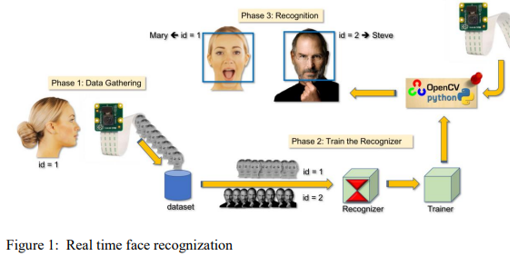

**1.1 Background**

Maintaining the attendance is very essential in all the educational institutions for checking the performance of students. Many biometric systems are available in the market but the key authentications are same in all of the techniques. Every biometric system consists of enrollment process in which the unique features of a person is stored in the database and after that, there are some processes of identification and verification of the person. These two processes compare the biometric feature of a person with previously stored template captured at the time of enrollment of a student.

**1.2 Problem Statement**

1. According to the previous attendance management system, the accuracy of the data collected is the biggest issue. This is because the attendance might not be recorded personally by the original person, in another word, the attendance of a particular person can be taken by a third party without the realization of the institution which violates the accuracy of the data. For example, student A is lazy to attend a particular class, so student B helped him/her to sign for the attendance which in fact student A didn't attend the class, but the system overlooked this matter due to no enforcement practiced. Supposing the institution establish an enforcement, it might need to waste a lot of human resource and time which in turn will not be practical at all. Thus, all the recorded attendance in the previous system is not reliable for analysis usage.

2. The second problem of the previous system is where it is too time consuming. Assuming the time taken for a student to sign his/her attendance on a 3-4 paged name list is approximately 1 minute. In 1 hour, only approximately 60 students can sign their attendance which is obviously inefficient and time consuming.

3. The third issue is with the accessibility of those information by the legitimate concerned party. For an example, most of the parents are very concerned to track their child’s actual whereabouts to ensure their kid really attend the classes in college/school. However, in the previous system, there are no ways for the parents to access such information. Therefore, evolution is needed to be done to the previous system to improve efficiency, data accuracy and provides accessibility to the information for those legitimate party.

* 1. **Objectives**: The proposed system will reduce the paperwork where attendance will no longer involve any manual recording. The new system will also reduce the total time needed to do attendance recording. The new system will acquire individual attendance by means of facial recognition to secure data accuracy of the attendance. The following are objectives of the project:

1. To develop a portable Smart Attendance System which is handy and self-powered.
2. To ensure the speed of the attendance recording process is faster than the previous system which can go as fast as approximately 3 second for each student.
3. To detect unique faces with the help of computer’s camera
4. Able to recognize the face of an individual accurately based on the face database.
5. Allow parents to track their child’s attendance.
6. Develop a database for the attendance management system.
7. Provide a user-friendly interface for admins to access the attendance database and for non-admins (parents) to check their child’s attendance by mailing the attendance.
8. Allow new students or to store their faces in the database by using a GUI.
   1. **Project Features**:
9. Long term storage of records.
10. High accuracy in calculation.
11. Time saving
12. Optimize the resource.
13. Efficiency in modification, sorting and retrieval of data.
14. Inexpensive updating in facilities and terms of organizations.
    1. **Scope and Limitations**

**1.5.1 Scope**:

1. The main intention of this project is to solve the issues encountered in the old attendance system while reproducing a brand new innovative smart system that can provide convenience to the institution.

2. Provides facility for the automated attendance of students.

3. An excel sheet is created which contains the student attendance and is mailed to the respected faculty.

**1.5.2 Limitation of project:**

1. The main problem of face recognition is large variability of recorded image.

2. Due to pose, illumination condition, facial expression, different hairstyle, presence of glasses, beard. Difficulties in code writing.

3.Difficulty to overcome ambiguity

**Chapter 2**

**LITERATURE REVIEW**

**2.1 Introduction**

The literature review deals with the topics and the researches that would help to understand Face Recognition Based Student Attendance System from the existing systems that are similar to Face Recognition Based Student Attendance system. The objective of this literature review is to analyze the related work to this project and mechanisms used in previous studies.

**2.2 Signature Based Attendance System**

According to our first research, we have “Smart Attendance Management and Analysis with Signature Verification.” This project is the Smart Attendance Management and Analysis System where after getting individual's signature of the student, the signature is scanned and converted into an image file. After segmentation, features are extracted from the signature. Verification of signature is made with the Database of student’s Signature and Excel sheet of absence and presence of student's attendance is generated. Signature is one of the most popular and legally accepted biometrics used in one’s person identification. A handwritten signature is one of the ways to verify person’s identity in legal, financial and administrative areas. [1]

**2.3 Fingerprint Based Attendance System Using Microcontroller and LabView**

According our next research journal “Fingerprint Based Attendance System Using Microcontroller and LabView” proposed a solution of using fingerprint to mark the attendance. This system is using 2 microcontrollers to deal with the fingerprint recognition process. Firstly, the fingerprint pattern will be obtained through a fingerprint sensor, then the information will be transmitted to microcontroller 1. Next microcontroller 1 will pass the information to microcontroller 2 to do the checking with the database that resides in it. After finding a student’s match, the details are sent to the PC through serial communication to be displayed. This design is good as it accelerates development while maintaining design flexibility and simplifies testing. But again, this system is attached to a PC which make it not portable. Other than that, the database information cannot be accessible easily.[2]

**2.4 RFID Based Student Attendance System**

RFID – Radio Frequency Identification is one method for attendance making. In this technology an individual has to carry his own RFID card. Therefore, this system is cost effective and can also give rise to fraud as any unauthorized person can use the card for fake attendance. [3]

**2.5 Face Recognition Attendance System**

This is one of the most efficient systems of all existing ones for identification of people. It can be used in school, colleges, or any organization. To avoid the difficulty of taking attendance of enormous number, there is a need of automated attendance system that is fast and reduces the chance of fake attendance. In this technology system is developed for deploying an easy and a secure way of taking down attendance. This attendance is recorded, by continuously detecting faces of employees or students via camera as they enter the classroom. The software first detects the faces and simultaneously compares them with the predefined database. [4]

**Chapter 3**

**METHODOLOGY**

**3.1 Introduction**

A methodology is a development system of methods that is used to plan, structure, and control the process of developing an information system. A wide variety of published development methodologies have evolved over the years, each with its own recognized strength and weakness. Different types of system project use available methodologies that best suits a specific project based on the project’s various technical development process. Below are the types of methodologies applied in developing this project.

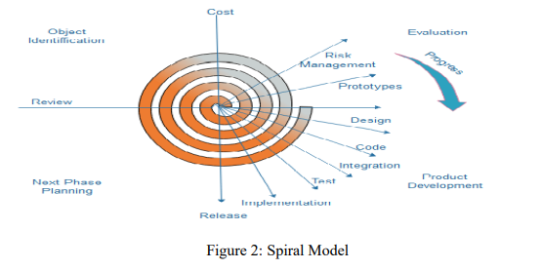

The spiral model, initially proposed by Boehm, is an evolutionary software process model that couples the iterative feature of prototyping with the controlled and systematic aspects of the linear sequential model. It implements the potential for rapid development of new versions of the software. Using the spiral model, the software is developed in a series of incremental releases. During the early iterations, the additional release may be a paper model or prototype. During later iterations, more and more complete versions of the engineered system are produced. [5] **Each cycle in the spiral is divided into four parts:**

**Objective setting:** Each cycle in the spiral starts with the identification of purpose for that cycle, the various alternatives that are possible for achieving the targets, and the constraints that exists.

**Risk Assessment and reduction**: The next phase in the cycle is to calculate these various alternatives based on the goals and constraints. The focus of evaluation in this stage is located on the risk perception for the project.

**Development and validation**: The next phase is to develop strategies that resolve uncertainties and risks. This process may include activities such as benchmarking, simulation, and prototyping.

**Planning:** Finally, the next step is planned. The project is reviewed, and a choice made whether to continue with a further period of the spiral. If it is determined to keep, plans are drawn up for the next step of the project.

**3.2 Hardware and software requirement**

**3.2.1 Hardware Requirement:**

* Computer

• Internet

• Mouse

• Keyboard

• Minimum 128 RAM

• Minimum 500 MB hard disk

**3.2.2 Software requirement**: The software is the non-physical part of the system that uses the hardware components to successfully run the system that has been built. The system must have word processor. The system will run windows Operating System.

Operating system: Windows, Linux

Different software we used are: Language : Python, OpenCV, Tkinter GUI.

Database : MYSQL

Spreadsheet : Excel

**3.2.1 Software Description**:

**OpenCV**: OpenCV is a Python open-source library, which is used for computer vision in Artificial intelligence, Machine Learning, face recognition, etc. The purpose of computer vision is to understand the content of the images. HAAR-Cascade Detection in OpenCV [8] OpenCV provides the trainer as well as the detector. We can train the classifier for any object like cars, planes, and buildings by using the OpenCV. There are two primary states of the cascade image classifier first one is training and the other is detection.

OpenCV provides two applications to train cascade classifier opencv_haartraining and opencv_traincascade. These two applications store the classifier in the different file format. For training, we need a set of samples.

There are two types of samples:

* Negative sample: It is related to non-object images.
* Positive samples: It is a related image with detect objects.
* A set of negative samples must be prepared manually, whereas the collection of positive samples is created using the opencv_createsamples utility.

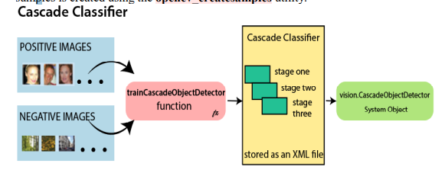

**LBPH:** Local Binary Pattern Histogram algorithm is a simple approach that labels the pixels of the image thresholding the neighborhood of each pixel.

**3.3 Proposed system analysis**

Systems analysis is a process of collecting factual data, understanding the processes involved, identifying problems and recommending feasible suggestions for improving the functionality of the system. This involves studying the business processes, entity relationships gathering operational data, understand the information flow, finding out bottlenecks and evolving solutions for overcoming the weaknesses of the system to achieve the organizational goals. System Analysis also includes decoupling of complex processes that make up the entire system, identification of data store and manual processes.

**3.4 Proposed system design**

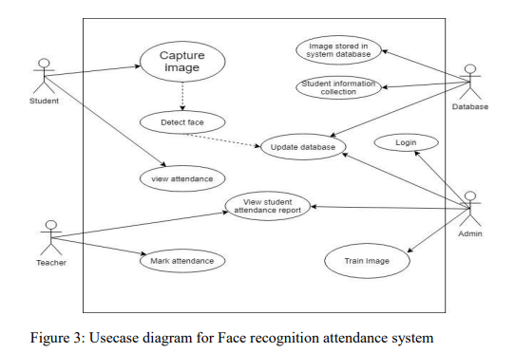

**3.5 Proposed project block diagram**

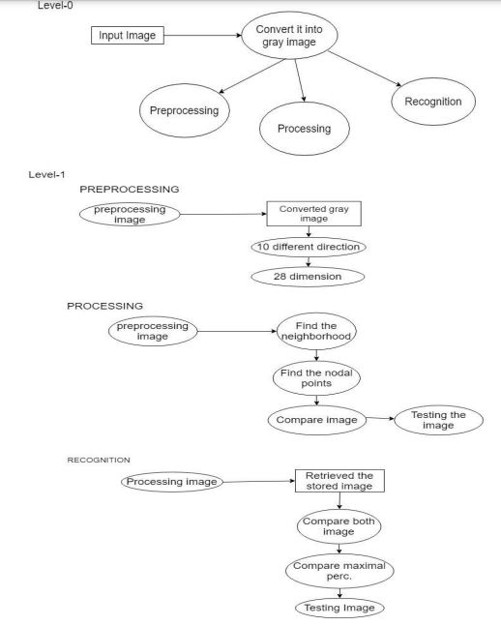

Figure 5 : Block Diagram for Face recognition attendance system

**3.6 Working principle**:

Algorithm: For Admin

Step1: START

Step2: Go to Home

Step3: Do you have a account?

3.1: If yes, Login to account

3.1.1: Go to the Home Page

3.1.1.1: Manage Student Detail, Image Process and Manipulate

3.1.1.2: Export the attendance detail

3.1.1.2.2: No, exit

3.2: If no, register for the account and go to step 3

Step4: STOP

Algorithm: For Face recognition and detection-based attendance of student

Step1: START

Step2: Image stored in System data base

Step3: Recognization Process start

Step4: Camera Capture the User image

Step5: Compare With database image

5.1: If Match

5.1.1: Present to the student

5.1.1.1: A file generated with student detail

5.1.1.2: Export the attendance detail

5.1.1.2.2: exit, go to step4

5.2: If no match, go to step 4

Step6: STOP

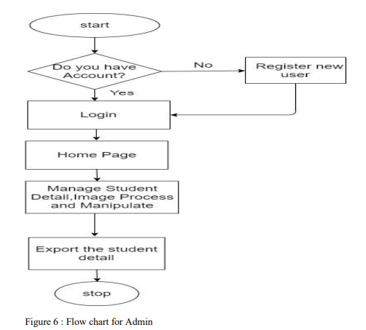

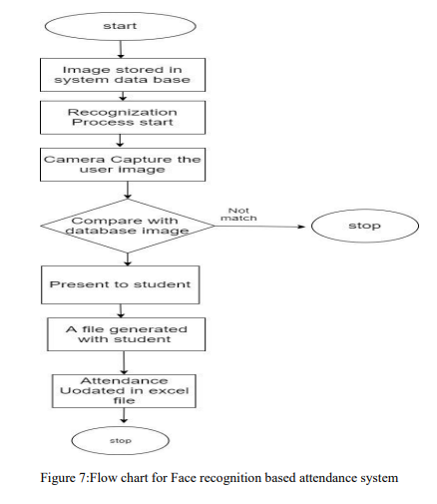

**Chapter 4**

**Results and analysis**

**Expected Output:**

* All the detail related to student, image process and manipulate, and export the attendance details of the student.
* Take the attendance automatically of students by detect the image of students so effectively

The home page of our project is:

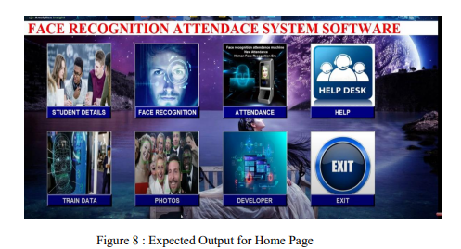

**REFERENCES**

[1] “Smart Attendance Management and Analysis with Signature Verification”(Hardika Chauhan, Chitaliya Nehal,2017)

[2] “Fingerprint Based Attendance System Using Microcontroller and LabView” (Kumar Yadav, Singh, Pujari, Mishra, 2015)

[3] “A Proposed RFID Based Student Attendance System “(Fawzi M Al-Naima and Maryam Alaa Saleh, (1 May) 2015)

[4] Charles A. Walton, electronic identification & recognition system Filed: Dec. 27, 1971 Appl. No.: 212,281.

[5] <https://www.javatpoint.com/>

[6] Smart Attendance System using Computer Vision and Machine Learning ( Dipti Kumbhar#1 , Prof. Dr. Y. S. Angal*2 # Department of Electronics and Telecommunication, BSIOTR, Wagholi, Pune, (7 July) 2017)

[7] Bifari, E.N.; Elrefaei, L.A.“Automated Fingerprint Identification System Based on Weighted Feature Points Matching Algorithm”, 978-1-4799-3080-7114/$31.00 ©2014 IEEE [8]. OpenCvDocumentation - https://opencv.org [9]. Numpy - https://numpy.org [10].CNN: https://www.academia.edu/Documents/in/CNN.