Accuracy Prediction using Machine Learning Techniques for Indian Patient Liver Disease



**Chapter 1**

**INTRODUCTION TO PREDICTION OF LIVER DISEASE**

This chapter describes about the Machine learning, problem statement of the project, objective of the project, Existing System, Proposed System and Advantages.

**1.1 Introduction to Prediction of Liver Disease**

The liver plays an important role in many bodily functions from protein production and bloodclotting to cholesterol, glucose (sugar), and iron metabolism. It has a range of functions,including removing toxins from the body, and is crucial to survival. The loss of those functions can cause significant damage to the body. When liver is infected with a virus injured by chemicals, or under attack from own immune system, the basic danger is the same that liver will become so damaged that it can no longer work to keep a person alive.

The point of this task is to some degree diminish the time delay caused because of the superfluous forward and backward transporting between the healing centre and the pathology lab. For this situation, a machine learning calculation will be prepared to foresee a liver ailment in patients. This is by all accounts a great case of managed learning.Our point will be to prepare an assortment of supervised learning and unsupervised Learning calculations on this information, so that, when another information point emerges, our best performing classifier can be utilized to classify the information point as a positive case or negative.To analyze the conceivable issue in view of the test report esteems. The specialists can enter the patient's report as information. Utilizing the framework we are foreseeing if the patient is having a liver infection or not by examining the accessible dataset.We are catching the test report contribution from UI and store it in a table. We have made a table with the current dataset which has every one of the records. We have utilized Naïve Bayes, Support Vector Machine, to make a model. In light of the model and the test information we are anticipating if the patient can have Liver Disease and the precision of the ailment.

**1.1.1 Introduction to Machine Learning**

Machine learning is a branch of Artificial Intelligence(AI) which is heavily used in the field of data science. It hasa strong potential in health-related data analysis for automated disease prediction. Machine learning technology is widely used these days



Dept. of CSE, KIT, Tiptur Page 1

Accuracy Prediction using Machine Learning Techniques for Indian Patient Liver Disease



in various fields such as WiFi-hot spot detection, diagnosis of heart disease, diagnosis of cancer, diagnosis of tumor detection, prediction of type of cancer, etc. Machine learning is a field of artificial intelligence (AI) that enables the system to learn by itself without being explicitly programmed.According to, it is a field of study that gives computers the ability to learn without programming them explicitly. Unsupervised machine learning is the method of inferring a function that defines the structure of unlabeled data. The main objective of unsupervised learning is to draw inferences from input data and model the structure based on that data.

**1.2 Overview of Project**

The work focuses on three different machine learning techniques, i.e., Naïve Bayes, K-means, and Support Vector Machine, propagation to compare their prediction accuracy and computational complexity. The study concentrates on liver disease-related health care data set and used for comparative performance measurement of the three techniques.

The utilization of medicinal datasets has pulled in the consideration of specialists around the world. Machine Learning methods have been broadly utilized as a part of creating choice emotionally supportive networks for ailments forecast through an arrangement of therapeutic datasets. Grouping systems have been broadly utilized as a part of the restorative field for exact order than an individual classifier. Liver malady is a sort of harm to or illness of the liver. In this task, I have taken the datasets of general Indian liver ailment patient's records to help basic leadership. Indian Liver Patient's datasets demonstrate that proposed technique amazingly enhances the illnesses expectation precision.

**1.3 Problem Statement**

The Liver Disease Detection Problem includes modeling past liver disease patient data with the knowledge of the ones that has liver disease or not. This model is then used to identify whether a new person is prone to get liver disease or not. Our aim here is to detect 100% of the liver disease prediction.

**1.4 Key Features of Machine Learning**

1. **Classification**: A set of numeric features can be conveniently described by a featurevector. An example of reaching a two-way classification from a feature vector (related to the perceptron) consists of calculating the scalar product between the feature vector



Dept. of CSE, KIT, Tiptur Page 2

Accuracy Prediction using Machine Learning Techniques for Indian Patient Liver Disease



and a vector of weights, comparing the result with a threshold, and deciding the class based on the comparison.

* 1. [**Character Recognition**:](https://en.wikipedia.org/wiki/Character_recognition) **features** may include [histograms](https://en.wikipedia.org/wiki/Histogram) counting the number of black pixels along horizontal and vertical directions, number of internal holes, stroke detection and many others.

1. [**Speech Recognition:**](https://en.wikipedia.org/wiki/Speech_recognition) featuresfor recognizing [phonemes](https://en.wikipedia.org/wiki/Phonemes) can include noise ratios, length of sounds, relative power, filter matches and many others.
2. [**Spam**](https://en.wikipedia.org/wiki/Spam_(electronic)) **Detection:** features may include the presence or absence of certain emailheaders, the email structure, the language, the frequency of specific terms, the grammatical correctness of the text.

**5.Selection and Extraction:** [Extracting](https://en.wikipedia.org/wiki/Feature_extraction) **or** [selecting](https://en.wikipedia.org/wiki/Feature_selection) **features** is a combination of artand science developing systems to do so is known as [feature engineering.](https://en.wikipedia.org/wiki/Feature_engineering) It requires the experimentation of multiple possibilities and the combination of automated techniques with the intuition and knowledge of the [domain expert.](https://en.wikipedia.org/wiki/Domain_expert) Automating this process is [feature learning,](https://en.wikipedia.org/wiki/Feature_learning) where a machine not only uses features for learning, but learns the features itself.

**1.5 Aim of the Project**

The main objective of this research is to use classification algorithms to identify the liver patients from healthy individuals. In this study,Three classification algorithms Support Vector Machines (SVM), K-mean algorithm and Naive Bayes have been considered for comparing their performance based on the liver patient data. Further, the model with the highest accuracy is implemented as a user friendly Graphical User Interface (GUI). The GUI can be readily utilized by doctors and medical practitioners as a screening tool for liver disease.

**1.6 Objective of the Project**

To solve the problems facing physicians in diagnosis of liver diseases. Experience has shown that many patients suffering from liver disorder die daily as a result of misdiagnosis of the diseases.

Early prediction of liver disease is very important to save human life and take proper steps to control the disease. This research work explores the early prediction of liver disease using deep learning techniques. The liver disease dataset which is select



Dept. of CSE, KIT, Tiptur Page 3

Accuracy Prediction using Machine Learning Techniques for Indian Patient Liver Disease



for this study is consisting of attributes like total bilirubin, direct bilirubin, age, gender, total proteins, albumin and globulin ratio.

Following are the objectives performed by the system:

* The application must provide user interface for doctors input object of the prescription.
* The application should have the capability for preprocessing of the given input.
* The System should be capable to detect the chances of lever disease using past patient data.

**1.7 Existing System**

In existing system to analyze the conceivable issue in view of the test reportesteems. The specialists can enter the patient's report as information. Utilizing the framework we are foreseeing if the patient is having a liver infection or not by examining the accessible dataset. Some degree diminish the time delay caused because of the superfluous forward and backward transporting between the healing centre and the pathology lab.

**Disadvantages of Existing System:**

* There is no real time identity verification.
* Not using data-mining technique to detect chances of getting lever disease.
* Time intense.

**1.8 Proposed System**

Work has been done in recognizing the beginning of sicknesses like coronary illness. For this situation, a machine learning calculation will be prepared to fore see a liver ailment in patients. This is by all accounts a great case of managed learning. We have been given a settled number of highlights for every datum point, and our point will be to prepare an assortment of supervised learning and unsupervised Learning calculations on this information Three classification algorithms Support Vector Machines (SVM), K-mean algorithm and Naive Bayes have been considered for comparing their performance based on the liver patient data. Further, the model with the highest accuracy is implemented as a user friendly Graphical User Interface (GUI). The GUI can be readily utilized by doctors and medical practitioners as a screening tool for liver disease.



Dept. of CSE, KIT, Tiptur Page 4

Accuracy Prediction using Machine Learning Techniques for Indian Patient Liver Disease



**Advantages of Proposed System:**

* Proposed system will allow people to get early prediction of getting chances of lever disease.
* It didn’t require medical expertise.
* Early prediction of liver disease can save human life and take proper steps to control the disease.

**1.9 Functional Requirements**

A function of software system is defined in functional requirement and the behavior of the system is evaluated when presented with specific inputs or conditions which may include calculations, data manipulation and processing and other specific functionality.

**1.10 Non-functional Requirements**

Nonfunctional requirements describe how a system must behave and establish constraints of its functionality.Attributes such as performance, security, usability, compatibility are not the feature of the system, they are a required characteristic. They are "developing" properties that emerge from the whole arrangement and hence we can't compose a particular line of code to execute them. Any attributes required by the customer are described by the specification. We must include only those requirements that are appropriate for our project.

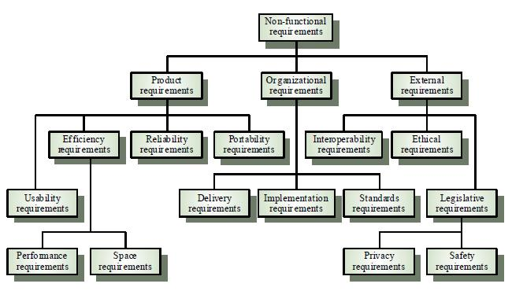

**Figure 1.1 Non Functional Requirements**

Figure 1.2 Non functional requirements shows details of all types of requirements in a hirachical form.



Dept. of CSE, KIT, Tiptur Page 5

Accuracy Prediction using Machine Learning Techniques for Indian Patient Liver Disease



**Some Non-Functional Requirements are as follows:**

* **Reliability:** The structure must be reliable and strong in giving the functionalities.The movements must be made unmistakable by the structure when a customer has revealed a couple of enhancements. The progressions made by the Programmer must be Project pioneer and in addition the Test designer.
* **Maintainability:** The system watching and upkeep should be fundamental andfocus in its approach. There should not be an excess of occupations running on diverse machines such that it gets hard to screen whether the employments are running without lapses.
* **Performance:** The framework will be utilized by numerous representatives all thewhile. Since the system will be encouraged on a single web server with a lone database server outside of anyone's ability to see, execution transforms into a significant concern. The structure should not capitulate when various customers would use everything the while. It should allow brisk accessibility to each and every piece of its customers. For instance, if two test specialists are all the while attempting to report the vicinity of a bug, then there ought not to be any irregularity at the same time.
* **Portability:** The framework should to be effectively versatile to anotherframework. This is obliged when the web server, which s facilitating the framework gets adhered because of a few issues, which requires the framework to be taken to another framework.
* **Scalability:** The framework should be sufficiently adaptable to include newfunctionalities at a later stage. There should be a run of the mill channel, which can oblige the new functionalities.
* **Flexibility:** Flexibility is the capacity of a framework to adjust to changingsituations and circumstances, and to adapt to changes to business approaches and rules. An adaptable framework is one that is anything but difficult to reconfigure or adjust because of diverse client and framework prerequisites. The deliberate division of concerns between the trough and motor parts helps adaptability as just a little bit of the framework is influenced when strategies or principles change.

**Summary**

This chapter gives the introduction to how the Liver disease is diagnosed, overview of the project, problem statement of the project, objective of the project, Existing system, proposed system, functional requirements and non-functional requirements.



Dept. of CSE, KIT, Tiptur Page 6

Accuracy Prediction using Machine Learning Techniques for Indian Patient Liver Disease



**Chapter 2**

**LITERATURE SURVEY ON LIVER DISEASE PREDICTION**

This chapter gives a clear history of machine learning techniques which are used in this project.

**2.1 Introduction**

To analyze the conceivable issue in view of the test report esteems. The specialists can enter the patient's report as information. Utilizing the framework, we are foreseeing if the patient is having a liver infection or not by examining the accessible dataset. The datasets are taken from UCI vault. We are catching the test report contribution from UI and store it in a table. We have made a table with the current dataset which has every one of the records. We have utilized , Naïve Bayes, Support Vector Machine, k-Means to make a model.

**2.2 Machine Learning Techniques**

**A. K-Means Algorithm**

K-means is a method of clustering observations into a specific number of disjoint clusters. The K” refers to the number of clusters specified. Various distance measures exist to determine which observation is to be appended to which cluster. The algorithm aims at minimizing the measure between the centroid of the cluster and the given observation by iteratively appending an observation to any cluster and terminate when the lowest distance measure is achieved.

* The sample Dataset is initially partitioned into K clusters and the observations are randomly assigned to the clusters.

For each sample:

* Calculate the personnel details of customer to the centroid of the cluster.
* IF the sample data is closer to its own cluster THEN Accept ELSE or reject
* Repeat steps 1 and 2 until no observations are moved from one cluster to another
* When step 3 terminates the clusters are stable and each sample is assigned a cluster which results in the lowest possible distance to the centroid of the cluster.



Dept. of CSE, KIT, Tiptur Page 7

Accuracy Prediction using Machine Learning Techniques for Indian Patient Liver Disease



A Person or Medical expert wants to analyze the data in order to know which person is prone to get liver disease or not. There is an enormous amount of data which one can actually retrieved from the health sector. The data can actually be used to detect the chance of liver disease. The proposed system categorizes chance of getting liver disease based on some personal information. Detection is then carried out to know the liver disease. The system takes all this information first as the input and points out person who are prone to get liver disease. A training dataset is being prepared beforehand based upon the person previous history. The system uses the concept of k-means clustering to cluster the person based upon the similarities or the patterns they share among each other naïve baye’s and SVM used to classify and detect the chance of getting liver disease with the training dataset and testing dataset and after classifying it will detect the liver disease.

K-means is a method of clustering analysis into a precise number of disjoint clusters. The K-refers to the total of clusters specified. Different distance events survive to resolve which observation is to be appended to which cluster.

* + A cluster of information items can be deal with as one gathering.
  + While doing bunch examination, we first parcel the arrangement of information into bunches in view of information comparability and afterward dole out the names to the gatherings.
  + The principle preferred standpoint of bunching over arrangement is that, it is versatile to changes and helps single out valuable highlights that recognize distinctive gatherings

1. **Distance measures**

Common distance measures include the Euclidean distance, the Euclidean squared distance and the Manhattan or City distance.

The Euclidean measure corresponds to the shortest geometric distance between to points.



A faster way of determining the distance is by use of the squared Euclidean

distance whichcalculates the above distance squared, i.e.

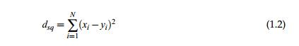

Dept. of CSE, KIT, Tiptur Page 8

Accuracy Prediction using Machine Learning Techniques for Indian Patient Liver Disease



The specific k-Means algorithm is defined as follows

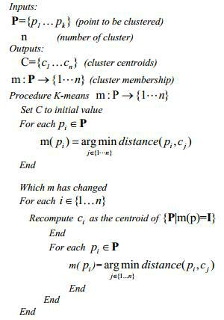

**C. Naïve Bayes**

Classification techniques are maximum ideal for predicting or describing facts sets with binary or nominal classes. They are less effective for ordinal classes because they do now not consider the implicit order among the classes. Other kinds of relationships, which includes the subclass–super class relationships among classes also are unnoticed. The remainder of this bankruptcy focuses best on binary or nominal magnificence labels.

A class technique is a scientific method to constructing type fashions from an enter information set. Examples encompass choice tree classifiers, rule-based totally classifiers, neural networks, aid vector machines, and Naive Bayes classifiers. Each approach employs a mastering set of rules to pick out a model that quality fits the connection among the attribute set and sophistication label of the enter records. The version generated by using a studying algorithm ought to each suit the input records properly and efficiently are expecting the magnificence labels of facts it has never visible earlier than. Therefore, a key goal of the gaining knowledge of set of rules is to construct fashions with correct generalization capability, models that accurately expect the elegance labels of previously unknown facts. The tree has 3 styles of nodes:



Dept. of CSE, KIT, Tiptur Page 9

Accuracy Prediction using Machine Learning Techniques for Indian Patient Liver Disease



* A root node that has no approaching edges and at least zero active edges
* Internal node, each of which has precisely one approaching edge and at least two active edges.
* Leaf or terminal node, each of which has precisely one approaching edge and no friendly edges.

Naive Bayes is a simple technique for constructing classifiers: models that assign class labels to problem instances, represented as vectors of [feature](https://en.wikipedia.org/wiki/Feature_vector) values, where the class labels are drawn from some finite set. It is not a single [algorithm](https://en.wikipedia.org/wiki/Algorithm) for training such classifiers, but a family of algorithms based on a common principle: all Naive Bayes classifiers assume that the value of a particular feature is [independent](https://en.wikipedia.org/wiki/Independence_(probability_theory)) of the value of any other feature, given the class variable.

* In this progression the grouping calculations assemble the classifier.
* The classifier is worked from the preparation set made up of database tuples and their related class marks.
* Each tuple that constitutes the preparation set is alluded to as a classification or class. These tuples can likewise be alluded to as test, question or information focuses.
* above diagram shows that the liver disease is detected based on person personal details.

**D. Support Vector Machine**

Support Vector Machine was first found by Vapnik in 1979. It was again recommended by Vapnik in 1995 for regression and classification. Support vector can be used for pattern classification which has multilayer perceptron and radial-basis function networks. The SVM is the advanced technology with maximum classification algorithms embedded in statistical learning theory. SVM methods are used in classification of linear and non-linear data. It transforms the original training data into higher dimension using non-linear mapping. Within this new dimension it searches for linear optimal separating hyperplane. Data from two classes can be separated by hyperplane with an appropriate nonlinear mapping to a sufficiently high dimension. Using support vectors and margins the SVM finds these hyperplane. SVM implements the classification task by maximizing the margin classifies both class while minimizing the classification errors. Although the SVM can be applied to various optimization problems such as regression, the classic problem is that of data classification. The data



Dept. of CSE, KIT, Tiptur Page 10

Accuracy Prediction using Machine Learning Techniques for Indian Patient Liver Disease



points are identified as being positive or negative, and the problem is to find a hyperplane that separates the data points by a maximal margin.

* Support Vector Machine” (SVM) is a supervised [machine learning](https://courses.analyticsvidhya.com/courses/introduction-to-data-science-2?utm_source=blog&utm_medium=understandingsupportvectormachinearticle) [algorithm](https://courses.analyticsvidhya.com/courses/introduction-to-data-science-2?utm_source=blog&utm_medium=understandingsupportvectormachinearticle) which can be used for both classification or regression challenges. However, it is mostly used in classification problems. In this algorithm, we plot each data item as a point in n-dimensional space (where n is number of features you have) with the value of each feature being the value of a particular coordinate. Then, we perform classification by finding the hyper-plane that differentiate the two classes very well (look at the below snapshot).
* Support Vectors are simply the co-ordinates of individual observation. Support Vector Machine is a frontier which best segregates the two classes (hyper-plane/ line)
* An SVM generates parallel partitions by generating two parallel lines. For each category of data in a high-dimensional space and uses almost all attributes. It separates the space in a single pass to generate flat and linear partitions. Divide the 2 categories by a clear gap that should be as wide as possible. Do this partitioning by a plane called hyperplane.
* An SVM creates hyperplanes that have the largest margin in a high-dimensional space to separate given data into classes. The margin between the 2 classes represents the longest distance between closest data points of those classes.
* STEP1: Select the feature sets from different classes of data
* STEP2: Calculate the intersection points of each class of feature and plot, repeat for all the features of data.
* STEP3: Remove the features which are intersecting and data of all the classes.
* STEP4: Plot the hyper planes for the remaining points.
* STEP5: Calculate the distance of the hyper planes in different class of objects.
* STEP6: Select the hyper plane which is consistent for each class of data

**Pros**

* Accuracy
* Works well on smaller cleaner datasets
* It can be more efficient because it uses a subset of training points



Dept. of CSE, KIT, Tiptur Page 11

Accuracy Prediction using Machine Learning Techniques for Indian Patient Liver Disease



**Cons**

* Isn’t suited to larger datasets as the training time with SVMs can be high
* Less effective on noisier datasets with overlapping classes

**2.3 Scope of the Project**

* The main intention of our project is to solve the problems faced by physicians in diagnosis of liver diseases by using Machine Learning technique.
* To early prediction of chance of getting Liver disease in health sector using K-Means and naive Bayesian and SVM algorithm in data mining.
* To save human life and take proper steps to control the disease by early prediction of disease.

**2.4 Related Work**

**Ashwani Kumar., [1] “Categorization of Liver Disease Using Classification Techniques”** It is one of the great techniques to dissect liver and non-liver patient inawesome exactness. They utilized the C4.5, Random Forest, CART, Random Tree and REP tree as classifier for order of liver information and accomplished 79.22% exactness in Random Forest utilizing 80-20% information segment with 6 highlights. They suggested Random woodland is better classifier for characterization of liver illness among all.

**Chandrasegar Thirumalai., [2]** **“Cost Optimization using Normal** **Linear**

**Regression Method for Breast Cancer Type I Skin**”Pearson strategy has brokendown its relationship coefficient with different characteristics, by utilizing Pearson strategy. From these coefficient esteems, the properties having values which are more prominent than 0.55, are mulled over. Further, machine learning technique is utilized for discovering the minimum cost capacity and its relating theta esteem. By utilizing straightforward direct relapse strategy on the diminished properties, we have gotten direct conditions. Their proposed display one can take astute choices with the assistance of convenient electronic gadgets like advanced cells and tabs.



Dept. of CSE, KIT, Tiptur Page 12

Accuracy Prediction using Machine Learning Techniques for Indian Patient Liver Disease



**Harsha Pakhale.,[3] “Development of an Efficient Classifier for Classification of Liver Patient with Feature Selection”** has examined the individual model does notfulfil the arrangement exactness of model so they have gathering the individual models to build up the hearty classifier. They have additionally connected the data pick up include determination strategy to computationally expand the execution of model.

**Dr. S. Vijayarani., [4] “Liver Disease Prediction using SVM and Naïve Bayes Algorithms”** finished up the SVM classifier is considered as a best calculation due toits most elevated grouping exactness. Then again, while looking at the execution time, the Naïve Bayes classifier needs least execution time.

**Anju Gulia., [5] “Liver Patient Classification Using Intelligent Techniques”**

presents an approach that will be utilized for half breed display development of group wellbeing administrations. These arrangement calculations can be actualized for other overwhelming sicknesses likewise like cardiovascular and diabetes forecast and grouping. Another extension is to seeing climate by applying new calculations will made any upgrades over strategies which are utilized as a part of this paper in future.

**Kalyan Nagaraj., [6] “NeuroSVM: A Graphical User Interface for Identification**

**of Liver Patients”** say an endeavour is made for forecast of liver infection in patientsutilizing information mining systems. A cross breed Neuro-SVM show was produced for characterization of liver patients in view of their organic parameters utilizing fake neural system. The cross-breed display is sent as a graphical UI (GUI) in R. The GUI can be utilized as a screening instrument by specialists for expectation of liver illness in patients in future.

**Jankisharan Pahareeya., [7]** , **“Liver Patient Classification using Intelligence**

**Techniques”** closes Throughout the examination ten times cross approval isperformed. The proposed Random Forest over testing (200%) show beat every single other method. The Random Forest over examining (200%) display is the generally best indicator among every single other strategy.

**Bendi Venkata Ramana.,[8]** **“A Critical Study of Selected** **Classification**

**Algorithms for Liver Disease Diagnosis”** has broken down Modified pivot timberland

calculation was proposed with multi-layer observation grouping calculation and



Dept. of CSE, KIT, Tiptur Page 13

Accuracy Prediction using Machine Learning Techniques for Indian Patient Liver Disease



irregular subset include determination technique for UCI liver informational collection. Changed pivot woodland calculation was proposed with closest neighbour arrangement calculation and connection-based element determination strategy for INDIA liver dataset.

**Kotsiantis. S.B., [9] “A Critical Study of Selected Classification Algorithms for**

**Liver Disease Diagnosis**”advises to build the forecast exactness of the straightforwardBayes demonstrate. The idea of joining classifiers is proposed as another bearing for the change of the execution of individual classifiers. He utilized a discretization strategy and expelled excess highlights utilizing a channel include determination technique. At long last, he played out a substantial scale correlation with different endeavours that have attempted to enhance the precision of the basic Bayes calculation and additionally other best in class calculations and he took better exactness as a rule utilizing less time for preparing, as well.

**Summary**

This chapter describes the machine learning techniques used in the project and also explaines the scope of project.



Dept. of CSE, KIT, Tiptur Page 14

Accuracy Prediction using Machine Learning Techniques for Indian Patient Liver Disease



**Chapter 3**

**SYSTEM ARCHITECTURE**

Design is a meaningful engineering representation of something that is to be built. It is the most crucial phase in the developments of a system. Software design is a process through which the requirements are translated into a representation of software. Design is a place where design is fostered in software Engineering. Based on the user requirements and the detailed analysis of the existing system, the new system must be designed. This is the phase of system designing.

**3.1 Introduction to System Architecture**

System Architecture design-identifies the overall hypermedia structure for the Application. Architecture design is tied to the goals establish for a Application, the content to be presented, the users who will visit, and the navigation philosophy that has been established. Content architecture, focuses on the manner in which content objects and structured for presentation and navigation. Application architecture, addresses the manner in which the application is structure to manage user interaction, handle internal processing tasks, effect navigation, and present content. Application architecture is defined within the context of the development environment in which the application is to be implemented.

**3.2 System Requirements**

Software Requirement Specification (SRS) is a fundamental document, which forms the foundation of the software development process. SRS not only lists the requirements of a system but also has a description of its major features. These recommendations extend the IEEE standards. The recommendations would form the basis for providing clear visibility of the product to be developed serving as baseline for execution of a contract between client and the developer. SRS constitutes the agreement between clients and developers regarding the contents of the software product that is going to be developed. SRS should accurately and completely represent the system requirements as it makes a huge contribution to the overall project plan. The software being developed may be a part of the overall larger system or may be a complete standalone system in its own right.



Dept. of CSE, KIT, Tiptur Page 15

Accuracy Prediction using Machine Learning Techniques for Indian Patient Liver Disease



**3.2.1 Hardware Requirements**

|  |  |  |
| --- | --- | --- |
| • | Processor | : Intel Core 2 Duo |
| • | RAM | :2GB |
| • | Hard Disk | :80GB |

**3.2.2 Software Requirements**

|  |  |  |
| --- | --- | --- |
| • | Operating System | : Windows (Any Version) |
| • | Programming Language | : JAVA, AWT, SWING |
| • | IDE | : Eclipse |

**3.3 System Architecture**

System Architecture design-identifies the overall structure for the Liver disease as shown in below diagram.

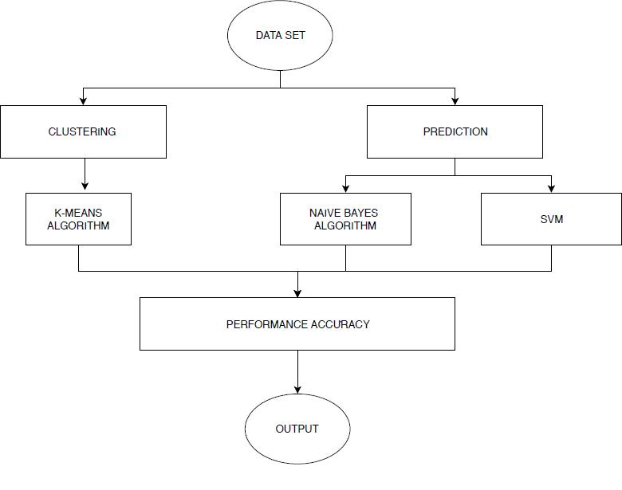

**Figure 3.1: System Architecture**

Figure 3.1 System Architecture for Liver disease ,Compares Naïve Bayes and SVM algorithms are done and it is based on the performance factors classification accuracy and execution time.



Dept. of CSE, KIT, Tiptur Page 16

Accuracy Prediction using Machine Learning Techniques for Indian Patient Liver Disease



**3.4 Data Flow Diagram**

Data flow diagram is a graphical portrayal of the flow of information through a data framework, displaying its procedure angles. A DFD is regularly utilized as a preparatory advance to make an outline of the framework without broadly expounding, which can later be explained. A DFD demonstrates what sort of data will be contribution to and yield from the framework, how the information will progress through the framework, and where the information will be put away. It doesn't indicate data about process timing or whether procedures will work in succession or in parallel, dissimilar to a customary organized flowchart which centers around control stream, or an UML movement work process outline, which presents both control and information streams as a brought together model.

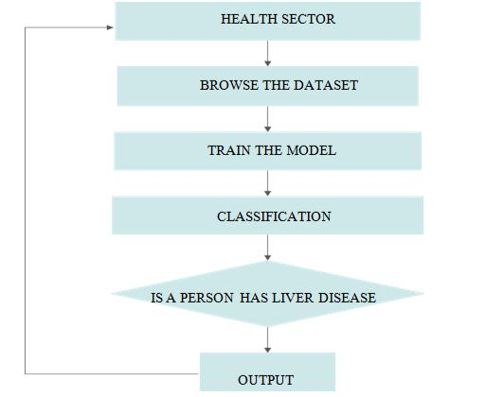

**Figure 3.2: Data flow diagram**

Figure 3.2 is the data flow diagram the output of the results is feedback to the dataset the flow of data presented above.A DFD demonstrates what sort of data will be contribution to and yield from the framework



Dept. of CSE, KIT, Tiptur Page 17

Accuracy Prediction using Machine Learning Techniques for Indian Patient Liver Disease



**3.5 Use Case Diagram**

Use case diagrams are utilized to accumulate the necessities of a framework including inside and outside impacts. These prerequisites are generally plan necessities. Thus, when a framework is investigated to assemble its functionalities, utilize cases are readied and on-screen characters are recognized. At the point when the underlying assignment is finished, utilize case outlines are demonstrated to exhibit the outside view. To somethings up, the motivations behind utilize case graphs can be said to be as per the given

* Used to assemble the prerequisites of a system.
* Used to get an outside perspective of a system.
* Distinguish the outer and interior components affecting the system.
* Demonstrate the collaboration among the necessities are on-screen characters.

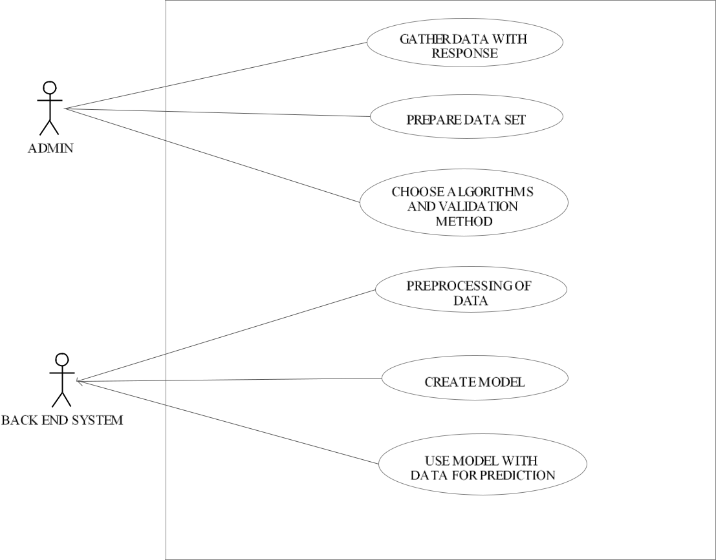

**Figure 3.3: Use Case diagram**



Dept. of CSE, KIT, Tiptur Page 18

Accuracy Prediction using Machine Learning Techniques for Indian Patient Liver Disease



**3.6 Sequence diagram**

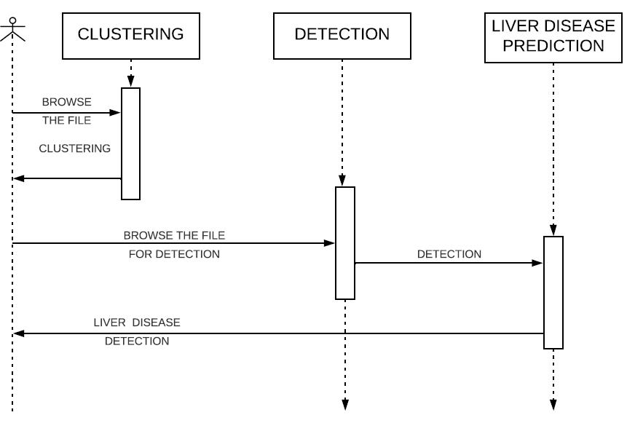

**Figure 3.4: Sequence diagram**

In Figure 3.4 a sequence diagram demonstrates protest collaborations organized in time arrangement.

It delineates the articles and classes engaged with the situation and the succession of messages traded between the items expected to complete the usefulness of the situation. Arrangement charts are regularly connected with utilize case acknowledge in the Logical View of the framework a work in progress.



Dept. of CSE, KIT, Tiptur Page 19

Accuracy Prediction using Machine Learning Techniques for Indian Patient Liver Disease



**3.7 Activity diagram**

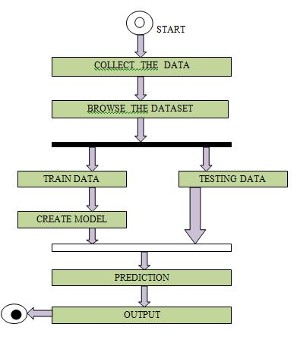

**Figure 3.5: Activity diagram**

In Figure 3.5 Activity diagram is essentially a flowchart to speak to the spill out of one action to another movement.

The action can be portrayed as an activity of the framework. The control stream is attracted starting with one task then onto the next. This stream can be consecutive, fanned, or simultaneous. Action graphs manage all sort of stream control by utilizing diverse components, for example, fork, join, and so on .The fundamental reasons for action charts is like other four graphs. It catches the dynamic conduct of the framework. Other four charts are utilized to demonstrate the message spill out of one protest another however action graph is utilized to indicate message spill out of one movement to another. Movement is a specific task of the framework. Movement graphs are not just utilized for envisioning the dynamic idea of a framework, yet they are additionally used to build the executable framework by utilizing forward and figuring out procedures. The main missing thing in the movement chart is the message part. It doesn't demonstrate any message spill out of one movement to another. Movement graph is some of the time considered as the flowchart. In spite of the fact that the graphs



Dept. of CSE, KIT, Tiptur Page 20

Accuracy Prediction using Machine Learning Techniques for Indian Patient Liver Disease



resemble a flowchart, they are definitely not. It indicates diverse streams, for example, parallel, fanned, simultaneous, and single. The reason for a activity diagram can be depicted as ,

* Draw the movement stream of a framework.
* Depict the succession starting with one action then onto the next.
* Depict the parallel, extended and simultaneous stream of the framework.

**Summary**

This chapter gives the description about the system architecture and system design. It gives description about the flow diagrams and use case diagrams,sequence diagrams and activity diagram.



Dept. of CSE, KIT, Tiptur Page 21

CONCLUSION

Classification is the major data mining technique which is primarily used in healthcare sectors for medical diagnosis and predicting diseases. This research work used classification algorithms namely Naïve Bayes and Support Vector Machine (SVM) for liver disease prediction. Comparisons of these algorithms are done and it is based on the performance factors classification accuracy and execution time. From the experimental results, this work concludes, the SVM classifier is considered as a best algorithm because of its highest classification accuracy. On the other hand, while comparing the execution time, the Naïve Bayes classifier needs minimum execution time





Accuracy Prediction using Machine Learning Techniques for Indian Patient Liver Disease



**REFERENCES**

[1] Ashwani Kumar, Neelam Sahu, “Categorization of Liver Disease Using Classification Techniques”, International Journal for Research in Applied Science & Engineering Technology (IJRASET), Volume 5 Issue V, May 2017, IC Value: 45.98 ISSN: 2321-9653.

[2] Chandrasegar Thirumalai, IEEE Member, Rashad Manzoor, “Cost Optimization using Normal Linear Regression Method for Breast Cancer Type I Skin”, International Conference on Electronics, Communication and Aerospace Technology ICECA 2017.

1. Harsha Pakhale, Deepak Kumar Xaxa, “Development of an Efficient Classifier for Classification of Liver Patient with Feature Selection”, International Journal of

Computer Science and Information Technologies, Vol. 7 (3), 2016, 1541-1544.

1. Dr. S. Vijayarani, Mr.S.Dhayanand, “Liver Disease Prediction using SVM and Naïve Bayes Algorithms”, International Journal of Science, Engineering and Technology Research (IJSETR) Volume 4, Issue 4, April 2015.
2. Anju Gulia, Dr. Rajan Vohra , Praveen Rani “Liver Patient Classification Using

Intelligent Techniques”, International Journal of Computer Science and Information Technologies, Vol. 5 (4), 2014, 5110-5115.

[6] Kalyan Nagaraj and Amulyashree Sridhar, “NeuroSVM: A Graphical User Interface

for Identification of Liver Patients”, IJCSIT. 5(6): 8280-8284 (2014).

[7] Jankisharan Pahareeya, Rajan Vohra, Jagdish Makhijani , Sanjay Patsariya, “Liver Patient Classification using Intelligence Techniques”, International Journal of Advanced Research in Computer Science and Software Engineering, Volume 4, Issue 2, February 2014.

[8] Bendi Venkata Ramana, Surendra. Prasad Babu. M, Venkateswarlu. N.B, “A Critical Study of Selected Classification Algorithms for Liver Disease Diagnosis”, International Journal of Database Management Systems (IJDMS), Vol.3, No.2, May 2011 page no 101-114.



Dept. of CSE, KIT, Tiptur Page 43

Accuracy Prediction using Machine Learning Techniques for Indian Patient Liver Disease



1. Kotsiantis. S.B, “Increasing the Classification Accuracy of Simple Bayesian

Classifier”, AIMSA, pp.198- 207, 2004.

[10] V.Kirubha, S.Manju Priya, “Survey on Data Mining Algorithms in Disease Prediction”, International Journal of Computer Trends and Technology (IJCTT) – Volume 38 Number 3 - August 2016.

[11] Bendi Venkata Ramana, Prof. M. S. Prasad Babu and Prof. N. B. Venkateswarlu, “Critical Comparative Study of Liver Patients from USA and INDIA: An Exploratory Analysis, International Journal of Computer Science Issues, ISSN: 1694 -0784, May 2012.

[13] A.S.Aneeshkumarand C.JothiVenkateswaran, “Estimating the Surveillance of Liver Disorder using Classification Algorithms”, International Journal of Computer Applications (0975 – 8887), Volume 57– No.6, November 2012.

[14] S. Karthik A, Priyadarishini, J. Anuradha and B. K. Tripathy (2011). “Classification and Rule Extraction using Rough Set for Diagnosis of Liver Disease and its Types”, Advances in Applied Science Research.

1. Esraa M Hashem, Mai S Mabrouk (2014). “A Study of Support Vector Machine Algorithm for Liver Disease Diagnosis”, American Journal of Intelligent Systems. 4(1):

9-14.



Dept. of CSE, KIT, Tiptur Page 44