**CHAPTER 1**

**INTRODUCTION**

* 1. **Overview**

Day by day need of crop production is increasing. By 2050, at least 50% more production is needed. Mainly production is high in Asia and Africa as well. Without horticulture expertise around 84% of farmers are farming. Because of this reason 50% of loss in crop yield happening every year. For the classification of crop diseases so many methods are there. The traditional method is analyzing crop diseases through human visual inspection but it’s not that much of accurate and not feasible. But with the help of Machine Learning and Computer Vision there is much more accurate and standardized solution for this issue. Once the software is designed then it is very easy to use. With the help of a smart phone with internet connection as well as camera of that smartphone. This software can be used to build a mobile application or website and with that application or website we will get accurate results already some popular commercial apps available namely ‘Plant Snap’. Smartphone usage gradually increasing every year globally. Worldwide around 5 billion smartphone users are there a part of that in India itself 1 billion users are there and 1 billion users in Africa as well. Nowadays Artificial Intelligence apps plays major role in society. In recent years usage of plant leaf disease detection using CNN technique gradually increased and also achieved excellent results. These techniques are very useful to reduce time and as well as error rate. Due to these features it is favorable to researchers. For grape plant leaf disease detection in 2015 Res Net was introduced. This architecture is a ground – breaking function. This technique has higher learning rate. So we will get more accurate results i.e.., achieved a 99% accuracy rate. For models performance data preprocessing is very difficult to differentiate fungal infections and viral bacteria often sharing an overlap of symptoms. Due to pathogens difference in shape, color or function symptoms are measurable. RGB data is preferable for this complexity. This results good, clarity and noise free images for better results and they take more amount of data to train than grayscale. Augmentation technique and transfer learning technique uses smaller data sets or unvaried data that can act on models accuracy. This technique training images not only improving model’s overall performance but also reduce over fitting. And can perform actions such as rotate, adding color, zoom and contrast changes. With these smaller datasets it is proved that it is very successful in the method of transfer learning. The quality of the dataset is also very important for getting accurate results. The photography of leaf will be unreliable when tested. So many plant leaf disease datasets are available the most accurate and very popular dataset which we took is ‘plant village’ dataset. The type of disease and in which stage of disease effected by the leaf of the plant, can be detected. To recognize this early disease detection, that particular image must be used. So many plant leaf diseases are not visible to naked eye but it can be identified using this Mask-R CNN techniques.

* 1. **Motivation**

for the Project Classification of leaf disease is necessary in evaluating agricultural produce, increasing market value and meeting quality standards. Identifying and taking further dealings for further diffusion of the diseases it is also helpful and also to present a hybrid model that employs gabor wavelet transform technique to extract relevant features related to image of tomato leaf along with Support Vector Machines (SVMs) with alternate kernel functions in order to detect and identify type of disease that infects tomato plant.

* 1. **Problem Definition and Scenarios**

Crop diseases are a major threat to food security, but their rapid Using a public dataset of 54306 images of diseased and healthy plant leaves a clear path toward smartphone-assisted crop disease diagnosis. The problem associated with automatic plant disease identification using visible range images has received considerable attention in the last two decades, however the techniques proposed so far are usually limited in their scope and dependent on ideal capture conditions in order to work properly. This apparent lack of significant advancements may be partially explained by some difficult challenges posed by the subject: presence of complex backgrounds that cannot be easily separated from the region of interest (usually leaf and stem), boundaries of the symptoms often are not well defined, uncontrolled capture conditions may present characteristics that make the image analysis more difficult, certain diseases produce symptoms with a wide range of characteristics, the symptoms produced by different diseases may be very similar, and they may be present simultaneously. This paper provides an analysis of each one of those challenges, emphasizing both the problems that they may cause and how they may have potentially affected the techniques proposed in the past. Some possible solutions capable of overcoming at least some of those challenges are proposed. deploy and use to benefit agricultural professionals and assist in use of technological advances.

**CHAPTER 2**

**LITERATURE REVIEW**

2.1 **Introduction For models performance**

data pre-processing is very difficult to differentiate fungal infections and viral bacteria often sharing an overlap of symptoms. Due to pathogens difference in shape, color or function symptoms are measurable. RGB data is preferable for this complexity. [1] This results good, clarity and noise free images for better results and they take more amount of data to train than grayscale. Augmentation technique and transfer learning technique uses smaller data sets or unvaried data that can act on models accuracy. This technique training images not only improving model’s overall performance but also reduce over fitting. And can perform actions such as rotate, adding color, zoom and contrast changes. With these smaller datasets it is proved that it is very successful in the method of transfer learning. The quality of the dataset is also very important for getting accurate results. The photography of leaf will be unreliable when tested. So many plant leaf disease datasets are available the most accurate and very popular dataset which we took is ‘plant village’ dataset. The type of disease and in which stage of disease effected by the leaf of the plant, can be detected. To recognize this early disease detection, that particular image must be used. So many plant leaf diseases are not visible to naked eye but it can be identified using this Mask-R CNN techniques.

2.2 **Plant Leaf Disease Detection and Classification Based on CNN with LVQ Algorithm**

Authors: Melike Sardogan, Adem Tuncer, Yunus Ozen

Year: IEEE Xplore 2018

The early detection of diseases is important in agriculture for an efficient crop yield. The bacterial spot, late blight, septoria leaf spot and yellow curved leaf diseases affect the crop quality of tomatoes. Automatic methods for classification of plant diseases also help taking action after detecting the symptoms of leaf diseases. This paper presents a Convolutional Neural Network (CNN) model and Learning Vector Quantization (LVQ) algorithm based method for tomato leaf disease detection and classification. The dataset contains 500 images of tomato leaves with four symptoms of diseases. We have modeled a CNN for automatic feature extraction and classification. Color information is actively used for plant leaf disease researches. In our model, the filters are applied to three channels based on RGB components. The LVQ has been fed with the output feature vector of convolution part for training the network. The experimental results validate that the proposed method effectively recognizes four different types of tomato leaf diseases.

2.3 **Plant disease analysis using image processing in MATLAB**

Authors: Hari Krishnan, Priyadarshini, Gowsic, Mahesh

Year: IEEE Xplore 2019

Recognizable proof of plant ailment is troublesome in horticulture field. In the event that recognizable proof is mistaken, at that point there is an enormous misfortune on the generation of yield and efficient estimation of market. Leaf infection recognition requires tremendous sum of work, information in the plant sicknesses, and furthermore require the additionally preparing time. So we can utilize picture handling for recognizable proof of leaf infection in MATLAB. Recognizable proof of ailment pursues the means like stacking the picture, differentiate upgrade, changing over RGB to HSI, extricating of highlights and SVM.

2.4 **A Hybrid Approach for Plant Leaf Disease Detection and Classification Using Digital Image Processing Methods**

Authors: Anusha Rao, Kulkarni

Year: SAGE Journals 4th October 2020

Detection of plant leaf disease has been considered an interesting research field which is helpful to improve the crop and fruit yield. Computer vision and machine learning based approaches have gained huge attraction in digital image processing field. Several visual computing based techniques have been presented in the past for early prediction of plant leaf diseases. However, detection accuracy is still considered as a challenging task. Hence, in order to overcome this issue, we introduce a novel hybrid approach carried out in three forms. During the first phase, image enhancement and image conversion scheme are incorporated, which helps to overcome the low-illumination and noise related issues. In the next phase, a combined feature extraction technique is developed by using GLCM, Complex Gabor filter, Curvelet and image moments. Finally, a Neuro-Fuzzy Logic classifier is trained with the extracted features. The proposed approach is implemented using MATLAB simulation tool where PlantVillage Database is considered for analysis. The average detection accuracy has been obtained as more than 90% for 2 test cases which shows that the proposed combination of feature extraction and image pre-processing process is able to obtain improved classification accuracy. This work is useful for the students of UG/PG programme to carry out Project-based learning.

**CHAPTER 3**

**PROJECT DESCRIPTION**

3.1 **Objective of the project work**

Plant disease is an ongoing challenge for smallholder farmers, which threatens income and food security. The recent revolution in smartphone penetration and computer vision models has created an opportunity for image classification in agriculture. Disease detection involves steps like image acquisition, image segmentation, feature extraction and classification. Our project is used to detect the plant diseases and provide solutions to recover from the disease. It shows the affected part of the leaf in percentage. In Mask R-CNN the input image is fed to the CNN to generate a convolutional future map, to identify the region of proposals and wrap them into squares and it is then reshaped into a fixed size by using RoI pooling layer so that it can be fed into fully connected layer mask r cnn are considered state-of-the-art in image recognition and offer the ability to provide a prompt and definite diagnosis Validation results show that the proposed method can achieve an accuracy of 97.2%

**3.2 Existing System**

Plants are considered as energy supply to mankind. Plant diseases can affect the agriculture which can be resulted in to huge loss on the crop yield. Therefore, leaf diseases detection plays a vital role in agricultural field. However, it requires large manpower, more processing time and extensive knowledge and skills about plant diseases. Hence, machine learning comes in play in the detection of diseases in plant leaves as it analyzes the data from various areas, and classifies it into one of the predefined set of classes. The features and properties like color, intensity and dimensions of the plant leaves are considered as a major fact for classification and the various types of plant diseases and different classification techniques in machine learning that are used for identifying diseases in different plants leaf.

**3.3 Shortcomings of Existing System**

One of the crucial drawbacks of the present study in the area of plant disease detection is a major drop in classification performance of the models on real images taken in fields compared to the images from a controlled environment.

**3.4 Proposed System**

The main goal of this study is to train a model to determine the plant leaf disease. In this we are mainly focused on three plant species i.e., potato, tomato and pepper. For all the three species models are trained to recognize which disease and how much the plant effected by that disease and also measures the healthiness of the plant and to classify diseases of plant by detecting symptoms of leaf disease through automatic methods. This paper presents a Mask-R Convolution Neural Network (Mask-R CNN) algorithm for tomato leaf, pepper leaf and potato leaf. In this we are using plant village dataset which contains more than 1000 images of potato, tomato and pepper leaves of each plant along with disease symptoms.

**3.5 Benefits of Proposed system**

So many small holder farmers are getting loss because of not detecting plant leaf disease at the right time. To prevent this finally we came with detection of plant leaf disease using Mask-R CNN and deployment of online app will happen. This requires a smart phone and internet connection. It is user friendly and free service also. With this app we are getting 98% accuracy. Models are trained to recognize which disease and how much the plant effected by that disease and also measures the healthiness of the plant and some of the main benifits are Overall performance of the datasetc, Model’s accuracy when tested with different images , Developing a user friendly application. To recognize this early disease detection, that particular image must be used. So many plant leaf diseases are not visible to naked eye but it can be identified using this Mask-R CNN techniques.

**CHAPTER 4**

**SYSTEM DESIGN**

**4.1 Architecture Diagram**

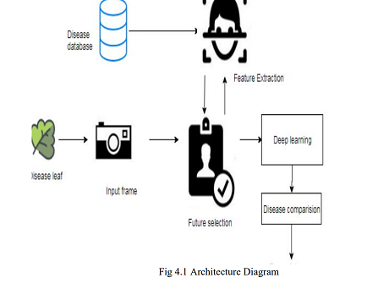

Fig 4.1 Architecture Diagram

As shown in figure 1 there is a database which consist of all the different plant leaf diseases which we have taken into account. The module is trained repetitively to attain the maximum accuracy. If a new image is given to the module it’s features get compared with the features that are already trained in the database. It then provides the appropriate result.

**4.2 Sequence Diagram**

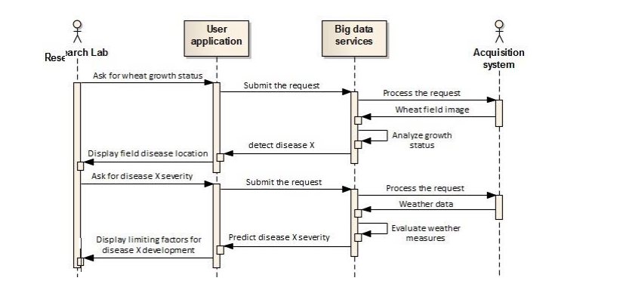

Fig 4.2 Sequence Diagram

The figure gives sequential process of the project. It will describes the process how the project works.

**4.3 Use-case Diagram**

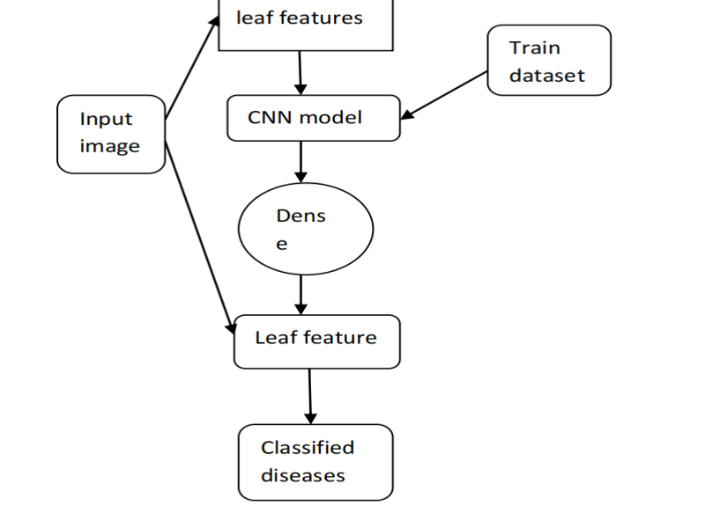

Fig 4.3 Use-case Diagram

When we give a new input image first the module extracts the leaf features. Then it goes through the Mask RCNN model. It then compares the features with already trained dataset. Then it goes through dense Mask CNN and the leaf features are extracted separately. Then the module will predict whether the plant leaf is affected by any disease or not. It shows the output from one of the 38 classes which are predetermined and trained. Then the output will be in a textual format.

**4.4 Activity Diagram**

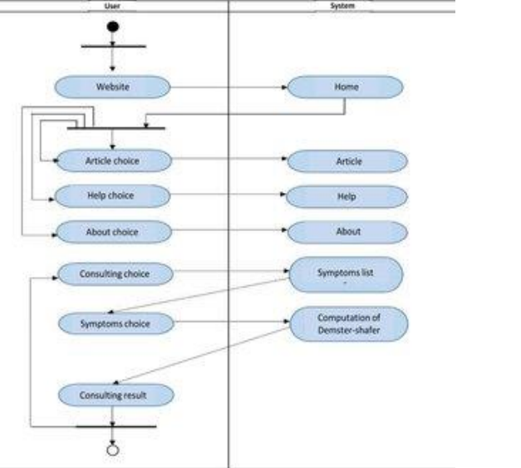

Fig 4.4 Activity Diagram

The above activity diagram represents the flow from one operation to other operation.

**CHAPTER 5**

**PROJECT REQUIREMENTS**

**5.1 Hardware and Software Specification**

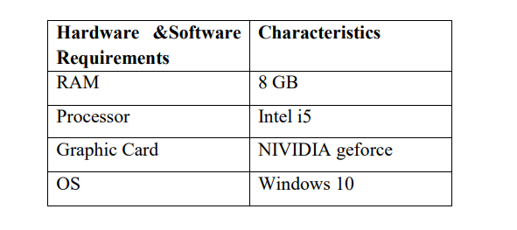

**5.2 Technologies Used**

We used MASK-R CNN technology which will come under conventional neural networks machine learning

1. Image size Trailing: In this phase we are getting F-score of image sizes 156x156 to 256x256 is greater than 90%. Running will be increased along with feature extraction when there is an increase in the image size. We got excellent results in this analysis with an accuracy of at least 85%.
2. Model Optimization: ResNet35 is optimized using most suitable images. Adding augmentation settings will improve model’s performance. Isolation and training of final two layers wrapping and changing of brightness operations will be added. Isolation and training done at default learning rate to the final two layers. With the number of epoch test series are performed at multiple trails.
3. Visualizations: With the test datasets and validation generation of visualizations are done also application will be created. All the needed files are stored in a github. git is linked to unified platforms and Render. Model optimization In this phase accuracy is increased to 0.95 as well as F1-score as 0.95. Fine tuning is used to plot graph between logistic scale v loss. As learning rate increases loss will also increases. The range of learning rate in between 1e-05 to 1e-04 gives best results.

**CHAPTER 6**

**MODULE DESCRIPTION**

**6.1 Introduction**

In this chapter we are going to discuss about the modules which are present in the project to give brief explanation of the project and process of the project.

There are four major modules in the proposed system starting from dataset creation and pre-processing till the final result.

Module 1: Import the given image from the dataset

Module 2: To train the module by given image dataset

Module 3: Working process of Layers in Mask RCNN model

Module 4: Plant disease identification

**6.2 Import the given image from the dataset**

We have to import our data set using Keras preprocessing image data generator function also we create size, rescale, range, zoom range, horizontal flip. Then we import our image dataset from folder through the data generator function. Here we set train, test, and validation also we set target size, batch size and class-mode from this function we have to train.

**6.3 To train the module by given image dataset**

To train our dataset using classifier and fit generator function also we make training steps per epoch’s then total number of epochs, validation data and validation steps using this data we can train our dataset.

Gray Scale Base: Gray information within a leaf can also be treating as important features. Leaf features such as shape, vein and damaged part of leaf appear generally darker than its surrounding leaf regions. Various recent feature extraction algorithms search for local gray minima within segmented leaf regions. The input images are first enhanced by contrast-stretching and gray-scale morphological routines to improve the quality of local dark patches and thereby make detection easier. The extraction of dark patches is achieved by low-level gray-scale threshold. Based method and consist three levels. Leaf gray scale behavior in pyramid images and it utilizes hierarchical Leaf location consist three levels. Higher two level based on images at different resolution and the lower level, edge detection method.

Edge Base: This work was based on analyzing line drawings of leafs from photographs, aiming to locate leaf features. To initially the images are enhanced by applying median filter for noise removal and histogram equalization for contrast adjustment.

**6.4 Working process of Layers in Mask RCNN model**

A Convolutional Neural Network (ResNet/CNN) is a Deep Learning algorithm which can take in an input image, assign importance (learnable weights and biases) to various aspects/objects in the image and be able to differentiate one from the other. The pre-processing required in a ResNet is much lower as compared to other classification algorithms. While in primitive methods filters are hand-engineered, with enough training, Convents have the ability to learn these filters/characteristics. The architecture of a ResNet is analogous to that of the connectivity pattern of Neurons in the Human Brain and was inspired by the organization of the Visual Cortex. Individual neurons respond to stimuli only in a restricted region of the visual field known as the Receptive Field.

Their network consists of four layers with 1,024 input units, 256 units in the first hidden layer, eight units in the second hidden layer, and two output units.

Input Layer: Input layer in Mask RCNN contain image data. Image data is represented by three dimensional matrixes. It needs to reshape it into a single column. Suppose you have image of dimension 28 x 28 =784, it need to convert it into 784 x 1 before feeding into input.

Convo Layer: Convo layer is sometimes called feature extractor layer because features of the image are get extracted within this layer. First of all, a part of image is connected to Convo layer to perform convolution operation as we saw earlier and calculating the dot product between receptive field(it is a local region of the input image that has the same size as that of filter) and the filter. Result of the operation is single integer of the output volume. Then the filter over the next receptive field of the same input image by a Stride and do the same operation again. Itwill repeat the same process again and again until it goes through the whole image. The output will be the input for the next layer.

Pooling Layer: Pooling layer is used to reduce the spatial volume of input image after convolution. It is used between two convolution layers. If it applies FC after Convo layer without applying pooling or max pooling, then it will be computationally expensive. So, the max pooling is only way to reduce the spatial volume of input image. It has applied max pooling in single depth slice with Stride of 2. It can observe the 4 x 4 dimension input is reducing to 2 x 2 dimensions.

Fully Connected Layer (FC): Fully connected layer involves weights, biases, and neurons. It connects neurons in one layer 25 to neurons in another layer. It is used to classify images between different categories by training.

Softmax / Logistic Layer: Softmax or Logistic layer is the last layer of Mask RCNN. It resides at the end of FC layer. Logistic is used for binary classification and softmax is for multi-classification.

Output Layer: Output layer contains the label which is in the form of one-hot encoded. Now you have a good understanding of Mask RCNN. 6.5 Plant disease identification We give input image using keras preprocessing package. That input mage converted into array value using pillow and image to array function package. We have already classified disease of leaf in our dataset. It classifies what are the plant disease leaves. Then we have to predict our leaf diseases using predict function.

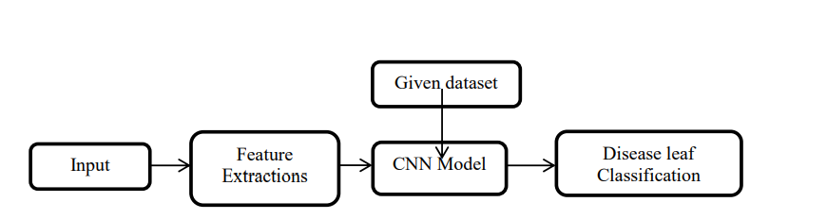

The leaf disease recognition method is based on a two-channel architecture that is able to recognize disease of leaf. The disease leaf parts are cropped and extracted and then used as the input into the inception layer of the Mask RCNN. The Training phase involves the feature extraction and classification using convolution neural network

**REFERENCES**

[1]. Plant Disease Detection Using Image Processing, Sachin, D. Khirade; A.B. Patil, 2019

[2]. Plant Leaf Disease Detection and Classification Based on CNN with LVQ Algorithm Melike Sardogan; Adem, Tuncer; Yunus Ozen, 2018

[3]. PLANT DISEASE DETECTION BY IMAGE PROCESSING: A LITERATURE REVIEW, Monishanker Halder, Feb 2019

[4]. Detection of plant leaf diseases using image segmentation and soft computing techniques VijaiSingh, Mar 2019

[5]. An Overview of the Research on Plant Leaves Disease detection using Image Processing Techniques, Ms. Kiran, R. Gavhale, Nov 2019

[6]. Plant Disease Detection using CNN, Emma Harte, Sep 2020

[7]. PLANT DISEASE DETECTION BY IMAGE PROCESSING: A LITERATURE REVIEW, Habibullah Bahar, Feb 2019

[8]. Plant Disease Detection and Classification by Deep Learning, Muhammad Hammad Saleem, Nov 2019

[9]. Early blight on potato and tomato, Available:https://www.apsnet.org/edcenter /disandpath/fungalasco/pdlessons/Pages/PotatoTomato.aspx

[10]. Bacterial Spot of Pepper and Tomato”, Available:https://content.ces.nc su.edu/bacte rialspot-of-pepper-and-tomato

[11]. Dr. Gary Vallad “IDENTIFYING AND CONTROLLING TOMATO, EGGPLANT & PEPPER DISEASES”

[12]. Pushkara Sharma , Pankaj Hans and Subhash Chand Gupta “CLASSIFICATION OF PLANT LEAF DISEASES USING MACHINE LEARNING AND IMAGE PREPROCESSING TECHNIQUES” 10th International Conference on Cloud Computing, Data Science & Engineering (Confluence)

[13]. Bharat Mishra, Mamta Lambert, Sumit Nema and Swapnil Nema “Recent Technologies of Leaf Disease Detection using Image Processing Approach” 2017 International Conference on Innovations in Information, Embedded and Communication Systems (ICIIECS)