**Face Recognition/Identification in Web Application**

**ABSTRACT**

There are a few works that have been conducted within the field of face recognition/identification systems from multi perspectives. In this work, the authors present a suitable software for the identification of human faces. This project has been divided into two main parts which cover live detecting faces including sad, happy, neutral, angry, or scared, and two-dimensional human face identifiers. The software is capable of identifying faces through labels that have been uploaded in the face recognition system files. Accordingly, we developed a web-based application which can detect faces from every side of the human faces like left, right, or frontal looking faces. In addition to that, the software can draw a rectangle on the faces that it detects, and can represent a description of that human face such as SSN (Social Security Number), address, blood group, criminal records, phone number, and nationality. In the live detecting faces, the application can draw a square blue vector on the detected individual face. After detecting the face, the software detection system identifies the facial expression that the person show. Our developed web-based application can be used as an effective multipurpose tool to help government officials and decision-makers within health care sectors, checkpoints to have full information of each citizen of any country.

**TABLE OF CONTENT**

Figures and Tables:

**Chapter 1**

**Introduction**

Creating and developing a computational prototype of face identification is quite challenging because faces are complicated, multidimensional, and meaningful graphical stimuli (Lawrance, 2001). Additionally, faces are a natural class of objects and stand in unambiguous differences to sine-wave vents. Unlike most early visual functions, for which we may build detailed examples of retinal or striate activity, face recognition is a very high-level task for which computational approaches. Face recognition systems can currently suggest broad constraints on the corresponding neural activity. Moreover, machine learning is a high technological task that we can assign to any high-performance computers. As a result, face recognition/identification systems are considered as machine learning tool for detecting and learning about face expression of people and which individual face belongs to which. Nevertheless, the current trend of face recognition/identification has shown a solution toward the world pandemic issue which is the novel Coronavirus widespread. Many countries such as China have used facial recognition/identification technology to identify infected individuals with COVID-19. The feature of the facial recognition/identification device is that it can detect the body temperature of the folks on the streets, and it can assume who is infected with the virus or not via the facial expression and the temperature of each person on the streets and public places. Correspondingly, owners of iPhone X have been introduced to the facial recognition/identification software. Owners of these devices can register their faces in the software database to enhance device security. After locking the iPhone, the individual needs to position the device in front of his/her face to unlock the iPhone. If the face is identical to the registered face in the software database, the device will unlock. Consequently, the face recognition/identification software that was developed by Apple was heavily criticized in China in late 2017 because of the inability of the software to differentiate between Chinese people. Thus, the idea of appending facial recognition software was excluded until 2018. The authors of this study develop a web-based application that performs in a way to define and recognize faces in a patterned style that does not need to have a full threedimensional model or detailed geometry to work on. And, this will lead to a fast, accurate, and reasonably simple prototype (Kakadiaris, 2007).

The face recognition/identification software can be used by governmental sectors such as finding criminal records and suspects in the checkpoints. The functionality of the software is by using face-recognition library face-api.js. The authors of this study have used the sync method to look up for the labeled pictures that were stored in the database and identify the individual. In addition to that, during 2020 and the crisis of COVID-19 the healthcare sectors can take advantage of this developed system. The system allows technical users to upload the suspected and infected individuals to the software database. This will help the countries to identify which person has or had that virus. The rehabilitated patients will have unique blood plasma. Therefore, the competent authorities can re-communicate with these patients to take blood plasma from them to help other infected persons to get recovered from that disease. In summary, face recognition/identification has a wide range of usage around the globe. The software aims to recognize faces and identify who is the person that is standing in front of the face recognition/identification device. There are also current trends of using facial recognition/identification that is being used nowadays which is the temperature detection of people in China and the face identify biometrics for the users of iPhone X devices. Additionally, the authors of this study introduce the web application to detect and identify faces in a patterned way that does not need to have full three-dimensional sides of any faces. Eventually, the software can be used as a tool to identify the rehabilitated COVID-19 patients and benefit the health sectors to communicate with these individuals and take their blood plasma for the current patients and help them to get recovered.

**Chapter 2**

**Literature Review**

Face recognition/identification is a data processing technology that calculates the location and size of a person's face in an absolute (digital) image. The facial features are identified and other object like trees, buildings, and bodies are ignored from the digital image. Face detection could be seen as a more overall example of face localization. In face localization, the duty is to find the locations and sizes of a known number of faces. There are two types of perspectives to identify facial parts in the given image such as feature base and based approach (Vineetha Sai et al, 2017). In features base approach, the software tries to take out features of the image and match it with the faces that are in the database. While the image base approach tries to obtain a fixed match between training and testing images. The authors of this study show that human eyes do the same procedure as software acts. For example, if there is a white blank paper, human eyes look to find an object on that white blank paper. In this task, it only takes less than two second for humans to realize that the paper is blank. If the eyes did not detect any object on the first side of the blank paper, humans try to flip the paper to the other side and the eye does the same task as how it did on the first side of the paper.

Ahmed Tolba in the year 2005 conducted a study called a Face Recognition Literature Review. The aim of the study was about the technique of face recognition systems. The study was mostly applied to frontal faces. And, the methods that were used in the study are eigenfaces, neural networks, and Markov model. Recently, the study was to analyze how the software reacts with the change of illumination and lightning of a facial image of an individual. The outcomes of the experiment were influenced by the background of the image as the image contained a huge amount of background area. The authors explained the powerful performance of the system under different lighting conditions by an important correlation between images with changes in illumination. Hence, the authors showed that the correlation between images of the whole faces is not efficient for satisfactory recognition performance.

Bernardin and Stiefelhagen in the year 2007 conveyed a study called automatic person detection and tracking using fuzzy controlled active cameras. The study aimed to create a system to recognize and identify the faces of people via automatic fuzzy cameras. This means the camera can track a person and change direction according to the person's direction. The equipment of the study was an ordinary SONY camera and an RC-232 connector to control the camera movement. All the process of the functionality of the face detection camera was done by a Pentium 3GHz dual-core processor. As a result of this study, the face detection compact camera was performing well, and it was responding with the moving person. Yet, if the individual turns and walks away from the camera, the camera fails its ability to identify the face.Still, the face detector camera was not losing the focus of the person. It was tracing the individual's body until the person faced the camera and then it recognized the face again.

Brandon Amos, Bartosz Ludwiczuk, and Mahadev Satyanarayanan in the year 2016 created an application called OpenFace. This application aims to increase the accuracy of face recognition in mobile devices. The app used a face recognition technique called LFW dataset. The LFW is a standard benchmark in face recognition research. Additionally, The LFW verification study anticipates whether pairs of images are of the same person. The accuracy in the restricted protocol is obtained by averaging the accuracy of ten studies. The data of the images are partitioned into ten folds and each fold is equal to the other adjacent fold and each study trains on nine folds and computes the accuracy on the remaining testing fold. The OpenFace outcomes are obtained by gauging the squared Euclidean distance on the pairs and labeling pairs under a threshold as being the same person and above the threshold as different people. The best threshold on the training folds is used as the threshold on the remaining fold. The best threshold is 0.99, in nine out of ten experiments. As a result, the OpenFace Library has been used by many computer developers to create a face recognition/identification software.

Shonal Chaudhry Rohitash Chandra conducted a study in the year 2016 called face detection and recognition in an unconstrained environment for mobile visual assistive systems. The goal of the study is to identify individuals using live camera detectors and other tools such as infrared and three-dimensional face recognition. The system can detect people and find out who these people are by comparing their faces with the faces in the software's database which contains more than 80,000 people's faces. The authors of the study used two methods for the face identification/recognition system which are cascade classifier and convolutional neural network. The authors make this experiment work on mobile devices to increase the accuracy and performance of the system. Eventually, the system responded well to the environment and started to detect people's faces and compare their faces to the faces of individuals in the face recognition database.

Matthew C. Fysh conducted a study in the year 2018 called Individual differences in the detection matching and memory of faces. The research has shown the detection matching and memory of faces but under inadequate conditions. The research includes three experiments. Experiment 1 tested face identification capability under circumstances created to enhance individual variations in accuracy but did not find any evidence in measures. Additionally, in experiments 2 and 3, the response time was utilized as the primary performance measure for face identification but accuracy for face matching and face memory is consistent with other research. Onward, these studies provide more evidence between face identification, face matching, and face memory. Yet, the research suggests that these latter duties share some common mechanisms.

**Chapter 3**

**Methodology**

The functionality of the recognition and identification software Face recognition/identification is a behavior that humans perform routinely and effortlessly, in our daily lives. The person’s face identification process goes through four main phases. First, the system detects the individual face. Second, the face of the person will be compared to the other faces in the system’s database. Finally, after comparison, the output identifies who is the detected person. The face recognition process is shown in Figure 1.

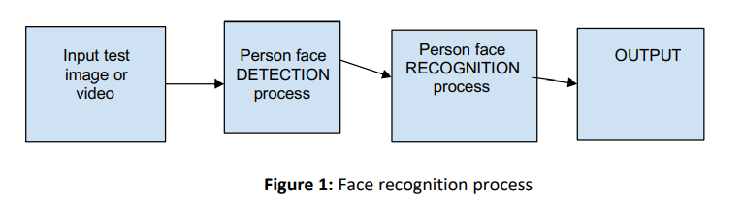

In the governmental sectors such as the FBI, they use facial recognition/identification software that is connected to several databases to detect criminal records of a suspected individual. Their software obligation is to take an image of the suspected individual and compare it to the faces in the software database. The process of how the FBI software works are shown in Figure 2.

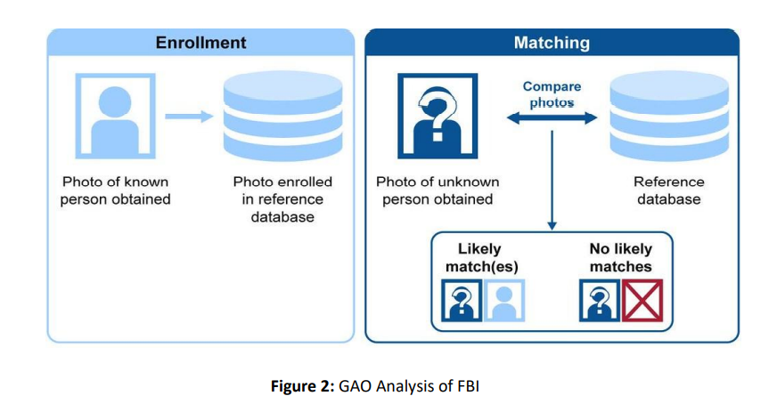

**3.1 Recognition/Identification Software:**

The web-based application is developed for multipurpose functionality. It aims to enable users to upload photos to the database via a browse button. This process is done by a variable called "imagevar." After that, the method "async" searches for the person's face in the files. Then it attempts to detect the person's face then identify it. After that, the process of detecting the person's face is handled by two variables called "labeled Function" and "Face Matcher." Labeled Function is responsible for enabling the program to wait until the image is loaded and Face Matcher is to detect the approximate similarity of the person's face. Finally, after the person's face is identified and recognized, a rectangle canvas would be drawn on the individual's face within a variable called "canva." Eventually, the records of that person will be displayed under the image. There is another feature of the face recognition/identification application. The user can add a new person's data to the labeled folders which is done by a method called "filewrapper." Later, it is important to have a facial expression identifier. The author of this study added a feature to the face recognition/identification software called live facial expression. This feature will draw nodes and lines on the face that is detected by the computer camera. The software will detect whether the individual who is in front of the camera is happy, sad, or neutral.

**3.2 Scenarios:**

Cameras and face IDs are widespread globally. 160 countries use their methodology and policy for face recognition/identification systems. According to Interpol Face Recognition Systems (IFRS), the database of IFRS contains faces data of 160 countries and that makes it a unique global criminal database. This would help that it could be effortless to detect and find criminals for Interpol. In this face recognition identification software, the goal is to make the usage of face facial recognition/identification to be more widespread in the Kurdistan region. The application can be used by different governmental sectors and private territory. As a result, it can be a straightforward achievement for the Kurdistan government to use this software to detect criminals and their records, and that could decrease the amount of effort they might take to find wanted suspects. Besides, face recognition/identification can be used by health care sectors too in purpose of identifying citizens’ health data.

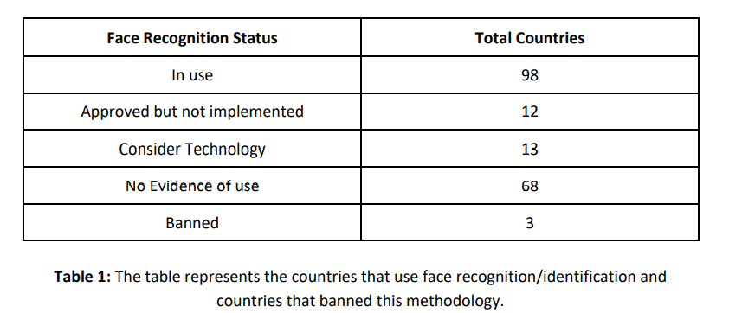

**3.3 Key Technologies:** A face recognition/identification system will use biometrics to identify faces from a file that those faces are found within the directory. It is not a matter if the files are images or videos, the system will compare the chosen face with the faces that are available within the labeled directory.

**3.4 Requirement Analysis:**

**3.4.1 Functional Requirement:** The software developed in this study would be able to find only one selected image. And this program will support JPEG, PNG, and BMP image formats. It should be noted that the software supports dynamic images including GIFs, which means that if the picture is in the state of moving, the program can detect or identify who is the person in the image.

**3.4.2 Non-Functional Requirement:** The program does not require accessing internet connection to function or perform the tasks of detecting faces. Therefore, it only needs a server such as a PHP server or XAMPP server to work properly. In addition to that, the program is responsive to all computer devices "PCs" and is an independent platform which will make a userfriendly application.

**Chapter 4**

**System Design**

**4.1 ER Diagram:**

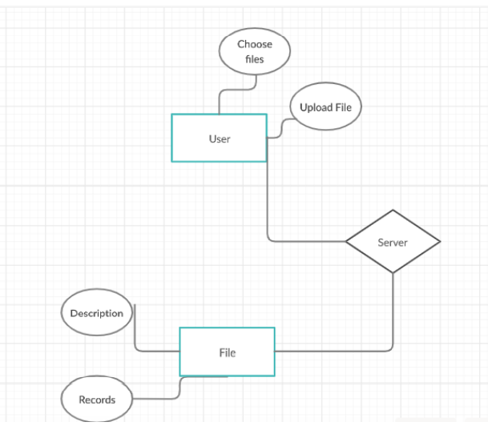

Figure 4.1: ER diagram

**4.2 Use-case Diagram:**

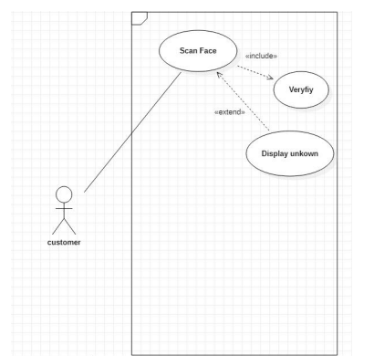

Figure 4.2 : Use-case diagram showing how the web application reacts with the user

**4.3 Activity Diagram:**

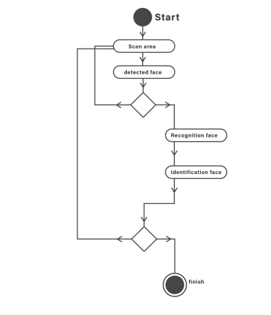

Figure 4.3: Activity diagram for face recognition/identification

**4.4 Analyze and Evaluation:** As we go through the project, we realize that there are weaknesses and strengths in the project. The developed software is qualified to identify faces correctly. However, the program can search through files without needing a database. Animated images could not be challenging for the software. This means it can detect the face of the individual even though the individual face is moving. In addition to that, the web application can detect more than one face in an image. On the other hand, the weakness of the project is that it needs two servers to run properly. It needs a server to detect faces and a server for uploading a face image to the application file, which needs more CPU and GPU resources.

**REFERENCES**

Brandon Amos, Bartosz Ludwiczuk, Mahadev Satyanarayanan. OpenFace; A general-purpose Face recognition library with mobile applications June, 2016.

Iman Ghoshm, Face Recognition World Map Visual Capitalist Website May, 2020.

Ergun Gumos, Evaluation of face recognition techniques using PCA, wavelets and SVM Science Direct September, 2010.

Andreea Diana Dinca, Face Detection/Recognition Research Paper University of Birmingham November, 2017.

Belhumeur, P., hespanha, J., and Kriegman, D., "Eigenfaces vs. Fisherfaces: Recognition Using Class Specific Linear Projection", IEEE Trans. Pattern Analysis Machine Intelligence, vol. 19, no. 7, pp. 711-720, July 1997.

Yasheng Huang , Meicen Sun and Yuze Sui, How Digital Contact Tracing Slowed Covid-19 in East Asia. April, 2020.

Brunelli, R., and Poggio, T., “Face Recognition: Features versus Templates”, IEEE Trans. Pattern Anal. Machine Intell., vol. 15, pp.1042-1052, June ,1993.

P J. Phillips, Patrick J. Grother, Ross J. Micheals, D M. Blackburn, Elham Tabassi, M Bone. Face Recognition Vendor Test 2002 March, 2003.

Chan, Y., Lin, S.-H., and Kung, S.Y., "Video Indexing and Retrieval", Multimedia Technology for Applications, Sheu and Ismail editors. IEEE Press, April ,1998.

A. S. Tolba, A.H. El-Baz, and A.A. El-Harby, “Face Recognition: A Literature Review.” 90 - 91. 2005

Bernardin, K., v. d. Camp, F., Stiefelhagen, R.: Automatic person detection and tracking using fuzzy controlled active cameras, 2007

Moon, H., and P.J. Phillips. 2001. “Computational and performance aspects of PCA-based face recognition algorithms,” Perception, 30, pp. 301-321.

Matthew C. Fysh.. “Individual differences in the detection, matching and memory of faces.” PubMed Central Website 2018 Steve Lawrence. “Face Recognition: A Hybrid Neural Network Approach.” ResearchGate 2001