DEMANDMAP
Go-to-Market Plan
v4 — ASO + Paid UA + Full Strategy
April 2026 | NYC Launch | $10K Budget
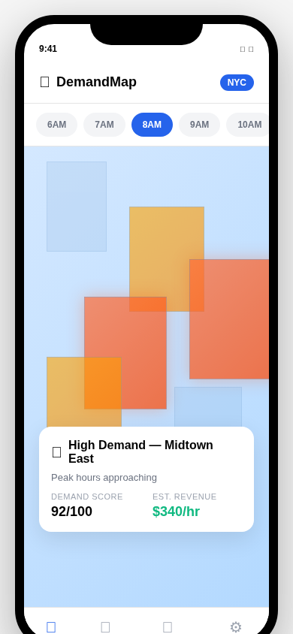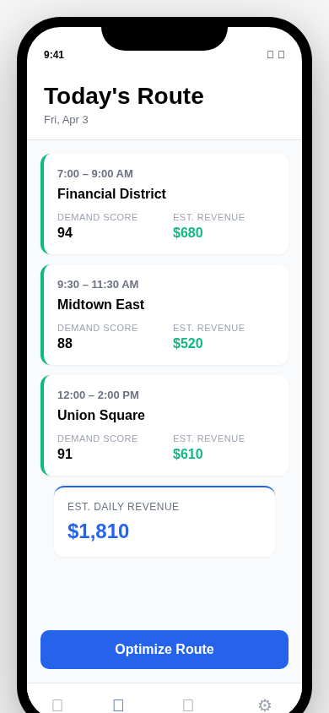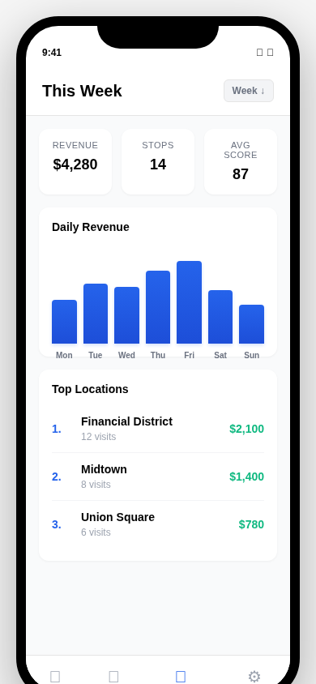
Know where demand is. Be there first.

Executive Summary
DemandMap is a demand planning app that tells food truck vendors, retail pop-ups, and mobile businesses exactly where and when to set up shop. Using real-time data — transit ridership, foot traffic patterns, weather, events, and competitor density — it scores every city block by the hour and generates optimized daily routes.
This plan covers a 6-month, $10,000 NYC launch combining:
- App Store Optimization (ASO) — organic discovery through keyword strategy, screenshots, and ratings
- Apple Search Ads (ASA) — $2,500 in targeted keyword bidding at $1.80–$2.50 CPI
- Google App Campaigns — $2,000 in ML-optimized installs at $2.50–$3.50 CPI
- Meta + TikTok — $1,000 in targeted social ads with creator-style content
- Guerrilla street marketing — $2,500 in boots-on-ground demos at food truck commissaries and markets
- Attribution + analytics — AppsFlyer Zero (free) + PostHog + GA4 for full-funnel tracking

Target: 2,000–2,500 installs and 215+ paying users by Month 6, generating $7,500+ MRR.

The Product: App Screenshots
DemandMap ships as a Progressive Web App (PWA) — installable from any browser, no App Store fees. These screens show the core experience:


Demand Map View Daily Route Planner
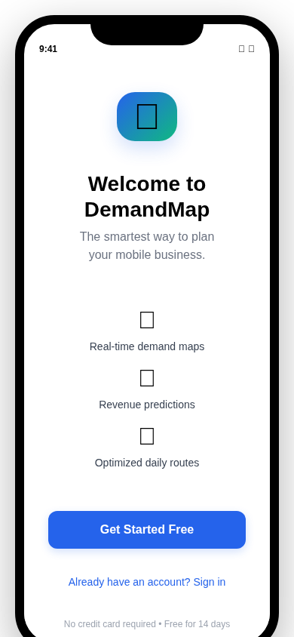
Analytics Dashboard Onboarding Flow

1. App Store Optimization (ASO)
ASO is your highest-ROI channel — it drives free, compounding organic installs. Here’s the complete strategy:

Keyword Strategy
Target 20–30 keywords across three tiers. Update metadata every 4 weeks for observable ranking changes.
Tier | Keywords | Competition | Strategy
Brand | DemandMap, demand map app | None | Defend — always bid on these
Category | food truck app, vendor planner, demand planning | Medium | Core targets — optimize title + subtitle
Long-Tail | food truck scheduling NYC, mobile vendor demand forecast | Low | Win quickly — less competition, higher intent
Competitor | Square for food trucks, food truck POS | Medium | Opportunistic — capture dissatisfied users

Metadata Optimization
iOS and Android have different indexing rules. Optimize both separately:

Field | iOS App Store | Google Play
Title (30 char) | DemandMap — Food Truck Planner | DemandMap: Smart Vendor Planning
Subtitle / Short Desc | Smart Demand Forecasting (iOS subtitle) | AI-powered demand maps for mobile vendors (80 char)
Keywords | 100-char hidden field: food truck scheduling, vendor planning, mobile business, demand forecasting | Not applicable — keywords indexed from description
Description | Write for CONVERSION (not indexed by Apple) | 1 keyword per 250 words; write for both SEO and conversion

Screenshot Strategy
Screenshots are the #1 conversion driver. The first screenshot alone determines 60%+ of install decisions.

Slot | Content | Headline Overlay | Size
1 (Hero) | Map view with demand heatmap | "See demand before you set up" | 1290 x 2796
2 | Route planner with revenue estimates | "AI-optimized daily routes" | 1290 x 2796
3 | Analytics dashboard | "Track what’s working" | 1290 x 2796
4 | Before/after revenue comparison | "Vendors earn 20% more" | 1290 x 2796
5 | Social proof / testimonial | "4.8 stars from 200+ vendors" | 1290 x 2796

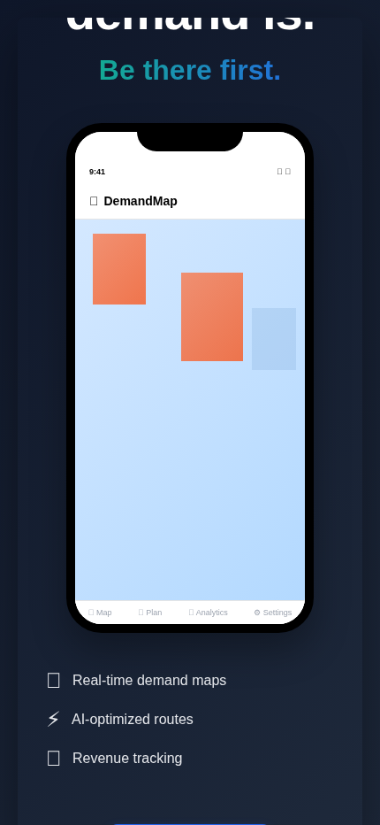
App Store marketing screenshot mockup

App Preview Video
Record a 20-second app preview showing: map loads with demand heatmap (3s) → user taps a hot zone (3s) → revenue estimate appears (3s) → route planner generates stops (5s) → analytics screen (3s) → CTA overlay (3s).
- Format: H.264, 1290 x 2796, under 500MB
- Create with CapCut (free) or VN Video Editor (free)
- Add text overlays on each transition explaining the benefit

Ratings & Reviews Playbook
A 0.5-star rating increase boosts installs by 20%. Here’s how to systematically build ratings:
- Trigger review prompts after the user completes their first successful route (not on first open)
- Use Apple’s native SKStoreReviewController — less intrusive, higher conversion than custom prompts
- Respond to every review within 24 hours using AppFollow’s free tier (Slack integration included)
- Target 4.0+ stars by Month 2 and 4.5+ by Month 4 to unlock “Featured” eligibility

Free ASO Tools
Tool | Free Tier | Use For
AppFollow | Unlimited team, Slack alerts | Review tracking, response automation, keyword ranks
Mobile Action | Basic keyword data | Keyword research and competitor monitoring
AppTweak | Free trial | Advanced keyword suggestions (use trial strategically)
Apple PPO | Native (free) | A/B test screenshots and metadata directly in App Store Connect
Google SLE | Native (free) | A/B test Play Store listings

2. Apple Search Ads (ASA)
ASA is the most efficient paid channel for utility apps — users are already searching the App Store with install intent. Use Advanced (not Basic) for full keyword control.

Why ASA Advanced
Factor | Basic | Advanced (Recommended)
Budget cap | $5,000/month max | Unlimited — full control
Keyword control | Apple auto-matches | You choose exact keywords
Pricing | Cost-Per-Install | Cost-Per-Tap (more efficient)
Placements | Limited | All App Store placements
Time investment | ~20% (hands-off) | ~80% (hands-on, but worth it)

Keyword Bidding Strategy
Start with 20–30 keywords. Bid aggressively in Week 1 to gather data, then optimize down.
Keyword Type | Examples | Max Bid (CPT) | Expected CPI
Branded | DemandMap | $2.00–$2.50 | $1.20–$1.50
Category | food truck app, vendor planner | $1.50–$2.00 | $1.80–$2.50
Long-tail | food truck demand forecast NYC | $0.75–$1.25 | $1.00–$1.80
Competitor | Square food truck, food truck POS | $1.25–$1.75 | $2.00–$3.00

Campaign Structure
- Campaign 1 — Exact Match (80% budget): Your 20–30 curated keywords. Full control, highest quality.
- Campaign 2 — Discovery (20% budget): Apple’s algorithm suggests related keywords. Cheaper CPT, broader reach.
- Negative keywords: Add irrelevant terms weekly (e.g., “coffee shop”, “restaurant POS”) to eliminate waste.

ASA Budget & Projections
Month | Daily Budget | Monthly Spend | Est. Installs | Avg CPI
Month 1 | $20/day | $600 | 240–330 | $1.80–$2.50
Month 2 | $30/day | $900 | 360–500 | $1.80–$2.50
Month 3 | $30/day | $900 | 400–500 | $1.80–$2.25
Months 4–6 | $17/day avg | $1,500 total | 700–830 | $1.80–$2.15

6-Month ASA Total: $3,900 | Expected Installs: 1,700–2,160

Key ASA Metrics
Metric | Benchmark (Utility Apps) | Your Target
Tap-Through Rate (TTR) | 11.3% | 10%+
Install Conversion | 10–15% of taps | 12%+
Cost Per Tap (CPT) | $2.00–$2.25 | Under $2.00
Cost Per Install (CPI) | $1.80–$2.50 | Under $2.25

3. Google App Campaigns
Google’s ML-driven App Campaigns distribute ads across Search, Play Store, YouTube, and Display Network. You provide creative assets; Google optimizes placement and targeting automatically.

Creative Requirements
Asset Type | Spec | Quantity | What to Show
Headlines | 30 characters each | 3–5 | "Smart Food Truck Planning" / "Boost Your Earnings" / "Free 14-Day Trial"
Descriptions | 90 characters | 3–5 | "AI-powered demand forecasting helps vendors maximize sales and reduce waste"
Images | 1200x628 or 1080x1080 | 5–10 | App UI screenshots, demand map, vendor lifestyle, earnings graph
Video | 1080x1920, <30 sec | 1–3 | 15-sec app demo: problem → solution → result → CTA

Google Budget & Projections
Month | Daily Budget | Monthly Spend | Est. Installs | Avg CPI
Month 1 | $20/day | $600 | 170–240 | $2.50–$3.50
Month 2 | $27/day | $800 | 230–320 | $2.50–$3.50
Month 3 | $27/day | $800 | 260–320 | $2.50–$3.00
Months 4–6 | $13/day avg | $1,200 total | 400–480 | $2.50–$3.00

6-Month Google Total: $3,400 | Expected Installs: 1,060–1,360

4. Meta (Facebook + Instagram) App Install Ads
Meta’s Advantage+ App Campaigns use automated targeting to find your best users. Start here, then graduate to manual campaigns once you have data.

Audience Targeting
Parameter | Setting
Age | 25–54 (core: 25–44 — 43% of mobile food business spending)
Location | NYC metro (expand to Boston, Philly, DC in Month 3+)
Interests | Food business, small business, entrepreneurship, mobile vendor, restaurant management
Behaviors | Small business owners, mobile business owners
Lookalike | 1–3% from email list or early user base (Month 2+)

Meta Budget & Projections
Month | Monthly Spend | Est. Installs | Avg CPI | Note
Month 1 | $200 | 50–80 | $2.50–$4.00 | Advantage+ test
Month 2 | $350 | 90–140 | $2.50–$4.00 | Scale winning creative
Month 3 | $300 | 85–120 | $2.50–$3.50 | Refine audience
Months 4–6 | $600 total | 170–240 | $2.50–$3.50 | Lookalike audiences

6-Month Meta Total: $1,450 | Expected Installs: 395–580

5. TikTok App Install Ads
TikTok delivers the lowest CPI of any channel ($0.70–$1.30) and reaches a highly engaged audience. The catch: creative must feel native — polished brand ads die here.

Creative Formula
- Hook (0–2 sec): "Food truck owners are leaving money on the table..."
- Problem (2–5 sec): Show the struggle — empty spot, wasted inventory, guessing game
- Solution (5–15 sec): App demo — demand map lights up, route generated, revenue predicted
- CTA (15–20 sec): "Download free" with app store badge

- Format: Vertical (9:16), 1080x1920, 9–21 seconds optimal
- Style: Creator-style UGC — first-person, authentic, relatable. NOT polished brand ad.
- Audio: Trending sounds or conversational voiceover. Native feel.
- Refresh: Every 2–4 weeks — TikTok audiences fatigue fast.

TikTok Budget & Projections
Month | Monthly Spend | Est. Installs | Avg CPI
Month 1 | $100 | 75–140 | $0.70–$1.30
Month 2 | $150 | 115–215 | $0.70–$1.30
Month 3 | $200 | 155–285 | $0.70–$1.30
Months 4–6 | $400 total | 310–570 | $0.70–$1.30

6-Month TikTok Total: $850 | Expected Installs: 655–1,210

6. Guerrilla Street Marketing
Paid ads get installs. Street marketing gets evangelists. Two people at $20/hr doing live demos at food truck commissaries, markets, and events converts at 3–5x the rate of any ad.

The 90-Second Demo Script
- Open the app — show the live demand map of their actual neighborhood
- Tap the hottest block — show the demand score, revenue estimate, and why
- Generate a route — show a full day plan with 3 stops and total projected revenue
- Show analytics — "This is what vendors who use DemandMap see after one week"
- Hand them a sticker with QR code — "Scan this, it’s free for 14 days"

Where to Be
Location Type | Examples | When | Why
Commissary kitchens | Brooklyn Navy Yard, Long Island City commissaries | 5–7 AM (prep time) | Every truck visits daily — captive audience
Food truck rallies | Smorgasburg, Urbanspace, Governors Island | Weekends | Dozens of vendors in one spot
Street vendor clusters | Midtown lunch corridor, FiDi, Union Square | 11 AM–1 PM | Demo in context — show demand scores for where they’re standing
Industry events | NYC Food Truck Association meetings, vendor meetups | Monthly | Credibility + word-of-mouth multiplier

Street Team Budget
 | Month 1 | Month 2 | Month 3 | Month 4 | Month 5 | Month 6
Person 1 (hrs/wk) | 8 | 10 | 10 | 8 | 6 | 5
Person 2 (hrs/wk) | — | 6 | 8 | 8 | 6 | 5
Monthly cost | $688 | $1,376 | $1,548 | $1,376 | $1,032 | $860

Rate: $20/hr | 4.3 weeks/month | 6-month street team total: ~$4,300

Swag & Materials
- 500 die-cut stickers with QR code ($60 via StickerMule)
- 200 business cards with app link + demo QR ($25 via Vistaprint)
- 1 pop-up banner for events ($45 via Canva Print)
- DemandMap-branded t-shirts for street team x4 ($80 via CustomInk)
Materials total: ~$210

7. Master Budget: $10,000 Over 6 Months

Channel Allocation
Channel | 6-Month Budget | % of Total | Est. Installs | Avg CPI
Apple Search Ads | $3,900 | 39% | 1,700–2,160 | $1.80–$2.25
Google App Campaigns | $3,400 | 34% | 1,060–1,360 | $2.50–$3.00
Meta (FB/IG) | $1,450 | 15% | 395–580 | $2.50–$3.50
TikTok | $850 | 9% | 655–1,210 | $0.70–$1.30
PAID ADS TOTAL | $9,600 | 96% | 3,810–5,310 | $1.81–$2.52

Month-by-Month Spend
 | M1 | M2 | M3 | M4 | M5 | M6 | Total
ASA | $600 | $900 | $900 | $600 | $500 | $400 | $3,900
Google | $600 | $800 | $800 | $500 | $400 | $300 | $3,400
Meta | $200 | $350 | $300 | $250 | $200 | $150 | $1,450
TikTok | $100 | $150 | $200 | $150 | $125 | $125 | $850
Tools/Swag | $150 | $50 | $50 | $50 | $50 | $50 | $400
TOTAL | $1,650 | $2,250 | $2,250 | $1,550 | $1,275 | $1,025 | $10,000

Dynamic Reallocation Rules
Review channel performance weekly. Move budget to what works:
- CPI < target: Increase that channel’s budget by 20%
- CPI > 1.5x target: Cut budget by 25%, test new creative
- No installs in 48 hours: Pause campaign, diagnose, reallocate
- Monthly review: Calculate LTV per channel; shift to highest LTV/CPI ratio

8. Measurement & Attribution

Attribution Stack
Tool | Cost | Role
AppsFlyer Zero | Free (12K installs) | Install attribution, SKAN handling, channel-level CPI tracking
PostHog | Free (1M events/mo) | Product analytics: feature usage, funnels, retention cohorts
GA4 | Free | Web-to-app attribution, UTM tracking, conversion paths
Dub.co | Free (1K links/mo) | QR code + link tracking for street marketing materials

iOS Privacy (ATT / SKAdNetwork)
~70–75% of iOS users opt out of tracking. Plan for it:
- SKAN provides aggregated data only — you’ll see channel-level installs but not individual user journeys on iOS
- Android gives full visibility — use Android data for early optimization, then apply learnings to iOS
- Set SKAN conversion events: install, first session, first demand forecast, first payment
- First-party data is gold — track in-app events (PostHog) independently of ad platform attribution

KPI Dashboard
Track these metrics daily in PostHog. Set Slack alerts for red flags.
Metric | Target | Red Flag | Action if Red
CPI (per channel) | See channel targets above | > 1.5x target | Pause, test new creative, reallocate
Day-1 Retention | > 40% | < 30% | UX issue — fix onboarding flow
Day-7 Retention | > 20% | < 15% | Value delivery problem — check core feature
App Store Rating | 4.0+ by Month 2 | < 3.5 stars | Respond to reviews, fix top complaints
Free → Paid Conversion | 14% | < 8% | Pricing or trial experience issue
Monthly Installs | See budget projections | < 50% of target | Increase ad spend or shift channels

9. Creative & Distribution Toolstack

Generate (Creative Production)
Tool | Cost | Use For
Canva Pro | $13/mo (1 seat) | Ad images, App Store screenshots, social posts, story templates
CapCut | Free | TikTok-style video ads, app demo recordings, transitions
VN Video Editor | Free | Longer-form video (app walkthroughs, testimonial edits)
OBS Studio | Free | Screen recording for app demo footage
Remove.bg | Free (limited) | Background removal for product shots

Deploy (Ad Platforms)
Platform | Min Budget | Best For
Apple Search Ads | $0.01 CPT min | Highest-intent users already in App Store
Google App Campaigns | $10/day min | Broadest reach across Search, YouTube, Display
Meta Ads Manager | $1/day min | Interest + lookalike targeting for food business owners
TikTok Ads Manager | $20/day min | Lowest CPI, youngest audience, creator-style content

Measure (Analytics)
Tool | Cost | Tracks
AppsFlyer Zero | Free (12K installs) | Install attribution by channel, SKAN, deep links
PostHog | Free (1M events) | Feature usage, retention cohorts, funnels, A/B tests
GA4 | Free | Web traffic, UTM attribution, conversion paths
Mixpanel (alt) | Free (20M events) | Alternative to PostHog if you prefer its UI

Distribute (Organic Channels)
Tool | Cost | Use For
Brevo (Sendinblue) | Free (300 emails/day) | Onboarding sequences, weekly tips, re-engagement
Dub.co | Free (1K links) | Branded short links + QR codes for stickers and cards
Buffer | Free (3 channels) | Schedule social posts across Instagram, TikTok, Twitter
Typefully | Free | Twitter/X thread scheduling for vendor tips content

Total toolstack cost: ~$78/6 months (only Canva Pro has a recurring cost)

10. 6-Month Timeline

Month | Focus | Paid Spend | Install Target | Milestones
Month 1 | Launch + test all channels | $1,500 | 535–790 | ASO live, all ad accounts running, street team active
Month 2 | Scale winners, start organic | $2,200 | 795–1,175 | 4.0+ rating, identify best CPI channel, email list > 200
Month 3 | Optimize + geographic test | $2,200 | 900–1,225 | Test Boston/Philly targeting, TikTok scaling, influencer test
Month 4 | Retention focus | $1,500 | Cumulative 2,000+ | D7 retention > 20%, paid conversion > 14%
Month 5 | LTV optimization | $1,225 | Focus on revenue | Identify highest-LTV channel, optimize pricing
Month 6 | Sustainability | $975 | 2,500+ total | Profitable unit economics, prepare Series Seed deck

11. Do This Monday
Stop planning. Start executing. Here’s your Day 1 checklist:

- Sign up for AppFollow (free) — connect to App Store Connect and Google Play Console
- Optimize App Store metadata: title, subtitle, keyword field, description (see Section 1)
- Create 5 App Store screenshots using Canva Pro ($13/mo) with headline overlays
- Record 20-second app preview video with OBS + CapCut
- Create Apple Search Ads account — set up exact match campaign with 20 keywords at $20/day
- Create Google App Campaign — upload 5 images + 3 headlines at $20/day
- Create Meta Advantage+ App Campaign targeting NYC food business owners at $7/day
- Create TikTok Ads account — film first creator-style video, launch at $5/day
- Install AppsFlyer SDK + configure SKAN conversion events
- Print 500 QR stickers via StickerMule ($60) and brief your street team

Total Day 1 commitments: $52/day in ads + $73 in tools + $60 in stickers = $185 to launch.

That’s it. The machine is running by Tuesday.

