LAPTOP

1. Asus M415DAO-VIPS351/VIPS352 R3-3250U/UMA/8G/512 W10 + OHS 14''

**Rp. 7.399.000**

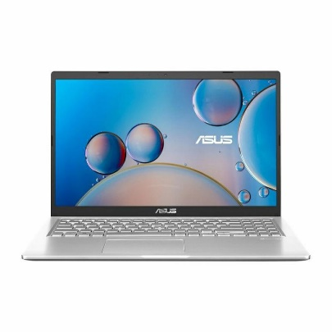 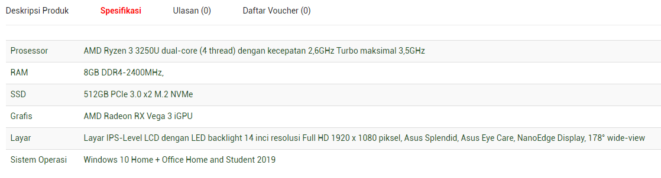

# ASUS A516JAO-VIPS521 Core i5-1035G1 / 256G /4GB DDR4 /15.6" /WIN 11 Home + OHS (90NB0SR1-M42530)

# Rp. 9.074.000

# C:\Users\Hp\Downloads\202112181410281094.jpeg

# 

# PC

HP PC AiO 24-df1009d i5-1135G7/8G/512 GB /23,8 /Win10 / W11 [397J5PA]

**Rp. 11.299.000**

# C:\Users\Hp\Downloads\202201211101016850.jpeg

# 

# 

PRINTER

PRINTER EPSON L6160 - **Rp. 5.249.000**

