## **Abstract**

Signal processing techniques are frequently used in equity and commodities trading strategies. Also called technical analysis, these signal processing methods often disregard and outperform fundamental equity valuation methods such as buying and selling securities based on a price to earnings ratio [1]. Technical analysis uses historical data to make bets on the future of stock prices given key assumptions. In this paper, we empirically analyze strategies for one technical analysis method: signal frontier analysis. Specifically, we explore the optimization of a sub-strategy of signal frontier analysis called momentum investing and its two key parameters: lookback period and holding period. Given a portfolio of stocks experiencing significant positive returns over a year and a half time frame, we test short-term, intermediate-term and long-term lookback periods and their associated holding periods to determine which offers the great risk adjusted return. Utilizing the Sharpe ratio as our performance metric for comparison, we find that intermediate term momentum investing strategies result in the greatest risk adjusted return.

## **Introduction**

Time series data is plentiful in finance. Equities are traded in nanoseconds based on market signals. Investment firms often employ engineers and other technically trained individuals to apply signal processing methods to financial time series data. This practice has unearthed multitudes of algorithms and data analysis methods for trading equities all now considered "technical analysis." These technical analysis methods often run contrary to the idea of the efficient market hypothesis, which assumes that security prices reflect all available information.

One such technical analysis method is momentum investing. At the heart of momentum investing is the assumption that signals are rarely completely random and have some degree of consistency of pattern [1]. Momentum investing also assumes that once a trend is established, the trend is likely to continue rather than revert. Investors applying a momentum strategy make bets on the future based on these trends instead of the current stock price and fundamental analysis methods such as liquidity and price to earnings ratios. In this paper, we empirically analyze and determine the optimal momentum investing strategy for a portfolio of fast food equities. We specifically choose the fast food industry because of the tremendous growth in the timeframe analyzed. Our objective is to test previous analysis showing intermediate term momentum strategies superiority [2] in a faster than market (S&P 500) growth portfolio.

Momentum investing can be classified into cross-sectional or time-series based momentum. The latter compares historical returns from a stock with respect to the stock itself, whereas cross-sectional momentum compares historical returns from a stock relative to other securities. In our case, we analyze a cross-sectional momentum portfolio of fast food stocks.

A momentum investor's goal is to capitalize on the continuance of existing trends in the market [3] utilizing two critical parameters: the lookback period and the holding period. Typically, a momentum investor will take a long position in an asset that is trending upward and a short position in an asset that is trending downward. The most common tool to establish this trending component is to draw a line between two points on a time series and calculate a cumulative return:

Equation 1: Momentum Calculation

$$return=\frac{t_{2}-t_{1}}{t_{1}}$$

Where $t$ represents the daily return for a given business day and the difference of daily returns for time two and time one ( $t_{2}-t_{1})$ is defined by the lookback period. For example, a lookback period of ten days would consider returns at a given business day as time two and returns at the given business day minus ten business days as time two. The ten days are the lookback period. This lookback period can be many frequency types: daily, hourly, monthly or yearly. In this paper, we choose a business daily lookback frequency. The lookback period and associated returns for a portfolio allow for the weighting of each investment in a portfolio. For example, given a lookback period of 30 days, if two out of five stocks are trending downward (have a negative return), these stocks would be down weighted in the portfolio. If the remaining stocks have an increasing trend, these stocks would be up weighted in the portfolio.

Based on the signal provided by a given lookback period, a momentum investor retains a portfolio mix of up-weighted and down-weighted stocks over a given "holding period," capturing cumulative returns over the holding period. This holding period can also take on any frequency, however, it should be consistent with the lookback period frequency in order to apply momentum weights appropriately. The ultimate goal is to maximize returns based on historical trends.

Based on the choice of lookback period, momentum investment strategies can be broken down into three different sub-strategies: short term, intermediate term and long-term momentum. Short term momentum strategies utilize one month or less of a lookback period, while long term strategies typically utilize greater than three years for a lookback period. Both long and short-term strategies have been empirically shown to experience significant reversion. Trends often change to the detriment of the investor [4]. However, intermediate term strategies, which use a lookback period of six to twelve months show greater success, often resulting in no reversals [1].

An acceptable metric to evaluate the performance for the portfolio is the Sharpe ratio. It compares the “mean average of the excess returns of the asset or strategy with the standard deviation of those returns” [5]. The Sharpe ratio helps to balance returns with volatility, resulting in a metric that allows an investor to judge both risk and return simultaneously.

Equation 2: Sharpe Ratio

$Sharpe ratio=\frac{{\overline{r}}_{p}-r_{f}}{σ_{p}}$,

where ${\overline{r}}_{p}$ is the expected portfolio return, $r_{f}$ is the risk-free rate, and $σ_{p}$ is the portfolio standard deviation. Typically, Sharpe Ratios greater than one are considered good. In our case, given base code from McKinney’s “Python for Data Analysis” [6], we consider a simplified Sharpe ratio that excludes the risk-free difference in the numerator. This metric still allows us to judge portfolio returns based on risk and return, but does not consider excess returns over the risk-free rate, which is usually based on treasury bond rates.

Ultimately, we use seven fast food equities to test various lookback and holding periods of a cross-sectional momentum investing strategy. Our portfolio includes Domino's, Papa John's, Yum Brands, Papa Murphy's, McDonalds, Kraft Heinz, and Dave and Buster's. The data collected is extracted from Yahoo Finance and the date range is from January 1st, 2016 to June 1st, 2017. Our objective, as stated previously, is to test the hypothesis that intermediate term momentum strategies outperform long and short-term strategies for a portfolio that outpaces the market (S&P 500).

**Methods**

In order to empirically investigate lookback and holding periods to find the optimal momentum investing parameters for our fast food equity portfolio, it is imperative to establish a searching solution. This means testing over various combinations of lookback and holding periods and calculating resulting Sharpe ratios. Specifically, we test lookback and holding periods from 10 to 360 business days, considered in 10 business day increments.

The Sharpe ratio gives a final comparison for each combination of lookback and holding period analyzed, allowing us to compare strategies with one performance metric. To accomplish this, we first have to create the portfolio by extracting historical Yahoo! finance stock prices, then ensure that the adjusted close data is accurate. We choose a date range of January 1, 2016 to June 1, 2017, considering business days.

Table 1: 5-day view of adjusted close price from Yahoo! Finance API for selected stocks

|  |  |  |  |  |  |  |  |  |
| --- | --- | --- | --- | --- | --- | --- | --- | --- |
| Date | DPZ | PZZA | YUM | FRSH | MCD | KHC | PLAY | SPY |
| 1/4/2016 | 107.02 | 53.64 | 49.64 | 10.92 | 111.20 | 68.69 | 41.71 | 193.04 |
| 1/5/2016 | 107.70 | 53.41 | 49.51 | 10.77 | 112.73 | 69.34 | 41.89 | 193.37 |
| 1/6/2016 | 107.55 | 51.36 | 49.16 | 11.23 | 111.97 | 69.48 | 42.44 | 190.93 |
| 1/7/2016 | 104.59 | 49.55 | 47.48 | 10.71 | 109.38 | 67.94 | 41.21 | 186.35 |
| 1/8/2016 | 106.76 | 47.50 | 46.84 | 10.26 | 109.21 | 67.26 | 39.51 | 184.30 |

We also include the S&P 500 initially to provide additional context for our objective. As seen in Figure 1, all stocks in our fast food portfolio except FRSH (Papa Murphy’s) outpace the market. We wish to test previous empirical observations showing intermediate term momentum investing strategies as superior [1] in a specific environment where our portfolio is growing. However, we also wish to maintain industry consistency, therefore our mix is contained to the fast food industry.

Figure 1: Cumulative Returns of Individual Stocks in Fast Food Portfolio and S&P 500

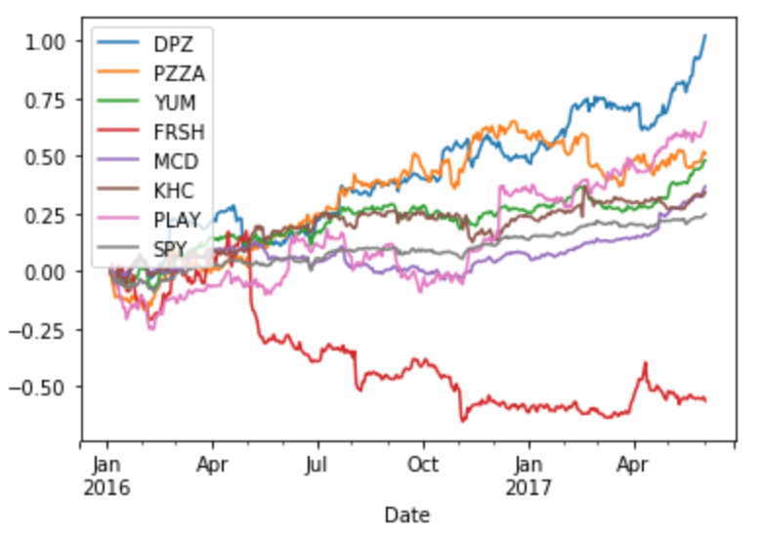

Following data cleansing by removing days where the market did not report in the Yahoo! data feed, we retrieve a baseline of the mean adjusted close prices of each stock over the given time period. The mean adjusted close prices of each stock are shown below in Figure 2.

Table 2: Mean adjusted close prices of portfolio for selected time period

|  |  |  |  |  |  |  |  |  |
| --- | --- | --- | --- | --- | --- | --- | --- | --- |
|  | DPZ | PZZA | YUM | FRSH | MCD | KHC | PLAY | SPY |
| mean | 150.08 | 70.68 | 60.12 | 6.82 | 119.31 | 82.02 | 47.44 | 211.10 |

To establish a momentum strategy, we must calculate two specific tabular outputs: momentum weights and holding period returns. We calculate the momentum for each stock in the portfolio by calculating the percentage change over the frequency of business days defined by the lookback period. This lookback period is established at the beginning of the dataset. For instance, if we use a ten-day lookback period and a timeframe beginning on January 1, 2016, January 19th would be the first valid business date in which we could calculate momentum or percentage change. These percentages are ranked in ascending order, demeaned and then standardized to obtain a tabular output of portfolio weights for each relevant business day based on a given lookback period. These weights follow momentum investing guidelines: stocks with the greatest momentum in the portfolio are weighted the heaviest.

For each lookback period, an accompanying holding period is also defined and cumulative returns are calculated for each stock in the portfolio based on this holding period:

Equation 3: Cumulative Returns for Each Holding Period

$${return}_{k}= \prod_{1}^{k}{x_{i}}$$

Where the cumulative return for a given stock in the portfolio is ${return}_{k}$. These returns are aggregated into holding period length bins, timestamped left-inclusive. For instance, if we held a portfolio position (mix of stocks) for ten business days, portfolio returns would be aggregated in ten business day increments with cumulative returns for each stock represented as in Table 2.

Table 3: Cumulative Returns for Holding Period

|  |  |  |  |  |  |  |  |
| --- | --- | --- | --- | --- | --- | --- | --- |
| Date | DPZ | PZZA | YUM | FRSH | MCD | KHC | PLAY |
| 2016-01-04 | -0.0464 | -0.1229 | -0.0647 | -0.0173 | -0.0204 | -0.0481 | -0.1603 |
| 2016-01-18 | 0.0937 | -0.0085 | 0.0787 | -0.1155 | 0.0746 | 0.1280 | 0.0356 |
| 2016-02-01 | -0.0388 | 0.0576 | -0.0695 | -0.0600 | -0.0472 | -0.0786 | -0.0771 |
| 2016-02-15 | 0.2273 | 0.2138 | 0.0605 | 0.1995 | 0.0001 | 0.0823 | 0.0982 |
| 2016-02-29 | -0.0170 | -0.0853 | 0.0889 | -0.0261 | 0.0383 | -0.0114 | 0.0340 |

Where each day in the table contains the cumulative return for each stock over ten business days.

These returns need to be weighted given our momentum investing strategy of buying on uptrends and selling off on downtrends that we previously defined. This is where our lookback period has direct effect on the size of each investment in our portfolio. Our lookback period is responsible for creating the momentum weights of our portfolio, which will be multiplied by the returns for each of the relevant stocks in the portfolio. However, given our returns are aggregated by the holding period chosen, the holding period also determines the aggregation or resampling method for the portfolio weights to ensure dates are aligned properly. As can be seen in Table 4, returns and weights are aligned based on the holding period timeframe of ten business days. As previously stated, stocks are ranked in ascending order based on their given momentum calculations. These ranks are then standardized in order to create weights for the portfolio.

Table 4: Momentum-Based Weights for Holding Period of 10 Days, Lookback Period of 3 Days

|  |  |  |  |  |  |  |  |
| --- | --- | --- | --- | --- | --- | --- | --- |
| Date | DPZ | PZZA | YUM | FRSH | MCD | KHC | PLAY |
| 2016-01-04 | -0.4629 | -1.3887 | -0.9258 | 0.0000 | 0.4629 | 1.3887 | 0.9258 |
| 2016-01-18 | 0.4629 | 0.0000 | 0.9258 | 1.3887 | -0.4629 | -0.9258 | -1.3887 |
| 2016-02-01 | 0.00000 | -0.9258 | 1.3887 | -1.3887 | 0.4629 | 0.9258 | -0.4629 |
| 2016-02-15 | -0.9258 | 1.3887 | -1.3887 | 0.9258 | 0.4629 | 0.0000 | -0.4629 |
| 2016-02-29 | 1.3887 | 0.9258 | -1.3887 | 0.4629 | -0.9258 | 0.0000 | -0.4629 |

These two tabular outputs thus give us returns and weights for each holding period over our timeframe of January 1, 2016 to June 1, 2017. We multiply these two tables and sum along the rows to get portfolio returns for each holding period. We then calculate a simplified Sharpe ratio by taking the mean of the returns divided by the standard deviation of the returns to score the quality of a given lookback, holding period combination.

Given our momentum strategy is established, we then set up a back-testing function to calculate the portfolio, iterating over many different lookback and holding period combinations. In our case, we examine a range of 10 to 360 periods for both lookback and holding periods, using the Sharpe ratio to rank each combination of parameters based on risk adjusted returns.

## **Results**

To rank momentum strategies, our method compares resulting Sharpe ratios for each combination of lookback and holding period analyzed using the previously mentioned momentum investing methods. The parameters for lookback and holding periods were iterated over to test possible combinations, and learn the optimal range of combinations for the two parameters. Each parameter was varied in 10 day increments up to 360 days of lookback and holding periods.

The heat map visualization in Figure 2 illustrates the outcomes from the tests, with brighter colors indicating a higher Sharpe Ratio. We only include Sharpe ratios considered “good,” or greater than one to de-clutter and find optimal clusters. The x-axis illustrates the lookback period, and the y-axis is the holding period.

A parameter grid search reveals the best returns for the fast food portfolio consistently occur in the 70-day lookback period. The 70-day lookback period has four holding periods with Sharpe ratio of 4.9 or greater. The maximum value of the Sharpe Ratio is the intersection of 70-day lookback with 230 day holding period, yielding a maximum value of 46. A Sharpe ratio of 11 was yielded from a lookback period of 70, with a 290 holding period. Success with longer holding periods make sense as the portfolio of fast food stocks are mostly increasing over the time span we are researching.

A 90-day lookback period also produces several significant Sharpe ratios, with 100 and 140 day holding periods offering 5.7 and 5.8 scores, respectively. Generalized, the fast food portfolio shows a stronger Sharpe ratio score for lookback periods greater than 30 business days, and longer holding periods, conforming to previous empirical studies [2]. However, following the strict definition of intermediate term means considering lookback periods specifically between six and twelve months. We find that, given our portfolio mix, lookback periods between two and six months tend to perform better. This presents a bit of a gray area, which both supports and discredits previous empirical analysis. Another observation can be seen as the lookback period increases, it is clear that Sharpe ratio frequency and values decrease dramatically.

Figure 2: Heatmap of Sharpe ratios for different lookback and holding period combinations.

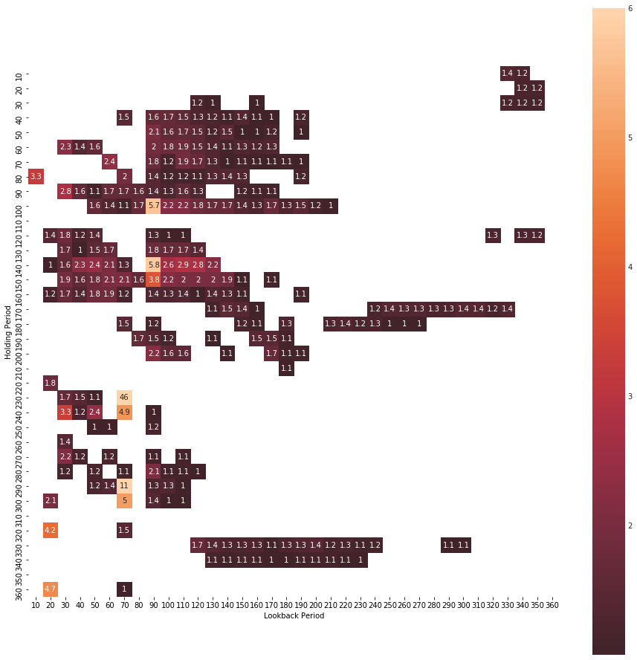

Given data visualization shows long-term lookback periods do not perform as well from a risk adjusted return standpoint, we consider formal comparisons of only short-term and intermediate term lookback periods using a Kruskal-Wallis test. Results bear out a significant difference (p<0.001) between the two groups. Indeed, a modified intermediate term lookback period strategy of 40 business days to 360 business days produce a median Sharpe ratio of 0.72, while short-term lookback period strategies of 30 days and less produce a median Sharpe ratio of 0.18. However, this grouping does not follow strict interpretation of short and intermediate terms because lookback periods greater than a month and less than six months are aggregated with the intermediate term category, which is typically between six and twelve months.

In order to be complete, we also follow a strict interpretation of short-term and intermediate-term lookback periods and introduce a third category between short-term and intermediate-term lookback periods of greater than one month and less than six months or 40 to 170 days. We ascertain that this “between” category actually outperforms both short and intermediate-term lookback periods. This can easily be seen in Figure 2; however, we also note that the median Sharpe ratio for this “between” lookback range is greater than the consolidated intermediate category at 0.79 compared to 0.72, respectively. A Kruskal-Wallis test also confirms significant differences in medians (p < 0.001). Holding periods follow suit, though not as strongly, where larger Sharpe ratios are found in the “between” category where 40 to 170 business days are considered.

In addition, the portfolio’s performance was also compared to the performance of the S&P 500. The S&P 500 returned a Sharpe ratio of 2.52 during the same time period. This shows that given an intermediate lookback period, momentum-based investing can significantly outperform S&P 500 over the 18-months between January 2016 and June 2017.

## **Future Work, Discussion Conclusions, and Next Steps**

Based on the results of our case, we are able to find a gray area for the lookback period parameter between 40 to 170 business days that maximizes risk adjusted returns for our high-growth portfolio in a momentum-based investing scenario. However, it can be seen that both short-term and long-term lookback periods do not provide for the greatest risk-free return, confirming the same empirical results from Titman and Jegadeesh [2]. Thus, it can be recommended to continue with empirically confirmed intermediate parameter ranges when considering high-growth portfolios and a momentum-based investing strategy, with the caveat that in some scenarios it may be worth exploring a lookback parameter greater than one month and less than six months. The same outcome holds true for holding periods based on our analysis, given our high-growth portfolio. A simple strategy in this case would be to apply roughly similar lookback and holding periods, avoiding short-term and long-term periods altogether.

The obligations of the financial industry to their customer – the end investor – have become strengthened over the last several decades. The most recent major change implemented was in July 2017 with full enactment in January 2018, was the “Fiduciary Standard” that required advisors to put the goals and objectives of their customers ahead of their own goals [8]. In simple terms, while the financial advisor may have been paid on commissions earned through active trading, or through sales of financial instruments to the customer it could open a conflict of interest, because the specific trades or financial instruments sold, may in a broader view detrimental to the customer’s end goals for investing.

This standard introduces a need for transparency of purpose, documentation, and most likely, better planning on the part of the financial advisor or the financial advisor’s firm to meet a potential future legal challenge from a disgruntled investor. A series of unfortunately timed trades that caused losses for the investor, but that the advisor may still have earned a commission from, could be seen by the investor as a self-motivated trade without benefit to the investor.

Sitkoff [9] spoke about financial advisors’ obligations under earlier law, noting that deterrence is the largest effect of fiduciary responsibility. Advisors should be deterred from making decisions in their own self-interest, and not in the interest of their customers, because of the possible consequences after the fact. The advisor should act out of loyalty and concern for their customer.

Reish [10] cites parts of the standard for fiduciaries and their recordkeepers, calling on fiduciaries to craft specific investment alternatives that fit the standards of their program. We think that in view of the new laws of financial advising, many new data-driven decisions will be born out of a need for transparency and reproducibility, given the financial market’s current standing and the data available to the advisor on a given day.

The employment of specific strategy driven algorithms, like the momentum or mean regression algorithms cited in McKinney [6] would offer an advisor a framework for allocation of funds, given an investor’s agreed upon goal, and produce a suggested mix of securities to achieve the best possible return. As information in the market changes, the model could follow and update the mix of securities periodically to manage for the best possible returns.

The model presented in this paper, the momentum investing strategy, certainly is a simplistic approach to investment management and encompasses only one aspect of the investment management. It could become part of a larger ecosystem devised by an investment firm with the goals of compliance to the regulatory burden imposed by the fiduciary responsibility laws.

One could imagine each interaction between customer and advisor is captured in a detailed set of data that speaks to the customer’s financial planning horizon, their final financial goals, and specific requests that are made during the session. Based on the inputs, the advisor would be provided a best-fit for portfolio, with ability to make specific modifications and record cause for modification. Thus, the investment firm is guiding decisions made by the individual advisors to be in the best interest, with the best-known information, about the market at any point in time.

While financial planning often talks of risk, the investment firm and advisors have increased responsibilities, and it could be said, risk with the fiduciary responsibility laws. Mitigation of these risks is likely an objective for any firm in the trade. While good ethics is the baseline way to begin mitigating this risk, there still exists many cases where the advisor’s decisions could be called into question.

The fiduciary rules allow class action lawsuits to be brought against financial advisors for failing to act in their clients’ best interests. One could imagine that the financial risk to a firm could reach a similar level to Citigroup’s settlement from the 2007 subprime crisis - $590 Million dollars to members of a class-action suit for allegedly misleading the investors. Ameriprise Financial paid a $27 million dollars settlement to the members of a class-action lawsuit, for breaking fiduciary responsibilities. Moving towards a rules and data driven system of financial advisement may be a strategy to improve impartiality of the advisor and reduce exposure to the risk of lawsuits from disgruntled investors.

## **References**

1. Shitoshna, N. “Signal Processing in Finance.” *Electrical and Computer Engineering Design Handbook.* Tufts University. 2013. sites.tufts.edu/eeseniordesignhandbook/2015/signal-processing-in-finance
2. Jagdeesh N., Titman, S. “Returns to Buying Winners and Selling Losers: Implications for Stock Market Efficiency”. Mar. 1993. *Wiley Online Library.* onlinelibray.wiley.com/doi/10.1111/j.1540-6261.1993.tb04702.x/full
3. “Momentum Investing.” Investopedia. www.investopedia.com/terms/m/momentum_investing.asp.
4. Jagdeesh, N. “Evidence of Predictable Behavior of Security Returns.” Jul 1990. *Wiley Online Library.* onlinelibrary.wiley.com/doi/10.1111/j.1540-6261.1990.tb05110.x/full.
5. Quantstart Team. “Sharpe Ratio for Algorithmic Trading Performance Measurement.” *Quantstart.* 29 May, 2013. www.quantstart.com/articles/Sharpe-Ratio-for-Algorithmic-Trading-Performance-Measurement.
6. McKinney, W. *Python for Data Analysis* pgs. 344-348. Wiley. 2012.
7. Moskowitz, T., Ooi, Yao, "Time Series Momentum.” *SSRN.* 1 Sep, 2011. papers.ssrn.com/sol3/papers.cfm?abstract_id=2089463.
8. Bernard, T. “Obama’s Fiduciary Rule, After a Delay, Will Go Into Effect.” *New York Times.* 23, May, 2017. www.nytimes.com/2017/05/23/business/obamas-fiduciary-rule-after-a-delay-will-go-into-effect.html
9. Sitkoff, Robert H. “The Fiduciary Obligations of Financial Advisers under the Law of Agency.” *SSRN - Journal of Financial Planning: pgs 42–49*. papers.ssrn.com/sol3/papers.cfm?abstract_id=2234830
10. Reish, F. “Interesting Angles on DOL’s Fiduciary Rule #74: One More Fiduciary Issue for Recordkeepers.” *National Law Review.* 18 Dec, 2017. www.natlawreview.com/article/interesting-angles-dol-s-fiduciary-rule-74-one-more-fiduciary-issue-recordkeepers
11. Silver-Greenberg, J. “Citigroup in $590 Million Settlement of Subprime Lawsuit.” *New York Times.* 29 Aug, 2012. dealbook.nytimes.com/2012/08/29/citigroup-in-590-million-settlement-of-subprime-lawsuit.

**Appendix**

All code and explanations have been submitted in a separate Jupyter notebook entitled NicholsC_MurrayD_BataillardJ_LawJ_QTW403CaseStudyUnit4.ipynb