## **Abstract**

Signal processing techniques are frequently used in equity and commodities trading strategies. Also called technical analysis, these signal processing methods often disregard and outperform fundamental equity valuation methods such as buying and selling securities based on a price to earnings ratio [1,2]. Technical analysis uses historical data to make bets on the future of stock prices given key assumptions. In this paper, we empirically analyze strategies for one technical analysis method: signal frontier analysis. Specifically, we explore a sub-strategy of signal frontier analysis called momentum investing and its two key parameters: lookback period and holding period given a portfolio of stocks experiencing significant positive returns over the time period analyzed. Utilizing the Sharpe ratio as our performance metric, we find that intermediate term momentum investing strategies result in the greatest risk adjusted return.

## **Introduction**

Time series data is plentiful in finance. Equities are traded in nanoseconds based on market signals. Investment firms often employ engineers and other technically trained individuals to apply signal processing methods to financial time series data. This practice has unearthed multitudes of algorithms and data analysis methods for trading equities all now considered "technical analysis." These technical analysis methods often run contrary to the idea of the efficient market hypothesis, which assumes that security prices reflect all available information.

One such technical analysis method is momentum investing. At the heart of momentum investing is the assumption that signals are rarely completely random and have some degree of consistency of pattern [1]. Momentum investing also assumes that once a trend is established, the trend is likely to continue rather than revert. Investors applying a momentum strategy make bets on the future based on this trend, instead of the current stock price and fundamental analysis methods such as liquidity and price to earnings ratios. In this paper, we empirically analyze and determine the optimal momentum investing strategy for a portfolio of fast food equities. We specifically choose this industry because of the tremendous growth in the timeframe analyzed.

Momentum investing can be further classified into cross-sectional or time-series based momentum. The latter compares historical returns from a stock with respect to the stock itself, whereas cross-sectional momentum compares historical returns from a stock relative to other securities. In our case, we analyze a cross-sectional momentum portfolio.

A momentum investor's goal is to capitalize on the continuance of existing trends in the market [4]. The two critical parameters of momentum investing are the lookback and holding periods. Typically, an investor will take a long position in an asset that is trending upward and a short position in an asset that is trending downward. The most common tool to establish this trending component is to draw a line between two points on a time series and calculate a cumulative return:

Equation 1: Momentum Calculation

$$return=\frac{t_{2}-t_{1}}{t_{1}}$$

Where the difference between time two and time one is the lookback period. This lookback period can be many frequency types: daily, hourly, monthly or yearly. In this paper, we choose a business daily lookback frequency. This lookback period and associated returns for a portfolio allow for the weighting of each investment in a portfolio. For example, given a lookback period of 30 days, if two out of five stocks are trending downward (have a negative return), these stocks would be down weighted in the portfolio. If the remaining stocks have an increasing trend, these stocks would be up weighted in the portfolio.

Based on the signal provided by a given lookback period, a momentum investor retains a portfolio mix of up-weighted and down-weighted stocks over a given "holding period," capturing compound returns on our portfolio. This holding period can also take on any frequency, however, it should be consistent with the lookback period frequency. The ultimate goal is to maximize returns based on historical trends.

Based on the choice of lookback period, momentum investment strategies can be broken down into three different sub-strategies: short term, intermediate term and long-term momentum. Short term momentum strategies utilize one month or less of a lookback period, while long term strategies typically utilize greater than three years for a lookback period. Both long and short-term strategies have been empirically shown to experience significant reversion. Trends often change to the detriment of the investor [5]. However, intermediate term strategies, which use a lookback period of six to twelve months show greater success, often resulting in no reversals. [6]

An acceptable metric to evaluate the performance for the portfolio is the Sharpe ratio. It compares the “mean average of the excess returns of the asset or strategy with the standard deviation of those returns” [7]. The Sharpe ratio helps to balance returns with volatility, resulting in a metric that allows an investor to judge both risk and return simultaneously.

Equation 2: Sharpe Ratio

$Sharpe ratio=\frac{{\overline{r}}_{p}-r_{f}}{σ_{p}}$,

where ${\overline{r}}_{p}$ is the expected portfolio return, $r_{f}$ is the risk-free rate, and $σ_{p}$ is the portfolio standard deviation. Typically, Sharpe Ratios greater than one are considered good.

In this case study, we use seven fast food equities to test various lookback and holding periods of a cross-sectional momentum investing strategy. Our portfolio includes Domino's, Papa John's, Yum Brands, Papa Murphy's, McDonalds, Kraft Heinz, and Dave and Buster's. The data collected is extracted from Yahoo Finance and the date range is from January 1st, 2016 to June 1st, 2017.

**Methods**

In order to empirically investigate lookback and holding periods to find the optimal momentum investing parameters for our fast food equity portfolio, it is imperative to establish a searching solution. This means testing over various combinations of lookback and holding periods and calculating resulting Sharpe Ratios. Specifically, we test lookback and holding periods from 10 to 360 business days, considered in 10 business day increments.

The Sharpe ratio gives a final comparison for each combination of lookback and holding period analyzed, allowing us to compare strategies with one performance metric. To accomplish this, we first have to create the portfolio by extracting historical Yahoo! finance stock prices, then ensure that the adjusted close data is accurate. We choose a date range of January 1, 2016 to June 1, 2017, considering only business days.

Table 1: 5-day view of adjusted close price from Yahoo! Finance API for selected stocks

|  |  |  |  |  |  |  |  |  |
| --- | --- | --- | --- | --- | --- | --- | --- | --- |
| Date | DPZ | PZZA | YUM | FRSH | MCD | KHC | PLAY | SPY |
| 1/4/2016 | 107.02 | 53.64 | 49.64 | 10.92 | 111.20 | 68.69 | 41.71 | 193.04 |
| 1/5/2016 | 107.70 | 53.41 | 49.51 | 10.77 | 112.73 | 69.34 | 41.89 | 193.37 |
| 1/6/2016 | 107.55 | 51.36 | 49.16 | 11.23 | 111.97 | 69.48 | 42.44 | 190.93 |
| 1/7/2016 | 104.59 | 49.55 | 47.48 | 10.71 | 109.38 | 67.94 | 41.21 | 186.35 |
| 1/8/2016 | 106.76 | 47.50 | 46.84 | 10.26 | 109.21 | 67.26 | 39.51 | 184.30 |

We also include the S&P 500 initially to provide context, from the overall market, to the growth the fast food portfolio experienced over the given time frame selected. Figure 2 illustrates the stocks making up the fast food portfolio far outpace the market from a returns perspective. We wish to test previous empirical observations showing intermediate term momentum investing strategies as superior [1], except in a specific environment where our portfolio is growing. However, we also wish to maintain industry consistency, therefore our mix is contained to the fast food industry.

Figure 1: Cumulative Returns of Individual Stocks in Fast Food Portfolio and S&P 500

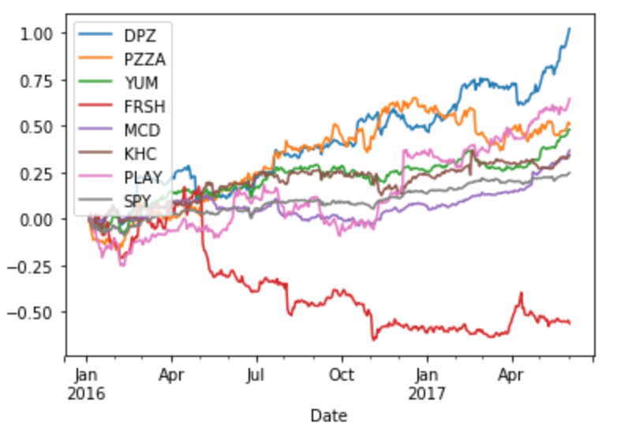

Following data cleansing by removing days where the market did not report in the Yahoo! data feed, we retrieve a baseline of the mean adjusted close prices of each stock over the given time period. The mean adjusted close prices of each stock are shown below in Figure 2.

Table 2: Mean adjusted close prices of portfolio for selected time period

|  |  |  |  |  |  |  |  |  |
| --- | --- | --- | --- | --- | --- | --- | --- | --- |
|  | DPZ | PZZA | YUM | FRSH | MCD | KHC | PLAY | SPY |
| mean | 150.08 | 70.68 | 60.12 | 6.82 | 119.31 | 82.02 | 47.44 | 211.10 |

To establish a momentum strategy, we must calculate two specific tabular outputs: momentum weights and holding period returns. We calculate the momentum for each stock in the portfolio by calculating the percentage change over the frequency of business days defined by the lookback period. This lookback period is established at the beginning of the dataset. For instance, if we use a ten-day lookback period and a timeframe beginning on January 1, 2016, January 19th would be the first valid business date in which we could calculate momentum or percentage change. These percentages are ranked in ascending order, demeaned and then standardized to obtain a tabular output of portfolio weights for each relevant business day based on a given lookback period. These weights follow momentum investing guidelines: stocks with the greatest momentum in the portfolio are weighted the heaviest.

For each lookback period, an accompanying holding period is also defined and cumulative returns are calculated for each stock in the portfolio based on this holding period:

Equation 3: Cumulative Returns

$${return}_{k}= \prod_{1}^{k}{x_{i}}$$

Where the cumulative return for a given stock in the portfolio is ${return}_{k}$. These returns are aggregated into holding period length bins, timestamped left inclusive. For instance, if we held the portfolio position for ten business days, portfolio returns would be aggregated in ten business day increments with cumulative returns for each stock represented as in Table 2.

Table 3: Cumulative Returns for Holding Period

|  |  |  |  |  |  |  |  |
| --- | --- | --- | --- | --- | --- | --- | --- |
| Date | DPZ | PZZA | YUM | FRSH | MCD | KHC | PLAY |
| 2016-01-04 | -0.0464 | -0.1229 | -0.0647 | -0.0173 | -0.0204 | -0.0481 | -0.1603 |
| 2016-01-18 | 0.0937 | -0.0085 | 0.0787 | -0.1155 | 0.0746 | 0.1280 | 0.0356 |
| 2016-02-01 | -0.0388 | 0.0576 | -0.0695 | -0.0600 | -0.0472 | -0.0786 | -0.0771 |
| 2016-02-15 | 0.2273 | 0.2138 | 0.0605 | 0.1995 | 0.0001 | 0.0823 | 0.0982 |
| 2016-02-29 | -0.0170 | -0.0853 | 0.0889 | -0.0261 | 0.0383 | -0.0114 | 0.0340 |

Where each day in the table contains the cumulative return for each stock over ten business days.

These returns need to be weighted given our momentum investing strategy of buying on uptrends and selling off on downtrends. This is where our lookback period has direct effect on the size of each investment in our portfolio. Our lookback period is responsible for creating the momentum weights of our portfolio, which will be multiplied by the returns for each of the relevant stocks in the portfolio. However, given our returns are aggregated by the holding period chosen, the holding period also determines the aggregation or resampling method for the portfolio weights to ensure dates are aligned properly. As can be seen in Table 4, returns and weights are aligned based on the holding period timeframe of ten business days. As previously stated, all weights are standardized after they are ranked in ascending order.

Table 4: Momentum-Based Weights

|  |  |  |  |  |  |  |  |
| --- | --- | --- | --- | --- | --- | --- | --- |
| Date | DPZ | PZZA | YUM | FRSH | MCD | KHC | PLAY |
| 2016-01-04 | -0.4629 | -1.3887 | -0.9258 | 0.0000 | 0.4629 | 1.3887 | 0.9258 |
| 2016-01-18 | 0.4629 | 0.0000 | 0.9258 | 1.3887 | -0.4629 | -0.9258 | -1.3887 |
| 2016-02-01 | 0.00000 | -0.9258 | 1.3887 | -1.3887 | 0.4629 | 0.9258 | -0.4629 |
| 2016-02-15 | -0.9258 | 1.3887 | -1.3887 | 0.9258 | 0.4629 | 0.0000 | -0.4629 |
| 2016-02-29 | 1.3887 | 0.9258 | -1.3887 | 0.4629 | -0.9258 | 0.0000 | -0.4629 |

These two tabular outputs thus give us returns and weights for each holding period over our timeframe of January 1, 2016 to June 1, 2017. We multiply these two tables and sum along the rows to get portfolio returns for each holding period. We then calculate a simplified Sharpe Ratio by taking the mean of the returns divided by the standard deviation of the returns to score the quality of a given lookback, holding period combination.

Given our momentum strategy is established, we then set up a back-testing function to calculate the portfolio by iterating over many different lookback and holding periods. In our case, we examine a range of 10 to 360 periods for both lookback and holding periods, using the Sharpe ratio to rank each combination of parameters based on risk adjusted returns.

## **Results**

As stated previously, our method compares the results of the Sharpe ratio for the fast food company stocks. The parameters for look back and holding periods were iterated to test possible combinations, and learn the optimum combination of the two parameters. Each parameter was varied in 10 day increments.

The heat map visualization in Figure 3 illustrates the outcomes from the tests, with brighter colors indicating a higher Sharpe Ratio. The x-axis illustrates the lookback period, and the y-axis illustrates the holding period.

The findings parameter grid search reveal the best returns for the fast food portfolio consistently occurs in the 70 day lookback period. The 70 day lookback period has four holding periods with Sharpe ratio of 4.9 or greater. The maximum value of the Sharpe Ratio is the intersection of 70 day lookback with 230 day holding period, yielding a maximum value of 46. A Sharpe ratio of 11 was yielded from a lookback period of 70, with a 290 holding period.

A 90 day look back period also produced several higher than average Sharpe ratios, with 100 and 140 day holding periods offering 5.7 and 5.8 scores respectively. Generalized, the fast food portfolio shows a stronger Sharpe ratio score for intermediate look back periods, and longer holding periods.

Figure 3 – Heatmap showing return values for different loopback / holding period pairs.

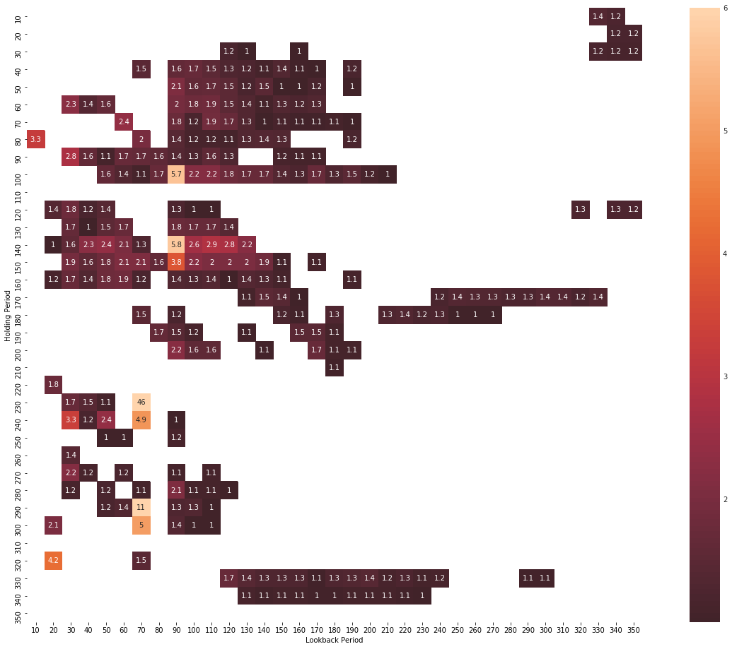

The strength of the portfolio is also matched by the fact that the risk involved in the Sharpe ratio helps determine the lower risk that the portfolio has overall. This was confirmed overall by the strength of the portfolio as shown by the percentage change over frequency of business days. Only one stock over this period had a negative performance, Papa Murphy’s (FRSH) as shown in figure 4.

Figure 4 – Diagram of cumulative returns per day

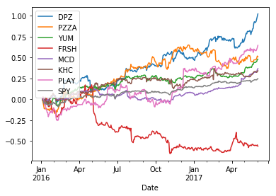

The portfolio’s performance was also extracted from the performance of the S&P 500 and the Sharpe ratios computed again, this time producing a return of 5.6747 during the full time period. The S&P 500 only returned a ratio of 2.5239 during the same time period. This shows that the given portfolio has a lower risk when compared to the S&P 500 over the 18-months between January 2016 and June 2017.

## **Future Work, Discussion Conclusions, and Next Steps**

The obligations of the financial industry to their customer – the end investor – have become strengthened over the last several decades. The most recent major change implemented was in July 2017 with full enactment in January 2018, was the “Fiduciary Standard” that required advisors to put the goals and objectives of their customers ahead of their own goals (8). In simple terms, while the financial advisor may have been paid on commissions earned through active trading, or through sales of financial instruments to the customer it could open a conflict of interest, because the specific trades or financial instruments sold, may in a broader view detrimental to the customer’s end goals for investing.

This standard introduces a need for transparency of purpose, documentation, and most likely, better planning on the part of the financial advisor or the financial advisor’s firm to meet a potential future legal challenge from a disgruntled investor. A series of unfortunately timed trades that caused losses for the investor, but that the advisor may still have earned a commission from, could be seen by the investor as a self-motivated trade without benefit to the investor.

Sitkoff [9] spoke about financial advisors’ obligations under earlier law, noting that deterrence is the largest effect of fiduciary responsibility. Advisors should be deterred from making decisions in their own self-interest, and not in the interest of their customers, because of the possible consequences after the fact. The advisor should act out of loyalty and concern for their customer.

Reish [10] cites parts of the standard for fiduciaries and their recordkeepers, calling on fiduciaries to craft specific investment alternatives that fit the standards of their program. We think that in view of the new laws of financial advising, many new data-driven decisions will be born out of a need for transparency and reproducibility, given the financial market’s current standing and the data available to the advisor on a given day.

The employment of specific strategy driven algorithms, like the momentum or mean regression algorithms cited in McKinney [3] would offer an advisor a framework for allocation of funds, given an investor’s agreed upon goal, and produce a suggested mix of securities to achieve the best possible return. As information in the market changes, the model could follow and update the mix of securities periodically to manage for the best possible returns.

The model presented in this paper, the momentum investing strategy, certainly is a simplistic approach to investment management and encompasses only one aspect of the investment management. It could become part of a larger ecosystem devised by an investment firm with the goals of compliance to the regulatory burden imposed by the fiduciary responsibility laws.

One could imagine each interaction between customer and advisor is captured in a detailed set of data that speaks to the customer’s financial planning horizon, their final financial goals, and specific requests that are made during the session. Based on the inputs, the advisor would be provided a best-fit for portfolio, with ability to make specific modifications and record cause for modification. Thus, the investment firm is guiding decisions made by the individual advisors to be in the best interest, with the best-known information, about the market at any point in time.

While financial planning often talks of risk, the investment firm and advisors have increased responsibilities, and it could be said, risk with the fiduciary responsibility laws. Mitigation of these risks is likely an objective for any firm in the trade. While good ethics is the baseline way to begin mitigating this risk, there still exists many cases where the advisor’s decisions could be called into question.

The fiduciary rules allow class action lawsuits to be brought against financial advisors for failing to act in their clients’ best interests. One could imagine that the financial risk to a firm could reach a similar level to Citigroup’s settlement from the 2007 subprime crisis - $590 Million dollars to members of a class-action suit for allegedly misleading the investors. Ameriprise Financial paid a $27 million dollars settlement to the members of a class-action lawsuit, for breaking fiduciary responsibilities. Moving towards a rules and data driven system of financial advisement may be a strategy to improve impartiality of the advisor and reduce exposure to the risk of lawsuits from disgruntled investors.

## **References**

1. Moskowitz, T., Ooi, Yao, "Time Series Momentum"
2. <https://sites.tufts.edu/eeseniordesignhandbook/2015/signal-processing-in-finance/>
3. Python for Data Analysis,William McKinney pgs. 344-348.
4. <https://www.investopedia.com/terms/m/momentum_investing.asp>
5. (Jagdeesh, Narsimhan - Evidence of Predictable Behavior of Security Returns)
6. Narasimhan Jegadeesh and Sheridan Titman “Returns to Buying Winners and Selling Losers: Implications for Stock Market Efficiency”.
7. <https://www.quantstart.com/articles/Sharpe-Ratio-for-Algorithmic-Trading-Performance-Measurement>
8. <https://www.nytimes.com/2017/05/23/business/obamas-fiduciary-rule-after-a-delay-will-go-into-effect.html>
9. Sitkoff, Robert H. “The Fiduciary Obligations of Financial Advisers under the Law of Agency.” Journal of Financial Planning 27 (2): 42–49.
10. <https://www.natlawreview.com/article/interesting-angles-dol-s-fiduciary-rule-74-one-more-fiduciary-issue-recordkeepers>
11. <https://dealbook.nytimes.com/2012/08/29/citigroup-in-590-million-settlement-of-subprime-lawsuit/>

## **Appendix – Python Code / iPython Notebook**

**import** **datetime** **as** **dt**

**import** **pandas** **as** **pd**

**from** **pandas** **import** Series, DataFrame

**from** **pandas_datareader** **import** data **as** web

**import** **numpy** **as** **np**

**import** **matplotlib.pyplot** **as** **plt**

**import** **seaborn** **as** **sns**

*# set date range*

date_time_start = dt.datetime(2016, 1, 1)

date_time_end = dt.datetime(2017, 6, 1)

*# add SPY (S&P 500 Index) to check for market correlations, comparisons for returns*

**def** get_portfolio():

*''' Get portfolio of stocks using buggy Yahoo'''*

port = pd.DataFrame()

names = ['DPZ', 'PZZA', 'YUM', 'FRSH', 'MCD', 'KHC', 'PLAY', 'SPY']

**for** stock **in** names:

**while** **True**:

**try**:

port[stock] = web.get_data_yahoo(stock, date_time_start, date_time_end)['Adj Close']

**break**

**except**:

print('Unable to read stock: **{0}**, trying again'.format(stock))

**return** port

px = get_portfolio()

px = px.loc[~(px==0).all(axis=1)] *# strip out days with no trading data for all stocks*

*# daily adjusted close prices for pizza portfolio*

px.head()

px.describe()

*# check linear relationships, including SP 500*

corr = px.corr()

mask = np.zeros_like(corr)

mask[np.triu_indices_from(mask)] = **True**

f, ax = plt.subplots(figsize=(8, 8))

**with** sns.axes_style("white"):

ax = sns.heatmap(corr, mask=mask, vmax=1, center=0, square=**True**, annot=**True**)

*# transform to business day frequency and calculate percentage change* *# show cumulative returns over frequency of business days* px = px.asfreq('B').fillna(method='pad') *# pad == ffill* rets = px.pct_change() print('Pizza Stocks mostly outperform SP 500 Greatly') ((1+rets).cumprod()-1).plot() plt.show()

*# potential reference: https://www.investopedia.com/terms/m/momentum_investing.asp*

*# compute momentum over a lookback and rank in ASCENDING order and standardize to get portfolio weights*

*# base code is not momentum out of the box, it is mean reversion, we can change to momentum by changing asc to True*

*# these form the weights for our portfolio and are based on standardized momentum ranks so we sum to 0 as part of*

*# our portfolio*

*# ascending = True - momentum*

*# ascending = False - mean reversion*

**def** calc_mom(price, lookback, lag):

*'''Calculates pct change based on user input shift and lookback period, ranks, then standardizes ranks'''*

mom_ret = price.shift(lag).pct_change(lookback) *# price shift forward lag periods (EOD) and calc % change based on*

*# lookback cumulative return for each day in index*

ranks = mom_ret.rank(axis=1, ascending=**True**) *# rank top performers for each day (ASCENDING = weight stocks with*

*# positive trend greater - this is momentum)*

demeaned = ranks.subtract(ranks.mean(axis=1), axis=0) *# subtract the mean rank for the portfolio for each day*

**return** demeaned.divide(demeaned.std(axis=1), axis=0) *# divide by sd of the ranks for each day to standardize*

compound = **lambda** x : (1+x).prod()-1 *# compound calc to give us compound returns for each holding period*

daily_sr = **lambda** x : x.mean() / x.std() *# calculate mean portfolio return divided by std deviation to get sharpe*

*# Sharpe Ratio is avg return above risk free rate*

*# Subtracting the risk-free rate from the mean return,*

*# the performance associated with risk-taking activities can be isolated.*

*# > sharpe ratio = more attractive risk adjusted return*

*# (https://www.investopedia.com/terms/s/sharperatio.asp)*

**def** strat_sr(prices, lb, hold):

*# Compute portfolio weights using rank-standardized momentum portfolio*

freq = '**%d**B' % hold *# set up holding period*

port = calc_mom(prices, lb, lag=1)

daily_rets = prices.pct_change()

*# Compute portfolio returns*

port = port.shift(1).resample(freq).first() *# shift out weights to apply to next period returns, resample holding*

*# period and take first relevant value for weights*

returns = daily_rets.resample(freq).apply(compound) *# resample daily returns and calc compound returns for each*

*# frequency bucket*

port_rets = (port * returns).sum(axis=1)

**return** port_rets, daily_sr(port_rets) * np.sqrt(252 / hold)

strat_sr(px.iloc[:,:-1], 90, 140)[1]

*# sharpe ratio comparison setup*

**from** **collections** **import** defaultdict

lookbacks = range(10, 360, 10)

holdings = range(10, 360, 10)

dd = defaultdict(dict)

**for** lb **in** lookbacks:

**for** hold **in** holdings:

dd[lb][hold] = strat_sr(px.iloc[:,:-1], lb, hold)[1]

ddf = pd.DataFrame(dd)

ddf.index.name = 'Holding Period'

ddf.columns.name = 'Lookback Period'

**def** heatmap(df, cmap = plt.cm.gray_r):

fig = plt.figure(figsize=(12,12))

ax = fig.add_subplot(111)

axim = ax.imshow(df.values, cmap = cmap, interpolation='nearest')

ax.set_xlabel(df.columns.name)

ax.set_xticks(np.arange(len(df.columns)))

ax.set_xticklabels(list(df.columns))

ax.set_ylabel(df.index.name)

ax.set_yticks(np.arange(len(df.index)))

ax.set_yticklabels(list(df.index))

plt.colorbar(axim)

heatmap(ddf)

plt.show()