Network Infrastructure Update

Sponsor: Highschool X

Team Members: Isabel Rivera

Carlos Gil

Dustin Nguyen

**B. Summary of Activities and Work Breakdown Structure (WBS):**

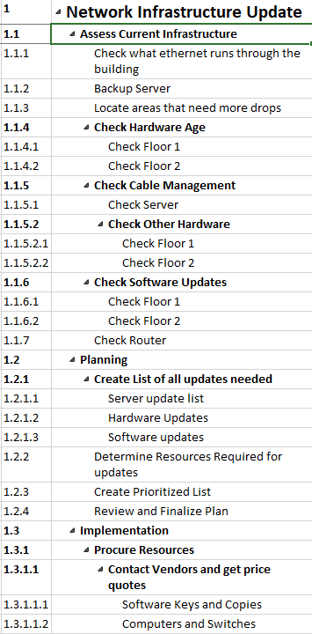

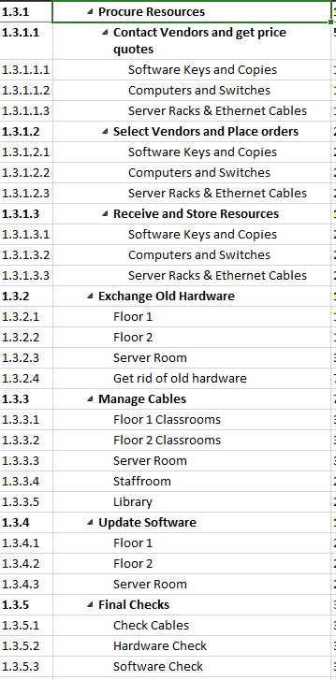

The top level of activities are the major phases of the project: Assessing the Current Infrastructure, Creating a Plan, and Implementing the updates from the plan. The second level comprises the major tasks needed to complete the phases of the project. Some examples of the second tier from the first phase of Assessment are: Check Hardware Age, Check Cable Management, and Check Software Updates. Please note that during the first phase of Assessment that a majority of the tasks can be done in parallel and the team is only limited by the staff that can be assigned to any of the tasks at any time. These tasks are further broken down into either physical areas or tasks that can be handled by one person at lower levels. Certain major tasks such as Procuring Resources during the Implementation phase, are further broken down into tasks at a fourth and fifth level, to separate different items that need to be ordered and the phases of getting price quotes, placing orders, and receiving goods. Tasks at the second level in the Assessment Phase generally were assigned to one person, so that one person could focus on keeping the same standards for the task. For example a single person would be responsible for major tasks such as Check Hardware Age or Check Software Updates. For the other phases, major tasks had their subtasks done in parallel by the whole team because, especially in the Implementation Phase, major tasks such as Exchange Old Hardware and Manage Cables are part of the critical path and needed to be completed fully before the project could move forward with any other tasks.

**C. Network Activity Diagram Summary:**

**a. What is the first activity in the project?**

Assess the current infrastructure.

**b. What is the last activity in the project?**

Final Checks to make sure everything is done.

**c. What is the critical path?**

The critical path is represented by the following table for clarity:

|  |  |  |  |  |  |
| --- | --- | --- | --- | --- | --- |
| Critical Path | | | | | |
| WBS # | Task Name | Duration | Start | Finish | Notes |
| 1.1 | Assess Current Infrastructure | 6 days | 1/3/22 | 1/10/22 | Because this phase is comprised of many tasks that can be done in parallel, this creates a large amount of critical paths that can be arbitrarily chosen at lower level tasks |
| 1.2.1 | Create List of all updates needed | 1 day | 1/11/22 | 1/11/22 | This task is also broken into subtasks of the same duration that can be done in parallel |
| 1.2.2 | Determine Resources Required | 1 day | 1/12/22 | 1/12/22 |  |
| 1.2.3 | Create Prioritized List | 2 days | 1/13/22 | 1/14/22 |  |
| 1.2.4 | Review and Finalize Plan | 2 days | 1/17/22 | 1/18/22 | The start date accounts for a weekend in between this and the previous critical task |
| 1.3.1.1 | Contact Vendors for Price Quotes | 5 days | 1/19/22 | 1/25/22 |  |
| 1.3.1.2 | Select Vendors and Place orders | 2 days | 1/26/22 | 1/27/22 |  |
| 1.3.1.3 | Receive and Store Resources | 10 days | 7/1/22 | 7/14/22 | This task starts at this date because the school will be in summer session with less activity making it available to do otherwise disruptive physical work. |
| 1.3.2.1 | Exchange Old Hardware: Floor 1 | 1 week | 7/15/22 | 7/21/22 | This can also be substituted by task 1.3.2.2 : Exchange Old Hardware: Floor 1 because these tasks are done in parallel |
| 1.3.3.1 | Manage Cables: Floor 1 Classrooms | 3 days | 7/22/22 | 7/26/22 | These two tasks are done in parallel with and can be substituted in the critical path with tasks 1.3.3.2 and 1.3.3.5 |
| 1.3.3.4 | Manage Cables: Staffroom | 2 days | 7/27/22 | 7/28/22 |
| 1.3.4.1 | Update Software: Floor 1 | 2 weeks | 7/29/22 | 8/11/22 | This task is done in parallel with and can be substituted in the critical path with task 1.3.4.2 |
| 1.3.5 | Final Checks | 3 days | 8/12/22 | 8/16/22 | This task consists of the 3 subtasks of the same duration that are done in parallel. |

**d. How many activities have a slack?**

All of the activities have slack due to the nature of working with the school over the year long period, we would work around their schedules and needs. This is due to an abundance of time between the beginning of the year and the latest finish time of the project at the start of the next school year.

**e. What are some of the activities that can be done in parallel?**

Most of the assessment activities could be done in parallel, like backing up the server and checking if the school’s computers need upgrading. Exchanging hardware and managing cables could be done in parallel. Many of the major tasks have been divided into subtasks that can be accomplished by a single person so that they can be done in parallel for major tasks that fall on the critical path.

**f. Which activity has the longest duration? (hint: this should be on the critical path)**

Procuring resources would take the longest as there are currently supply chain issues affecting computer part shipments, as it is largely out of our control it has the potential to take the longest.

**D. Project Schedule Summary:**

**a. What is the scheduled start date of the project, and what is the scheduled end**

**date of the project?**

The scheduled start date is 1/3/22, and the scheduled end date is 9/1/22.

**b. What are the start and end dates for summary activities?**

The start and end dates for summary activities are :

Assess Current Infrastructure - 1/3/22 - 1/10/22

Check Hardware Age - 1/6/22 - 1/7/22

Check Cable Management- 1/6/22 - 1/10/22

Check Software Updates- 1/6/22 - 1/7/22

Create List of All Updates Needed- 1/11/22 - 1/11/22

Procure Resources - 1/19/22 - 7/14/22

Exchange Old Hardware- 7/15/22 - 8/4/22

Manage Cables - 8/5/22 - 8/11/22

Update Software - 8/12/22 - 8/25/22

Final Checks- 8/26/22 - 8/30/22

**c. What are the start and end dates for critical path activities?**

Assess Current Infrastructure- 1/3/22- 1/10/22

Create list of all updates needed-1/11/22-1/11/22

Determine Resources Required- 1/12/22 - 1/12/22

Create Prioritized List - 1/13/22 - 1/14/22

Review and finalize plan - 1/17/22-1/18/22

Contact Vendors for price quotes- 1/19/22 -1/25/22

Select Vendors and place orders- 1/26/22 - 1/27/22

Receive and store resources- 7/1/22 - 7/14/22

Exchange Old hardware: Floor 1- 7/15/22 - 7/21/22

Manage cables - Floor 1 classrooms- 7/22/22- 7/26/22

Manage Cables: Staffroom - 7/27/22 - 7/28/22

Update software :floor 1- 7/29/22 - 8/11/22

Final Checks - 8/12/22 - 8/16/22

**d. Is there a way to shorten the schedule and complete the project ahead of**

**schedule? What strategies would the team employ to shorten the schedule?**

**Which activities should be shortened to bring the scheduled completion date in?**

Yes, there is a way to shorten the schedule and complete the project ahead of schedule. If equipment is newer than it seems and if it meets current standards and does not need to be replaced, that would shorten the time we are waiting for new parts to come in. It is also possible to shorten time if we order from vendors and receive new equipment sooner, and have the storage space for everything. If the school is using all available rooms, we would have to wait to order things until after school is over for the summer. We may also be able to shorten time if software updates take less than the allocated 2 weeks.

**APPROVAL SECTION:**

“I affirm that I have contributed to this deliverable project, including participating in discussions,

decision-making, and developing the content for the deliverable.

Dustin Nguyen DN

Isabel Rivera IR

Carlos Gil CG