# Assignment #3

Chapter 4: Selection Structures: Making Decisions

**Other Instructions will be provided by the instructor**

**Question 1:**

Consider the equation Ax2 + B = 0.

* If B/A < 0, this equation has two solutions. The solutions are:

(1) X1 = Sqrt(–B/A)

(2) X2 = −Sqrt(–B/A)

* If B/A = 0, this equation has one solution which is X = 0
* If B/A > 0, this equation has no real number solutions

**Draw a flowchart and Write a program** to have the user input any numbers for the coefficients, A and B, for this equation. If A = 0, terminate the program. Otherwise, solve the equation.

**Question 2:**

**Write a program** that allows the user to input a total dollar amount for an online shopping order and computes and outputs the shipping cost based on the following schedule:

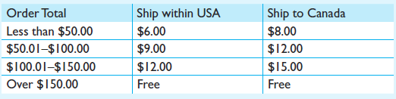

**Rubrics:**

|  |  |  |  |
| --- | --- | --- | --- |
|  | **Excellent (70%-100%)** | **Good (50%-70%)** | **Poor (0%-50%)** |
| Algorithm | Learned Materials Applied Professionally | Learned Materials Applied Professionally | Learned Materials Applied Professionally |
| Development | Codes have been developed correctly and implementing the algorithm proposed | Codes have been developed correctly and implementing the algorithm proposed | Codes have been developed correctly and implementing the algorithm proposed |
| Coding Style | Correct use of coding style, comments, indentation, loops, etc. | Correct use of coding style, comments, indentation, loops, etc. | Correct use of coding style, comments, indentation, loops, etc. |