* Npm init -y
  + Automatically makes package.json file
  + Touch .gitignore
    - Add node_modules/ .gitignore and session.store.db to file
* Setup git repo
  + Git init
  + Git branch -M main
  + Git add .
  + Git commit -m “first commit”
  + Make remote repo on github
  + Git remote add origin <https://github.com/dpocsai/taboo.git>
  + Git push -u origin main
* Mkdir
  + Lib
    - Js files
  + Public
    - Images
    - Stylesheets
    - javascripts
  + Views
    - Pub files
* Touch
  + Taboo.js - in root directory not lib (main project file)
  + Layout.pug in views
* Npm I ___ --save
  + Express
  + Pug
  + morgan
* Npm I ___ --save-dev
  + Nodemon
* Setup server
  + 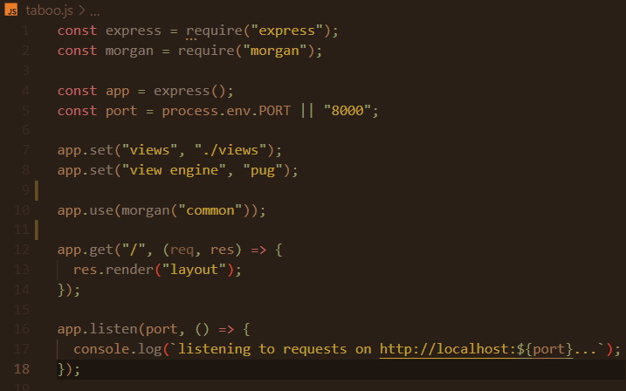
* Create app startup script in package.json and change main file to taboo.js
  + 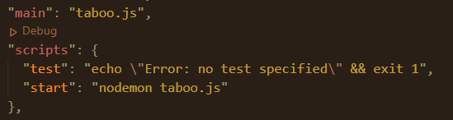
  + Start app with npm start
* Setup layout view and stylesheets
  + Link stylesheets to layout view
    - Style.css
    - Tantek-celiks whitespace reset
* Install express-flash and express-session and import
  + Usage: <https://launchschool.com/lessons/778bd44c/assignments/76690b47>
* Install express-validator and import body and validationResult functions
  + Usage: <https://launchschool.com/lessons/778bd44c/assignments/bd0a2c59>
* Install connect-loki and import as store
  + Add session-store.db to .gitignore
  + Const LokiStore = store(session)
  + Add session cookie to session object
  + Add store: new LokiStore({}) to session object
* Completed setup:
  + 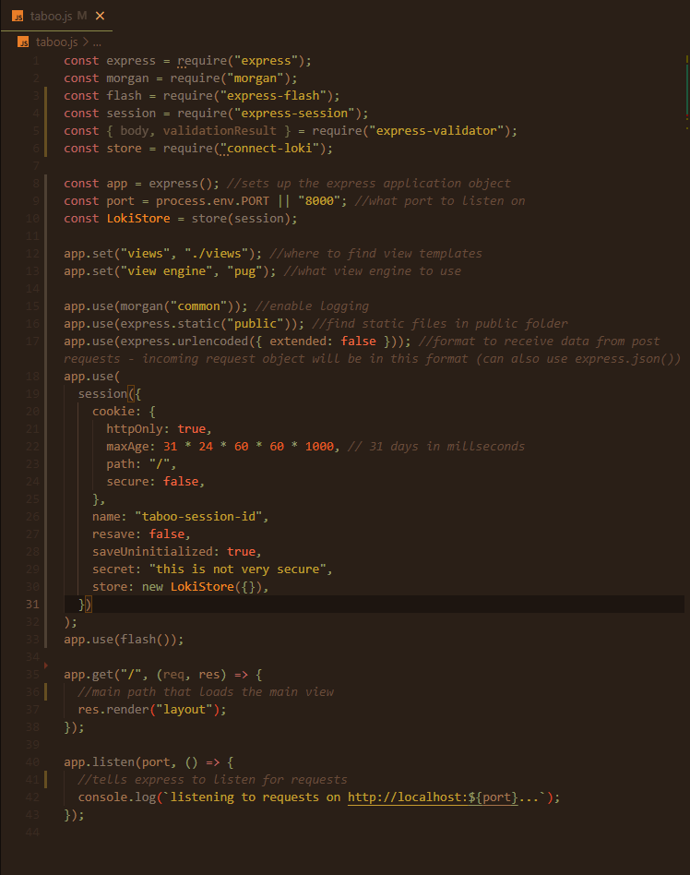

App design - visual

* App title at top - link back to homepage
* Navigation:
  + Rules
  + Settings
    - Time: radio slider 30 60 90 120 sec
    - Teams: 2-4 textbox input for team names
  + Buzzer?
* Main
  + Section
    - New game button only at first - When clicked loads new page with settings configured
  + Div - info
    - Play button (starts timer) with play icon
    - Display time with clock icon
    - Display score
  + Div - card
    - Ul
      * List header class is the word to say
      * Rest of list is 5 words you cant say
    - Keep this blank at first, until they hit play
  + Div - buttons
    - X (-1 point) - for skipping or if error
    - checkmark (+1 point)
  + Scoresheet - takes user to scoresheet which is automatically updated
    - Can be edited in case of mistake
    - Has stats?
      * Correct
      * Incorrect
      * Total cards
    - Can be closed to return to main page

