USER AGENT

The **User-Agent** request header contains a characteristic string that allows the network protocol peers to identify the application type, operating system, software vendor or software version of the requesting software user agent.

To learn more about User Agent: https://developers.whatismybrowser.com/

USER AGENT SNIFFING

“User-Agent Sniffing” (or “UA Sniffing for short”) is the quickest approach to the problem. One can derive properties of the client by looking at the User-Agent header in the HTTP request. UA Sniffing usually involves searching for a specific string or pattern in the UA string and basing choices on the result of that search.

UA Sniffing may seem like the solution to many problems, but, like most quick solutions, it has hidden long-term costs. One cost is the going down the slippery slope of constantly updating your sites and services to follow the never-ending evolution of the browser and device market. Newer devices may not say ‘iPhone” in the UA string, while other devices may say “iPhone” for the purpose of “extorting” the iPhone version of a web site without guarantee that they deserve it.

FEATURE DETECTION

https://modernizr.com/docs

Feature detection is where you don't try to figure out which browser is rendering your page, but instead, you check to see if the specific feature you need is available. If it's not, you use a fallback. However, there are cases where browsers do not report their own capabilities accurately.

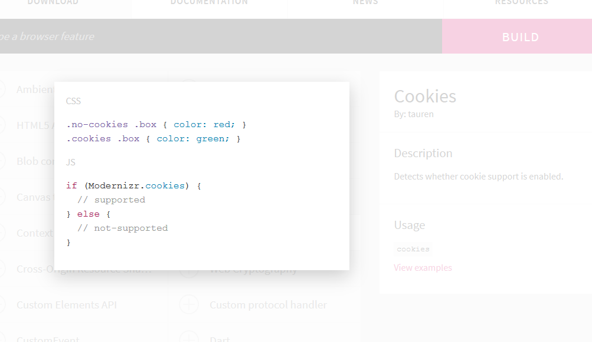

DEVICE DETECTION

Device detection has little to do with old-school browser sniffing [UA-sniffing] except for the fact that it is also based on analysing User Agent strings. Its aim is not to limit the UX or block certain kinds of browsers but to adjust UX by offering an optimal viewing experience on all devices.

<--I don’t understand the bold part below-->

**One of the most popular applications of device detection is known as Adaptive Web Design (AWD), adaptive delivery or content adaptation. AWD is a design principle in which different markup is sent to different buckets of devices based on detection of devices accessing web content. Each set of markup creates a different, device-optimized experience. Here are** [**10 examples of high-profile, high-traffic websites using Adaptive Web Design**](https://deviceatlas.com/blog/adaptive-web-design-examples)**.**

**Many RWD websites also use device detection to fine-tune the experience without redirecting users to a different HTML/CSS. This technique is called** [**RESS**](https://deviceatlas.com/blog/ress-helps-you-get-best-adaptive-and-responsive-techniques)**. With server-side device detection it is possible to use detailed device knowledge to adapt those aspects of a responsive website that may create bottlenecks or degrade the experience on mobile devices. This typically relates to heavy images, scripts, menus, etc.**

**Device detection is also used to deliver** [**advertising targeted at device level**](https://deviceatlas.com/blog/device-detection-ad-platforms)**. In this case, device detection enables the ad server to send advertising campaigns to specific devices based on screen size, operating system, phone brand, phone model, or any of the device characteristic that the device database tracks.**

**The knowledge of user devices is widely used by** [**website analytics platforms**](https://deviceatlas.com/blog/mobile-web-analytics)**. Device detection can provide data for web analytics tool on all aspects of device use, such as device types (phone, tablet, desktop), device models, screen sizes, operating systems, etc. Thanks to this information, you may learn that, for example, Samsung Galaxy S4 delivers 12% conversion rate, while iPhone 6S delivers 23% conversion rate, which helps you make data-driven decisions on allocating advertising budget.**

|  |  |  |  |
| --- | --- | --- | --- |
|  | UA-sniffing | Feature Detection | Device detection (not sure) |
| Method | Analyse user agent | Check features available / Check capability of browser | Uses User Agent to analyse |
| Disadvantage | -No standard for every user agent  -Needs update every time new device launches  -User agent can be modified by user, the information may be false | -Slower  -Files size maybe larger  -Do not detect the device |  |
| Advantages | -Faster  -Easy to obtain information if included in user agent | -More accurate / reliable  -Only detect the features needed | -Do not block user  -Just modify to enhance experience  -able to do analysis |
|  |  |  |  |

|  |  |  |
| --- | --- | --- |
|  | UA-sniffing/parser? | Feature Detection |
| suggestion | https://developers.whatismybrowser.com/ | https://modernizr.com/docs |

**SOFTWARE / CODE**

UA-sniffing

Mobile detect : http://demo.mobiledetect.net/

Piwik : https://github.com/piwik/device-detector

Feature detection

Modernizr : https://modernizr.com/docs

Featurejs : http://featurejs.com/

REFERENCE

More info on User Agent

https://developers.whatismybrowser.com/

Some explanation on user-agent sniffing on Mozilla

https://developer.mozilla.org/en-US/docs/Web/HTTP/Browser_detection_using_the_user_agent

More on detection

https://www.html5rocks.com/en/tutorials/detection/

https://msdn.microsoft.com/en-us/library/jj149688.aspx