User Agent -- https://developers.whatismybrowser.com/

A User-Agent (UA) is an alphanumeric string that identifies the ‘agent’ or program making a request to a web server for an asset such as a document, image or web page.

Product tokens are used to allow communicating applications to identify themselves by software name and version. Most fields using product tokens also allow sub-products which form a significant part of the application to be listed, separated by white space.

Each product token includes a product name and its version separated by a “/” sign with some optional information in brackets. The tokens are typically listed by significance, however this is completely left up to software publisher. Tokens can be used to send browser-specific information and to acquire device-specific information from the device’s ROM, such as the model ID, operating system and its version, etc.

User Agent strings come in all shapes and sizes, and the number of unique user agents is growing all the time.

Point:

* A string
* May contain much information if provided
* The standard for different device may varies
* May be modified by user

Link: android . iphone . iphone facebook app

Feature Detection -- https://modernizr.com/

Feature detection actually programmatically checks if Awesome-New-Feature™ works in the browser, and gives you either a true or false result. So now as soon as your least favorite browser adds support for Awesome-New-Feature™, your code works there - automatically! No more having to update, ever. The code ends up being similar, but much clearer to its actual intention.

It looks like this:

if (Modernizr.awesomeNewFeature) {

showOffAwesomeNewFeature();

} else {

getTheOldLameExperience();

}

Link: feature detection

**User Agent sniffing**

Refer: https://developers.whatismybrowser.com/

**Android user agent**

Example1:

Mozilla/5.0 (Linux; U; Android 4.4.2; en-us; SCH-I535 Build/KOT49H) AppleWebKit/534.30 (KHTML, like Gecko) Version/4.0 Mobile Safari/534.30

Main information:

Android Browser 4 on Android (KitKat)

Samsung Galaxy S III (SCH-I535)

Detail information:

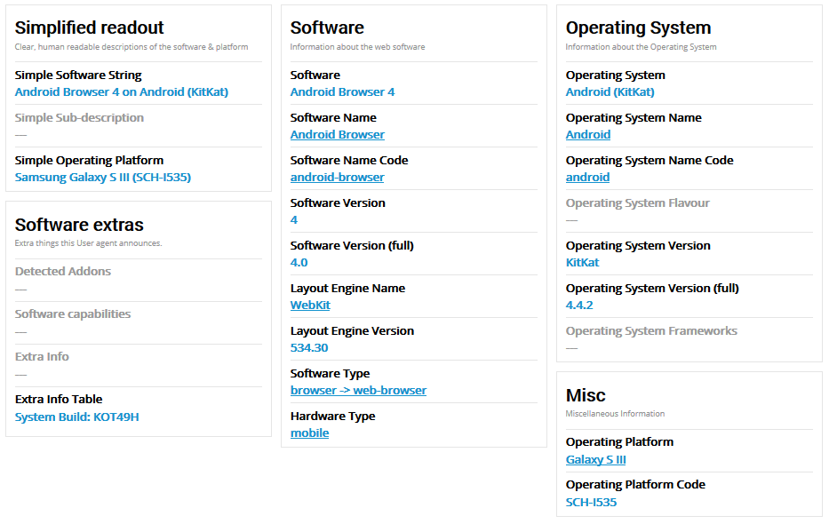

Example2:

# Mozilla/5.0 (Linux; Android 6.0.1; SM-G920V Build/MMB29K) AppleWebKit/537.36 (KHTML, like Gecko) Chrome/52.0.2743.98 Mobile Safari/537.36

Main information:

Chrome 52 on Android (Marshmallow)

Samsung SM-G920V

Detail information:

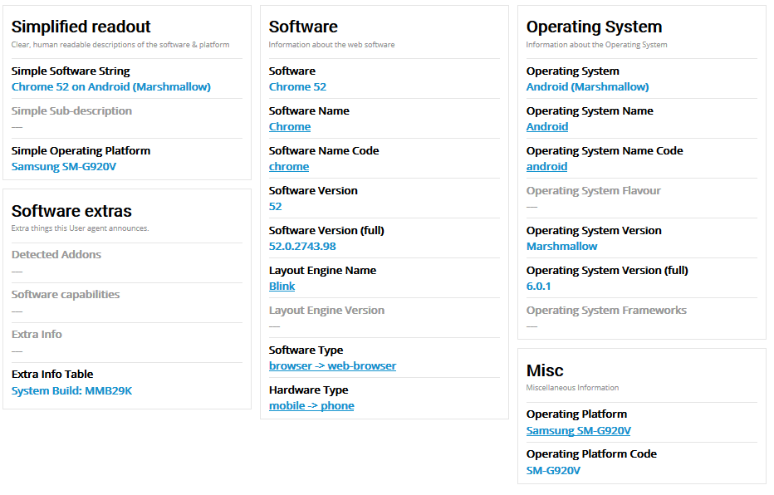

**Iphone user agent**

Example1:

# Mozilla/5.0 (iPhone; CPU iPhone OS 9_1 like Mac OS X) AppleWebKit/601.1.46 (KHTML, like Gecko) Version/9.0 Mobile/13B143 Safari/601.1

Main information:

Safari 9 on iOS 9.1

Apple iPhone

Detail information:

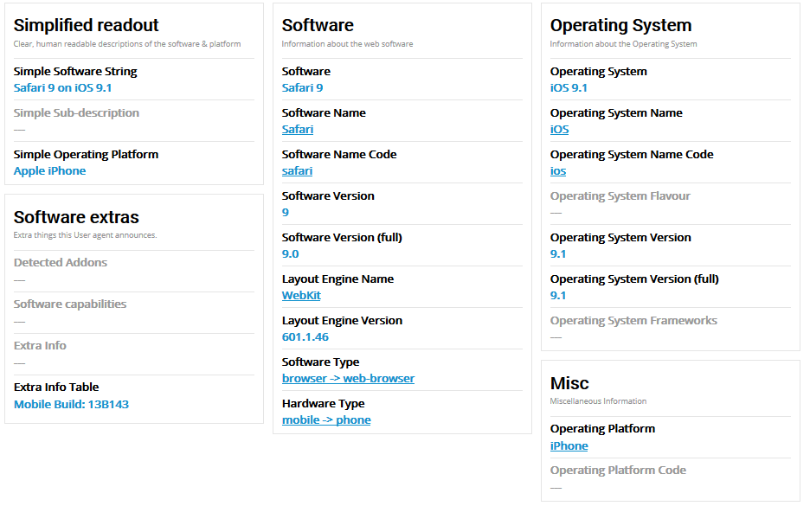

Example2:

# Mozilla/5.0 (iPhone; CPU iPhone OS 9_3_2 like Mac OS X; en-US) AppleWebKit/537.51.1 (KHTML, like Gecko) Mobile/13F69 UCBrowser/10.7.3.808 Mobile

Main information:

UC Browser 10.7 on iOS 9.3

Apple iPhone

Detail information:

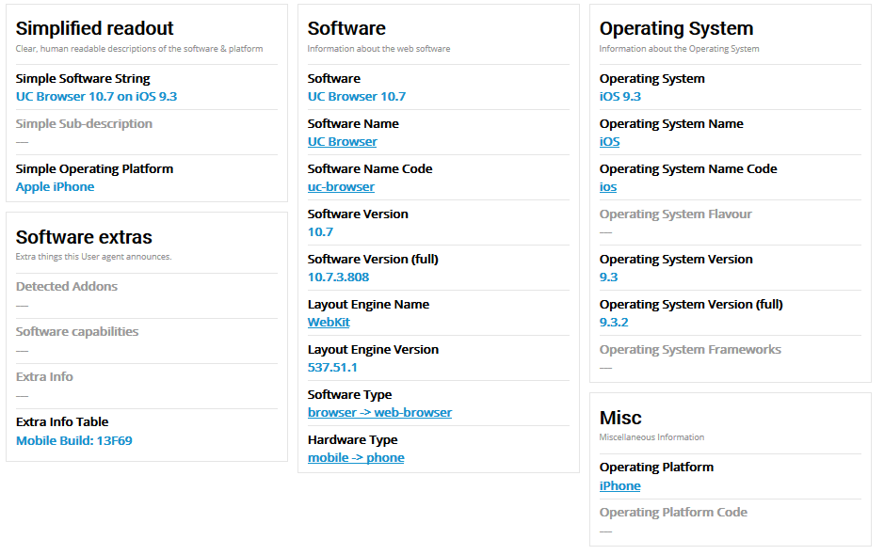

**Iphone User Agent on Facebook Application**

Example:

# Mozilla/5.0 (iPhone; CPU iPhone OS 9_3_2 like Mac OS X) AppleWebKit/601.1.46 (KHTML, like Gecko) Mobile/13F69 [FBAN/FBIOS;FBAV/59.0.0.51.142;FBBV/33266808;FBRV/0;FBDV/iPhone7,1;FBMD/iPhone;FBSN/iPhone OS;FBSV/9.3.2;FBSS/3;FBCR/Telkomsel;FBID/phone;FBLC/en_US;FBOP/5] evaliant

Main information:

Facebook App 59 on iOS 9.3

Apple iPhone 6 Plus

Detail information:

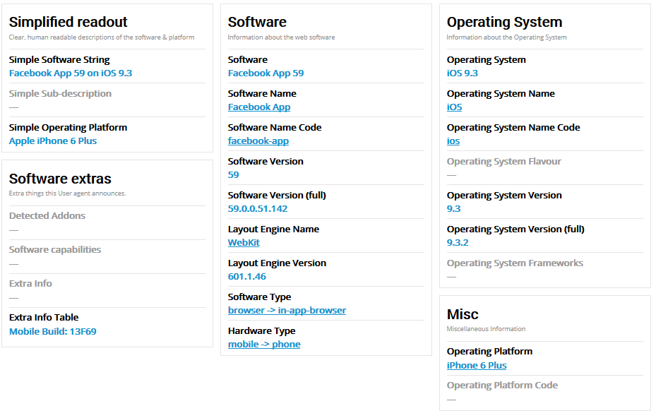

**Note:**

[FBAN/FBIOS;FBAV/59.0.0.51.142;FBBV/33266808;FBRV/0;FBDV/iPhone7,1;FBMD/iPhone;FBSN/iPhone OS;FBSV/9.3.2;FBSS/3;FBCR/Telkomsel;FBID/phone;FBLC/en_US;FBOP/5] evaliant

This line is added by Facebook application where:  
FBAN: FaceBook Application Name

FBAV: FaceBook Application Version

FBBV: FaceBook Build Version

FBDV: FaceBook Device Version

FBMD: FaceBook Major Device

FBSN: FaceBook System Name

FBSV: FaceBook System Version

FBSS: FaceBook System Something :)

FBCR: FaceBook CarrieR

FBID: FaceBook Identity of Device

FBLC: FaceBook Language Code

**Feature Detection**

To detect whether cookie support is enabled.

CSS

.no-cookies .box { color: red; }

.cookies .box { color: green; }

JS

if (Modernizr.cookies) {

// supported

} else {

// not-supported

}

Another example:

Modernizr.on('flash', function( result ) {

if (result) {

// the browser has flash

} else {

// the browser does not have flash

}

});

https://modernizr.com/

In modernizr >documentation to implement / use the function

Modernizr>download to select feature and get the code?

