From https://www.fastcomet.com/tutorials/magento2/installing-extensions

**Preparation**

**Find the Extension Menu**

To install a new extension, you will need to access your admin dashboard and navigate to **System>Web Setup Wizard**.

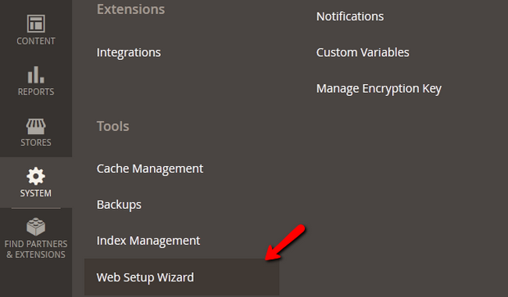

From the 3 blocks of options you have at your disposal, choose **the Component Manager**.

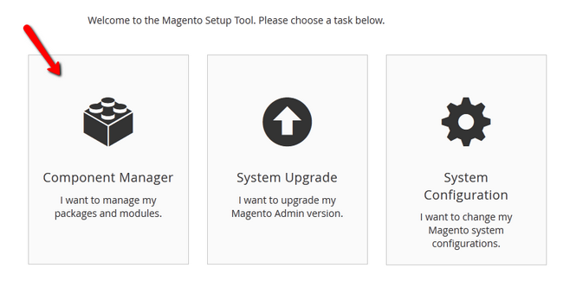

Here you will see the already installed extensions on your website, any new updates for them and new extensions which you can install. Click on the **Install** link below the New Purchases label.

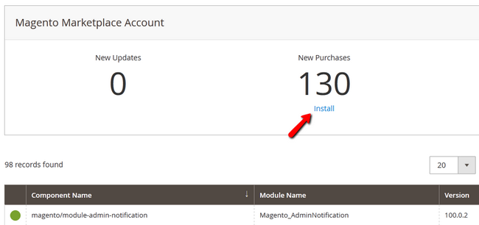

Select the extension/s you want to install and click on the Install button or mark then and select a bulk install action form the top of the page.

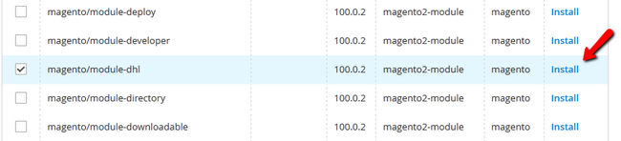

**Step 1** **Start a Readiness Check**

The First Step is the Readiness Check which will check if your Magento 2 installation has all of the necessary components required for the extension installation. Click on the **Start Readiness Check** button.

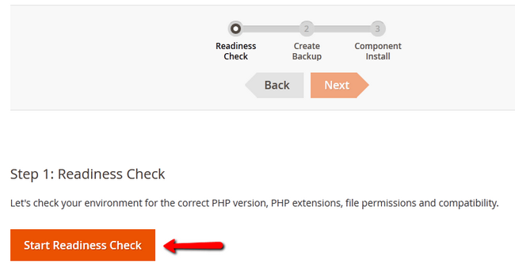

After the check has been completed and your installation covers all of the requirements, you will be able to proceed by clicking on the **Next** button.

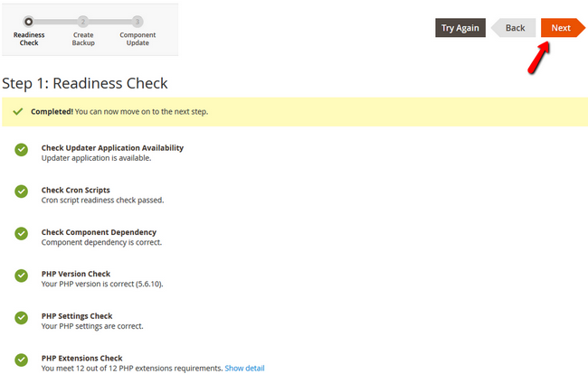

If you have a component marked as red, you will be able to check how to fix the issues with it by clicking on the link below it. This will direct you to the official Magento 2 documentation section where you will find a guide on the matter.

**Step 2** **Backup your Data**

The second step involves creating a Backup on your Store. We have recommended you to do this at the start of this tutorial as sometimes the integrated Magento Backup system will not create a proper backup of your data which is something you want to avoid at all costs.

You can de-select the backup options here and click on the Next button or click on Create Backup if you have selected an option.

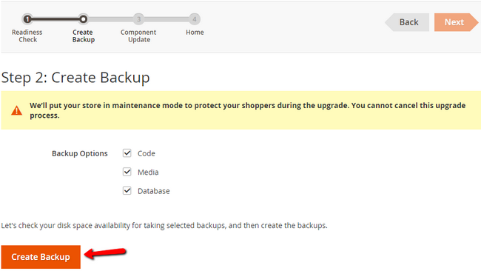

If you choose the latter, you will receive a confirmation screen that the backup has been successfully created and then you can hit the **Next** button to proceed.

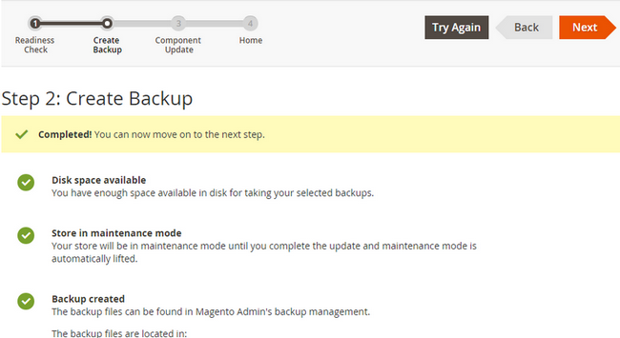

**Step 3** **Install the Extension**

In the last step, you will see again the extension/s you wanted to install. Click on the **Install** button to continue.

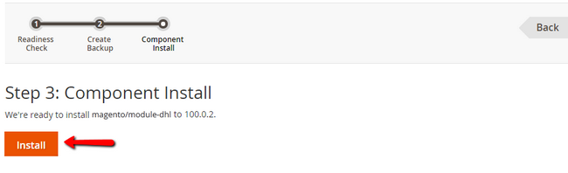

Once the installation has been completed, you will receive a confirmation and the ability to go back by clicking on the **Back to Setup Tool** button.

Congratulations, you now know how to install extensions in your Magento 2 website.