Some guide / information about wordpress / gravityflows

These are links…..

Install plugin

Pipwave configuration 1 ( api key / secret )

Pipwave configuration 2

Multiple payment methods

INSTALL PLUGIN

Conditions: wordpress installed, gravity flows installed

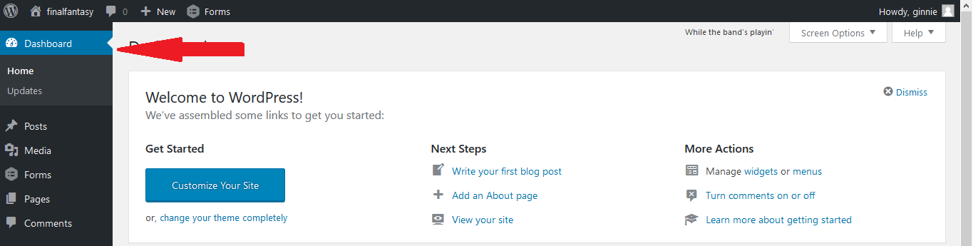Go to dashboard.

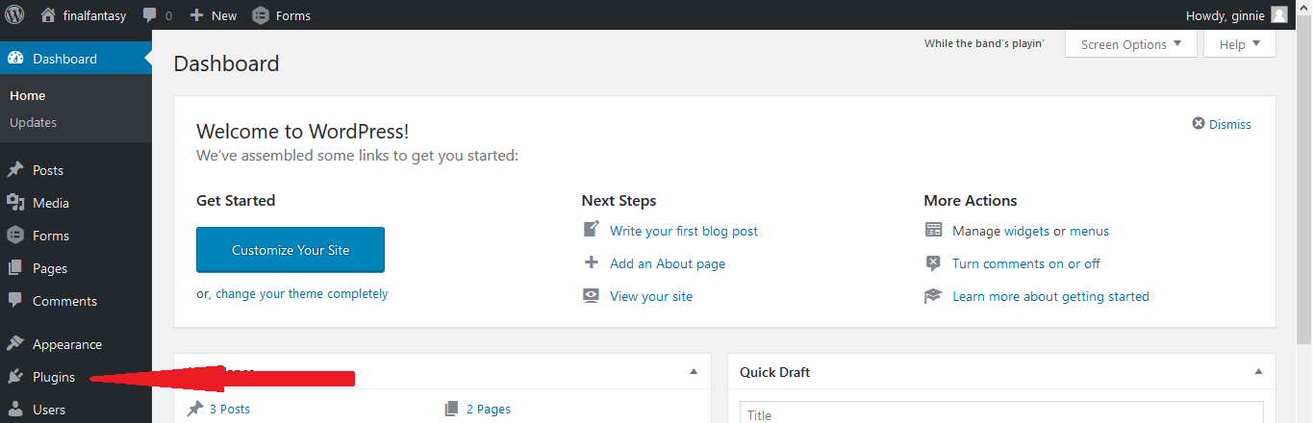Click Plugin

Search for the desired plugin. (if search failed, click add new)

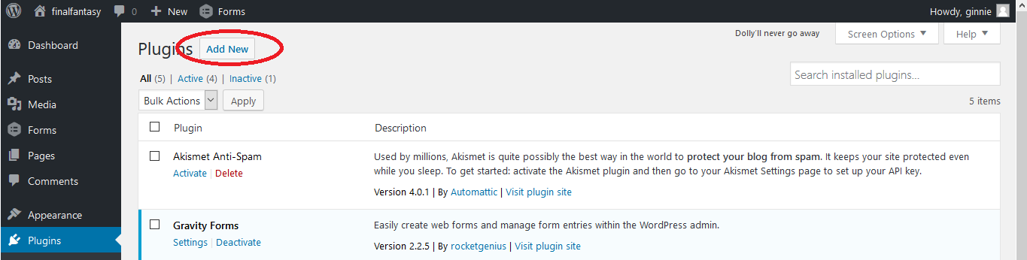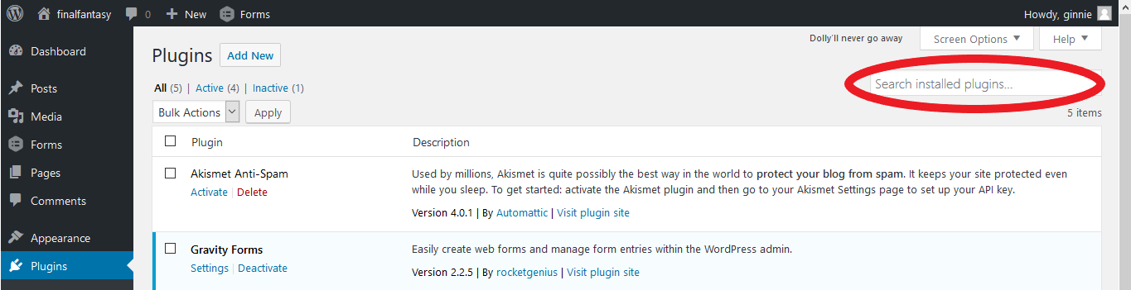

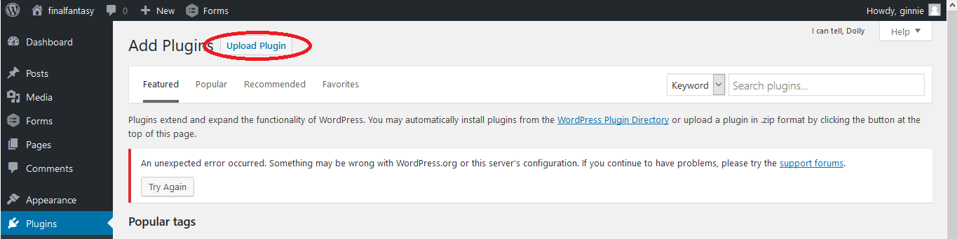Click upload plugin

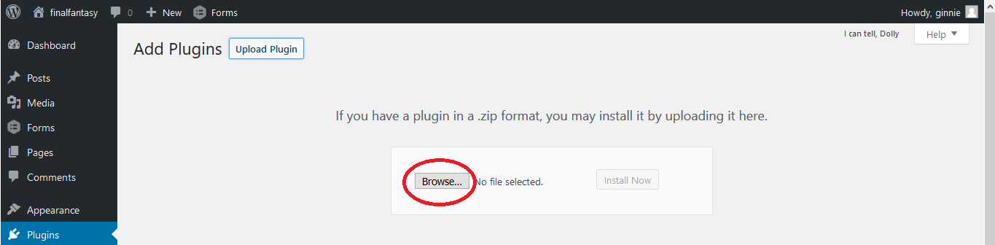Browse your directory

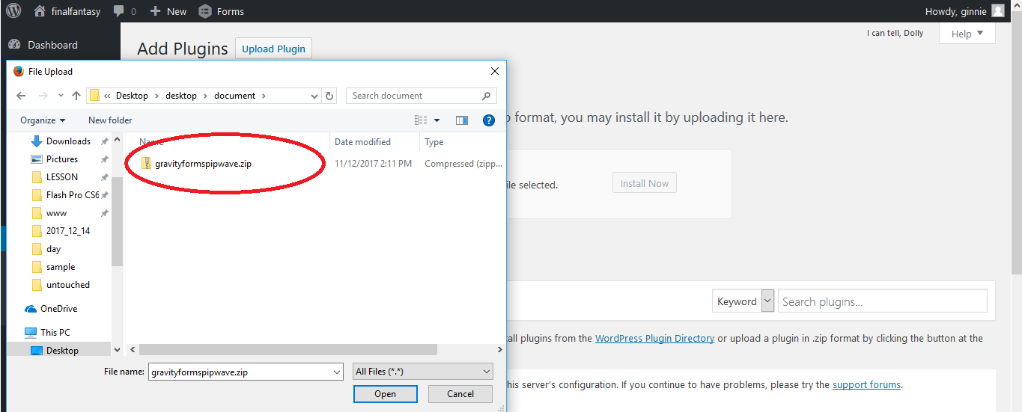Select your plugin. Download your plugin beforehand. Plugin should be in zip format.

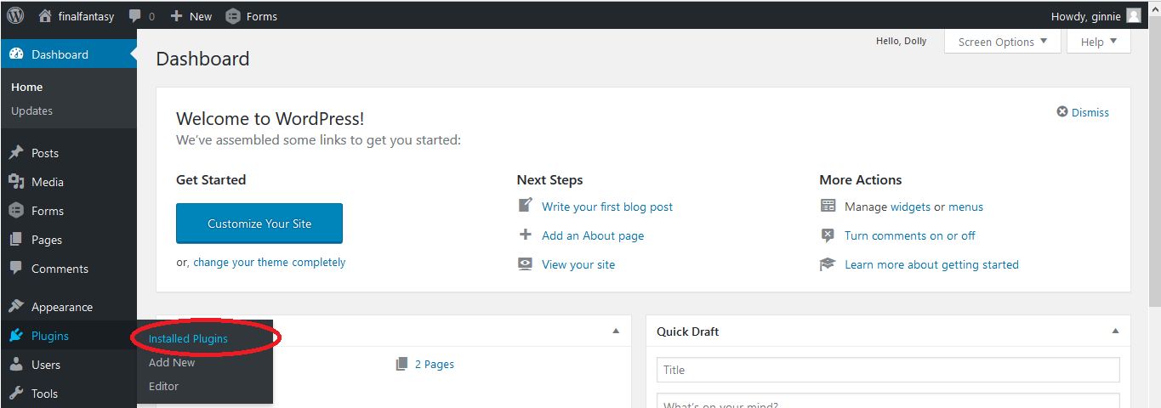Activate your plugin

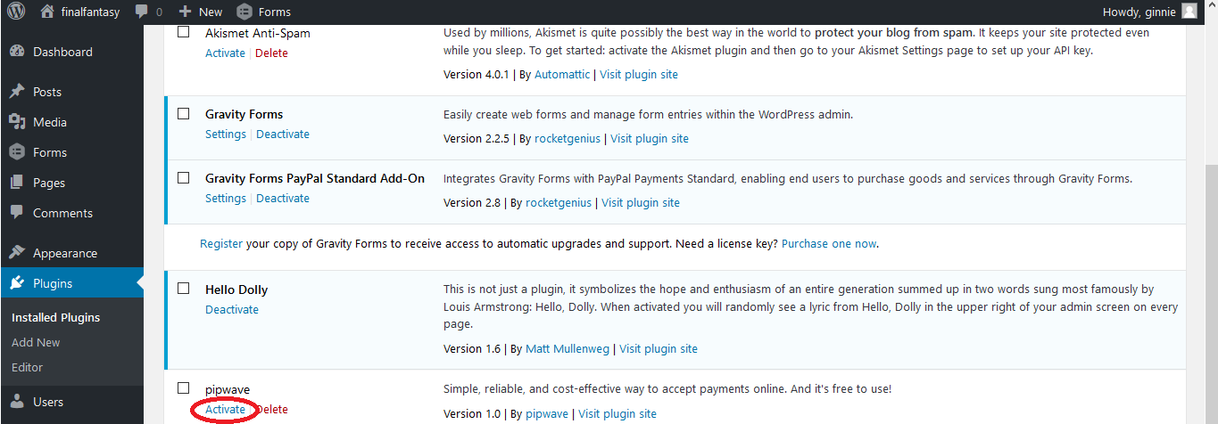

PIPWAVE CONFIGURATION 1 [ API KEY | API SECRET ]

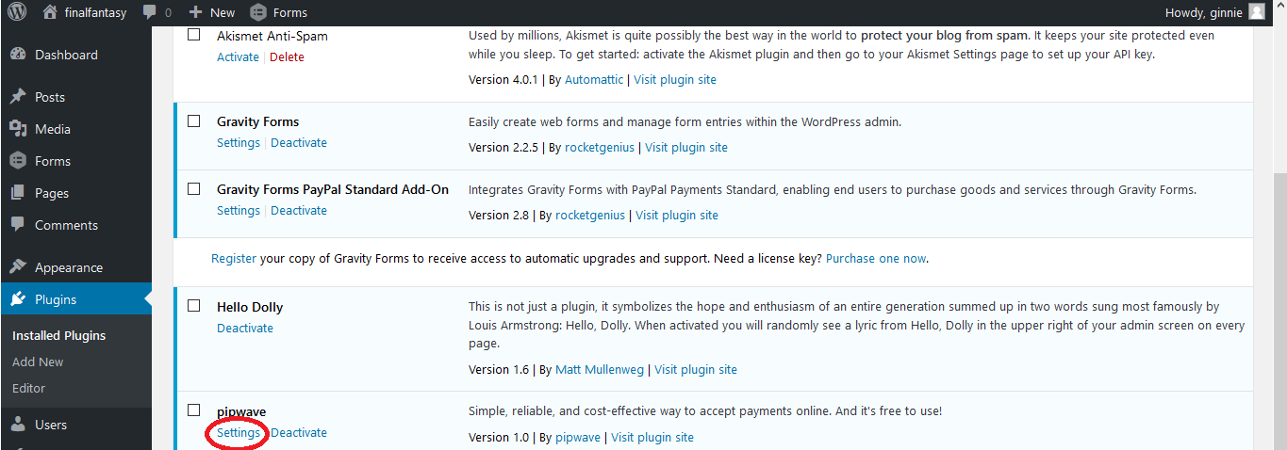Search pipwave plugin, click setting

Key in API key and API secret. They are provided in link. Hover mouse to the ‘question’ figure to view the link. Update Settings after key in.

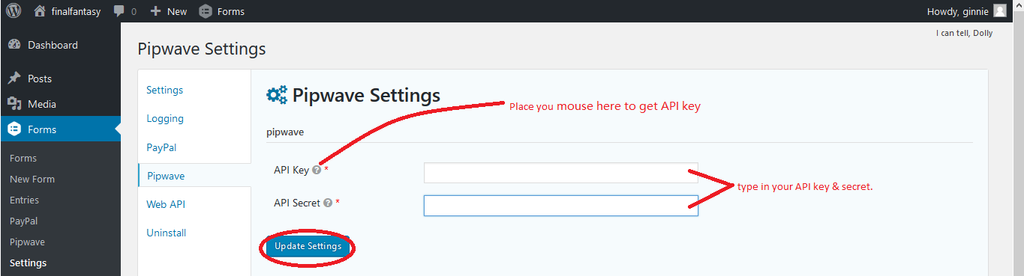

PIPWAVE CONFIGURATION 2

Click form.

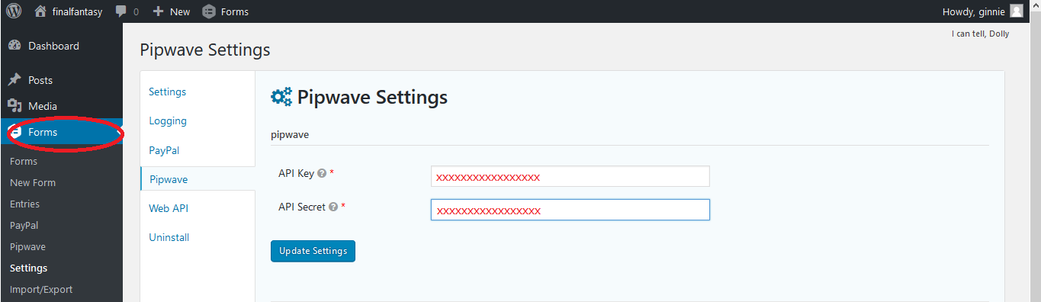

Choose any of your form. Your form should be created beforehand. Hover to settings. Click pipwave.

*or you may click the form. Then click setting. Then click pipwave.

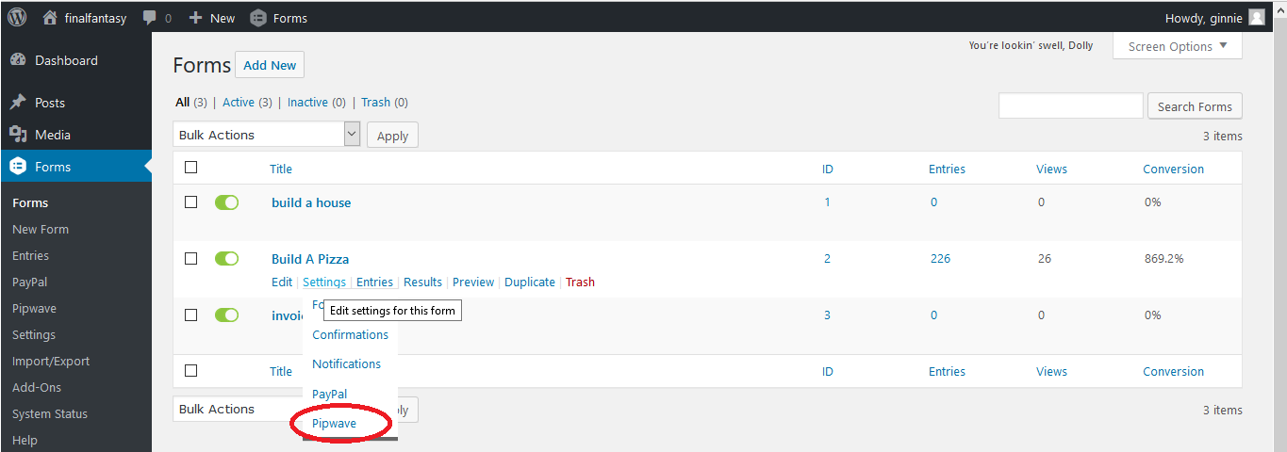

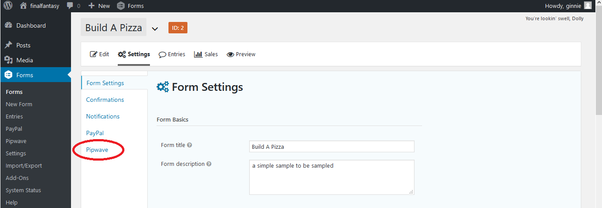

Click Add New

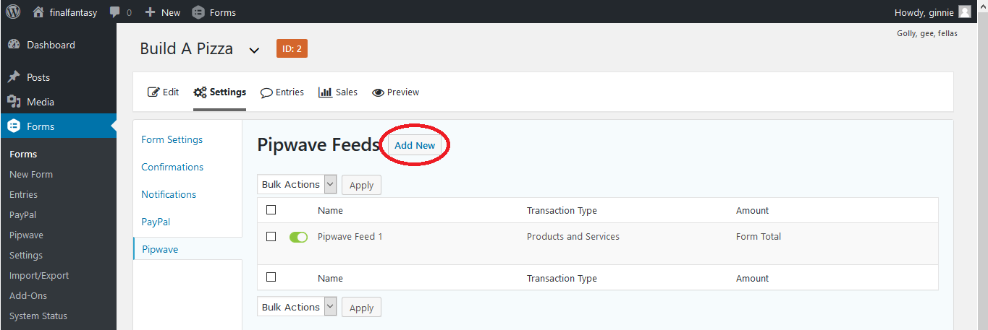

Map the field to your form field. *means it’s necessary. When edit your form try to add the field.

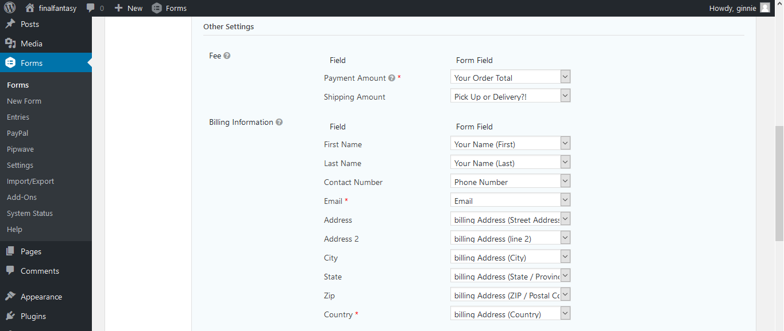

MULTIPLE PAYMENT METHODS

When editing your form, drag a radio button to your form

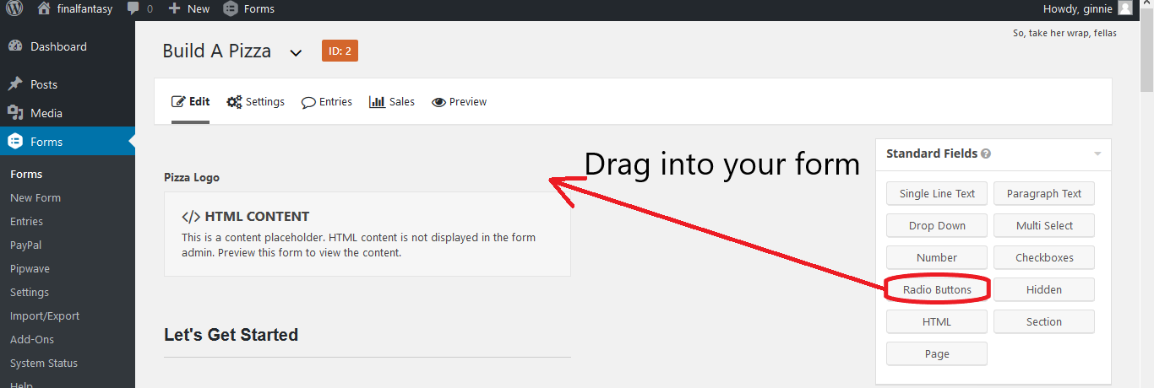

Click on the radio button field. Type in your payment name. *it can be anything *buyer will see this

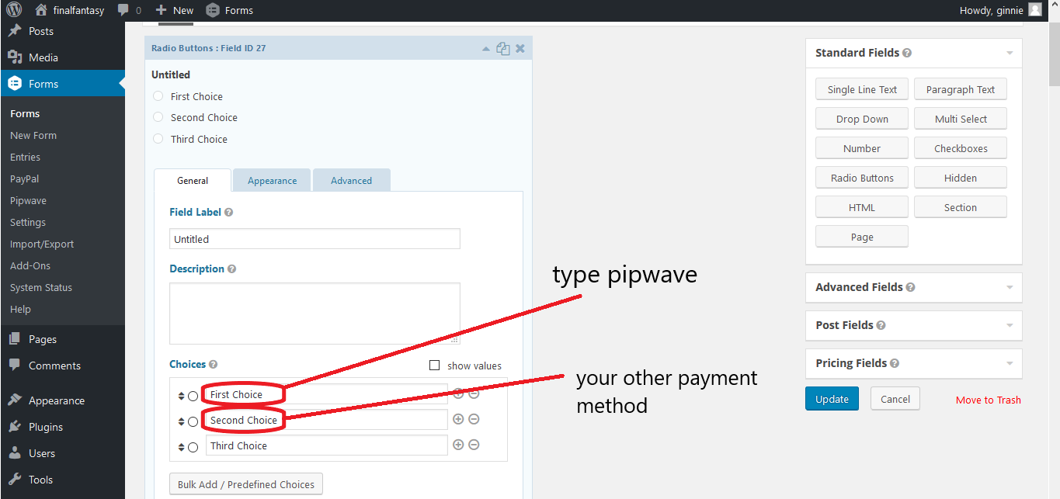

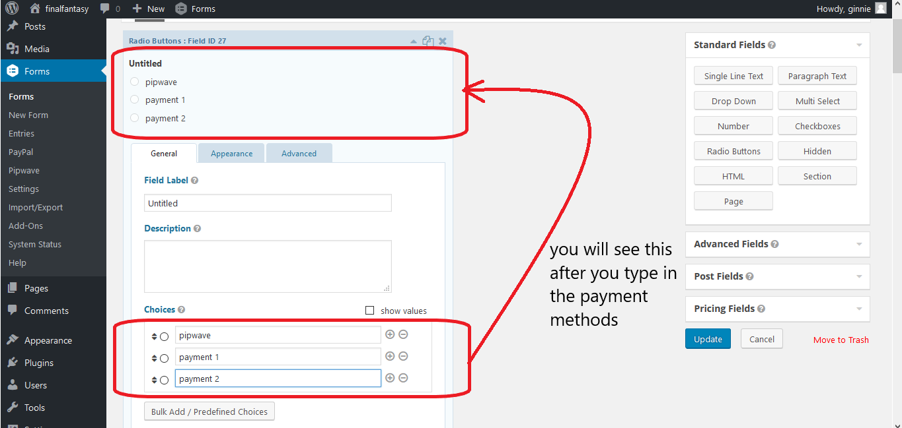

This is important. When you assign this label for the field don’t forget this name. it will be needed later.

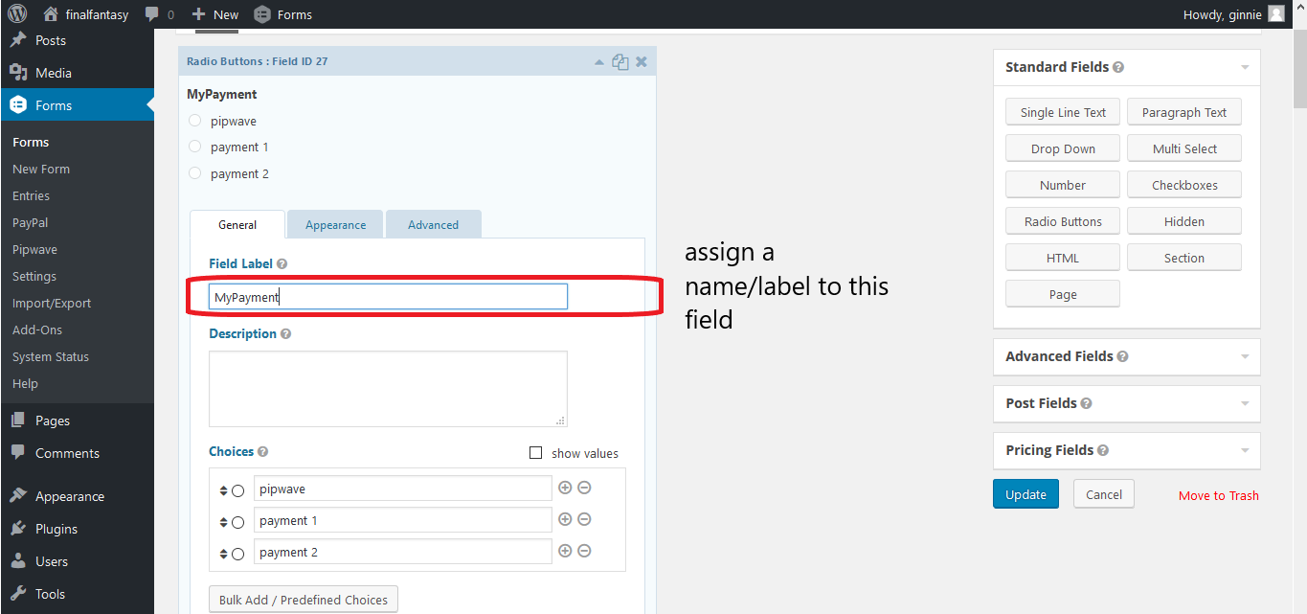

Update.

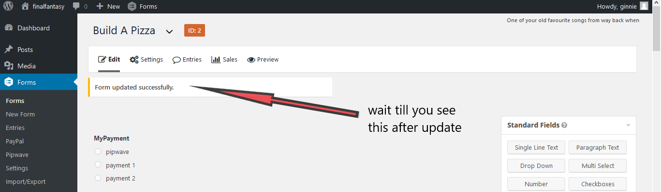

Go to setting. This is also where you map your form field to our field.

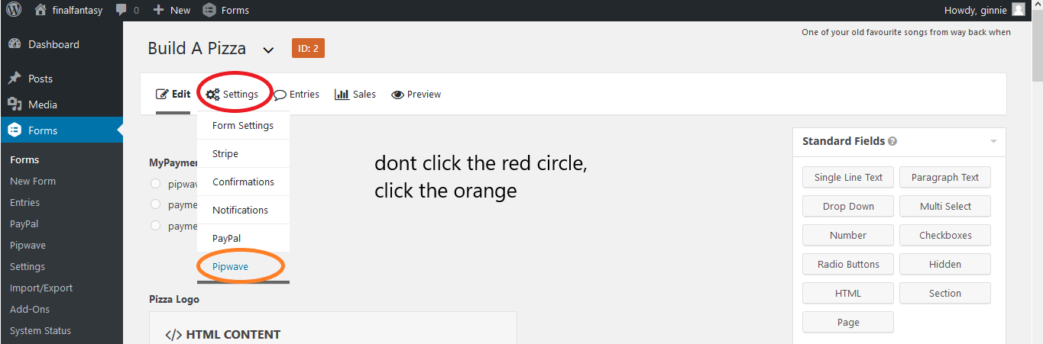

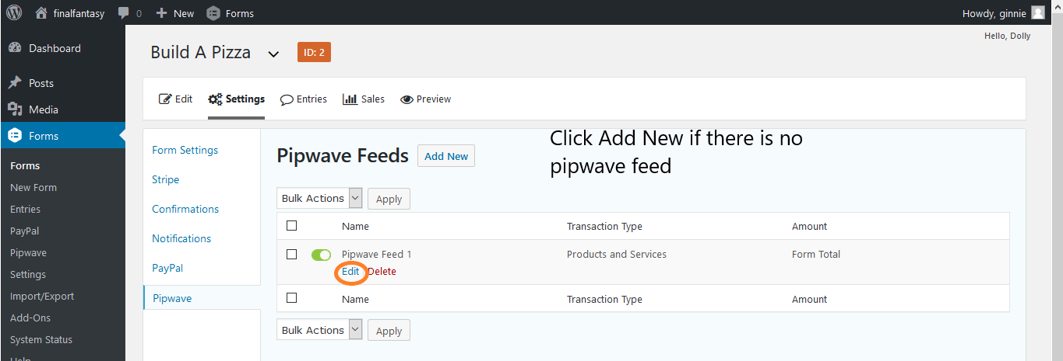

This is where you map the fields. Scroll to the bottom.

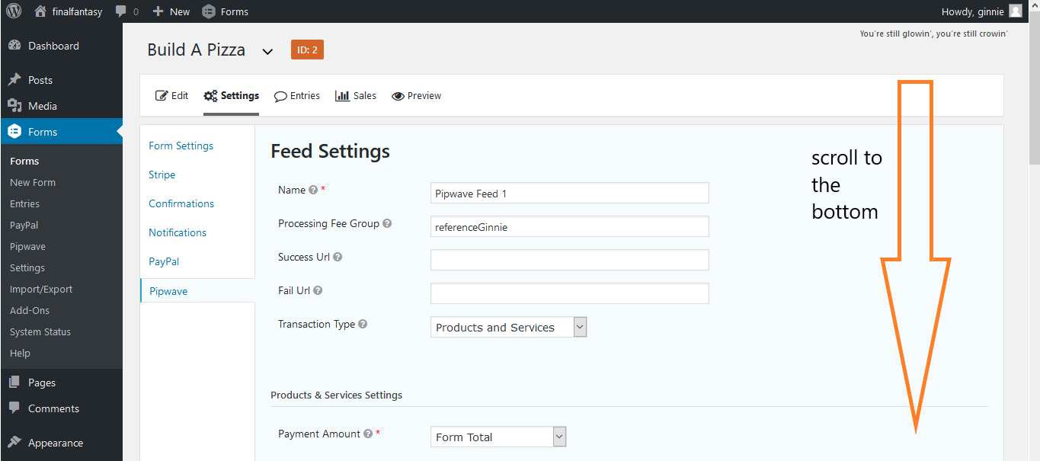

Check / tick the ‘enable condition’ button

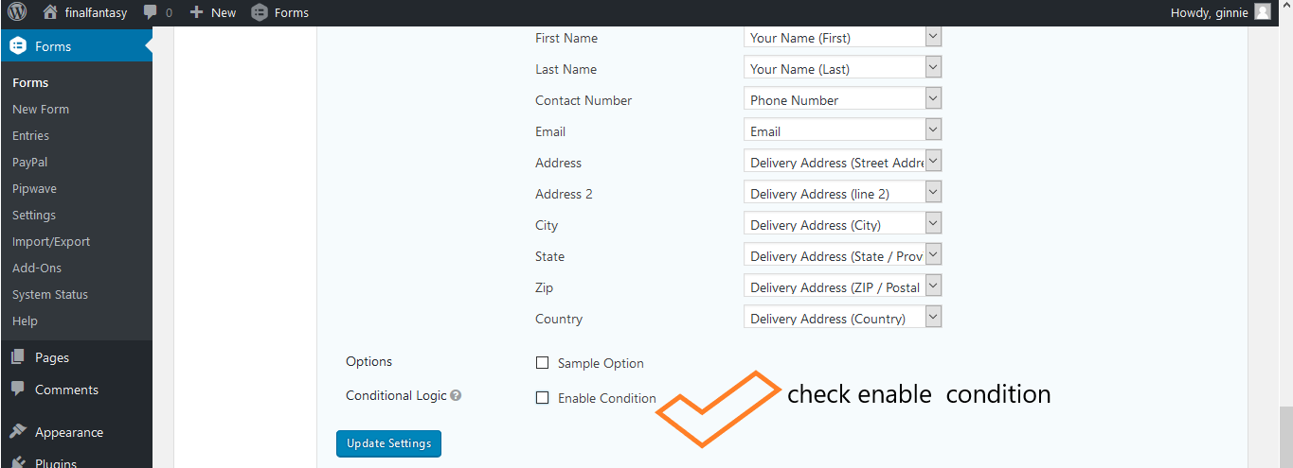

Configure this.

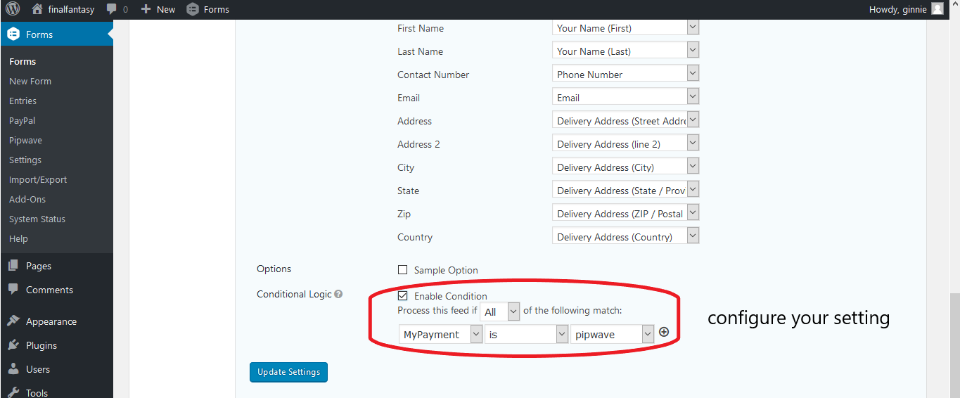

The left option should be the label I told not to forget.

The right option should be the payment method you set.

