# Edux.fit.cvut.cz/courses/MI-NUR/lectures/start

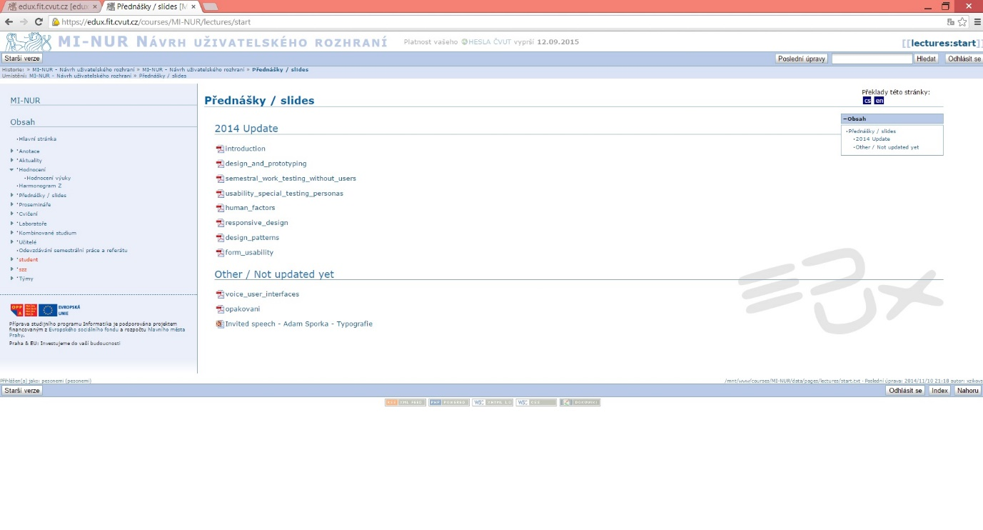

## According to the Nielsen’s heuristics

1. **Visibility of system status:**

- The “Lectures/Slides” is not highlighted in the navigation menu bar in the left, but

+ The sub topic in the middle on top of the site tells that user is in the section of “Lectures/slides”.

1. **Match between a system and the real world:**

+ Looks like any other web site and thus it’s familiar to user (match between this and other web sites).

+ The slides are presented in the same order they have been used in the lessons (natural and logical order).

1. **User control and freedom:**

+ User can choose any of the PDF files, does not need to open them in any specific order.

- There is no “escape” or “back”-button in the application itself when you open an PDF file but that functionality is built-in to browser.

1. **Consistency and standards:**

+ Layout and navigation/interaction is like in any other web site.

+ Could be used also with the browser of a mobile phone.

+ The web site changes when the orientation of the mobile phone changes, and it is even more readable when the device is on landscape orientation (fonts are bigger) but the layout is still the same familiar one.

- However the clickable content is not usable with fingers, they are too small.

1. **Error prevention:**

+ Not that many options to get any errors.

- Does not ask confirmation about opening the PDF files.

1. **Recognition rather than recall**

+ There are sub-topics which tell about the relevancy of the PDF files (lecture slides): other are updated for this semester and others are not.

+ It is clearly shown which kind of materials are offered in the web site. The logo of PDF file is right there, on the left side of the lectures.

- It is not quite clear that the PDF files are clickable for opening. There could be option for open and download in this page and not after clicking. Users need to remember that it is possible after clicking the file name.

1. **Flexibility and efficiency of use**

- All the PDF files need to be downloaded separately which is not very efficient.

- Usable only with mouse or finger (mobile phones). There are no keyboard options for using this page.

- Both novice and expert users use the site the same way. Easy to learn but not possible to make the usage faster or efficient later on.

1. **Aesthetic and minimalist design**

+ Only relevant information is shown. There is nothing extra.

1. **Help users recognize, diagnose and recover from errors**
2. **Help and documentation**

+ The content of the page is minimal and easy to search for the correct lecture slides.

- No “Help” offered. User cannot find any tips for using this page.

- There could be numbers next to the PDF logo just before the topic of that lesson so that finding for example lecture slides of week 5 could be easier than just calculate the correct one every time starting from the top.

## What’s good (other)

+ It is consistent: every page has the same layout both visually and what it comes to interaction.

+ Available also for mobile phones and looks the same there also. When the mobile phone is on landscape orientation the page follows it and shows even with bigger font which is better.

+ When the size of the browser changes, also the content changes the same way. So that it is scalable.

+ Option to return to “Home screen” (up left corner).

+ Displays a list of items inside (PDF files are all shown).

+ There is no need for unnatural horizontal scrolling but vertical one only is the screen is small in size.

## What’s bad (other)

- Same layout for both browser of a computer and a mobile phone is not necessarily usable when the size of the display changes that dramatically.

- Every clickable option is too small for using with finger. So the layout and the information do not change enough along with the device.

- No “Help” –option.

- Not color-coded in any way that the latter part of the page is non-updated lecture slides.

# Moodle2.tut.fi/course/lecture-slides

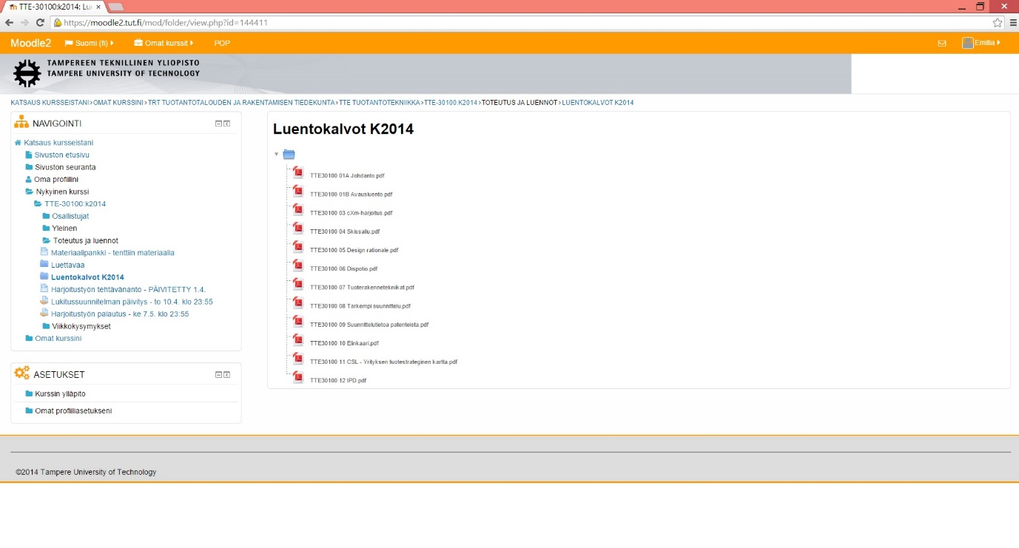

## According to the Nielsen’s heuristics

1. **Visibility of system status:**

+ The “Lectures/Slides” is highlighted in the navigation menu bar in the left.

+ Also the sub topic in the middle on top of the site tells that user is in the section of “Lectures/slides”.

1. **Match between a system and the real world:**

+ Looks like any other web site and thus it’s familiar to user (match between this and other web sites).

+ The slides are presented in the same order they have been used in the lessons (natural and logical order).

1. **User control and freedom:**

+ User can choose any of the PDF files, does not need to open them in any specific order.

- There is no “escape” or “back”-button in the application itself when you try to open a PDF file but user can cancel the downloading the it.

- By clicking a lecture slides they are by default downloaded not opened for viewing (which is the opposite they had it in Edux system above).

1. **Consistency and standards:**

+ Layout and navigation/interaction is like in any other web site.

+ Could be used also with the browser of a mobile phone.

+ The web site changes when the orientation of the mobile phone changes, and the layout of the site changes also to more readable version where user can scroll vertically in order to see all the content.

- Loading the page with mobile phone is very slow.

1. **Error prevention:**

+ Not that many options to get any errors.

- Does not ask confirmation about whether the user wants to just open or download the PDF files. The default cannot be changed in anywhere.

1. **Recognition rather than recall**

+ It is clearly shown which kind of materials are offered in the web site. The logo of PDF file is right there, on the left side of the lectures and also in the end of the name of the lesson.

- It is not quite clear that the PDF files are clickable for opening. There could be option for open and download in this page and not after clicking. Users need to remember that it is possible after clicking the file name.

1. **Flexibility and efficiency of use**

- All the PDF files need to be downloaded separately which is not very efficient.

- Usable only with mouse or finger (mobile phones). There are no keyboard options for using this page.

- Both novice and expert users use the site the same way. Easy to learn but not possible to make the usage faster or efficient later on.

1. **Aesthetic and minimalist design**

+ Only relevant information is shown. There is nothing extra.

1. **Help users recognize, diagnose and recover from errors**
2. **Help and documentation**

+ The content of the page is minimal and easy to search for the correct lecture slides.

+ There are numbers next to the PDF logo just before the topic of that lesson so that finding for example lecture slides of week number 5 could be easy and fast.

- No “Help” offered. User cannot find any tips for using this page.

## What’s good (other)

+ It is consistent: every page has the same layout both visually and what it comes to interaction.

+ Available also for mobile phones. When the mobile phone is on landscape orientation the page follows it and shows even with bigger font which is better.

+ When the size of the browser changes, also the content changes the same way. So that it is scalable.

+ Option to return to “Home screen” (up left corner “Sivuston etusivu”).

+ Displays a list of items inside (PDF files are all shown at one glance).

+ There is no need for unnatural horizontal scrolling but vertical one only is the screen is small in size.

- However the naming of the home page is not ideal. Literal translation “The first page of this web site”.

## What’s bad (other)

+ Layout changes when using the web site with mobile phone or computer. The layout has been designed well for both devices.

- No “Help” –option.

## Summary

According to Nielsen’s heuristics:

1. **Visibility and system status:**

Both studied systems used subtopics to tell users where they are in the system but only the other one used highlighting also in the navigation bar. Thus in our system we will show the sub topic and also the path where the user is up in the middle to ensure the visibility and system status.

1. **Match between a system and the real world**

Both also looked like any other web site and the content is presented in logical order when comparing the time when they were presented and which lecture it was. Thus we are also going to have a familiar layout on the web site and then the material will be presented in chronological order.

1. **User control and freedom**

Also the content of the web site could be opened at one by one in any order but there was no “escape” or “back” –button if the user clicked some lecture slides by accident and didn’t want to open or download it. However the operating system or internet browser offered it. On the other studied system the lecture slides were first open for viewing but in another one they were immediately downloaded, user didn’t have the choice. Thus is our system the user can choose whether to open or download the file, and also all the files can be downloaded all together and not just one by one like in the studied systems.

1. **Consistency and standards**

Both studied systems used layout and navigation structure as any other web site and could be also viewed with mobile phone with vertical or horizontal orientation. However the other one didn’t change for mobile phone at all and was very difficult to use and another one took too long time to load the page with mobile phone. Thus in our system the layout will be different for devices with smaller display so that it is also usable with fingers and we use lazy-loading so that it won’t take too long to load the basic information because after that user can wait more when choosing another part for loading. The navigation and layout in our systems reminds also a lot about the other web sites and thus it will be consistent.

1. **Error prevention**

None of the studied versions had too many options for user to get an error done which is a good thing. However none of them also asked about confirmation for user to open or download the file clicked by user but they acted by default (other one was opening and another downloading right away). Thus we give the control to user more by asking whether he wants to open or download it. In the future this option could also be changed in settings so that more professional users could use the system more efficient than new ones.

1. **Recognition rather than recall**

In both systems the type of the content is clearly shown with the PDF logo in front and also if there are still some non-updated files there they are separated with different subtopics. Also the lecture slide files could be more clearly (both the blue colour and underlining) presented that they are actually clickable so that users don’t need to remember that. All this will be fixed for our version also.

1. **Flexibility and efficiency of use**

The same three errors found here were in both systems: 1) files could not be downloaded as once but only one by one, 2) there were no keyboard options for using the site but mouse or finger was needed and 3) there were no different options for using the site depending on whether user was an expert or a novice. Thus in our system the file downloading is enabled as well as changing the default settings so that different users can use it in their own way. The keyboard option is not that serious flaw with this kind of system but with filling documents it is crucial.

1. **Aesthetic and minimal design**

Both studied systems managed to score this heuristic: they were simplistic so that only relevant information is shown and we will do the same.

1. **Help users recognize, diagnose and recover from errors**

The other systems didn’t have any kind of help for users to recognize, diagnose or overcome from errors basically because they didn’t have options for user to fail. We definitely want the same!

1. **Help and documentation**

The studied systems had minimalistic page which was easy to use for searching for lecture slides however there was no “help” offered at all and the slides were only presented there. Great thing was also that they were in chronological order but only one of the studied systems had the number of the lecture in front of the file so that it would be easier to find for example the lecture of 6th week. In our system we will offer also the help-option and search-option in order to help users be more efficient but the numbering of the lectures will be the responsibility of the administrative user not the application itself.