# Edux.fit.cvut.cz/courses/MI-NUR/lectures/start

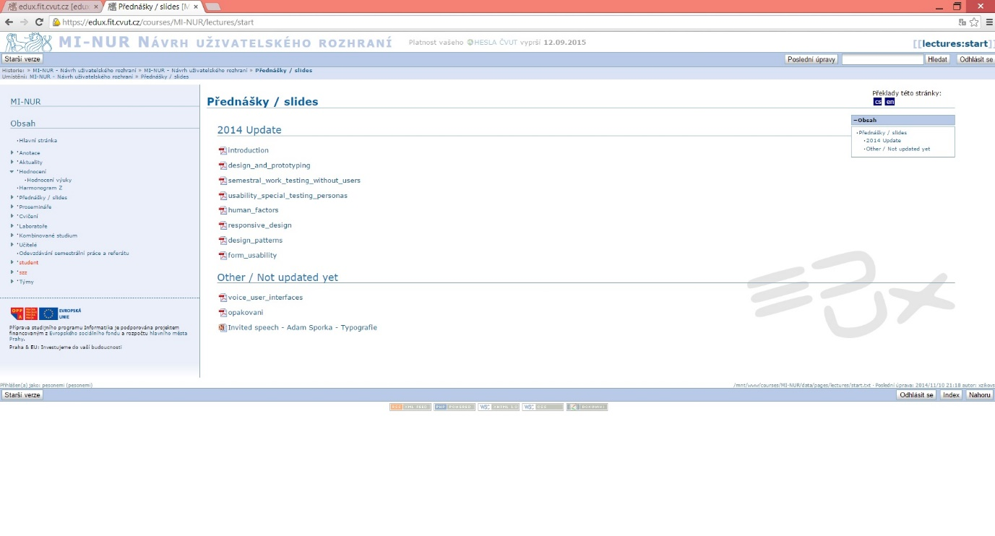

## According to the Nielsen’s heuristics

1. **Visibility of system status:**

- The “Lectures/Slides” is not highlighted in the navigation menu bar in the left, but

+ The sub topic in the middle on top of the site tells that user is in the section of “Lectures/slides”.

1. **Match between a system and the real world:**

+ Looks like any other web site and thus it’s familiar to user (match between this and other web sites).

+ The slides are presented in the same order they have been used in the lessons (natural and logical order).

1. **User control and freedom:**

+ User can choose any of the PDF files, does not need to open them in any specific order.

- There is no “escape” or “back”-button in the application itself when you open an PDF file but that functionality is built-in to browser.

1. **Consistency and standards:**

+ Layout and navigation/interaction is like in any other web site.

+ Could be used also with the browser of a mobile phone.

+ The web site changes when the orientation of the mobile phone changes, and it is even more readable when the device is on landscape orientation (fonts are bigger) but the layout is still the same familiar one.

- However the clickable content is not usable with fingers, they are too small.

1. **Error prevention:**

+ Not that many options to get any errors.

- Does not ask confirmation about opening the PDF files.

1. **Recognition rather than recall**

+ There are sub-topics which tell about the relevancy of the PDF files (lecture slides): other are updated for this semester and others are not.

+ It is clearly shown which kind of materials are offered in the web site. The logo of PDF file is right there, on the left side of the lectures.

- It is not quite clear that the PDF files are clickable for opening. There could be option for open and download in this page and not after clicking. Users need to remember that it is possible after clicking the file name.

1. **Flexibility and efficiency of use**

- All the PDF files need to be downloaded separately which is not very efficient.

- Usable only with mouse or finger (mobile phones). There are no keyboard options for using this page.

- Both novice and expert users use the site the same way. Easy to learn but not possible to make the usage faster or efficient later on.

1. **Aesthetic and minimalist design**

+ Only relevant information is shown. There is nothing extra.

1. **Help users recognize, diagnose and recover from errors**
2. **Help and documentation**

+ The content of the page is minimal and easy to search for the correct lecture slides.

- No “Help” offered. User cannot find any tips for using this page.

- There could be numbers next to the PDF logo just before the topic of that lesson so that finding for example lecture slides of week 5 could be easier than just calculate the correct one every time starting from the top.

## What’s good (other)

+ It is consistent: every page has the same layout both visually and what it comes to interaction.

+ Available also for mobile phones and looks the same there also. When the mobile phone is on landscape orientation the page follows it and shows even with bigger font which is better.

+ When the size of the browser changes, also the content changes the same way. So that it is scalable.

+ Option to return to “Home screen” (up left corner).

+ Displays a list of items inside (PDF files are all shown).

+ There is no need for unnatural horizontal scrolling but vertical one only is the screen is small in size.

## What’s bad (other)

- Same layout for both browser of a computer and a mobile phone is not necessarily usable when the size of the display changes that dramatically.

- Every clickable option is too small for using with finger. So the layout and the information do not change enough along with the device.

- No “Help” –option.

- Not color-coded in any way that the latter part of the page is non-updated lecture slides.

# Moodle2.tut.fi/course/lecture-slides

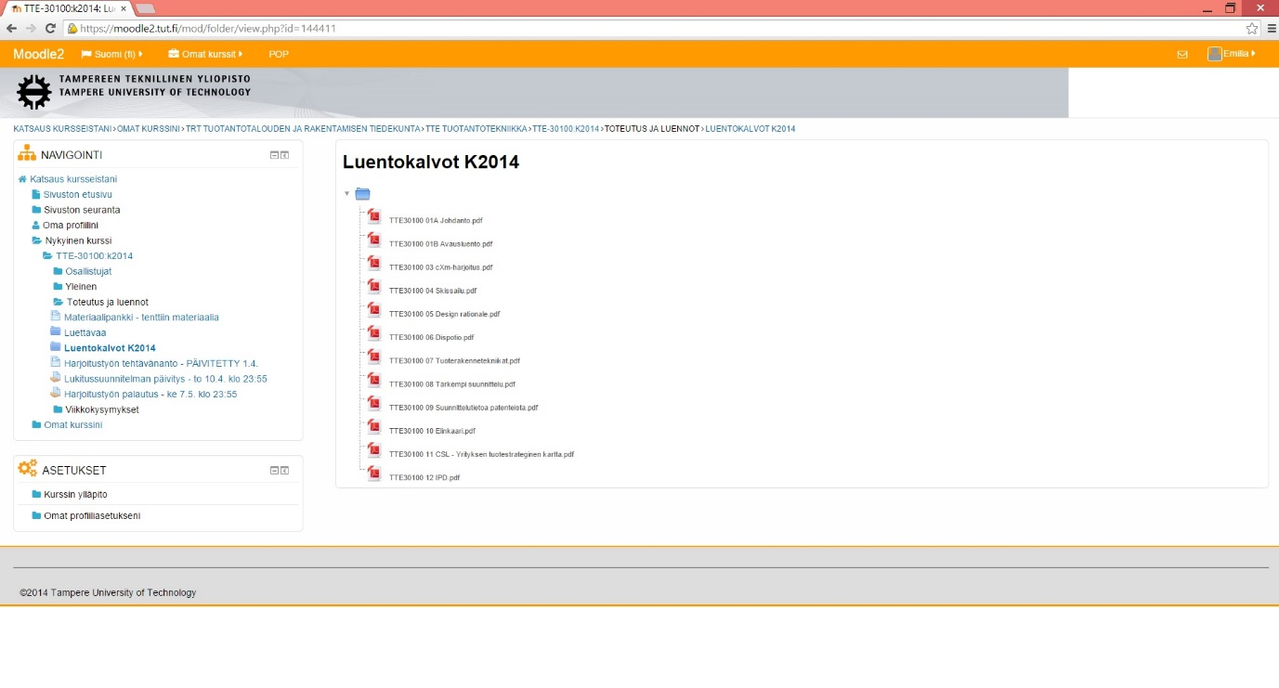

## According to the Nielsen’s heuristics

1. **Visibility of system status:**

+ The “Lectures/Slides” is highlighted in the navigation menu bar in the left.

+ Also the sub topic in the middle on top of the site tells that user is in the section of “Lectures/slides”.

1. **Match between a system and the real world:**

+ Looks like any other web site and thus it’s familiar to user (match between this and other web sites).

+ The slides are presented in the same order they have been used in the lessons (natural and logical order).

1. **User control and freedom:**

+ User can choose any of the PDF files, does not need to open them in any specific order.

- There is no “escape” or “back”-button in the application itself when you try to open a PDF file but user can cancel the downloading the it.

- By clicking a lecture slides they are by default downloaded not opened for viewing (which is the opposite they had it in Edux system above).

1. **Consistency and standards:**

+ Layout and navigation/interaction is like in any other web site.

+ Could be used also with the browser of a mobile phone.

+ The web site changes when the orientation of the mobile phone changes, and the layout of the site changes also to more readable version where user can scroll vertically in order to see all the content.

- Loading the page with mobile phone is very slow.

1. **Error prevention:**

+ Not that many options to get any errors.

- Does not ask confirmation about whether the user wants to just open or download the PDF files. The default cannot be changed in anywhere.

1. **Recognition rather than recall**

+ It is clearly shown which kind of materials are offered in the web site. The logo of PDF file is right there, on the left side of the lectures and also in the end of the name of the lesson.

- It is not quite clear that the PDF files are clickable for opening. There could be option for open and download in this page and not after clicking. Users need to remember that it is possible after clicking the file name.

1. **Flexibility and efficiency of use**

- All the PDF files need to be downloaded separately which is not very efficient.

- Usable only with mouse or finger (mobile phones). There are no keyboard options for using this page.

- Both novice and expert users use the site the same way. Easy to learn but not possible to make the usage faster or efficient later on.

1. **Aesthetic and minimalist design**

+ Only relevant information is shown. There is nothing extra.

1. **Help users recognize, diagnose and recover from errors**
2. **Help and documentation**

+ The content of the page is minimal and easy to search for the correct lecture slides.

+ There are numbers next to the PDF logo just before the topic of that lesson so that finding for example lecture slides of week number 5 could be easy and fast.

- No “Help” offered. User cannot find any tips for using this page.

## What’s good (other)

+ It is consistent: every page has the same layout both visually and what it comes to interaction.

+ Available also for mobile phones. When the mobile phone is on landscape orientation the page follows it and shows even with bigger font which is better.

+ When the size of the browser changes, also the content changes the same way. So that it is scalable.

+ Option to return to “Home screen” (up left corner “Sivuston etusivu”).

+ Displays a list of items inside (PDF files are all shown at one glance).

+ There is no need for unnatural horizontal scrolling but vertical one only is the screen is small in size.

- However the naming of the home page is not ideal. Literal translation “The first page of this web site”.

## What’s bad (other)

+ Layout changes when using the web site with mobile phone or computer. The layout has been designed well for both devices.

- No “Help” –option.