S2 Empirical Strategy Consolidation
Progressive Reduced-Rank VECM Design with tsDyn
Consolidated strategy, workflow figure, helper chunks, frozen tag dictionary, and freeze-readiness assessment

Purpose. This note consolidates the S2 empirical strategy as a single progressive VECM study, documents the object dictionary that defines every model cell, records the helper code chunks already drafted for implementation, and assesses whether the design is conceptually saturated enough to freeze before coding resumes.
Workflow Figure
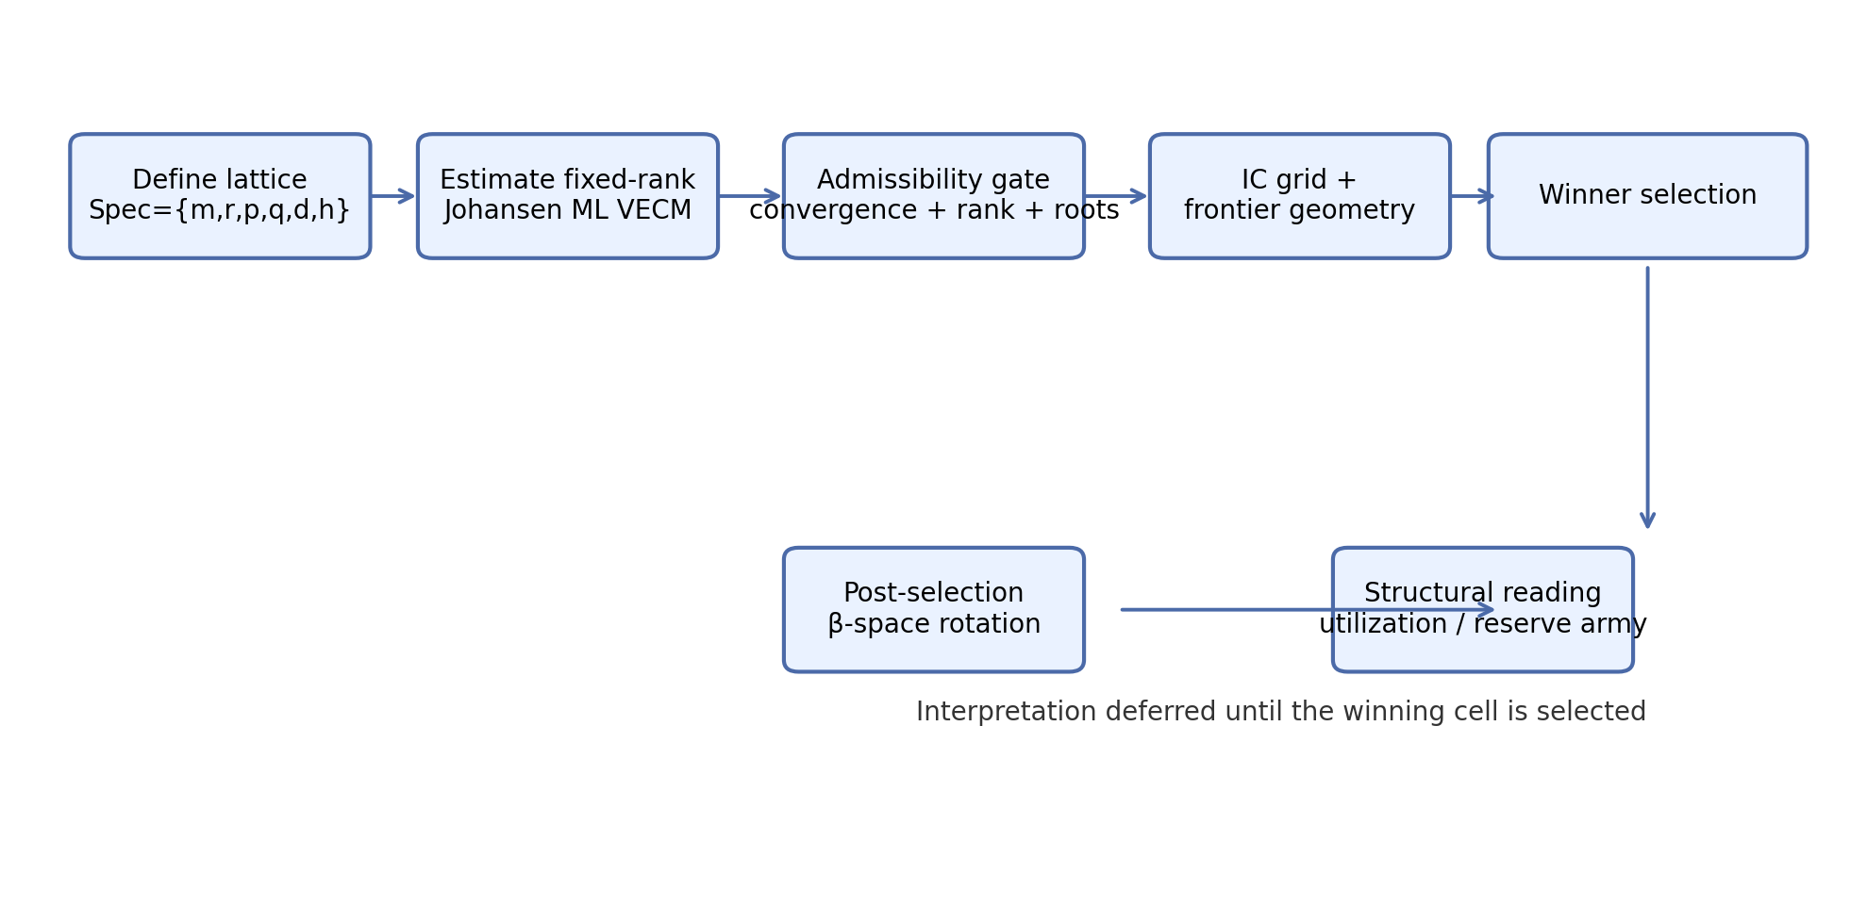
Figure S2.1. Locked workflow order: lattice definition → estimation → admissibility → information grid → winner selection → post-selection structural rotation.
1. Study identity and objective
S2 is a single progressive reduced-rank VECM study rather than a pair of disconnected exercises. It contains two nested branches.
S2.1 — baseline system
X_t = (lnY_t, lnK_t), rank fixed at r = 1
S2.2 — expanded system
X_t = (lnY_t, lnK_t, ln e_t), rank fixed at r = 2
Interpretation is deferred until model selection. In the baseline branch, the candidate structural reading is the capacity–utilization relation lnY_t − θ lnK_t. In the expanded branch, the candidate structural reading is a rank-2 space supporting both utilization confinement and reserve-army discipline through utilization.
2. Full S2 lattice and selection protocol
Canonical specification object
Spec = {m, r, p, q, d, h}
Selection order
estimate all cells → admissibility filter → information criteria contest → global frontier → winner selection → structural rotation of β-space
Core selection rule
No structural rotation is used during the search. Theoretical interpretation begins only after a winning cell has been selected from the admissible frontier.
3. Visualization system inherited from S1
S2 keeps the S1 plotting grammar and treats the plotting stage agnostically. Historical and deterministic branches are handled as specification attributes, not as pre-interpreted mechanisms.
Figure S2.2 — Global likelihood frontier
x-axis = k_total, y-axis = −2 logLik; layers: admissible scatter, global frontier, frontier labels only
Figure S2.3 — Conditional information-criteria frontiers
same plane, with AIC, BIC, HQ, ICOMP, and RICOMP winners highlighted
Figure S2.4 — Informational domain (Ω20)
top informational region shown through facetting or shading; used to identify where additional complexity yields meaningful gains
4. tsDyn engine crosswalk
All S2 cells are estimated with Johansen ML through tsDyn::VECM. The engine does not impose the research interpretation; it only provides admissible deterministic placements and reduced-rank estimates. Interpretation comes from the design.
Deterministic knobs in tsDyn
include controls short-run deterministic terms; LRinclude controls long-run deterministic terms
Stability discipline
a cell is admissible only if the constrained-rank VECM converges and the implied levels-VAR companion roots show the expected number of unit roots (m − r) with no additional explosive roots
5. Helpers section (implementation chunks already drafted)
The design is conceptually frozen independently of code, but the following helper chunks have already been drafted and are included here for future implementation continuity.
6. Freeze-readiness assessment
The strategy is conceptually close to saturation. The remaining open issues are at the implementation layer, not the design layer.
Freeze verdict
The S2 design can be frozen as a conceptual object. The main remaining risks concern coding choices for how q is computed ex post, exact k_total counting in the system, and visual density management in the final plots, not gaps in the empirical logic.
Helper 1 — tsDyn deterministic branch mapping
map_det_branch_tsdyn <- function(d) {
if (d == "d0") return(list(include = "none", LRinclude = "none"))
if (d == "d1") return(list(include = "none", LRinclude = "const"))
if (d == "d2") return(list(include = "const", LRinclude = "none"))
if (d == "d3") return(list(include = "const", LRinclude = "const"))
stop(sprintf("Unknown deterministic branch: %s", d), call. = FALSE)
}
Helper 2 — historical toggle mapping
map_hist_toggle_exogen <- function(data_exog, h,
col_1956 = "D1956",
col_1973 = "D1973",
col_1980 = "D1980") {
if (h == "h0") return(NULL)
if (h == "h1") return(as.data.frame(data_exog[, c(col_1973), drop = FALSE]))
if (h == "h2") return(as.data.frame(data_exog[, c(col_1956, col_1973, col_1980), drop = FALSE]))
stop(sprintf("Unknown historical toggle: %s", h), call. = FALSE)
}
Helper 3 — compact specification code
make_s2_spec_id <- function(m, r, p, q, d, h) {
paste0("m", m, "-r", r, "-p", p, "-q", q, "-", d, "-", h)
}
Helper 4 — root diagnostics summary
vecm_root_summary_row <- function(mod, r, spec_id, m, p, q, d, h,
tol_unit = 1e-3,
tol_explosive = 1e-6,
unit_root_rule = "exact") {
dg <- vecm_root_diagnostics(mod = mod, r = r,
tol_unit = tol_unit,
tol_explosive = tol_explosive,
unit_root_rule = unit_root_rule)
cbind(data.frame(spec_id = spec_id, m = m, p = p, q = q, d = d, h = h,
stringsAsFactors = FALSE), dg$summary)
}
Helper 5 — master grid runner skeleton
run_s2_grid <- function(grid_df, data_main, data_exog = NULL, estim = "ML") {
# iterate over Spec = {m, r, p, q, d, h}
# estimate Johansen ML VECM in each cell
# collect logLik, -2logLik, k_total, IC, and root diagnostics
# return a tidy master table plus a long roots table
}
7. S2 — Final Frozen Object Dictionary
Core specification object
Spec = {m, r, p, q, d, h}
m — system dimension
m2 = (lnY_t, lnK_t); m3 = (lnY_t, lnK_t, ln e_t)
r — confinement dimension
r1 = one stationary structural relation; r2 = two stationary structural relations; locked mapping: m2 → r1, m3 → r2
p — lag depth
p1, p2, p3, p4 (VECM lag ceiling)
q — short-run memory descriptor
q-sym = symmetric treatment; q-kXX-yYY = asymmetric memory shares with s_K = XX/100 and s_Y = YY/100; in m3, s_e = 1 − s_K − s_Y
d — deterministic structure
d0 = no LR or SR mean; d1 = LR mean only; d2 = SR mean only; d3 = LR + SR mean
h — historical architecture
h0 = none; h1 = full institutional shock only (1973); h2 = full institutional shock + partial shocks (1973 + 1956 + 1980, with partial shocks restricted to reserve-army mechanism shifts and short-run parametric shifts)
Compact specification code
m2-r1-p2-q-sym-d1-h0
m2-r1-p4-q-k55-y45-d1-h1
m3-r2-p3-q-k40-y35-d3-h2
8. Assessment of freeze completeness
What is already frozen: system progression, rank mapping, p-grid, q tags, deterministic ladder, historical toggles, admissibility logic, visualization grammar, and the post-selection interpretation order.
What is intentionally descriptive rather than restrictive: q. Memory shares are summarized ex post and do not impose short-run Γ restrictions during estimation.
What still lives at the implementation layer: exact k_total counting, ex-post calculation of q from estimated short-run structure, and final label density choices in the published plots.
Angles not left out conceptually: rank meaning, deterministic placement, institutional-shock architecture, frontier design, and stability discipline are all covered. The remaining open items are engineering choices, not missing empirical logic.
Bottom line: S2 is ready to be frozen as an empirical strategy. Any further changes should be justified as implementation refinements or later robustness extensions, not as unresolved design gaps.
Appendix A. Deterministic crosswalk
Branch | Economic reading | tsDyn mapping | Role
d0 | No mean in LR or SR | include="none"; LRinclude="none" | Severe benchmark
d1 | LR mean only | include="none"; LRinclude="const" | Structural baseline
d2 | SR mean only | include="const"; LRinclude="none" | Alternative placement
d3 | LR + SR mean | include="const"; LRinclude="const" | Flexible robustness
Appendix B. Rank–dimension crosswalk
System | Rank | Stochastic trends | Economic reading
m2: (lnY, lnK) | r1 | 1 | Capacity–utilization confinement
m3: (lnY, lnK, ln e) | r2 | 1 | Capacity–utilization + reserve-army discipline
Appendix C. Short-run memory crosswalk
q tag | System | Reading
q-sym | m2 / m3 | Neutral benchmark short-run architecture
q-kXX-yYY | m2 | Asymmetric memory split between K and Y
q-kXX-yYY | m3 | Asymmetric split across K, Y, with e as residual share

