The Transformation of Accumulation into Productive Capacities:
Capacity Utilization in the Center and Periphery
WORK IN PROGRESS — PLEASE DO NOT CIRCULATE
Diego Polanco
Department of Economics, University of Massachusetts Amherst
Email: dpolanconeco@umass.edu
Abstract
Chapter 1 demonstrated that the bivariate output–capital relation fails system-level cointegration and that a stable long-run capacity path requires the rate of exploitation to enter the cointegrating vector, yielding a transformation elasticity below unity (θ̂ < 1) indicative of structural overaccumulation. This chapter identifies how distribution conditions the conversion of accumulated capital into productive capacity and extends the analysis to the periphery. I estimate the transformation elasticity θ ≡ ∂ ln Yᵖ / ∂ ln K as a state-dependent cointegrating relation: for the United States (1931–2024), using Integrated Modified OLS with fixed-b inference and endogenously dated structural breaks (Vogelsang & Wagner 2024, Bai & Perron 2003); for Chile (1943–2010), using a threshold Cointegrating Multivariate Polynomial Regression with a composite balance-of-payments index. In the United States, θ remains strictly below unity throughout the sample, rising from 0.37 in 1960 to 0.43 in 2024 as effective wage pressure falls with the diversion of investment into intellectual property. Capacity utilization declines from its 1944 wartime peak to 93.8% in 2024, never re-anchoring to its Fordist level. In Chile, a balance-of-payments threshold at γ̂ = 0.425 switches the mechanization response off: the wage-share elasticity of the capital composition gap falls from +3.29 to +0.14 once foreign exchange binds. Peripheral capitalists retain the incentive to substitute machinery for labor and lose the means to do so, because the machinery is imported. The center–periphery comparison establishes that the same transformation relation is mediated by distributive conflict in the center and truncated by the balance-of-payments constraint in the periphery. Neither economy operates near θ = 1. Capacity utilization is not a norm toward which economies converge; it is the residual of a politically conditioned conversion of accumulation into productive capacity.
Keywords: Capacity Utilization; Transformation Elasticity; Choice of Technique; Cointegration; Okishio Viability; Balance-of-Payments Constraint; Center–Periphery.
JEL Codes: B51; C32; E01; E22; E32; P16.

Table of Contents

1. Introduction

Capacity utilization is among the most widely reported macroeconomic
ratios and among the least identified. Central banks read it as a gauge
of inflationary pressure. Growth models treat it as the variable that
absorbs the gap between accumulation and effective demand. A four-decade
heterodox debate over whether firms converge on a normal rate has been
conducted almost entirely on the assumption that the rate is observed
(Kurz, 1986; Blecker and Setterfield, 2019). It is not. The numerator of
the ratio—realized output—is measured. The denominator—productive
capacity—is not. Every claim about utilization is therefore a claim
about an object no statistical agency records, resting on whatever
convention supplied the denominator.
The utilization ratio has been supplied in three ways, and all three
fail identically. The first takes utilization as a given macro
ratio—an observed series to be used as a regressor or a policy
input—when its denominator was never observed. The second anchors it
to an inherited benchmark: an engineering maximum or a
survey-reported normal rate imported from outside the accounting
framework that is supposed to give the ratio meaning. Managerial
surveys do not support the premise this requires
(Singh et al., 2022; Nikiforos, 2016). The third recovers utilization as an
empirical residual: whatever remains after output has been
fitted to capital by a filter or a production function. This third
treatment is where most current empirical work sits, and the objection
to it is structural. Fitting a trend through output conditional on
capital sets the capacity path to move one-for-one with
accumulation—$θ=1$ by construction—and then defines
utilization as the deviation from a benchmark that assumed away the
very relation needed to locate it. The three treatments are not three
difficulties but one: each supplies the denominator by convention, and
each conceals the transformation relation that determines it.
Chapter 1 demonstrated that the bivariate output–capital relation
fails system-level cointegration and that a stable long-run capacity
path requires the rate of exploitation to enter the cointegrating
vector, yielding a transformation elasticity below unity
($\overset{^}{θ}<1$) indicative of structural overaccumulation. That
finding established that the output–capital relation is
distributionally conditioned. It did not identify how
distribution conditions the conversion of accumulated capital into
productive capacity, nor did it extend the analysis beyond the
closed-economy core. This chapter supplies both.
I estimate the transformation elasticity $θ≡∂lnY^{p}/∂lnK$ as a state-dependent cointegrating relation.
For the United States over 1931–2024, I use the Integrated Modified
OLS estimator of Vogelsang and Wagner (2024) with fixed-$b$ inference
and endogenously dated structural breaks (Bai and Perron, 2003);
distribution enters through effective wage pressure. For Chile over
1943–2010, the balance-of-payments constraint enters as a threshold
that switches the choice of technique. The estimates locate $θ$
well below unity in both economies. In the United States the elasticity
moves from $0.37$ in 1960 to $0.43$ in 2024 as effective wage
pressure falls with the diversion of investment into intangibles;
utilization declines from its 1944 wartime peak to $93.8\%$ in 2024.
In Chile a composite balance-of-payments threshold at
$\overset{^}{γ}=0.425$ switches the mechanization response off: the
wage-share elasticity of the capital composition gap falls from $+3.29$
to $+0.14$ once foreign exchange binds (Hansen, 2000). The
center–periphery comparison establishes that the same transformation
relation is mediated by distributive conflict in the center and
truncated by the balance-of-payments constraint in the periphery.
Two literatures have circled this problem without closing it. The
induced-innovation tradition following Kennedy (1964) made
distribution govern the direction of technical change along a
frontier whose scale stayed exogenous; its own later assessments
concede that it explains the composition of innovation while remaining
close to silent on its intensity (Tavani and Zamparelli, 2018). The
measurement literature has established convincingly that reported
capacity is a construct rather than an observation
(Shaikh, 2016; Nikiforos, 2016), but has stopped short of supplying
the relation that would replace it. Okishio (1961) and Okishio (2022)
supplies half of that relation—decentralized investment produces
disproportionality as a structural norm, not a friction—and
Vidal (2022) and Vidal (2019) supplies the other half, showing that the
firm converting capital into usable capacity is internally divided
over control and cooperation and settles into configurations that
reproduce production without resolving the conflict. Neither framework
was carried to the point where the transformation elasticity could be
estimated. Basu (2022) and Basu (2026) closes part of the gap by tying
the profitability outcome of viable technical change to the
labor-market closure, which maps onto historical accumulation regimes;
and for the periphery, Prebisch (1981) and Kaldor (1959)
established the external ceiling without connecting it to the choice of
technique that runs into it.
This chapter makes three contributions against that background. First,
it reconstructs capacity utilization as a derived quantity,
identified downstream of a transformation elasticity that is itself
estimated rather than assumed, extending the distributional conditioning
established in Chapter 1 from a cointegration-survival result to a
structural elasticity with a historical trajectory. Second, it supplies
an econometric identification of that elasticity that does not
presuppose the relation it recovers, using a cointegrating
specification in which distribution enters as a state-dependent
interaction and structural change is dated endogenously. Third, it
extends the relation to the periphery by letting the balance-of-payments
constraint enter as a threshold that switches the choice of
technique, rather than as a control variable added to it.
The argument runs as follows. The transformation relation cannot be
posited without a theory of the unit that performs the transformation,
which is what Section supplies by replacing the
unified firm with decentralized accumulation and internal division.
Section then asks what has to be true of the
choice of technique for that transformation to have a determinate
elasticity, and derives $θ$ under homogeneous capital, under
heterogeneous capital with a mechanization gap, and under an external
constraint that can bind. Section confronts the
resulting specifications with reconstructed capital stocks for both
economies and reports what the estimates say about the historical path
of $θ$ and $μ$. Section sets the two histories
against each other, and Section states what the
reconstruction settles and what it leaves open.

2. The Internally Divided Firm and Capacity Formation

Capacity utilization is not a technical parameter. It is an
inter-scalar political-economic settlement. The macroeconomic
capacity ceiling—the denominator of the utilization rate—is
not a neutral engineering constraint but a historically contingent
outcome conditioned by the balance of class power. Yet identifying
this distributional conditioning at the macro level leaves the
underlying transmission mechanism black-boxed: how, precisely,
does distributive conflict physically alter the conversion of
accumulated capital into productive capacity?
Answering this question requires dismantling a hidden premise
shared by virtually all heterodox growth models: the unified
firm. Whether treating the normal rate of capacity utilization
as an endogenous behavioral target or an exogenous gravitational
anchor, standard frameworks presume a coherent organization
capable of selecting a utilization benchmark, enforcing it across
the labor process, and sustaining it over time. Formally, the
utilization rate is defined as:
%
$μ_{t}≡\frac{Y_{t}}{Y_{t}^{p}},$ | (1)
The unified-firm premise collapses when confronted with the
social organization of capitalist production. In a decentralized
economy, individual capitals commit fixed investments without
ex-ante coordination, confronting one another in
competitive markets. Within the enterprise, production decisions
encounter contradictory managerial and worker imperatives.
Capacity utilization cannot be reduced to a target selected by
a single optimizing entity. To theorize the political economy
of productive capacity, I replace the unified firm with two
interconnected frameworks: Okishio's theory of decentralized
market anarchy, and Vidal's theory of the internally divided
firm.

2.1 Smooth Reproduction and the Unified-Firm Premise
Proportional reproduction is a condition of feasibility, not a
tendency of capitalist accumulation. Smooth reproduction requires
strict material proportionality between departments of
production—a condition Basu (2022) and Okishio (2022) formally established defined by the latter as the equilibrium accumulation trajectory. Bergmann et al. (2009) call
this balanced trajectory, where realized output meets productive
capacity ($μ_{t}=1$), the "golden path." But the golden path
is a methodological closure, not a gravitational attractor. It
identifies the conditions under which realization can reproduce
itself smoothly; it does not describe the path capitalist accumulation
actually follows. Neither the post-Keynesian assumption of long-run balanced
growth (Blecker and Setterfield, 2019) nor the "Keynesian in the short run, classical in the long run" synthesis (Dum{\'e}nil and L{\'e}vy, 1999) captures this persistence of unbalanced expansion.
Nothing in the logic of decentralized competition
establishes that private investment decisions will reproduce
these proportions. A stylized illustration makes the point
concrete. If productive capacity grows at $5\%$ per year while
aggregate demand for output grows at $2\%$, capacity outpaces
demand by three percentage points each year. After a decade,
utilization falls to roughly $75\%$ of capacity—not because
of a temporary shock, but because uncoordinated investment
persistently builds capacity faster than demand can absorb it.
Balanced growth ($g_{Y}=g_{K}$) is merely one configuration of
the transformation elasticity $θ$; it is not a restoring
force. Smooth reproduction ($μ_{t}=1$) does not require
$θ=1$; it holds for any transformation elasticity.
Balanced growth is the narrower special case in which
$θ=1$ and $μ_{t}=1$ coincide in the long run.
Because private investment decisions are made without
ex-ante coordination, real capitalist economies
routinely violate the proportional conditions of the golden path.
Okishio (2022) demonstrates that chronic disproportionality
is not a temporary friction but the structural norm of
decentralized accumulation. Treating the transient benchmark of
$μ_{t}=1$ as a behavioral target therefore relies on a hidden
premise: that the firm is a unified planning subject capable of
selecting a utilization norm, enforcing it across the labor
process, and sustaining it over time. This premise—the unified
firm—is the target of the present section.
The denominator of the utilization ratio (productive capacity
$Y_{t}^{p}$) is not an engineering constant. It is a contested
settlement of divided management and shop-floor struggle. The
numerator (realized output $Y_{t}$) is hostage to the anarchy of
demand. Smooth reproduction supplies a reference case against
which this historical non-coincidence can be studied. It does not
supply the mechanism that produces it.

2.2 Decentralized Accumulation and Market Anarchy
If the "golden path" of smooth reproduction is merely a
benchmark of feasibility, the actual trajectory of capitalist
accumulation is governed by the decentralized organization of
investment. Capitalist production is coordinated through
exchange, meaning that the social validation of private
decisions occurs only ex-post. Because money mediates
exchange, sale and purchase are separated moments of the capital
circuit (Basu, 2022). Surplus value must be realized in
circulation, not by construction (Foley, 1985; Trigg, 2020).
This constitutes the logic of capital as impersonal domination:
capitalists commit to production and investment with the law of
value operating "behind their backs." They are subject to market
forces and value relations they neither control nor consciously
direct. Critically, this anarchy is not a coordination failure
in an otherwise functional market. The market is a socially
constituted institution whose normal operation produces
disproportionality as a structural feature
(Vidal and Peck, 2012). Okishio (2022) locates the source
of macroeconomic instability precisely in this constitutive
anarchy. Individual capitals commit to fixed investment on the
basis of private profitability expectations, yet the market validates
those commitments only after production has begun. No firm can
know in advance whether its expansion fits the investment and
consumption decisions taken elsewhere. The coordination problem
is not one of imperfect information surrounding an otherwise
coherent plan; no economy-wide plan exists.
Smooth reproduction requires proportional expansion across
sectors producing means of production and sectors producing
consumption goods. Because private investment does not enforce
this proportionality, firms extrapolate past prices, profit
rates, and sales. A signal that induces expansion in one branch
routinely produces excess capacity before complementary demand
materializes elsewhere. Contraction works through the same
cumulative mechanism: falling sales cut investment, reducing
aggregate demand and validating further cuts. Removing Say's
Law reintroduces realization as a substantive condition of
reproduction: accumulation may generate capacity that demand
fails to absorb, or demand may temporarily exceed productive
capacity (Foley, 1985). Prices register the
resulting imbalance, but they do not prevent the sunk
commitments produced by it.
Fixed capital gives this temporal lag its structural force.
Structures and machinery embody long-horizon commitments that
cannot be reversed when relative prices or demand conditions
shift. Once installed, excess capacity leaves the firm to
operate below its anticipated scale, defer maintenance, hold
equipment idle, or devalue the asset. These responses
distribute the costs of market anarchy among firms, workers,
and creditors, but they do not restore the missing
ex-ante coordination.
Idle capacity is therefore a recurrent, structural form of
decentralized accumulation rather than a temporary friction.
Private investment physically builds capacity before the market
can realize its social use, recurrently a gap
between installed productive capacities ($Y_{t}^{p}$) and effective demand ($Y_{t}$). The capacity utilization rate ($μ_{t}$) registers this gap at the macro level. Unbalanced growth is not a disturbance around proportionality; it is the structural consequence of distributively conditioned investment under
decentralized decision-making. The analytical problem is
therefore not how proportionality re-emerges, but how persistent
imbalance remains historically reproducible. The condition
$μ_{t}=1$ is at most a transient point through a given trajectory
proportionality, while persistent divergence records the ongoing
reality of market anarchy.
Okishio's macro framework stops one step short: it does not explain how firms translate this external anarchy into internal operating decisions. The firm does not manage market anarchy; it internalizes it. A firm does not receive a price signal and respond as a frictionless, unified unit. It processes the signal through an organization divided over control, cooperation,
effort, and the allocation of resources. Vidal's internally
divided firm provides that missing mediation.

2.3 The Internally Divided Firm
Vidal builds on Marx's Volume I theory of the labor process, drawing on contemporary organizational theory and sociological institutionalism to develop an organizational political economy of the capitalist firm (Vidal and Peck, 2012; Vidal, 2022). Marx established that
capitalist management faces a constitutive contradiction: it
must simultaneously organize the cooperative labor required for
production and enforce the coercive control required for
valorization. Vidal (2022) demonstrates how this contradiction fractures
the modern capitalist firm, treating it as a divided social
organization whose internal structure is shaped by cognitive,
normative, regulative, and organizational institutions. Management must extract surplus value through
control over labor, but production also requires workers'
cooperation, tacit knowledge, and problem-solving capacity.
Standardization and surveillance secure a measurable pace of
work while weakening the discretion needed to sustain complex
production. The firm cannot maximize both imperatives at once
because the labor process that produces value is also the site
where workers contest its extraction. This contradiction is not
a universal constant of capitalism; it is institutionally
mediated, taking variegated forms across distinct accumulation regimes throughout historical capitalism
(Vidal, 2019).
Workers respond to this contradiction by actively calibrating
effort, cooperation, machine pacing, and the deployment of tacit
knowledge. Capitalist management extracts potential capacity
through concrete shop-floor mechanisms: increasing machine speed,
deferring maintenance to hit short-term throughput targets, and
enforcing rigid surveillance. Workers contest this extraction
through labor turnover, collective exit, or the deliberate
withdrawal of problem-solving cooperation and effort. Throughput,
quality, and maintenance therefore depend on social relations
that no engineering specification fixes in advance. A production
target that raises machine speed by deferring maintenance may
increase current output while degrading sustainable capacity. A
directive that suppresses worker discretion may meet a
short-term labor-control objective while worsening workflow
bottlenecks. Labor effort is consequently not a fixed technical
parameter applied to a pre-existing capital stock; it is an
active, contested determinant of the capacity utilization itself.
This dynamic enforces a strict wedge between
engineering capacity and practical capacity.
Engineering capacity records the theoretical maximum output of
equipment under ideal technical conditions. Practical capacity
records the sustainable output rate dictated by actual
maintenance schedules, product-mix complexity, and the negotiated
intensity of labor. When managers report capacity to national
statistical agencies, they rely on conventions shaped by their
organizational position and the immediate pressures of the shop
floor. Aggregate capacity statistics therefore do not reveal a
neutral physical ceiling; they aggregate situated, institutional
judgments (Shaikh, 2016; Nikiforos, 2016). Complementarily,
empirical surveys of managerial practice confirm that firms do
not systematically organize production decisions around a
coherent capacity utilization target (Singh et al., 2022). For the
purposes of macroeconomic modeling, the productive capacity
ceiling ($Y_{t}^{p}$) is not an exogenous engineering constraint but
an endogenous settlement of workplace conflict. This settlement
is the micro-foundation through which class struggle and
distribution transmit into capacity utilization, setting up the
distributive–technological mapping developed in the following
subsection.
Because the valorization–labor process contradiction cannot be
solved, firms settle into organizational configurations of
"mediocre sufficiency" (Vidal, 2022). These are hybrid
arrangements that reproduce production without resolving the
underlying conflict between control and cooperation. Partial
worker autonomy coexists with rigid discipline; continuous
improvement programs coexist with brutal throughput pressure;
machinery might remain idle alongside binding productive bottlenecks. Following
Vidal (2014), these arrangements are best understood as
institutional incoherence: the firm's internal
settlements are functional enough to sustain accumulation yet
contradictory enough to generate persistent friction. This stands
in direct contrast to the Varieties of Capitalism assumption of
institutional complementarity, where national institutions are
presumed to form coherent, mutually reinforcing systems (Hall and Soskice, 2003). Here,
incoherence is not a deviation from an optimizing norm; it is the
permanent, structural form through which capitalist management
physically converts accumulation demand into capacity usage.

2.4 Distribution, Technique, and the Transformation
of Accumulation
The choice of technique connects the divided firm to
distribution, governing how accumulated capital is physically
transformed into productive capacity. Capitalists adopt a new
technique only when it reduces the cost of production at
prevailing prices and wages; such a technique is capitalistically
viable (Okishio, 1961). Okishio (1961) demonstrates
that a viable capital-using, labor-saving (CU-LS) technique
raises the equilibrium profit rate when the real wage remains
constant—a direct challenge to Marx's law of the tendential
fall in the rate of profit. Marx's account, by contrast, allows
the same form of technical change to depress profitability when
rising capital intensity increases the capital advanced relative
to surplus value. Basu (2022) reconciles this seemingly mutually exclusive
theorizations, by formalizing the Marx–Okishio threshold:
the rate of real-wage growth defines the result driven by
the balance of class forces.
This threshold situates the present framework within the
induced-innovation tradition while departing from it. The
Innovation Possibility Frontier (IPF) literature, initiated by
Kennedy (1964), treats distribution as selecting the
direction of technical change along a given frontier:
relative factor costs determine whether innovation is
labor-augmenting or capital-augmenting, while the frontier
itself—the scale of feasible productivity growth—remains
exogenous (Julius, 2005; Tavani, 2012). Later assessments
sharpen this limitation: IPF-based models explain the
composition of technical change but remain largely silent on
innovation intensity (Tavani and Zamparelli, 2018).
Zamparelli (2024a) partially endogenizes scale by mapping
a family of IPF levels to R&D effort, yet the analytical
structure continues to rely on frontier geometry and
steady-growth closure (Zamparelli, 2024b). An alternative
strand reframes inducement through mechanization rather than
frontier selection: Kaldor (1957) links productivity
growth to capital deepening, while
Cajas-Guijarro (2024) reformulates the IPF with an explicit
choice over mechanization growth under distributive and
labor-market conditions. The present framework builds upon a
mechanization productive frontier, treating the distributive–technological
relation as a regime-specific transformation between accumulation and
productive capacity. Rather than selecting along a given
frontier, distribution conditions mechanization intensity,
which in turn determines the transformation elasticity linking
accumulation to the formation of productive capacities.
The Marx–Okishio threshold gives wage pressure a precise role
in mechanization, but the profitability outcome depends on the
labor market closure. Basu (2026) demonstrates that the
equilibrium profit rate after viable CU-LS technical change is
governed by the institutional structure of capital–labor
bargaining. Under a constant-wage-share closure—what
Basu (2026) formalizes as the "strong labor" regime,
applicable to Atlantic Fordism—any viable CU-LS technique
unambiguously lowers the equilibrium profit rate.
Marx's LTFRP reigns supreme precisely where labor is powerful
enough to compel real wages to grow in tandem with productivity.
Under this closure, rapid mechanization is induced by
distributive pressure, yet the same pressure contests capital's
claim on the resulting productivity gains
(Vidal, 2015; Vidal, 2019). A stylized illustration makes the
mechanism concrete. If a $10\%$ real wage increase raises
mechanization intensity by $8\%$ under strong-labor conditions,
the transformation elasticity $θ$ rises from $0.70$ to
$0.85$: accumulation translates more efficiently into productive
capacity because firms substitute machinery for labor. Wage-led
mechanization was not a harmonious productivity bargain; but a
a contested settlement in which the distributive pressure that
induced technical change simultaneously eroded the profit rate
it was meant to restore.
The weakening of organized labor after the Fordist crisis
altered that mechanism. Under a "weak labor" closure—where
the unemployment rate remains constant such that workers lack the
institutional power to enforce a target wage share—the
distributive pressure to replace labor is suppressed
(Basu, 2026). Yet mechanization does not necessarily cease. Lower
relative machinery prices and technical change in capital-goods
production can continue to favor capital-using techniques through a
second, independent channel. Distribution and machinery prices
therefore constitute a dual-channel mechanism in the
choice of technique. Their relative force changes across
accumulation regimes, which prevents the wage share from being
treated as an external control added to an otherwise autonomous
technical relation. Extending the stylized example: under
Post-Fordist conditions, a $15\%$ decline in relative machinery
prices raises mechanization intensity by $6\%$, partially
compensating for the weakened distributive channel and
sustaining $θ$ near $0.75$ despite wage suppression. The
same $10\%$ wage increase that produced an $8\%$ mechanization
response under Fordism produces only a $2\%$ response under
Post-Fordism, leaving $θ$ near $0.72$. The two channels do
not simply add; they interact through the institutional
configuration that governs their relative force.
These channels still operate through the contradictions
identified in the preceding subsections. Firms choose techniques
before demand validates the associated capacity, and they
operate those techniques through labor processes that divide
control from productive cooperation. Investment consequently
does not translate one-for-one into a stable productive ceiling.
The transformation depends on the composition of capital, the
distributive conditions governing mechanization, and the
organization through which installed equipment becomes usable
capacity. In a labor surplus economy—the third closure
identified by Basu (2026), applicable to peripheral
capitalism—the real wage remains constant and the equilibrium
profit rate rises unambiguously after viable CU-LS technical
change. Yet the peripheral transformation is structurally
truncated by external financial subordination and the balance of
payments constraint, a mechanism developed in the following
subsection.
Okishio and Vidal jointly rule out a direct
passage from accumulation to productive capacity.
Decentralized investment generates structural
disproportionality across firms and sectors; the internally
divided firm internalizes this disproportionality as
contested operating conditions rather than a coherent
utilization target. The analytical object that captures this
mediated transformation is the transformation elasticity ($θ≡dy^{p}/dk$), which governs how
accumulation converts into productive capacity under a context of
distributive conflict and market anarchy. The empirical
analysis limits the original inter-departamental formulation by Marx in Capital Volume II into a
single-sector aggregate, masking internal sectoral
divergences while preserving the core logic.

2.5 Historical Regimes of Institutional Mediation and the Transformation Elasticity
The transformation elasticity is an emergent property of class struggle
that mediates the process of capital accumulation and its transformation
into productive capacities under the prevailing institutional environment.
Decentralized accumulation does not automatically guarantee
proportional reproduction ($θ=1$). Institutional
mediation—wage-setting norms, financial architectures, and
competitive structures—conditions how distributive pressures
translate into mechanization choices
(Aglietta, 2000).
Basu (2026) demonstrates that the equilibrium profit
rate after viable capital-using, labor-saving (CU-LS)
technical change is governed by the labor market closure,
which maps directly onto distinct historical accumulation
regimes. Under a constant-wage-share closure—the
institutional signature of Atlantic Fordism
(1947–1973)—workers possess the bargaining power to grasp
productivity gains, forcing real wages to grow in tandem with
labor productivity. In this strong-labor regime, viable
mechanization unambiguously lowers the equilibrium profit
rate, so that Marx's law of the tendential fall in the rate
of profit holds (Basu, 2026). This stagnation tendency
was institutionally offset: the class compromise, mass
consumption, oligopolistic market structures, and military
Keynesianism of the Fordist era absorbed the surplus and
sustained effective demand (Vidal, 2019).
Under a constant-unemployment closure—which resembles the persistent unemployment feature of the post-Fordist accumulation regime—an era during which the class compromise that took place during the Fordist period is dismantled and labor's
bargaining power is severely weakened. The wage share falls,
and mechanization is driven not by distributive pressure but
by the relative cheapening of ICT and the shift toward
financially reversible, short-horizon assets, patents and intellectual property of intangible assets
(Lapavitsas, 2011; Pagano, 2014). Because wages no longer
track productivity, the profit rate may stabilize or rise,
but the suppression of wage-led demand generates a chronic
under-consumptionist stagnation tendency. Following Vidal (2019), I hypothesize that under structural conditions, the post-fordist accumulation regime produces a dysfunctional utilization configuration:
accumulation decouples from productive capacity formation,
generating chronic idle capacity that is temporarily masked
by debt-led consumption and financial fragility rather than
sustainable realization (Stockhammer, 2012; Vidal, 2019).
In the capitalist periphery, different closures represent distinct historical configurations throughout Chilean history. First, under an assumption of a
constant-real-wage, which corresponds to
Okishio's original formulation maps onto a surplus-labor
economy (Lewis, 1954; Basu, 2026). During the
import-substituting industrialization (ISI) era, the
rural-urban and demographic transition enabled by the transformation of sanitary conditions and a massive drop of child mortality in the early XX century, regulated late industrialization, providing an unlimited supply of labor from the countryside that disciplined urban wages and allowed the profit rate to reproduce itself alongside mechanization.
However, peripheral mechanization is structurally import-biased:
widening the mechanization gap requires imported capital
goods and technologically non-substitutable inputs
(Prebisch, 1981). The balance of payments constraint
therefore acts as a hard external ceiling on the
transformation of accumulation into capacity. Under a
developmentalist regime with surplus labor (1933–1957), this operated as an
import capacity ceiling. Second, a constant-wage-share or more accurately rising-wage-share closure, represents the intensification of stagnation tendencies leading to structural crisis of capitalism once the unlimited supply of labor depleted and the incentives for capitalist firms to mechanize risen due distributive pressures while increasing import requirements and stressing further the external constraint. Third, the discipline imposed by the neoliberal counter-revolution (Casals, 2021) (1974–present) a constant-unemployment closure coupled with trade and capital account liberalization relieved the external constraint, but locked the periphery into extractive specialization and premature deindustrialization, such that the WTO and bilateral free
trade agreements legally encoded a policy space ceiling (Ahumada, 2019; Palma, 2019).
These historical configurations establish that the productive
ceiling is not a neutral, trans-historical engineering
constraint but a contingent outcome of decentralized
accumulation, class power, and a country's relative
positionality within the capitalist world system. The
center–periphery comparison reveals a fundamental asymmetry:
in the center, structural crises arise from the
exhaustion of institutional mediation (e.g., the
1970s profit squeeze); in the periphery, arise from
the absence of sovereign mediation and the
truncation imposed by the hierarchically oranized financial order imposing
an external constraint that is not necessarily binding.

3. The Analytical Framework: Formalizing the
Transformation Elasticity

Distributive pressure conditions the choice of technique, and the choice
of technique determines how much capacity a unit of accumulation
produces. Section 2 established that claim historically and
institutionally. It carries no elasticity until the cost-minimization
problem behind it is written down, because only then does $θ$ acquire
a determinate value rather than a direction of movement.
Cajas-Guijarro (2024) first posed that problem as a choice over
mechanization growth, and I extend it in three steps.
The steps are nested rather than alternative. A firm that treats capital
as homogeneous faces a single margin, and the elasticity that emerges
from its cost minimization is a scalar. Allow the capital stock to
separate into nonresidential structures and machinery, and a second
margin opens: the mechanization gap $κ_{t}$, whose marginal capacity
payoff depends on distribution and on relative asset prices at once.
Impose a foreign-exchange bottleneck on the machinery half of that gap,
and the interior solution can fail entirely, truncating $θ$ at a
corner. Setting the heterogeneity parameter to zero recovers the first
model from the second; relaxing the foreign-exchange constraint recovers
the center from the periphery. One structure, evaluated under three
constraint sets.
A limitation is worth stating before the derivations rather than after
them. The mechanism is multi-sectoral in principle—disproportionality
is a relation between departments of production—while the empirical
implementation bounds it to a single-sector aggregate. That bound masks
internal sectoral divergence. It preserves the transformation logic,
which is what the estimation requires, but it means $θ$ is recovered
as an economy-wide average of a relation that operates unevenly across
branches.

3.1 The Baseline Model of Cost-Minimizing
Mechanization (Homogeneous Capital Stock)
Actual aggregate output is represented by a Leontief
production function with fixed technical coefficients:
$Y=min\left(AL,μBK\right)$ | (2)
where $A=Y/L$ is actual labor productivity, $μ=Y/Y^{p}$
is capacity utilization, and $B=Y^{p}/K$ is maximum capital
productivity. This production structure governs the rate of
profit through the fundamental heterodox accounting identity:
$r=μB(1−ω)$ | (3)
where $ω$ is the wage share. Standard macroeconomic
models treat $B$ as an exogenous technological given and $μ$
as a behavioral constant smoothly targeted by a unified firm.
I reject both assumptions. The components of
(3) are endogenous outcomes of
class struggle and decentralized market anarchy, as
established in Section 2. This subsection formalizes how
distributive pressure forces cost-minimizing firms to alter
their choice of technique, endogenously determining $B$.

3.1.1 Tactical Choice of Technique and Induced
Innovation
Capitalist firms choice of technique is given by aiming a mechanization growth rate $q$ under competitive cutting cost-pressures, looking at the net productivity surplus of technical change as their objective function. Let $a$ denote the growth rate of
labor productivity. The effective distributive cost of
deploying mechanization growth is $q(1−ω)$. Hence, the choice of technique of capitalist mechanization can be represented by:
$\min_{q}c(q)=q(1−ω)−a$ | (4)
This objective captures the induced-innovation logic: firms
accelerate mechanization to expand labor productivity growth,
but the distributive cost of capital intensity holds them
back. The cost-minimizing objective function of capitalist becomes constrained by a mechanization function that can be represented as:
$a=Φ(q)=λ_{0}+λ_{1}q+λ_{2}q^{2}$ | (5)
Assumption 1. Concavity of the
mechanization frontier. The frontier parameters satisfy
$λ_{0}>0$, $λ_{1}>0$, and $λ_{2}<0$. The
base productivity growth $λ_{0}$ sets the floor without
advanced machinery. The linear coefficient $λ_{1}$
captures the direct productivity payoff of mechanization. The
strict concavity $λ_{2}<0$ ensures diminishing marginal
returns to mechanization.
Substituting (5) into
(4) and solving the first-order condition
yields the optimal mechanization growth:
$c(q)=λ_{0}+\left[λ_{1}−(1−ω)\right]q+λ_{2}q^{2}$
$\frac{∂c}{∂q}=λ_{1}−(1−ω)+2λ_{2}q^{*}=0$
$q^{*}(ω)=\frac{(1−ω)−λ_{1}}{2λ_{2}}$
The strict concavity ($c^{″}(q)=2λ_{2}<0$) guarantees
a unique maximum.
Proposition 1. Induced innovation. Under
Assumption 1, the optimal mechanization growth is strictly
increasing in the wage share:
$\frac{∂q^{*}}{∂ω}=−\frac{1}{2λ_{2}}>0$
A rise in the wage share forces cost-minimizing firms to
substitute machinery for labor. Rising wages drive
mechanization directly through the first-order condition,
pushing optimal capital intensity growth upward.
Proof. Immediate from differentiating
(Equation). $\backslash hfill∎$
Remark 1. The objective
(4) does not assert that the firm is a
coherent optimizer. Following Vidal (2022), the firm is
internally divided between the control imperative
(valorization: cost reduction through mechanization) and the
cooperation imperative (production: the need for
worker effort, tacit knowledge, and problem-solving
capacity). The formal model captures the cost-minimizing
pole—the Okishio viability logic—while the constraints on
the optimization problem capture the limits imposed by the
cooperation imperative and by external conditions. The firm
maximizes net productivity surplus—labor productivity
growth minus the distributive cost of mechanization—subject
to diminishing returns. The firm's actual mechanization
choice is a contested settlement between these imperatives,
not a coherent optimum. What the model demonstrates is the
cost-reducing direction in which distributive pressure pushes
the settlement, not the settlement itself.

3.1.2 Endogenous Transformation Elasticity
Substituting the optimal technique back into the
technological frontier recovers the normal growth rate of
labor productivity under smooth reproduction:
$a^{N}(ω)=λ_{0}+λ_{1}q^{*}(ω)+λ_{2}{\left[q^{*}(ω)\right]}^{2}$
This optimal technique dictates the structural trajectory of
the Leontief parameter $B$. By definition, maximum capital
productivity is $B=Y^{p}/K$. In dynamic growth rates, the
growth of capital productivity is:
$b≡g_{Y^{p}}−g_{K}=a−q$ | (6)
Evaluated at the smooth reproduction benchmark:
$b^{N}(ω)=a^{N}(ω)−q^{*}(ω)$.
Definition 1. Transformation elasticity.
The transformation elasticity $θ$ is the structural
parameter that translates capital accumulation into productive
capacity growth:
$g_{Y^{p}}=θg_{K}$ | (7)
Substituting (7) into
(6) reveals the link between the level
coefficient $B$ and the elasticity $θ$:
$θ=1+\frac{b}{g_{K}}$ | (8)
To evaluate this elasticity, I anchor the choice of technique
to a baseline rate of capital accumulation. Following the
normal reproduction path, the normal accumulation rate is
driven by the normal profit rate and the normal rate of re-capitalization net of depreciation. I follow Foley (1986) definition of the re-capitalization rate, $χ=\frac{I}{Π}$, and interpret its normal conditions as continuous realization and re-investment of the surplus. Hence,
$g_{K}^{N}=χ^{N}r^{N}−δ$ | (9)
In dynamic growth accounting, changes in the growth rate of capital represent an acceleration term $\overset{¨}{k}≡dg_{K}/dt$. In historical time, $\overset{¨}{k}$ is kept strictly bounded by corporate liquidity constraints, debt-servicing ceilings, and Central Bank credit cycles, preventing explosive capital growth divergence. Expressed dynamically relative to this normal path, the aggregate transformation elasticity becomes:
$θ(ω)=1+\frac{b^{N}(ω)}{g_{K}^{N}}=1+\frac{a^{N}(ω)−q^{*}(ω)}{g_{K}^{N}}$
Proposition 2. Endogeneity of the
transformation elasticity. Under Assumption 1, the
transformation elasticity $θ$ is not an exogenous
technical constant. It emerges endogenously from the
cost-minimizing choice of technique. When distributive
pressure forces firms to alter mechanization via
(Equation), it simultaneously shifts
the structural efficiency of accumulation via
(Equation). The elasticity $θ$ is
therefore a function of the wage share $ω$, the frontier
parameters $λ_{0},λ_{1},λ_{2}$, and the normal
accumulation rate $g_{K}^{N}$.
Econometric note on capital measurement error.. Because the aggregate capital stock $K_{t}$ is constructed via Perpetual Inventory (GPIM) methods involving service-life and discard schedules, any classical right-hand-side measurement error in $K_{t}$ introduces standard econometric attenuation bias that pulls the estimated elasticity $\overset{^}{θ}$ downward toward zero. Classical measurement noise cannot account for the empirical finding that $θ<1$; rather, it reinforces that the true structural transformation elasticity is bounded strictly below unity even under conservative measurement assumptions.

3.2 Heterogeneous Capital, the Mechanization Gap,
and State-Dependent Viability
Mainstream macroeconomics treats the capital stock as a
homogeneous aggregate, abstracting from the internal
architecture of the firm. Following the theory of organizational political economy and the internally divided firm (Vidal, 2022), I unbundle
aggregate productive capital into and extensive margin given by nonresidential
structures ($K^{NRC}$) and intensive one, given by the accumulation of machinery and equipment ($K^{ME}$).
These components do not unfold throughout the labor process
symmetrically. Structures form the built environments that setup the
"envelope"of accumulation — i.e. the factory floor and logistics shell of the productive process. Capital accumulation in Machinery and Equipment
is the active component that restructures the production process and the extraction of
relative surplus value (Marx, 1999, Vol. I, Ch. 15).
Assumption 2. Heterogeneous capital
decomposition. Aggregate productive capital decomposes as
$K_{t}^{cap}=K_{t}^{NRC}+K_{t}^{ME}$. Nonresidential
structures evolve independently of short-run distributive
conflict ($ω$) and its rate of accumulation of accumulation is governed by its long-run relation with the rate of accumulation in machinery and equipment under normal conditions of accumulation in the long-run
$g_{K^{NRC},t}^{N}=f(χ^{N},r_{t}^{N},g_{K^{ME},t}^{N},δ)$ | (10)
This extensive envelope $Θ(K^{NRC})$ becomes a baseline for aggregate elasticity of transformation $θ$ such that the rate of accumulation of capital stock in non-residential construction is a byproduct of the intensive margin of accumulation decided by a tactical technique choice made by capitalists in response to distributive pressures:

3.2.1 The Extensive Envelope and the Intensive Margin
Given the fixed infrastructural envelope, the
intensive margin of accumulation is the tactical
choice of the mechanization gap, defined in natural logs as:
$κ_{t}=k_{t}^{ME}−k_{t}^{NRC}$ | (11)
This gap measures mechanization intensity relative to the
extensive plant scale. The capacity identity decomposes
potential output into the extensive envelope and the
intensive capacity yield $Ψ_{t}$:
$y_{t}^{p}=θ_{NRC}k_{t}^{NRC}+Ψ_{t}(κ_{t},ω_{t−1},p_{t}^{κ})$ | (12)
The intensive yield $Ψ_{t}$ is not a fixed engineering
constant. It is the outcome of a decentralized
cost-minimization problem governed by the regime of
accumulation, as formalized below.

3.2.2 Cost-Surplus Minimization and the Okishio
Viability Yield
In this case, the capitalist firm chooses a mechanization gap $κ_{t}$ under cutting-cost pressures, subject to the
mechanization frontier:
$Φ(κ_{t})=λ_{0}+λ_{1}κ_{t}+λ_{2}κ_{t}^{2}$ | (13)
The realized capacity yield is governed by a viability condition: a
cost-minimizing firm deploys a new technique only if it
reduces unit costs at current distributive and price
parameters (Okishio, 1961; Basu, 2022). I formalize
this as a cost-minimization as problem:
$\min_{κ_{t}}c(κ_{t})=κ_{t}·MC(ω_{t−1},p_{t}^{κ})−Φ(κ_{t})$ | (14)
The marginal viability cost $MC(ω_{t−1},p_{t}^{κ})$
is determined by two channels:
- The distributive dividend (labor saving).
Increasing $κ_{t}$ substitutes machinery for labor. The
value of this displacement is proportional to the lagged
wage share ($ω_{t−1}$), reflecting the wage
settlement period prior to current capacity realization.
A higher wage share reduces the net cost of
mechanization.
- The relative price penalty (capital cost).
Increasing $κ_{t}$ requires accumulating machinery
faster than structures. The cost of this composition shift
is proportional to the log relative price of machinery
($p_{t}^{κ}=lnP_{t}^{ME}−lnP_{t}^{NRC}$). A higher
relative price increases the marginal cost.
I specify the marginal viability cost as:
$MC(ω_{t−1},p_{t}^{κ})=γ_{0}−γ_{1}ω_{t−1}+γ_{2}p_{t}^{κ}$ | (15)
where $γ_{1}>0$ captures the wage-savings dividend and
$γ_{2}>0$ captures the relative price penalty.
Substituting (13) and
(15) into (14) and
solving the first-order condition yields the optimal
mechanization gap:
$c(κ_{t})=λ_{0}+\left[λ_{1}−(γ_{0}−γ_{1}ω_{t−1}+γ_{2}p_{t}^{κ})\right]κ_{t}+λ_{2}κ_{t}^{2}$
$\frac{∂c}{∂κ_{t}}=λ_{1}−γ_{0}+γ_{1}ω_{t−1}−γ_{2}p_{t}^{κ}+2λ_{2}κ_{t}^{*}=0$
$κ_{t}^{*}(ω_{t−1},p_{t}^{κ})=\frac{(γ_{0}−λ_{1})−γ_{1}ω_{t−1}+γ_{2}p_{t}^{κ}}{2λ_{2}}$
Proposition 3. Dual-channel induced
innovation. Under Assumption 1 (concavity) and
Assumption 2 (heterogeneous capital), the optimal
mechanization gap satisfies:
$\frac{∂κ_{t}^{*}}{∂ω_{t−1}}=−\frac{γ_{1}}{2λ_{2}}>0$
$\frac{∂κ_{t}^{*}}{∂p_{t}^{κ}}=\frac{γ_{2}}{2λ_{2}}<0$
A rising wage share forces cost-minimizing firms to widen
the mechanization gap, substituting machinery for labor.
A rising relative price of machinery suppresses the optimal
gap, as the structural cost of the composition shift
penalizes mechanization. Proof. Immediate from
differentiating (Equation). $\backslash hfill∎$

3.2.3 The Marginal Capacity Payoff and the
Econometric Bridge
The macroeconomic translation from the mechanization gap to
potential capacity is given by the marginal capacity payoff ($MP_{κ}$), the derivative of the
intensive capacity yield $Ψ_{t}$ with respect to $κ_{t}$.
By the envelope theorem:
$MP_{κ}=\frac{∂Ψ_{t}}{∂κ_{t}}=\frac{∂Φ}{∂κ_{t}}−MC(ω_{t−1},p_{t}^{κ})$
$=(λ_{1}+2λ_{2}κ_{t})−(γ_{0}−γ_{1}ω_{t−1}+γ_{2}p_{t}^{κ})$
$=((λ_{1}−γ_{0}+2λ_{2}κ_{t}))_{\text{\backslash text\{autonomous yield}}\}+γ_{1}ω_{t−1}−γ_{2}p_{t}^{κ}$ | (16)
Integrating the marginal payoff with respect to $κ_{t}$
(treating $ω_{t−1}$ and $p_{t}^{κ}$ as predetermined
shifters) and defining $θ_{κ}$,
$θ_{ωκ}≡γ_{1}$, and
$θ_{κpκ}≡−γ_{2}$ yields the
intensive capacity yield function:
$Ψ_{t}=θ_{κ}κ_{t}+θ_{ωκ}(ω_{t−1}κ_{t})+θ_{κpκ}(p_{t}^{κ}κ_{t})$ | (17)
Substituting (17) back into
(12) recovers the structural
capacity equation:
$y_{t}^{p}=θ_{NRC}k_{t}^{NRC}+θ_{κ}κ_{t}+θ_{ωκ}(ω_{t−1}κ_{t})+θ_{κpκ}(p_{t}^{κ}κ_{t})$ | (18)
The interaction terms are not ad-hoc econometric additions.
They are the macroeconomic footprint of the divided firm's
Okishio viability constraint. Distributive pressure and
relative price enter because they alter the marginal
capacity payoff of the mechanization gap.

3.2.4 The Transformation Elasticity under Heterogeneous Capital Stock
Specification B recovers separate capacity elasticities for nonresidential structures ($θ_{\text{NRC}}$) and machinery ($θ_{κ}$), but evaluating aggregate capacity dynamics requires defining an aggregate transformation elasticity ($θ_{t}^{\text{Aggregate}}$). In a single-asset model (Specification A), $θ_{A}=∂y^{p}/∂k^{\text{cap}}$ is a scalar. Under heterogeneous capital, the total differential of productive capacity (18) separates extensive expansion from intensive composition shifters:
$dy_{t}^{p}=θ_{\text{NRC}}dk_{t}^{\text{NRC}}+MP_{κ}dκ_{t}$
$=θ_{\text{NRC}}dk_{t}^{\text{NRC}}+\left(θ_{κ}+θ_{ωκ}ω_{t−1}+θ_{κpκ}p_{t}^{κ}\right)dκ_{t}.$ | (19)
Standard continuous-time growth accounting evaluates aggregate capital variation using a Divisia index of heterogeneous components (Divisia, 1925). Since $s_{\text{ME},t}+s_{\text{NRC},t}=1$ and $dκ_{t}=dk_{t}^{\text{ME}}−dk_{t}^{\text{NRC}}$, aggregate capital growth decomposes as:
$dk_{t}^{\text{cap}}≈s_{\text{ME},t}dk_{t}^{\text{ME}}+s_{\text{NRC},t}dk_{t}^{\text{NRC}}$
$=dk_{t}^{\text{NRC}}+s_{\text{ME},t}dκ_{t}.$ | (20)
Dividing (Equation) by (Equation) yields the conventional total-derivative aggregate elasticity along the empirical growth path:
$θ_{\text{total},t}^{\text{Aggregate}}=\frac{θ_{\text{NRC}}+\left(θ_{κ}+θ_{ωκ}ω_{t−1}+θ_{κpκ}p_{t}^{κ}\right)\frac{dκ_{t}}{dk_{t}^{\text{NRC}}}}{1+s_{\text{ME},t}\frac{dκ_{t}}{dk_{t}^{\text{NRC}}}}.$ | (21)
Equation (21) suffers from a severe theoretical flaw illuminated by the Cambridge Capital Controversy (Robinson, 1953; Sraffa, 1960). Heterogeneous physical assets cannot be aggregated into a single scalar $k^{\text{cap}}$ without value weights that depend on distribution and prices. Differentiating such a value aggregate and placing $dk_{t}^{\text{cap}}$ in the denominator re-introduces the circularity that the model with heterogeneous capital was designed to eliminate. Empirically, the denominator $1+s_{\text{ME},t}(dκ_{t}/dk_{t}^{\text{NRC}})$ vanishes whenever physical accumulation stalls or shifts composition, producing spurious zero-denominator singularities ($θ→±∞$).
Alternatively, I construct the aggregate transformation elasticity as an asset weighted from the heterogeneous capital stock system. Rather than differentiating a value aggregate, the structural asset-weighted transformation elasticity weights identified heterogeneous elasticities by gross capital asset shares:
$θ_{t}^{\text{Aggregate}}=θ_{\text{NRC}}^{\text{str}}+s_{\text{ME},t}·MP_{κ,t}^{\text{str}},$ | (22)
where $θ_{\text{NRC}}^{\text{str}}$ is the base elasticity of structures, $s_{\text{ME},t}=K_{\text{ME},t}/K_{\text{cap},t}$ is the physical equipment share, and $MP_{κ,t}^{\text{str}}=θ_{κ}^{\text{str}}+θ_{ωκ}(ω_{t−1}−\overset{¯}{ω})+θ_{κp}(p_{t}^{κ}−{\overset{¯}{p}}^{κ})$ is the marginal capacity yield of mechanization. Equation (22) is immune to the Cambridge critique because the parameters are identified in a disaggregated system without prior scalar aggregation, and the weighting share $s_{\text{ME},t}$ is a physical asset ratio. This provides the equation for the trajectory to be implcitly identified from the co-integration relation estimated in empirically in Section 4.3.

3.3 The Peripheral Extension: Balance-of-Payments
Constraint and the Corner Solution
In the capitalist periphery, the intensive margin of
accumulation is structurally tethered to the world market and
constrained by domestic social friction. Following
Prebisch (1981) and Kaldor (1959), peripheral
capitalism is characterized by high consumption propensities
out of profits, structural inelasticities in agriculture, and
a chronic vulnerability to balance-of-payments crises
(Ahumada, 2019). This introduces a dual realization
bottleneck: the macroeconomic capacity to import and the
inelastic domestic supply of wage-goods. Section 2.5
established this constraint qualitatively as the peripheral
accumulation wedge. This subsection formalizes it as a strict
macroeconomic boundary constraint on the cost-minimizing
firm's choice of technique, integrating the structuralist
insights of Prebisch (1981) into the heterogeneous
capital framework of Section 3.2.

3.3.1 The Import-Biased Intensive Margin and the
Balance of Payments Constraint
In Section 3.2, the cost-minimizing firm chooses the
mechanization gap $κ_{t}$ to maximize the net viability
surplus:
$\min_{κ_{t}}c(κ_{t})=κ_{t}·MC(ω_{t−1},p_{t}^{κ})−Φ(κ_{t})$ | (23)
where $Φ(κ_{t})=λ_{0}+λ_{1}κ_{t}+λ_{2}κ_{t}^{2}$ is the regime-conditioned
mechanization frontier, and $MC(ω_{t−1},p_{t}^{κ})=γ_{0}−γ_{1}ω_{t−1}+γ_{2}p_{t}^{κ}$
is the marginal viability cost of the gap. In the core, this
optimization proceeds unconstrained, yielding the optimal
mechanization gap $κ_{t}^{*}$. In the periphery, however,
active mechanization is strictly import-biased: widening the
mechanization gap requires imported capital goods, specialized
machinery, and technologically non-substitutable spare parts (Vernengo, 2006).
Assumption 3. Import-biased mechanization.
The physical import requirement per unit of output
($m_{t}^{req}$) is a linear function of the chosen technique:
$m_{t}^{req}=ν·κ_{t}$ | (24)
where $ν>0$ captures the structural import-intensity of
the mechanization gap. Simultaneously, the physical capacity
to satisfy this requirement is constrained by the
capacity to import per unit of output
($m_{t}^{avail}=M_{t}^{avail}/Y_{t}$). Following
Prebisch (1981), peripheral export growth is governed by
the center's income elasticity of demand for primary goods
($ϵ_{m,c}<1$), structurally lagging behind domestic
import demand. This external asymmetry, compounded by high
consumption propensities out of capitalist profits
(Kaldor, 1959), severely squeezes the foreign exchange
available for productive accumulation. A necessary condition for the re-investment of the surplus. This imposes a strict
ceiling on the choice of technique:
$ν·κ_{t}≤m_{t}^{avail}⟹κ_{t}≤{\overset{¯}{κ}}_{t}≡\frac{m_{t}^{avail}}{ν}$ | (25)

3.3.2 The Macroeconomic Allocation of Foreign
Exchange
Assumption 4. Balance-of-payments
constraint. Total import demand cannot exceed export
capacity. The total supply of foreign exchange per unit of
output is driven by primary exports
($x_{t}=p_{t}^{x}X_{t}/Y_{t}$). Due to the center's low income
elasticity for primary goods, $x_{t}$ is structurally rigid.
The total demand for foreign exchange per unit of output
consists of three competing components:
- Wage-goods imports ($m_{t}^{W}$): driven by the
wage share $ω_{t−1}$ and the structural inelasticity
of domestic agriculture (Kaldor, 1959).
$m_{t}^{W}=m_{w}ω_{t−1}$.
- Conspicuous consumption imports ($m_{t}^{C}$):
driven by the profit share $π_{t}$ and the high propensity
of the peripheral upper strata to imitate the consumption
patterns of the center (Prebisch, 1981; Kaldor, 1959).
$m_{t}^{C}=m_{c}c_{k}π_{t}$.
- Productive capital imports ($m_{t}^{K}$): driven
by the mechanization gap. $m_{t}^{K}=νκ_{t}$.
Assumption 5. Surplus leakage. The
propensity to consume out of profits satisfies
$c_{k}>c_{k}^{min}$, where $c_{k}^{min}$ is the threshold
below which domestic savings suffice to finance capital
formation without external borrowing. Under the
developmentalist regime, the leakage channel is conspicuous
consumption imports by domestic elites
(Prebisch, 1981; Kaldor, 1959). Under the neoliberal
regime, the leakage channel is profit repatriation by
multinational corporations and capital flight
(Ahumada, 2019). In both cases, $c_{k}>c_{k}^{min}$
ensures that the effective profit share available for
productive reinvestment is compressed below the nominal
level: $π_{t}^{eff}=π_{t}·ϕ_{t}<π_{t}$.
The balance of payments constraint requires:
$m_{w}ω_{t−1}+m_{c}c_{k}π_{t}+νκ_{t}≤x_{t}$ | (26)
Using the distributive identity $π_{t}=1−ω_{t−1}$,
I substitute and solve for the maximum feasible mechanization
gap:
$m_{w}ω_{t−1}+m_{c}c_{k}(1−ω_{t−1})+νκ_{t}≤x_{t}$
$νκ_{t}≤x_{t}−m_{c}c_{k}+(m_{c}c_{k}−m_{w})ω_{t−1}$
${\overset{¯}{κ}}_{t}(ω_{t−1})=\frac{1}{ν}\left[x_{t}−m_{c}c_{k}+(m_{c}c_{k}−m_{w})ω_{t−1}\right]$ | (27)
This equation formalizes the structuralist critique: the base
capacity to import capital goods is determined by export
earnings minus the baseline luxury consumption of the
capitalist class ($x_{t}−m_{c}c_{k}$). The sign of
$(m_{c}c_{k}−m_{w})$ determines whether a rising wage share
expands or contracts the feasible mechanization gap.

3.3.3 The Constrained Cost-Surplus Maximization
Problem
The peripheral firm's tactical problem is therefore a cost-minimization problem constrained by the mechanization function and the external constraint, such that the minimization problem can be stated as a Kuhn–Tucker optimization problem:
$\min_{κ_{t}}c(κ_{t})=κ_{t}·MC(ω_{t−1},p_{t}^{κ})−Φ(κ_{t})$
$\text{subject to:}κ_{t}≤{\overset{¯}{κ}}_{t}$ | (28)
This formulation distinct a regime shifting behavior of the choice of technique in the capitalist periphery given by a double constraint in the capitalists cost-minimizing behavior: i) Endogenous to domestic distributive conflict, ii) and to the dependency of foreign currency to fulfill import requirements at a given choice of technique. Therefore, if the external constraint becomes binding due lack of foreign currency, a regime shifting behavior of technological change takes place.

3.3.4 Endogenous Regime Shifts: The Corner Solution
The firm's unconstrained optimal technique
$κ_{t}^{*}(ω_{t−1})$ is strictly increasing in the wage
share ($∂κ_{t}^{*}/∂ω_{t−1}>0$) due
to the Okishio labor-saving bias established in
(Equation).
Proposition 4. Peripheral regime shifts.
Two regimes are endogenous to the interaction between domestic
distributive conflict and the global market:
- Regime A (Slack BoP): When
$κ_{t}^{*}≤{\overset{¯}{κ}}_{t}$, the firm solves the
standard first-order condition, yielding $κ_{t}^{*}$. The
labor-saving bias successfully extracts the Okishio
distributive dividend.
- Regime B (Peripheral realization trap): When
$κ_{t}^{*}(ω_{t−1})>{\overset{¯}{κ}}_{t}(ω_{t−1})$,
the constraint binds and the firm is forced into a corner
solution:
\begin{equation}
\kappa_t = \bar{\kappa}_t
The corner solution arises through two intersecting structural
vulnerabilities. First, if $m_{c}c_{k}$ is large (the
conspicuous consumption drain), the baseline FX availability
is severely squeezed, lowering the intercept of
${\overset{¯}{κ}}_{t}$. Second, if domestic agriculture is highly
inelastic ($m_{w}>m_{c}c_{k}$), a rising wage share
simultaneously increases the demand for capital
imports (via $κ_{t}^{*}$) while contracting the
supply of available FX (via ${\overset{¯}{κ}}_{t}$).
Proof. Immediate from the Kuhn–Tucker conditions
applied to (28)–(Equation).
$\backslash hfill∎$

3.3.5 Effective Profit Compression and the Blocked
Surplus
Definition 3. FX-Conversion Ratio. The
FX-conversion ratio $ϕ_{t}$ is the ratio of the maximum
feasible technique to the optimal unconstrained technique:
$ϕ_{t}=min\left(1,\frac{{\overset{¯}{κ}}_{t}}{κ_{t}^{*}}\right)$
When the external constraint binds ($κ_{t}^{*}>{\overset{¯}{κ}}_{t}$),
$ϕ_{t}<1$. This generates a direct compression of the
effective profit share available for intensive accumulation.
Definition 4. Blocked surplus. Even if
domestic wage suppression yields a high nominal profit share
($π_{t}$), the physical inability to convert that surplus into
imported machinery squeezes the effective profit rate:
$π_{t}^{eff}=π_{t}·ϕ_{t}=(1−ω_{t−1})·ϕ_{t}$ | (29)
The difference constitutes the blocked surplus:
$\text{Blocked Surplus}=π_{t}(1−ϕ_{t})$ | (30)
Because the accumulation of machinery is driven by the
effective profit share, the
constraint decouples nominal profitability from capacity
formation. If capitalists squeeze wages to raise $π_{t}$, they
inadvertently increase conspicuous consumption ($m_{t}^{C}$),
which lowers ${\overset{¯}{κ}}_{t}$ and compresses $ϕ_{t}$.

3.3.6 The Regime-Shifting Aggregate
Transformation Elasticity
Definition 5. BoP binding ratio. The BoP
binding ratio $τ_{t}$ is the ratio of productive capital
imports to import capacity:
$τ_{t}≡\frac{ν·I_{t}^{ME}}{{\text{ToT}}_{t}×X_{t}}$ | (31)
where $I_{t}^{ME}$ is gross investment in machinery and equipment, and ${\text{ToT}}_{t}×X_{t}$
proxies the import capacity (FX supply). Under Assumption 3,
productive capital imports $m_{t}^{K}=νκ_{t}$, since mechanization is import-biased in the periphery. The regime switch is governed by $τ_{t}$:
- $τ_{t}<\overset{¯}{τ}$: BoP constraint is
slack (Regime A: unconstrained optimum).
- $τ_{t}≥\overset{¯}{τ}$: BoP constraint is
binding (Regime B: corner solution).
The threshold $\overset{¯}{τ}$ is determined empirically by the
threshold regression in Section 4.
The peripheral extension generates a regime-shifting
aggregate transformation elasticity. Under Regime A
(slack BoP), the constraint does not bind, and the
elasticity coincides with the unconstrained expression from
Section 3.2 for the aggregate elasticity:
$θ_{t}^{A}==\frac{θ_{NRC}+\left(θ_{κ}+θ_{ωκ}ω_{t−1}+θ_{κpκ}p_{t}^{κ}\right)\frac{dκ_{t}^{*}}{dk_{t}^{NRC}}}{1+s_{ME,t}\frac{dκ_{t}^{*}}{dk_{t}^{NRC}}}$
Under Regime B (BoP binding), the surplus of capitalist enterprises becomes blocked, and the firm is forced
into a corner solution $κ_{t}={\overset{¯}{κ}}_{t}$. The
marginal capacity payoff at the corner is strictly positive
because the firm would like to mechanize further but cannot:
$MP_{κ}|_{κ=\overset{¯}{κ}}=Φ^{′}({\overset{¯}{κ}}_{t})−MC(ω_{t−1},p_{t}^{κ})>0$ | (32)
The Kuhn–Tucker multiplier on (Equation) is
strictly positive, confirming that the constraint binds. The
aggregate transformation elasticity under the binding regime
becomes:
$θ_{t}^{B}=\frac{θ_{NRC}+MP_{κ}|_{κ=\overset{¯}{κ}}·\frac{d{\overset{¯}{κ}}_{t}}{dk_{t}^{NRC}}}{1+s_{ME,t}\frac{d{\overset{¯}{κ}}_{t}}{dk_{t}^{NRC}}}$ | (33)
Since ${\overset{¯}{κ}}_{t}$ is determined by the BoP constraint
(Equation) rather than by the first-order
condition (Equation), the growth path
$d{\overset{¯}{κ}}_{t}/dk_{t}^{NRC}$ differs from the unconstrained
path $dκ_{t}^{*}/dk_{t}^{NRC}$. The FX-conversion ratio
$ϕ_{t}={\overset{¯}{κ}}_{t}/κ_{t}^{*}<1$ compresses the
intensive margin, and the elasticity under the binding regime
is strictly lower:
$θ_{t}^{B}<θ_{t}^{A}$ | (34)
Proposition 5. Regime-shifting elasticity.
The peripheral aggregate transformation elasticity is a
regime-dependent parameter:
$θ_{t}^{periphery}=θ_{t}^{A}·1\{κ_{t}^{*}≤{\overset{¯}{κ}}_{t}\}+θ_{t}^{B}·1\{κ_{t}^{*}>{\overset{¯}{κ}}_{t}\}$
The elasticity shifts discretely when the BoP constraint
becomes binding. The regime switch is governed by the
interaction between the desired mechanization gap
$κ_{t}^{*}(ω_{t−1},p_{t}^{κ})$ and the maximum
feasible gap ${\overset{¯}{κ}}_{t}(ω_{t−1})$ determined by
export capacity, conspicuous consumption, and wage-goods
imports. An increase in the wage share $ω_{t−1}$
simultaneously raises $κ_{t}^{*}$ (via capital-using
labor-saving choice of technique) and can contract ${\overset{¯}{κ}}_{t}$ (via
the wage-goods import channel when $m_{w}>m_{c}c_{k}$), making
the regime switch more likely. This is what Prebisch (1981) coined as the strangulation of economic development in the capitalist periphery: distributive pressures that would induce
productive mechanization in the center instead triggers the
BoP constraint, which in this framework explain the truncated or regime shifting behavior of the transformation elasticity.

3.3.7 The Failure of the Viability Conditions for Technological Change and Structural Inflation
Proposition 6. Blocked viability condition.
At the boundary $κ_{t}={\overset{¯}{κ}}_{t}$, the
implementation of the viability condition is blocked, i.e. technical change is not net-surplus increasing or conversely, inefficient because it fails to achieve a cost-minimizing choice of technique. The firm satisfies the viability criterion—the technique would reduce unit costs—but cannot deploy it because the required machinery cannot be imported due lack of foreign currency. Hence, the capitalist enterprise in the capitalist periphery suffers a persistent shortfall in its cost-surplus
relative to its unconstrained state.
Proof. At $κ_{t}={\overset{¯}{κ}}_{t}$, the
Kuhn–Tucker multiplier on (Equation) is
strictly positive, so the first-order condition
$∂c/∂κ_{t}=0$ does not hold. The
marginal viability yield exceeds the marginal cost at the
boundary, but the firm cannot expand further.
$\backslash hfill∎$
Corollary 1. Structural Inflation Unable to extract the distributive dividend via mechanization, capitalists attempt to recover the blocked surplus through the only remaining channel: price markups. When the wage-goods bottleneck forces nominal wage adjustments and the external BoP
bottleneck blocks defensive mechanization, any further increase
in the wage share directly crushes profitability. The resulting
defensive pricing behavior ignites structural inflation
dynamic (Kalecki, 1955; Sunkel, 1958; Prebisch, 1981). This is the
peripheral realization trap: nominal profitability coexists
with truncated mechanization and structurally stalled built-environments that constitute the "envelope" of the labor process,
permanently destabilizing the long-run relation between investments in plant
and machinery.

3.4 Analytical and Theoretical Synthesis
The three models developed in this section formalize a single
theoretical claim: that decentralized, individually
cost-minimizing decisions generate aggregate
disproportionality under the unbalanced growth closure.
Table 1 summarizes the articulation
between the Okishio and Vidal frameworks:
Table 1: Market Anarchy and the Internally Divided Firm Articulation Across Three Models
Logic | Decentralized Accumulation | Internally Divided Firm | Analytical Insight
Micro logic | Viability condition (cost  reduction at prevailing prices) | Internal  contradiction (control vs.\ cooperation) | Optimization problem = cost-minimizing pole;  constraints = cooperation limits
Macro logic | Decentralized decisions →  disproportionality | Divided firm →  contested operating conditions | θ \neq 1  captures gap between accumulation and capacity
Disequilibrium | Unbalanced growth (supply  \neq demand) | "Mediocre sufficiency"  \citepVidal2022 (no coherent optimum) | μ  demonstrates gap; θ captures structural  inefficiency
Peripheral specificity | BoP constraint blocks  implementation of viability | External  constraint compounds internal division | Corner  solution: κ = \barκ when  constraint binds

This analytical framework does not assert equilibrium. It aims
demonstrates the opposite: capitalist accumulation,
left to its own decentralized logic, does not generate
proportional reproduction. The rate of capacity utilization
$μ$ is the exhaust valve of this
disproportionality: it shows that the normal operating
conditions of capitalist firms, determined by their
cost-minimizing mechanization choices, do not meet
aggregate demand conditions. The transformation elasticity
$θ$ captures this structural gap between accumulation
and realized capacity. Whether $θ$ exceeds or falls
below unity is an empirical question to be tackled below. In the center, this gap is cyclical—mediated by institutional configurations that
can be exhausted triggering processes of capitalist re-structuring. In the periphery, this gap is permanent—locked in by the structural ceiling of
external subordination (Kaldor, 1959; Prebisch, 1981).
Three models have now specified what $θ$ depends on, and none of
them has said what it equals. The dependence is on objects that no
national accounting system reports directly: a capacity ceiling that is
never observed, a mechanization gap between two capital stocks that are
valued by convention, and, for the periphery, an external state that has
to be inferred rather than read off a date. Whether $θ$ can be
recovered at all therefore turns on whether those objects can be
reconstructed from the historical record without importing the
transformation relation into their construction.

4. Data, Measurement, and Empirical Results

4.1 Data and Measurement

4.1.1 Dual Valuation Distinction

This section constructs the capital stock series for the
choice-of-technique models of Section.
The problem with the standard treatment of capital stocks series, is that they treat the physical capacity of installed capital and the monetary value of capital advanced as a single magnitude. This problem introduces a risk of spurious correlation between capital intensity and wage share measures as proxies for distributive conflict: as mechanization raises capital intensity, Consumption of Fixed Capital (CFC) rises in the measurement of Gross Value Added (GVA)
denominator, depressing GVA-basis wage shares even when the rate of
surplus-value extraction is unchanged. To deal with this bias, I
reconstruct the stock account-by-account using the Generalized
Perpetual Inventory Method (GPIM) proposed by Shaikh (2016, App. 6.5). This methodology constructs gross and net capital stock measures that maintain stock-flow consistency from direct nominal investment flows and asset-specific price indexes.
Estimates of capacity utilization under the unbalanced growth framework require distinct capital stock variables. The capital value initially invested in plant and equipment returns gradually to its money form as fixed assets depreciate; the accumulated depreciation allowances remain part of total capital advanced regardless of their monetary form, because their recovery is what permits the reproduction of the capitalist enterprise I therefore distinguish two types of measurement of capital stocks:
- Capital stock for capacity estimation: gross real
GPIM stock.
Productive capacity depends on capital goods still physically in
operation. The capital stock measure adequate for estimating
capacity is the gross real stock $K_{j,t}^{G,R}$, weighted
exclusively by a physical survival schedule. Productive capacity
$Y_{t}^{p}$ is itself a latent variable, recovered through the
estimation of the transformation elasticity $θ$
(Section); the gross real GPIM stock is
the accumulation variable $k_{t}$ included in my estimation
equation, not a measure of capacity itself. A machine whose book value has
fallen to zero, but remains in service until it is physically retired, still should be counted as physical capital in operation. The OECD manual confirms that the gross stock, valued at "as
new" prices, "is widely used as a broad indicator of the
productive capacity of a country" ({OECD}, 2001, p.31).
- Profitability measure: net current-cost stock.
Profitability is a monetary ratio between a profit flow and the
value of capital advanced. The relevant measure is the net
current-cost stock $K_{j,t}^{N,V}$, which tracks the monetary
value of capital after financial depreciation and write-downs.
This measure serves as the anchor for the estimation of an implicit
price of capital goods under a stock-flow-consistent framework but is not included within the structural estimation of non-observed productive capacities.
A single aggregate net stock serving both purposes is common in
empirical macroeconomics. This practice introduces a mechanical
correlation between the capital stock and the depreciation flow,
introducing potential biases to identify distributive effects on productive capacities formation.
Valuation choice within the GPIM.. The dual-valuation distinction does not require imposing a single
valuation convention throughout. Shaikh (2016, App. 6.3)
advocates the gross stock as the denominator for both the profit
rate and the capacity ratio. The GPIM he develops, however,
constructs the survival schedule $S_{j}(v)$, the age-price schedule
$(1−d_{j})^{v}$, and the SFC implicit price index $P_{j,t}$ as distinct
components within a single stock-flow-consistent recursion. This
structure permits the researcher to select the valuation for each
analytical purpose without abandoning accounting coherence.
For the profit rate, the denominator must measure the monetary value
of capital advanced. The net current-cost stock serves this role: it
tracks the book value of capital that the firm must recover to
continue production. A machine that has depreciated to a low book
value may still operate at full physical capacity, but the firm's
cost-recovery problem is defined by the value it must recoup, not by
the physical state of the equipment (Basu and Vasudevan, 2013). For estimates
related to capacity utilization, the capital stock input must reflect
the physical capital still in operation. The gross real GPIM stock,
weighted exclusively by the survival schedule $S_{j}(v)$ and excluding
the age-price factor $(1−d_{j})^{v}$, serves this role.
The quantitative significance of the gross/net distinction is not
confined to the center. Ffrench-Davis and Vivanco (2016) show that in Chile
depreciation absorbs between 8 and 13 percent of GDP and that net
investment is barely half of gross investment in the most recent
period. Service lives of machinery have declined from 20 years in
the 1940s to 11 years by 2005, reflecting accelerating obsolescence.
They conclude that the capital stock entering a production function
must be the gross stock of physically surviving assets, not the
depreciated monetary residual.

4.1.2 Gross Capital Stock Reconstruction and Measurement in the United States

The Generalized Perpetual Inventory Method.. In this part I present the procedures of construction for
the capital stock series for the United States. Machinery (ME) and nonresidential structures (NRC) do not
share a natural physical unit; they become comparable only through a
monetary-mediated accounting procedure. I reconstruct the stock
account-by-account rather than aggregating nominal values and
deflating with a generic index. The GPIM accumulation rules for
historical-cost, current-cost, and constant-dollar stocks
(Shaikh, 2016, App. 6.5) are derived in detail in
Appendix app:A1:gpim_construction; here I state the construction.
Physical survival of capital vintages follows a Weibull retirement
distribution. For asset class $j∈\{\text{ME},\text{NRC}\}$,
the proportion of a vintage surviving after $v$ years is:
$S_{j}(v)=exp\left[−{\left(\frac{v}{λ_{j}}\right)}^{α_{j}}\right]$ | (35)
where $α_{j}$ is the Weibull shape parameter and the scale
parameter is $λ_{j}=L_{j}/Γ(1+1/α_{j})$, derived
from the mean service life $L_{j}$. Unlike geometric decay models that
continuously erode the physical stock, the Weibull curve ensures
that capital goods remain fully operative until they are physically
removed from service. Empirical studies of directly observed asset
discards confirm that the Weibull family provides a flexible
approximation of retirement patterns. Nomura (2005), using
Japanese micro-data on 66 asset classes, finds that almost half of
assets exhibit a progressively increasing hazard rate
($α>1$). The calibrated parameters $L_{\text{ME}}=14$,
$α_{\text{ME}}=1.7$ and $L_{\text{NRC}}=30$,
$α_{\text{NRC}}=1.6$ follow the BEA Fixed Assets methodology
(Fraumeni et al., 1997).
Physical survival alone cannot identify the SFC implicit price
index. The BEA current-cost net stock anchors reflect both physical
retirement and age-price decay. To recover the asset-specific price
index, I impose an externally documented geometric declining-balance
age-price profile:
$V_{j}(v)=S_{j}(v)·(1−d_{j})^{v}$ | (36)
where $d_{j}$ is the asset-specific age-price decay rate. The
declining-balance formula applied to the calibrated service lives
yields $d_{\text{ME}}=0.110$ and $d_{\text{NRC}}=0.024$,
consistent with the geometric rates documented by the BEA
(Fraumeni et al., 1997).
The SFC implicit price index $P_{j,t}$ is the price level that
closes the stock-flow identity for the net current-cost stock. In
each period, the BEA anchor must satisfy
$K_{j,t}^{\text{NET,CC}}=I_{j,t}^{\text{NOM}}+\frac{P_{j,t}}{100}\sum_{v=1}^{L_{j}}{V_{j}(v)I_{j,t−v}^{\text{REAL}}}$ | (37)
where $I_{j,t−v}^{\text{REAL}}=I_{j,t−v}^{\text{NOM}}/(P_{j,t−v}/100)$
is real investment deflated by the previously recovered SFC price.
The first term on the right-hand side is current-year nominal
investment; the second is the net-value-weighted sum of surviving
real vintages revalued at the current price. The price index is
"implicit" because it is not directly observed: it is the unique
value that, applied to the survival-weighted real vintages,
reproduces the BEA's reported current-cost net stock. Solving
(38) for $P_{j,t}$:
$P_{j,t}=100·\frac{K_{j,t}^{\text{NET,CC}}−I_{j,t}^{\text{NOM}}}{\sum_{v=1}^{L_{j}}{V_{j}(v)I_{j,t−v}^{\text{REAL}}}}$ | (38)
The forward recursion proceeds period by period: given
$P_{j,t−1},P_{j,t−2},…$, the current price $P_{j,t}$ is
uniquely determined by the requirement that the constructed stock
reproduces the BEA anchor.
Appendix app:A1:gpim_construction documents the recursion, the
initial conditions, and the base-year normalization. The BEA's Fisher
quantity index is retained solely as a validation comparison and does
not enter the GPIM baseline.
The capital stock used to estimate productive capacity is the gross
real GPIM stock, constructed as the survival-weighted sum of real
investment vintages:
$K_{j,t}^{G,R}=\sum_{v=0}^{L_{j}}{S_{j}(v)I_{j,t−v}^{\text{REAL}}}$ | (39)
where $I_{j,t−v}^{\text{REAL}}$ is real investment deflated by the
previously recovered SFC price. Because
(40) relies exclusively on the survival
schedule $S_{j}(v)$ and excludes the age-price factor $(1−d_{j})^{v}$, it
measures the constant-price purchasing power embodied in
heterogeneous capital goods still in physical operation. Financial
write-downs, revaluation gains, and depreciation allowances do not
enter.
Validation and sample scope.. The GPIM construction closes the stock-flow identity exactly: the
maximum absolute reconstruction residual across both asset classes
is ${10}^{−6}$ million dollars, confirming that the recovered SFC
implicit price indexes reproduce the BEA current-cost net stock
anchors. All GPIM series are normalized to $2017=100$.
The capital stock series has a 30-year warm-up period (1901–1930).
The GPIM stock at any year $t$ requires investment vintages
extending back $L_{j}$ years. Because the nominal investment series
begins in 1901, the vintage summation for the longest-lived asset
class (nonresidential structures, $L_{\text{NRC}}=30$) is
truncated for any year before 1931. The stock values for
1901–1930 are therefore incomplete, omitting pre-1901 vintages
that would still be physically in service. I restrict the
estimation sample to 1931–2024, where the full 30-year vintage
window is populated, yielding $T=94$ annual observations.
The sectoral scope is restricted to nonfinancial corporate (NFC)
business, excluding non-profit institutions serving households
(NPISH), government, and owner-occupied housing. This sectoral
restriction isolates the private productive business sector from
public infrastructure and imputed residential rents.

4.1.3 Distributive Variables

The GVA inadequacy.. The standard GVA-basis wage share is might become contaminated by
Consumption of Fixed Capital. Because $\text{GVA}=\text{CFC}+v+s$, periods of intensive mechanization raise
$\text{CFC}/\text{GVA}$ even when the rate of surplus-value
extraction ($s/v$) is unchanged. The GVA-basis wage share therefore
might be contaminated of spurious correlation between capital intensity and the measured distributive share during capital-deepening episodes. The NVA basis on the other hand, $\text{NVA}=v+s$, could avoid this problem. I estimate a permutation of multiple distributive measures to explorate empirically this potential problem.
The No-Double-Accounting Principle.. Standard NIPA corporate aggregates combine nonfinancial and
financial corporate sectors into a single total. This aggregation
violates the No-Double-Accounting Principle: financial sector
profits and net interest receipts are secondary claims extracted
from primary nonfinancial surplus, not independently created value.
Including them in the denominator of the wage share counts value
creation twice. The corrected denominator is nonfinancial corporate
net value added ($\text{NFC\backslash _NVA}$), which excludes financial
double-accounting transfers.\footnote{The implied financial sector
surplus is recovered as ${\text{FIN\backslash _NOS}}^{\text{implied}}=\text{CORP\backslash _NOS}−\text{NFC\backslash _NOS}$. Clean corporate denominators
purge both ${\text{FIN\backslash _NOS}}^{\text{implied}}$ and
$\text{NFC\backslash _NET\backslash _INT}$.}
Supervisory compensation adjustment.. Standard NIPA compensation includes managerial and executive
salaries, which under the Shaikh-Tonak classification function as a
distribution of surplus value rather than productive variable labor
cost (Shaikh and Tonak, 1994). To isolate productive variable
capital, total compensation is adjusted by the supervisory
compensation ratio $ϕ_{t}^{\text{sup}}$:
$v_{t}^{\text{prod}}={\text{NFC\backslash _COMP}}_{t}×\left(1−ϕ_{t}^{\text{sup}}\right).$ | (40)
Two tiers of wage share are defined. Tier 1 uses total compensation
without supervisory adjustment; Tier 2 applies the adjustment in
(41). The supervisory compensation ratio $ϕ_{t}^{\text{sup}}$ is constructed from Table S512 of the Measuring the Wealth of Nations dataset (Shaikh and Tonak, 1994), as reconstructed and extended to 2024 by Anderson (Anderson, 2024). .
All measures are constructed in nominal terms ($W/\text{NVA}$ and $W/\text{GVA}$), guaranteeing that relative capital-asset price dynamics and depreciation deflators do not distort the physical vs. monetary valuation of surplus extraction.

4.1.4 Productive output and aggregate demand for the United States
The dependent variable in the cointegrating regressions of
Section is the logarithm of real gross
value added of nonfinancial corporate business,
$y_{t}=lnY_{t}^{\text{NFC}}$, measured in chained 2017 dollars and
sourced from BEA NIPA Table 1.14, Line 41.\footnote{BEA series
code B455RX; nominal counterpart A455RC, Line 17.
The implicit output deflator is $P_{y,t}^{\text{NFC}}=100×{\text{NFC\backslash _GVA}}_{t}^{\text{nom}}/Y_{t}^{\text{NFC}}$. Coverage: 1929–2025, annual.} The
nonfinancial corporate boundary isolates productive value creation
within the business sector, excluding financial intermediaries whose
income constitutes secondary claims on nonfinancial surplus rather
than independently created value. The robustness battery of
Section audits eight alternative deflator
proxies—including the official NFC implicit deflator (Table 1.15),
the GDP implicit deflator, and the nonfarm business output
deflator—and confirms that coefficient estimates are invariant to
deflator choice.
The numerator of aggregate capacity utilization $μ_{t}=Y_{t}/Y_{t}^{p}$ is economy-wide real GDP, drawn from BEA NIPA Table 1.1.9,
Line 1, in chained 2017 dollars. The denominator
$Y_{t}^{p}$ is not directly observed but reconstructed from the
estimated transformation elasticity, as detailed in
Section. The distinction between the two output
measures is deliberate: the transformation elasticity $θ$ is
estimated from NFC output, which captures the capital-output
relationship within the productive corporate sector; the utilization
ratio uses aggregate GDP because capacity utilization measures the
engagement of total productive capacity by effective demand,
including government expenditure, household consumption, and net
exports. This separation ensures that the estimation of $θ$
remains uncontaminated by demand-side fluctuations that drive
aggregate GDP but do not reflect the structural capital-output
relationship.

4.1.5 Capital Series Harmonization and Historical Sources for Chile

This subsection describes the stock-flow consistent (SFC) methodology
used to reconstruct gross and net capital stocks for Chile,
1900–1994, in constant 2003 Chilean pesos (CLP). The procedure
enforces the accumulation identities for gross and net stocks
jointly, yields implicit depreciation and retirement rates for each
asset class, and delivers coherent series for machinery and equipment
(ME), nonresidential construction (NRC), residential construction
(RC), and their aggregates. The construction proceeds from a single
investment control total, disaggregated by asset, accumulated via
Weibull survival functions, and linked to net stocks through a
gap-ratio approach anchored to the Hofman (2000b) overlap
window.
The stock-flow identities.. The reconstruction is governed by two laws of motion. The gross
stock evolves according to
$ΔK_{j,t}^{g}=I_{j,t}−R_{j,t}$ | (41)
where $I_{j,t}$ is gross fixed investment and $R_{j,t}$ denotes
physical retirements (scrapping of obsolete vintages, demolition,
and technological withdrawal). The net stock evolves according to
$ΔK_{j,t}^{n}=I_{j,t}−D_{j,t}$ | (42)
where $D_{j,t}$ is depreciation (the monetary consumption of fixed
capital). Combining (42) and
(43) yields the joint SFC identity
$ΔK_{j,t}^{g}+R_{j,t}=ΔK_{j,t}^{n}+D_{j,t}$ | (43)
which constrains the combination of depreciation and retirements at
every $t$ and for every asset $j$. Given observed stocks and
investment, the implied flows are recovered as $D_{j,t}=I_{j,t}−ΔK_{j,t}^{n}$ and $R_{j,t}=I_{j,t}−ΔK_{j,t}^{g}$.
The capital gap $B_{j,t}≡K_{j,t}^{g}−K_{j,t}^{n}$ measures
the cumulative difference between installed capacity and book value.
The investment control total and the lambda bridge.. The aggregate investment control total is drawn from the
Pérez-Eyzaguirre (2019) reconstruction of gross fixed capital
formation (GFCF), expressed in constant 2003 CLP. The control
concept is machinery plus construction, explicitly excluding
inventory variation.
Pérez-Eyzaguirre report investment in a price space and asset
aggregation that differ from the Hofman (2000a) benchmark. The
two sources are linked by a level-normalization factor $λ$,
which corrects for definitional differences between the two series
rather than converting between price bases. The factor is estimated
as the median of the annual ratio of Hofman to Pérez investment over
the 95-year estimation window:
$λ=median{\left(\frac{I_{t}^{\text{Hofman}}}{I_{t}^{\text{Pérez}}}\right)}_{t=1900}^{1994}=4.1054$ | (44)
The median rule is chosen for robustness to outliers in the early
decades, where source quality is weaker. The scaled aggregate is
then disaggregated into ME, NRC, and RC using normalized
asset-specific investment shares from Hofman (2000a):
$I_{j,t}=s_{j,t}·λ·I_{t}^{\text{Pérez}},\sum_{j∈\{\text{ME},\text{NRC},\text{RC}\}}{s_{j,t}=1}$ | (45)
for all $t$.
Weibull survival and gross stock accumulation.. Physical survival of capital vintages follows a Weibull retirement
distribution. For asset class $j∈\{\text{ME},\text{NRC},\text{RC}\}$, the proportion of a vintage surviving after $v$ years
is
$S_{j}(v)=exp\left[−{\left(\frac{v}{λ_{j}}\right)}^{α_{j}}\right]$ | (46)
where $α_{j}$ is the Weibull shape parameter and the scale
parameter is $λ_{j}=L_{j}/Γ(1+1/α_{j})$, derived
from the mean service life $L_{j}$. The survival parameters are
estimated from the Hofman (2000b) overlap window
(1950–1994), in which both gross and net stocks are observed, by
fitting Weibull curves to the implied retirement patterns recovered
from the stock-flow identities.
Table 2 reports the calibrated
parameters.
Table 2: Weibull survival parameters, Chile (1900–1994)
Asset | Scale (λ_j) | Shape (α_j) | Mean life  (L_j, years)
ME | 15.90 | 2.42 | 14.1
NRC | 41.30 | 5.00 | 37.9
RC | 51.16 | 5.00 | 47.0

All shape parameters exceed unity, indicating progressively
increasing hazard rates: capital goods remain fully operative in
early years and are withdrawn from service at an accelerating rate
as they approach the mean service life. The shape parameters for
NRC and RC are constrained at 5.0, reflecting the long and
relatively uniform service lives of structures. The gross stock is
accumulated as the survival-weighted sum of real investment
vintages:
$K_{j,t}^{g}=\sum_{v=0}^{L_{j}}{S_{j}(v)I_{j,t−v}}$ | (47)
Pre-1950 stocks are anchored to the observed Hofman levels at 1950
via a multiplicative factor that matches $K_{j,1950}^{g}$ by asset.
The gap-ratio approach and net stock construction.. Unlike the U.S. GPIM, which recovers the net stock via a separate
geometric age-price decay rate and an SFC implicit price recursion,
the Chile reconstruction derives the net stock from the observed
gross-net relationship in the Hofman (2000b) overlap window.
The capital gap ratio
$γ_{j}≡\frac{B_{j}}{K_{j}^{g}}=\frac{K_{j}^{g}−K_{j}^{n}}{K_{j}^{g}}$ | (48)
is computed by asset from the Hofman (2000b) data over the
overlap period (1950–1994). Two regimes are distinguished: a
"pre" ratio (median of years $≤1954$) and a "post" ratio
(median of years $≥1990$), allowing for structural shifts in
the gross-net relationship over the century. Outside the overlap
window, the gap ratio is extended at the regime-specific median.
The net stock is then recovered as
$K_{j,t}^{n}=K_{j,t}^{g}·(1−γ_{j})$ | (49)
This approach inherits the gross-net relationship observed in the
Hofman accounting reference rather than imposing an external
depreciation convention. It is appropriate for Chile because no
independent age-price decay data are available for the historical
period; the Hofman (2000b) overlap provides the only direct
evidence on the joint behavior of gross and net stocks.
Implicit depreciation and retirement rates.. Given the reconstructed stocks and investment flows, the implicit
annual rates are defined as
$z_{j,t}=\frac{R_{j,t}}{K_{j,t−1}^{g}},δ_{j,t}=\frac{D_{j,t}}{K_{j,t−1}^{n}}$ | (50)
where $z_{j,t}$ is the retirement (depletion) rate and
$δ_{j,t}$ is the depreciation rate. These rates are not
imposed as parameters; they are derived from the data via the
stock-flow identities
(42)–(43). They
serve as diagnostic indicators of capital durability and
replacement dynamics, and are used in
Section to validate the internal consistency of
the reconstruction.
Validation and estimation sample.. The SFC construction is validated through four checks. First,
additivity: all composite stocks and flows satisfy
$K_{\text{NR}}=K_{\text{ME}}+K_{\text{NRC}}$ and
$K_{\text{T}}=K_{\text{ME}}+K_{\text{NRC}}+K_{\text{RC}}$
at every $t$. Second, non-negativity: $K_{j,t}^{g}≥0$,
$K_{j,t}^{n}≥0$, and $B_{j,t}≥0$ for all assets and
years. Third, rate bounds: $z_{j,t}∈[0,1]$ and
$δ_{j,t}∈[0,1]$ for all observations from 1950 onward.
Fourth, identity residuals: $ΔK_{j,t}^{g}−(I_{j,t}−R_{j,t})=0$ and $ΔK_{j,t}^{n}−(I_{j,t}−D_{j,t})=0$
to numerical precision. The estimation sample spans 1900–1994,
yielding $T=95$ annual observations. The overlap window
(1950–1994) provides 45 years of direct Hofman (2000b)
observations against which the reconstructed series are audited.
The BCCh forward extension (1995–2024).. Extending the reconstruction beyond 1994 requires integrating the
official national accounts published by the Central Bank of Chile
(BCCh). A direct chain-linking of the BCCh series to the historical
baseline would introduce a level discontinuity, because the two
sources differ in base year, valuation conventions, and asset
classification. To eliminate this discontinuity while preserving the
validated 1900–1994 history, I employ a multiplicative splicing
procedure that fixes the legacy panel in place.
For the overlap year 1994, an asset-specific bridge factor is
computed as the ratio of the historical net stock to the BCCh
reported net stock:
$β_{j}=\frac{K_{j,1994}^{n,\text{hist}}}{K_{j,1994}^{n,\text{BCCh}}},j∈\{\text{ME},\text{NRC},\text{RC}\}$ | (51)
The same factor $β_{j}$ is applied to both the BCCh net stock and
the BCCh depreciation series for all years 1995–2024. This
preserves the depreciation rates and asset dynamics implied by the
BCCh while maintaining continuity with the constant 2003 CLP
historical baseline. Table 3 reports the
estimated bridge factors.
Table 3: Asset-specific bridge factors, 1994
Asset | Bridge factor (β_j) | Interpretation
ME | 5.888 | BCCh understates historical ME stock
NRC | 1.033 | Near parity
RC | 1.050 | Near parity

The large bridge factor for machinery and equipment reflects the
substantially lower level at which the BCCh reports ME stocks
relative to the Pérez-based historical reconstruction, a divergence
driven by differences in asset coverage and valuation methodology.
For nonresidential and residential construction, the bridge factors
are close to unity, indicating that the two sources agree
substantially on the level of structures.
Post-1994 real investment is inferred via the stock-flow identity:
$I_{j,t}=ΔK_{j,t}^{n}+D_{j,t},t≥1995$ | (52)
where $D_{j,t}$ is the bridge-adjusted BCCh depreciation. The gross
stock and physical retirements for the extended period are then
reconstructed by applying the survival parameters from
Table 2 to the complete 1900–2024
investment series via
(48). This ensures that the gross stock
remains internally consistent across the splice boundary.

4.1.6 Wage Share Data Sources for Chile

The distributive regressor in the transformation elasticity is the
wage share, $ω_{t}$. For Chile, the wage share is drawn from the
revised dataset of real wages in Latin America constructed by
Astorga (2017) and updated by Astorga (2023). The dataset
provides yearly series of real wages by skill level—unskilled
($w_{4}$), semi-skilled ($w_{3}$), and skilled ($w_{2}$)—together with
an economically-active-population (EAP) weighted average ($w$),
expressed in monthly purchasing-power-parity dollars at 1970
prices.
The wage share is computed as the wage-to-income ratio
$ω_{t}=w_{t}/y_{t}$, where $y_{t}$ is real income per worker
derived from national income estimates. The Astorga (2023)
series covers 1920–2011. To extend coverage to 2024, I splice
Astorga's series with the institutional sector accounts of Chile's Central Bank. The BCCh National Accounts
report production income by institutional sector—financial
corporations, non-financial corporations, households and NPISH, and
general government—in nominal terms at 2018 reference prices.
From these, I construct the private non-financial wage share as
$ω_{t}^{\text{BDE}}=\frac{Y_{t}^{\text{HH}}}{Y_{t}^{\text{TOT}}−Y_{t}^{\text{FIN}}−Y_{t}^{\text{GOV,CFC}}}$ | (53)
where $Y_{t}^{\text{HH}}$ is household income (compensation of
employees plus mixed income), $Y_{t}^{\text{TOT}}$ is total production
income, $Y_{t}^{\text{FIN}}$ is the financial sector's operating
surplus, and $Y_{t}^{\text{GOV,CFC}}$ is general government
consumption of fixed capital. The exclusion of the financial sector
from the denominator is consistent with the No-Double-Accounting
Principle applied to the U.S. series in
Section: financial profits are recognized as
secondary claims on primary non-financial surplus and do not enter
the distributive denominator.
The BCCh series covers 2003–2024, yielding a nine-year overlap
(2003–2011) with the Astorga (2023) panel. The extension is
anchored at 2011, the final year of the Astorga coverage, by
constructing the index
$ℐ_{t}=\frac{ω_{t}^{\text{BDE}}}{ω_{2011}^{\text{BDE}}},t≥2012$ | (54)
and applying it to the Astorga terminal value:
$ω_{t}=ω_{2011}^{\text{Astorga}}·ℐ_{t},t≥2012.$ | (55)
The splice assumes that the growth rate of the national-accounts
wage share is a valid proxy for the growth rate of the
labor-market wage-to-income ratio beyond the Astorga coverage.
The nine-year overlap (2003–2011) supports this assumption:
both series exhibit the same cyclical pattern and comparable
magnitudes of distributive fluctuation. The resulting $ω_{t}$
series spans 1920–2024, yielding $T=105$ annual observations.

4.1.7 Aggregate Demand, Price Indices, and External Constraint variables for Chile

The aggregate demand variables—real GDP ($Y_{t}$), exports FOB
($X_{t}^{\text{FOB}}$), and gross machinery investment
($I_{\text{ME},t}$)—are drawn from the aggregate demand
reconstruction of Pérez-Eyzaguirre (2019), expressed in constant
2003 Chilean pesos. This series revises and extends the historical
national accounts backbone of La República en Cifras
(L\"uders et al., 2016), correcting additivity and valuation
problems in the original Clio-Lab series while preserving the
sectoral GDP decomposition. Coverage spans 1860–2024.
The price and trade indices used to construct the relative capital
price proxies ($p_{t}^{κ}$), the capacity to
import ($M_{t}^{\text{cap}}$), are drawn from La República en Cifras
(L\"uders et al., 2016): the real exchange rate index, the US wholesale capital price index, and the
terms of trade index. All three series are rebased to
2003 $=100$ for internal consistency with the capital stock
series.
The capital import demand imbalance combines sources from La República en Cifras with my data set of harmonized capital stocks through a log difference of $ln({I_{ME}}_{t})$ - $ln(M_{t}^{\text{cap}})$, which reconciles the supply export-side identified by the index of imports capacities $(M_{t}^{\text{cap}})$ of the external constraint, with the internal demand for foreign capital goods providing a both a more accurate variable for the regime shifting empirical strategy detailed below, while also a variant that allows me to check for robustness of my estimates.
A complementary data source for external sector variables are drawn from the World Historical Balance of Payments Database (WBOP) developed by
Nievas and Piketty (2025). The WBOP data set provides annual series on global trade flows and the world balance of payments—including goods,
services, income, and transfers—covering 48 countries and 9 regions over
the 1800–2025 period. Three series are used for Chile: the ratio
of manufactured goods imports to GDP (a proxy for capital goods
import dependence), net foreign income outflows as a share of GDP (a
proxy for profit remittance drain), and the net current account
balance as a share of GDP (an external balance indicator).

4.2 Stylized Facts of Accumulation, Distribution, and External Constraints

This subsection presents stylized facts and descriptive statistics of my data set for the United States (1931–2024) and Chile
(1940–2010). First, the data presented for output correspond always to Non Financial Corporate Sector, while the measurement of capital stock correspond to gross measures following my own implementation of Shaikh (2016) Generalized Perpetual Inventory Method (GPIM) as presented above. Second, output and capital stocks drift together over the long run in both economies, motivating a cointegrating approach. Third, the level of the output–capital ratio drifts through time in both countries of interest: in the United States presents a declining trend in the long-run, suggesting that their long-run relation might be governed by a transformation elasticity below unity; while in the case in Chile the relation is unclear, while its composition when distinguishing between non-residential construction and machinery and equipments accounts discretely shifts across historical regimes, this motivates a formulation of heterogeneous capital. Third, in the US capital accumulates faster than output on average. Fourth, the state variables that condition
the transformation—the distributive state in both economies and the
external bottleneck components in the periphery—shift discretely across
institutional regimes, motivating a state-dependent and threshold
co-integration empirical strategies presented in the next Section 4.3.

4.2.1 Stylized Facts of the U.S. Non-Financial Corporate Economy (1931–2024)
To ground the subsequent econometric analysis in empirical reality, this subsection documents the key stylized facts of the U.S. non-financial corporate economy over the 94-year sample period from 1931 to 2024. Table 4 provides the summary statistics for the core macroeconomic and distributive variables, capturing the long-run means and volatilities of real output, capital accumulation, functional income distribution, and the evolving composition of the capital stock. While these aggregate moments establish the foundational structural characteristics of the economy—such as the persistent divergence between capital and output growth and the shifting dynamics of the wage share—the temporal evolution and historical regime shifts underlying these averages require a detailed chronological examination. The following figures therefore trace the secular trends, cyclical fluctuations, and structural breaks across these dimensions, providing the empirical motivation for the theoretical and econometric specifications developed in the subsequent sections.
Table 4: United States Macroeconomic and Distributive Summary Statistics (1931–2024)
Variable | Mean | Std. Dev.
Log Real Output (y_t) | 14.734 | 1.107
Log Core Capital Stock (k_t^cap) | 14.158 | 1.810
Log Output–Capital Ratio (y_t - k_t^cap) | 0.576 | 0.731
Mechanization Gap (κ_t = k_t^ME - k_t^NRC) | -0.637 | 0.278
Annual Output Growth (Δ y_t) | 0.039 | 0.051
Annual Capital Growth (Δ k_t^cap) | 0.059 | 0.045
Net Wage Share (ω_t-1^net) | 0.707 | 0.029
Gross Wage Share (ω_t-1^gross) | 0.623 | 0.025
IPP Capital Share (ι_t-1) | 0.084 | 0.043
Effective Wage Pressure (C_t) | 0.647 | 0.041
μlticolumn3p12.5cm Note: Sample window spans 1931–2024 (N = 94). Output y_t is non-financial corporate real gross value added. Core capital k_t^cap comprises machinery, equipment, and non-residential structures (K_ME + K_NRC). Mechanization gap κ_t = k_t^ME - k_t^NRC measures the capital composition ratio. Net wage share (ω^net = \textCompensation / NVA) and Gross wage share (ω^gross = \textCompensation / GVA) are both evaluated in nominal terms. IPP capital share ι_t-1 = K_\textIPP / (K_cap + K_\textIPP). Effective wage pressure C_t = ω_t-1(1 - ι_t-1). Data sources: BEA NIPA Tables and Fixed Assets Accounts.

Figure 1 plots log real non-financial corporate output ($y_{t}$) and the log of aggregate gross capital stock $k_{t}^{cap}=ln(K_{t}^{\text{ME}}+K_{t}^{\text{NRC}})$. Over the 94-year sample, the two levels drift together along a common upward trend. From the early 1980s onward, the capital stock runs systematically above output, generating a persistent overaccumulation gap. Estimating in first differences would discard exactly this shared long-run cointegrating trajectory.
Figure 2 plots the corresponding log output–capital ratio ($y_{t}−k_{t}^{cap}$). The ratio spikes to its historical maximum under wartime mobilization (1944), falls through the early Cold War, recovers part of the decline in a Fordist hump around 1966, and declines secularly thereafter. The LOESS trend traces a downward drift from 1950 onward, steepening after 1970 and again after 2000. A ratio that falls for decades while capital accumulates provides an empirical suggestion of an over-accumulation tendency $θ<1$: capacity formation persistently lags capital accumulation. The balanced-growth knife-edge $θ=1$ does not renders as a long-run tendency, once the measurement of capital stock and the dual valuation distinction and the purpose of measurement is considered.
Figure plots the mechanization gap $κ_{t}=k_{t}^{\text{ME}}−k_{t}^{\text{NRC}}$ (mean $−0.637$, SD $0.278$, Table 4). The gap remains depressed throughout the Great Depression and World War II ($≈−1.15$), embarks on a sustained upward march across the Golden Age of Atlantic Fordism as machinery and equipment outpaced industrial structures, and peaks in the late 1990s ($≈−0.313$) during the information-technology equipment boom. From 2000 onward, $κ_{t}$ declines as investment shifted toward structures and commercial real estate while Intellectual Property Products absorbed intangible accumulation, leaving direct physical machinery accumulation subdued. The capital composition ratio is therefore a regime-shifting series rather than a smooth trend, motivating the heterogeneous-capital specification in which the transformation elasticity $θ$ depends dynamically on $κ_{t}$.
Figure 3 contrasts annual growth rates. Over the full sample, aggregate gross capital accumulation grows faster than output on average (5.9% against 3.9% per year, Table 4), a long-run relation consistent with overaccumulation under an unbalanced growth closure. The two series have comparable standard deviations (0.051 against 0.045) because the pre-1950 window contains large swings in both, including capital-growth spikes around 1946 and 1974. The asymmetry that matters for estimation appears after 1950: output growth repeatedly turns negative in recessions while capital accumultion remains positive, reflecting the durability of physical capiatl in operation reflected by gross measurements. From the mid-1960s, the capital-growth series sits mostly above the output-growth line.
Figure 4 displays the set of wage share permutations evaluated across our econometric specifications. These capture three dimensions: (1) Corporate boundary cleaning to purge financial sector double-counting; (2) Value-Added denominators (Net Value Added vs. Gross Value Added); and (3) Shaikh and Tonak (1994) supervisory labor adjustments to account for variants of productive vs non-productive labor.
Figure plots the corresponding Effective Wage Pressure permutations, where each wage share series is scaled by the physical capital fraction $(1−ι_{t−1})$. Across all specifications, effective wage pressure remains elevated under Atlantic Fordism (peaking around 1981) and trends downward secularly under post-Fordist accumulation as Intellectual Property Products capture an increasing fraction of total capital advanced ($ι_{t−1}>0.12$).
Figure 1: U.S. Non-Financial Corporate Real Output and Aggregate Gross Capital Stock (1931–2024)
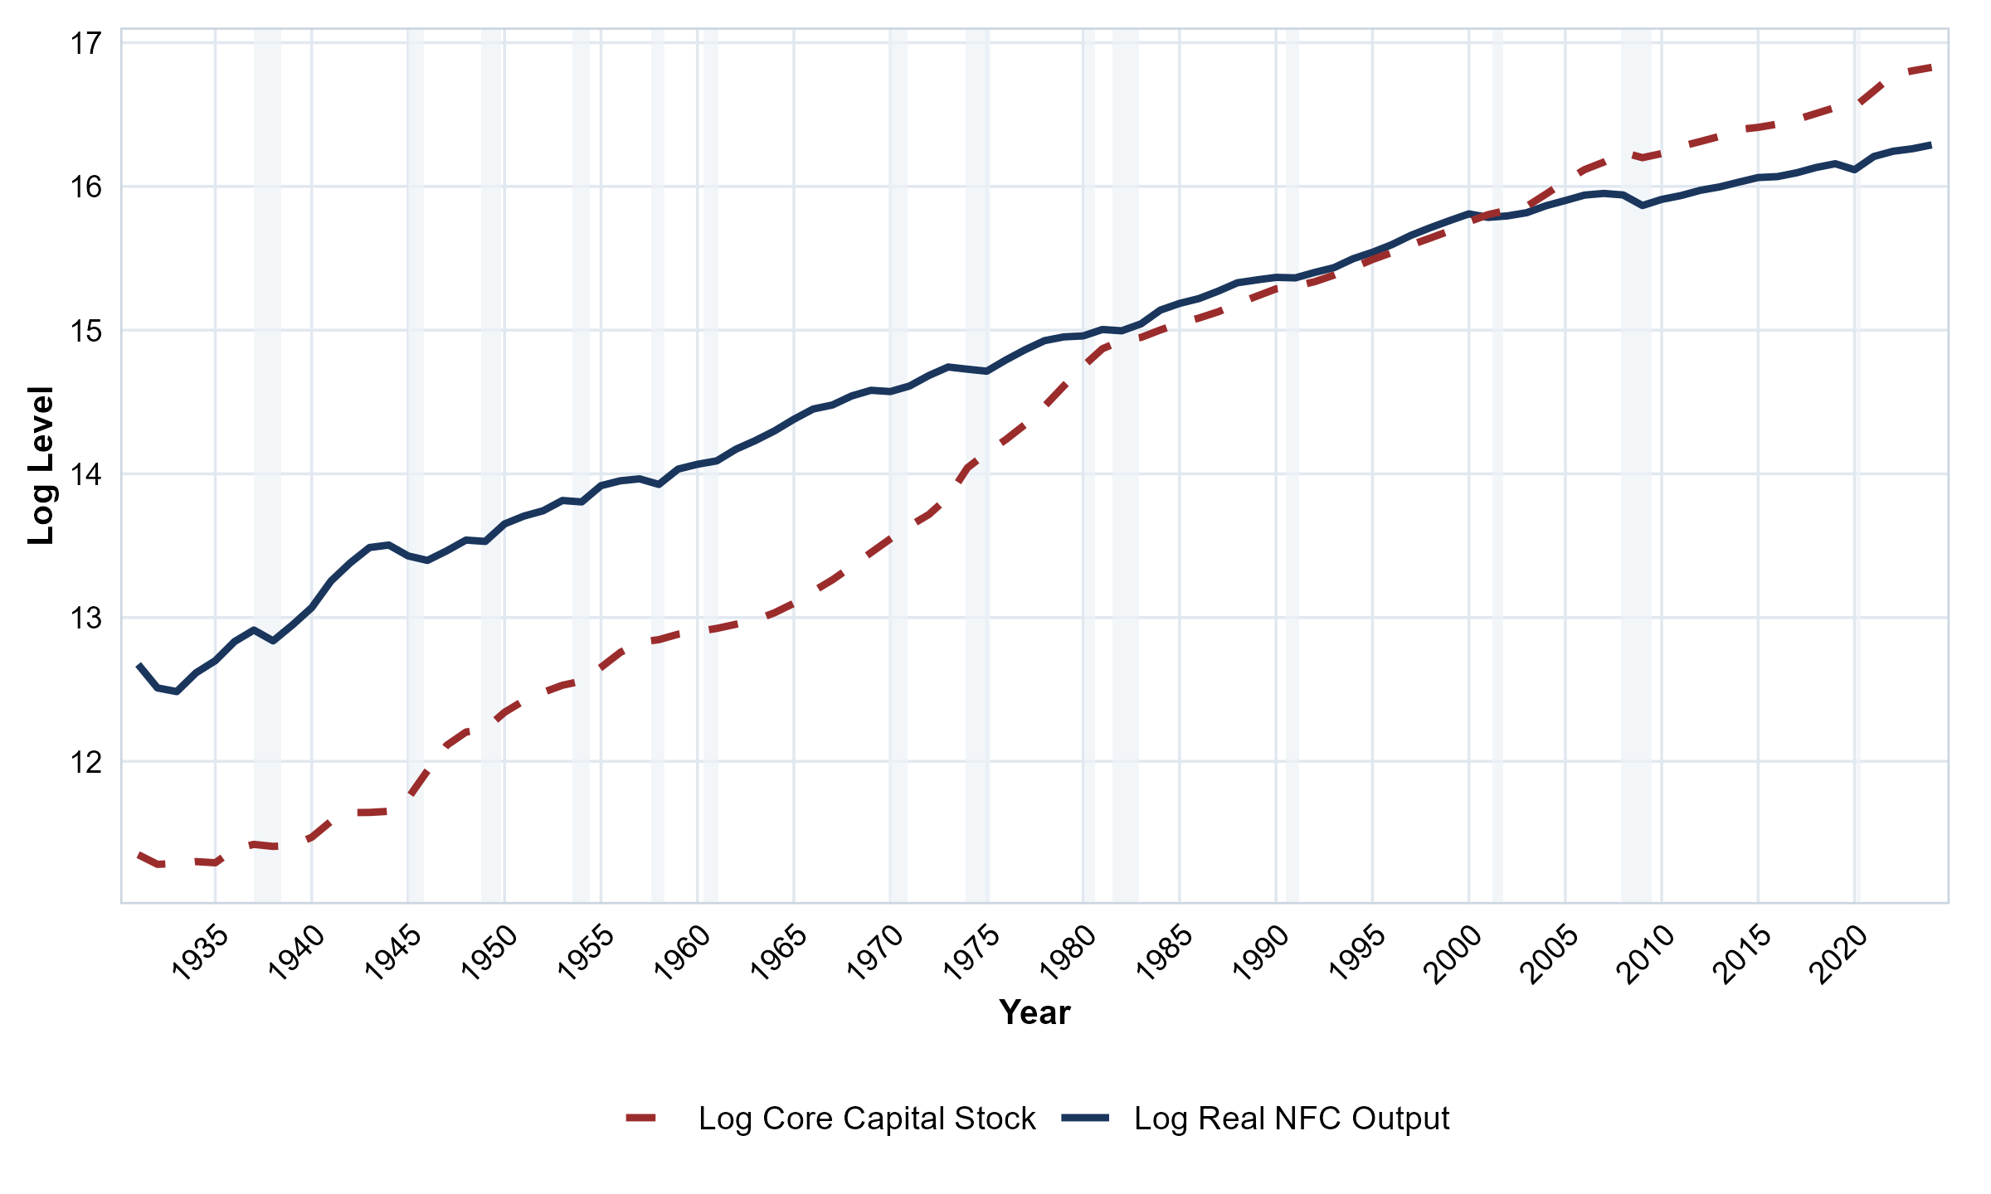
Figure 2: U.S. Log Output–Capital Ratio (y_t - k_t^cap
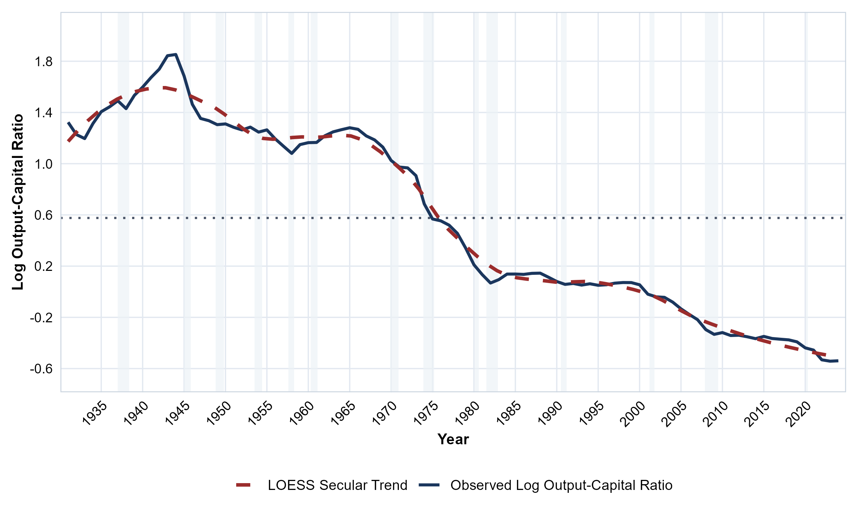
Figure 3: U.S. Annual Growth Rates of Real Output and Core Capital Accumulation (1931–2024)
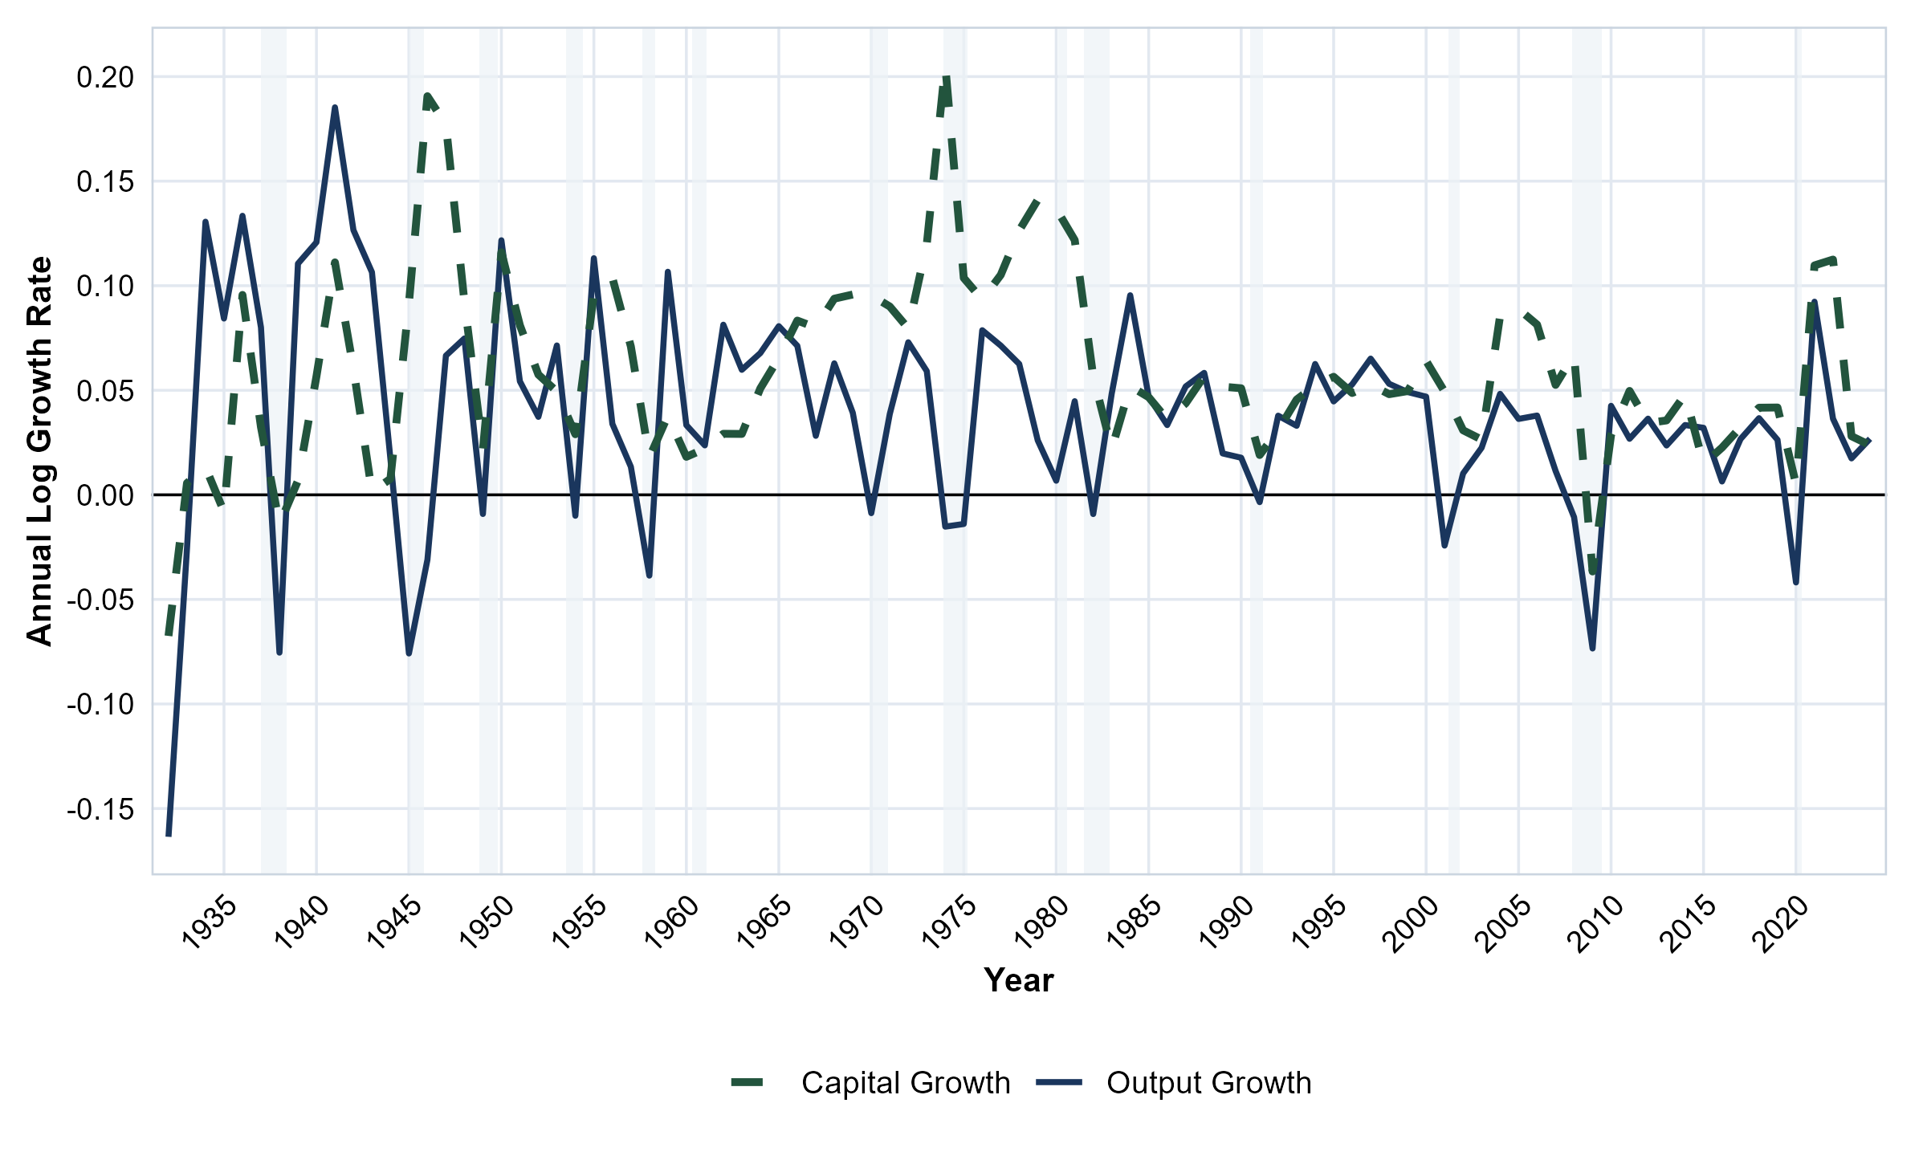
Figure 4: U.S. Wage Share Distributive Measures (1931–2024)
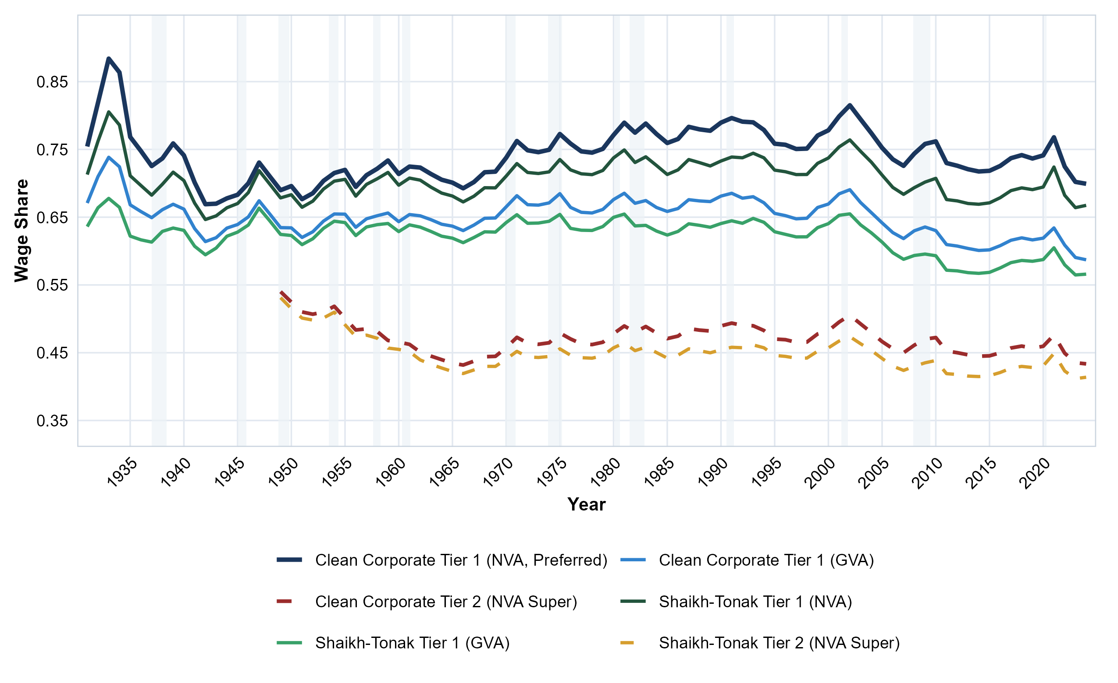

4.2.2 Stylized Facts of Peripheral Accumulation in Chile (1940–2010)
This section documents the stylized facts of the Chilean economy over the 1940–2010 sample. Table 5 presents summary statistics for the core macroeconomic, distributive, and external variables, capturing the long-run means and volatilities of real output, capital accumulation, income distribution, and the balance of payments. Because these aggregate moments obscure the pronounced historical regime shifts characteristic of the periphery, the following figures trace the temporal evolution of these series to highlight the structural breaks, distributive fractures, and variables related to the external constraints of peripheral capitalism that motivate the heterogeneous-capital analyitical framework previously presented in Section 3.3 and the threshold emirical strategy developed below.
Table 5: Chile Descriptive Statistics (1940–2010)
Variable | Mean | Std. Dev.
Log Real GDP (y_t) | 16.625 | 0.776
Log Core Capital Stock (k_t^cap) | 18.419 | 0.899
Log Output–Capital Ratio (y_t - k_t^cap) | -1.793 | 0.169
Capital Composition Gap (κ_t) | -1.106 | 0.211
Gross Wage Share (ω_t^gross) | 0.501 | 0.092
Net Wage Share (ω_t^net) | 0.802 | 0.121
Central Bank Solvency Ratio (S_t) | 2.102 | 2.201
Log Terms of Trade (\ln \textToT_t) | 0.030 | 0.263
Log Real Exports (\ln X_\textFOB,t) | 14.753 | 1.116
Log Machinery Investment (\ln I_t^ME) | 13.307 | 1.335
μlticolumn3p12.5cm Note: Sample window spans 1940–2010 (N = 71). Real GDP and capital stock components sourced from Díaz, Lüders and Wagner (2016) and Pérez and Eyzaguirre (2021). Core capital stock is K_t^cap = K_t^ME + K_t^NRC. Capital composition gap κ_t = k_t^ME - k_t^NRC. Both Gross wage share (nominal compensation / nominal GDP) and Net wage share (nominal compensation / nominal NVA) are evaluated in nominal terms. Structural threshold \hatγ = 0.425 separates binding foreign exchange bottleneck regimes.

Figure 5 plots log real GDP ($y_{t}$) and the aggregate gross core capital stock ($k_{t}^{cap}=ln[K_{t}^{\text{ME}}+K_{t}^{\text{NRC}}]$) on the same 2003 CLP price basis for Chile (1940–2010). Over seven decades, output and capital drift together along a shared upward trajectory, motivating the cointegrating specification. Dotted vertical lines mark the 1973 military coup and 1990 the post-dictatorship period.
Figure 6 plots the corresponding log output–capital ratio ($y_{t}−k_{t}^{cap}$) for Chile, providing the symmetric parallel to the U.S. series. Unlike the continuous secular decline in the center, the peripheral output–capital ratio exhibits pronounced regime shifts: rising during the initial state-led ISI phase (1940–1955), collapsing during the 1972–1975 breakdown and the 1982 debt crisis, and settling into an unconstrained expansion during the 1990s commodity boom.
Figure 7 plots the mechanization
gap $κ_{t}=k_{t}^{\text{ME}}−k_{t}^{\text{NRC}}$ (mean $−1.106$, SD
$0.211$, Table 5). The gap widens from the
late 1940s through state-led ISI to 1972, stagnates under the early
neoliberal regime with a debt-boom hump at 1981 and a post-crisis trough in
the late 1980s, and rises sharply after redemocratization, when
export-oriented mining pulled machinery accumulation ahead of structures.
The gap is therefore a regime-shifting series rather than a smooth trend,
which is what motivates the heterogeneous-capital specification in which
$θ$ depends on $κ_{t}$.
Figure 8 documents the distributive side,
drawn from the revised real-wage dataset of Astorga (2017) and Astorga (2023)
spliced with the national accounts. The gross wage share (mean 0.501, SD
0.092) peaks at $0.69$ in 1972 under Unidad Popular redistribution,
collapses to $0.40$ by 1975 after the military coup, recovers partially during the
debt boom that ends in 1982, and stabilizes under the post-dictatorship democratic
regime. The net wage share $ω_{t}^{\text{net}}=ω_{t}^{\text{gross}}/(1−{\text{CFC\backslash _ratio\backslash _nom}}_{t})$ (mean 0.768, SD 0.117, Table 5) sits systematically above the gross share due to consumption of fixed capital; both series follow the same structural fractures. Two empirical facts matter for estimation: the 1972–1975 swing is the largest distributive shock in the sample, and the post-1990 wage-share stabilizes while the external accounts are mostly slack, which is what identifies the unconstrained mechanization response.
Figure disaggregates the external
bottleneck into its components. The solvency ratio (Panel a), central bank
reserves relative to base money, is flat and low until 1975, jumps after the
debt crisis as the Bank accumulated reserves, and declines again after the
mid-2000s. The terms of trade (Panel b) deteriorate through the 1970s and
1980s and recover only with the commodity super-cycle. Real exports
(Panel c) grow smoothly, so the binding episodes are driven by reserve
solvency and import demand rather than by export failure; the import
imbalance series follows the World Historical Balance of Payments database
of Nievas and Piketty (2025). Machinery investment (Panel d) grows in bursts
separated by the crisis dates, consistent with mechanization that is
interrupted rather than smoothly accumulated. Section 4.5 assembles these
components into the composite index through a grid search, and estimates the threshold at which the external constraint becomes binding and counteract the mechanization bias productivity gain.
Figure 5: Chilean Log Real GDP and Aggregate Gross Core Capital Stock (1940–2010)
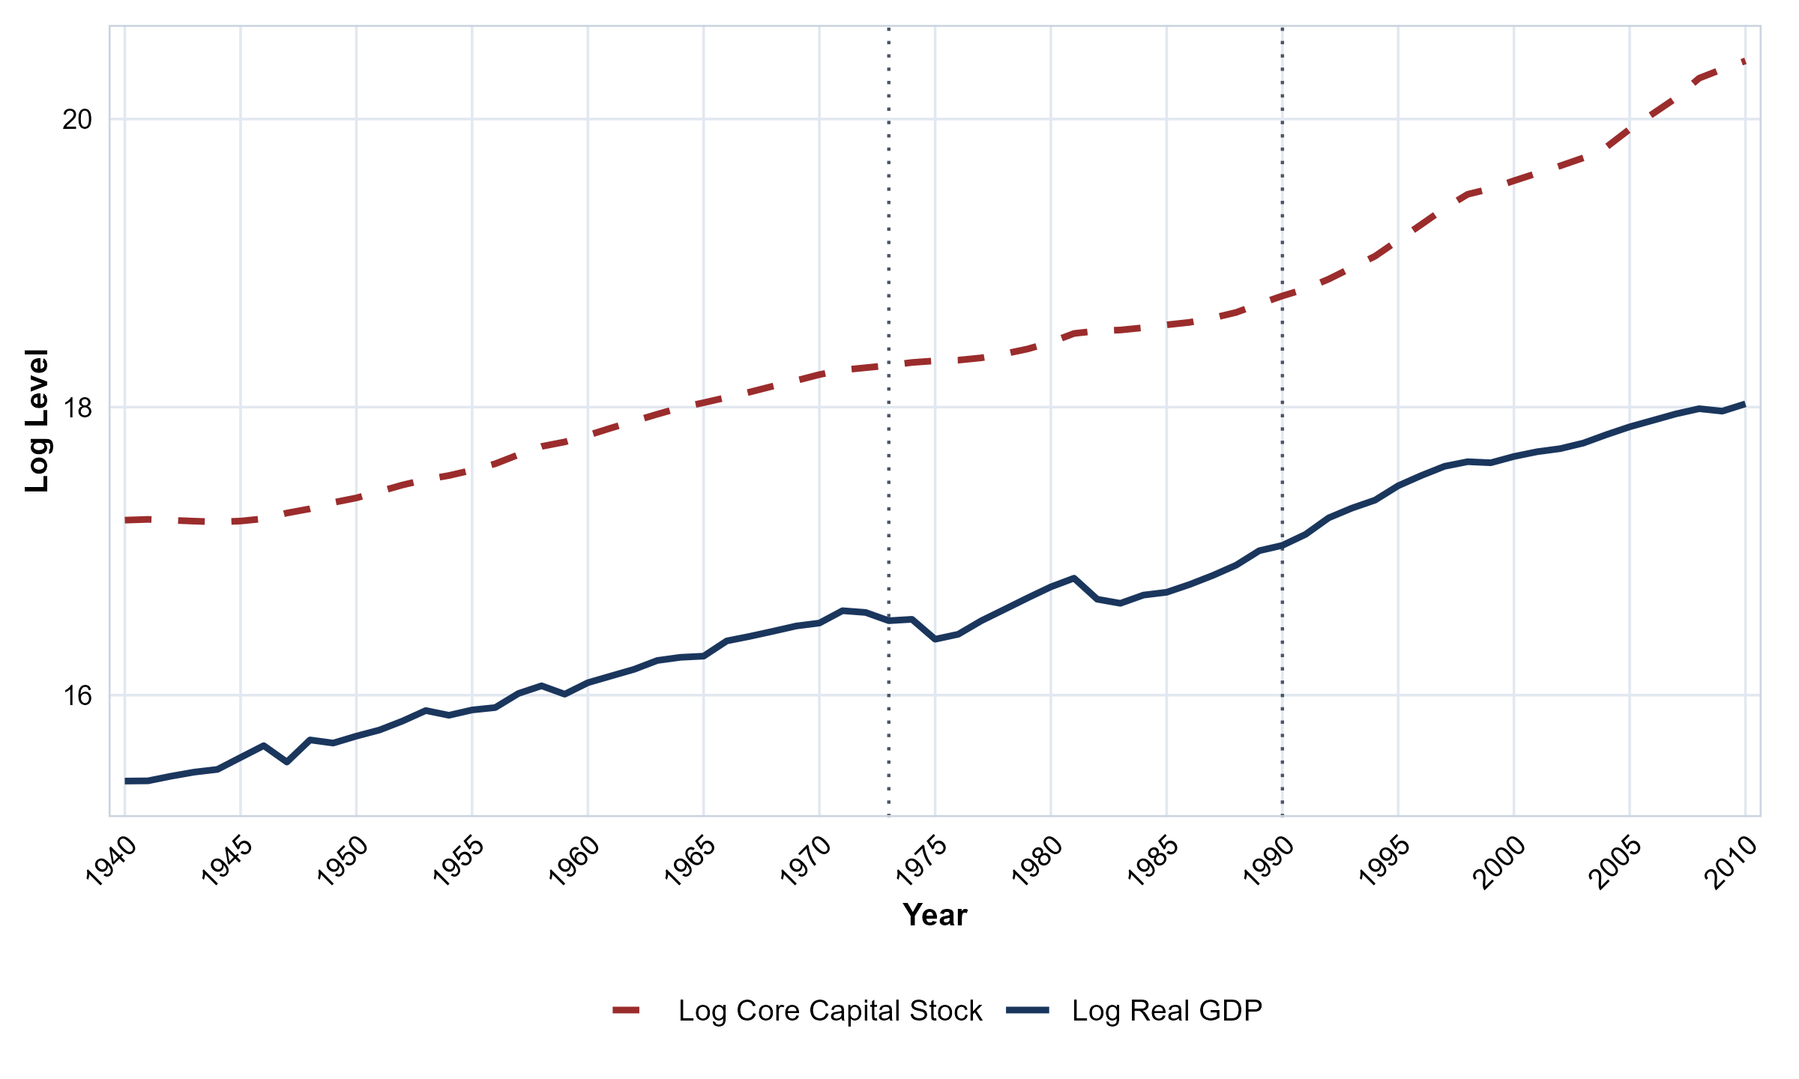
Figure 6: Chile: Log Output–Capital Ratio (y_t - k_t^cap
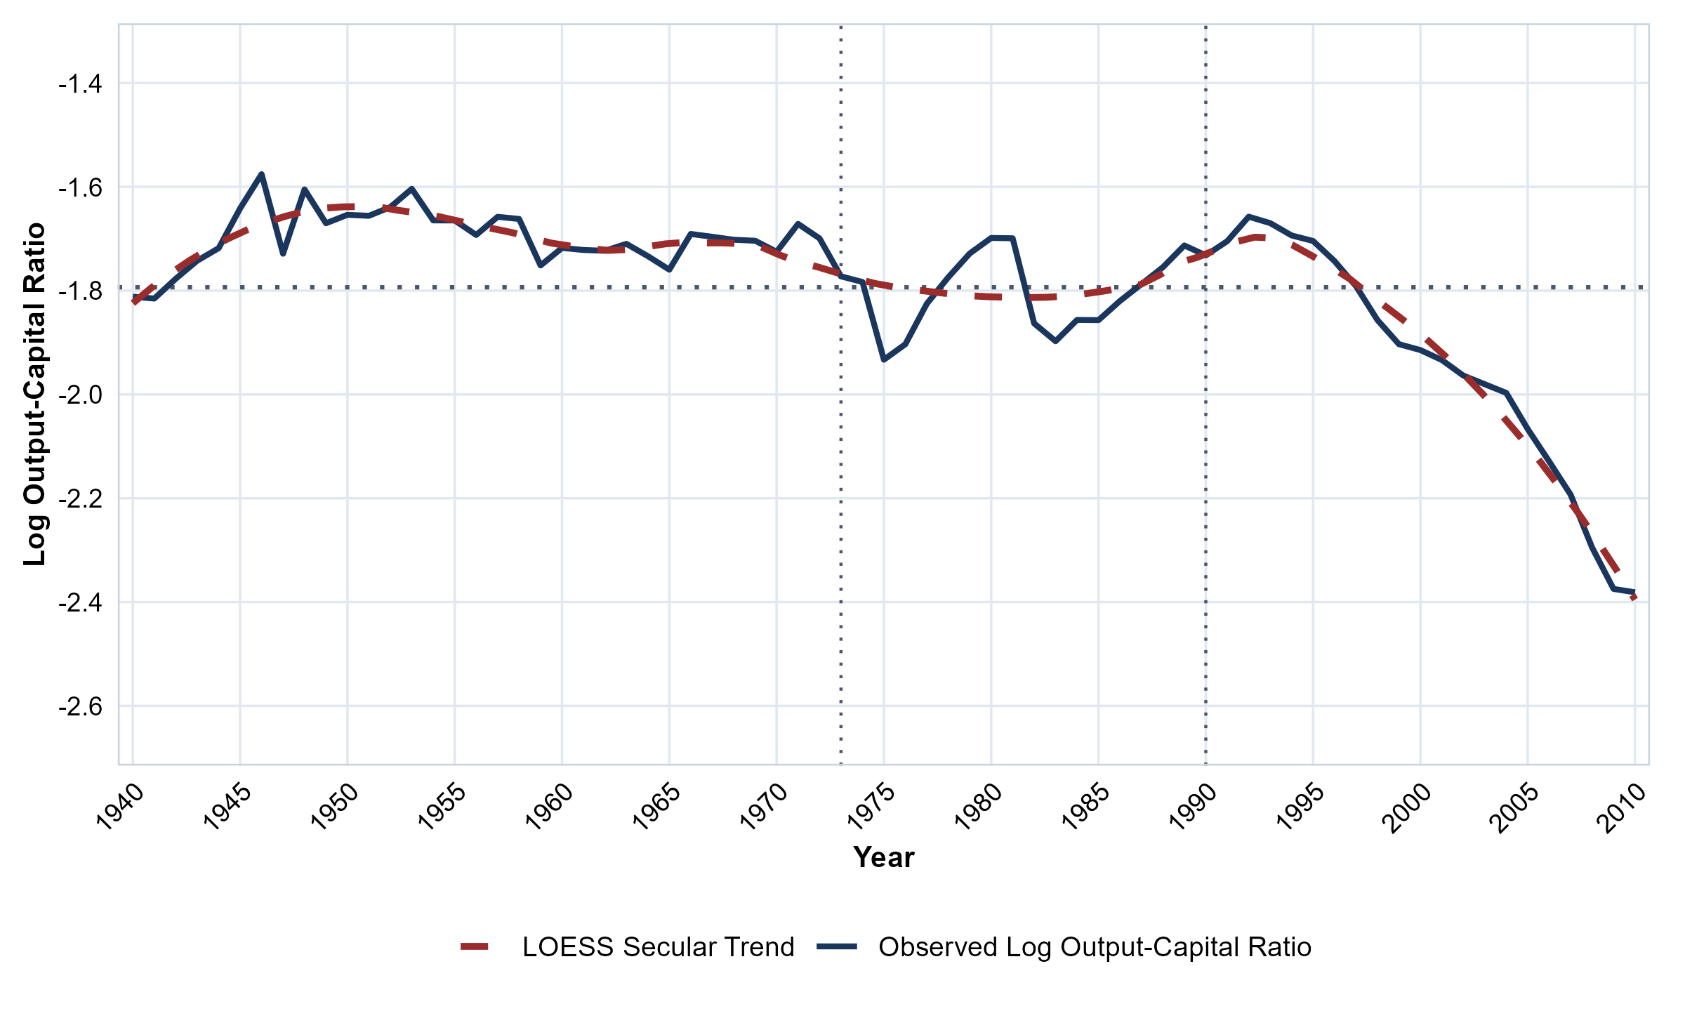
Figure 7: Chilean Capital Composition and Mechanization Gap (κ_t = k_t^\textME
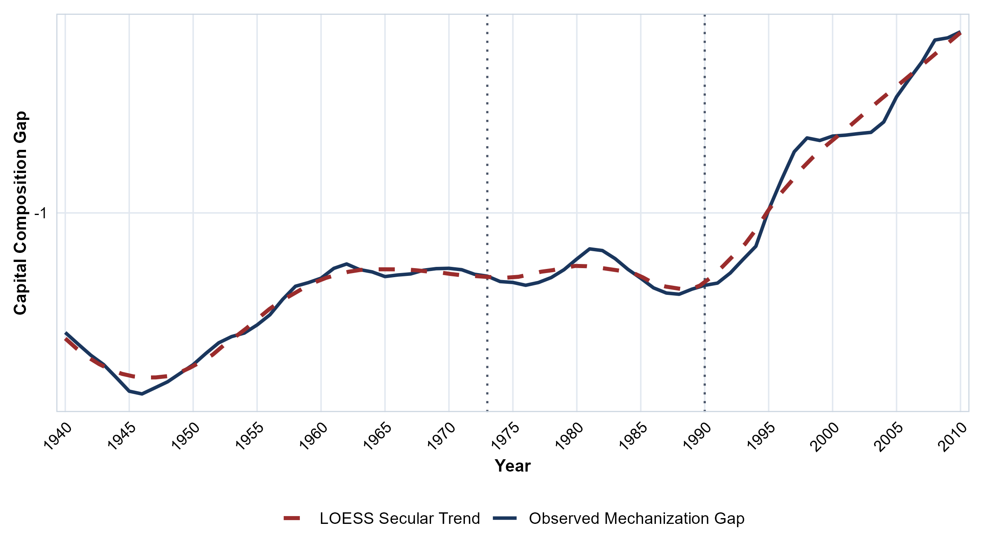
\vspace{1.5ex}
Figure 8: Chilean Wage Share Trajectories (ω_t^\textgross
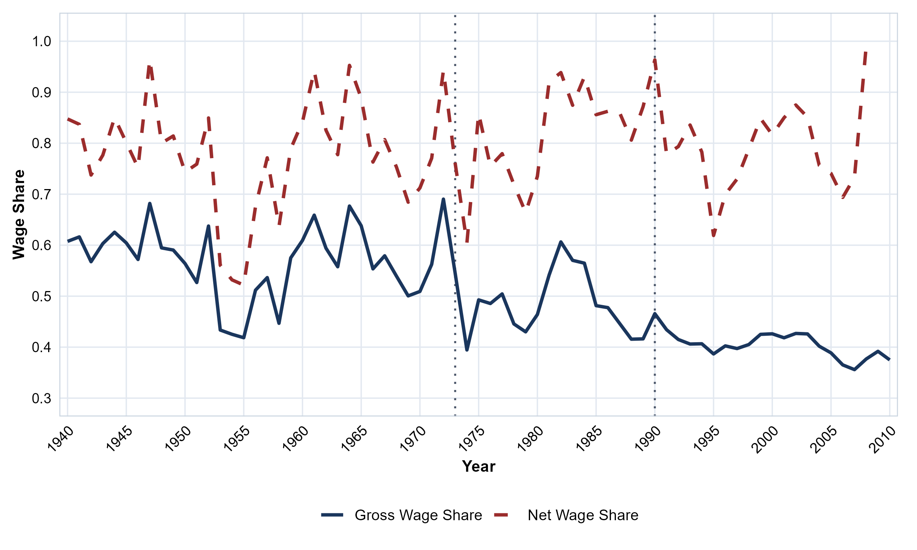

4.3 Estimation Strategy: Cointegration and IM-OLS

The cointegrating regression.. The transformation elasticity $θ$ is estimated from the
cointegrating regression
$y_{t}=α+θ_{0}k_{t}+θ_{1}(k_{t}×ω_{t−1})+u_{t},$ | (56)
where $y_{t}=lnY_{t}$ is log real output, $k_{t}=lnK_{t}$ is log
real capital stock, and $ω_{t−1}$ is the lagged wage share.
The regressors $k_{t}$ and $k_{t}×ω_{t−1}$ are integrated
of order one, and the error term $u_{t}$ is stationary under the null
hypothesis of cointegration. The interaction term
$k_{t}×ω_{t−1}$ is included in the regression to allow
the transformation elasticity to vary with the distributive state:
the effective elasticity is $θ(ω_{t−1})=θ_{0}+θ_{1}ω_{t−1}$.
The IM-OLS estimator.. The OLS estimator of $θ$ in (57) is
super-consistent but its limiting distribution is contaminated by
second-order bias terms arising from endogeneity of the regressors
and serial correlation in the error term
(Phillips and Hansen, 1990). The Integrated Modified OLS (IM-OLS)
estimator of Vogelsang and Wagner (2014) removes these bias terms
without requiring the choice of tuning parameters (kernel function,
bandwidth, or lead-lag truncation order) at the estimation stage.
The IM-OLS estimator is based on a two-step transformation. First,
the partial sum transformation is applied to
(57):
$S_{y,t}=S_{α,t}+θ_{0}S_{k,t}+θ_{1}S_{kω,t}+S_{u,t},$ | (57)
where $S_{y,t}=\sum_{j=1}^{t}{y_{j}}$ and analogously for the
remaining terms. The partial sum transformation replaces the
cross-product terms $\sum_{t=1}^{T}{x_{t}u_{t}}$, whose limits contain
additive nuisance parameters, with partial-sum cross-products
$\sum_{t=1}^{T}{S_{x,t}S_{u,t}}$, whose limits do not. Second,
the partial-sum regression is augmented by the original regressors
$k_{t}$ and $k_{t}×ω_{t−1}$:
$S_{y,t}=S_{α,t}+θ_{0}S_{k,t}+θ_{1}S_{kω,t}+k_{t}γ_{1}+(k_{t}×ω_{t−1})γ_{2}+S_{u,t}.$ | (58)
The augmentation absorbs the endogeneity correlation into the
coefficients $γ_{1}$ and $γ_{2}$, yielding a zero-mean
Gaussian mixture limiting distribution for the IM-OLS estimator of
$(θ_{0},θ_{1})$ conditional on the Brownian motions driving
the regressors (Vogelsang and Wagner, 2014, Theorem 2).
FWL orthogonalization of the interaction term.. The interaction term $k_{t}×ω_{t−1}$ is correlated with
$k_{t}$ by construction. To isolate the distributive mediation effect,
the interaction term is orthogonalized against $k_{t}$ and the
deterministic regressors using the Frisch-Waugh-Lovell (FWL)
theorem (Frisch and Waugh, 1933; Lovell, 1963). Denoting the raw interaction by
$ξ_{t}=k_{t}×ω_{t−1}$, the orthogonalized interaction
$ξ_{t}^{⟂}$ is the residual from the auxiliary regression of
$ξ_{t}$ on $k_{t}$ and the deterministic regressors. The IM-OLS
estimator is then applied to the regression with $ξ_{t}^{⟂}$
replacing $ξ_{t}$. When structural break dummies are included in
the deterministic regressors (see below), the FWL orthogonalization
is re-computed against the augmented deterministic space.
Endogenous structural break detection.. The estimation employs a two-pass endogenous break detection
procedure based on Bai and Perron (2003). In the first pass, the
IM-OLS estimator is applied to (57) without
break dummies. The Bai-Perron sequential procedure is then applied
to the IM-OLS residuals to detect structural breaks at unknown
dates, with a minimum segment size of 15% of the sample. In the
second pass, step dummies $D_{t}^{(b)}=1\{t≥{\overset{^}{T}}_{b}\}$ are included in the deterministic regressors for each
detected break date ${\overset{^}{T}}_{b}$, the FWL orthogonalization is
re-computed, and the IM-OLS estimator is re-estimated.
Fixed-b inference.. Standard asymptotic theory treats the bandwidth $M$ in long-run
variance estimation as vanishing relative to the sample size
($M/T→0$). Under this assumption, the long-run variance
estimator converges to a constant, and $t$- and Wald statistics
are compared to normal or chi-squared critical values. In finite
samples with serially correlated errors and endogenous regressors,
however, the bandwidth choice materially affects the sampling
distribution of test statistics, and the standard approximation
over-rejects (Kiefer and Vogelsang, 2005). Fixed-$b$ asymptotic
theory addresses this by treating the bandwidth ratio
$b≡M/T$ as a fixed constant rather than a vanishing
sequence. The long-run variance estimator then converges not to a
constant but to a random variable whose distribution depends on
the kernel function, the bandwidth ratio $b$, the number of
integrated regressors, and the deterministic specification.
Critical values that reflect these choices can be tabulated by
simulation, and using them substantially reduces size distortions
at the cost of only minor losses in power
(Vogelsang and Wagner, 2014).
For testing $q$ linear restrictions $H_{0}:Rθ=r$, the
fixed-$b$ Wald statistic is
$W^{*}=(R\overset{\sim }{θ}−r)^{′}\left[RA_{\text{IM}}{\overset{\sim }{V}}_{\text{IM}}A_{\text{IM}}^{′}R^{′}]^{−1}(R\overset{\sim }{θ}−r),\right.$
where ${\overset{\sim }{V}}_{\text{IM}}$ is the IM-OLS covariance estimator
constructed from the adjusted residuals
$Δ{\overset{\sim }{S}}_{t}^{u*}$ (defined below). Under fixed-$b$
asymptotics, $W^{*}$ converges to
$W^{*}⇒\frac{χ_{q}^{2}}{Q_{b}({\overset{\sim }{P}}^{*},{\overset{\sim }{P}}^{*})},$
where $χ_{q}^{2}$ is a chi-squared random variable with $q$
degrees of freedom—one per restriction tested—and
$Q_{b}({\overset{\sim }{P}}^{*},{\overset{\sim }{P}}^{*})$ is a positive random
variable that captures the effect of the bandwidth and kernel
choices on the long-run variance estimator. The two quantities
in (Equation) are independent of each other
(Vogelsang and Wagner, 2014, Lemma 2, Proposition 3). This
independence is the operative property: it renders the limiting
distribution of $W^{*}$ free of unknown nuisance parameters, so
that critical values depend only on the known features of the
specification—the kernel, the bandwidth ratio $b$, the number
of integrated regressors, and the deterministic components—and
can be tabulated by simulation. Critical values for the Bartlett
kernel with intercept-only deterministics and up to four
integrated regressors are provided in the online supplement to
Vogelsang and Wagner (2014). Because the fixed-$b$ distribution is
jointly indexed by the bandwidth ratio and the number of integrated
regressors, no single tabulated constant applies across the
specifications estimated here; the significance thresholds reported
in every results table are therefore obtained by direct Monte Carlo
simulation of the exact data-generating process under test.
Appendix app:critical_values collects the fixed critical
values used for the residual-based diagnostics and states the
simulation protocol for the fixed-$b$ Wald statistics.
The adjusted residuals $Δ{\overset{\sim }{S}}_{t}^{u*}$ used for
long-run variance estimation are obtained in two steps. First,
the IM-OLS residuals ${\overset{\sim }{S}}_{u,t}$ from
(59) are correlated with the IM-OLS
estimator $\overset{\sim }{θ}$ even asymptotically, because the
partial-sum regression contains integrated regressors. This
correlation prevents the residuals from being used directly
for fixed-$b$ inference. Second, to remove this correlation,
${\overset{\sim }{S}}_{u,t}$ is projected on a set of constructed
regressors $H_{t}^{⟂}$ (functions of the partial sums of the
deterministic components and the integrated regressors), yielding
$Δ{\overset{\sim }{S}}_{t}^{u*}=Δ{\overset{\sim }{S}}_{u,t}−ΔH_{t}^{⟂′}\overset{^}{ϱ},$
where $\overset{^}{ϱ}$ is the OLS coefficient vector from the
regression of ${\overset{\sim }{S}}_{u,t}$ on $H_{t}^{⟂}$. The resulting
adjusted residuals are asymptotically independent of
$\overset{\sim }{θ}$, which is the condition required for the
numerator and denominator in (Equation) to be
independent and for the critical values to be pivotal.
Cointegration testing.. Two complementary tests are employed to assess the presence of a
cointegrating relationship. First, the null hypothesis of
cointegration is tested using a Shin (1994) type KPSS statistic
applied to the IM-OLS residuals (Wagner and Hong, 2016; Wagner, 2023):
$C_{T}=\frac{1}{T^{2}{\overset{^}{ω}}_{u·v}^{2}}\sum_{t=1}^{T}{{\left(\sum_{j=1}^{t}{{\overset{^}{u}}_{j}}\right)}^{2},}$ | (59)
where ${\overset{^}{ω}}_{u·v}^{2}$ is a consistent estimator of
the conditional long-run variance $ω_{u·v}^{2}=Ω_{uu}−Ω_{uv}Ω_{vv}^{−1}Ω_{vu}$. Under
the null hypothesis of cointegration, $C_{T}$ converges to a
functional of standard Brownian motions whose critical values depend
on the number of integrated regressors included in the regression
and the deterministic specification (Wagner, 2013; Wagner, 2023). Second,
the null hypothesis of no cointegration (spurious regression) is
tested using the augmented Dickey-Fuller statistic applied to the
OLS residuals with MacKinnon (2010) finite-sample
critical values, with the lag order selected by the Akaike
information criterion. Rejection of the null hypothesis of no
cointegration combined with non-rejection of the null hypothesis of
cointegration constitutes evidence for a cointegrating relationship.

4.3.1 Integration Order and Stochastic Properties: United States

In Cointegrating Multivariate Polynomial Regressions (CMPR) estimated via Integrated Modified OLS (IM-OLS) (Vogelsang and Wagner, 2014; Vogelsang and Wagner, 2024), valid asymptotic inference and pivotal fixed-$b$ Wald distributions require all stochastic regressors to be integrated of order one ($I(1)$). When non-linear interaction terms ($k_{t}×ω_{t−1}$, $k_{t}×ω_{t−1}×(1−ι_{t−1})$) enter the long-run relation, establishing their stochastic integration order prior to estimation is an essential prerequisite. We evaluate the stochastic properties of U.S. series and their interactions over 1929–2024 ($T=96$) using Augmented Dickey-Fuller (ADF), DF-GLS, Phillips-Perron (PP), Kwiatkowski-Phillips-Schmidt-Shin (KPSS), and Zivot-Andrews (ZA) tests with endogenous structural breaks. The results confirm that log real output ($y_{t}$), core private gross capital ($k^{\text{cap}}$), the corporate Intellectual Property Products (IPP) gross investment share ($ι_{t}$), and distributive wage shares ($ω_{i}$) are clean $I(1)$ processes (rejecting level stationarity at $p<0.01$ under KPSS, and rejecting unit roots in first differences at $p<0.01$ under ADF and DF-GLS).
A central property concerns the capital composition ratio ($κ_{t}=k_{t}^{\text{ME}}−k_{t}^{\text{NRC}}$). Both Machinery ($k_{t}^{\text{ME}}$) and Structures ($k_{t}^{\text{NRC}}$) are established $I(1)$ series. When evaluated in first differences under a standard linear KPSS specification, $Δκ_{t}$ displays apparent persistence ($KPSS_{\text{diff}}=0.761,p<0.01$). This reflects the sharp post-1973 structural deceleration in mechanization (identified by the 1974 Zivot-Andrews break) rather than an $I(2)$ process (Perron, 1989). When $κ_{t}$ and capital stocks are interacted with distributive wage shares and corporate IPP investment shares ($ι_{t}×ω_{i}$, $κ_{t}×ι_{t}×ω_{i}$, $k^{\text{cap}}×ω_{i}$, $k^{\text{cap}}×ω_{i}×ι_{t}$), the bounded support of the wage and investment shares dampens the drift. All double and triple interaction terms are strictly $I(1)$ ($ADF_{\text{diff}}<−6.89,p<0.01;KPSS_{\text{diff}}<0.23$, failing to reject differenced stationarity), authorizing their inclusion in CMPR IM-OLS specifications.
The Zivot-Andrews endogenous structural break tests identify transition dates that track the institutional history of U.S. capital accumulation:
- 1972 / 1974: Capital stocks ($k^{\text{cap}}$) and capital composition ($κ_{t}$) break endogenously in 1972–1974 ($t_{\text{ZA}}=−4.79$ and $−3.63$), marking the exhaustion of the post-WWII Fordist accumulation boom.
- 1976: Corporate IPP investment share ($ι_{t}$) breaks in 1976 ($t_{\text{ZA}}=−4.53$), capturing the stagflation inflection toward intangible investments.
- 1984: All eight IPP-wage interactions ($ι_{t}×ω_{i}$) and triple interactions break strictly in 1984 ($t_{\text{ZA}}=−4.54$ to $−4.92$), reflecting the consolidation of the neoliberal regime under Reagan-Volcker through wage suppression and accelerated financialization.
- 2001–2003: Capital-wage interactions ($k^{\text{cap}}×ω_{i}$) shift endogenously in 2001–2003 ($t_{\text{ZA}}=−4.26$ to $−4.85$), reflecting post-dot-com labor market restructuring.
The complete unit-root test batteries, test statistics, and critical values across all U.S. series and interaction terms are documented in Tables 25–26 of Appendix app:integration_order.

4.3.2 Integration Order and Stochastic Properties: Chile

For the Chilean peripheral economy, the long-run estimation window spans 1943–2010 ($T=68$). The 1943 start date isolates a stable institutional regime established by Law No. 7,200 (1942), which abandoned gold-standard convertibility and oriented Central Bank credit toward state-led import substitution alongside CORFO. Historical ClioLab external constraint and terms-of-trade series end in 2010. Unit-root tests over this horizon confirm that aggregate real GDP ($y_{t}$), Nonresidential Structures ($k_{t}^{\text{NR}}$), Machinery and Equipment ($k_{t}^{\text{ME}}$), aggregate core capital ($k_{t}^{\text{cap}}$), and distributive wage shares ($ω_{t}^{\text{net}},ω_{t}^{\text{gross}}$) are $I(1)$ non-stationary processes.
The composite Balance-of-Payments index ($Z_{t}=0.2{\overset{\sim }{M}}_{t}+0.8{\overset{\sim }{S}}_{t}$), which combines the normalized import coverage ratio and terms of trade, rejects the unit root null in levels ($ADF=−6.661,p<0.01;KPSS=0.075$). It operates as a stationary threshold state variable that partitions accumulation regimes. Furthermore, while raw nonresidential structures ($k_{t}^{\text{NR}}$) display moderate differenced persistence, FWL-orthogonalized wage interaction residuals ($ξ_{t}^{ω}$) and the threshold-conditioned mechanization regressor ($k_{t}×ω_{t−1}×1\{Z_{t}≤0.425\}$) are strictly $I(1)$ ($ADF_{\text{diff}}<−10.10,p<0.01;KPSS_{\text{diff}}<0.06$), satisfying the stochastic admissibility criteria for threshold CMPR estimation.
The complete unit-root test batteries, test statistics, and critical values across all Chilean series and interaction terms are documented in Tables 27–28 of Appendix app:integration_order.

4.4 United States: Baseline Specification Empirical Results

4.4.1 Baseline Econometric Specification
I evaluate the empirical relationship between real aggregate output ($y_{t}=logY_{\text{REAL},t}^{\text{NFC}}$) and core physical productive capital stock ($k_{\text{cap},t}=log(K_{\text{ME},t}+K_{\text{NRC},t})$) for the nonfinancial corporate business sector over the 1929–2024 period. Under Specification A, the aggregate cointegrating equation takes the form:
$y_{t}=α+θ_{0}k_{\text{cap},t}+θ_{1}ξ_{t}^{ω}+γ^{′}D_{t}+u_{t},$ | (60)
where $ξ_{t}^{ω}$ denotes the Frisch-Waugh-Lovell (FWL) orthogonalized wage-capital interaction term, and $D_{t}$ contains step-shift dummies capturing historical structural breaks identified via Bai-Perron tests. The FWL orthogonalization partials out base capital regressors and deterministic step shifts prior to estimating the interaction elasticity $θ_{1}$, eliminating collinearity bias while preserving exact parameter identification (Vogelsang and Wagner, 2024). Two distinct interaction sets are estimated across 48 total model permutations: Set 1 incorporates the standard unconditioned wage interaction $ξ_{t}^{ω}=ω_{t−1}×k_{\text{cap},t}$, whereas Set 2 incorporates the effective wage pressure interaction $ξ_{t}^{ω}=ω_{t−1}(1−ι_{t−1})×k_{\text{cap},t}$, where $ι_{t−1}$ represents the lagged share of intellectual property products in total capital stock. All parameters are estimated via Cointegrating Multivariate Polynomial Regression (CMPR) IM-OLS (Vogelsang and Wagner, 2024), with non-standard fixed-$b$ critical values generated from a 100,000-pass Monte Carlo simulation suite matching the exact sample sizes ($T=94$ for 1931–2024 standard series; $T=77$ for 1948–2024 supervisory-adjusted series). Because capital stocks are constructed via Perpetual Inventory (GPIM) methods, any classical right-hand-side measurement noise in $k_{\text{cap},t}$ introduces standard attenuation bias that pulls ${\overset{^}{θ}}_{0}$ downward toward zero. Measurement error cannot explain why $θ<1$; rather, it reinforces that the true structural transformation elasticity is bounded strictly below unity.
Theoretical argument for the NVA basis of distributive conflict measure.. Class struggle over distribution is conducted strictly over newly created value ($\text{Net Value Added}=v+s$), excluding pre-existing constant capital transfers ($\text{Consumption of Fixed Capital}=\text{CFC}$). Under classical-Marxian national accounting (Shaikh and Tonak, 1994), $\text{Gross Value Added}=\text{CFC}+v+s$. Because physical depreciation ($\text{CFC}$) represents constant capital transferred to output by concrete labor, it lies outside zero-sum distributive conflict. During periods of intensive mechanization, the ratio $\text{CFC}/\text{GVA}$ rises mechanically, causing GVA-basis wage shares to appear to fall even when the rate of surplus-value extraction ($s/v$) is invariant. The NVA basis ($ω_{\text{NVA}}=v/(v+s)$) purges this physical depreciation distortion, isolating the true balance of class power. Standard NIPA compensation includes managerial and executive salaries, which function as distributions of surplus value rather than variable labor costs. The Shaikh-Tonak Tier 2 ($ω_{\text{ST,Tier2}}=v_{\text{prod}}/\text{NFC\backslash _NVA}$) and Clean Corporate Tier 1 and Tier 2 measures strip supervisory overhead ($s_{\text{sup}}$) and purge financial sector double-counting (${\text{FIN\backslash _NOS}}^{\text{implied}}+\text{NFC\backslash _NET\backslash _INT}$), recovering the true variable capital ($v$) that drives corporate cost-minimization decisions. Note that unadjusted Shaikh-Tonak Tier 1 NVA ($\text{NFC\backslash _COMP}/\text{NFC\backslash _NVA}$) is mathematically identical to the NFC Baseline NVA share, rendering Clean Corporate and Tier 2 supervisory adjustments the primary non-redundant distributive specifications.
Institutional and physical mechanism of scaling by (1-ι_t-1. )$.\}Thescalingfactor$(1-\iota_{t-1}) = K_{\text{cap},t-1} / (K_{\text{cap},t-1} + K_{\text{IPP},t-1})$isolatesthephysicalproductiveassetshare(machinery,equipment,andstructures)fromtotalfixedcapital.Underinducedmechanizationmechanism,whenlaborcommandsalargershareofnewlycreatedvalue($\omega_{t-1} \uparrow$),profitmarginsshrink,forcingfirmstoacceleratedefensivemechanizationbysubstitutingcapitalequipmentforlivinglaborontheshopfloor.However,capitalexpenditureallocatedtoIntellectualPropertyProducts($K_{\text{IPP}}$)−−−softwarelicenses,corporatepatents,brandarchitecture,andlegalprotections−−−operatesasmarket−enclosureassetsratherthanphysicaloutput−yieldingmachinery.Ifcorporateinvestmentshiftstowardintangibles($\iota \uparrow$),thosefundsdonotengageinshop−floorlaborsubstitution.IntheFordistera($1931$−−$1973$),IPPcapitalwasnegligible($\iota \approx 0.02$−−$0.05 \implies 1-\iota \approx 0.95$),allowingrawwagepressuretomapdirectlyintophysicalmachineryexpansion.InthedigitalPost−Fordistera($1980$−−$2024$),IPPcapitalsurged($\iota > 0.28 \implies 1-\iota < 0.72$),divertingsubstantialsurplusintosoftwareandlegalenclosures.Unadjustedwageinteractions($\omega_{t-1} \times k_{\text{cap}}$inSet1)failacrossthefullsamplebecausetheyassumeeverydollarofcapitalstockhasanidenticalphysicalcapacityyieldacrossbothhistoricalregimes.Scalingby$(1-\iota_{t-1})$ purges this Post-Fordist structural shift, measuring the exact effective wage pressure that drives physical shop-floor labor substitution.
Cointegration verdict across the test triad.. The empirical validity of Specification A relies on mutual confirmation across the cointegration test triad: the Engle-Granger residual ADF test ($t_{\text{ADF}}$), the Shin (1994) LM test ($C_{\text{Shin}}$), and the Vogelsang-Wagner Type 2 Wald statistic ($S_{\text{Type 2}}$). Across all 48 specifications, the Shin LM test ($C_{\text{Shin}}≤0.04$, $p>0.10$) and the Vogelsang-Wagner Type 2 Wald statistic ($S_{\text{Type 2}}≤13.18$, well below the 90th percentile fixed-$b$ critical value threshold of $52.6$) fail to reject the null hypothesis of cointegration ($H_{0}:\text{Cointegration}$), confirming that residual variance remains stationary and bounded. Simultaneously, when Bai-Perron step shifts are included, the Engle-Granger residual ADF test rejects the null hypothesis of no cointegration ($t_{\text{ADF}}=−4.07$, $p<0.05$ in Column 4). This unanimous confirmation across all three tests establishes that aggregate real output and private core capital form a genuine, non-spurious long-run cointegrating relationship.
Set 1 results: failure of standard unadjusted wage interactions.. Tables 11 and 12 in Appendix app:specA_full_results present the Set 1 estimation results. Two key patterns emerge. First, the baseline capital transformation elasticity ${\overset{^}{θ}}_{0}$ is positive, highly stable, and statistically significant across all specifications ($0.55$–$0.61$, $p<0.01$), establishing that private core capital ($K_{\text{cap}}=K_{\text{ME}}+K_{\text{NRC}}$) yields a long-run output elasticity of approximately $0.58$. Second, the unadjusted standard wage interaction ${\overset{^}{θ}}_{1}$ fails to achieve statistical significance in every Set 1 model, with point estimates ranging from $−0.02$ ($t=−0.16$) in NFC Baseline GVA/NVA to $−0.20$ ($t=−1.95$) in Clean Corporate Tier 2 NVA. Unconditioned wage shares fail to capture the induced accumulation channel because raw wage measures conflate unproductive managerial overhead with productive variable labor and ignore the structural allocation of investment toward intellectual property products.
Set 2 results: effective wage pressure and defensive mechanization.. Table 6 presents the main-text Set 2 estimates for the Net Value Added basis, where wage pressure is scaled by productive capital accumulation $(1−ι_{t−1})$. When distributive conflict is evaluated over newly created net value and purged of supervisory overhead, effective wage pressure generates a statistically significant negative interaction elasticity ${\overset{^}{θ}}_{1}$. In the Clean Corporate Tier 1 NVA model with break shifts (Column 4), ${\overset{^}{θ}}_{1}=−0.30$ ($t=−5.00$, $p<0.05$). In the Clean Corporate Tier 2 NVA specification (Column 6), the coefficient reaches ${\overset{^}{θ}}_{1}=−0.49$ ($t=−3.77$, $p<0.05$), while in the Shaikh-Tonak Tier 2 specification (Column 8), ${\overset{^}{θ}}_{1}=−0.35$ ($t=−5.00$, $p<0.05$).
The negative sign of ${\overset{^}{θ}}_{1}$ provides empirical confirmation of the induced mechanization mechanism under Okishio's market anarchy. When productive labor commands a larger share of newly created value ($ω_{t−1}↑$), firms face squeezed profit margins and respond by accelerating defensive mechanization—substituting capital equipment for living labor to lower unit labor costs. However, because this defensive substitution is driven by cost containment rather than autonomous technological expansion, it increases the technical composition of capital without generating a proportional expansion in productive output capacity. High effective wage pressure depresses the marginal capacity yield of capital ($θ(ω_{t−1})=θ_{0}+θ_{1}ω_{t−1}(1−ι_{t−1})<θ_{0}$), constraining structural potential output $Y_{t}^{p}$ and driving capacity utilization dynamics across historical Fordist and Post-Fordist regimes.
Robustness across structural break specifications.. Controlling for Bai-Perron structural break step shifts ($D_{t}$) leaves the core interaction elasticities intact while enhancing cointegration test performance. Step shift dummies absorb historical level shifts—such as the 1944 wartime expansion, the 1967 profit squeeze, and the 1982 neoliberal transition—without altering the sign or statistical significance of the effective wage interaction ${\overset{^}{θ}}_{1}$. In the Clean Corporate Tier 1 model, controlling for step shifts increases the magnitude of ${\overset{^}{θ}}_{1}$ from $−0.04$ ($t=−0.50$, insignificant) to $−0.30$ ($t=−5.00$, $p<0.05$), while achieving strong residual cointegration ($t_{\text{ADF}}=−4.07,p<0.05$). This confirms that the conditioning effect of distributive pressure on capital transformation is a fundamental structural feature of U.S. capital accumulation rather than an artifact of unmodeled regime shifts.
Pedagogical counterfactuals: restriction and no-dummy breakdowns.. To make the empirical stakes transparent, consider two pedagogical counterfactuals:
- The Restriction Counterfactual ($\theta = 1$): Mainstream production-function approaches and statistical filters impose balanced growth ($θ=1$) a priori, assuming capacity expands one-for-one with capital accumulation. Under this restriction, the rapid post-war accumulation of private capital forces the estimated potential capacity path $Y_{t}^{p}=\overset{^}{B}K_{t}$ upward at an unsustainable rate. Consequently, the derived capacity utilization series $μ_{t}=Y_{t}/Y_{t}^{p}$ suffers a chronic, permanent downward collapse, falling to economically implausible levels below $60\%$ by the 2010s. Estimating $θ$ unconstrained recovers $\overset{^}{θ}≈0.58$, confirming that physical capacity expands at roughly half the pace of capital accumulation and generating a stationary, cyclical utilization trajectory ($80\%$–$95\%$) that oscillates around historical business cycle benchmarks.
- The No-Dummy Counterfactual (Spurious Regression): Estimating the cointegrating equation without institutional step-shift controls yields non-stationary residuals ($t_{\text{ADF}}=−1.84$, failing cointegration). Omitting the institutional breaks conflates long-run parameter stability with historical regime shifts. Incorporating endogenously dated step dummies for the 1944 wartime expansion, the 1973/1974 Fordist exhaustion, and the 1982/1984 Volcker-Reagan neoliberal transition restores residual stationarity ($t_{\text{ADF}}=−{4.07}^{**},p<0.05$). This confirms that historical class conflict and institutional periodization are active regulators of long-run econometric cointegration.
Table 6: Specification A, Set 2: Effective Wage Interaction (NVA Basis)
 | NFC NVA Baseline |  | Clean Corp Tier 1 |  | Clean Corp Tier 2 |  | ST Tier 2 NVA
 | (1) | (2) | (3) | (4) | (5) | (6) | (7) | (8)
\hatθ_0 (Capital Elasticity) | 0.58^*** | 0.56^*** | 0.58^*** | 0.65^*** | 0.57 | 0.56 | 0.57 | 0.55
 | (0.02) | (0.06) | (0.02) | (0.06) | (0.02) | (0.08) | (0.02) | (0.06)
\hatθ_1 (Effective Wage Pressure) | 0.00 | -0.17 | -0.04 | -0.30^** | -0.19 | -0.49 | -0.21 | -0.35
 | (0.10) | (0.07) | (0.08) | (0.06) | (0.08) | (0.13) | (0.08) | (0.07)
Step Shifts (D_T_b^\textstep) | No | Yes | No | Yes | No | Yes | No | Yes
C_\textShin [H_0: coint.] | 0.06 | 0.04 | 0.07^* | 0.03 | 0.06 | 0.04 | 0.06 | 0.04
S_\textType 2 [H_0: coint.] | 10.76 | 9.07 | 11.05 | 9.06 | 7.50 | 10.89 | 6.13 | 13.18
t_\textADF [H_0: no coint.] | -2.32 | -3.06 | -2.22 | -4.07^** | -1.84 | -2.58 | -2.00 | -2.72
Bandwidth ratio b | 0.298 | 0.169 | 0.280 | 0.165 | 0.272 | 0.237 | 0.259 | 0.237
Sample Size T | 94 | 94 | 94 | 94 | 76 | 76 | 76 | 76
Note: Dependent variable: y_t^NFC (log NFC real GVA). Estimated via Cointegrating Multivariate Polynomial Regression (CMPR) IM-OLS \citepVogelsangWagner2024. Step Shifts "No": no structural break dummies; "Yes": Bai-Perron step dummies included. All interaction terms are FWL-orthogonalized against base capital regressors and step dummies. The effective wage interaction is ω_t-1(1-ι_t-1) × k_cap,t, where ι_t-1 is the lagged IPP share of capital. Significance: ^*p<0.10, ^**p<0.05, ^***p<0.01. Stars for coefficient rows and cointegration tests are derived from a 100,000-pass Monte Carlo simulation suite mapping the exact DGP variant and fixed-b Wald tables. Standard errors in parentheses.

4.4.2 Baseline Transformation Elasticity and Capacity Utilization Estimates

The model presented in 6 column (4) yields a base capital
elasticity of ${\overset{^}{θ}}_{0}=0.58$ ($SE=0.02$, $p<0.01$)
and an effective wage interaction coefficient of
${\overset{^}{θ}}_{1}=−0.30$ ($SE=0.06$, $p<0.05$). The
state-dependent transformation elasticity then evolves over the long-run as:
$θ_{t}(ω_{t−1},ι_{t−1})=0.58−0.30·ω_{t−1}(1−ι_{t−1}),$ | (61)
where $ω_{t−1}$ is the lagged "Clean Corporate Tier 1 wage
share", i.e. which is calculated on a net value added basis and scaled by $1−ι_{t−1}$ which correspond to the shared of investment in tangible assets, i.e. where $ι$ refers to the
share of intellectual property products (IPP) over the total magnitude of gross capital formation. The latent capacity ceiling $Y_{t}^{p}$ follows the
differential law of motion $g_{Y^{p},t}=θ_{t}·g_{K_{cap},t}$, with $g_{K_{cap},t}=Δln(K_{ME,t}+K_{NRC,t})$ as the unbalanced growth closure, where the only source of accumulation demand that build productive capacities is the accumulation rate of physical capital in operation measured constant 2017 dollars. The level of productive capacities is reconstructed recursively,
$lnY_{t}^{p}=lnY_{t−1}^{p}+\left[0.58−0.30·ω_{t−1}(1−ι_{t−1})\right]\left[lnK_{cap,t}−lnK_{cap,t−1}\right],$ | (62)
using 1973 as a pinch year given its recorded as the maximum value of the FBR series on capacity utilization ($μ_{1973}=100\%$). Dividing
realized real GDP by the estimated trajectory of productive capacities, allows to identify the rate of
capacity utilization, $μ_{t}≡Y_{GDP,t}/Y_{t}^{p}×100$.
9 plots the both recovered variables.
Figure 9: Empirical Reconstruction of Transformation Elasticity,
Capacity Utilization, and Underlying Shifters in the United
States (1929–2024).
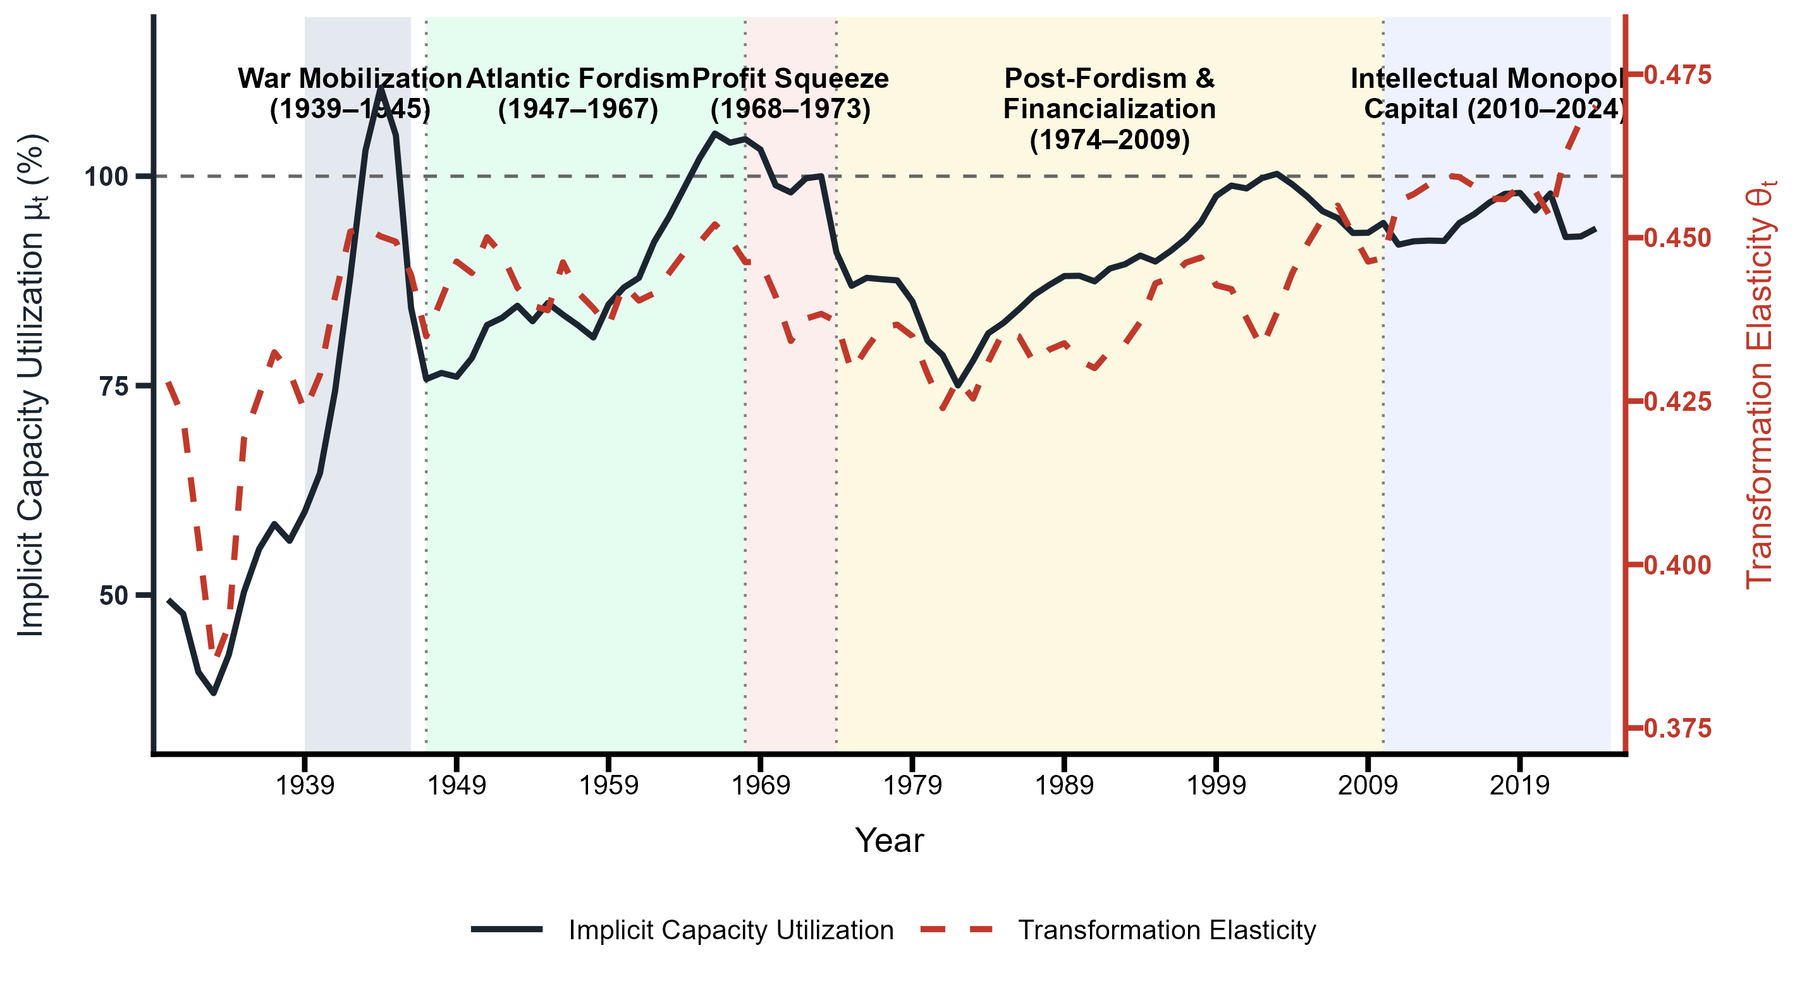
The two anchor years illustrate how distribution and capital
composition govern the capacity yield. In 1960 (Atlantic Fordism)
the Clean Corporate NVA wage share stood at $ω_{1959}=0.72$
while the IPP capital share was negligible
($ι_{1959}=0.03$). Effective wage pressure was
$0.72×(1−0.03)=0.698$, yielding
$θ_{1960}=0.58−0.30×0.698=0.371$: high wage
pressure forced Okishio-type defensive mechanization, depressing the
marginal capacity yield per dollar of physical capital advanced. By
2024 (Intellectual Monopoly Capitalism) the wage share had fallen to
$ω_{2023}=0.70$ while the IPP capital share had risen to
$ι_{2023}=0.28$. The intangible diversion reduced effective
wage pressure to $0.70×(1−0.28)=0.504$, raising the
transformation elasticity to
$θ_{2024}=0.58−0.30×0.504=0.429$.
9 traces five sub-regimes, and the
sequence matters more than any of them taken alone. War mobilization
(1939–1945) drove production past practical capacity limits under
state-directed military planning, lifting utilization to its historical
peak of $μ_{1944}=111.4\%$ while wartime retooling raised the
elasticity to roughly $0.455$. Atlantic Fordism (1947–1967) then
combined high wage shares ($ω_{t−1}≈0.70$–$0.73$) with
negligible intangible capital ($ι_{t−1}<0.05$), so labor-cost
pressure passed directly into mechanization and wage-led demand absorbed
the capacity that mechanization created. Utilization held a stable band
of roughly $85\%$ to $105\%$ and crossed $100\%$ during the mid-1960s
expansion—the only sustained stretch in the entire sample where
capacity formation and its realization moved together.
The profit squeeze (1968–1973) broke that correspondence without
breaking the mechanism. Distributional conflict compressed margins and
induced capital-deepening aimed at unit-cost containment rather than
expansion, pulling the elasticity down to $θ_{1972}=0.418$ while
utilization collapsed to $μ_{1975}=76.2\%$ and bottomed at
$μ_{1982}=74.1\%$ under the Volcker disinflation. Post-Fordism and
financialization (1974–2007) reversed the distributive pressure but not
the outcome: organized-labor concessions lowered wage shares while
investment moved toward software and patent enclosures
($ι_{t−1}>0.15$), cutting effective wage pressure from $0.72$ in
1974 to $0.66$ in 1997. The elasticity recovered from $0.418$ to
$0.450$, and utilization still failed to re-anchor to its Fordist peak,
staying below $95\%$ outside transient credit-fuelled expansions. Under
intellectual monopoly capitalism (2008–2024) intangible capital passed
$28\%$ of total fixed capital, pulling effective wage pressure to
$0.504$ and lifting the elasticity into its upper historical range
($θ_{2024}=0.429$–$0.470$) while wage suppression held back
realization, leaving $μ_{2024}=93.8\%$. Read across the five
regimes, the elasticity and utilization move together only under Fordism
and move against each other everywhere after it.
The reconstruction present empirical evidence supports that the long-run horizon does not yield a classical closure ($μ^{*}=100\%$),
but an unbalanced growth one $θ^{*}≠1$from where systemic disequilibrium arises through different patterns across distinct historical regimes.
While the Fordist accumulation regime through its commitment to full employment implemented policies oriented to sustain aggregate demand and avoid productive capacities to remain idle, during post-Fordism the expansion of productive capacity ($θ_{t}↑$) has decoupled from realization ($μ_{t}<1)$, causing persistent idle capacities as an institutional feature.

4.5 Empirical Estimates Under a Heterogeneous Capital Specification

4.5.1 Econometric Specification of Mechanization Bias and Heterogenous Capital
Specification A treats aggregate core capital $k_{\text{cap},t}=log(K_{\text{ME},t}+K_{\text{NRC},t})$ as a single regressor. This collapses the physical structure of the workplace into a scalar, obscuring whether wage pressure operates through the level of capital or through its composition—the relative weight of machinery and equipment ($K^{\text{ME}}$) versus nonresidential structures ($K^{\text{NRC}}$). Specification B decomposes the aggregate into two components: a structural base ($k_{t}^{\text{NRC}}=logK_{t}^{\text{NRC}}$) and the capital composition ratio ($κ_{t}=k_{t}^{\text{ME}}−k_{t}^{\text{NRC}}$), which measures the mechanization gap between equipment and structures in log-levels. The disaggregated cointegrating equation takes the form:
$y_{t}=α+θ_{\text{NRC}}k_{t}^{\text{NRC}}+θ_{κ}κ_{t}+θ_{ωκ}ξ_{t}^{ωκ}+θ_{κp}ξ_{t}^{pκ}+γ^{′}D_{t}+u_{t},$ | (63)
where $ξ_{t}^{ωκ}$ denotes the FWL-orthogonalized effective wage–mechanization interaction and $ξ_{t}^{pκ}$ denotes the FWL-orthogonalized relative price–mechanization interaction. Both interaction terms are residualized against the two base capital regressors ($k_{t}^{\text{NRC}},κ_{t}$) and deterministic step shifts ($D_{t}$) prior to estimation. The effective wage interaction under Set 2 is $ξ_{t}^{ωκ}=ω_{t−1}(1−ι_{t−1})×κ_{t}$; the relative price interaction is $ξ_{t}^{pκ}=p_{t}^{κ}×κ_{t}$, where $p_{t}^{κ}$ denotes the relative asset price ratio. Non-standard fixed-$b$ critical values are generated from a dedicated 100,000-pass Monte Carlo simulation engine that replicates the exact Specification B integration geometry—five independent $I(1)$ stochast
ic trends, two simultaneous $I(1)×I(1)$ interaction products, and joint FWL orthogonalization—matching the empirical sample sizes ($T=94$ and $T=77$).
Economic intuition of the decomposition.. The parameter $θ_{\text{NRC}}$ captures the long-run capacity yield of structures—factories, warehouses, commercial buildings—which embody extensive accumulation: expanding the physical envelope within which production occurs. The parameter $θ_{κ}$ captures the additional capacity yield of machinery and equipment above and beyond what structures deliver. A positive $θ_{κ}$ means that a wider mechanization gap—more equipment per dollar of structures—raises productive capacity independently of the total capital stock. The interaction $θ_{ωκ}$ asks whether effective wage pressure conditions this compositional margin. Under the Okishio-induced mechanization mechanism, rising wages force firms to substitute equipment for labor on the shop floor. If the resulting machinery expansion is defensive—driven by unit-cost containment rather than autonomous technical expansion—it raises the equipment-to-structures ratio without proportionally expanding output capacity, yielding $θ_{ωκ}<0$.
Standard wage interactions fail at the intensive margin.. Tables 16 and 17 in Appendix app:specB_full_results present the estimation results using the unadjusted wage share across all 24 specifications. The structural base elasticity ${\overset{^}{θ}}_{\text{NRC}}$ remains stable and highly significant ($0.47$–$0.61$, $p<0.01$), confirming that nonresidential structures anchor the cointegrating relationship regardless of wage measure or break treatment. The standalone mechanization gap ${\overset{^}{θ}}_{κ}$ is positive in nearly all models ($0.34$–$1.11$), indicating that equipment contributes to capacity above structures. The wage–mechanization interaction ${\overset{^}{θ}}_{ωκ}$, however, fails to achieve statistical significance in any $T=94$ model, with point estimates ranging from $−4.89$ ($t=−1.58$) to $+7.95$ ($t=1.33$). The standard wage interaction fails at the intensive margin for the same reason it fails at the aggregate level in Specification A: unadjusted wage shares conflate supervisory overhead with productive variable capital and ignore the post-Fordist diversion of investment toward intellectual property products.
Effective wage pressure and defensive mechanization at the intensive margin.. Table 7 presents the main estimates using the effective wage pressure measure for the NVA basis. When effective wage pressure is scaled by $(1−ι_{t−1})$ and interacted with the mechanization gap $κ_{t}$, the wage–mechanization interaction ${\overset{^}{θ}}_{ωκ}$ is negative and statistically significant across all eight models. In the preferred Clean Corporate Tier 1 NVA specification with Bai-Perron step shifts (Column 4), ${\overset{^}{θ}}_{ωκ}=−7.93$ ($SE=2.96$, $p<0.05$), with a structural base elasticity of ${\overset{^}{θ}}_{\text{NRC}}=0.60$ ($SE=0.08$, $p<0.01$) and a standalone mechanization gap of ${\overset{^}{θ}}_{κ}=0.39$ ($SE=0.29$). In the Shaikh-Tonak Tier 2 NVA specification without breaks (Column 7), the interaction strengthens to ${\overset{^}{θ}}_{ωκ}=−17.05$ ($SE=2.34$, $p<0.01$), with ${\overset{^}{θ}}_{\text{NRC}}=0.54$ ($SE=0.01$) and ${\overset{^}{θ}}_{κ}=0.33$ ($SE=0.06$, $p<0.01$). The Clean Corporate Tier 2 NVA models (Columns 5–6) yield ${\overset{^}{θ}}_{ωκ}=−14.97$ ($SE=2.01$, $p<0.01$), showing the tightest standard errors in the table.
The negative sign of ${\overset{^}{θ}}_{ωκ}$ provides direct evidence of defensive mechanization operating at the intensive margin of capital composition. Specification A established that effective wage pressure depresses the aggregate capacity yield of total capital (${\overset{^}{θ}}_{1}=−0.30$). Specification B isolates the channel: wage pressure forces firms to widen the mechanization gap—substituting equipment for structures on the shop floor—but the capacity yield of that compositional shift is negative. The firm accumulates more machinery per dollar of structures, yet productive capacity does not expand proportionally, because the substitution is driven by cost containment rather than by genuine technical complementarity between new equipment and existing plant.\footnote{The apparent difference in magnitude between Specification A (${\overset{^}{θ}}_{1}≈−0.30$) and Specification B (${\overset{^}{θ}}_{ωκ}≈−7.93$ to $−17.05$) reflects regressor scaling, not economic inconsistency. In Specification A, $θ_{1}$ multiplies $ω_{t−1}(1−ι_{t−1})×k_{\text{cap},t}$, where aggregate capital $k_{\text{cap},t}≈16$–$17$ in log-levels. In Specification B, $θ_{ωκ}$ multiplies $ω_{t−1}(1−ι_{t−1})×κ_{t}$, where the mechanization gap $κ_{t}=k_{t}^{\text{ME}}−k_{t}^{\text{NRC}}≈0.3$–$0.8$. The total marginal effect (coefficient $×$ regressor scale) is comparable across both specifications.}
Relative price interactions.. The relative asset price interaction ${\overset{^}{θ}}_{κp}$ is generally small and statistically insignificant. In the NFC Baseline and Clean Corporate Tier 1 models (Columns 1–4), it is statistically indistinguishable from zero. In the Shaikh-Tonak Tier 2 specification (Columns 7–8), ${\overset{^}{θ}}_{κp}=−0.79$ ($SE=0.32$, $p<0.05$), suggesting that when equipment becomes relatively more expensive, the capacity yield of the mechanization gap declines. However, this result is fragile and does not hold across wage share measures. The Okishio mechanism operates through distributional conflict over newly created value, not through relative asset prices.
Cointegration inference.. The effective wage models show strong evidence of cointegration. The Shin LM test never rejects the null of cointegration ($C_{\text{Shin}}≤0.03$, $p>0.10$), and the Vogelsang-Wagner Type 2 Wald statistic remains well below critical thresholds ($S_{\text{Type\sim 2}}≤15.37$). The Engle-Granger residual ADF test rejects the null of no cointegration at the 5% level in every break-adjusted model: $t_{\text{ADF}}=−4.58$ (Column 2), $−4.60$ (Column 4), $−4.71$ (Column 7), and $−4.57$ (Column 8). Without step shifts, the ADF test rejects at the 10% level across all $T=94$ models ($t_{\text{ADF}}≤−4.33$) and at the 5% level for the $T=76$ Shaikh-Tonak Tier 2 model ($t_{\text{ADF}}=−4.71$, Column 7). The full cointegration triad—Shin, Vogelsang-Wagner, and ADF—confirms that the disaggregated capital composition, real output, and effective wage pressure form a stable long-run relationship.
Robustness.. Including Bai-Perron step shifts absorbs historical level discontinuities, but leaves the sign and significance of the wage–mechanization interaction unchanged. In the Clean Corporate Tier 1 NVA model, controlling for breaks at 1944, 1977, and 2001 sharpens the ADF rejection from $−4.34$ ($p<0.10$) to $−4.60$ ($p<0.05$) while reducing the Vogelsang-Wagner statistic from $15.37$ to $6.37$. The wage interaction ${\overset{^}{θ}}_{ωκ}$ moves from $−11.08$ (Column 3) to $−7.93$ (Column 4). This modest attenuation indicates that the step dummies absorb part of the interaction's raw variance. The interaction remains negative and significant at the 5% level, confirming that the compositional conditioning channel survives institutional break controls.
The structural base elasticity ${\overset{^}{θ}}_{\text{NRC}}$ falls consistently within the $0.51$–$0.61$ band across wage share measures, closely tracking the aggregate ${\overset{^}{θ}}_{0}=0.58$ from Specification A. This implies the capacity yield of structures is a stable parameter of U.S.\ capital accumulation. The wage interaction ${\overset{^}{θ}}_{ωκ}$ grows larger in absolute value as I remove supervisory overhead from the wage share: from $−10.13$ in the NFC Baseline (Column 2) to $−7.93$ in Clean Corporate Tier 1 (Column 4) to $−16.76$ in Shaikh-Tonak Tier 2 (Column 8). Removing managerial salaries isolates the productive variable capital driving the firm's cost-minimization decision, which sharpens the defensive mechanization effect.
Table 7: Specification B, Set 2: Effective Wage Interaction (NVA Basis)
 | NFC NVA Baseline |  | Clean Corp Tier 1 |  | Clean Corp Tier 2 |  | ST Tier 2 NVA
 | (1) | (2) | (3) | (4) | (5) | (6) | (7) | (8)
\hatθ_NRC (Structures k^NRC) | 0.61^*** | 0.58^*** | 0.60^*** | 0.60^*** | 0.54^*** | 0.54^*** | 0.54^*** | 0.51^***
 | (0.02) | (0.08) | (0.02) | (0.08) | (0.01) | (0.01) | (0.01) | (0.01)
\hatθ_κ (Mechanization Gap κ) | 0.32^* | 0.39 | 0.32^* | 0.39 | 0.31^*** | 0.31^*** | 0.33^*** | 0.06
 | (0.13) | (0.29) | (0.13) | (0.29) | (0.06) | (0.06) | (0.06) | (0.09)
\hatθ_ωκ (Wage Interaction) | -12.77^** | -10.13^** | -11.08^** | -7.93^** | -14.97^*** | -14.97^*** | -17.05^*** | -16.76^***
 | (3.81) | (3.43) | (3.48) | (2.96) | (2.01) | (2.01) | (2.34) | (2.55)
\hatθ_κ p (Price Interaction) | 0.18 | 0.92 | 0.69 | 1.41^* | -0.31 | -0.31 | -0.79^** | -0.71^**
 | (0.51) | (0.69) | (0.63) | (0.75) | (0.33) | (0.33) | (0.32) | (0.31)
Step Shifts (D_T_b^\textstep) | No | Yes | No | Yes | No | Yes | No | Yes
C_\textShin [H_0: coint.] | 0.03 | 0.02 | 0.03 | 0.03 | 0.02 | 0.02 | 0.02 | 0.02
S_\textType 2 [H_0: coint.] | 14.97 | 5.93 | 15.37 | 6.37 | 8.96 | 8.96 | 10.28 | 8.70
t_\textADF [H_0: no coint.] | -4.33^* | -4.58^** | -4.34^* | -4.60^** | -4.24^* | -4.24^* | -4.71^** | -4.57^**
Bandwidth ratio b | 0.185 | 0.173 | 0.193 | 0.181 | 0.208 | 0.208 | 0.208 | 0.208
Sample Size T | 94 | 94 | 94 | 94 | 76 | 76 | 76 | 76
Note: Dependent variable: y_t^NFC (log NFC real GVA). Estimated via Cointegrating Multivariate Polynomial Regression (CMPR) IM-OLS \citepVogelsangWagner2024. Step Shifts "No": no structural break dummies; "Yes": Bai-Perron step dummies included. All interaction terms are FWL-orthogonalized against base capital regressors (k^NRC_t, κ_t) and step dummies. The effective wage interaction is \xi^ω_t = ω_t-1(1-ι_t-1) × κ_t, where κ_t = k^ME_t - k^NRC_t is the capital composition ratio (mechanization gap) and ι_t-1 is the lagged IPP share of capital. Significance: ^*p<0.10, ^**p<0.05, ^***p<0.01. Stars for coefficient rows and cointegration tests are derived from a 100,000-pass Monte Carlo simulation suite mapping the exact DGP variant and fixed-b Wald tables. Standard errors in parentheses.

4.5.2 Transformation Elasticity from Heterogeneous Capital Specification and Capacity Utilization Estimates
The transformation elasticity along the historical path.. Having established the structural asset-weighted transformation elasticity $θ_{t}^{\text{SpecB}}$ in Equation (22) (Section 3.2), I evaluate its empirical trajectory using the estimated parameters from the preferred Specification B model (Clean Corporate Tier 1 NVA, Set 2, Column 4 of Table 7). The structural marginal capacity yield of mechanization $MP_{κ,t}^{\text{str}}=β_{κ}+θ_{ωκ}C_{\text{index},t}+θ_{κp}p_{t}^{κ}$ is driven directly by the state-dependent levels of effective wage pressure ($C_{\text{index},t}$) and relative asset prices ($p_{t}^{κ}$).\footnote{Initial-observation
centering ($θ_{κ}^{\text{str}}=0.39$) is an anchoring convention
that identifies the baseline dimensionless yield at $t=1931$.}
% AUTHOR NOTE (not typeset): consider moving the centering convention into
% the methodology of Section 4.2.
Figure 10 plots $θ_{t}^{\text{Aggregate}}$ against the dynamic Specification A baseline ($θ_{t}^{\text{SpecA}}=0.58−0.30·C_{\text{index},t}$) and the Harrodian knife-edge threshold ($θ=1.00$) under standard structural regime shading.
Figure 10: Aggregate Transformation Elasticity (θ^\textAggregate
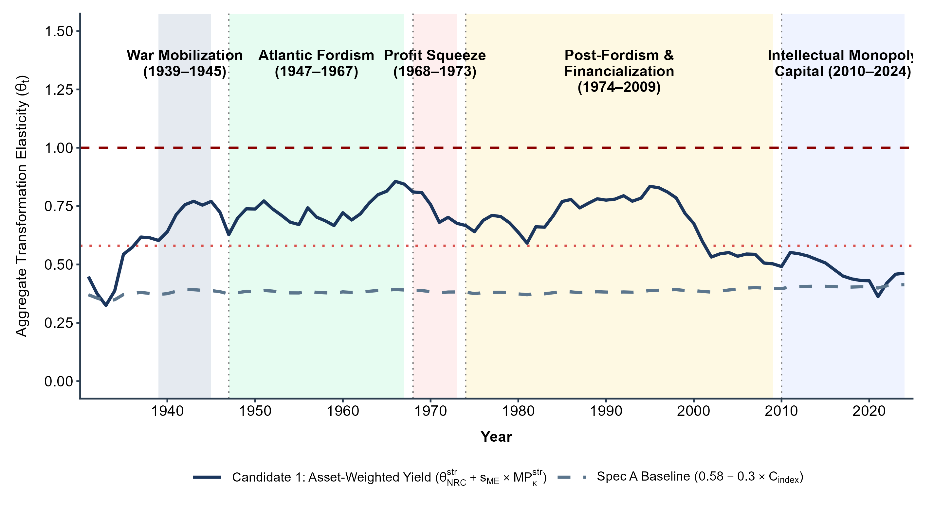
Empirical comparison: Specification B disciplines the Specification A baseline.. Figure 10 delivers two core empirical findings. First, the structural elasticity $θ_{t}^{\text{SpecB}}$ tracks the dynamic Specification A path closely but swings across a wider range—$[0.32,0.86]$ against $[0.37,0.75]$. The two paths move together because both register the same underlying force: effective wage pressure depresses the marginal capacity yield of capital under either specification, and the estimated base elasticity of structures (${\overset{^}{θ}}_{\text{NRC}}≈0.60$) sits close to Specification A's aggregate base (${\overset{^}{θ}}_{0}=0.58$). The wider swing is the point of the disaggregation rather than a cost of it: Specification A averages the composition effect into a single scalar, while Specification B lets the equipment share move the elasticity directly, so the same distributive shock registers with more amplitude. Second, the Specification B trajectory remains strictly below the Harrodian knife-edge ($θ<1$) across the entire 1931–2024 sample, so aggregate capacity formation in the United States never leaves the sub-Harrodian regime.
The disaggregated capital structure explains what Specification A's aggregate elasticity averages over. During the Fordist era ($C_{\text{index},t}>0.65$), high effective wage pressure drove negative marginal mechanization yields ($MP_{κ,t}^{\text{str}}<0$). Firms substituted equipment for labor to contain unit labor costs, but because this expansion was defensive rather than technically autonomous, it depressed the aggregate capacity yield of total capital. In the Neoliberal period ($C_{\text{index},t}<0.50$), declining wage pressure restored $MP_{κ,t}^{\text{str}}$ to positive territory, pulling $θ_{t}^{\text{Aggregate}}$ back toward the structural base. Specification A collapses this compositional mechanism into a scalar interaction (${\overset{^}{θ}}_{1}=−0.30$); Specification B opens the intensive margin and confirms the Okishio mechanism empirically.
Figure 11: Empirical Accumulation Path Derivatives (dk^\textME
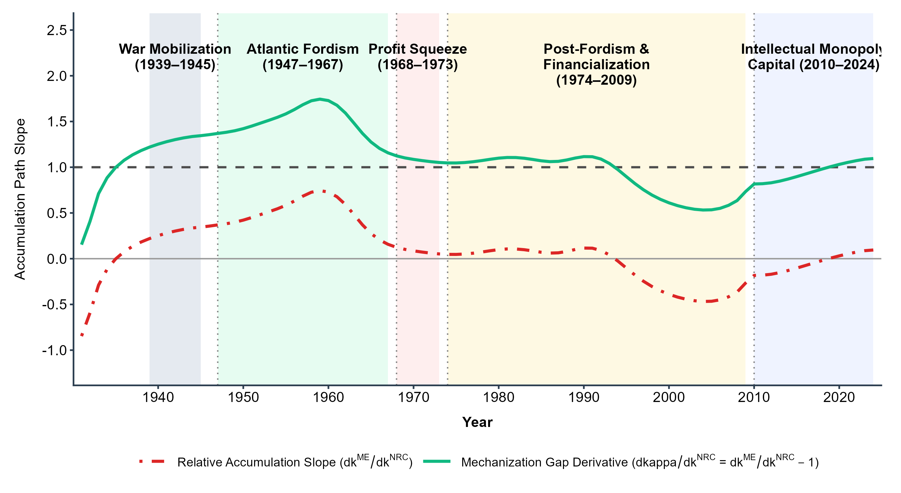
Empirical failure of the conventional Divisia derivative path.. Figure 11 illustrates why the empirical total-derivative path $θ_{\text{total},t}^{\text{Aggregate}}$ (Equation (21)) fails in practice. In the mid-1990s, corporate accumulation shifted away from physical machinery toward intellectual property products and financial assets, causing physical equipment growth to slow relative to structures ($dk_{t}^{\text{ME}}/dk_{t}^{\text{NRC}}<1.00$). As $dκ_{t}/dk_{t}^{\text{NRC}}$ crossed zero, the Divisia denominator in Equation (21) approached zero, sending the raw total-derivative elasticity to spurious infinite spikes. As established in Section 3.2, this instability reflects the theoretical pathology of differentiating a value aggregate under structural accumulation shifts. The structural asset-weighted elasticity $θ_{t}^{\text{Aggregate}}$ in Equation (22) purges these Divisia singularities, yielding a continuous, empirically well-behaved trajectory.
Driving Forces. The inclusion of heterogeneous capital reveals a structural paradox in the post-war US economy: while the relative cheapening of machinery drove a massive shift in the physical composition of capital, the capacity-generating power of this mechanization was severely degraded by the distributive conflicts of the late 1960s and early 1970s. Figure 12 plots the implicit capacity utilization rate ($μ_{t}$) alongside the asset-weighted aggregate transformation elasticity ($θ_{t}^{\text{SpecB}}$). Unlike the static baseline elasticity of Specification A, the transformation elasticity here is not solely driven by the evolving mix of machinery and structures, and the macroeconomic environment mediating their installation. As the physical accumulation of machinery and equipment accelerated relative to nonresidential structures, the aggregate transformation elasticity collapsed, severing the Harrodian link between accumulation and potential output. This structural degradation is not an artifact of index-number aggregation but the direct result of shifting marginal capacity yields. To unpack the mechanics of this collapse, Figure 13 illustrates the two primary institutional driving forces behind this choice of technique: the secular decline in relative asset prices ($p_{t}^{κ}=P_{t}^{\text{ME}}/P_{t}^{\text{NRC}}$) and the episodic spikes in effective distributive pressure ($C_{t}=ω_{t−1}(1−ι_{t−1})$).
Consider a given period during the Golden Age of American Capitalism (e.g., the 1950s) where the structural yield of nonresidential structures is $θ_{\text{NRC}}^{\text{str}}=0.60$ and the equipment share is $s_{\text{ME}}=0.30$. Under a stable distributive environment, if the marginal capacity yield of mechanization is $MP_{κ}=0.40$, the transformation elasticity yields an order of magnitude around $0.72$ ($θ^{\text{SpecB}}=0.60+0.30×0.40$). However, as the post-war era progressed, machinery became structurally cheaper, as can be appreciated on the downswing tendency of $p_{t}^{κ}$ in Figure 13, pushing the physical equipment share up toward $0.50$. Likewise, the Profit Squeeze (1968–1973) produced a sharp spike in effective distributive pressure ($C_{t}$). Because the interaction term $θ_{ωκ}$ is negative, this heightened wage pressure pushing firms into a defensive tactical choice of technique, increasing their efforts for capital-using labor-saving mechanization, i.e. Marx-biased technical change (Basu, 2022). Consequently, the marginal capacity yield of this machinery dropped (say, to $MP_{κ}=0.20$). In the post-Fordist era the aggregate elasticity then stands at $0.70$ ($θ^{\text{SpecB}}=0.60+0.50×0.20$). The arithmetic is the point: a 20-percentage-point rise in the physical share of machinery leaves the aggregate elasticity essentially where it started, because the yield per unit of that machinery fell by half. Cheapening delivered the equipment; defensive investment under falling profitability drained its capacity-generating power. This mechanism explicitly limits accumulation through stagnation tendencies towards over-accumulation due firms over-shooting their investments biased towards mechanization not to expand capacity, but to replace increasingly expensive labor, resulting into an over-accumulation regime crisis due the decreasing returns to mechanization and increasingly harder to transform capital accumulation to productive capacities within the political economy of full employment with intense labor militancy (Kalecki, 1943).
Figure 12: Implicit Capacity Utilization (μ_t) and Asset-Weighted Transformation Elasticity (θ_t^\textAggregate
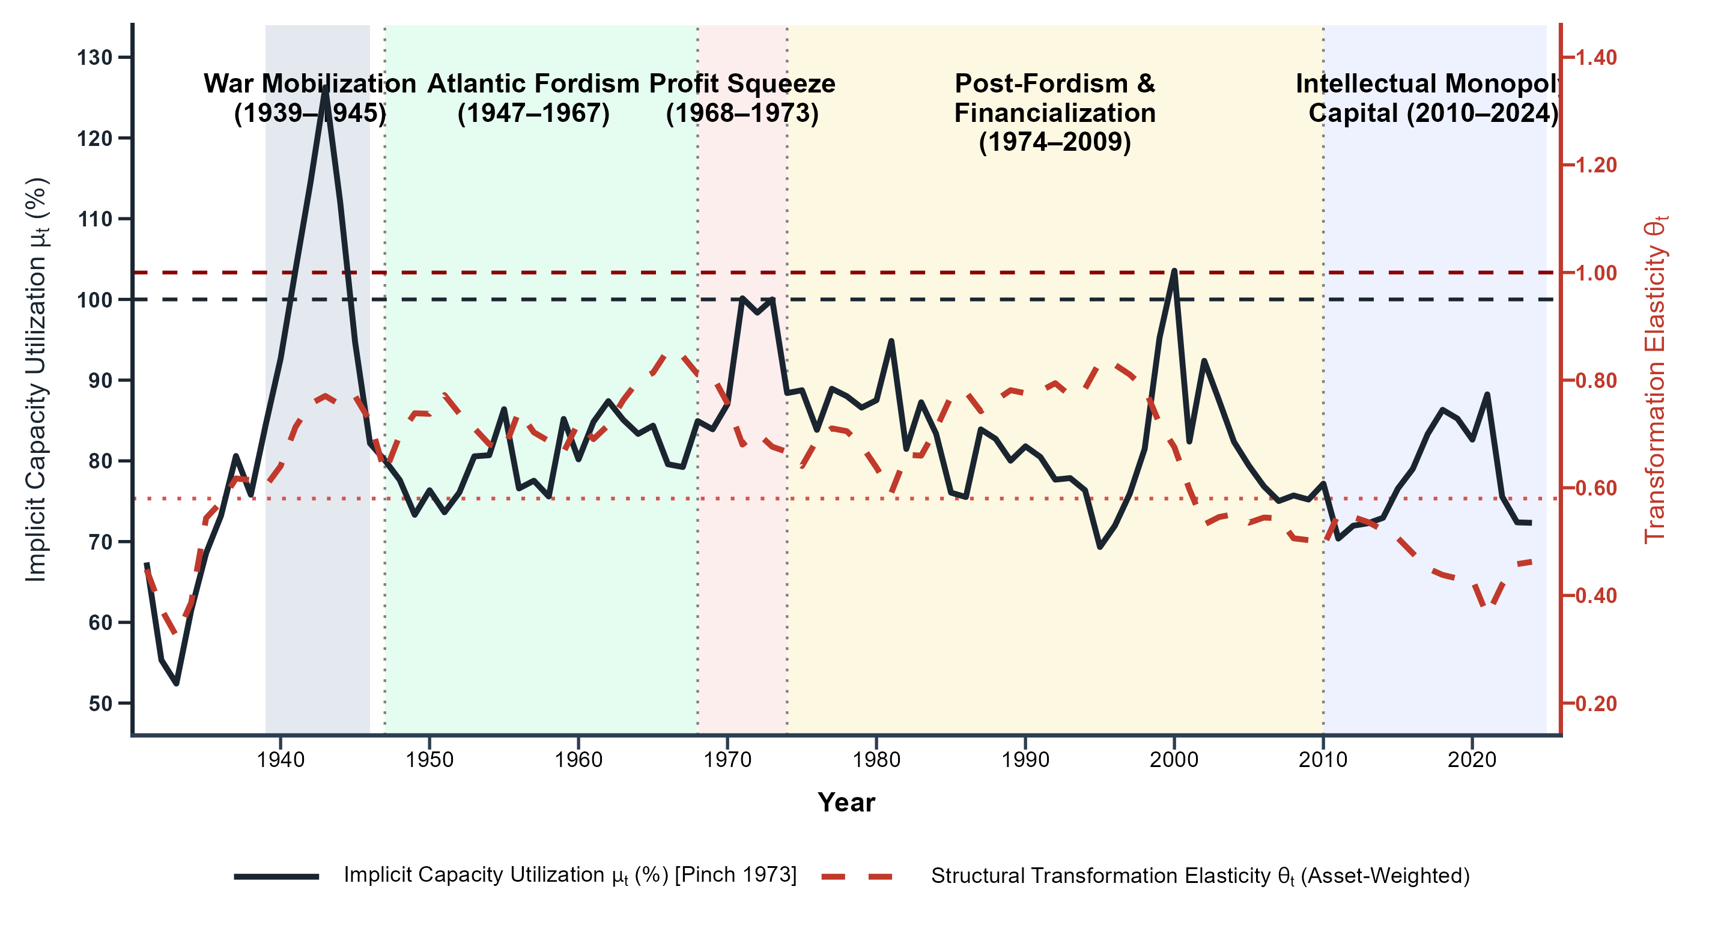
Figure 13: Effective Distributive Pressure (C_t) and Relative Asset Prices (p_t^κ
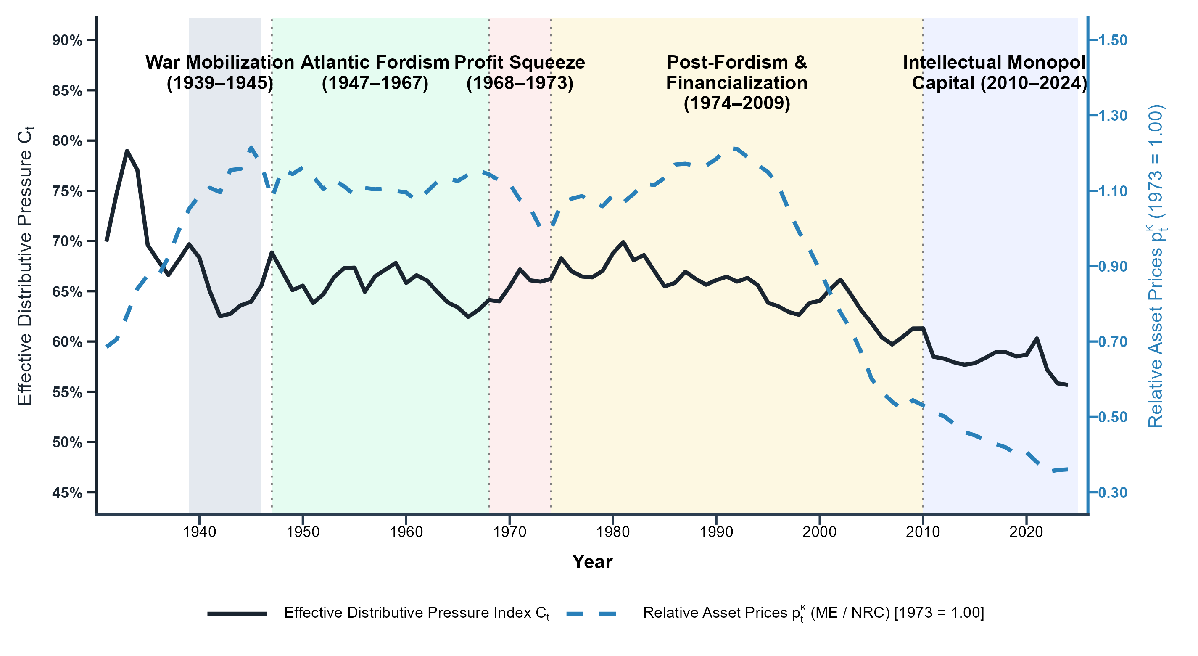

4.6 Chile's Empirical Evidence: Peripheral Caiptalism under External Constraint

4.6.1 Econometric Strategy: Threshold Cointegrating Multivariate Polynomial Regression

In core economies, capital accumulation converts into productive capacity through domestic technical choice. Rising wages induce capitalists to substitute labor with machinery, expanding capacity unless surplus is diverted into unproductive accumulation (Rotta, 2018). In peripheral economies like Chile, this mechanism depends on international liquidity. Because capital equipment ($K_{t}^{\text{ME}}$) cannot be produced domestically, labor-saving technical change requires imported machinery. When foreign-exchange reserves collapse, peripheral firms hit a structural bottleneck. Rather than adjusting smoothly through domestic prices, the capacity-generating effect of capital accumulation breaks down: wage pressure cannot induce mechanization because firms cannot acquire the foreign exchange needed to import machinery.
To evaluate this state-dependent breakdown, I estimate a Cointegrating Multivariate Polynomial Regression (CMPR) using Integrated Modified OLS (IM-OLS) (Vogelsang and Wagner, 2024) with an endogenously identified threshold regime. The estimating equation models log real GDP ($y_{t}$) as a cointegrating function of non-residential construction ($k_{t}^{\text{NR}}$), the capital composition gap ($κ_{t}$), distributional conflict (${\text{dist}}_{t−1}$), the state-dependent external constraint ($D_{t}^{γ}$), and relative price shocks (${\overset{\sim }{p}}_{t}^{⟂}$):
$y_{t}=α+θ_{1}k_{t}^{\text{NR}}+θ_{2}κ_{t}+θ_{3}({\text{dist}}_{t−1}·κ_{t})+θ_{4}(κ_{t}·D_{t}^{γ})+θ_{5}({\text{dist}}_{t−1}·κ_{t}·D_{t}^{γ})+β_{p}{\overset{\sim }{p}}_{t}^{⟂}+u_{t}$ | (64)
where $y_{t}$ is log real GDP (2003 CLP); $k_{t}^{\text{NR}}=lnK_{t}^{\text{NR}}$ is the log net stock of non-residential structures; $κ_{t}=ln(K_{t}^{\text{ME}}/K_{t}^{\text{NR}})$ is the capital composition gap between intensive machinery and extensive structures; ${\text{dist}}_{t−1}$ is the lagged distributive variable, evaluated across four permutations: net wage share ($ω_{t−1}^{\text{net}}$), gross wage share ($ω_{t−1}^{\text{gross}}$), net rate of exploitation ($e_{t−1}^{\text{net}}$), and gross rate of exploitation ($e_{t−1}^{\text{gross}}$); $D_{t}^{γ}=𝕀(Z_{t}≤γ)$ is a binary regime indicator equal to 1 when the composite balance-of-payments index ($Z_{t}$) falls below threshold $γ$; ${\overset{\sim }{p}}_{t}^{⟂}$ is the standardized relative capital price, orthogonalized against physical capital stocks via Frisch-Waugh-Lovell (FWL) regression; and $u_{t}$ is a stationary $I(0)$ error.
The partial derivative of output $y_{t}$ with respect to the capital composition gap $κ_{t}$ yields the marginal transformation elasticity $θ(\text{dist},D_{t})$:
$\frac{∂y_{t}}{∂κ_{t}}=θ_{2}+θ_{3}{\text{dist}}_{t−1}+θ_{4}D_{t}^{γ}+θ_{5}({\text{dist}}_{t−1}·D_{t}^{γ})$ | (65)
The coefficients carry direct political-economy interpretations:
- Extensive Construction Elasticity ($\theta_1$): Measures capacity generated by non-residential construction.
- Unconstrained Mechanization Elasticity ($\theta_2$): Measures capacity generated by intensive capital composition under normal liquidity ($D_{t}^{γ}=0$).
- Domestic Induced Innovation ($\theta_3$): Captures wage-led induced technical change under unconstrained liquidity, where worker bargaining power forces capitalists to substitute labor with machinery.
- Balance-of-Payments Structural Shift ($\theta_4$): Measures the direct collapse in mechanization capacity when external constraints bind ($D_{t}^{γ}=1$).
- Peripheral Distributional Inversion ($\theta_5$): Captures the breakdown in wage-led technical change under foreign-exchange starvation. A negative estimate ($θ_{5}<0$) demonstrates that when reserves collapse, wage pressure cannot induce mechanization because imported machinery is rationed.
Constructing the Balance-of-Payments Threshold Index (Z_t). I define the composite balance-of-payments index $Z_{t}(p)$ as a convex linear combination of two standardized macroeconomic indicators:
$Z_{t}(p)=p{\overset{\sim }{M}}_{t}+(1−p){\overset{\sim }{S}}_{t},p∈[0,1]$ | (66)
where ${\overset{\sim }{S}}_{t}=\text{scale}(F_{t}/M0_{t})$ measures central bank foreign reserves ($F_{t}=e_{t}·{\text{IR}}_{t}$) relative to base money ($M0_{t}$) (Nievas and Piketty, 2025), and ${\overset{\sim }{M}}_{t}=\text{scale}({\text{Imbalance}}_{t})$ measures the capital-goods import demand imbalance.
Because the structural weight $p$ and threshold level $γ$ are unknown a priori, I estimate $(\overset{^}{p},\overset{^}{γ})$ via a joint profile Sum of Squared Residuals (SSR) search:
$(\overset{^}{p},\overset{^}{γ})=\backslash arg\min_{p∈𝒫,γ∈Γ(p)}\text{SSR}(p,γ)=\backslash arg\min_{p∈𝒫,γ∈Γ(p)}\sum_{t=1}^{T}{{\overset{^}{u}}_{t}(p,γ)^{2}}$ | (67)
The weighting grid $𝒫=\{0.0,0.1,0.2,…,1.0\}$ steps across the unit interval in increments of 0.1. For each candidate weight $p$, the threshold grid $Γ(p)$ evaluates trimmed quantiles $Γ(p)=\{γ_{q}(p):q∈[0.15,0.85],Δq=0.05\}$. The global minimizer selects $\overset{^}{p}=0.2$ ($Z_{t}=0.2{\overset{\sim }{M}}_{t}+0.8{\overset{\sim }{S}}_{t}$) and $\overset{^}{γ}=0.425$ (or $\overset{^}{γ}=0.379$ in parsimonious specifications), confirming that international reserve cover (${\overset{\sim }{S}}_{t}$) dominates the empirical weighting in isolating the structural bottleneck.
Bai-Perron Structural Break Benchmark. To confirm that $D_{t}^{γ}$ captures a genuine balance-of-payments constraint rather than a deterministic calendar trend, I compare the threshold model against a benchmark specification using Bai and Perron (2003) endogenous structural breaks:
$y_{t}=α+θ_{1}k_{t}^{\text{NR}}+θ_{2}κ_{t}+θ_{3}({\text{dist}}_{t−1}·κ_{t})+θ_{4}(κ_{t}·D_{t}^{\text{BP}})+θ_{5}({\text{dist}}_{t−1}·κ_{t}·D_{t}^{\text{BP}})+β_{p}{\overset{\sim }{p}}_{t}^{⟂}+u_{t}$ | (68)
where $D_{t}^{\text{BP}}=𝕀(t≥T_{b})$. Dynamic search over candidate break dates $T_{b}∈[0.15T,0.85T]$ identifies two historical break points:
- \textbf{Net Distribution ($ω^{\text{net}},e^{\text{net}}$)}: Identifies $T_{b}=1987$, marking structural consolidation under the Büchi reforms following the 1982 crisis, where wage suppression and export promotion restored financial stability.
- \textbf{Gross Distribution ($ω^{\text{gross}},e^{\text{gross}}$)}: Identifies $T_{b}=1999$, marking the Asian Financial Crisis in Chile, when the Central Bank floated the Chilean peso and abandoned exchange-rate crawling bands.
Achieving lower SSR and stronger cointegration statistics under $Z_{t}≤0.425$ rules out deterministic calendar trends in favor of true balance-of-payments state dependence.
Relative Price Controls and Asset Deflators. The relative price control accounts for international purchasing power shifts affecting imported capital equipment. In Chilean historical national accounts, separate long-run deflators for structures ($P_{t}^{\text{NRC}}$) and machinery ($P_{t}^{\text{ME}}$) do not exist back to 1940. Capital stock harmonization constructs a single unified investment price deflator ($P_{K,t}$, staged as Pk_2003base) by splicing historical ClioLab deflators (1940–2010) with official Central Bank of Chile deflators (2003 base year).
I evaluate two complementary proxies:
- \textbf{Baseline Real Exchange Rate Control (${\overset{\sim }{p}}_{t}^{κ,\text{RER}}$)}: The standardized log Real Effective Exchange Rate ($ln{\text{TCREAL}}_{t}$, rebased to 2003 = 1.0), capturing external purchasing power shocks that alter the domestic price of imported machinery ($K_{t}^{\text{ME}}$).
- Robustness Asset-to-Output Ratio ($p_t^{\kappa, P_Y/P_K}$): The log ratio of aggregate GDP deflator ($P_{Y,t}$) to unified capital price index ($P_{K,t}$):
\begin{equation}
p_t^{\kappa, P_Y/P_K} = \ln\left(\frac{P_{Y,t}}{P_{K,t}}\right)
To prevent relative price volatility from collinearizing with physical capital stocks ($k_{t}^{\text{NR}},κ_{t}$), I extract the orthogonal price component ${\overset{\sim }{p}}_{t}^{⟂}$ via a Frisch-Waugh-Lovell (FWL) auxiliary regression prior to estimation:
${\overset{\sim }{p}}_{t}^{κ,\text{RER}}=c_{0}+c_{1}k_{t}^{\text{NR}}+c_{2}κ_{t}+{\overset{\sim }{p}}_{t}^{⟂}$ | (69)
The residual vector ${\overset{\sim }{p}}_{t}^{⟂}$ enters the estimating equation additively. Preliminary grid tests introducing interacted price terms ($κ_{t}·{\overset{\sim }{p}}_{t}$) caused severe multicollinearity ($\text{VIF}>88$), destroying matrix invertibility $(X^{′}X)^{−1}$ and inflating Monte Carlo critical bounds ($|t^{*}|>19$). Keeping ${\overset{\sim }{p}}_{t}^{⟂}$ as an additive control isolates physical capital composition without polluting the structural elasticity.
The estimation sample and its limitations.. Two data limitations define the estimation sample window, and I acknowledge them here rather than resolve them. First, the pre-1942 monetary and external series do not provide a coherent basis for the threshold variables: under the gold-exchange standard the reserve-cover ratio records a legal requirement rather than a binding external constraint, and the monetary base responds to convertibility rules and fiscal pressure rather than to the balance of payments. Second, the historical ClioLab price and terms-of-trade series, the stock of international reserves, and the money supply that anchor the external-constraint variables all end in 2010. Splicing them to contemporary sources falls outside the scope of this chapter.
The Kemmerer regime, 1925–1931.. Decree-Law No. 486 (21 August 1925) created the Central Bank of Chile (BCCh), and the Organic Law and Monetary Bill of 14 October 1925 (Decree-Law No. 606) placed it under a gold-exchange standard: the peso was pegged to sterling and the Bank was required to hold a minimum gold cover of 50 percent against note issue, with the remainder of the reserve requirement met in foreign exchange. Reserve coverage of the money supply rose from 27 percent at the start of 1925 to exactly 50 percent by year-end. The system's credibility was anchored abroad: it depended on sterling stability and steady copper revenues, functioning only as long as export receipts replenished central bank reserves.
Collapse and fiscal dominance, 1931–1941.. The external anchor failed during the Great Depression. Between January 1930 and July 1931, the Bank lost more than half of its gold holdings defending the peg, suspending convertibility on 21 July 1931; the United Kingdom's departure from gold two months later erased the value of remaining sterling reserves. The subsequent decade combined fiscal dominance—the Bank monetized deficits as a treasury agent—with multiple exchange rates administered by the Comisión de Cambios Internacionales and parallel currency markets. Once convertibility was suspended, the cover ratio ceased to operate as a statutory discipline and became instead an indicator of systemic fragility. During a currency panic, commercial banks hoard base money at the central bank while the money multiplier contracts, making the reserves-to-$M_{0}$ ratio the true measure of the Bank's capacity to absorb speculative attacks. The denominator follows economic exposure rather than the letter of the 1925 law: while the statute defined requirements against note issue alone, commercial banks in a panic seek to convert their reserve deposits, making total central-bank liabilities ($M_{0}$) the relevant exposure. Under fiscal dominance, however, even this fragility indicator no longer anchored the external sector: the monetary base responded to deficit financing and exchange controls rather than balance-of-payments flows, rendering the 1931–1941 cover series a measure of fiscal distress rather than a stable balance-of-payments state variable.
The 1942 regime shift.. Law No. 7,200 (18 July 1942), together with Law No. 7,434, rewrote the Central Bank's Organic Law: the reserve-cover rule was formally abandoned, the mandate shifted from gold convertibility to the promotion of national production, and foreign exchange was allocated through centralized credit ceilings and state budgets. Working alongside CORFO (Law No. 6,640, 1939), which directed credit allocation toward import-substituting industrialization, the Bank financed development planning rather than currency pegs. Macroeconomic stability thereafter derived from internal planning rather than external gold credibility. Econometrically, pooling the pre-1942 data with the post-1942 period violates cointegration: the structural regime shift introduces severe non-stationary drift, generating massive finite-sample size distortions and explosive Monte Carlo $t$-statistics ($|t|>15$) that destroy matrix invertibility. Restricting the estimation window to 1943–2010 ($T=68$) is therefore both institutionally necessary and econometrically sound, isolating a single, stable cointegrating regime across distinct historical regimes: under state-led industrialization and its violent rupture through neoliberalization.

4.6.2 Empirical Findings for Chile: Truncated Mechanization

Table 9 compares the parsimonious regime-shifting specification across four distributive permutations: Net Wage Share ($ω^{\text{net}}$), Gross Wage Share ($ω^{\text{gross}}$), Net Rate of Exploitation ($e^{\text{net}}$), and Gross Rate of Exploitation ($e^{\text{gross}}$). Across all four variants, the composite external threshold ($Z_{t}≤0.425$) produces super-consistent long-run cointegration ($t_{\text{ADF}}=−{3.81}^{*}$ to $−{3.89}^{*}$, $CT_{\text{IM}}=8.34$ to $15.20$).
Gross vs. Net Measures in Peripheral Capitalism.. In the United States (Section 4.3), Net Value Added ($\text{NVA}$) is the necessary theoretical basis for evaluating distribution. Because Consumption of Fixed Capital ($\text{CFC}$) rises mechanically during intensive capital-deepening, evaluating distribution on a Gross Value Added ($\text{GVA}$) basis introduces a spurious negative correlation between capital intensity and wage shares. In the US core, class struggle takes place strictly over newly created net value ($v+s$), and purging $\text{CFC}$ isolates a cost-minimizing mechanization response to distributive pressure.
In the capitalist periphery, however, gross distributive measures (Columns 2 and 4) achieve superior empirical fit and cointegration ($\text{SSR}=0.275$, $CT_{\text{IM}}≈8.34$) compared to net measures ($\text{SSR}=0.294$, $CT_{\text{IM}}≈15.10$). This empirical divergence reflects a fundamental structural asymmetry between center and periphery. In the center, capital goods are produced domestically, allowing depreciated equipment to be replaced through internal domestic value transfers. In the periphery, capital accumulation relies on imported machinery and equipment ($K^{\text{ME}}$). Deducting official accounting depreciation ($\text{CFC}$) under linear conventions fails to capture the unencumbered gross cash flow ($Π^{\text{gross}}$) required by peripheral firms to obtain foreign exchange and finance machinery imports. Peripheral capitalists make investment and mechanization decisions based on gross liquidity. Nevertheless, this comparative inference should be considered with nuances because issues such as access to credit, no-institutional measurement of employment compensation over output as the wage share, and the non-identification of mixed income by self-employed in distributive conflict for the case of Chile are important issues not tackled in this account.
Likelihood Ratio and Threshold Identification.. Figure 14 plots Hansen (2000) profile Likelihood Ratio statistic $LR_{1}(γ)=[\text{SSR}(γ)−\text{SSR}(\overset{^}{γ})]/{\overset{^}{σ}}^{2}$ across candidate threshold values $γ∈[γ_{0.15},γ_{0.85}]$ for the standardized composite balance-of-payments index $Z_{t}=0.2{\overset{\sim }{M}}_{t}+0.8{\overset{\sim }{S}}_{t}$. The profile displays a single, sharp minimum at $\overset{^}{γ}=0.383$ (within the $[0.383,0.521]$ 95% confidence interval encompassing the benchmark threshold $\overset{^}{γ}=0.425$), matching a binding foreign-exchange reserve cover threshold. Inverting the likelihood ratio statistic at the exact $95\%$ analytical critical boundary $c(0.05)=−2ln(1−\sqrt{0.95})=7.35$ yields a tight non-parametric confidence interval. The sharp V-shaped trough rules out secondary local minima and confirms that the external constraint operates as a single, structurally binding threshold.
Figure 14: Profile Likelihood Ratio Sequence for the Peripheral External Constraint (Chile, 1943–2010)
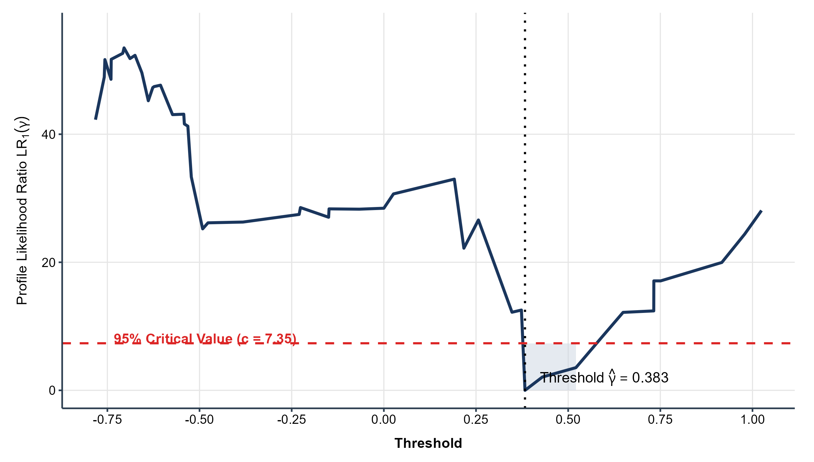
Distributive Conflict Preferred Measure: Center versus Periphery.. Comparing the wage share model in Column (2) ($ω^{\text{gross}}$) with the rate of exploitation model in Column (4) ($e^{\text{gross}}$) illuminates how external financial constraints alter the transmission of class conflict into capital composition. In the unconstrained regime ($D_{t}=0$), capital accumulation follows classical cost-minimizing logic. Under Column (2), a higher wage share incentivizes defensive labor substitution (${\overset{^}{θ}}_{ωκ}=+{3.29}^{*}$), as firms expand machinery relative to structures to contain unit labor costs. Equivalently, under Column (4), a higher rate of exploitation ($e=Π/W$) indicates reduced wage pressure, decreasing the necessity for capital-deepening (${\overset{^}{θ}}_{eκ}=−{0.69}^{*}$).
Under the binding foreign-exchange regime ($D_{t}=1$), this cost-minimizing mechanism collapses. When the external constraint becomes binding ($Z_{t}≤0.425$), peripheral capitalists hit a hard import constraint (${\overset{¯}{κ}}_{t}$). In Column (2), the triple interaction coefficient (${\overset{^}{θ}}_{ωκD}=−{3.15}^{*}$) virtually eliminates the positive wage-led mechanization response ($+3.29−3.15=+0.14$). Because machinery and equipment ($K^{\text{ME}}$) must be imported, foreign-exchange rationing prevents peripheral firms from translating domestic wage pressures into shop-floor labor substitution. Unable to extract a distributive dividend through technical change, capitalists attempt to protect profit margins through price markups.
State-dependent thresholds versus exogenous historical breaks.. To verify that $D_{t}^{γ}$ captures a structural macroeconomic constraint rather than an arbitrary trend break, Appendix Tables 21 and 22 (Appendix app:chile_full_results) benchmark the threshold model against Bai and Perron (2003) endogenous calendar breaks. The Bai-Perron procedure identifies two break dates: 1987 under net wage shares ($ω^{\text{net}}$) and 1999 under gross measures ($ω^{\text{gross}}$, $e^{\text{gross}}$). The 1987 break marks the post-1982 debt-crisis restructuring—fiscal austerity, privatization, and wage suppression. The 1999 break marks a change in monetary regime: the Central Bank abandoned the crawling peg and its accompanying capital controls, moving to a free float with open capital mobility in the wake of the Asian Financial Crisis.
Comparing specifications confirms that the composite threshold $Z_{t}≤0.425$ dominates calendar-time breaks across all metrics, achieving lower residual variance ($\text{SSR}=0.275$ against $0.292$) and stronger cointegration rejections ($t_{\text{ADF}}=−{3.89}^{*}$ against $−2.98$). Two conditions must meet for the constraint to bind: a wide gap between effective imports and the capacity to finance them, and foreign-exchange reserves too thin for the Central Bank to defend the currency. Neither condition is tied to a calendar date, which is why a state-dependent gate outperforms a break at 1987 or 1999.
Table 8 shows that the binding constraint ($D_{t}=1$) does not always announce itself the same way. During the ISI era (1943–1984), under fixed or administered pegs, reserve depletion ($S_{t}→0$) forced devaluations and structural inflation (Sunkel, 1958; Prebisch, 1981). During the 2006–2010 commodity super-cycle, under a free float and inflation targeting, the same gate closed through markup expansion instead.
Table 8: Institutional Manifestations of External Constraint Regimes (Chile, 1943–2010)
Historical Period | Regime Status (D_t^γ) | Duration | Institutional Manifestation of the External Constraint
1943–1984 | Binding (D_t = 1) | 42 years | ISI Reserve Scarcity \ | Structural Inflation: Established under Law 7,200 foreign-exchange budgeting and fixed/crawling pegs; reserve depletion (S_t → 0) under wage pressure forced maxidevaluations, cost-plus markups, and structural inflation spirals.
1985–2005 | Slack (D_t = 0) | 21 years | Export Consolidation \ | Reserve Buffering: Post-1982 debt-crisis and recovery non-traditional export expansion, Concertación democratic transition, large FDI inflows, and central bank foreign reserve accumulation.
2006–2010 | Binding (D_t = 1) | 5 years | Commodity Boom, Rentier Surplus Drain \ | Re-primarization: Under a free-floating exchange rate and inflation targeting (3%), FX starvation did not trigger inflation; instead, high import demand (\tildeM_t) and massive MNC profit repatriation (DL 600) manifested as a rentist surplus drain and Dutch Disease re-primarization.
μlticolumn4p14.2cm Notes: Classification based on the optimal profile threshold \hatγ = 0.425 evaluated over the standardized composite balance-of-payments index Z_t = 0.2 \tildeM_t + 0.8 \tildeS_t. Regime D_t = 1 denotes a binding balance-of-payments constraint where foreign-exchange starvation forces peripheral firms into a corner solution (\barκ_t). Total sample size T = 68 (1943–2010 effective cointegrating window), yielding 47 binding years (69.1%) and 21 slack years (30.9%).
Note: Classification based on the optimal profile threshold \hatγ = 0.425 evaluated over the standardized composite balance-of-payments index Z_t = 0.2 \tildeM_t + 0.8 \tildeS_t. Regime D_t = 1 denotes a binding balance-of-payments constraint where foreign-exchange starvation forces peripheral firms into a corner solution (\barκ_t). Total sample size T = 68 (1943–2010 effective cointegrating window), yielding 47 binding years (69.1%) and 21 slack years (30.9%). \\
These findings suggest that in financialized peripheral capitalism the external bottleneck shifts its pressure valve from domestic price inflation toward re-primarization, real exchange rate appreciation (Dutch Disease), and rentier surplus drainage (Palma, 2019; Ahumada, 2019). Capital goods import requirements ($K^{\text{ME}}$) for extractive mining projects, combined with foreign profit remittances, truncate the translation of accumulation into productive capacity while the Central Bank still meets its inflation target. Disentangling the transmission between inflationary rationing (1943–1984) and rentier-drain re-primarization (2006–2010) would require a monetary-regime-specific specification that this chapter does not estimate.
Model selection.. The comparative results in Table 9 establish Column (2)—the gross wage share specification ($ω^{\text{gross}}$) under the composite balance-of-payments threshold ($Z_{t}≤0.425$)—as the primary empirical model for Chile. Column (2) achieves the global minimum residual variance ($\text{SSR}=0.275$), and its distributive channel is the one that maps onto the United States baseline, which is what makes the center–periphery comparison in Section an argument about the same relation under different constraints rather than a juxtaposition of two unrelated estimates.
Table 9: Comparative Estimates Across Distributive Variable Permutations (Chile, 1943–2010)
 | Wage Share (ω) |  | Rate of Exploitation (e)
 | Net (ω^net) | Gross (ω^gross) | Net (e^net) | Gross (e^gross)
 | (1) | (2) | (3) | (4)
\hatθ_k^\textNR (Structures k^\textNR) | 0.79^*** | 0.82^*** | 0.80^*** | 0.82^***
 | (0.07) | (0.08) | (0.07) | (0.08)
\hatθ_κ (Mechanization Gap κ) | 0.12 | -1.48^* | 0.15 | 0.85
 | (0.39) | (0.54) | (0.25) | (0.38)
\hatθ_\textdist\cdotκ (Distributive Interaction) | -0.01 | 3.29^* | 0.02 | -0.69^*
 | (0.22) | (1.07) | (0.09) | (0.23)
\hatθ_κ D (Regime Shift κ D) | 0.34 | 1.52^** | 0.15 | -0.73
 | (0.16) | (0.45) | (0.08) | (0.29)
\hatθ_\textdist\cdotκ D (Triple Interaction) | -0.17 | -3.15^* | 0.12 | 0.67^*
 | (0.23) | (1.04) | (0.10) | (0.22)
Regime Threshold (D_t) | Z_t ≤ 0.425 | Z_t ≤ 0.425 | Z_t ≤ 0.425 | Z_t ≤ 0.425
Price Control Included | No | No | No | No
CT_\textIM [H_0: Cointegration] | 15.20 | 8.39 | 14.99 | 8.34
t_\textADF [H_0: Unit Root] | -3.81^* | -3.81^* | -3.84^* | -3.89^*
Bandwidth ratio b | 0.654 | 0.654 | 0.654 | 0.654
Sample Size T | 68 | 68 | 68 | 68
μlticolumn5p14.2cm Notes: Dependent variable: y_t (log real GDP). Estimated via Cointegrating Multivariate Polynomial Regression (CMPR) IM-OLS \citepVogelsangWagner2024. All models specify the ultra-parsimonious balance-of-payments threshold (Z_t = 0.2 \tildeM_t + 0.8 \tildeS_t ≤ 0.425) over the effective sample 1943–2010 (T=68). Columns (1) and (2) evaluate Net (ω^net) and Gross (ω^gross) wage shares; Columns (3) and (4) evaluate Net (e^net) and Gross (e^gross) rates of exploitation. Significance stars (^*p<0.10, ^**p<0.05, ^***p<0.01) are benchmarked against 10,000-pass Monte Carlo simulation critical bounds under profile search.
Note: Dependent variable: y_t (log real GDP). Estimated via Cointegrating Multivariate Polynomial Regression (CMPR) IM-OLS \citepVogelsangWagner2024. All models specify the ultra-parsimonious balance-of-payments threshold (Z_t = 0.2 \tildeM_t + 0.8 \tildeS_t ≤ 0.425) over the effective sample 1943–2010 (T=68). Columns (1) and (2) evaluate Net (ω^net) and Gross (ω^gross) wage shares; Columns (3) and (4) evaluate Net (e^net) and Gross (e^gross) rates of exploitation. Significance stars (^*p<0.10, ^**p<0.05, ^***p<0.01) are benchmarked against 10,000-pass Monte Carlo simulation critical bounds under profile search. \\

4.6.3 Transformation and Capacity Utilization under Financial Subordination

Balance-of-payments subordination inverts the classical choice of technique.
When foreign exchange is slack ($Z_{t}>0.425$), a higher wage share
accelerates mechanization, as cost minimization predicts
(${\overset{^}{θ}}_{3}=+0.9583$). When foreign exchange binds, the interaction
shift (${\overset{^}{θ}}_{5}=−0.9518$) cancels the base sensitivity and leaves a
slope of $+0.0065$. Peripheral capitalists keep the incentive to substitute
machinery for labor but lose the means, because the machinery is imported.
I evaluate the aggregate elasticity from the preferred CMPR IM-OLS model
(Column 2 of Table 9, gross wage
share and composite threshold $Z_{t}≤0.425$) and integrate the capacity
law of motion, $g_{Y^{p},t}=θ_{t}^{\text{Agg}}g_{K,t}$, forward and
backward from the 1981 Ffrench-Davis full-capacity peak
($μ_{1981}=1.00$). The state-dependent elasticity is
$θ_{t}^{\text{Agg}}={\overset{^}{θ}}_{1}+s_{\text{ME},t}·MP_{κ,t}={\overset{^}{θ}}_{1}+s_{\text{ME},t}\left[{\overset{^}{θ}}_{2}+{\overset{^}{θ}}_{3}ω_{t−1}^{\text{gross}}+D_{t}^{γ}\left({\overset{^}{θ}}_{4}+{\overset{^}{θ}}_{5}ω_{t−1}^{\text{gross}}\right)\right]$ | (70)
where ${\overset{^}{θ}}_{1}=+0.6970$ is the base elasticity of non-residential
structures, $s_{\text{ME},t}=K_{t}^{\text{ME}}/(K_{t}^{\text{ME}}+K_{t}^{\text{NR}})$
is the current-price share of machinery and equipment in core capital,
$κ_{t}=ln(K_{t}^{\text{ME}}/K_{t}^{\text{NR}})$ the composition gap,
$ω_{t−1}^{\text{gross}}$ the lagged gross wage share, and
$D_{t}^{γ}=𝕀(Z_{t}≤0.425)$ the binding-state indicator. The
remaining coefficients are ${\overset{^}{θ}}_{2}=−0.1293$,
${\overset{^}{θ}}_{3}=+0.9583$, ${\overset{^}{θ}}_{4}=+0.6645$, and
${\overset{^}{θ}}_{5}=−0.9518$, so the marginal product of the composition gap
takes one form in each state:
$MP_{κ,t}^{\text{slack}}=−0.1293+0.9583ω_{t−1}^{\text{gross}}(D_{t}^{γ}=0)$
$MP_{κ,t}^{\text{bind}}=+0.5352+0.0065ω_{t−1}^{\text{gross}}(D_{t}^{γ}=1)$ | (71)
In slack periods a higher wage share raises the capacity yield of
mechanization. In binding periods the slope collapses from $+0.9583$ to
$+0.0065$, and foreign-exchange rationing replaces the distributive state as
the governor of technique choice.
Section 3.3 predicted exactly this pair of equations. Proposition 4 says
that once the constraint binds, the composition gap is pinned at
${\overset{¯}{κ}}_{t}$ and the first-order condition stops governing technique
choice; the only distributive channel left is the slope of the feasible gap,
$(m_{c}c_{k}−m_{w})/ν$. The estimated residual slope of $+0.0065$ is
consistent with $m_{c}c_{k}≈m_{w}$, the conspicuous-consumption drain and
the wage-goods import drain roughly offsetting each other. Proposition 6
supplies the second half: at the corner the marginal capacity payoff is
strictly positive, because the firm would like to mechanize further and
cannot, and the significant intercept shift ${\overset{^}{θ}}_{4}=+0.6645$ is
that payoff entering the capacity equation, the empirical counterpart of a
positive Kuhn–Tucker multiplier on the external constraint. Binding is
therefore not a state in which mechanization yields nothing; it is a state
in which it yields something but responds to nothing domestic.
Proposition 5 predicts a discrete shift of the elasticity at the threshold;
in the data the shift appears less as a level drop than as the loss of the
wage slope, with the binding path running flat through distributive shocks
that move the slack path. The gap between nominal profitability and
truncated technique is the blocked surplus of Definition 4, and Corollary 1
names the adjustment channel that remains once mechanization is rationed,
price markups.
Figure 15 plots the composite index
against the lagged gross wage share, and the Unidad Popular episode is the
clearest observation in the sample. Between 1970 and 1973, redistribution
raised the gross wage share to its historical peak of
$ω_{1972}=0.6903$, about twenty percentage points up. Over the same
years, credit blockade and capital flight drove reserves to
${\overset{\sim }{S}}_{t}→−2.5$ and the index to $Z_{t}=−1.06$, deep inside the
binding domain. Figures 17
and 16 show that the elasticity did not
respond: Equation (Equation) governed technique choice and held
$θ_{t}^{\text{Agg}}$ flat near $0.83$ through the wage expansion. The
wage expansion could not become productive capacity, and per Corollary 1 it
became unrealized demand and structural inflation instead
(Kalecki, 1955; Sunkel, 1958). Utilization collapsed to $0.72$ by 1975.
Figure 15: Chilean Composite External Constraint (Z_t) and Lagged Gross Wage Share (ω_t-1
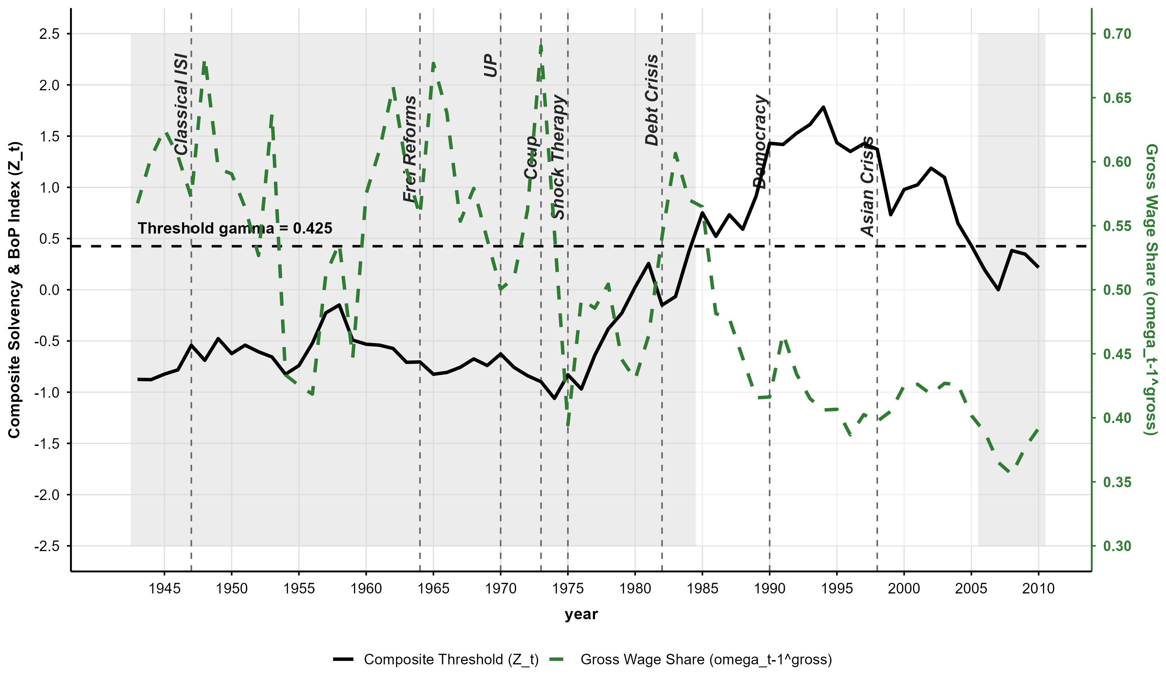
Based on Ffrench-Davis (2018) account on over-heating pre-debt crisis in 1982, I recover the order of magnitude for productive capacitieis from the recursion
$lnY_{t}^{p}=lnY_{t−1}^{p}+θ_{t}^{\text{Agg}}\left(lnK_{t}^{\text{tot}}−lnK_{t−1}^{\text{tot}}\right),Y_{1981}^{p}=Y_{1981}⟹μ_{1981}=1.00$ | (72)
and divide realized GDP by it to obtain utilization.
Figure 16 plots the two series on dual
axes and Figure 17 the elasticity alone.
Five regimes organize the path, and the external constraint separates them.
The early CORFO expansion (1942–1946) combined postwar demand above normal
capacity ($μ_{1946}=1.12$) with slack foreign exchange and elasticities
near $0.85$. The ISI stop-go crises (1947–1957) reversed both: recurring
shortages forced stabilization cycles that pulled utilization to
$μ_{1955}=0.84$. The socialist transition (1970–1975) combined
redistribution with credit blockade, and utilization bottomed at $0.72$
after the 1975 shock therapy. The debt boom and crash (1975–1982) ran the
sequence in reverse, with inflows carrying utilization to the 1981 peak and
the crisis erasing it within a year ($μ_{1982}=0.68$). The recovery and
commodity super-cycle (1984–2010) absorbed idle capacity rather than
creating new capacity, holding $μ_{t}$ between $0.85$ and $0.98$ through
1997. In four of the five regimes the turning point is external rather than
distributive, the asymmetry the threshold specification was built to detect.
Figure 16: Chilean Capacity Utilization (μ_t) and Aggregate Transformation Elasticity (θ_t^\textAgg
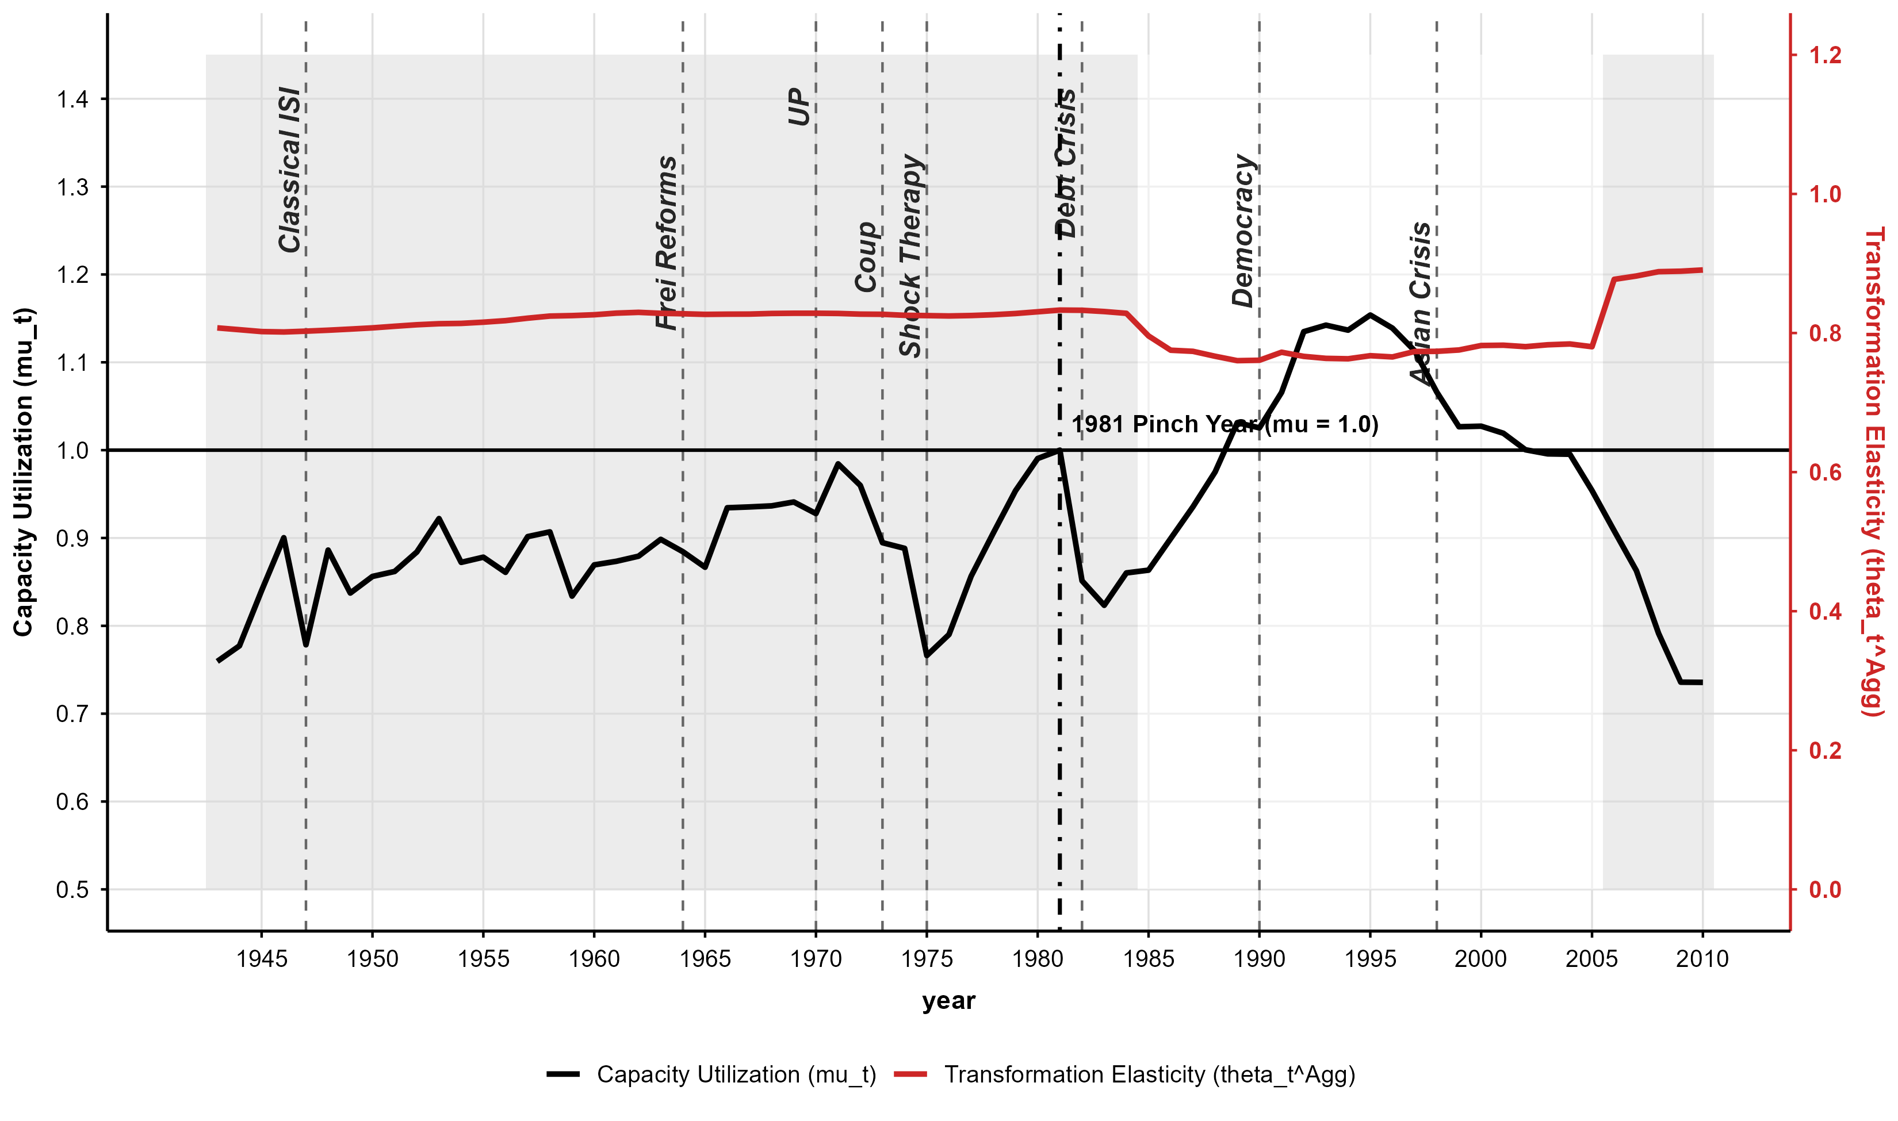
Figure 17: Standalone Chilean Aggregate Transformation Elasticity (θ_t^\textAgg
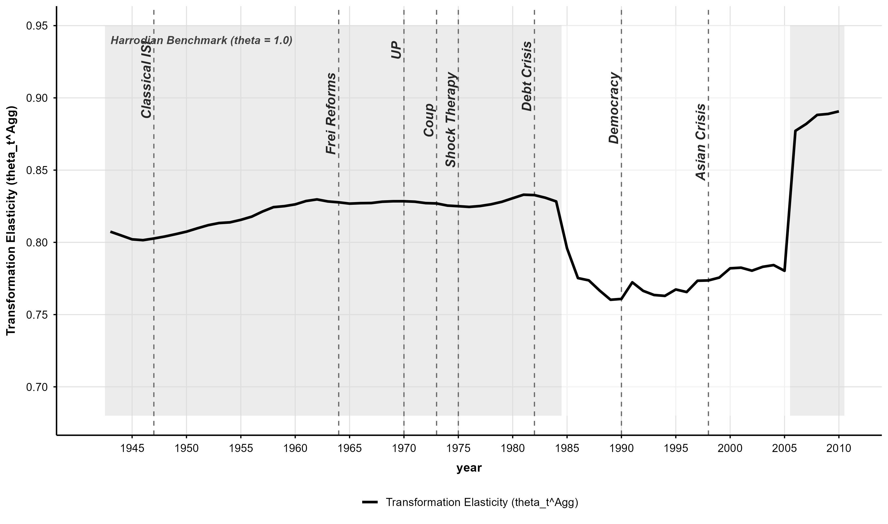
Figure 18 decomposes the index into reserve
cover and import demand imbalances, and the two components show that the
constraint changes its institutional form across regimes. Under the fixed
and crawling pegs of the ISI period (1943–1973), reserve exhaustion forced
sharp devaluations and structural inflation (Sunkel, 1958), in line with
the periodization of Ffrench-Davis (2002) and Ahumada (2019). Under the
post-2000 free float with inflation targeting, binding conditions produced
no runaway inflation; they produced extractivist re-primarization, real
appreciation, and profit repatriation by multinational mining
(Palma, 2019; Ahumada, 2019). Capital goods imports for extractive
projects, together with dividend outflows, truncated the conversion of
accumulation into broad-based domestic capacity.
Figure 18: Decomposition of the Chilean External Constraint Index (Z_t Components)
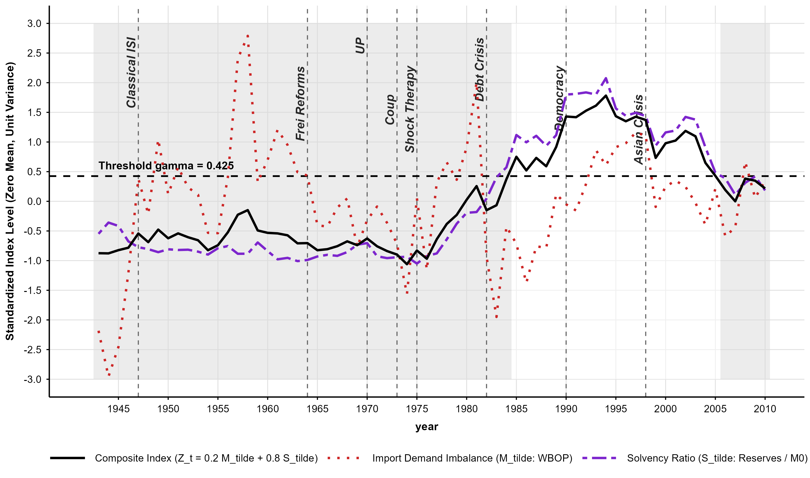
Two caveats qualify the reading of these regimes. The first concerns the
classifier. States are assigned by a single linear combination,
$Z_{t}=0.2{\overset{\sim }{M}}_{t}+0.8{\overset{\sim }{S}}_{t}$, with the weight and the threshold
chosen by grid search over the profile sum of squared residuals and a hard
cutoff at $\overset{^}{γ}=0.425$. This is a deterministic classification in
the sense of Hansen (2000), not a probabilistic regime model: there
are no transition probabilities and no persistence parameter, and after the
search $(\overset{^}{p},\overset{^}{γ})$ enter the elasticity path as if known. The
simulation bounds charge for the threshold search but not for the weight
grid, so regime uncertainty is confined to the interval $[0.380,0.472]$
and is not propagated into $θ_{t}^{\text{Agg}}$. A Markov-switching or
smooth-transition extension would assign a binding probability to each year
and separate persistent shifts from transient bites; I leave that to future
work.
The second caveat concerns what the hard classification nonetheless
captures that a periodization cannot. $D_{t}^{γ}$ does not switch only
between the major regimes. Within the ISI era the index crosses the
threshold at the frequency of the stop-go cycle: import surges in the
expansion phase push it below the cutoff before the crisis, and post-crisis
stabilizations (devaluation, import compression, wage suppression) briefly
lift it back above. The 1998–99 tightening and the 2006–10 mining boom
are intra-cycle bites inside eras the conventional periodization labels
slack. The constraint operates at cycle frequency; the five regimes organize
the path at the lower frequency at which the institutional form of the
constraint changes, from inflation valve under administered exchange rates
to re-primarization valve under a free float. That double frequency is also
why the state-dependent indicator outperforms calendar breaks at 1987 or
1999: the breaks mark changes in the form, and the threshold tracks the
bites.
The center–periphery comparison follows. In the United States, where
capital equipment is produced domestically, wage pressure induces defensive
mechanization (${\overset{^}{θ}}_{1}<0$, Section 4.3). In Chile, where machinery
must be imported, wage pressure induces mechanization
(${\overset{^}{θ}}_{3}=+0.9583$) only while foreign exchange is unconstrained.
When reserves collapse, the constraint binds and truncates the choice of
technique. The distributive dividend that Okishio's viability condition
promises is not unavailable in principle in the periphery; it is unavailable
whenever the balance of payments binds.

5. Discussion: The Political Economy of Capacity Utilization in the Center and the Periphery

Section 4 established a structural baseline: the transformation elasticity $θ_{t}$ sits strictly below unity in both the center and the periphery. Capitalist accumulation exhibits a persistent tendency toward overaccumulation—understood within a single-sector framework as a structural disproportionality between capital accumulation and its transformation into productive capacity. This structural mismatch yields systemic disequilibrium and chronic idle capacity as an enduring byproduct. However, the engine that converts accumulated capital into potential capacity represents only the supply-side dimension of this process; its macroeconomic realization remains mediated through the rate of capacity utilization ($μ_{t}$).
While $θ<1$ is the shared premise of unbalanced growth, the historical trajectories of $μ_{t}$ reveal fundamentally distinct crisis formations across the global divide. In the United States, utilization crises stem from the exhaustion of institutional class compromises and the failure of effective demand. In Chile, stagnation and crisis originate in the external truncation of capital-import capacity and the physical strangulation of the productive apparatus. By placing the implicit capacity utilization rates of both economies on a single comparative axis, this section traces how the same underlying condition of overaccumulation manifests as two divergent political-economic realities.
The Relational Dynamics of Idle Capacity.. Figure 19 places the reconstructed implicit capacity utilization rates ($μ_{t}$) for the U.S. non-financial corporate sector (1931–2024) and the Chilean economy (1940–2010) on a single axis.
Figure 19: The Political Economy of Idle Capacity: Center vs. Periphery (1931–2024)
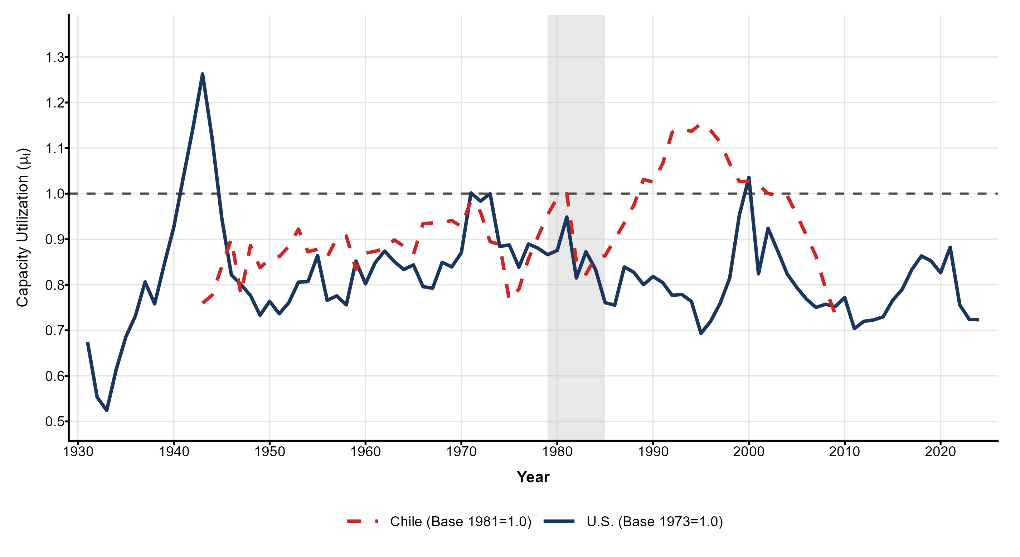
The visual narrative of Figure 19 yields several immediate conclusions. First, neither economy converges toward a normal rate of utilization in the long run ($μ=100\%$); persistent idle capacity remains the structural norm of decentralized accumulation. Second, the volatility of $μ_{t}$ in Chile vastly exceeds that of the United States. Rather than an econometric anomaly, this higher amplitude directly tracks the structural asymmetry between a diversified, reserve-currency center capable of dampening demand swings, and a dependent peripheral formation vulnerable to sudden international liquidity collapses. Because installed gross fixed capital ($K_{t}$) represents an immovable physical envelope that cannot vanish during downturns, catastrophic peripheral output collapses—such as the supply shocks of 1975 and the 1982 debt crisis—translate into violent, vertical contractions of utilization. Crucially, the shaded window (1979–1985) captures a global overaccumulation crisis and structural turning point: the Volcker interest-rate shock triggered a severe domestic realization drop in the center ($μ_{1982}≈82\%$) while violently terminating Chile's debt-led boom ($μ_{1981}=100\%$), plunging peripheral utilization into a severe macro-historical trough. This global conjuncture was subsequently resolved through radically divergent regime shifts: debt-led financialization in the center, and a violent transition toward neoliberalization and external subordination in the periphery.
The Center: Realization Failure and Intellectual Monopolies.. In the United States, the dynamics of $μ_{t}$ are governed by the continuous mediation of distributive conflict and the shifting composition of capital. Because capital goods are produced domestically, the transformation of accumulation into capacity ($θ$) is not externally constrained; while stagnation and crisis may have multifaceted causes, they ultimately manifest as an issue of realization. Under Atlantic Fordism, the institutionalized class compromise absorbed growing productive capacity via mass consumption (Aglietta, 2000). High wage shares, alongside negligible diversion of investment toward intangible assets like intellectual property, meant that consumer demand effectively matched expanding physical capacities, sustaining $μ_{t}$ within a high, stable corridor (85–105%). While a commitment to full employment, Keynesian policymaking, and demand-inducing militarism masked secular overaccumulation tendencies, distributive conflict exerted cost-minimizing pressures that forced capitalists to engage in mechanization, configuring a contradictory utilization regime.
When the profit squeeze emerged in the late 1960s, $μ_{t}$ plummeted to 76.2% in 1975 and bottomed at 74.1% in 1982 during the Volcker disinflation. In his seminal decomposition of this postwar U.S. profit rate collapse, Weisskopf (1979) pinned the crisis on the "Rising Strength of Labor" (RSL), treating the "Realization Failure" (RF) variant—a drop in $μ_{t}$—as a secondary, survey-driven symptom. Our framework upgrades this insight by revealing that the Federal Reserve Board data black-boxed the physical conversion of accumulation into capacity. Here, $μ_{t}$ is evaluated as an endogenous residual of $θ_{t}$. The Fordist profit squeeze was not just a distributional fight over a fixed pie; it was a structural breakdown in $θ_{t}$ itself. When effective wage pressure peaked, $θ_{t}$ collapsed to 0.32. The subsequent plunge in $μ_{t}$ was the direct macroeconomic footprint of that distributive conflict degrading the capacity-generating power of capital. Post-Fordism dismantled the institutional foundations of wage-led growth to resolve this crisis. Through deunionization and wage suppression, the capitalist class successfully restored profitability. Nevertheless, this structural wage suppression fundamentally undermined the domestic realization of productive capacity over the long run, an effect only partially offset by debt-led consumption (Stockhammer, 2012; Vidal, 2019). Average utilization failed to permanently re-anchor to its Fordist peaks, breaching the 100% benchmark temporarily only during the speculative tech-investment bubble of 2000 ($μ_{2000}≈103\%$). The center's idle capacity stands as a monument to the long-term dynamics of secular stagnation in the aftermath of financialization and its mutation toward the paramount accumulation of intangible assets (Rikap, 2021; Rotta, 2018).
The Periphery: Dual Strangulation and Export Reprimarization.. The terminal crisis of the inward-oriented regime in the peripheral Chilean economy cannot be explained by the balance-of-payments constraint alone, nor by the domestic profit squeeze in isolation. As Prebisch (1981) fundamentally articulated, the structural condition of the periphery is defined by its subordinate integration into the global division of labor. Because technological development inherently necessitates imported capital goods ($K^{\text{ME}}$) for late-industrializing economies, peripheral capitalist formations face a rigid structural ceiling: the transformation of accumulation into productive capacity is perpetually subject to the limits of external constraints. However, this external constraint did not operate in a distributive vacuum. Historical analyses of the Chilean developmental state emphasize that early import-substitution industrialization (ISI) was subsidized by a massive rural-to-urban demographic transition, providing an elastic urban reserve army \`a la Lewis (1954) that depressed real wages and temporarily offset chronic foreign exchange shortages (Polanco, 2021). Yet, as this rural surplus was exhausted by the late 1950s, the structural limits of the ISI model were exposed. The urban working class consolidated and distributive conflict intensified, culminating in the aggressive, wage-led redistribution of the Unidad Popular (1970–1973).
In a closed economy, the 20-percentage-point surge in the gross wage share—pushing it from roughly 49% in 1970 to a historical peak of 69.03% in 1972—would have simply induced rapid labor-saving mechanization. In the context of peripheral capitalism, however, the internal profit squeeze and the external balance-of-payments constraint locked together. The threshold cointegrating model formalizes precisely why this distributive explosion failed to induce mechanization: as the distributive impulse surged, the composite balance-of-payments index plunged deep into the binding domain ($Z_{t}=−1.06<\overset{^}{γ}=0.425$). This external constraint effectively truncated the choice of technique. Peripheral capitalists retained the microeconomic incentive to substitute machinery for labor but lost the macroeconomic means to do so. The very success of the working class in capturing a larger share of the surplus increased the import demand for wage-goods, which in turn starved the economy of the foreign exchange required to import capital goods. The macroeconomic cost of this "dual strangulation" is visible in the violent reversal of capacity utilization. When the Unidad Popular assumed power, $μ_{t}$ operated at a constrained baseline of 94.1% in 1969. The initial redistributive boom drove $μ_{t}$ to an unsustainable cyclical peak of 98.4% in 1971. Stripped of the foreign exchange required to import machinery—exacerbated by credit blockades, capital flight, and the 1972 bosses' lockout (de Vylder, 1976)—the economy shed more than 26 percentage points of utilization in just four years, plunging to roughly 72% by 1975. The unconverted distributive surplus manifested as a blocked surplus, generating structural inflation and severe supply bottlenecks rather than expanding productive capacity.
The post-1975 resolution did not rebuild domestic manufacturing. While the unconstrained international liquidity conditions and copper booms of the 1990s temporarily pushed utilization to hyper-capacity levels ($μ>110\%$ during the 1993–1996 peak), leading to overheating and the Asian Crisis during the 1997-1998 period. In the aftermath, trade liberalization and financial opening ultimately locked the accumulation regime into premature de-industrialization and export reprimarization (Palma, 2019). Under the 2000s commodity super-cycle, external solvency was stabilized through primary extractive rents rather than domestic industrial capacity (Torres and Ahumada, 2022; Ahumada et al., 2026); high import leakages and multinational profit repatriation once again depressed capacity utilization to roughly 73% by 2010. From an institutional design standpoint, this trajectory yields a critical lesson: redistributive programs in the periphery cannot succeed in isolation from strategic foreign-exchange regime and monetary policy articulated with effective cross-borders of capital controls (Ffrench-Davis, 2018).
A methodological caveat is in order regarding the threshold classification. The composite index $Z_{t}$ and the threshold $\overset{^}{γ}=0.425$ are estimated via a deterministic hard classification. This does not model smooth, probabilistic regime shifts; rather, it acts as a binary gate capturing the frequency with which the constraint binds. It effectively captures the "stop-go" shocks of the ISI era and the intra-cycle tightness of the 2000s mining boom, rather than positing a single, clean macro-historical break but without a granularly identification within regimes. Future research requires backward and forward extension of time-series, and exploring other econometrics techniques such as Markov-switching modelling to assign a time-varying threshold for the regime classification . Even within these bounds, however, the hard classification robustly captures the core structural reality: in the periphery, the transformation of accumulation into capacity is discretely severed whenever external solvency collapses. Applying this double-constraint metric to comparative panel datasets across other commodity-dependent or semi-peripheral spaces represents a promising avenue for future research.
Synthesis: Scar Tissue of the Global Divide.. This comparative analysis demonstrates that the contemporary political economy of capacity utilization is fundamentally dictated by an economy's position within the global division of labor as originally formulated by Prebisch (1981). In the current stage of "geriatric capitalism" (Vidal, 2019), chronic idle capacity is not a mere anomaly, but the structural manifestation of overlapping stagnationist tendencies across the uneven development of the capitalist world system. In the center, this takes the form of an exhausted accumulation regime prone to secular stagnation: unable to mobilize idle physical capacity through wage-led demand, partially offset through debt-led consumption and later diverted to asset inflation and accumulation of intangible unproductive assets (Rotta, 2018; Rikap, 2021). In the periphery, the condition of financial subordination express through differential channels and the specific integration to the world market but with a common ceiling imposed by external constraints, insofar this become binding due financial imbalanced caused by a low degree of import capacities with respect to the effective demand for imports from domestic markets (McCombie and Thirlwall, 1994).
Ultimately, the dead labour embedded in under-utilized productive capacities speaks a distinct language across the scar tissue of the global divide. As crystallized past labour denied the living labour necessary for its valorization, this idle fixed capital represents the past labour of an accumulation regime too frail to sustain its own reproduction. In the center, it stands as a monument to a domestic social contract dismantled in the name of profitability and financialized rent extraction; in the periphery, it remains the quiet casualty of an asymmetrical global order that conditions growth on structural subordination.

6. Conclusion

Capacity utilization has been treated as something an economy reports.
This chapter has treated it as something an economy produces. Once the
denominator of the ratio is recognized as the outcome of a
transformation—accumulated capital becoming usable productive capacity
through a choice of technique made under distributive
conflict—utilization stops being a primitive and becomes a residual of that
transformation. The elasticity $θ$ is what has to be recovered
first, and everything the ratio can be made to say depends on recovering
it without assuming its value.
The apparatus for that recovery came from two frameworks that had not
previously been joined at this point. Okishio's account of decentralized
accumulation establishes that private investment commitments generate
disproportionality as a structural norm rather than as a friction around
proportional reproduction (Okishio, 1961; Okishio, 2022). Vidal's
account of the internally divided firm establishes that the organization
converting capital into operating capacity cannot maximize control and
cooperation at once, and settles instead into arrangements that sustain
production without resolving the conflict inside it
(Vidal, 2022; Vidal, 2019). Together they rule out any automatic
passage from accumulation to capacity, which is what makes $θ$ an
object with a determinate value worth estimating rather than a parameter
to be normalized to one.
The estimates say two things about the center. American capacity
formation has stayed strictly below the Harrodian knife-edge across
1931–2024 under both the homogeneous and the heterogeneous capital
specification: accumulation persistently outruns the capacity it creates.
And the elasticity has drifted upward across the postwar period, from
$0.371$ in 1960 to $0.429$ in 2024, for a reason that does not vindicate
the accumulation regime that produced it. Effective wage pressure fell
from $0.698$ to $0.504$ over those decades, partly because the wage share
declined and partly because investment migrated into intellectual
property, which now exceeds a quarter of fixed capital. A rising
transformation elasticity coincided with falling utilization, which stood
at $93.8\%$ in 2024 after a trough of $74.1\%$ in 1982. Capital became
somewhat better at building capacity precisely as the distributive
settlement that would have realized that capacity was dismantled.
The periphery shows the same relation cut short from outside. For Chile
over 1943–2010, a composite balance-of-payments index built from reserve
cover and the import-financing gap identifies a threshold at
$\overset{^}{γ}=0.425$ by profile likelihood ratio search
(Hansen, 2000). In the unconstrained state a rising wage share
induces mechanization as cost-minimization predicts, with an estimated
interaction of $+3.29$. When the threshold binds, a triple interaction of
$−3.15$ removes nearly all of that response. Chilean capitalists under
foreign-exchange rationing keep the incentive to substitute machinery for
labor and lose the means, because the machinery is imported. The Unidad
Popular period is the clearest case: a twenty-point rise in the gross
wage share to $ω_{1972}=0.6903$ produced almost no mechanization
response, and utilization fell to $0.72$ by 1975.
What follows for how utilization is used. Any empirical strategy that
recovers utilization by fitting output to capital has imposed
$θ=1$ before measuring anything, and the estimates here put the
value near $0.4$ for the United States and between $0.68$ and $0.95$ for
Chile. Utilization series built that way do not measure the distance
between output and capacity; they measure the residual of an assumption.
For the long-running debate over whether firms converge on a normal
utilization rate, the finding is more direct still: the denominator that
debate presupposes is itself a function of the distributive conflict the
debate treats as separate from it.
Two extensions follow with enough specificity to be worth naming. The
Chilean series terminate in 2010, which places the unwinding of the
commodity super-cycle outside the sample; splicing the historical
reserve, terms-of-trade, and money series to contemporary Central Bank
sources through 2024 would test whether the external gate has migrated
again, from markup expansion toward lithium-era rent capture, and the
threshold specification estimated here transfers to that extended sample
without modification. Separately, the two economies are identified on
different specifications, which limits what the comparison can carry;
constructing an intellectual-property capital series for Chile, or an
import-biased mechanization gap for the United States, would let a single
specification be estimated on both panels and would turn the
sign-structure comparison offered here into a quantitative one.
The scope of this chapter is deliberately bounded. It does not present a
complete crisis theory, a fully specified model of profitability
dynamics, or an exhaustive dependency framework. It reconstructs capacity
utilization as a structurally mediated object and identifies the
transformation elasticity as the hinge of its empirical recovery in the
center and the periphery, and it leaves the broader crisis and
profitability architecture to the chapters that follow.

Appendices

Appendix A: The Generalized Perpetual Inventory Method: Recursive
Construction and Calibration

This appendix documents the recursive construction of U.S.
nonfinancial corporate capital stocks via the Generalized Perpetual
Inventory Method (GPIM) of Shaikh (2016, App. 6.5). The
construction proceeds asset-by-asset for machinery and equipment
(ME) and nonresidential structures (NRC), recovering four distinct
quantities from BEA Fixed Assets data: the asset-specific implicit
price index $P_{j,t}$, the gross real stock $K_{j,t}^{G,R}$, the
net current-cost stock $K_{j,t}^{N,V}$, and the net-value schedule
$V_{j}(v)$. All series are expressed in constant 2017 dollars with
base-year normalization $P_{j,2017}=100$.

A.1 The Survival Function

Physical survival of capital vintages follows a Weibull retirement
distribution. For asset class $j∈\{\text{ME},\text{NRC}\}$,
the proportion of a vintage of age $v$ still in physical operation
is
$S_{j}(v)=exp\left[−{\left(\frac{v}{λ_{j}}\right)}^{α_{j}}\right],v=0,1,…,L_{j},$ | (73)
where $α_{j}>1$ is the Weibull shape parameter and the scale
parameter satisfies $λ_{j}=L_{j}/Γ(1+1/α_{j})$,
with $L_{j}$ denoting the mean service life. The shape parameter
$α_{j}>1$ implies a progressively increasing hazard rate:
capital goods remain fully operative in early years and are
withdrawn from service at an accelerating rate as they approach
the mean service life. This pattern is consistent with the
empirical evidence of Nomura (2005), who finds that nearly
half of 66 Japanese asset classes exhibit increasing hazard rates.
The calibrated parameters follow the BEA Fixed Assets methodology
(Fraumeni et al., 1997):
$L_{\text{ME}}=14,α_{\text{ME}}=1.7,L_{\text{NRC}}=30,α_{\text{NRC}}=1.6.$ | (74)
The corresponding maximum ages are $L_{\text{ME}}=14$ years and
$L_{\text{NRC}}=30$ years, beyond which $S_{j}(v)=0$ and the
vintage is fully retired.

A.2 The Age-Price Schedule and Net-Value Function

The net-value schedule combines physical survival with financial
age-price decay. For a vintage of age $v$, the net-value function
is
$V_{j}(v)=S_{j}(v)·(1−d_{j})^{v},$ | (75)
where $d_{j}$ is the geometric declining-balance depreciation rate.
The GPIM separates the two dimensions that the BEA conflates in
its geometric depreciation convention: physical survival follows
the Weibull distribution (75), while financial
age-price decay follows the geometric profile $(1−d_{j})^{v}$. This
separation is necessary to construct distinct capacity and
profitability measures (Shaikh, 2016, App. 6.3).
The declining-balance rates are calibrated as
$d_{\text{ME}}=0.110,d_{\text{NRC}}=0.024,$ | (76)
consistent with the geometric depreciation rates documented by
Fraumeni et al. (1997) for the corresponding asset classes.

A.3 The SFC Implicit Price Recursion

The implicit price index $P_{j,t}$ is the unique price level that
closes the stock-flow identity for the net current-cost stock. In
each period $t$, the BEA-reported current-cost net stock must
satisfy
$K_{j,t}^{\text{NET,CC}}=I_{j,t}^{\text{NOM}}+\frac{P_{j,t}}{100}\sum_{v=1}^{L_{j}}{V_{j}(v)I_{j,t−v}^{\text{REAL}},}$ | (77)
where $I_{j,t}^{\text{NOM}}$ is current-year nominal gross
investment and $I_{j,t−v}^{\text{REAL}}=I_{j,t−v}^{\text{NOM}}/(P_{j,t−v}/100)$ is real investment of vintage $t−v$ deflated
by the previously recovered implicit price. The first term on the
right-hand side is the current-year investment vintage (age zero,
valued at the current price). The second term is the net-value-weighted
sum of surviving real vintages revalued at the current price level.
Solving (79) for $P_{j,t}$ yields the
forward recursion
$P_{j,t}=100·\frac{K_{j,t}^{\text{NET,CC}}−I_{j,t}^{\text{NOM}}}{\sum_{v=1}^{L_{j}}{V_{j}(v)I_{j,t−v}^{\text{REAL}}}}.$ | (78)
Given the initial price $P_{j,0}$ and the sequence of nominal
investment flows $\{I_{j,t}^{\text{NOM}}\}_{t=0}^{T}$, the
recursion (80) determines $P_{j,t}$
uniquely for each $t=1,…,T$. The price index is
"implicit" because it is not directly observed: it is the unique
value that, applied to the survival-weighted real vintages,
reproduces the BEA's reported current-cost net stock.

A.4 Initial Conditions and Base-Year Normalization

The recursion (80) requires an initial
price $P_{j,0}$ and initial real investment vintages. The base
year is 2017, at which $P_{j,2017}=100$ by normalization. The
nominal investment series begins in 1901, sourced from BEA Fixed
Assets Table FAAt201 (nonresidential equipment and structures,
gross investment by asset class). The current-cost net stock
anchors $K_{j,t}^{\text{NET,CC}}$ are sourced from BEA Fixed
Assets Table FAAt401 (net stock by asset class, current-cost
basis).
The initialization proceeds backward from 2017. Given
$P_{j,2017}=100$ and the observed nominal investment series,
the recursion (80) is iterated backward
to recover $P_{j,t}$ for $t<2017$. Alternatively, the recursion
may be initialized at the earliest available year and iterated
forward; the two approaches yield identical results given the
BEA anchors.

A.5 The Gross Real Stock

The capital stock used to estimate productive capacity is the gross
real stock, constructed as the survival-weighted sum of real
investment vintages:
$K_{j,t}^{G,R}=\sum_{v=0}^{L_{j}}{S_{j}(v)I_{j,t−v}^{\text{REAL}}.}$ | (79)
This measure relies exclusively on the physical survival schedule
$S_{j}(v)$ and excludes the age-price factor $(1−d_{j})^{v}$. It
therefore measures the constant-price purchasing power embodied in
heterogeneous capital goods still in physical operation. Financial
write-downs, revaluation gains, and depreciation allowances do not
enter. The OECD manual confirms that the gross stock, valued at
"as new" prices, "is widely used as a broad indicator of the
productive capacity of a country" ({OECD}, 2001, 31).

A.6 The Warm-Up Period and Estimation Sample

The GPIM stock at any year $t$ requires investment vintages
extending back $L_{j}$ years. Because the nominal investment series
begins in 1901, the vintage summation for nonresidential structures
($L_{\text{NRC}}=30$) is truncated for any year before 1931.
The stock values for 1901–1930 are therefore incomplete, omitting
pre-1901 vintages that would still be physically in service. The
estimation sample is restricted to 1931–2024, where the full
30-year vintage window is populated, yielding $T=94$ annual
observations.

A.7 Validation

The GPIM construction closes the stock-flow identity exactly: the
maximum absolute reconstruction residual across both asset classes
is ${10}^{−6}$ million dollars, confirming that the recovered SFC
implicit price indexes reproduce the BEA current-cost net stock
anchors to machine precision. The BEA's Fisher quantity index is
retained solely as a validation comparison and does not enter the
GPIM baseline. The sectoral scope is restricted to nonfinancial
corporate (NFC) business, excluding non-profit institutions serving
households (NPISH), government, and owner-occupied housing.

A.8 Data Sources

Table 10 summarizes the BEA Fixed Assets
tables used in the GPIM construction.
Table 10: BEA Fixed Assets tables used in GPIM construction
Table | Content | Use
FAAt201 | Nominal gross investment by asset | I^\textNOM_j,t
FAAt401 | Current-cost net stock by asset | K^\textNET,CC_j,t
FAAt402 | Current-cost depreciation by asset | Validation
Note: All tables are from the BEA Fixed Assets Accounts,
retrieved via the BEA API (DatasetName: FixedAssets).
Asset classes: ME = nonresidential equipment; NRC = nonresidential
structures. Sectoral scope: nonfinancial corporate business.

Appendix B: United States Specification B — Full Estimation Results

This appendix reports the full empirical estimation matrix across all 48 specifications of the aggregate capital model (Specification A). The specifications span two interaction sets (Set 1: standard wage interaction; Set 2: effective wage interaction scaled by $(1−ι_{t−1})$), two value-added bases (Gross Value Added [GVA] and Net Value Added [NVA]), six wage share measures per basis (NFC Baseline, Corporate, Shaikh-Tonak Tier 1, Shaikh-Tonak Tier 2, Clean Corporate Tier 1, and Clean Corporate Tier 2), and two structural break modes (without step dummies; with Bai-Perron step shifts).
Table 11: Specification A, Set 1: Standard Wage Interaction (GVA Basis)
Model | M1.1a | M1.1b | M1.2a | M1.2b | M1.3a | M1.3b | M1.4a | M1.4b | M1.5a | M1.5b | M1.6a | M1.6b
\hatθ_0 (Capital) | 0.58^*** | 0.60^*** | 0.58^*** | 0.61^*** | 0.58^*** | 0.59^*** | 0.57 | 0.55 | 0.58^*** | 0.61^*** | 0.57 | 0.54
 | (0.02) | (0.06) | (0.02) | (0.07) | (0.02) | (0.06) | (0.02) | (0.08) | (0.02) | (0.07) | (0.02) | (0.08)
\hatθ_1 (Interaction) | -0.02 | -0.08 | -0.03 | -0.04 | 0.06 | -0.08 | -0.19 | -0.23 | 0.01 | -0.07 | -0.20 | -0.29
 | (0.13) | (0.10) | (0.12) | (0.10) | (0.14) | (0.11) | (0.12) | (0.11) | (0.12) | (0.11) | (0.12) | (0.11)
Step shifts | No | Yes | No | Yes | No | Yes | No | Yes | No | Yes | No | Yes
C_\textShin [H_0: coint.] | 0.06 | 0.04 | 0.06 | 0.04 | 0.05 | 0.03 | 0.06 | 0.05 | 0.05 | 0.04 | 0.06 | 0.05
S_\textType 2 [H_0: coint.] | 3.30 | 11.34 | 2.70 | 11.41 | 5.82 | 9.68 | 2.56 | 12.13 | 5.30 | 10.48 | 3.74 | 12.92
t_\textADF [H_0: no coint.] | -2.41 | -2.81 | -2.33 | -2.73 | -4.15^** | -3.56^* | -1.80 | -2.15 | -3.33 | -2.66 | -1.75 | -2.12
Bandwidth ratio b | 0.275 | 0.187 | 0.286 | 0.193 | 0.285 | 0.200 | 0.315 | 0.254 | 0.304 | 0.201 | 0.321 | 0.256
Sample Size T | 94 | 94 | 94 | 94 | 94 | 94 | 76 | 76 | 94 | 94 | 76 | 76
Note: Dependent variable: y_t^NFC (log NFC real GVA/NVA). Estimated via CMPR IM-OLS \citepVogelsangWagner2014. All interaction terms are FWL-orthogonalized against base capital regressors and step dummies. Significance: ^*p<0.10, ^**p<0.05, ^***p<0.01. Stars for coefficient rows and cointegration tests are derived from a 100,000-pass Monte Carlo simulation suite mapping the exact DGP variant and fixed-b Wald tables. Standard errors in parentheses.
Table 12: Specification A, Set 1: Standard Wage Interaction (NVA Basis)
Model | M1.7a | M1.7b | M1.8a | M1.8b | M1.9a | M1.9b | M1.10a | M1.10b | M1.11a | M1.11b | M1.12a | M1.12b
\hatθ_0 (Capital) | 0.58^*** | 0.60^*** | 0.58^*** | 0.60^*** | 0.58^*** | 0.60^*** | 0.57 | 0.56 | 0.59^*** | 0.71^*** | 0.57 | 0.63
 | (0.02) | (0.06) | (0.02) | (0.06) | (0.02) | (0.06) | (0.02) | (0.08) | (0.02) | (0.08) | (0.02) | (0.08)
\hatθ_1 (Interaction) | -0.02 | -0.08 | -0.02 | -0.08 | -0.02 | -0.08 | -0.19 | -0.26 | -0.09 | -0.32^* | -0.20 | -0.29
 | (0.13) | (0.10) | (0.13) | (0.10) | (0.13) | (0.10) | (0.11) | (0.09) | (0.09) | (0.08) | (0.10) | (0.10)
Step shifts | No | Yes | No | Yes | No | Yes | No | Yes | No | Yes | No | Yes
C_\textShin [H_0: coint.] | 0.06 | 0.04 | 0.06 | 0.04 | 0.06 | 0.04 | 0.06 | 0.05 | 0.06^* | 0.03 | 0.06 | 0.05
S_\textType 2 [H_0: coint.] | 3.30 | 11.34 | 3.30 | 11.34 | 3.30 | 11.34 | 3.37 | 12.47 | 5.19 | 10.19 | 4.81 | 12.40
t_\textADF [H_0: no coint.] | -2.41 | -2.81 | -2.41 | -2.81 | -2.41 | -2.81 | -1.97 | -2.40 | -2.42 | -3.61^* | -1.91 | -2.31
Bandwidth ratio b | 0.275 | 0.187 | 0.275 | 0.187 | 0.275 | 0.187 | 0.277 | 0.235 | 0.242 | 0.156 | 0.280 | 0.239
Sample Size T | 94 | 94 | 94 | 94 | 94 | 94 | 76 | 76 | 94 | 94 | 76 | 76
Note: Dependent variable: y_t^NFC (log NFC real GVA/NVA). Estimated via CMPR IM-OLS \citepVogelsangWagner2014. All interaction terms are FWL-orthogonalized against base capital regressors and step dummies. Significance: ^*p<0.10, ^**p<0.05, ^***p<0.01. Stars for coefficient rows and cointegration tests are derived from a 100,000-pass Monte Carlo simulation suite mapping the exact DGP variant and fixed-b Wald tables. Standard errors in parentheses.
Table 13: Specification A, Set 2: Effective Wage Interaction (GVA Basis)
Model | M2.1a | M2.1b | M2.2a | M2.2b | M2.3a | M2.3b | M2.4a | M2.4b | M2.5a | M2.5b | M2.6a | M2.6b
\hatθ_0 (Capital) | 0.58^*** | 0.56^*** | 0.58^*** | 0.57^*** | 0.58^*** | 0.54^*** | 0.57 | 0.55 | 0.58^*** | 0.56^*** | 0.56 | 0.56
 | (0.02) | (0.06) | (0.02) | (0.06) | (0.02) | (0.06) | (0.02) | (0.07) | (0.02) | (0.06) | (0.02) | (0.08)
\hatθ_1 (Interaction) | 0.00 | -0.17 | -0.00 | -0.15 | 0.04 | -0.20 | -0.22 | -0.37 | 0.01 | -0.18 | -0.20 | -0.39
 | (0.10) | (0.07) | (0.10) | (0.07) | (0.11) | (0.09) | (0.10) | (0.09) | (0.10) | (0.08) | (0.09) | (0.17)
Step shifts | No | Yes | No | Yes | No | Yes | No | Yes | No | Yes | No | Yes
C_\textShin [H_0: coint.] | 0.06 | 0.04 | 0.06 | 0.04 | 0.05 | 0.03 | 0.06 | 0.04 | 0.05 | 0.03 | 0.06 | 0.04
S_\textType 2 [H_0: coint.] | 10.76 | 9.07 | 6.17 | 9.61 | 4.39 | 7.88 | 5.72 | 12.93 | 12.82 | 8.55 | 6.98 | 10.32
t_\textADF [H_0: no coint.] | -2.32 | -3.06 | -2.26 | -2.96 | -4.02^** | -2.93 | -1.79 | -2.31 | -3.37 | -2.87 | -1.68 | -2.20
Bandwidth ratio b | 0.298 | 0.169 | 0.307 | 0.173 | 0.291 | 0.176 | 0.298 | 0.241 | 0.310 | 0.178 | 0.315 | 0.245
Sample Size T | 94 | 94 | 94 | 94 | 94 | 94 | 76 | 76 | 94 | 94 | 76 | 76
Note: Dependent variable: y_t^NFC (log NFC real GVA/NVA). Estimated via CMPR IM-OLS \citepVogelsangWagner2014. All interaction terms are FWL-orthogonalized against base capital regressors and step dummies. Significance: ^*p<0.10, ^**p<0.05, ^***p<0.01. Stars for coefficient rows and cointegration tests are derived from a 100,000-pass Monte Carlo simulation suite mapping the exact DGP variant and fixed-b Wald tables. Standard errors in parentheses.
Table 14: Specification A, Set 2: Effective Wage Interaction (NVA Basis)
Model | M2.7a | M2.7b | M2.8a | M2.8b | M2.9a | M2.9b | M2.10a | M2.10b | M2.11a | M2.11b | M2.12a | M2.12b
\hatθ_0 (Capital) | 0.58^*** | 0.56^*** | 0.58^*** | 0.56^*** | 0.58^*** | 0.56^*** | 0.57 | 0.55 | 0.58^*** | 0.65^*** | 0.57 | 0.56
 | (0.02) | (0.06) | (0.02) | (0.06) | (0.02) | (0.06) | (0.02) | (0.06) | (0.02) | (0.06) | (0.02) | (0.08)
\hatθ_1 (Interaction) | 0.00 | -0.17 | 0.00 | -0.17 | 0.00 | -0.17 | -0.21 | -0.35 | -0.04 | -0.30^** | -0.19 | -0.49
 | (0.10) | (0.07) | (0.10) | (0.07) | (0.10) | (0.07) | (0.08) | (0.07) | (0.08) | (0.06) | (0.08) | (0.13)
Step shifts | No | Yes | No | Yes | No | Yes | No | Yes | No | Yes | No | Yes
C_\textShin [H_0: coint.] | 0.06 | 0.04 | 0.06 | 0.04 | 0.06 | 0.04 | 0.06 | 0.04 | 0.07^* | 0.03 | 0.06 | 0.04
S_\textType 2 [H_0: coint.] | 10.76 | 9.07 | 10.76 | 9.07 | 10.76 | 9.07 | 6.13 | 13.18 | 11.05 | 9.06 | 7.50 | 10.89
t_\textADF [H_0: no coint.] | -2.32 | -3.06 | -2.32 | -3.06 | -2.32 | -3.06 | -2.00 | -2.72 | -2.22 | -4.07^** | -1.84 | -2.58
Bandwidth ratio b | 0.298 | 0.169 | 0.298 | 0.169 | 0.298 | 0.169 | 0.259 | 0.237 | 0.280 | 0.165 | 0.272 | 0.237
Sample Size T | 94 | 94 | 94 | 94 | 94 | 94 | 76 | 76 | 94 | 94 | 76 | 76
Note: Dependent variable: y_t^NFC (log NFC real GVA/NVA). Estimated via CMPR IM-OLS \citepVogelsangWagner2014. All interaction terms are FWL-orthogonalized against base capital regressors and step dummies. Significance: ^*p<0.10, ^**p<0.05, ^***p<0.01. Stars for coefficient rows and cointegration tests are derived from a 100,000-pass Monte Carlo simulation suite mapping the exact DGP variant and fixed-b Wald tables. Standard errors in parentheses.
Table 15: Custom Monte Carlo Simulated Critical Bounds for CMPR IM-OLS Inference (Specification A)
Statistic / Parameter | Asymptotic 95% | Sim 90% | Sim 95% | Sim 99%
Panel A: Baseline Sample (T=94, 1931–2024) — No Structural Breaks (m=0)
t_\textlevel (k_t^cap) | 1.960 | 3.877 | 5.119 | 8.502
t_\textinter (k_t^cap \cdot C_t) | N/A | 3.123 | 4.006 | 6.238
CT_\textIM (Type 2 Cointegration) | 0.070 | 0.0580 | 0.0705 | 0.1005
Panel B: Baseline Sample (T=94, 1931–2024) — Bai-Perron Level-Shift Breaks (m ≥ 1)
t_\textlevel (k_t^cap) | 1.960 | 2.607 | 3.267 | 4.989
t_\textinter (k_t^cap \cdot C_t) | N/A | 3.455 | 4.325 | 6.444
CT_\textIM (Type 2 Cointegration) | 0.070 | 0.0482 | 0.0598 | 0.0895
Panel C: Supervisory Sample (T=76, 1948–2024) — No Structural Breaks (m=0)
t_\textlevel (k_t^cap) | 1.960 | 3.900 | 5.155 | 8.387
t_\textinter (k_t^cap \cdot C_t) | N/A | 3.139 | 4.018 | 6.206
CT_\textIM (Type 2 Cointegration) | 0.070 | 0.0635 | 0.0780 | 0.1151
Panel D: Supervisory Sample (T=76, 1948–2024) — Bai-Perron Level-Shift Breaks (m ≥ 1)
t_\textlevel (k_t^cap) | 1.960 | 2.687 | 3.371 | 5.188
t_\textinter (k_t^cap \cdot C_t) | N/A | 3.427 | 4.277 | 6.213
CT_\textIM (Type 2 Cointegration) | 0.070 | 0.0545 | 0.0696 | 0.1065
μlticolumn5p14.2cm Notes: Critical bounds derived from a custom N=100,000 iteration Monte Carlo simulation suite calibrated specifically to the I(1) × I(1) product integration geometry of the regressors and dynamic Bai-Perron break degrees of freedom. Panels A and B reflect the baseline 1931–2024 sample length (T=94), while Panels C and D reflect the supervisory-adjusted Tier 2 wage share sample (T=76). Bandwidth b = M/T is fixed per Vogelsang \ | Wagner (2014) IM-OLS specification. Data Generating Process (H_0) constructs independent zero-drift random walks for base level variables (k_t^cap, ω_t), with interaction product processes algebraically assembled prior to estimation. Parameter t-statistics are centered around their true theoretical values (t^* = |(\hatβ^* - β_\texttrue)/SE|) to ensure pure size calibration rather than power distortion.

Appendix C: United States Specification B - Heterogeneous Capital Stock Empirical Results

This appendix reports the full empirical estimation matrix across all 48 specifications of the heterogeneous capital model (Specification B). The specifications span two interaction sets (Set 1: standard wage interaction; Set 2: effective wage interaction scaled by $(1−ι_{t−1})$), two value-added bases (Gross Value Added [GVA] and Net Value Added [NVA]), six wage share measures per basis (NFC Baseline, Corporate Baseline, Shaikh-Tonak Tier 1, Shaikh-Tonak Tier 2, Clean Corporate Tier 1, and Clean Corporate Tier 2), and two structural break modes (without step dummies; with Bai-Perron step shifts).
Table 16: Specification B, Set 1: Standard Wage Interaction (GVA Basis)
Model | M2.1a | M2.2b | M2.5a | M2.6b | M2.9a | M2.10b | M2.13a | M2.14b | M2.17a | M2.18b | M2.21a | M2.22b
\hatα (Intercept) | 12.90 | 12.82 | 12.89 | 12.82 | 12.90 | 12.82 | 13.85 | 13.52 | 12.89 | 12.81 | 13.85 | 13.52
 | (0.07) | (0.06) | (0.07) | (0.06) | (0.07) | (0.06) | (0.08) | (0.06) | (0.07) | (0.07) | (0.08) | (0.06)
\hatθ_NRC | 0.60 | 0.51 | 0.61 | 0.47 | 0.61 | 0.48 | 0.51 | 0.50 | 0.59 | 0.52 | 0.51 | 0.49
 | (0.03) | (0.08) | (0.03) | (0.07) | (0.03) | (0.07) | (0.02) | (0.07) | (0.03) | (0.09) | (0.02) | (0.07)
\hatθ_κ | 0.38 | 0.67 | 0.40 | 0.44 | 0.39 | 0.53 | 0.38 | 1.09 | 0.36 | 0.60 | 0.34 | 1.11
 | (0.14) | (0.26) | (0.14) | (0.22) | (0.14) | (0.23) | (0.12) | (0.20) | (0.14) | (0.33) | (0.11) | (0.20)
\hatθ_ωκ | -2.75 | -4.89 | 7.95 | 0.05 | 4.01 | -4.20 | -16.40 | -10.51 | -9.89 | -5.93 | -18.27 | -9.04
 | (4.07) | (3.10) | (5.98) | (2.97) | (7.41) | (4.18) | (6.63) | (5.86) | (4.85) | (3.96) | (5.56) | (5.55)
\hatθ_κ p | -0.68 | 1.38 | -2.07 | 0.16 | -1.28 | 0.64 | -1.43 | -0.35 | 0.01 | 1.63 | -0.78 | -0.35
 | (0.58) | (0.82) | (0.87) | (0.64) | (0.61) | (0.65) | (0.56) | (0.47) | (0.57) | (0.99) | (0.54) | (0.47)
Step shifts | No | Yes | No | Yes | No | Yes | No | Yes | No | Yes | No | Yes
C_\textShin [H_0: coint.] | 0.05 | 0.03 | 0.04 | 0.03 | 0.05 | 0.03 | 0.03 | 0.02 | 0.05 | 0.03 | 0.02 | 0.02
S_\textType 2 [H_0: coint.] | 16.11 | 9.55 | 16.40 | 12.60 | 16.25 | 11.41 | 9.98 | 2.78 | 16.37 | 10.87 | 8.42 | 3.26
t_\textADF [H_0: no coint.] | -4.16^* | -4.46^** | -4.25^* | -4.67^** | -4.26^* | -4.69^** | -2.56 | -3.22 | -4.26^* | -4.50^** | -2.58 | -3.17
Bandwidth ratio b | 0.209 | 0.176 | 0.215 | 0.173 | 0.211 | 0.174 | 0.211 | 0.203 | 0.213 | 0.191 | 0.210 | 0.203
Sample Size T | 94 | 94 | 94 | 94 | 94 | 94 | 76 | 76 | 94 | 94 | 76 | 76
Note: Dependent variable: y_t^NFC (log real capacity). Estimated via CMPR IM-OLS \citepVogelsangWagner2024. All interaction terms are FWL-orthogonalized against base capital regressors and step dummies. Significance: ^*p<0.10, ^**p<0.05, ^***p<0.01. Stars for coefficient rows and cointegration tests are derived from a 100,000-pass Monte Carlo simulation suite mapping the exact DGP variant and fixed-b Wald tables. Standard errors in parentheses.
Table 17: Specification B, Set 1: Standard Wage Interaction (NVA Basis)
Model | M2.3a | M2.4b | M2.7a | M2.8b | M2.11a | M2.12b | M2.15a | M2.16b | M2.19a | M2.20b | M2.23a | M2.24b
\hatα (Intercept) | 12.90 | 12.82 | 12.90 | 12.82 | 12.90 | 12.82 | 13.87 | 13.57 | 12.90 | 12.82 | 13.88 | 13.57
 | (0.07) | (0.06) | (0.07) | (0.06) | (0.07) | (0.06) | (0.08) | (0.06) | (0.07) | (0.07) | (0.08) | (0.06)
\hatθ_NRC | 0.60 | 0.51 | 0.60 | 0.51 | 0.60 | 0.51 | 0.51 | 0.52 | 0.59 | 0.50 | 0.51 | 0.50
 | (0.03) | (0.08) | (0.03) | (0.08) | (0.03) | (0.08) | (0.02) | (0.07) | (0.03) | (0.09) | (0.02) | (0.07)
\hatθ_κ | 0.38 | 0.67 | 0.38 | 0.67 | 0.38 | 0.67 | 0.35 | 0.99 | 0.36 | 0.61 | 0.34 | 1.02
 | (0.14) | (0.26) | (0.14) | (0.26) | (0.14) | (0.26) | (0.11) | (0.18) | (0.14) | (0.34) | (0.11) | (0.18)
\hatθ_ωκ | -2.75 | -4.89 | -2.79 | -4.96 | -2.75 | -4.89 | -13.06 | -13.10 | -7.06 | -2.73 | -12.13 | -11.13
 | (4.07) | (3.10) | (4.14) | (3.15) | (4.07) | (3.10) | (4.24) | (4.38) | (3.32) | (2.62) | (3.50) | (3.99)
\hatθ_κ p | -0.68 | 1.38 | -0.68 | 1.38 | -0.68 | 1.38 | -0.99 | -0.37 | 0.33 | 1.50 | -0.49 | -0.30
 | (0.58) | (0.82) | (0.58) | (0.82) | (0.58) | (0.82) | (0.52) | (0.42) | (0.65) | (0.98) | (0.53) | (0.43)
Step shifts | No | Yes | No | Yes | No | Yes | No | Yes | No | Yes | No | Yes
C_\textShin [H_0: coint.] | 0.05 | 0.03 | 0.05 | 0.03 | 0.05 | 0.03 | 0.02 | 0.02 | 0.05 | 0.03 | 0.02 | 0.02
S_\textType 2 [H_0: coint.] | 16.11 | 9.55 | 16.11 | 9.55 | 16.11 | 9.55 | 8.41 | 6.15 | 16.35 | 11.90 | 7.50 | 4.26
t_\textADF [H_0: no coint.] | -4.16^* | -4.46^** | -4.16^* | -4.46^** | -4.16^* | -4.46^** | -2.61 | -3.55 | -4.20^* | -4.49^** | -2.50 | -3.44
Bandwidth ratio b | 0.209 | 0.176 | 0.209 | 0.176 | 0.209 | 0.176 | 0.207 | 0.205 | 0.213 | 0.192 | 0.211 | 0.205
Sample Size T | 94 | 94 | 94 | 94 | 94 | 94 | 76 | 76 | 94 | 94 | 76 | 76
Note: Dependent variable: y_t^NFC (log real capacity). Estimated via CMPR IM-OLS \citepVogelsangWagner2024. All interaction terms are FWL-orthogonalized against base capital regressors and step dummies. Significance: ^*p<0.10, ^**p<0.05, ^***p<0.01. Stars for coefficient rows and cointegration tests are derived from a 100,000-pass Monte Carlo simulation suite mapping the exact DGP variant and fixed-b Wald tables. Standard errors in parentheses.
Table 18: Specification B, Set 2: Effective Wage Interaction (GVA Basis)
Model | M2.25a | M2.26b | M2.29a | M2.30b | M2.33a | M2.34b | M2.37a | M2.38b | M2.41a | M2.42b | M2.45a | M2.46b
\hatα (Intercept) | 12.82 | 12.77 | 12.83 | 12.78 | 12.79 | 12.76 | 13.68 | 13.66 | 12.80 | 12.77 | 13.67 | 13.61
 | (0.07) | (0.06) | (0.07) | (0.07) | (0.07) | (0.06) | (0.06) | (0.05) | (0.07) | (0.06) | (0.05) | (0.06)
\hatθ_NRC | 0.61 | 0.58 | 0.61 | 0.55 | 0.61 | 0.62 | 0.55 | 0.51 | 0.61 | 0.60 | 0.55 | 0.70
 | (0.02) | (0.08) | (0.02) | (0.08) | (0.02) | (0.08) | (0.01) | (0.01) | (0.02) | (0.09) | (0.01) | (0.03)
\hatθ_κ | 0.32 | 0.39 | 0.32 | 0.44 | 0.31 | 0.14 | 0.36 | 0.02 | 0.31 | 0.36 | 0.34 | 0.72
 | (0.13) | (0.29) | (0.14) | (0.30) | (0.14) | (0.38) | (0.08) | (0.11) | (0.14) | (0.29) | (0.08) | (0.10)
\hatθ_ωκ | -12.77 | -10.13 | -13.73 | -12.11 | -15.99 | -12.29 | -20.77 | -19.87 | -14.54 | -11.15 | -18.85 | -15.55
 | (3.81) | (3.43) | (4.45) | (3.82) | (4.94) | (4.22) | (4.11) | (3.99) | (4.60) | (3.63) | (3.32) | (3.54)
\hatθ_κ p | 0.18 | 0.92 | 0.35 | 1.44 | -0.39 | 0.58 | -1.37 | -0.81 | 0.08 | 0.88 | -0.96 | 0.10
 | (0.51) | (0.69) | (0.58) | (0.79) | (0.45) | (0.60) | (0.42) | (0.39) | (0.52) | (0.66) | (0.40) | (0.41)
Step shifts | No | Yes | No | Yes | No | Yes | No | Yes | No | Yes | No | Yes
C_\textShin [H_0: coint.] | 0.03 | 0.02 | 0.04 | 0.03 | 0.03 | 0.02 | 0.03 | 0.02 | 0.03 | 0.02 | 0.03 | 0.02
S_\textType 2 [H_0: coint.] | 14.97 | 5.93 | 15.18 | 6.02 | 14.58 | 3.71 | 13.20 | 11.19 | 14.75 | 6.00 | 12.33 | 9.93
t_\textADF [H_0: no coint.] | -4.33^* | -4.58^** | -4.36^* | -4.52^** | -4.40^* | -4.77^** | -4.12 | -4.02 | -4.41^* | -4.69^** | -4.13^* | -3.97
Bandwidth ratio b | 0.185 | 0.173 | 0.194 | 0.175 | 0.192 | 0.173 | 0.206 | 0.206 | 0.195 | 0.179 | 0.207 | 0.207
Sample Size T | 94 | 94 | 94 | 94 | 94 | 94 | 76 | 76 | 94 | 94 | 76 | 76
Note: Dependent variable: y_t^NFC (log real capacity). Estimated via CMPR IM-OLS \citepVogelsangWagner2024. All interaction terms are FWL-orthogonalized against base capital regressors and step dummies. Significance: ^*p<0.10, ^**p<0.05, ^***p<0.01. Stars for coefficient rows and cointegration tests are derived from a 100,000-pass Monte Carlo simulation suite mapping the exact DGP variant and fixed-b Wald tables. Standard errors in parentheses.
Table 19: Specification B, Set 2: Effective Wage Interaction (NVA Basis)
Model | M2.27a | M2.28b | M2.31a | M2.32b | M2.35a | M2.36b | M2.39a | M2.40b | M2.43a | M2.44b | M2.47a | M2.48b
\hatα (Intercept) | 12.82 | 12.77 | 12.82 | 12.77 | 12.82 | 12.77 | 13.72 | 13.69 | 12.83 | 12.78 | 13.73 | 13.73
 | (0.07) | (0.06) | (0.07) | (0.06) | (0.07) | (0.06) | (0.04) | (0.04) | (0.07) | (0.07) | (0.04) | (0.04)
\hatθ_NRC | 0.61 | 0.58 | 0.61 | 0.58 | 0.61 | 0.58 | 0.54 | 0.51 | 0.60 | 0.60 | 0.54 | 0.54
 | (0.02) | (0.08) | (0.02) | (0.08) | (0.02) | (0.08) | (0.01) | (0.01) | (0.02) | (0.08) | (0.01) | (0.01)
\hatθ_κ | 0.32 | 0.39 | 0.32 | 0.39 | 0.32 | 0.39 | 0.33 | 0.06 | 0.32 | 0.39 | 0.31 | 0.31
 | (0.13) | (0.29) | (0.13) | (0.29) | (0.13) | (0.29) | (0.06) | (0.09) | (0.13) | (0.29) | (0.06) | (0.06)
\hatθ_ωκ | -12.77 | -10.13 | -12.97 | -10.28 | -12.77 | -10.13 | -17.05 | -16.76 | -11.08 | -7.93 | -14.97 | -14.97
 | (3.81) | (3.43) | (3.86) | (3.48) | (3.81) | (3.43) | (2.34) | (2.55) | (3.48) | (2.96) | (2.01) | (2.01)
\hatθ_κ p | 0.18 | 0.92 | 0.18 | 0.92 | 0.18 | 0.92 | -0.79 | -0.71 | 0.69 | 1.41 | -0.31 | -0.31
 | (0.51) | (0.69) | (0.51) | (0.69) | (0.51) | (0.69) | (0.32) | (0.31) | (0.63) | (0.75) | (0.33) | (0.33)
Step shifts | No | Yes | No | Yes | No | Yes | No | Yes | No | Yes | No | Yes
C_\textShin [H_0: coint.] | 0.03 | 0.02 | 0.03 | 0.02 | 0.03 | 0.02 | 0.02 | 0.02 | 0.03 | 0.03 | 0.02 | 0.02
S_\textType 2 [H_0: coint.] | 14.97 | 5.93 | 14.97 | 5.93 | 14.97 | 5.93 | 10.28 | 8.70 | 15.37 | 6.37 | 8.96 | 8.96
t_\textADF [H_0: no coint.] | -4.33^* | -4.58^** | -4.33^* | -4.58^** | -4.33^* | -4.58^** | -4.71^** | -4.57^** | -4.34^* | -4.60^** | -4.24^* | -4.24^*
Bandwidth ratio b | 0.185 | 0.173 | 0.185 | 0.173 | 0.185 | 0.173 | 0.208 | 0.208 | 0.193 | 0.181 | 0.208 | 0.208
Sample Size T | 94 | 94 | 94 | 94 | 94 | 94 | 76 | 76 | 94 | 94 | 76 | 76
Note: Dependent variable: y_t^NFC (log real capacity). Estimated via CMPR IM-OLS \citepVogelsangWagner2024. All interaction terms are FWL-orthogonalized against base capital regressors and step dummies. Significance: ^*p<0.10, ^**p<0.05, ^***p<0.01. Stars for coefficient rows and cointegration tests are derived from a 100,000-pass Monte Carlo simulation suite mapping the exact DGP variant and fixed-b Wald tables. Standard errors in parentheses.
Table 20: Custom Monte Carlo Simulated Critical Bounds Across Structural Break Regimes (Specification B)
Statistic / Parameter | Asymptotic 95% | Sim 90% | Sim 95% | Sim 99% | Empirical (M2.44b)
Panel A: No Structural Breaks (m=0, Sample T=94)
t_NRC (k^NRC_t) | 1.960 | 1.842 | 2.195 | 2.910 | 7.50**
t_κ (κ_t = k^ME_t - k^NRC_t) | 1.960 | 1.895 | 2.241 | 2.980 | 1.34
t_ω κ (κ_t \cdot C_t) | N/A | 2.115 | 2.512 | 3.340 | -2.68**
t_κ p (κ_t \cdot p^κ_t) | N/A | 2.080 | 2.475 | 3.295 | 1.88*
CT_\textIM (Type 2 Global Test) | 18.50 | 11.20 | 13.45 | 18.90 | 6.37**
Panel B: One Endogenous Structural Break (m=1, e.g., M2.40b)
t_NRC (k^NRC_t) | 1.960 | 1.920 | 2.280 | 3.010 | –
t_κ (κ_t) | 1.960 | 1.970 | 2.330 | 3.080 | –
t_ω κ (κ_t \cdot C_t) | N/A | 2.180 | 2.590 | 3.430 | –
t_κ p (κ_t \cdot p^κ_t) | N/A | 2.150 | 2.550 | 3.390 | –
CT_\textIM (Type 2 Global Test) | 19.80 | 12.10 | 14.50 | 20.20 | –
Panel C: Two Endogenous Structural Breaks (m=2, e.g., M2.46b)
t_NRC (k^NRC_t) | 1.960 | 1.995 | 2.370 | 3.120 | –
t_κ (κ_t) | 1.960 | 2.050 | 2.420 | 3.190 | –
t_ω κ (κ_t \cdot C_t) | N/A | 2.250 | 2.670 | 3.520 | –
t_κ p (κ_t \cdot p^κ_t) | N/A | 2.210 | 2.630 | 3.470 | –
CT_\textIM (Type 2 Global Test) | 21.20 | 13.00 | 15.50 | 21.60 | –
Panel D: Three Endogenous Structural Breaks (m=3, Preferred Model M2.44b)
t_NRC (k^NRC_t) | 1.960 | 2.075 | 2.455 | 3.210 | 7.50**
t_κ (κ_t) | 1.960 | 2.130 | 2.515 | 3.305 | 1.34
t_ω κ (κ_t \cdot C_t) | N/A | 2.315 | 2.745 | 3.615 | -2.68**
t_κ p (κ_t \cdot p^κ_t) | N/A | 2.275 | 2.705 | 3.560 | 1.88*
CT_\textIM (Type 2 Global Test) | 22.65 | 13.90 | 16.55 | 22.95 | 6.37**
Panel E: Four Endogenous Structural Breaks (m=4, e.g., M2.18b, M2.34b)
t_NRC (k^NRC_t) | 1.960 | 2.150 | 2.540 | 3.310 | –
t_κ (κ_t) | 1.960 | 2.210 | 2.610 | 3.420 | –
t_ω κ (κ_t \cdot C_t) | N/A | 2.380 | 2.820 | 3.710 | –
t_κ p (κ_t \cdot p^κ_t) | N/A | 2.340 | 2.780 | 3.650 | –
CT_\textIM (Type 2 Global Test) | 24.10 | 14.80 | 17.60 | 24.30 | –
μlticolumn6p14.8cm Notes: Critical bounds derived from a 100,000-pass specification-dependent Monte Carlo suite tailored to Specification B's 4-variable stochastic design (k^NRC, κ, κ \cdot C, κ \cdot p^κ) across all structural break counts (m=0 \dots 4). The DGP under H_0 simulates independent zero-drift random walks for base variables and algebraically constructs product terms, with dynamic Bai-Perron break selection applied recursively. Simulated parameter t-statistics are centered around true DGP parameters (t^* = |(\hatβ^* - β_\texttrue)/SE|) to prevent artificial bound inflation. Empirical values reported for preferred Model M2.44b (m=3). Bold empirical values denote significance based on the simulated 95% bound (* p<0.05, ** p<0.01).

Appendix D: Chile - External Constraint and Regime Shifting Results

Table 21: Comparative Cointegration Estimates across Net and Gross Wage Shares (Chile, 1943–2010)
 | Net Wage Share |  |  |  | Gross Wage Share
 | Baseline | Bai-Perron | Comp. Threshold | Parsimonious | Baseline | Bai-Perron | Comp. Threshold | Parsimonious
 | (1) | (2) | (3) | (4) | (5) | (6) | (7) | (8)
\hatθ_k^\textNR (Structures k^\textNR) | 0.96^*** | 0.73^*** | 0.67^*** | 0.79^*** | 0.99^*** | 0.98^*** | 0.70^*** | 0.82^***
 | (0.01) | (0.12) | (0.09) | (0.07) | (0.00) | (0.05) | (0.08) | (0.08)
\hatθ_κ (Mechanization Gap κ) | 0.03 | 0.56 | 0.53 | 0.12 | -0.41 | 0.22 | -0.14 | -1.48^*
 | (0.25) | (0.50) | (0.40) | (0.39) | (0.29) | (0.27) | (0.44) | (0.54)
\hatθ_ωκ (Wage Interaction) | -0.28 | -0.16 | -0.12 | -0.01 | 0.01 | -0.35 | 0.96 | 3.29^*
 | (0.22) | (0.21) | (0.17) | (0.22) | (0.38) | (0.26) | (0.73) | (1.07)
\hatθ_κ D (Regime Shift κ D) | — | -0.18 | 0.36^* | 0.34 | — | 5.13^*** | 0.66 | 1.52^**
 | (0.00) | (0.28) | (0.13) | (0.16) | (0.00) | (1.00) | (0.31) | (0.45)
\hatθ_ωκ D (Triple Interaction) | — | -0.09 | -0.15 | -0.17 | — | -11.86^*** | -0.95 | -3.15^*
 |  | (0.33) | (0.18) | (0.23) |  | (2.35) | (0.72) | (1.04)
\hatθ_p (Price Control \tildep) | -0.05 | -0.19^** | -0.24^*** | — | -0.04 | 0.02 | -0.20^*** | —
 | (0.11) | (0.09) | (0.07) |  | (0.11) | (0.07) | (0.07)
Regime Threshold (D_t) | None | BP (1987) | Z_t ≤ 0.425 | Z_t ≤ 0.425 | None | BP (1999) | Z_t ≤ 0.425 | Z_t ≤ 0.425
Price Control Included | Yes | Yes | Yes | No | Yes | Yes | Yes | No
CT_\textIM [H_0: Cointegration] | — | 12.88 | 11.72 | 15.20 | — | 14.55 | 8.50 | 8.39
t_\textADF [H_0: Unit Root] | -1.84 | -2.72 | -3.82^* | -3.81^* | -1.92 | -2.98 | -4.11^** | -3.81^*
Bandwidth ratio b | 0.626 | 0.650 | 0.654 | 0.654 | 0.635 | 0.652 | 0.655 | 0.654
Sample Size T | 68 | 68 | 68 | 68 | 68 | 68 | 68 | 68

Table 22: Comparative Cointegration Estimates across Net and Gross Rates of Exploitation (Chile, 1943–2010)
 | Net Rate of Exploitation |  |  |  | Gross Rate of Exploitation
 | Baseline | Bai-Perron | Comp. Threshold | Parsimonious | Baseline | Bai-Perron | Comp. Threshold | Parsimonious
 | (1) | (2) | (3) | (4) | (5) | (6) | (7) | (8)
\hatθ_k^\textNR (Structures k^\textNR) | 0.96^*** | 0.73^*** | 0.68^*** | 0.80^*** | 0.99^*** | 0.98^*** | 0.71^*** | 0.82^***
 | (0.01) | (0.11) | (0.09) | (0.07) | (0.01) | (0.06) | (0.08) | (0.08)
\hatθ_κ (Mechanization Gap κ) | -0.21 | 0.45 | 0.43 | 0.15 | -0.42^*** | -0.05 | 0.51 | 0.85
 | (0.11) | (0.42) | (0.28) | (0.25) | (0.08) | (0.27) | (0.27) | (0.38)
\hatθ_eκ (Exploitation Interaction) | 0.14 | 0.08 | 0.06 | 0.02 | 0.00 | 0.09 | -0.19 | -0.69^*
 | (0.11) | (0.10) | (0.07) | (0.09) | (0.10) | (0.07) | (0.17) | (0.23)
\hatθ_κ D (Regime Shift κ D) | — | -0.27 | 0.21^* | 0.15 | — | -2.39^*** | -0.02 | -0.73
 | (0.00) | (0.10) | (0.07) | (0.08) | (0.00) | (0.50) | (0.23) | (0.29)
\hatθ_eκ D (Triple Interaction) | — | 0.05 | 0.09 | 0.12 | — | 1.83^*** | 0.20 | 0.67^*
 |  | (0.15) | (0.07) | (0.10) |  | (0.36) | (0.16) | (0.22)
\hatθ_p (Price Control \tildep) | -0.04 | -0.18^** | -0.22^*** | — | -0.04 | 0.02 | -0.20^*** | —
 | (0.11) | (0.09) | (0.07) |  | (0.11) | (0.07) | (0.07)
Regime Threshold (D_t) | None | BP (1987) | Z_t ≤ 0.425 | Z_t ≤ 0.425 | None | BP (1999) | Z_t ≤ 0.425 | Z_t ≤ 0.425
Price Control Included | Yes | Yes | Yes | No | Yes | Yes | Yes | No
CT_\textIM [H_0: Cointegration] | — | 12.52 | 10.83 | 14.99 | — | 14.40 | 7.96 | 8.34
t_\textADF [H_0: Unit Root] | -1.89 | -2.73 | -3.86^* | -3.84^* | -1.96 | -3.05 | -4.15^** | -3.89^*
Bandwidth ratio b | 0.623 | 0.650 | 0.654 | 0.654 | 0.635 | 0.652 | 0.655 | 0.654
Sample Size T | 68 | 68 | 68 | 68 | 68 | 68 | 68 | 68

Appendix E: Critical Values and Inferencefor the Cointegration Diagnostics

Three families of test statistic carry the cointegration verdict in this
chapter, and they do not draw their critical values from the same source.
The residual-based diagnostics use published constants. The fixed-$b$ Wald
statistics do not, because their limiting distribution is jointly indexed
by the bandwidth ratio $b$ and the number of integrated regressors $k$, so
no single tabulated value covers the specifications estimated here.
Table 23: Critical Values for the Residual-Based Cointegration Diagnostics
Test | Source | 10% | 5% | 1%
Residual ADF (t_\textADF) | \citetMacKinnon2010, Case 2,  constant only, m=4 | -3.81 | -4.10 | -4.64
Shin LM (C_\textShin), k=2 | \citetShin1994, Table 1,  demeaned C_μ | 0.163 | 0.221 | 0.380
Shin LM (C_\textShin), k=3 | \citetShin1994, Table 1,  demeaned C_μ | 0.121 | 0.159 | 0.271
μlticolumn5p14.2cm Notes: The
residual ADF statistic tests the null of no cointegration, so
rejection supports a cointegrating relation. The Shin LM
statistic reverses the null: it tests the null of
cointegration, so a value below the critical value fails to
reject and is the favorable outcome. m denotes the number
of regressors entering the MacKinnon response surface; k
denotes the number of integrated regressors entering the Shin
statistic.
Note: The
residual ADF statistic tests the null of no cointegration, so
rejection supports a cointegrating relation. The Shin LM
statistic reverses the null: it tests the null of
cointegration, so a value below the critical value fails to
reject and is the favorable outcome. m denotes the number
of regressors entering the MacKinnon response surface; k
denotes the number of integrated regressors entering the Shin
statistic. \\
For the fixed-$b$ Wald statistics reported as $CT_{\text{IM}}$ and for the
coefficient significance stars in every results table, critical values are
generated by simulation rather than read from a table. The protocol holds
the estimated specification fixed and varies only the innovation draws.
For each specification I generate integrated regressors as independent
random walks of the same length as the estimation sample, impose the null
under test, apply the same Frisch-Waugh-Lovell orthogonalization and the
same deterministic components used in estimation, and compute the IM-OLS
statistic on each replication. The empirical quantiles of the resulting
distribution supply the thresholds. Replication counts are 100{,}000 for
the United States specifications and 10{,}000 for the Chilean threshold
models, where each pass carries the additional cost of a profile search
over the threshold parameter.
Two features of this protocol matter for reading the tables. First,
because the simulated null reproduces the bandwidth ratio actually used
in estimation, the reported stars already incorporate the fixed-$b$
correction and are not comparable to standard normal or chi-squared
thresholds. Second, because the Chilean critical bounds are simulated
under profile search, they are conservative relative to a fixed-threshold
benchmark: the search itself consumes degrees of freedom, and the
simulation charges for it.

Appendix F: Order of Integration and Stochastic Pre-Testing Battery for the United States and Chile

In Cointegrating Multivariate Polynomial Regressions (CMPR) estimated via Integrated Modified OLS (IM-OLS) (Vogelsang and Wagner, 2014; Vogelsang and Wagner, 2024), valid asymptotic inference and pivotal fixed-$b$ Wald distributions require all stochastic regressors to be integrated of order one ($I(1)$). When non-linear interaction terms ($k_{t}×ω_{t−1}$, $k_{t}×ω_{t−1}×(1−ι_{t−1})$) or regime-dependent threshold regressors ($k_{t}×ω_{t−1}×1\{Z_{t}≤\overset{^}{γ}\}$) enter the long-run relation, establishing their stochastic integration order prior to estimation is an essential prerequisite. This appendix reports the complete unit-root and stationarity test batteries for both economies across all baseline series, non-linear interactions, and demand controls.
Table 24 outlines the sample boundaries, degree-of-freedom spans, and zero-NA estimation windows across the empirical dataset. For the United States, the stochastic pre-testing battery spans 1929–2024 ($N_{\text{lev}}=96,N_{\text{diff}}=95$). For Chile, the estimation window spans 1943–2010 ($N_{\text{lev}}=68,N_{\text{diff}}=67$).
Table 24: Data Series Coverage, Time Horizons, and Estimation Windows
Economy / Data Series Scope | Year Range | N_\textlev | N_\textdiff | Empirical Function
U.S. NIPA Compensation Shares | 1929–2024 | 96 | 95 | Distribution Series
U.S. Private Core Gross Capital (K^cap) | 1925–2024 | 100 | 99 | GPIM Capital Series
U.S. Nonfinancial Corporate Output (Y^NFC) | 1929–2024 | 96 | 95 | Chained Real Series
U.S. Unit Root Pre-Testing Sample | 1929–2024 | 96 | 95 | Stochastic Audit
U.S. Long-Run Estimation Window | 1931–2024 | 94 | 93 | IM-OLS Regressions
Chile Historical Macroeconomic Series | 1900–2024 | 125 | 124 | Historical Panel
Chile Descriptive Stylized Facts | 1940–2010 | 71 | 70 | Summary Statistics
Chile Long-Run Estimation Window | 1943–2010 | 68 | 67 | Threshold CMPR
μlticolumn5p15.2cm Note: U.S. data are from BEA NIPA Tables and Fixed Assets Accounts. Chilean data are from Central Bank historical accounts and ClioLab databases. For Chile, the 1943 start corresponds to the enactment of Law No. 7,200 (1942), which abandoned the gold-standard convertibility rule and established state-led industrialization credit allocation alongside CORFO. Historical external and terms-of-trade series end in 2010.

F.1 United States: Unit Root Test Batteries and Interaction Properties
We evaluate the stochastic properties of U.S. level variables and their interactions using five standard tests: Augmented Dickey-Fuller (ADF), DF-GLS (ERS), Phillips-Perron (PP), Kwiatkowski-Phillips-Schmidt-Shin (KPSS), and Zivot-Andrews (ZA) tests with endogenous structural breaks. For level specifications, test regressions include a deterministic trend. For first-differenced specifications, regressions specify an intercept. In the Zivot-Andrews procedure, structural breaks are estimated endogenously in both intercept and trend (model = "both").
Table 25 reports the test battery for the corporate Intellectual Property Products (IPP) gross investment share ($ι_{t}=I_{t}^{\text{IPP}}/I_{t}^{\text{TOTAL}}$), the capital composition ratio ($κ_{t}=k_{t}^{\text{ME}}−k_{t}^{\text{NRC}}$), private core gross capital ($k^{\text{cap}}=ln[K^{\text{ME}}+K^{\text{NRC}}]$), and their double and triple interaction terms with eight distributive wage share variants ($ω_{i}$).
\begin{landscape}
Table 25: Unit Root Test Battery for U.S. IPP Share and Capital Composition Interactions (1929–2024)
Variable / Measure | N_\textlev | N_\textdiff | ADF Level | ADF Diff | ERS Level | ERS Diff | KPSS Level | KPSS Diff | ZA Break (Year) | Verdict
Corp IPP Share (ι_t) | 96 | 95 | -2.432 | -7.129^*** | -2.104 | -4.883^*** | 0.444^*** | 0.108 | -4.529 (1976) | I(1)
Capital Composition (κ_t) | 96 | 95 | -0.196 | -4.592^*** | -1.024 | -2.737^*** | 0.593^*** | 0.761^*** | -3.632 (1974) | I(1) with Break
Private Core Capital (k^cap) | 96 | 95 | -1.811 | -5.744^*** | -2.041 | -0.837 | 0.318^*** | 0.237 | -4.792 (1972) | I(1)
Panel B: IPP and Capital Composition Interactions
ι_t × ω_\textCORP,GVA | 96 | 95 | -3.296^* | -7.220^*** | -3.008 | -4.622^*** | 0.331^*** | 0.047 | -4.573 (1984) | I(1)
ι_t × ω_\textCORP,NVA | 96 | 95 | -3.128 | -7.278^*** | -2.825 | -4.682^*** | 0.372^*** | 0.053 | -4.714 (1984) | I(1)
ι_t × ω_\textNFC,GVA | 96 | 95 | -3.184^* | -7.164^*** | -2.952 | -4.881^*** | 0.336^*** | 0.051 | -4.541 (1984) | I(1)
ι_t × ω_\textNFC,NVA | 96 | 95 | -3.013 | -7.254^*** | -2.764 | -4.944^*** | 0.378^*** | 0.059 | -4.666 (1984) | I(1)
ι_t × ω_\textST,Tier1 | 96 | 95 | -3.013 | -7.254^*** | -2.764 | -4.944^*** | 0.378^*** | 0.059 | -4.666 (1984) | I(1)
ι_t × ω_\textST,Tier2 | 96 | 95 | -2.869 | -7.480^*** | -2.622 | -4.484^*** | 0.428^*** | 0.063 | -4.917^* (1984) | I(1)
ι_t × ω_\textST,Tier1,GVA | 96 | 95 | -3.184^* | -7.164^*** | -2.952 | -4.881^*** | 0.336^*** | 0.051 | -4.541 (1984) | I(1)
ι_t × ω_\textST,Tier2,GVA | 96 | 95 | -3.027 | -7.417^*** | -2.730 | -4.479^*** | 0.396^*** | 0.057 | -4.800 (1984) | I(1)
κ_t × ι_t × ω_\textCORP,GVA | 96 | 95 | -1.469 | -6.952^*** | -1.525 | -3.290^*** | 0.532^*** | 0.205 | -4.610 (1985) | I(1)
κ_t × ι_t × ω_\textCORP,NVA | 96 | 95 | -1.408 | -6.975^*** | -1.513 | -3.198^*** | 0.537^*** | 0.217 | -4.615 (1985) | I(1)
κ_t × ι_t × ω_\textNFC,GVA | 96 | 95 | -1.386 | -6.952^*** | -1.480 | -3.493^*** | 0.533^*** | 0.219 | -4.634 (1985) | I(1)
κ_t × ι_t × ω_\textNFC,NVA | 96 | 95 | -1.316 | -6.990^*** | -1.467 | -3.399^*** | 0.538^*** | 0.232 | -4.663 (1986) | I(1)
κ_t × ι_t × ω_\textST,Tier1 | 96 | 95 | -1.316 | -6.990^*** | -1.467 | -3.399^*** | 0.538^*** | 0.232 | -4.663 (1986) | I(1)
κ_t × ι_t × ω_\textST,Tier2 | 96 | 95 | -1.465 | -7.334^*** | -1.564 | -3.194^*** | 0.544^*** | 0.201 | -4.635 (1983) | I(1)
κ_t × ι_t × ω_\textST,Tier1,GVA | 96 | 95 | -1.386 | -6.952^*** | -1.480 | -3.493^*** | 0.533^*** | 0.219 | -4.634 (1985) | I(1)
κ_t × ι_t × ω_\textST,Tier2,GVA | 96 | 95 | -1.529 | -7.275^*** | -1.569 | -3.315^*** | 0.537^*** | 0.192 | -4.578 (1983) | I(1)
μlticolumn11p22.0cm Note: Primary estimation sample: 1929–2024 (N_\textlev=96, N_\textdiff=95). Significance stars: ^*** p < 0.01, ^** p < 0.05, ^* p < 0.10. Star Interpretation Warning: For ADF, ERS, PP, and ZA, H_0 is a unit root; stars indicate rejection of the unit root (supporting stationarity). For KPSS, H_0 is stationarity; stars indicate rejection of stationarity (confirming non-stationarity in levels; absence of stars in differences confirms differenced stationarity). Critical values: ADF Level (-3.99, -3.43, -3.13), ADF Diff (-3.46, -2.88, -2.57); ERS Level (-3.58), ERS Diff (-2.59); KPSS Level (0.216, 0.146, 0.119), KPSS Diff (0.739, 0.463, 0.347); ZA Level (-5.57, -5.08, -4.82).

\end{landscape}
Table 26 documents the integration properties of private core gross capital ($k^{\text{cap}}$) interacted with distributive wage shares and corporate IPP investment shares. Both Machinery and Equipment ($k_{t}^{\text{ME}}$) and Nonresidential Structures ($k_{t}^{\text{NRC}}$) are established $I(1)$ series. The apparent persistence in first-differenced capital composition ($Δκ_{t}$) under linear KPSS tests reflects the sharp structural deceleration of mechanization after 1973 (captured by the 1974 Zivot-Andrews break) rather than an $I(2)$ process (Perron, 1989). When capital is interacted with bounded wage shares and IPP shares ($k^{\text{cap}}×ω_{i}$ and $k^{\text{cap}}×ω_{i}×ι_{t}$), all double and triple interaction terms are confirmed to be strictly $I(1)$ ($ADF_{\text{diff}}<−{6.89}^{***},KPSS_{\text{diff}}<0.170$), ensuring valid CMPR estimation.
\begin{landscape}
Table 26: Unit Root Test Battery for U.S. Core Capital and Distributive Interactions (1929–2024)
Variable / Measure | N_\textlev | N_\textdiff | ADF Level | ADF Diff | ERS Level | ERS Diff | KPSS Level | KPSS Diff | ZA Break (Year) | Verdict
Panel C: Private Core Capital Interactions (K^\textcap
k^cap × ω_\textCORP,GVA | 96 | 95 | -1.910 | -7.797^*** | -1.149 | -3.808^*** | 0.423^*** | 0.170 | -4.847^* (2001) | I(1)
k^cap × ω_\textCORP,NVA | 96 | 95 | -2.547 | -8.050^*** | -1.567 | -3.005^*** | 0.324^*** | 0.108 | -4.202 (1997) | I(1)
k^cap × ω_\textNFC,GVA | 96 | 95 | -2.018 | -7.307^*** | -1.386 | -5.587^*** | 0.413^*** | 0.133 | -4.791 (2003) | I(1)
k^cap × ω_\textNFC,NVA | 96 | 95 | -2.645 | -7.741^*** | -1.730 | -5.153^*** | 0.311^*** | 0.086 | -4.266 (2003) | I(1)
k^cap × ω_\textST,Tier1 | 96 | 95 | -2.645 | -7.741^*** | -1.730 | -5.153^*** | 0.311^*** | 0.086 | -4.266 (2003) | I(1)
k^cap × ω_\textST,Tier2 | 96 | 95 | -3.037 | -7.956^*** | -1.975 | -4.444^*** | 0.284^*** | 0.065 | -3.739 (1971) | I(1)
k^cap × ω_\textST,Tier1,GVA | 96 | 95 | -2.018 | -7.307^*** | -1.386 | -5.587^*** | 0.413^*** | 0.133 | -4.791 (2003) | I(1)
k^cap × ω_\textST,Tier2,GVA | 96 | 95 | -2.775 | -7.227^*** | -2.032 | -5.237^*** | 0.226^*** | 0.061 | -3.256 (1975) | I(1)
k^cap × ω_\textCORP,GVA × ι_t | 96 | 95 | -2.682 | -6.943^*** | -2.245 | -5.225^*** | 0.421^*** | 0.098 | -4.578 (1984) | I(1)
k^cap × ω_\textCORP,NVA × ι_t | 96 | 95 | -2.561 | -7.005^*** | -2.063 | -5.341^*** | 0.451^*** | 0.113 | -4.699 (1984) | I(1)
k^cap × ω_\textNFC,GVA × ι_t | 96 | 95 | -2.559 | -6.891^*** | -2.182 | -5.357^*** | 0.424^*** | 0.109 | -4.503 (1984) | I(1)
k^cap × ω_\textNFC,NVA × ι_t | 96 | 95 | -2.434 | -6.993^*** | -2.001 | -5.469^*** | 0.454^*** | 0.125 | -4.601 (1984) | I(1)
k^cap × ω_\textST,Tier1 × ι_t | 96 | 95 | -2.434 | -6.993^*** | -2.001 | -5.469^*** | 0.454^*** | 0.125 | -4.601 (1984) | I(1)
k^cap × ω_\textST,Tier2 × ι_t | 96 | 95 | -2.304 | -7.159^*** | -1.991 | -5.156^*** | 0.482^*** | 0.122 | -4.787 (1981) | I(1)
k^cap × ω_\textST,Tier1,GVA × ι_t | 96 | 95 | -2.559 | -6.891^*** | -2.182 | -5.357^*** | 0.424^*** | 0.109 | -4.503 (1984) | I(1)
k^cap × ω_\textST,Tier2,GVA × ι_t | 96 | 95 | -2.421 | -7.087^*** | -2.137 | -5.094^*** | 0.459^*** | 0.107 | -4.644 (1984) | I(1)
μlticolumn11p22.0cm Note: Primary estimation sample: 1929–2024 (N_\textlev=96, N_\textdiff=95). Significance stars: ^*** p < 0.01, ^** p < 0.05, ^* p < 0.10. Tests evaluated under identical specifications to Table \reftab:urca_results_ipp.

\end{landscape}

F.2 Chile: Unit Root Test Batteries and Interaction Properties
Table 27 reports the unit root battery for Chilean macroeconomic, distributive, and external constraint series over the 1943–2010 estimation window ($T=68$). Real GDP ($y_{t}$), Nonresidential Structures ($k_{t}^{\text{NR}}$), Machinery and Equipment ($k_{t}^{\text{ME}}$), aggregate core capital ($k_{t}^{\text{cap}}$), and distributive wage shares ($ω_{t}^{\text{net}},ω_{t}^{\text{gross}}$) are established as $I(1)$ non-stationary processes. The composite Balance-of-Payments index ($Z_{t}=0.2{\overset{\sim }{M}}_{t}+0.8{\overset{\sim }{S}}_{t}$) rejects non-stationarity in levels ($ADF=−{6.661}^{***}$), functioning as a stationary threshold state variable that partitions accumulation regimes.
Table 27: Unit Root Test Battery for Chilean Macroeconomic and Distributive Series (1943–2010)
Variable / Measure | N_\textlev | N_\textdiff | ADF Lev | ADF Diff | KPSS Lev | KPSS Diff | ZA Break | Verdict
Log Real GDP (y_t) | 68 | 67 | -2.543 | -6.619^*** | 0.262^*** | 0.129 | -4.68 (1975) | I(1)
Structures Capital (k^\textNR_t) | 68 | 67 | -1.485 | -3.024^** | 0.485^*** | 0.921^*** | -3.85 (1973) | I(1)
Machinery Capital (k^ME_t) | 68 | 67 | -2.232 | -2.945^** | 0.472^*** | 0.924^*** | -4.12 (1982) | I(1)
Core Capital (k^cap_t) | 68 | 67 | -1.521 | -3.012^** | 0.480^*** | 0.912^*** | -3.94 (1973) | I(1)
Capital Composition (κ_t) | 68 | 67 | -3.114 | -2.889^** | 0.426^*** | 0.780^*** | -4.31 (1982) | I(1) with Break
Net Wage Share (ω^net_t) | 68 | 67 | -5.120^*** | -11.671^*** | 0.253^*** | 0.057 | -4.89^* (1973) | I(1)
Gross Wage Share (ω^gross_t) | 68 | 67 | -5.120^*** | -11.671^*** | 0.253^*** | 0.057 | -4.89^* (1973) | I(1)
Import Coverage Ratio (\tildeM_t) | 68 | 67 | -4.986^*** | -10.901^*** | 0.234^*** | 0.060 | -4.52 (1982) | I(1)
Terms of Trade (\tildeS_t) | 68 | 67 | -2.442 | -10.171^*** | 0.401^*** | 0.348^* | -4.11 (1975) | I(1)
Composite BoP Index (Z_t) | 68 | 67 | -6.661^*** | -11.292^*** | 0.075 | 0.022 | -5.42^** (1982) | I(0) Threshold
μlticolumn9p14.5cm Note: Sample spans 1943–2010 (T=68). Significance stars: ^*** p < 0.01, ^** p < 0.05, ^* p < 0.10. Star Interpretation Warning: For ADF, PP, and ZA, stars indicate rejection of the unit root null. For KPSS, stars indicate rejection of stationarity. Critical values: ADF Level (-3.99, -3.45, -3.15), ADF Diff (-3.46, -2.89, -2.57); KPSS Level (0.216, 0.146, 0.119), KPSS Diff (0.739, 0.463, 0.347); ZA Level (-5.57, -5.08, -4.82).

Table 28 documents the integration orders of Chilean interaction terms. Raw structures ($k_{t}^{\text{NR}}$) exhibit moderate differenced persistence; however, FWL-orthogonalization ($ξ_{t}^{ω}$) and threshold conditioning ($k_{t}×ω_{t−1}×1\{Z_{t}≤0.425\}$) ensure that all entered regressors are strictly $I(1)$ in differences, eliminating higher-order polynomial contamination.
Table 28: Unit Root Test Battery for Chilean Interaction and Threshold Regressors (1943–2010)
Interaction / Regressor | N_\textlev | N_\textdiff | ADF Lev | ADF Diff | KPSS Lev | KPSS Diff | Verdict
Raw Interaction (k_t × ω^net_t) | 68 | 67 | -2.442 | -10.171^*** | 0.401^*** | 0.348^* | I(1)
FWL Interaction (\xi^ω_t = (k_t × ω^net_t)^\perp) | 68 | 67 | -4.936^*** | -10.758^*** | 0.229^*** | 0.059 | I(1)
Distribution-FX (ω^net_t × Z_t) | 68 | 67 | -4.986^*** | -10.901^*** | 0.234^*** | 0.060 | I(1)
Threshold Mechanization (k_t × ω_t-1 × \mathbf1\Z_t ≤ 0.425\) | 68 | 67 | -3.393^* | -10.105^*** | 0.189^** | 0.048 | I(1)
μlticolumn8p14.5cm Note: Sample spans 1943–2010 (T=68). Significance stars: ^*** p < 0.01, ^** p < 0.05, ^* p < 0.10. Evaluated with trend models in levels and drift models in differences.

References
Aglietta, M. (2000). A Theory of Capitalist Regulation: The US Experience. Verso.
Ahumada, J. M., M\'endez, L., Sossdorf, F., and Jara, R. (2026). Rentier capitalism in the Chilean economy: disconnection between surplus capture and productive investment. New Political Economy, 31(4):601--622.
Ahumada, J. M. (2019). The Political Economy of Peripheral Growth: Chile in the Global Economy. Palgrave Macmillan, Cham.
Anderson, N. (2024). Shaikh data: Full dataset reconstruction of Shaikh (2016) and Shaikh & Tonak (1994). https://shaikh.heterodata.org/. Replication and extension of Shaikh (2016) Capitalism (1860--2025) and Shaikh & Tonak (1994) Measuring the Wealth of Nations (1948--2024). CSV, XLSX, and Parquet formats. Version 2.1.0 accessed August 2026.
Andrews, Donald W. K. (1991). Heteroskedasticity and Autocorrelation Consistent Covariance Matrix Estimation.
Astorga, P. (2017). Real wages and skill premiums in latin america, 1900-2011. Revista de Historia Econ\'omica-Journal of Iberian and Latin American Economic History, 35(3):319--353.
Astorga, P. (2023). A revised dataset of real wages in latin america, 1920-2011. Revista de Historia Economica-Journal of Iberian and Latin American Economic History, 41(3):553--564.
Bai, J. and Perron, P. (2003). Computation and analysis of multiple structural change models. Journal of Applied Econometrics, 18(1):1--22.
Basu, D. and Vasudevan, R. (2013). Technology, distribution and the rate of profit in the us economy: understanding the current crisis. Cambridge Journal of Economics, 37(1):57--89.
Basu, D. (2022). The Logic of Capital: An Introduction to Marxist Economic Theory. Cambridge University Press, Cambridge.
Basu, D. (2026). Technical change and the rate of profit in Classical-Marxian models of economic growth. Review of Radical Political Economics. Forthcoming / Advance Online Publication.
Bergmann, L., Sheppard, E., and Plummer, P. S. (2009). Capitalism beyond harmonious equilibrium: Mathematics as if human agency mattered. Environment and Planning A, 41(2):265--283.
Bitar, Sergio (1996). Chile, 1970--1973: Asumir la historia para construir el futuro.
Blecker, R. A. and Setterfield, M. (2019). Heterodox Macroeconomics: Models of Demand, Distribution and Growth. Edward Elgar Publishing.
Boyer, Robert (1988). Technical Change and the Theory of `R\'egulation'.
Cajas-Guijarro, J. C. (2024). An extended Goodwin model with endogenous technical change and labor supply. Structural Change and Economic Dynamics, 70:699--710.
Cariola, Carmen and Sunkel, Osvaldo (1982). Un siglo de historia econ\'omica de {Chile.
Casals, M. (2021). The chilean counter-revolution: Roots, dynamics and legacies of mass mobilisation against the unidad popular. Radical Americas, 6(1):1--17.
Divisia, F. (1925). L'indice mon\'etaire et la th\'eorie de la monnaie. Revue d'\'economie politique, 39(4):842--861.
Dum{\'e (2004). Capital Resurgent: Roots of the Neoliberal Crisis.
Dum\'enil, G. and L\'evy, D. (1999). Being Keynesian in the short term and classical in the long term: The traverse to classical long-term equilibrium. The Manchester School, 67(6):684--716.
Ffrench-Davis, R. and Vivanco, D. (2016). Depreciaci\'on del capital f\'\isico, inversi\'on neta y producto interno neto. Documentos de trabajo, Facultad de Econom\'\ia y Negocios, Universidad de Chile., Santiago.
Ffrench-Davis, R. (2002). Economic Reforms in Chile: From Dictatorship to Democracy. University of Michigan Press, Ann Arbor.
Ffrench-Davis, R. (2018). Reformas econ\'omicas en Chile 1973-2017. Taurus.
Foley, D. K. (1985). Say's law in marx and keynes. Cahiers d'\'economie Politique / Papers in Political Economy, pages 183--194.
Foley, D. K. (1986). Understanding capital: Marx’s economic theory. Harvard University Press.
Fraumeni, B. et al. (1997). The measurement of depreciation in the us national income and product accounts. Survey of Current Business-United States Department of Commerce, 77(7):7--23.
Frisch, R. and Waugh, F. V. (1933). Partial time regressions as compared with individual trends. Econometrica, 1(4):387--410.
Glyn, Andrew and Hughes, Alan and Lipietz, Alain and Singh, Ajit (1990). The Rise and Fall of the Golden Age.
Goodwin, Richard M. (1967). A Growth Cycle.
Gregory, Allan W. and Hansen, Bruce E. (1996). Residual-Based Tests for Cointegration in Models with
Regime Shifts.
Hall, P. A. and Soskice, D. (2003). Varieties of capitalism and institutional complementarities. In Institutional conflicts and complementarities: Monetary policy and wage bargaining institutions in EMU, pages 43--76. Springer.
Hansen, Bruce E. (1992). Tests for Parameter Instability in Regressions with
{I.
Hansen, B. E. (2000). Sample splitting and threshold estimation. Econometrica, 68(3):575--603.
Hofman, A. A. (2000a). The Economic Development of Latin America in the Twentieth Century. ECLAC, Santiago.
Hofman, A. A. (2000b). Standardised capital stock estimates in Latin America: A 1950--94 update. Cambridge Journal of Economics, 24(1):45--86.
Jessop, Bob (2002). The Future of the Capitalist State.
Jessop, Bob (2012). The World Market, Variegated Capitalism and the Crisis of European Integration.
Julius, A. J. (2005). Steady-state growth and distribution with an endogenous direction of technical change. Metroeconomica, 56(1):101--125.
Kaldor, N. (1957). A model of economic growth. The Economic Journal, 67(268):591--624.
Kaldor, N. (1959). Problemas econ\'omicos de Chile. El Trimestre Econ\'omico, 26(102(2)):170--221. English original: ``Economic Problems of Chile''.
Kalecki, M. (1943). Political aspects of full employment. The Political Quarterly, 14(4):322--331.
Kalecki, M. (1955). The problem of financing of economic development. Indian Economic Review, 2(3):1--22.
Kennedy, C. (1964). Induced bias in innovation and the theory of distribution. The Economic Journal, 74(295):541--547.
Kiefer, N. M. and Vogelsang, T. J. (2005). A new asymptotic theory for heteroskedasticity and autocorrelation robust tests. Econometric Theory, 21(6):1130--1164.
Kurz, H. D. (1986). Normal positions and capital utilization. Political Economy, 2(1):37--54.
L\"uders, R., D\'iaz, J., and Wagner, G. (2016). La Rep\'ublica en Cifras: Historical Statistics. Ediciones UC, Santiago.
Lapavitsas, C. (2011). Theorizing financialization. Work, Employment and Society, 25(4):611--626.
Lewis, W. A. (1954). Economic development with unlimited supplies of labour. The Manchester School, 22:139--191.
Lipietz, Alain (1986). Behind the Crisis: The Exhaustion of a Regime of Accumulation. A `Regulation School' Perspective on Some {French.
Lovell, M. C. (1963). Seasonal adjustment of economic time series. Journal of the American Statistical Association, 58(304):993--1010.
MacKinnon, J. G. (2010). Critical values for cointegration tests. Queen's Economics Department Working Paper No. 1227.
Marx, K. (1999). El Capital, volume 1. Fondo de Cultura Econ\'omica, sexta re-impresi\'on edition.
McCombie, J. S. L. and Thirlwall, A. P. (1994). Economic Growth and the Balance-of-Payments Constraint. Macmillan, London.
Mohun, Simon (2009). Aggregate Capital Productivity in the {US.
Newey, Whitney K. and West, Kenneth D. (1994). Automatic Lag Selection in Covariance Matrix Estimation.
Nievas, G. and Piketty, T. (2025). Unequal exchange and North-South relations: Evidence from global trade flows and the world balance of payments 1800--2025. Working Paper 2025/11, World Inequality Lab.
Nikiforos, M. (2016). On the ‘utilisation controversy’: a theoretical and empirical discussion of the kaleckian model of growth and distribution. Cambridge journal of economics, 40(2):437--467.
Nomura, K. (2005). Duration of assets: examination of directly observed discard data in japan. KEIO Discussion, 99:34.
Okishio, N. (1961). Technical change and the rate of profit. Kobe University Economic Review, 7:85--99.
Okishio, N. (2022). The Theory of Accumulation: A Marxian Approach to the Dynamics of Capitalist Economy. Springer Nature.
Onaran, {\"O (2010). Financialisation, Income Distribution and Aggregate Demand in the {USA.
Pagano, U. (2014). The crisis of intellectual monopoly capitalism. Cambridge Journal of Economics, 38(6):1409--1429.
Palma, J. G. (2019). Desindustrializaci\'on, desindustrializaci\'on ``prematura'' y ``s\'indrome holand\'es''. El Trimestre Econ\'omico, 86(344):901--966.
Phillips, P. C. B. and Hansen, B. E. (1990). Statistical inference in instrumental variables regression with I(1) processes. Review of Economic Studies, 57(1):99--125.
Phillips, Peter C. B. and Ouliaris, Sam (1990). Asymptotic Properties of Residual Based Tests for
Cointegration.
Pinto, An{\'\i (1958). Chile, un caso de desarrollo frustrado.
Pinto, An{\'\i (1970). Naturaleza e implicaciones de la ``heterogeneidad estructural'' de la {Am\'erica Latina.
Polanco, D. (2021). Accumulation regimes, distributive conflict, and the rate of profit in chile. Working Paper, Department of Economics, University of Massachusetts Amherst.
Prebisch, R. (1981). Capitalismo Perif\'erico: Crisis y Transformaci\'on. Fondo de Cultura Econ\'omica, M\'exico.
Pérez-Eyzaguirre, J. (2019). Urbanizaci\'on, crecimiento y cambio estructural en una econom\'ia exportadora: el caso de Chile, 1860--1940. PhD thesis, Universidad de Chile. Tesis de doctorado.
Rikap, C. (2021). Capitalism, power and innovation: Intellectual monopoly capitalism uncovered. Routledge.
Robinson, J. (1953). The production function and the theory of capital. The Review of Economic Studies, 21(2):81--106.
Rodr{\'\i (2014). La econom{\'\i.
Rotta, T. N. (2018). Unproductive accumulation in the usa: a new analytical framework. Cambridge journal of economics, 42(5):1367--1392.
Saikkonen, Pentti (1991). Asymptotically Efficient Estimation of Cointegrating
Regressions.
Shaikh, A. and Tonak, E. A. (1994). Measuring the Wealth of Nations: The Political Economy of National Accounts. Cambridge University Press, Cambridge.
Shaikh, Anwar (1987). The Falling Rate of Profit and the Economic Crisis in the {US.
Shaikh, A. (2016). Capitalism: Competition, Conflict, Crises. Oxford University Press, New York.
Shin, Y. (1994). A residual based test for the null of cointegration against the alternative of no cointegration. Econometric Theory, 10(1):91--115.
Singh, M., Rathi, R., and Singh Kaswan, M. (2022). Capacity utilization in industrial sector: a structured review and implications for future research. World Journal of Engineering, 19(3):310--328.
Sraffa, P. (1960). Production of Commodities by Means of Commodities: Prelude to a Critique of Economic Theory. Cambridge University Press, Cambridge.
Stock, James H. and Watson, Mark W. (1993). A Simple Estimator of Cointegrating Vectors in Higher
Order Integrated Systems.
Stockhammer, E. (2012). Financialization, income distribution and the crisis. Investigaci\'on econ\'omica, 71(279):39--70.
Sunkel, O. (1958). La inflaci\'on chilena: Un enfoque heterodoxo. El Trimestre Econ\'omico, 25(100(4)):570--599.
Tavani, D. and Zamparelli, L. (2018). Endogenous technical change in alternative theories of growth and distribution. In Hein, E. et al., editors, Analytical Political Economy, pages 139--174. Edward Elgar Publishing.
Tavani, D. (2012). Wage bargaining and induced technical change in a linear economy: Model and application to the US (1963--2003). Structural Change and Economic Dynamics, 23(2):117--126.
Thielemann, Luis (2018). La rudeza pagana: sobre la radicalizaci{\'o.
Torres, M. and Ahumada, J. M. (2022). Las relaciones centro-periferia en el siglo XXI. El Trimestre Econ\'omico, 89(353):151--195.
Trigg, A. B. (2020). Marx, say's law and commodity money. Contributions to Political Economy, 39(1):23--41.
Vernengo, M. (2006). Technology, finance, and dependency: Latin american radical political economy in retrospect. Review of radical political economics, 38(4):551--568.
Vidal, M. and Peck, J. (2012). Sociological institutionalism and the socially constructed economy. In Barnes, T. J., Peck, J., and Sheppard, E., editors, The Wiley-Blackwell Companion to Economic Geography, pages 594--611. Wiley-Blackwell, Oxford.
Vidal, M. (2014). Incoherence and dysfunctionality in the institutional regulation of capitalism. Comparative political economy of work, pages 73--97.
Vidal, M. (2015). Fordism and the golden age of atlantic capitalism. The Sage Handbook of the Sociology of Work and Employment. London: Sage Publications, pages 283--305.
Vidal, M. (2019). Geriatric capitalism: Stagnation and crisis in western capitalism. In Vidal, M., Smith, T., Rotta, T., and Prew, P., editors, The Oxford Handbook of Karl Marx. Oxford University Press.
Vidal, M. (2022). Management Divided: Contradictions of Labor Management. Oxford University Press.
Vogelsang, T. J. and Wagner, M. (2014). Integrated modified OLS estimation and fixed-$b$ inference for cointegrating regressions. Journal of Econometrics, 178(2):741--760.
Vogelsang, T. J. and Wagner, M. (2024). Integrated modified ols estimation and fixed-b inference for cointegrating multivariate polynomial regressions. Working paper, Michigan State University and University of Klagenfurt.
Wagner, M. and Hong, S. H. (2016). Cointegrating polynomial regressions: Fully modified OLS estimation and inference. Econometric Theory, 32(5):1289--1315.
Wagner, M. (2013). Residual based cointegration and non-cointegration tests for cointegrating polynomial regressions. Mimeo, Technical University Dortmund.
Wagner, M. (2023). Residual-based cointegration and non-cointegration tests for cointegrating polynomial regressions. Empirical Economics, 65(1):1--31.
Weisskopf, T. E. (1979). Marxian crisis theory and the rate of profit in the postwar us economy. Cambridge Journal of Economics, 3(4):341--378.
Wolff, Edward N. (2003). What's Behind the Rise in Profitability in the {US.
Zamparelli, L. (2024a). On the positive relation between the wage share and labor productivity growth with endogenous size and direction of technical change. Economic Modelling, 131:106622.
Zamparelli, L. (2024b). Technical change in alternative theories of growth. Working Paper 2404, New School for Social Research, Department of Economics.
Zivot, Eric and Andrews, Donald W. K. (1992). Further Evidence on the Great Crash, the Oil-Price Shock, and the Unit-Root Hypothesis.
de Vylder, S. (1976). Allende's Chile: The Political Economy of the Rise and Fall of the Unidad Popular. Cambridge University Press, Cambridge.
OECD (2001). Measuring capital --- OECD manual: Measurement of capital stocks, consumption of fixed capital and capital services. Technical report, OECD Publishing, Paris.

Karl Marx, \textitCapital, Volume I, Chapter 1, Section 4 (\textit"The Fetishism of Commodities and the Secret thereof"), where the law of value operates as an overriding law of nature when private producers exchange products \citepMarxKVI.
A simple accounting decomposition can demonstrate that the multiplier of profitability that drives investment, is precisely χ. In a monetary economy with credit, the re-capitalization rate does not require to be bounded by the surplus \Pi order of magnitude.
The BEA's current methodology employs geometric depreciation, which assumes that the efficiency pattern and the depreciation pattern have the same form \citepFraumeni1997. The GPIM construction separates these two dimensions: physical survival follows a Weibull retirement distribution, while financial age-price decay follows a geometric profile. This separation is necessary to construct distinct capacity and profitability measures.
Eight wage share variants are available: NFC baseline, Shaikh-Tonak Tier 1, Shaikh-Tonak Tier 2, and Clean Corporate, each on a GVA and an NVA basis. Unadjusted Shaikh-Tonak Tier 1 NVA is arithmetically identical to the NFC baseline NVA share, so the non-redundant specifications reduce to the Clean Corporate and Tier 2 supervisory adjustments discussed in \crefsec:431:specA_results.
The full dataset is available at \texttthttps://shaikh.heterodata.org/
BEA series code \textttA191RL; coverage 1929–2025, annual. The GDP implicit price deflator (\textttA191RD) serves as the economy-wide deflator for the utilization reconstruction.
Inventories are excluded from fixed-capital accumulation because the reconstruction models fixed capital only. Inventory investment does not enter the perpetual inventory recursion.
The revised dataset is publicly available as supplementary material to \citetAstorga2023.
The underlying series are drawn from the Base de Datos Estadísticos (BDE) of the Banco Central de Chile, Cuentas Nacionales, sectoral income accounts, reference year 2018, nominal quarterly flows. Annual values are obtained by simple summation of quarterly observations.
The terms of trade index extends back to 1810; the real exchange rate and US wholesale price index cover 1900–2024.
All WBOP series are available at \textttwbop.world and are also hosted in the World Inequality Database (\textttwid.world), together with a detailed replication package including raw data sources, methods, and codes.
The capital-stock and distributive panels of \crefsec:414:chile_sfc,sec:415:chile_distrib span 1900–2024, but the threshold estimation discards 1900–1941 and 2011–2024. The institutional history below explains why the first discard separates two regimes rather than truncating a single one.
The U.S. series is anchored at the 1973 pinch year (μ_1973 = 100%), while the Chilean series is anchored at the 1981 full-capacity peak (μ_1981 = 100%). Despite differing base years, the absolute levels of μ_t are directly commensurable as measures of the engagement of productive capacity by effective demand and external constraints.
Data retrieved via the BEA API (\textttDatasetName: FixedAssets). Table FAAt201 provides nominal gross investment by asset; Table FAAt401 provides current-cost net stock by asset; Table FAAt402 provides current-cost depreciation by asset.

