CTS optimizations for UDS

Introduction to Unstructured Data Service (UDS)
The Unstructured Data Service (UDS) is a core component of the Data Cloud, responsible for ingesting and transforming unstructured data into consumable formats like Chunks and Embeddings. UDS automates data processing by leveraging AI models and establishing data pipelines with Spark Streaming, facilitating seamless integration into the Data Cloud Lakehouse and Milvus Vector Database.
As a multi-tenant service, UDS ensures compute and storage isolation, maintaining data security and operational efficiency. It also primes the Keyword Index Store used by CRM Search, enhancing search accuracy and performance. Key infrastructure components include the Data Cloud Lakehouse, Milvus Vector Database, and Spark Streaming, all contributing to a scalable and high-performance data ecosystem.
Strategically, UDS plays a vital role in Data Cloud’s operational efficiency, supporting advanced search capabilities, real-time data processing, and vector-based AI applications, while contributing to overall cost efficiency and service scalability.

Problem Statement
With the company's pivot towards AgentForce, the UDS consumption skyrocketed after Dreamforce 2024. The graph below shows the number of search indexes created in the weeks following the Dreamforce announcement.
With the service and the pipeline being new and a lot of scale parameter tuning still in backlog (with the assumption of a gradual scale increase of UDS), we had to scale the infrastructure components rapidly to meet the demand. This, in turn, led to a significant increase in the Cost-to-Serve (CTS) for the service.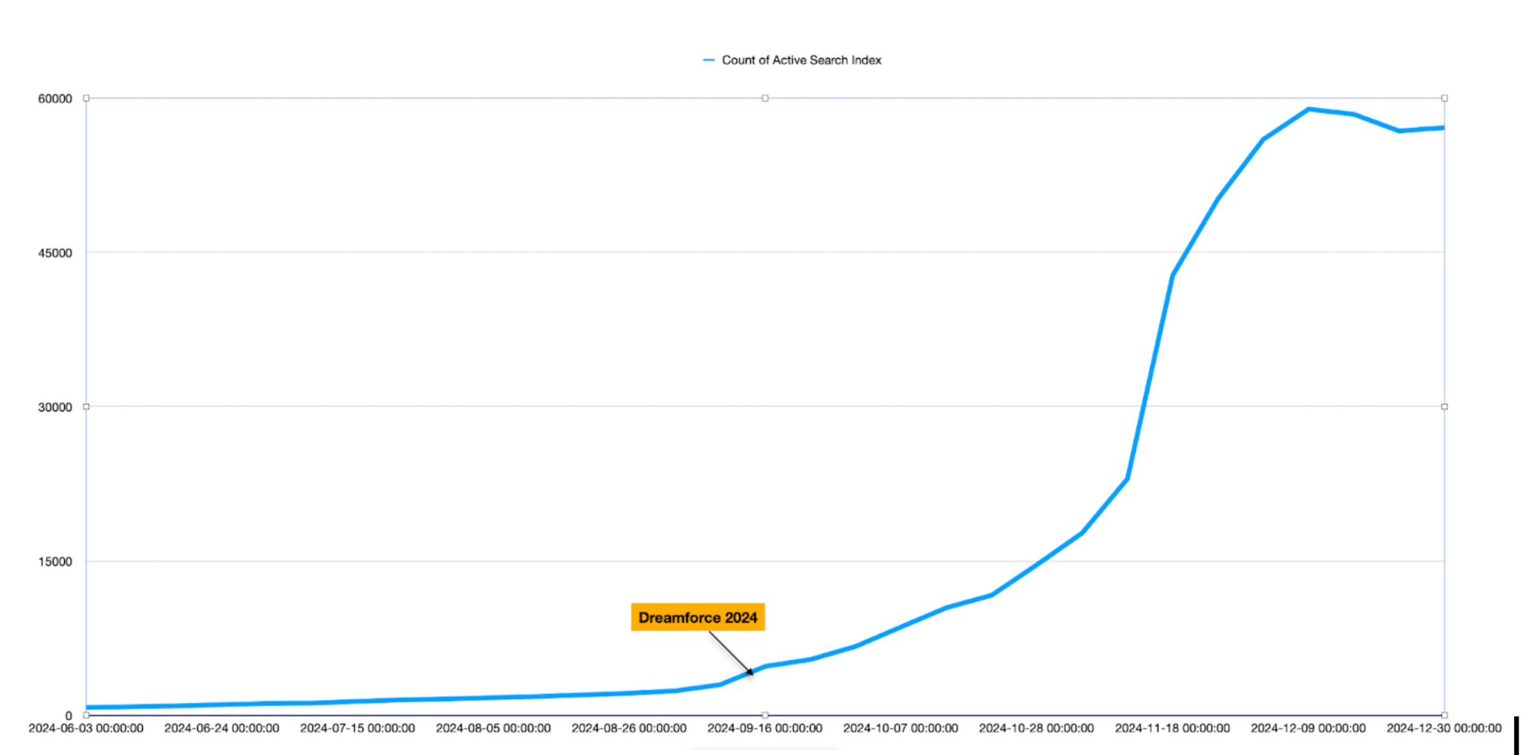

Solution Approach
The Unstructured CTS Reduction Plan outlines several completed and planned initiatives to reduce the Cost-to-Serve (CTS) for Unstructured Data Services:

Completed Initiatives :
- Disable Streaming for DE Tenants:
The surge in the UDS consumption was initially focused on internal enablers and users experimenting on AgentForce. This led to the creation of a large number of Developer Edition (DE) orgs, primarily used by Trailblazers with a developer persona. To mitigate scale issues caused by automatic Spark streams activating when users modified or uploaded new document versions, we disabled streaming in Developer Edition orgs. Instead, users were asked to manually trigger rebuilds when ready. While this created a suboptimal experience for developers, we accepted this trade-off, considering these orgs were mostly internal consumers. Importantly, Enterprise Orgs were left untouched to maintain their user experience.
- Streaming jobs for Developer Edition (DE) tenants were disabled in December.
- Reduced inference engine costs from $66K to $46K daily, saving ~$600,000 per month.
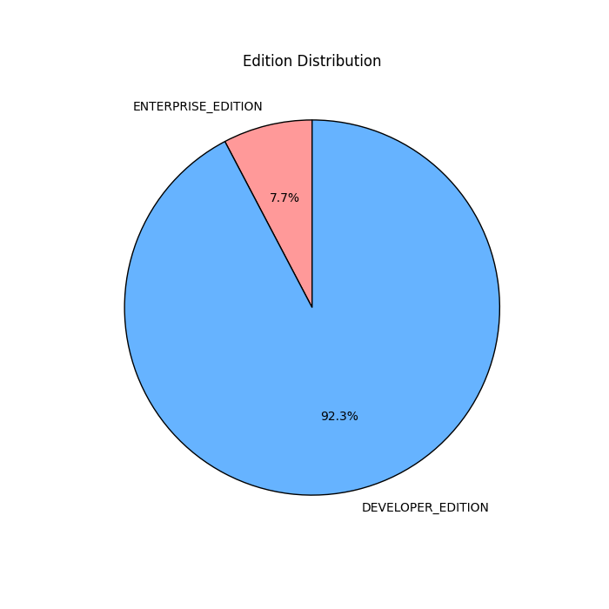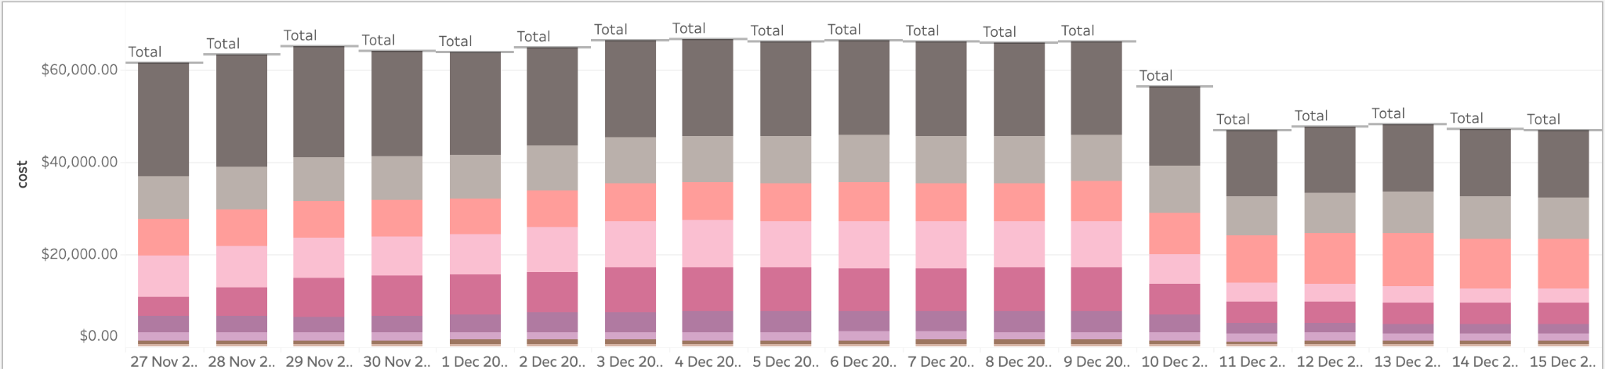
- Hibernation:
With 2 Spark streaming jobs always running for every tenant, we needed a way to conserve compute resources when the tenant is idle and there is no data to process. While hibernation was originally planned as a long-term optimization, the sudden scale surge made it a critical priority. The team took on this project with a war footing, implementing hibernation for streaming jobs to efficiently manage compute usage and reduce costs.
- Implemented in February for UDS streaming jobs.
- Enabled on all FI-FDs in a stagger manner, reducing daily CTS from ~$67K to $27K.
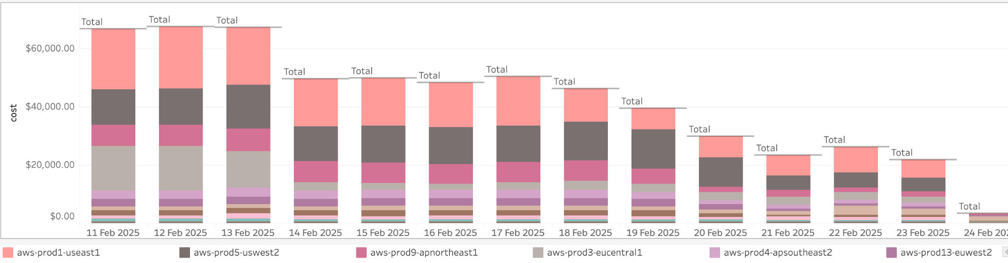
- Docker Image Optimization:
Since we use sidecar containers to process data in our Data Pipe, we needed to bring these containers with Docker images. We noticed an optimization opportunity by ensuring that Docker images, which are generally very large due to model hosting, are not copied across AWS regions. This approach significantly reduced cross-region data transfer costs, contributing to daily CTS reduction.
- Reduced the size of custom Docker images and optimized cross-region downloads.
- Daily CTS decreased from $30K to $11K.

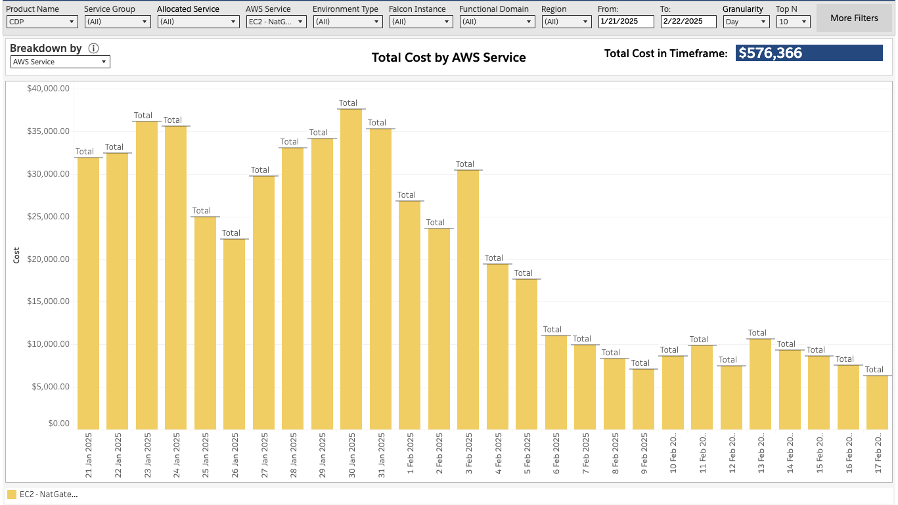
- DC Native Index for Small Size Index DMO: (Partially done)
The UDS Spark jobs previously used Milvus as a vector database, requiring a new Milvus cluster for every 10,000 search indices. However, many search indices contained smaller datasets with fewer than 100,000 vectors. To optimize performance, we implemented a strategy to bypass Milvus indexing for Developer Edition tenants. Instead, vector search is now handled directly through the Lakehouse, leading to significant cost and resource savings.

Future Planned Initiatives:
- Cluster Dynamic Sizing:
  - Full refresh UDS jobs currently use a fixed number of executors, causing inefficiencies.
  - The plan is to dynamically size clusters based on data size, tenant edition, and other parameters.

Financial Impact so far:
- Streaming Disabling: ~$600,000/month savings
- Hibernation: Daily CTS reduced by ~$40K
- Docker Optimization: Daily CTS reduction of $19K
- DC Native Indexing: Contributed to overall cost efficiency and performance improvements.
- Planned Initiatives: Expected to further enhance cost efficiency and performance stability.

