**Kofax Index Reconciliation for OnBase Application**

**Deployment Guide**

**Version 1.0.0.0**

**03/18/2020**

**Bug**

**Work Order -**

|  |  |  |  |
| --- | --- | --- | --- |
| **Author** | **Version** | **Date** | **Comment** |
| Dmitri Ponarin | 1.0.0.0 | 03/18/2020 | Initial version of KofaxIndexRecon_OnBase. |

### Overview

The Kofax Index Reconciliation for OnBase tool is a console application which runs from Monday to Friday as a scheduled task. This application reconciles data in OnBase against Kofax_FormInfo database and updates “Status” in the Kofax_FormInfo Database.

### 

### Abstract

This guide helps you to plan and carry out the deployment of the Kofax Index Reconciliation for OnBase application. The guide describes the system requirements and deployment methods as well as the procedures to maintain and support the software after deployment.

# Contents

Overview 2

Abstract 2

Contents 3

Part 1: Update Database Servers 4

A. Update “Kofax_FormInfo” Database 4

B. Update OnBaseHelper Database 4

A. Update SQL in OnBaseHelper database 4

B. Run program SqlUpdater to generate stored procedure in OnBaseHelper database 4

C. Grant permissions to service account in OnBase database 5

Part 2: Update Web Server(s) 6

A. Install .NET 4.7.1 Framework 6

B. Uninstall Existing KofaxIndexRecon_OnBase Application 6

C. Install Updated Kofax Index Reconciliation Application 6

D. Grant Folder Permissions 7

Part 3: Set-up Daily Runs 8

# Part 1: Update Database Servers

**NOTE**: This can be deployed any time - during business hours or after business hours.

Take full fresh backup of “Kofax_FormInfo” and “TowerDB” databases beforer deployment.

### Update “Kofax_FormInfo” Database

**Note: This is a one-time process to be completed on the target server**

On target server where “Kofax_FormInfo” database is located, copy “**Update Kofax_FormInfo Database.zip**” file to a temporary folder. Extract the zip file.

**NOTE**: You may have to physically log on to target database server to execute SQL scripts

* 1. Verify there are total of 10 (Ten) SQL scripts
  2. Execute following 8 scripts in order:
* KofaxFormInfoOB-1-CreateTable.Sql
* KofaxFormInfoOB-2-CreateDummyScripts.sql
* KofaxFormInfoOB-3-KfxIndxRcon_SelectRecFromKofaxInfo.Sql
* KofaxFormInfoOB-4-KfxIndxRconOB_SelectRecFromKofaxInfo.Sql
* KofaxFormInfoOB-5-KfxIndxRconOB_TruncateTables.Sql
* KofaxFormInfoOB-6-KfxIndxRcon_UpdtRecNotScanned.sql
* KofaxFormInfoOB-7-KfxIndxRconOB_UpdtRecScannedButMissingInOnBase.sql
* KofaxFormInfoOB-8-KfxIndxRconOB_UpdateFormInfoTable.Sql
  1. In scripts “***KofaxFormInfoOB-9-Create_Kofax_FormInfo_Login.sql***” and “***KofaxFormInfoOB-10-Grant_Permissions_Kofax_FormInfo.sql***” update variables *@KFX_Login* and *@KFX_ServiceAccount* with values specific to target environment.

Service account used in Dev: **DEVNCSECU\svc-dkfx-process**

* 1. Execute in order following scripts:
* KofaxFormInfoOB-9-Create_Kofax_FormInfo_Login.sql
* KofaxFormInfoOB-10-Grant_Permissions_Kofax_FormInfo.sql

### Update OnBaseHelper Database

**Note: This is a one-time process to be completed on the target server**

#### Update SQL in OnBaseHelper database

On target server where database “OnBaseHelper” is located, copy file “**Update OnBaseHelper Database.zip**” to a temporary folder. Extract the zip file.

Verify there are total of 3 SQL scripts. Execute following scripts in order:

* OnBaseHelper-1-CreateDummyScripts.sql
* OnBaseHelper-2-CreateUserLogin.sql
* OnBaseHelper-3-GrantPermissions.sql

#### Run program SqlUpdater to generate stored procedure in OnBaseHelper database

**Note: previous step is a prerequisite for this step.**

On target server where database “OnBaseHelper” is located, copy file “**SqlUpdater.zip**” to a temporary folder. Extract the zip file. File *README.docx* explains the purpose of SqlUpdated application.

**Note**: One can review all SQL statements and stored procedure that will be executed by the program: they are stored as configuration values in the file SqlUpdated.exe.config .

Being logged in as an user with administrative privileges on the database OnBaseHelper, execute program SqlUpdater.exe

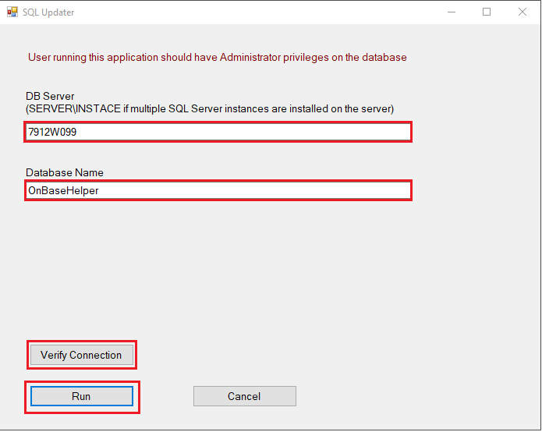

**DB Server** – provide name of the server on which the installation being performed. If there are multiple instances of SQL Server are installed on this server, specify server and instance name.

**Database Name** – provide name of OnBaseHelper database.

**Verify Connection** – it is recommended to click button Verify Connescion to verify that connection to database with provided values establishes without issues.

**Run** – execute the program.

### Grant permissions to service account in OnBase database

**Note: This is a one-time process to be completed on every server hosting OnBase database to which OnBaseHelper is linked.**

* On target server where database “OnBase” is located, copy file “**OnBase_CreateUserLogin_GrantPermissions.sql**” to a temporary folder.
* In this script update variables @KFX_Login and @KFX_ServiceAccount with values specific to target environment.
* Execute the script

# Part 2: Update Web Server(s)

### Install .NET 4.7.1 Framework

**Note: This is a one-time process and may have been completed on the target server(s)**

If .NET 4.7.1 is not installed on the Image Web Server(s), please install it.

**NOTE**: Please make sure to use exact same version in all environments.

**In DEV**, Image servers are “DIMG9901v” and “DIMG9902v”

### Uninstall Existing KofaxIndexRecon_OnBase Application

If installed, uninstall previous version of the KofaxIndexRecon_OnBase application from the Image web server(s)

**NOTE**: Before uninstalling existing application, save “KofaxIndexRecon_OnBase.exe.config” file. It will be helpful to find target environment related information for following steps.

**In DEV**, Image servers are “DIMG9901v” and “DIMG9902v”

### Install Updated Kofax Index Reconciliation Application

On target server(s), copy “**KofaxindexRecon_OnBase_Setup_1.0.0.zip**” file in a temporary folder . Extract the zip file.

1. As an administrator, execute “**setup.exe**”.
2. On poped up window,
   1. Choose desired folder for installation
   2. Select “**Everyone**” radio button
   3. Click “**Next**”

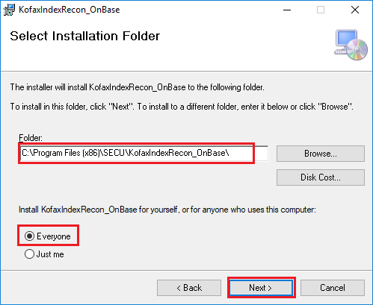

1. In next “KofaxIndexRecon_OnBase Configuration Settings” window specify applicable databases connection strings, log folder location and make needed email addresses change.

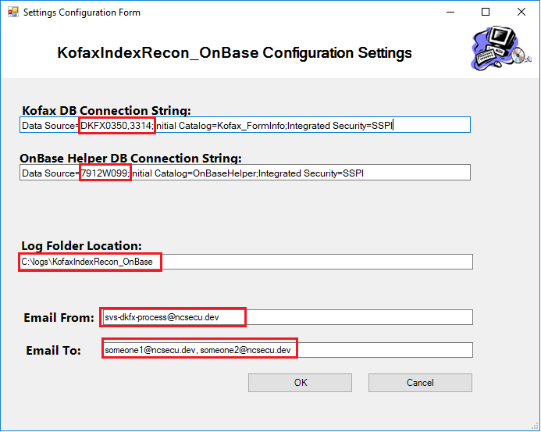

**Kofax DB Connecting String** – Update name of the server that hosts database “Kofax_FormInfo” in the target environment

**OnBase Helper DB Connecting String** – Update name of the server that hosts database “OnBaseHelper” in the target environment

**Log Folder Location** – Update desired log file location for target environment

**Email From** – Put email corresponding to service account in the target environment

[in Dev: [svc-dkfx-process@ncsecu.dev](mailto:svc-dkfx-process@ncsecu.dev) ]

**Email To** – Update receiver’s email address for target environment

(**NOTE**: Can have multiple comma separated email address)

1. Continue till you get “Installation completed successfully” window

### Grant Folder Permissions

**Note: This is a one-time process and may have been completed on the target server**

Using AD group policy, add the following **Active Directory** accounts to the local administrators group on the installation server. This account should have “FULL” (Read, Write, Delete and Update) permissions on the application installation folder and on the Log folder.

* + **AD Account:** **DEV** : svs-dkfx-process

# Part 3: Set-up Daily Runs

**Note: This is a one-time process and may have been completed on the target server**

~~Create two scheduled tasks:~~

**~~NOTE~~**~~: Work with “TowerDB” Admins to determine best time to run the tasks~~

* **~~Nightly~~** ~~- To be run from Monday to Friday~~

~~Scheduled task command:~~ ***~~<ApplicationExeFolderLocation>\KofaxIndexRecon –n~~***

~~Scheduled Task to be run/executed by:~~

* + **~~AD Account:~~****~~DEV~~** ~~: Devncsecu\svs-dkfx-process~~
* **~~Weekly~~** ~~- To be run on Saturday~~

~~Scheduled task command:~~ ***~~< ApplicationExeFolderLocation>\KofaxIndexRecon –w~~***

~~Scheduled Task to be run/executed by:~~

* + **~~AD Account:~~****~~DEV~~** ~~: Devncsecu\svs-dkfx-process~~