2.4 I can select and use appropriate development techniques to link information across pages

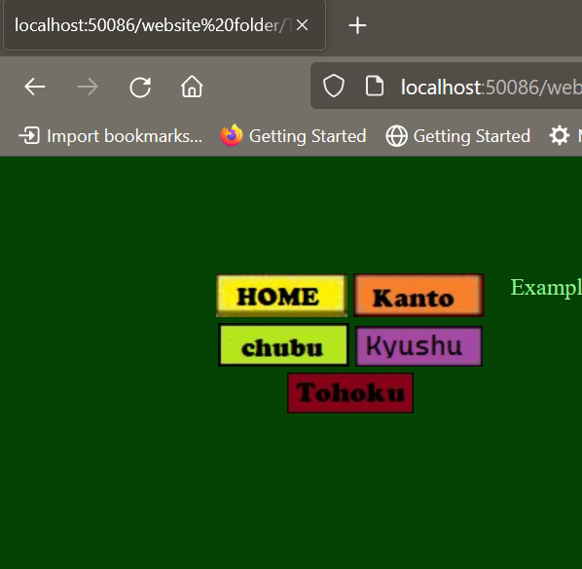

[These are the buttons that I made for the website I made]

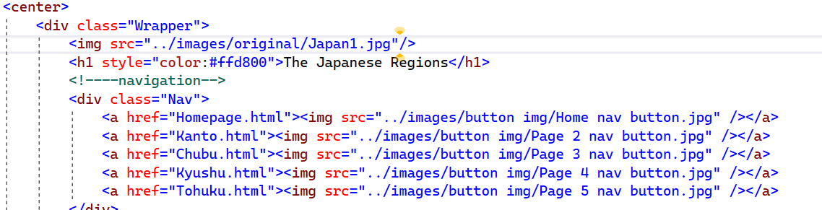

[This is the code that I used to make the buttons function]

I will now show you re-making my Home button:

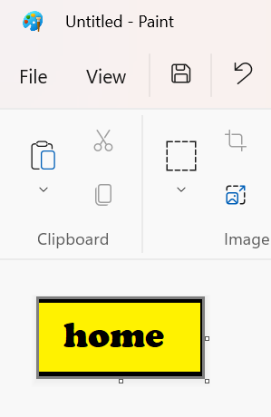

[The above photo shows the new button that I made in paint, I made the dimensions a little bit bigger than the last]

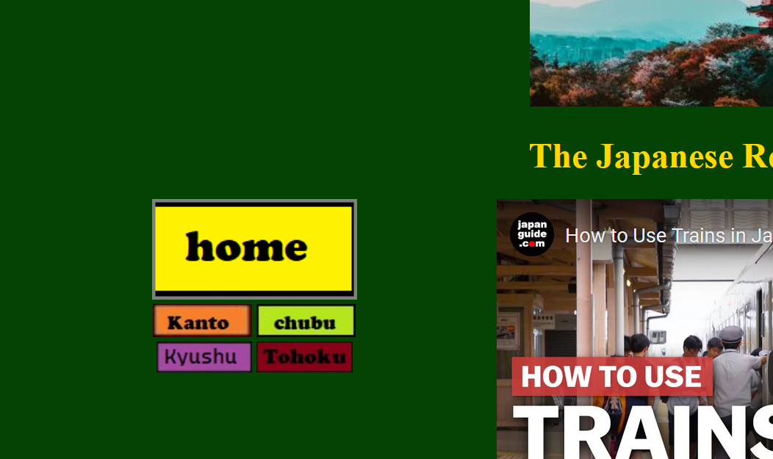

[This is the new button on my website and on the side shows the video I linked]

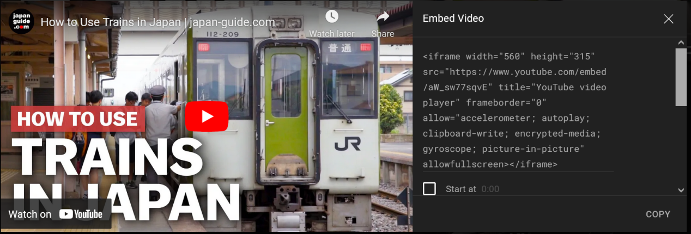

[Above shows the video that I linked to my website]