Assignment for AWS VM installation

1. AWS console page for both sever launches in running state

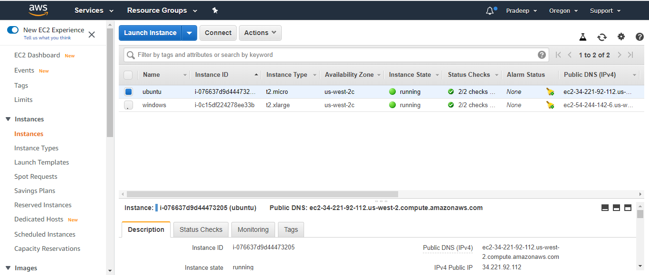

2. ISS webserver page for windows VM

1. lallllllllanjkjijebndnniss issn
2. issn s

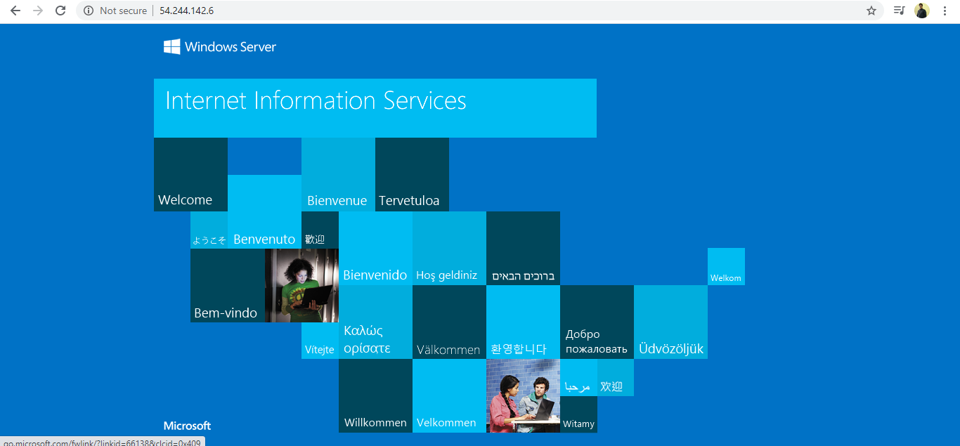

1. ngnix server page for Ubuntu VM 