To refresh the sql query in Excel go to the Data tab, and click on Connections.

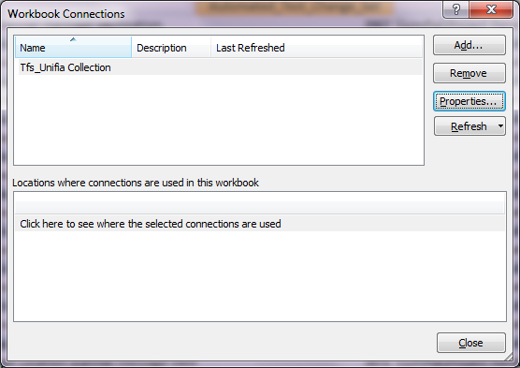

Click on Properties, and then Definitions.

Highlight all the text in the Command Text, and delete the text.

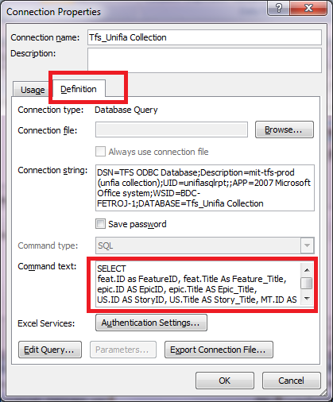

Go to TFS $/Unifia/Test/UserStoryTracing/SQL_UNIFIA_TraceMatrix.sql and copy all the text and paste it in the Command Text. Then click OK.
NOTE It will take 10 to 15 minutes to refresh the data. Excel will look like it’s not responding. Do not close it. Just let it run.

Nicole,

The spreadsheet has been checked in here: $/Unifia/Test/UserStoryTracing/11192015Trace.xls.

Please download it and click Refresh All under Data tab. If you don't have an ODBC connection, Excel will prompt you to create one.

Here's how I created mine.

Server: mit-sql-prod
User: unifiasqlrpt
Password: 0lympu$
Database: TFS_Unifia Collection

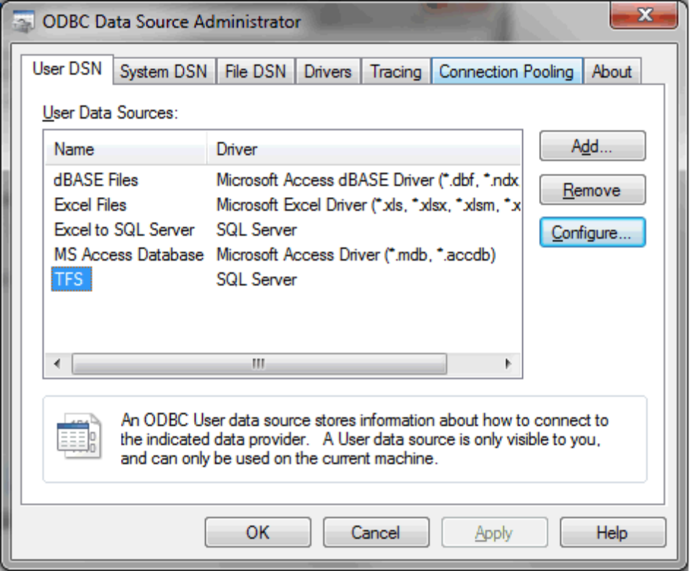
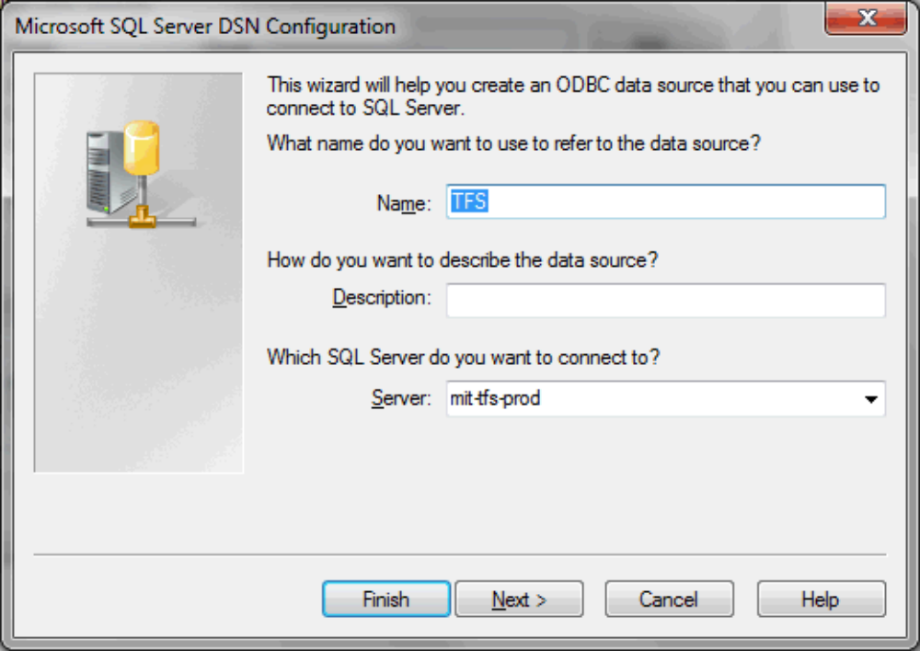

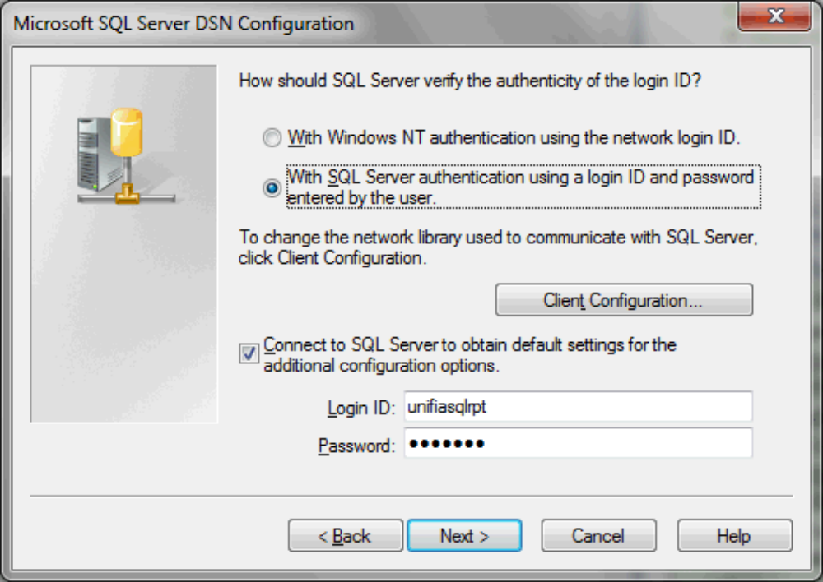
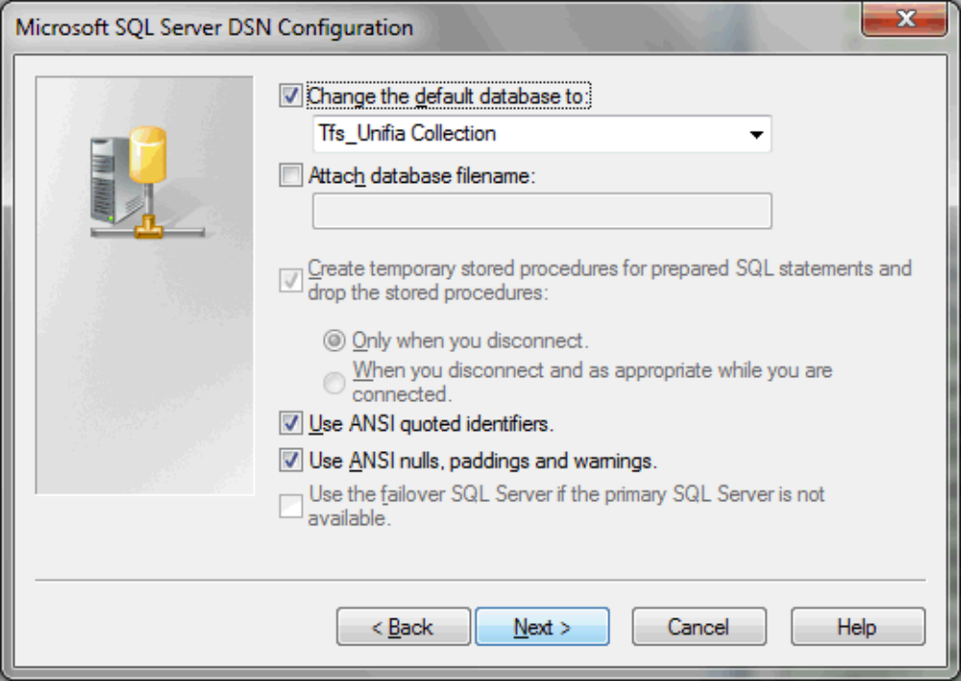
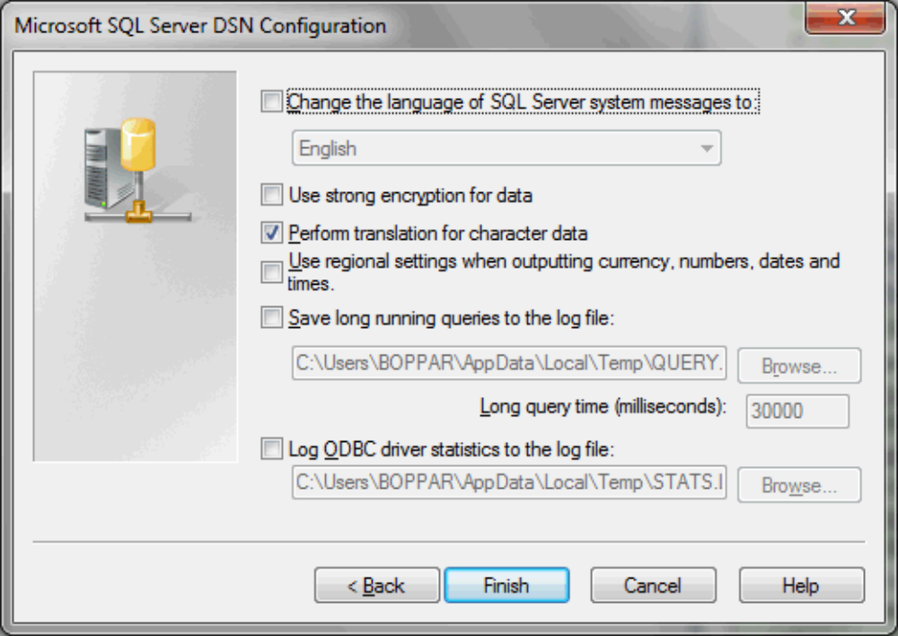
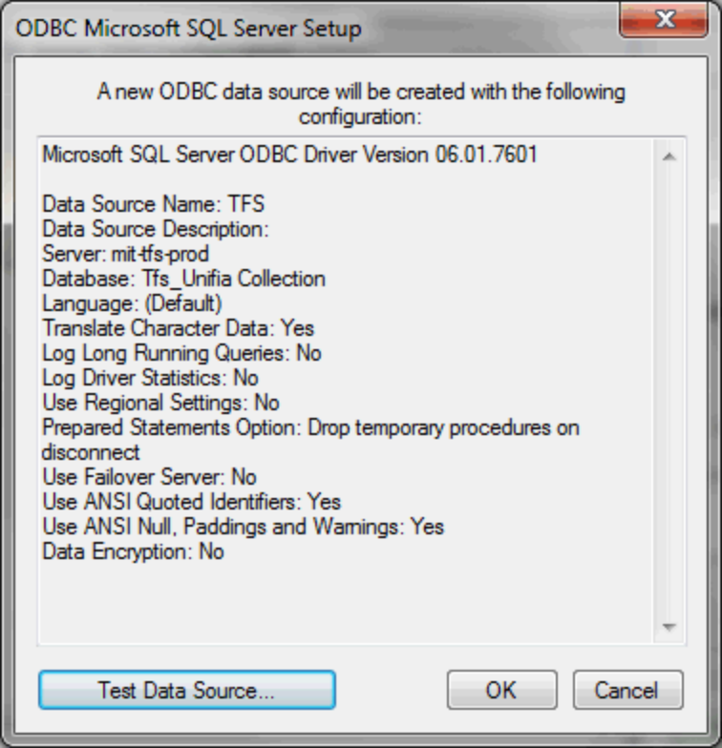
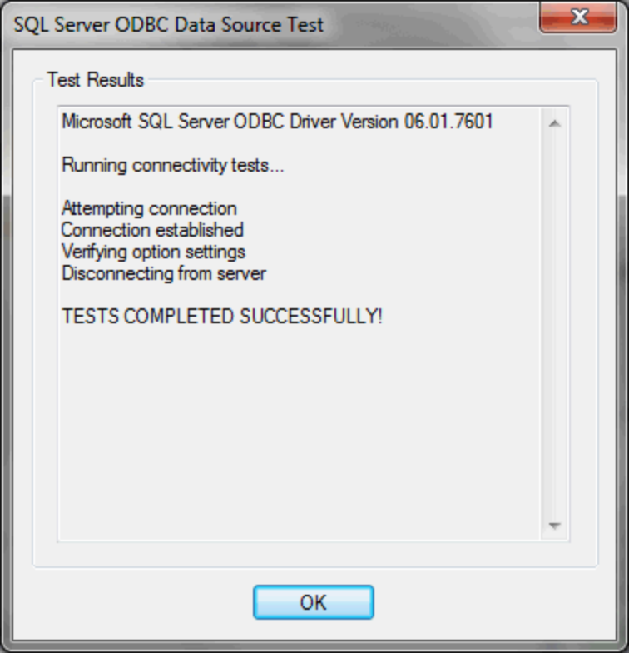

From: Nicole McKinley/HQ/Medical/OAI
To: Ravikiran Boppana/HQ/Medical/OAI@OAI, Jon Fetrow/HQ/Medical/OAI@OAI
Date: 02/18/2016 08:44 AM
Subject: Unifia Trace

Hi Ravi and Jon,
Would you please remind me how to get the trace matrix for Unifia? I wanted to make sure all the updates we've been doing for automation are traced properly and I can't remember how to do the trace or find my email with the trace instructions. I also checked the test team wiki and it hasn't been updated with the latest instructions. I'll update the wiki once you send them to me if you'd like.
Wiki:
http://mit-tfs-prod/sites/Unifia%20Collection/Unifia/Team%20Wiki/Create%20a%20Trace%20Matrix%20from%20User%20Stories%20to%20Tests.aspx

Thanks,
Nicole
Nicole McKinley
Principal Software Test Engineer SDC
Olympus America, Inc.
nicole.mckinley@olympus.com
484.896.5330 (x105330)

