**Tutorial-2**

**1.** **: Predict and write output for the following code.**

**Code:**

using System;

namespace DecisionMaking

{

class Program

{

static void Main(string[] args)

{

/* local variable definition */

int a = 10;

/* check the boolean condition using if statement */

if (a < 20)

{

/* if condition is true then print the following */

Console.WriteLine("a is less than 20");

}

Console.WriteLine("value of a is : {0}", a);

Console.ReadLine();

}

}

}

**Output:**

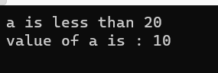

**2.** **Write missing statement to get the desired output.**

**Code:**

using System;

namespace DecisionMaking

{

class Program

{

static void Main(string[] args)

{

/* local variable definition */

int a = 100;

/* check the boolean condition */

if (a < 20)

{

/* if condition is true then print the following */

Console.WriteLine("a is less than 20");

}

else

{

/* if condition is false then print the following */

Console.WriteLine("a is not less than 20"); //………………………………Missing statement-1……………………………….//

Console.WriteLine("Value of a is " + a); //………………………………Missing statement-2……………………………….//

}

Console.ReadLine();

}

}

}

**Output:**

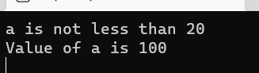

**3.Correct the following code and write output for the corrected code.**

**Code:**

using System;

namespace ConsoleApplication1

{

class Program

{

static void Main(string[] args)

{

string firstName = "John";

string lastName = "Doe";

Console.WriteLine("Name: " + firstName + " " + lastName);

Console.WriteLine("Please enter a new first name:");

firstName = Console.ReadLine();

Console.WriteLine("New name: " + firstName + " " + lastName);

Console.ReadLine();

}

}

}

**Output:**

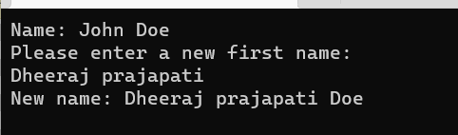

**4.** **Input two number A and B. perform different operations using different operators and different data types available in C#. (Note : Follow all the operators and data types to do above task. Use Online help whenever necessary.)**

**Code:**

using System;

namespace _4

{

class Program

{

static void Main(string[] args)

{

int n, n1, n2;

bool a = true, b = false, result;

Console.WriteLine("Enter the first number : ");

n1 = Convert.ToInt32(Console.ReadLine());

Console.WriteLine("Enter the first number : ");

n2 = Convert.ToInt32(Console.ReadLine());

n = n1 + n2;

Console.WriteLine("Addition is " + n);

n = n1 - n2;

Console.WriteLine("Subtraction is " + n);

n = n1 * n2;

Console.WriteLine("Multiplication is " + n);

n = n1 / n2;

Console.WriteLine("Divisor is " + n);

n = n1 % n2;

Console.WriteLine("Modulo is " + n);

result = a && b;

Console.WriteLine("AND Operator: " + result);

// OR operator

result = a || b;

Console.WriteLine("OR Operator: " + result);

// NOT operator

result = !a;

Console.WriteLine("NOT Operator: " + result);

}

}

}

**Output:**

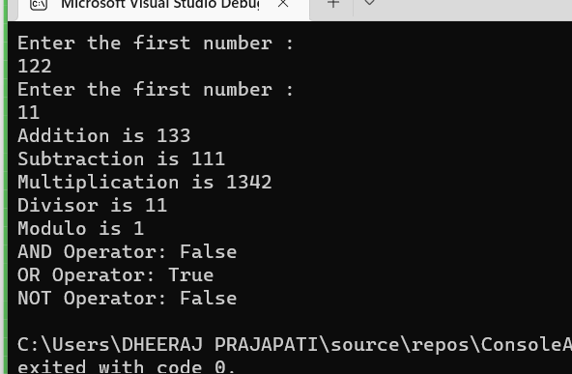

**5.** **Rearrange the given code to correct the program. The resultant program will be to enter 5 elements into an array and print sum of these elements.**

**Code:**

using System;

public class Program

{

public static void Main()

{

int[] a = new int[100];

int i, n, sum = 0;

Console.Write("\n\nFind sum of all elements of array:\n");

Console.Write("--------------------------------------\n");

Console.Write("Input the number of elements to be stored in the array :");

n = Convert.ToInt32(Console.ReadLine());

Console.Write("Input {0} elements in the array :\n", n);

for (i = 0; i < n; i++)

{

Console.Write("element - {0} : ", i);

a[i] = Convert.ToInt32(Console.ReadLine());

}

for (i = 0; i < n; i++)

{

sum += a[i];

}

Console.Write("Sum of all elements stored in the array is : {0}\n\n", sum);

}

}

**Output:**

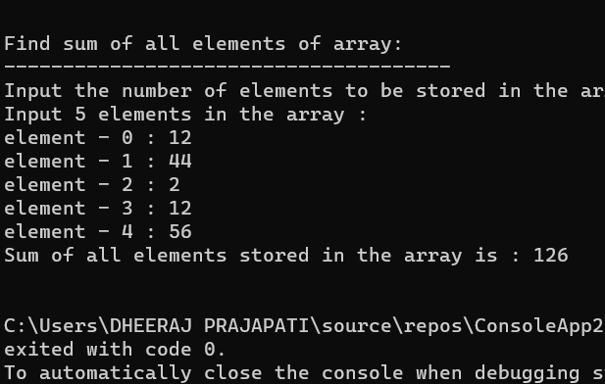

**6.** **Write missing statement to get the desired output.**

**Code:**

using System;

public class prgram

{

public static void Main(string[] args)

{

Console.WriteLine("Hello, World!");

Console.WriteLine("You entered the following {0} command line arguments:", args.Length);

for (int i = 0; i < args.Length; i++)

{

Console.WriteLine("{0}", args[i]);

}

}

Console.WriteLine("A");

Console.WriteLine("B");

Console.WriteLine("c");

Console.WriteLine("D");

}

**Output:**

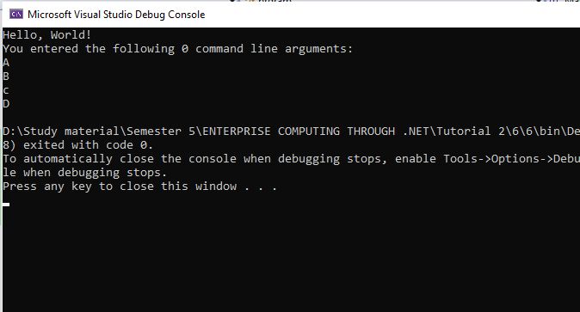

**7.Predict and write the output of the given code.**

**Code:**

using System;

namespace CalculatorApplication

{

class NumberManipulator

{

public void swap(ref int x, ref int y)

{

int temp;

temp = x; /* save the value of x */

x = y; /* put y into x */

y = temp; /* put temp into y */

}

}

class TestRef

{

static void Main(string[] args)

{

NumberManipulator n = new NumberManipulator();

/* local variable definition */

int a = 100;

int b = 200;

Console.WriteLine("Before swap, value of a : {0}", a);

Console.WriteLine("Before swap, value of b : {0}", b);

/* calling a function to swap the values */

n.swap(ref a, ref b);

Console.WriteLine("After swap, value of a : {0}", a);

Console.WriteLine("After swap, value of b : {0}", b);

Console.ReadLine();

}

}

}

**Output:**

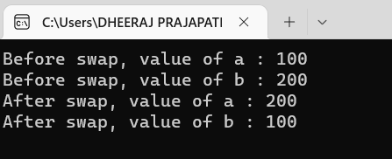

**8.** **Find out error code and correct it. Write the output of the corrected code.**

**Code:**

using System;

namespace CalculatorApplication

{

class NumberManipulator

{

public void getValues(out int x, out int y)

{

Console.WriteLine("Please enter the first value:");

x = Convert.ToInt32(Console.ReadLine());

Console.WriteLine("Please enter the second value:");

y = Convert.ToInt32(Console.ReadLine());

}

static void Main(string[] args)

{

NumberManipulator n = new NumberManipulator();

int a, b;

n.getValues(out a, out b);

Console.WriteLine("After the method call, the value of a: {0}", a);

Console.WriteLine("After the method call, the value of b: {0}", b);

Console.ReadLine();

}

}

}

**Output:**

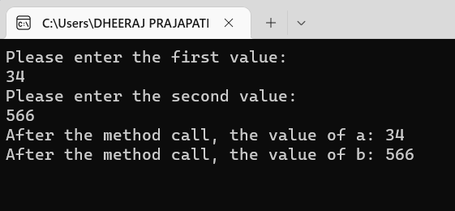

**9.** **Given an array A containing 2*N+2 positive numbers, out of which 2*N numbers exist in pairs whereas the other two number occur exactly once and are distinct. Find the other two numbers.**

**Code:**

using System;

class dp

{

static void UniqueNumbers2(int[] arr, int n)

{

int sum = 0;

for (int i = 0; i < n; i++)

{

sum = (sum ^ arr[i]);

}

sum = (sum & -sum);

int sum1 = 0;

int sum2 = 0;

for (int i = 0; i < arr.Length; i++)

{

if ((arr[i] & sum) > 0)

{

sum1 = (sum1 ^ arr[i]);

}

else

{

sum2 = (sum2 ^ arr[i]);

}

}

Console.WriteLine("The non-repeating "

+ "elements are " + sum1 + " and "

+ sum2);

}

static public void Main()

{

int[] arr = { 1, 2, 3, 2, 1, 4 };

int n = arr.Length;

UniqueNumbers2(arr, n);

}

}

**Output:**

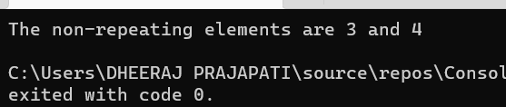

**10.** **Given a matrix mat[][] of size N x M, where every row and column is sorted in increasing order, and a number X is given. The task is to find whether element X is present in the matrix or not.**

**Code:**

using System;

class Rahul

{

static void binarySearch(int[,] mat, int i, int j_low,

int j_high, int x)

{

while (j_low <= j_high)

{

int j_mid = (j_low + j_high) / 2;

if (mat[i, j_mid] == x)

{

Console.Write("Found at (" + i +

", " + j_mid + ")");

return;

}

else if (mat[i, j_mid] > x)

j_high = j_mid - 1;

else

j_low = j_mid + 1;

}

Console.Write("Element no found that is 0");

}

static void sortedMatrixSearch(int[,] mat, int n,

int m, int x)

{

if (n == 1)

{

binarySearch(mat, 0, 0, m - 1, x);

return;

}

int i_low = 0;

int i_high = n - 1;

int j_mid = m / 2;

while ((i_low + 1) < i_high)

{

int i_mid = (i_low + i_high) / 2;

if (mat[i_mid, j_mid] == x)

{

Console.Write("Found at (" + i_mid +

", " + j_mid + ")");

return;

}

else if (mat[i_mid, j_mid] > x)

i_high = i_mid;

else

i_low = i_mid;

}

if (mat[i_low, j_mid] == x)

Console.Write("Found at (" + i_low +

"," + j_mid + ")");

else if (mat[i_low + 1, j_mid] == x)

Console.Write("Found at (" + (i_low

+ 1) + ", " + j_mid + ")");

else if (x <= mat[i_low, j_mid - 1])

binarySearch(mat, i_low, 0, j_mid - 1, x);

else if (x >= mat[i_low, j_mid + 1] &&

x <= mat[i_low, m - 1])

binarySearch(mat, i_low, j_mid + 1, m - 1, x);

else if (x <= mat[i_low + 1, j_mid - 1])

binarySearch(mat, i_low + 1, 0, j_mid - 1, x);

else

binarySearch(mat, i_low + 1, j_mid + 1, m - 1, x);

}

public static void Main(String[] args)

{

int n = 3, m = 5, x = 8;

int[,] mat = {{3, 30, 38},

{44, 52, 54},

{57, 60, 69}};

sortedMatrixSearch(mat, n, m, x);

}

}

**Output:**

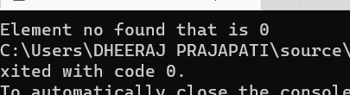

**11.** **Write a program to find the sum of N elements of an Array.**

**Code:**

using System;

public class Exercise3

{

public static void Main()

{

int[] a = new int[100];

int i, n, sum = 0;

Console.Write("\n\nFind sum of all elements of array:\n");

Console.Write("--------------------------------------\n");

Console.Write("Input the number of elements to be stored in the array :");

n = Convert.ToInt32(Console.ReadLine());

Console.Write("Input {0} elements in the array :\n", n);

for (i = 0; i < n; i++)

{

Console.Write("element - {0} : ", i);

a[i] = Convert.ToInt32(Console.ReadLine());

}

for (i = 0; i < n; i++)

{

sum += a[i];

}

Console.Write("Sum of all elements stored in the array is : {0}\n\n", sum);

}

}

**Output**

**:** 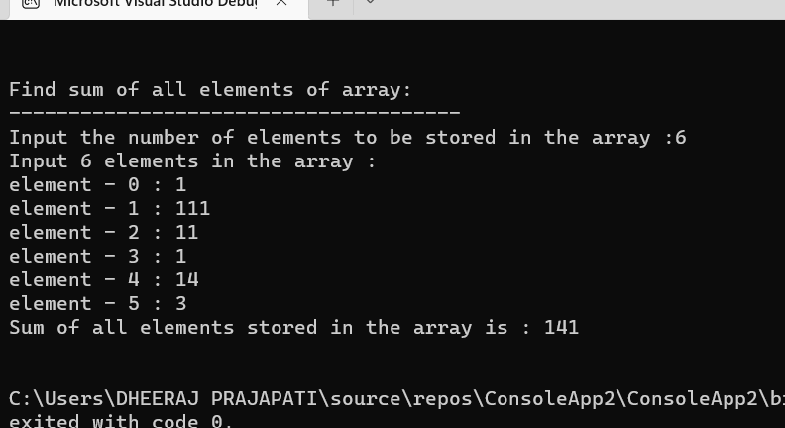

12. **.  Write a program to find the element from an Array and print 1 if element is found else print 0.**

**Code:**

using System;

using System.Linq;

public static class Extensions

{

public static bool find<T>(this T[] array, T target)

{

return array.Contains(target);

}

}

public class Example

{

public static void Main()

{

int[] array = { 1, 2, 3, 4, 5 };

int target ;

Console.WriteLine("Enter the target element");

target = Convert.ToInt32(Console.ReadLine());

bool isExist = array.find(target);

if (isExist)

{

Console.WriteLine("1");

}

else

{

Console.WriteLine("0");

}

}

}

**Output:**

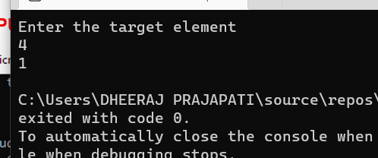

**13.** **. Write a Program that will accept the amount and find how many minimum  
no of notes you required for that.  
(Using the rupee notes of 1, 2, 5, 10, 20, 50, 100, 200, 500, 2000)  
Input: 5748.**

**Code:**

using System;

public class Rahul

{

public static void countCurrency(int amount)

{

int[] notes = new int[] { 2000, 500, 200, 100, 50, 20, 10, 5, 2, 1 };

int[] noteCounter = new int[9];

for (int i = 0; i < 9; i++)

{

if (amount >= notes[i])

{

noteCounter[i] = amount / notes[i];

amount = amount % notes[i];

}

}

Console.WriteLine("Currency Count ->");

for (int i = 0; i < 9; i++)

{

if (noteCounter[i] != 0)

{

Console.WriteLine(notes[i] + " : "

+ noteCounter[i]);

}

}

}

public static void Main()

{

int amount = 5748;

countCurrency(amount);

}

}

**Output:**

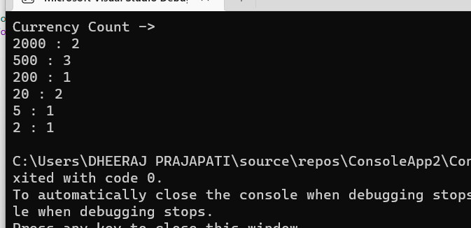

**14.** **Write a Program to find the eligibility of admission for a  professional course  
based on the following criteria:  
Marks in Maths >=65  
Marks in Phy >=55  
Marks in Chem>=50 and  
Total in all three subject >=180 or  
Total in Math and Physics >=140**

**Code;**

using System;

public class Exercise10

{

public static void Main()

{

int p, c, m;

Console.Write("Find eligibility for admission :\n");

Console.Write("----------------------------------");

Console.Write("\n\n");

Console.Write("Eligibility Criteria :\n");

Console.Write("Marks in Maths >=65\n");

Console.Write("and Marks in Phy >=55\n");

Console.Write("and Marks in Chem>=50\n");

Console.Write("and Total in all three subject >=180\n");

Console.Write("or Total in Maths and Physics >=140\n");

Console.Write("-------------------------------------\n");

Console.Write("Input the marks obtained in Physics :");

p = Convert.ToInt32(Console.ReadLine());

Console.Write("Input the marks obtained in Chemistry :");

c = Convert.ToInt32(Console.ReadLine());

Console.Write("Input the marks obtained in Mathematics :");

m = Convert.ToInt32(Console.ReadLine());

Console.Write("Total marks of Maths, Physics and Chemistry : {0}\n", m + p + c);

Console.Write("Total marks of Maths and Physics : {0}\n", m + p);

if (m >= 65)

if (p >= 55)

if (c >= 50)

if ((m + p + c) >= 180 || (m + p) >= 140)

Console.Write("The candidate is eligible for admission.\n");

else

Console.Write("The candidate is not eligible.\n\n");

else

Console.Write("The candidate is not eligible.\n\n");

else

Console.Write("The candidate is not eligible.\n\n");

else

Console.Write("The candidate is not eligible.\n\n");

}

}

**Output:**

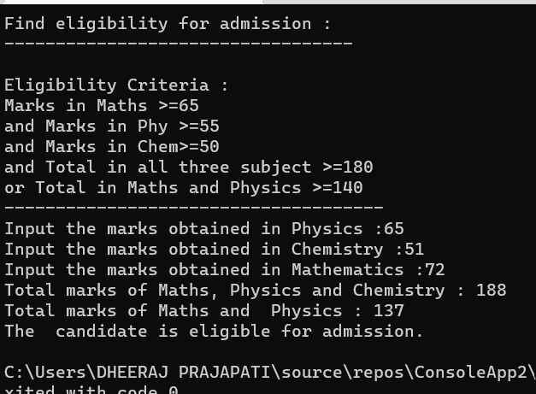

**15.** **.Write a Program which accepts name from the user and prints the same**

**INPUT : R K University**  
**OUTPUT: R K University**

**Code:**

using System;

namespace _15

{

class Program

{

static void Main(string[] args)

{

Console.WriteLine("Enter the name : ");

string userName = Console.ReadLine();

Console.WriteLine(userName);

}

}

}

**Output:**

