**Tutorial – 9**

**1.Design an application which will demonstrate the operations like Insert, Update and Delete on data using Connected Approach.**

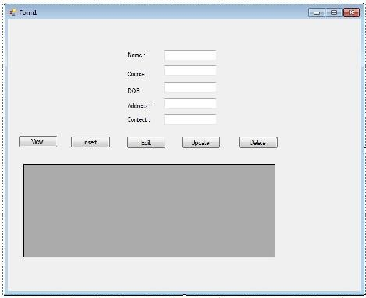

**Code:**

using System;

using System.Collections.Generic;

using System.ComponentModel;

using System.Data;

using System.Data.SqlClient;

using System.Drawing;

using System.Linq;

using System.Text;

using System.Threading.Tasks;

using System.Windows.Forms;

namespace CRUD_demo

{

public partial class Form1 : Form

{

public Form1()

{

InitializeComponent();

}

private void Btninsert_Click(object sender, EventArgs e)

{

this.Enabled = false;

String constr = @"Data Source=(LocalDB)\MSSQLLocalDB;AttachDbFilename=E:\Gautam\CRUDdemo\CRUD demo\CRUD demo\Student.mdf;Integrated Security=True;Connect Timeout=30";

SqlConnection con = new SqlConnection(constr);

con.Open();

String query = "Insert into student(EnrlNo,Name,Age,City)Values(@EnrlNo,@Name,@Age,@City)";

SqlCommand cmd = new SqlCommand(query, con);

cmd.Parameters.AddWithValue("@EnrlNo", txtEnrlNo.Text);

cmd.Parameters.AddWithValue("@Name", txtName.Text);

cmd.Parameters.AddWithValue("@Age", txtAge.Text);

cmd.Parameters.AddWithValue("@City", txtCity.Text);

cmd.ExecuteNonQuery();

con.Close();

MessageBox.Show("Insertion successful", "Insertion");

reset();

this.Enabled = true;

}

public void reset()

{

txtAge.Text = "";

txtCity.Text = "";

txtEnrlNo.Text = "";

txtName.Text = "";

}

private void BtnReset_Click(object sender, EventArgs e)

{

reset();

}

private void Btnupdate_Click(object sender, EventArgs e)

{

this.Enabled = false;

String constr = @"Data Source=(LocalDB)\MSSQLLocalDB;AttachDbFilename=E:\Gautam\CRUDdemo\CRUD demo\CRUD demo\Student.mdf;Integrated Security=True;Connect Timeout=30";

SqlConnection con = new SqlConnection(constr);

con.Open();

String query = "Update student set Name=@Name, Age=@Age, City=@City where EnrlNo=@EnrlNo";

SqlCommand cmd = new SqlCommand(query, con);

cmd.Parameters.AddWithValue("@EnrlNo", txtEnrlNo.Text);

cmd.Parameters.AddWithValue("@Name", txtName.Text);

cmd.Parameters.AddWithValue("@Age", txtAge.Text);

cmd.Parameters.AddWithValue("@City", txtCity.Text);

cmd.ExecuteNonQuery();

con.Close();

MessageBox.Show("Update successful", "Insertion");

reset();

this.Enabled = true;

}

private void Btndelete_Click(object sender, EventArgs e)

{

this.Enabled = false;

String constr = @"Data Source=(LocalDB)\MSSQLLocalDB;AttachDbFilename=E:\Gautam\CRUDdemo\CRUD demo\CRUD demo\Student.mdf;Integrated Security=True;Connect Timeout=30";

SqlConnection con = new SqlConnection(constr);

con.Open();

String query = "DELETE FROM Student where EnrlNo=EnrlNo";

SqlCommand cmd = new SqlCommand(query, con);

cmd.Parameters.AddWithValue("@EnrlNo", txtEnrlNo.Text);

cmd.ExecuteNonQuery();

con.Close();

MessageBox.Show("Deletion successful", "Insertion");

reset();

this.Enabled = true;

}

}

**Output:**

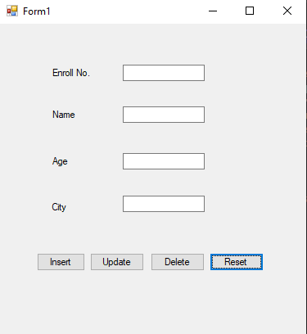

**2.Design an application which provide the search facility from database records using DataGridView component.**

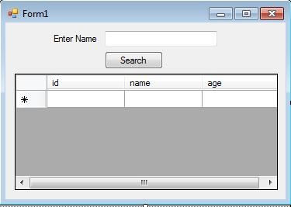

Code: