CLARITY
Real insights in seconds

The most relevant publications of the week
Cardiology · 2026-10-30 · 3 studies across 2 subspecialties
LONG EDITION
Contents
AI-curated from the leading cardiology-relevant journals of the last 7 days.
● Electrophysiology & Devices — 1 study
● Coronary Artery Disease / ACS — 2 studies
● For editorial review — 1

ELECTROPHYSIOLOGY & DEVICES
1 Left Bundle-Branch Area Pacing vs Right Ventricular Pacing for Atrioventricular Block and Preserved Left Ventricular Function: The LEAP-Block Randomized Clinical Trial
JAMA · 2026 Oct 28 · Li X., Wang H., Zhang W. et al.
● RCT
RCT, multicenter, superiority  DESIGN | 482  PARTICIPANTS | 24 months  FOLLOW-UP

PRIMARY ENDPOINT — All-cause death, HF events, or upgrade to biventricular pacing, 24 mo
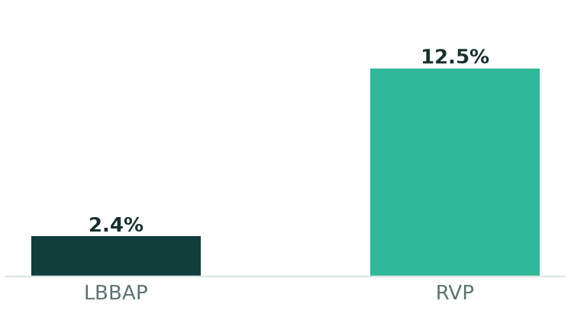
Absolute risk difference -10.1% (95% CI -16.8% to -3.4%); P = .003

OTHER ENDPOINTS
Endpoint | LBBAP | RVP | Effect
HF events | 3.4% | 11.3% | -7.9% (95% CI -13.0% to -2.8%)
Primary end point, Kaplan-Meier 24-mo cumulative incidence | 5.0% | 13.2% | HR 0.37 (95% CI 0.19 to 0.73); P = .004
Acute procedure success | 97.9% | 99.6% | P = .22

SUMMARY
The abstract states that the optimal pacing strategy to reduce heart failure (HF) and all-cause mortality in patients with atrioventricular block requiring high-burden ventricular pacing remains uncertain. LEAP-Block was a prospective, multicenter, randomized, controlled, superiority trial conducted across 14 Chinese hospitals from January 2021 to August 2025, with last follow-up on June 3, 2025. Of 551 patients with LVEF 50% or greater requiring ventricular pacing who underwent eligibility assessment, 499 with anticipated ventricular pacing greater than 40% were randomized 1:1 to LBBAP (n = 249) or RVP (n = 250). The primary end point was a composite of all-cause death, HF events, or upgrade to biventricular pacing at 24 months; secondary end points included pacing-induced cardiomyopathy and device-related complications. The primary analysis included 482 patients (LBBAP, n = 242; RVP, n = 240; mean age, 67 years; 46% female). Acute procedure success was 237/242 (97.9%) with LBBAP vs 239/240 (99.6%) with RVP (P = .22), and left bundle-branch capture was confirmed in 188 of 236 patients (79.7%). The primary end point occurred in 2.4% with LBBAP vs 12.5% with RVP (absolute risk difference, -10.1% [95% CI, -16.8% to -3.4%]; P = .003). HF events occurred in 3.4% vs 11.3% (-7.9% [95% CI, -13.0% to -2.8%]). No significant differences were observed in all-cause death, biventricular pacing upgrade, device-related complications, or pacing-induced cardiomyopathy. The 24-month Kaplan-Meier estimated cumulative incidence of the primary end point was 5.0% for LBBAP vs 13.2% for RVP (hazard ratio, 0.37 [95% CI, 0.19 to 0.73]; P = .004), and superiority of LBBAP was consistent across all prespecified subgroups. The authors conclude that LBBAP was superior to RVP in reducing the risk of the composite end point at 24 months.
RELATION TO EXISTING EVIDENCE
No directly comparable studies were considered for this topic.
RELATION TO GUIDELINES
For this topic the guideline 2025 ESC/EACTS Guidelines for the management of valvular heart disease exists; no comparison of content is made in this edition.

AUTHORS' CONCLUSION (AS REPORTED)
The authors conclude that, among patients with atrioventricular block and preserved LVEF requiring high-burden ventricular pacing, LBBAP was superior to RVP in reducing the risk of the composite of all-cause death, HF events, or upgrade to biventricular pacing at 24 months.

View on PubMed · DOI: 10.1001/jama.2026.18146

CORONARY ARTERY DISEASE / ACS
1 Performance of 0/1 h versus 0/3 h pathways in patients with suspected myocardial infarction: a systematic review and individual participant data meta-analysis of randomised controlled trials
Lancet · 2026 Oct 29 · Boeddinghaus J., Kunz M., Lopez-Ayala P. et al.
● META-ANALYSIS / SYSTEMATIC REVIEW
IPD meta-analysis of RCTs  DESIGN | 110,933  PARTICIPANTS | 30 days  FOLLOW-UP

PRIMARY ENDPOINT — All-cause death or new type 1 MI, 30 days
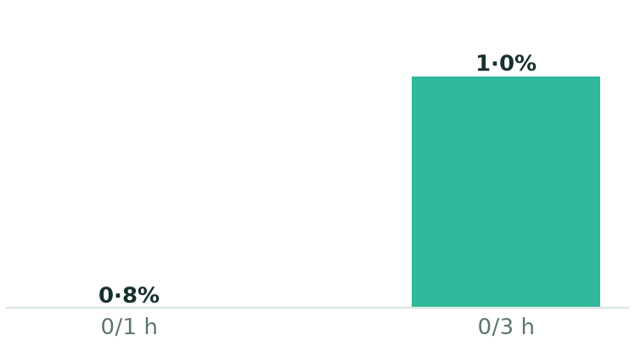
Pooled OR 0·83 (95% CI 0·45-1·53); I2=62·9%; τ2=0·143

OTHER ENDPOINTS
Endpoint | 0/1 h | 0/3 h | Effect
ED length of stay (median, min) | 314 | 308 | Geometric mean ratio 1·03 (95% CI 0·85-1·25)
Direct discharge from ED | 67·0% | 65·8% | Pooled OR 1·31 (95% CI 0·79-2·16)

SUMMARY
In patients with suspected myocardial infarction, the 0/1 h pathway is recommended in current guidelines for early risk stratification, but individual trials used different safety outcomes and efficacy outcomes were inconclusive or not assessed. This systematic review and individual participant data meta-analysis searched PubMed, Cochrane Central Register of Controlled Trials, Scopus, and the International Clinical Trials Registry Platform from inception to July 6, 2026, for randomised trials comparing 0/1 h with 0/3 h pathways. Outcome definitions were harmonised and the primary analysis used a two-stage random-effects meta-analysis. After receipt of the individual participant data but before harmonisation or analysis, the primary safety outcome was refined to all-cause death or new type 1 myocardial infarction within 30 days. The primary efficacy outcomes were emergency department length of stay and direct discharge from the emergency department. Five randomised trials were identified, all providing individual participant data, with 110,933 patient presentations (55,489 with the 0/1 h pathway and 55,444 with the 0/3 h pathway). The primary safety outcome occurred in 446 (0·8%) versus 562 (1·0%) patient presentations (pooled OR 0·83 [95% CI 0·45-1·53]; I2=62·9%; τ2=0·143). Emergency department length of stay was 314 min (IQR 211-481) versus 308 min (209-453), with a pooled geometric mean ratio of 1·03 (95% CI 0·85-1·25; I2=99·2%; τ2=0·024). Direct discharge occurred in 37,190 (67·0%) versus 36,485 (65·8%) patient presentations (pooled OR 1·31 [95% CI 0·79-2·16]; I2=97·8%; τ2=0·156). The definition of the primary safety outcome varied among trials, and in four trials emergency department length of stay was not reported for the whole analysis population. The authors conclude that short-term adverse event rates were low with both pathways but the pooled safety estimate remained imprecise, that earlier troponin retesting on average did not reduce length of stay or clearly increase direct discharge, and that substantial between-study heterogeneity indicates effects might not translate uniformly across health-care systems.
RELATION TO EXISTING EVIDENCE
No directly comparable studies were considered for this topic.
RELATION TO GUIDELINES
For this topic the guideline 2025 ESC/EACTS Guidelines for the management of valvular heart disease exists; no comparison of content is made in this edition.

AUTHORS' CONCLUSION (AS REPORTED)
The authors conclude that, across the available randomised trials, short-term adverse event rates were low with both pathways but the pooled safety estimate remained imprecise, and that earlier troponin retesting did not on average reduce emergency department length of stay or clearly increase direct discharge. They state that, for hospitals considering a transition from a 0/3 h to a 0/1 h pathway, broader diagnostic and organisational considerations are relevant to implementation decisions.

View on PubMed · DOI: 10.1016/S0140-6736(26)01767-8

CORONARY ARTERY DISEASE / ACS
2 Clopidogrel Versus Aspirin Monotherapy According to Atherothrombotic Risk Profile
Circ Cardiovasc Interv · 2026 Oct 29 · Lee J., Gim D., Park Y. et al.
● RCT
Post hoc analysis of RCT  DESIGN | 5,506  PARTICIPANTS | Median 2.3 years  FOLLOW-UP

PRIMARY ENDPOINT — MACCE in higher-risk patients (median 2.3 y)
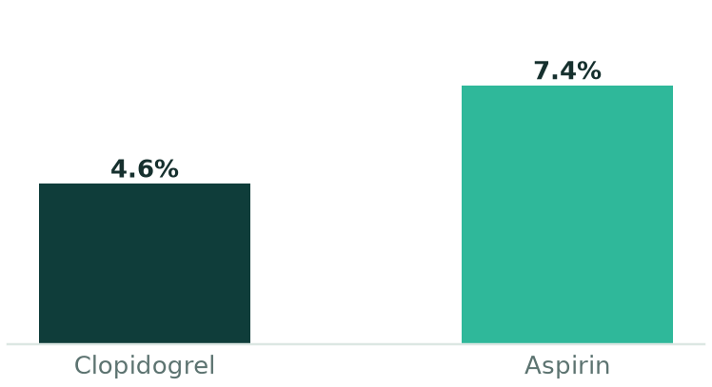
HR 0.67 (95% CI 0.50-0.89); P=0.006

OTHER ENDPOINTS
Endpoint | Clopidogrel | Aspirin | Effect
MACCE, higher-risk vs. lower-risk group | 6.1% | 3.1% | HR 1.83 (95% CI 1.17-2.78); P=0.007
MACCE in lower-risk patients (clopidogrel vs. aspirin) | 3.0% | 3.2% | HR 1.03; P=0.945; interaction P=0.242

SUMMARY
The background notes that clopidogrel monotherapy has shown superior efficacy compared with aspirin after completion of dual antiplatelet therapy following PCI, but that it was unclear whether the effect differs by overall atherothrombotic risk integrating clinical and angiographic factors. This was a post hoc analysis of the randomized SMART-CHOICE 3 trial, which included patients who completed guideline-directed dual antiplatelet therapy after PCI. Atherothrombotic risk was defined using the TIMI Risk Score for Secondary Prevention and complex PCI. Patients with a score ≥3 or complex PCI were classified as higher risk, and those with a score <3 without complex PCI as lower risk. The comparison was clopidogrel versus aspirin monotherapy. The primary end point was MACCE (death, myocardial infarction, or stroke), and bleeding was defined as BARC type 2, 3, or 5. Among 5,506 patients, 4,486 (81.5%) were higher risk and 1,020 (18.5%) lower risk. Over a median 2.3 years, MACCE was higher in the higher-risk group (6.1% versus 3.1%; HR 1.83 [95% CI 1.17-2.78]; P=0.007). In higher-risk patients, clopidogrel reduced MACCE compared with aspirin (4.6% versus 7.4%; HR 0.67 [95% CI 0.50-0.89]; P=0.006), whereas lower-risk patients showed 3.0% versus 3.2% (HR 1.03; P=0.945; interaction P=0.242). Bleeding was similar between groups. The authors conclude that clopidogrel monotherapy was associated with lower ischemic risk than aspirin in higher-risk patients, without increased bleeding.
RELATION TO EXISTING EVIDENCE
No directly comparable studies were considered for this topic.
RELATION TO GUIDELINES
For this topic the guideline 2025 ESC/EACTS Guidelines for the management of valvular heart disease exists; no comparison of content is made in this edition.

AUTHORS' CONCLUSION (AS REPORTED)
The authors conclude that, after completion of dual antiplatelet therapy following PCI, clopidogrel monotherapy was associated with lower ischemic risk than aspirin in patients with higher atherothrombotic risk, without increased bleeding.

View on PubMed · DOI: 10.1161/CIRCINTERVENTIONS.126.017277

For editorial review
Not selected automatically but conspicuous (e.g. top journal, known trial name, failed processing). Reviewed by the editor before distribution.
Impact of obesity on clinical outcomes and the treatment effect of catheter ablation in atrial fibrillation: insights from CABANA
Europace · 2026 Oct 01 · RCT · PubMed
RCT/meta-analysis below the relevance threshold (score 5)

CLARITY is an independent literature curation service and is not affiliated with, endorsed by, or associated with the journals or societies named herein. This document is a factual summary of published research, provided for information and continuing-education purposes only. It does not constitute medical advice, a treatment recommendation or clinical guidance, and must not be used as a basis for patient care decisions. Summaries are AI-generated and may contain errors; always consult the original publication and the applicable clinical guidelines.

