Fundamentals of Data Science
Assignment 1

Name: Praptee Dewan
Student ID: 25068590
Module Code: UFCFK1-15-0
Instructor: Kaushal Rimal
Submission Date: 17 April 2026

- Flowchart of Python Working

This diagram shows how Python works using three stages: input, processing, and output.
- Flowchart:

Input: User data, keyboard, files, etc.

Processing: Python code will execute (includes logic and calculations)

Output: Result is either shown on screen or saved inside a file

- Arithmetic Operations
This program takes two integers from the user and performs addition, multiplication, division, modulus, and exponentiation.

- Code:
- ''This program takes user input for two integers and performs basic arithmetic operations'''
- a = int(input("Enter first number: "))
- b = int(input("Enter second number: "))
- print("Addition:", a + b)
- print("Multiplication:", a * b)
- print("Division:", a / b)
- print("Modulus:", a % b)
- print("Exponentiation:", a ** b)

- Output Screenshot:
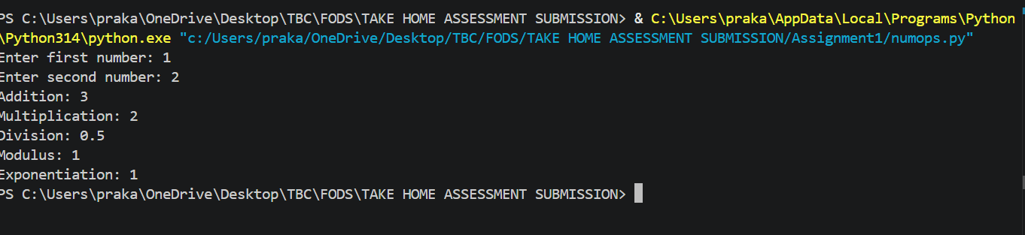

- Number Classification

This program checks whether a number is positive/negative and even/odd.
- Code:
- '''Classifies numbers as positive negative even or odd'''
- num = int(input("Enter a number: "))

- if num > 0:
- if num % 2 == 0:
- print("Positive Even")
- else:
- print("Positive Odd")
- elif num < 0:
- if num % 2 == 0:
- print("Negative Even")
- else:
- print("Negative Odd")
- else:
- print("Zero")

- Output Screenshot:
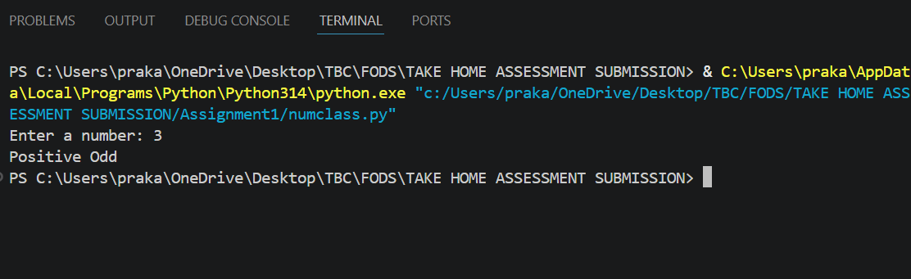

- Mathematical Operations
This program calculates cube, cube root, logarithms, and power of a number.
- Code:

- import math

- num = float(input("Enter a number: "))

- print("Cube:", num**3)
- print("Cube root:", num**(1/3))
- print("Natural log:", math.log(num))
- print("Log base 2:", math.log2(num))
- print("Power 6:", num**6)

- Output Screenshot:
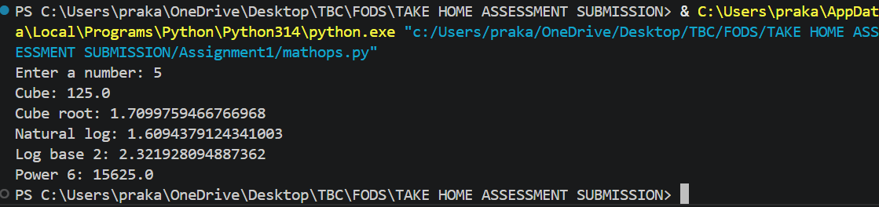

- Marks and Grade
This program calculates total, average, percentage, and assigns a grade based on rules.
- Code:
- marks = []
- for i in range(6):
- m = float(input(f"Enter marks for subject {i+1}: "))
- marks.append(m)

- total = sum(marks)
- avg = total / 6
- percentage = avg

- if percentage >= 85:
- grade = "Distinction"
- elif percentage >= 70:
- grade = "First Division"
- elif percentage >= 55:
- grade = "Second Division"
- elif percentage >= 45:
- grade = "Third Division"
- else:
- grade = "Fail"

- print("Total:", total)
- print("Average:", avg)
- print("Percentage:", percentage)
- print("Grade:", grade)

- Output Screenshot:
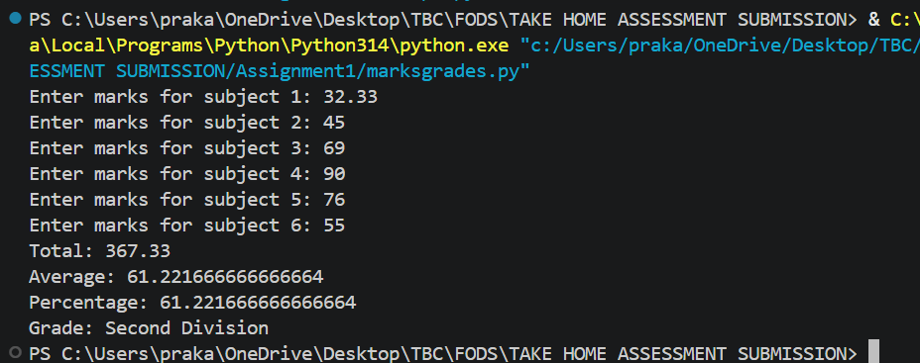

- Prime Numbers in Range
This program displays all prime numbers within a given range and calculates their count and sum.
- Code:
- start = int(input("Enter start: "))
- end = int(input("Enter end: "))

- count = 0
- total = 0

- for num in range(start, end+1):
- if num > 1:
- for i in range(2, num):
- if num % i == 0:
- break
- else:
- print(num)
- count += 1
- total += num

- print("Count:", count)
- print("Sum:", total)

- Output Screenshot:
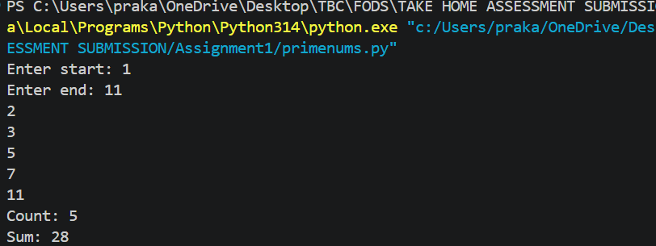

- Divisible Numbers

This program finds numbers divisible by 9 but not by 6 within a range.
- Code:
- start = int(input("Enter start: "))
- end = int(input("Enter end: "))

- for num in range(start, end+1):
- if num % 9 == 0 and num % 6 != 0:
- print(num)

- Output Screenshot:
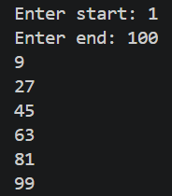

- Factorial
This program calculates factorial and validates user input.

- Code:
- num = input("Enter a number: ")

- if num.isdigit():
- num = int(num)
- fact = 1
- for i in range(1, num+1):
- fact *= i
- print("Factorial:", fact)
- else:
- print("Invalid input!")

- Output Screenshot:
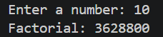

- Sum of Positive and Negative Numbers

This program calculates separate sums using a loop until user exits.

- Code:
- pos_sum = 0
- neg_sum = 0

- while True:
- num = int(input("Enter number: "))

- if num > 0:
- pos_sum += num
- else:
- neg_sum += num

- choice = input("Continue? (y/n): ")
- if choice.lower() == 'n':
- break

- print("Positive sum:", pos_sum)
- print("Negative sum:", neg_sum)

- Output Screenshot:
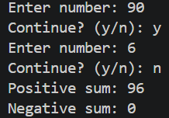

- Number Guessing Game

This program generates a random number and allows the user to guess within limited attempts.

- Code:
- import random

- number = random.randint(1, 50)

- for i in range(7):
- guess = int(input("Guess number: "))

- if guess > number:
- print("Too high")
- elif guess < number:
- print("Too low")
- else:
- print("Correct!")
- break
- else:
- print("Better luck next time!")

- Output Screenshot:
