Fundamentals of Data Science
Assignment 2
Name: Praptee Dewan
Student ID: 25068590
Module Code: UFCFK1-15-0
Instructor: Kaushal Rimal
Submission Date: 17 April 2026

- Function for Arithmetic Operations

This program defines a function that takes two integers and calculates sum, difference, product, and quotient.

- Code:
- def calculate(a, b):
- print("Sum:", a + b)
- print("Difference:", a - b)
- print("Product:", a * b)

- if b != 0:
- print("Quotient:", a / b)
- else:
- print("Quotient: Cannot divide by zero")

- num1 = int(input("Enter first integer: "))
- num2 = int(input("Enter second integer: "))

- calculate(num1, num2)

- Output Screenshot:
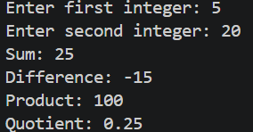

- Separate Functions

This program implements separate functions for arithmetic operations such as addition, multiplication, division, floor division, and exponentiation.
- Code:
- def add(a, b):
- return a + b

- def multiply(a, b):
- return a * b

- def divide(a, b):
- if b != 0:
- return a / b
- else:
- return "Cannot divide by zero"

- def floor_divide(a, b):
- if b != 0:
- return a // b
- else:
- return "Cannot divide by zero"

- def power(a, b):
- return a ** b

- num1 = int(input("Enter first number: "))
- num2 = int(input("Enter second number: "))

- print("\n--- Results ---")
- print("Addition:", add(num1, num2))
- print("Multiplication:", multiply(num1, num2))
- print("Division:", divide(num1, num2))
- print("Floor Division:", floor_divide(num1, num2))
- print("Exponentiation:", power(num1, num2))

- Output Screenshot:
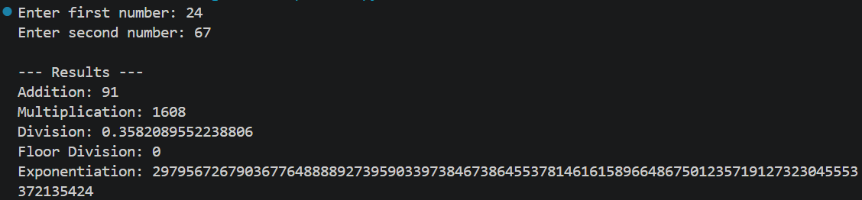
- Armstrong Number

This program checks whether a number is an Armstrong number using a function.

- Code:
- def is_armstrong(num):
- power = len(str(num))
- total = sum(int(d)**power for d in str(num))
- return total == num

- num = int(input("Enter number: "))
- print("Armstrong" if is_armstrong(num) else "Not Armstrong")

- Output Screenshot:
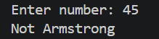

- Count Occurrences (Dictionary)

This function takes a list and returns a dictionary showing frequency of each element.

- Code:
- def count_frequency(numbers):
- freq = {} # empty dictionary

- for num in numbers:
- if num in freq:
- freq[num] += 1
- else:
- freq[num] = 1

- return freq

- list1 = [1, 2, 2, 3, 3, 3]
- print("List 1:", list1)
- print("Frequency:", count_frequency(list1))
- print()

- list2 = [5, 5, 5, 1, 2, 2]
- print("List 2:", list2)
- print("Frequency:", count_frequency(list2))
- print()

- list3 = [10, 20, 10, 30, 20, 10]
- print("List 3:", list3)
- print("Frequency:", count_frequency(list3))

- list4 = [25, 20, 20, 25, 20, 3]
- print("List 4:", list3)
- print("Frequency:", count_frequency(list4))

- Output Screenshot:
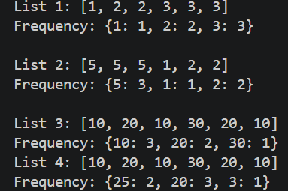

- Reverse Alphabetical Sorting

This function sorts student names in reverse alphabetical order.

- Code:
'''Sorting a list of names in reverse alphabetical order'''
def sort_reverse(names):
return sorted(names, reverse=True)

students = []

n = int(input("Enter number of students: "))

for i in range(n):
name = input("Enter student name: ")
students.append(name)

sorted_names = sort_reverse(students)

print("\nNames in reverse alphabetical order:")
for name in sorted_names:
print(name)

- Output Screenshot:
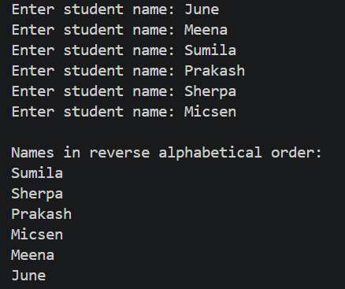

- Search Country

This function searches for a country in a list and returns its index.

- Code:
- def search_country(country_list, country):
- for i in range(len(country_list)):
- if country_list[i] == country:
- return i
- return "Not Found in List"

- countries = []

- n = int(input("Enter number of countries: "))

- for i in range(n):
- name = input("Enter country name: ")
- countries.append(name)

- search = input("Enter country to search: ")

- result = search_country(countries, search)

- if result == "Not Found in List":
- print(result)
- else:
- print("Country found at index:", result)

- Output Screenshot:
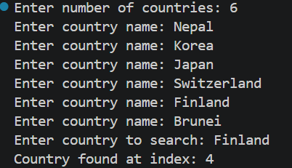
- Character Frequency

This function counts occurrences of characters in a sentence (excluding spaces).

- Code:
- def key_value(sentence):
- freq = {}

- for char in sentence:
- if char != " ":
- if char in freq:
- freq[char] += 1
- else:
- freq[char] = 1

- return freq

- text = input("Enter a sentence: ")

- result = key_value(text)

- print("\nCharacter frequency (excluding spaces):")
- print(result)

- Output Screenshot:
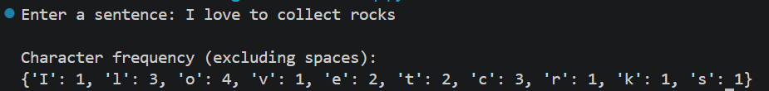

- Remove Duplicates and Sort

This program removes duplicates and sorts numbers in ascending order.

- Code:
- def remove_duplicates_sort(numbers):
- unique_numbers = list(set(numbers))

- # Sort the list in ascending order
- unique_numbers.sort()

- return unique_numbers

- numbers = []

- n = int(input("Enter how many numbers: "))

- for i in range(n):
- num = int(input("Enter number: "))
- numbers.append(num)

- result = remove_duplicates_sort(numbers)

- print("\nList after removing duplicates and sorting:")
- print(result)
- Output Screenshot:
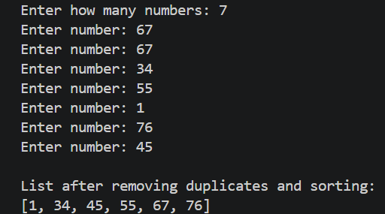

- Movies Dictionary

This program stores details of 3 movies using a dictionary.

- Code:
- movies = {}

- for i in range(1, 4):
- print(f"\nEnter details for Movie {i}:")

- title = input("Title: ")
- director = input("Director: ")
- year = int(input("Release Year: "))
- rating = float(input("Rating (out of 10): "))

- movies[title] = {
- "Director": director,
- "Year": year,
- "Rating": rating
- }

- print("\n===== MOVIE DETAILS =====\n")

- for title, details in movies.items():
- print("Title:", title)
- print("Director:", details["Director"])
- print("Release Year:", details["Year"])
- print("Rating:", details["Rating"])
- print("------------------------")

- Output Screenshot:
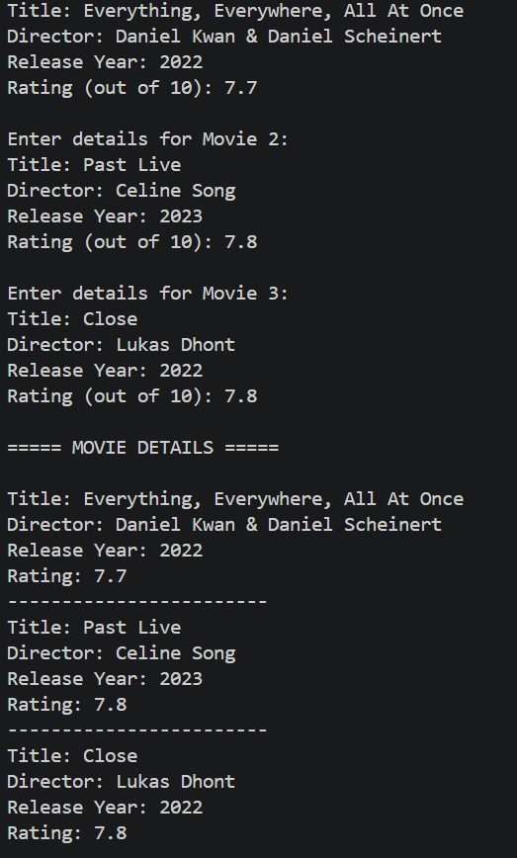

- Dice Guessing Game

This program simulates a dice guessing game with conditions for correct and near guesses.

- Code:
- import random

- dice = random.randint(1, 6)

- guess = int(input("Guess the dice value (1 to 6): "))

- print("\nDice value was:", dice)

- if guess == dice:
- print("😊 Correct guess! Well done!")
- elif abs(guess - dice) == 1:
- print("😐 Close guess! You were off by 1.")
- else:
- print("❌ Wrong guess! Try again.")

- Output Screenshot:
