Fundamentals of Data Science
Assignment 3

Name: Praptee Dewan
Student ID: 25068590
Module Code: UFCFK1-15-0
Instructor: Kaushal Rimal
Submission Date: 17 April 2026

- Read CSV file

Program Description
This program reads data from a file named records.csv and displays student details such as name, roll number, program, year, and group.

Code

'''
This program reads data from "records.csv" and displays
student details such as name, roll number, program, year, and group.
'''

import csv #used to read CSV easily

try: #used to handle errors(e.g file not found errors)
with open("records.csv", "r") as file:

reader = csv.reader(file) #creates an object and also converts each line of the file into a list of words

print("Student Records:\n")

for row in reader: #used to look at every row in the file
if len(row) < 5: #if there is missing data/empty row this skips it
continue

print("Name:", row[0])
print("Roll No:", row[1])
print("Program:", row[2])
print("Year:", row[3])
print("Group:", row[4])
print("---------------------")

except FileNotFoundError: #if file doesn't exist then the try block stops and this code will be excuted
print("Error: records.csv file not found!")

Explanation of Code
- The program uses the csv module to read data.
- It opens the file using with open().
- Each row is read and displayed using a loop.
- Exception handling is used to avoid file errors.

Screenshot of Input-Output
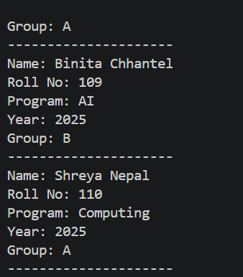

- Append CSV data

Program Description
This program takes user input for student details and appends the data to the existing records.csv file.

Code
'''
Program Name: Append Student Records to CSV
Description: Takes student details as input and appends them to records.csv.
'''

import csv #handles CSV files

student_name = input("Enter student name: ")
roll_no = input("Enter roll number: ")
program = input("Enter program: ")
year = input("Enter year: ")
group = input("Enter group: ")

with open("records.csv", "a", newline="") as file: #file opened in append mode #'newline' prevents any addition of extra unneccessary rows
writer = csv.writer(file) #this method will automatically put in the commas so you don't have to e.g name, roll, etc
writer.writerow([student_name, roll_no, program, year, group])

print("Record added successfully!")

Explanation of Code
- Uses input() to take user data.
- Opens file in append mode ("a").
- Writes new data using csv.writer().

Screenshot of Input-Output
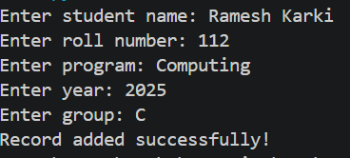
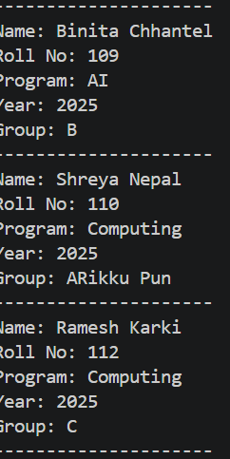

- Arithmetic Operations & File Storage

Program Description
This program takes a list of integers from the user, performs arithmetic operations, and saves results with date and time into a file. The program runs continuously until the user exits.

Code
'''Performs arithmetic operations on user input numbers,
stores results with timestamp in a file, and displays history on exit'''

from datetime import datetime #this gets the current date & time

file_name = "results.txt"

while True: #keeps the program running in a lopp
numbers = input("Enter numbers separated by space: ")
num_list = list(map(float, numbers.split()))
#this gets numbers as strings, splites them and makes them to float type

print("\n1.Add 2.Subtract 3.Multiply 4.Divide")
choice = input("Choose operation: ")

if choice == "1":
result = sum(num_list)

elif choice == "2":
result = num_list[0]
for n in num_list[1:]:
result -= n

elif choice == "3":
result = 1
for n in num_list:
result *= n

elif choice == "4":
try:
result = num_list[0]
for n in num_list[1:]:
result /= n

except ZeroDivisionError:
print("Cannot divide by zero!")
continue
else:
print("Invalid choice")
continue

time_now = datetime.now().strftime("%Y-%m-%d %H:%M:%S") #this creates a timestamp

with open(file_name, "a") as f:
f.write(f"{time_now} | {num_list} | Result: {result}\n")

cont = input("Continue? (yes/no): ").lower()
if cont == "no":
break

print("\n--- FILE CONTENTS ---\n")

with open(file_name, "r") as f:
print(f.read())

Explanation of Code
- Uses loops for continuous execution.
- Performs addition, subtraction, multiplication, division.
- Stores results in a file with timestamp.
- Displays file contents on exit.

Screenshot of Input-Output
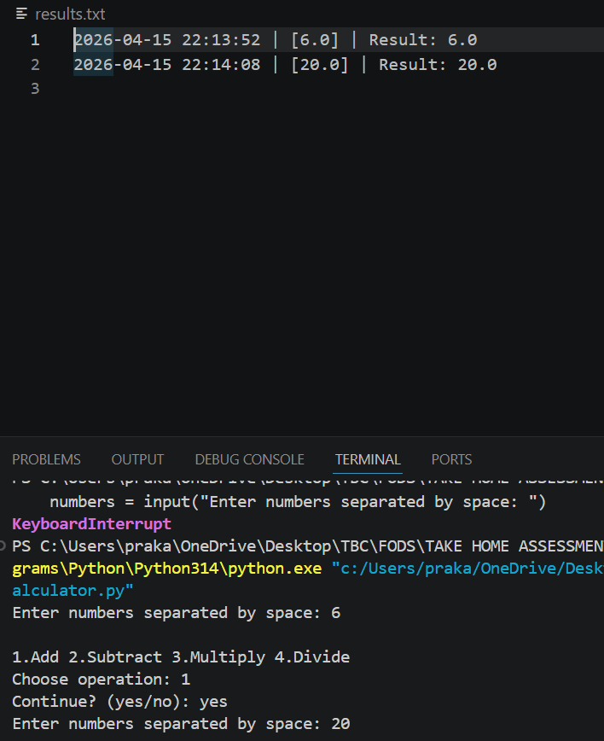

- File Copy Program

Program Description
This program copies content from one file to another. It handles errors such as missing input file or existing output file.

Code
'''
Copy file contents
This program will read text from one file and write it into another
'''

try:
#user input for the name of the file to read from
# open it in read mode
f1 = open(input("Input file: "), "r")

# user input for the name of the file to create/write to
# open in write mode
f2 = open(input("Output file: "), "w")

# read everything from the first file and immediately write it to the second
# f1.read() gets the text; f2.write() puts it in the new file
f2.write(f1.read())

# close files to save the changes and free up memory
f1.close()
f2.close()

print("Copied!")

# if input file doesn't exist or any other error happens,
# the program jumps here instead of crashing.
except:
print("Error occurred")

Explanation of Code
- Takes file names as input.
- Uses file handling to copy contents.
- Uses try/except for error handling.

Screenshot of Input-Output
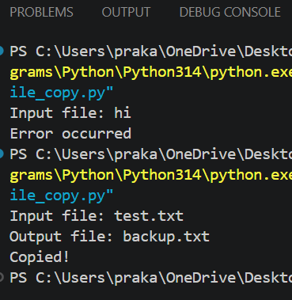

- Learner Class

Program Description
This program defines a class Learner and takes input for its attributes, then displays the learner details.

Code
'''
Learner Class
This program takes user input to create an object and then displays the student's details
There are 6 attributes in this Learner class
'''

class Learner:
# 2. The __init__ method will initialize the attributes for each new student (setup)
# 'self' allows the class to remember the specific data for each object
def __init__(self, roll_no, full_name, address, enrollment_year, program, group):
self.roll_no = roll_no
self.full_name = full_name
self.address = address
self.enrollment_year = enrollment_year
self.program = program
self.group = group

# this will print the data back to the user in a neat and organized manner
def show_details(self):
print("\n--- Learner Details ---")
print("Roll No: ", self.roll_no)
print("Full Name: ", self.full_name)
print("Address: ", self.address)
print("Enrollment: ", self.enrollment_year)
print("Program: ", self.program)
print("Group: ", self.group)
print("-----------------------")

# organizing the required attributes for easier code understanding
r = input("Enter Roll No: ")
n = input("Enter Full Name: ")
a = input("Enter Address: ")
y = input("Enter Enrollment Year: ")
p = input("Enter Program: ")
g = input("Enter Group: ")

# object is created
# all the user's inputs is passed into the Learner class here
student1 = Learner(r, n, a, y, p, g)

# this method will display the information
student1.show_details()

Explanation of Code
- Defines a class with attributes.
- Uses object creation.
- Displays data using methods or print statements.

Screenshot of Input-Output

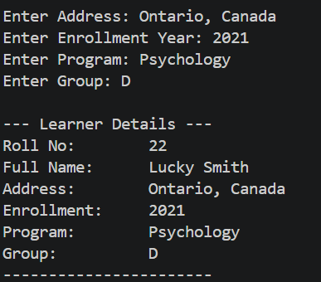

- Cookbook Class

Program Description
This program creates classes Dish and Cookbook to manage a collection of dishes.

Code
'''
Dish and Cookbook
This program shows how one class can store information created
by abother class
In this case class Cookbook stores information from Dish
'''

class Dish:
def __init__(self, name):
self.name = name

class Cookbook:
def __init__(self):
self.list = [] #empty so as to hold dish names

def add(self, dish): #this will take a Dish object and add its 'name' to the list
self.list.append(dish.name)

def show(self): #this will print the final list of dishes
print(self.list)

c = Cookbook() #creating cookbook
c.add(Dish(input("Dish: ")))
#takes user input to create a dish and adds it to the cookbook
#the above method will create an object and c.add will store it
c.add(Dish(input("Dish: ")))

c.add(Dish(input("Dish: ")))

c.show()

Explanation of Code
- Dish stores dish details.
- Cookbook manages multiple dishes.
- Demonstrates OOP concepts.

Screenshot of Input-Output
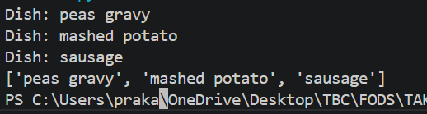

- Staff Management System

Program Description
This program creates a Staff class, stores multiple staff details in staff.csv, and allows viewing of records.

Code

'''
Staff Management System
This program asks user input for a specific number of staff members,
collects their details, and saves them into a CSV file.
'''

file = open("staff.csv", "w") #opens or creates the file staff.csv in wirte mode

n = int(input("How many staff? "))

for i in range(n): #use a for loop to ensure loop repeats n number of times
emp = input("ID: ")
name = input("Name: ")
salary = input("Salary: ")

file.write(emp + "," + name + "," + salary + "\n")

file.close() #close the file to save all the data properly

print("Saved")

file = open("staff.csv", "r") #reopen file in read mode to check results
print(file.read())
file.close()

Explanation of Code
- Uses class for staff data.
- Writes data into CSV file.
- Reads and displays stored data.
- Uses exception handling.

Screenshot of Input-Output

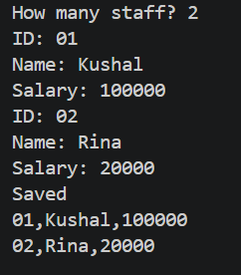

- Library Management System

Program Description
This program implements a basic library system with features such as borrowing, returning, and searching books using OOP and file handling.

Code
'''
Library Management System
This program checks if a book exists in the library
It allows the user to search for a specific title.
'''

books = ["The Secret History", "If We Were Villians", "Alone With You In the Ether", "Crush", "On Earth We're Briefly Gorgeous"] #database of books in a list

print("Books:", books) #this displays the collection to the user

search = input("Search book: ")

if search in books: #the in keyword checks if the book user inputs is within our list/library
print("Book found")
else:
print("Not found")

Explanation of Code
- Uses classes for books and library.
- Implements methods for borrow, return, search.
- Stores data using file handling.
- Applies OOP principles.

Screenshot of Input-Output

Conclusion
This assignment helped me to better understand Python concepts like file handling, CSV operations, exception handling, and object-oriented programming concepts. The programs demonstrate practical implementation of these concepts.

