Student Profile Management System

Fundamentals of Data Science | UFCFK1-15-0
Final Assessment Project Report
Submitted to:
Module Tutor: Saurav Gautam
Submission Date: 19 April 2026
Year: 2025/2026

Submitted by:

Shahjida Khatun (Student ID: 26002348)
Shivani Giri (Student ID: 25068614)
Aayushna Chapagain (Student ID: 25068604)
Praptee Dewan (Student ID:25068590)

1. Introduction
This report documents the design, development, and testing of a Student Profile Management System built using Python. The system manages student personal information, examination data, and extracurricular activities (ECA) through a command-line interface with role-based access control for administrators and students.
The project demonstrates key programming concepts including Object-Oriented Programming (OOP), file handling with text files, exception handling, modular function design, and data visualization using matplotlib.

2. System Design

2.1 System Architecture
The system is structured using OOP principles with the following class hierarchy:
- Person (Base Class): Stores common attributes like ID, name, age, address, and phone.
- Student (Inherits Person): Adds grades dictionary and ECA list with methods for display and average calculation.
- Admin (Inherits Person): Represents admin users with full system access.
- FileHandler: Static utility class for reading, writing, and appending to text files with exception handling.
- DataManager: Central data layer that loads/saves all four text files and manages authentication.
- AnalyticsEngine: Generates charts and analytics dashboards using matplotlib for admin users.
- MenuSystem: Handles all user interactions, login flow, and menu navigation.

2.2 Functional Decomposition
The system is designed using modular functions such as login(), add_student(), update_record(), and generate_reports(). These functions break the program into smaller, manageable units, improving code readability, maintainability, and reusability.

2.3 Data Files
File | Description
users.txt | Stores user ID, name, age, address, phone, and role (admin/student)
grades.txt | Contains marks for 5 subjects per student with semester info
eca.txt | Semicolon-separated list of extracurricular activities per student
passwords.txt | Username and password pairs for authentication

2.4 System Flowchart

The flowchart illustrates the system workflow starting from login validation. Based on user role, the system redirects to admin or student menu.

Admin can manage records and view analytics, while students can view and update their data.
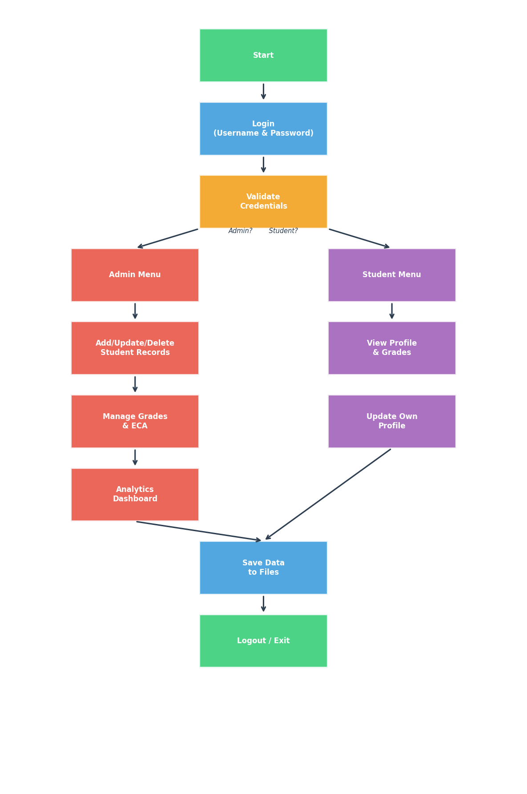
Figure 1: System Flowchart

3. Features Implemented

3.1 Login System
The system validates usernames and passwords from passwords.txt. On successful login, it checks the user's role from users.txt and redirects to the appropriate menu (Admin or Student). Invalid credentials trigger an error message with re-prompt.

3.2 Admin Features
- Add new students with auto-generated unique IDs
- View all students with summary table
- Update/modify student personal info, grades, and ECA
- Delete student records with confirmation
- Access the Performance Analytics Dashboard

3.3 Student Features
- View personal profile information
- Update own profile (name, age, address, phone)
- View exam grades with calculated average
- View ECA participation list

3.4 Analytics Dashboard (Task 2 Bonus)
The analytics module provides six visualization and analysis features for admin users, powered by matplotlib and numpy:
- Subject-wise average grades (bar chart)
- Individual student grade comparison (grouped bar chart)
- Grade distribution per subject (box plot)
- ECA impact on academic performance (scatter plot with trend line)
- Performance alerts for students below threshold
- Top performers ranking

4. Creativity Features

The system includes several creative enhancements beyond the basic requirements:

- Data Visualization: Graphs such as bar charts, box plots, and scatter plots are used to present student performance clearly.
- Performance Alerts: Automatically identifies students performing below a threshold.
- Ranking System: Display top-performing students based on average grades.
- User-Friendly Menu: Clean and structured command-line interface for easy navigation.
- ECA Impact Analysis: Correlates extracurricular activities with academic performance.

These features enhance usability and provide deeper insights into student data.

5. Test Output Screenshots

5.1 Subject Average Grades

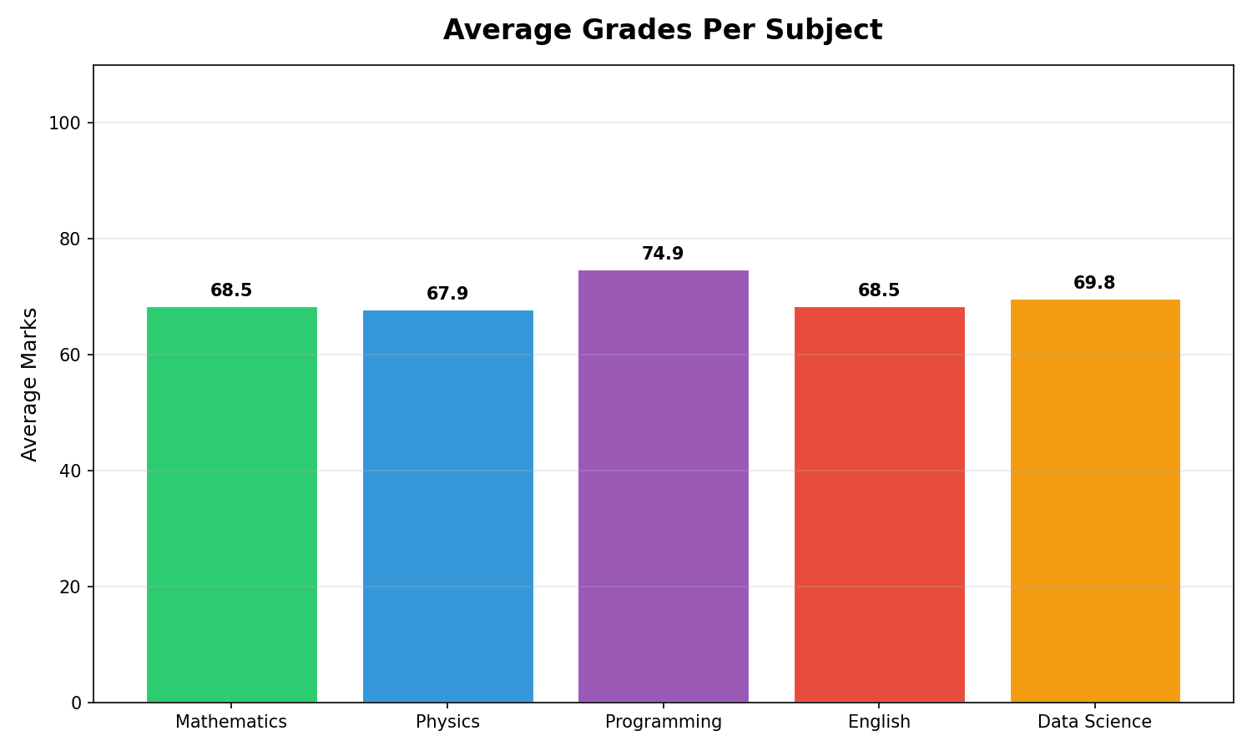
Figure 2: Average Grades Per Subject

5.2 Student Grade Comparison

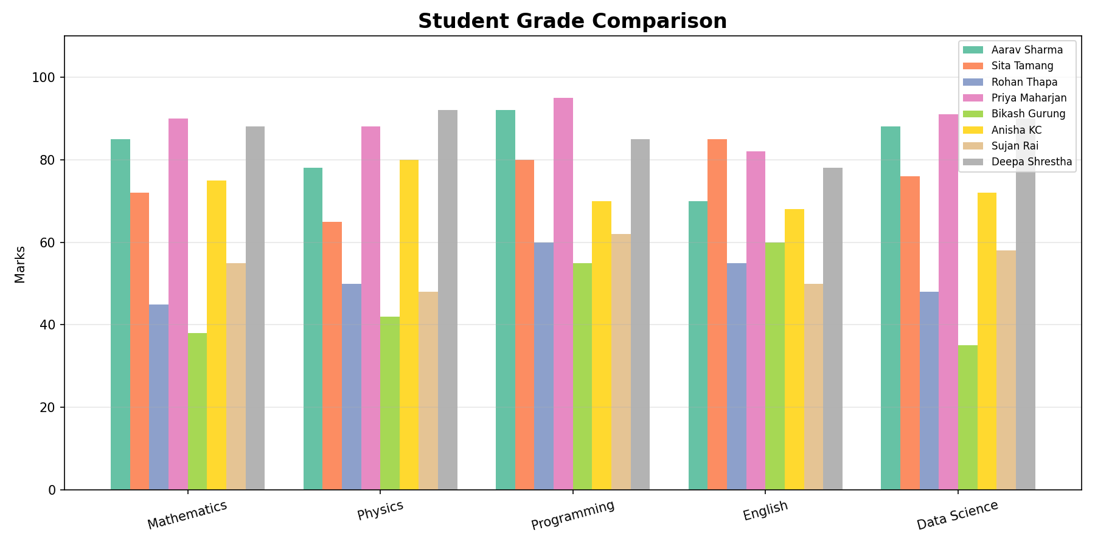
Figure 3: Student Grade Comparison

5.3 Grade Distribution

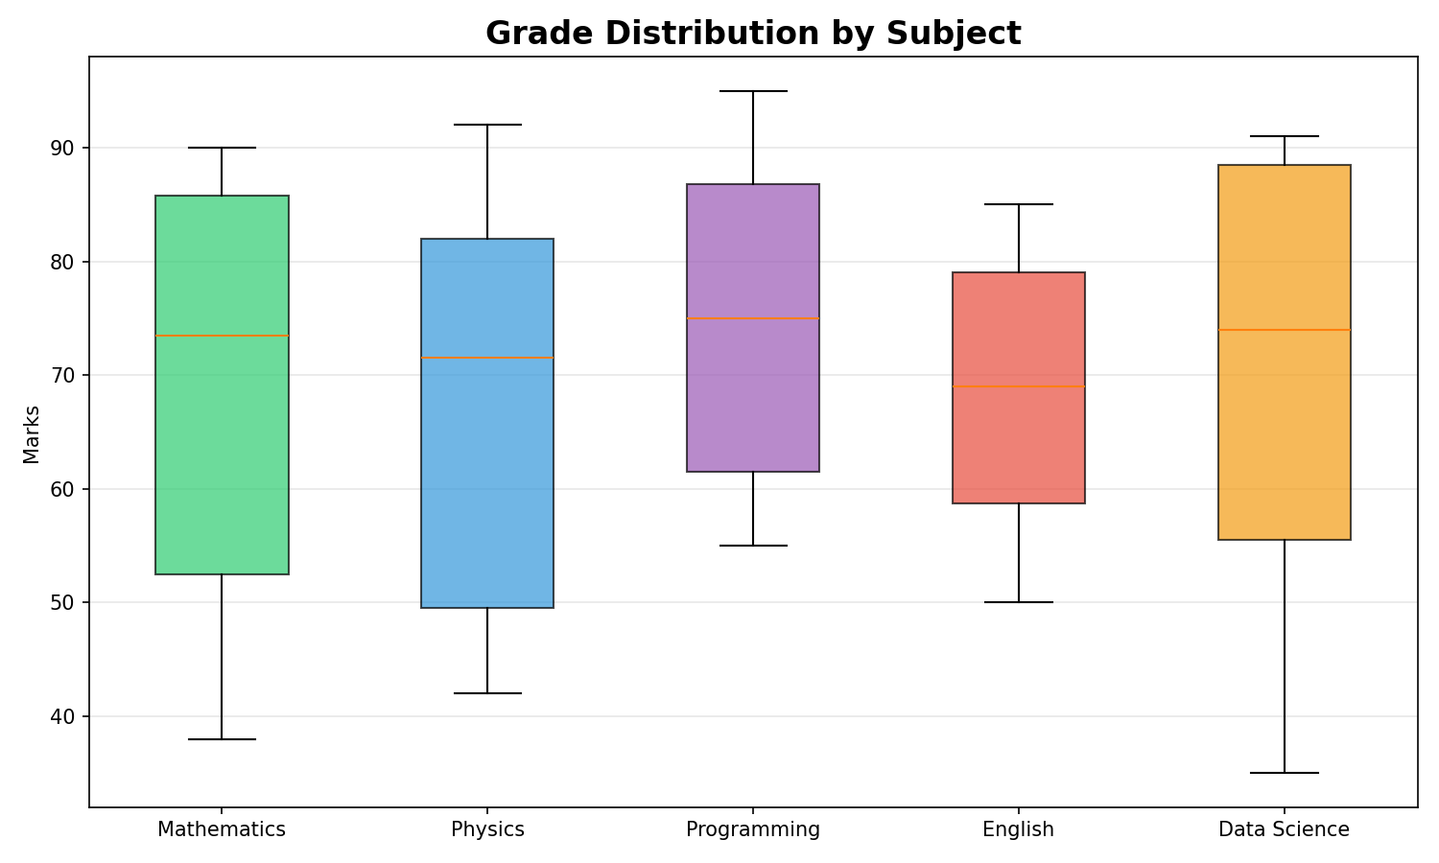
Figure 4: Grade Distribution Box Plot

5.4 ECA Impact Analysis

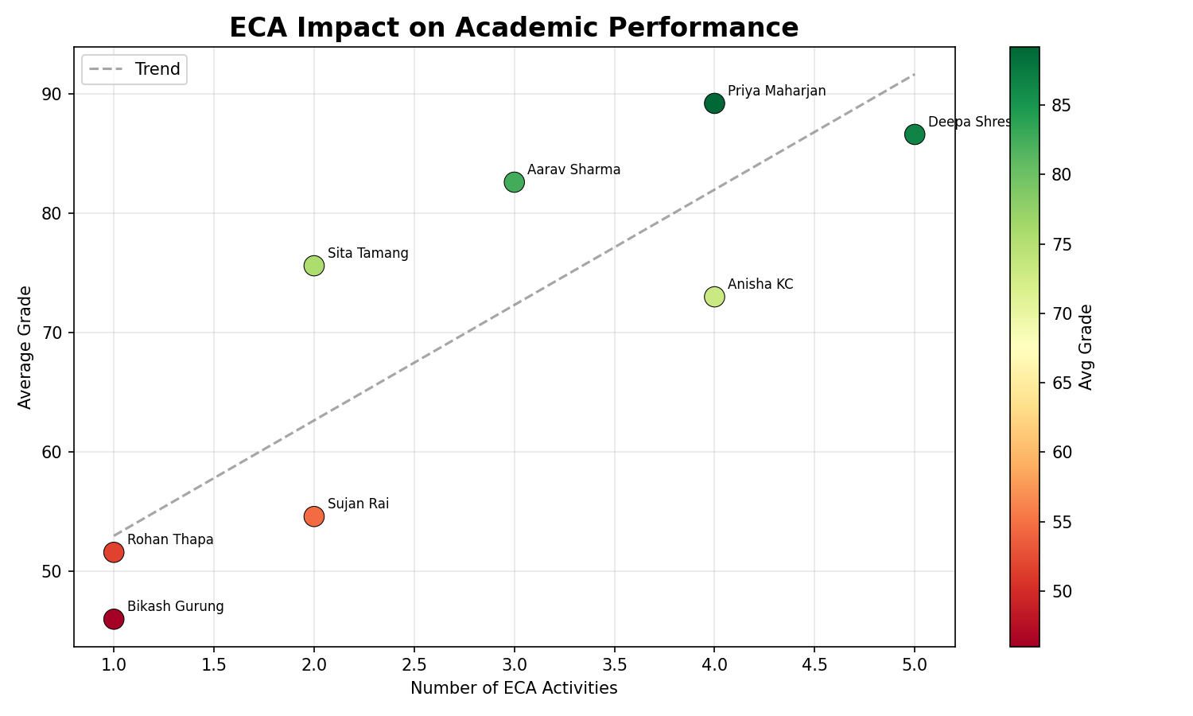
Figure 5: ECA Impact on Academic Performance

5.5 Sample Console Output
Below is a sample of the program's console output demonstrating login, viewing students, grades, performance alerts, and the top performers ranking:
Admin Login & View All Students:
Username: A001 | Password: admin123
Welcome, Saurav Gautam! (Role: ADMIN)

--- All Students ---
ID Name Age Average
S001 Aarav Sharma 19 82.60
S002 Sita Tamang 20 75.60
S003 Rohan Thapa 18 51.60
S004 Priya Maharjan 21 89.20
S005 Bikash Gurung 19 46.00
S006 Anisha KC 20 73.00
S007 Sujan Rai 18 54.60
S008 Deepa Shrestha 19 86.60

TOP PERFORMERS RANKING
1 Priya Maharjan 89.20
2 Deepa Shrestha 86.60
3 Aarav Sharma 82.60
4 Sita Tamang 75.60
5 Anisha KC 73.00

6. OOP Concepts Demonstrated
Concept | Implementation
Classes | Person, Student, Admin, FileHandler, DataManager, AnalyticsEngine, MenuSystem
Inheritance | Student and Admin inherit from Person base class
Encapsulation | Private attributes with @property decorators for controlled access
Polymorphism | display_info() and to_file_string() methods adapted by subclasses
Abstraction | FileHandler provides simple interface hiding file I/O complexity

7. Exception Handling
The system implements comprehensive exception handling throughout: FileNotFoundError and PermissionError in file operations, ValueError for numeric input validation, general Exception catches as safety nets, and try-except blocks around all user input sections to prevent crashes from unexpected input.

8. Work Contribution and Reflection
This project was completed as a group effort. The development process involved: designing the class hierarchy and data flow, implementing core CRUD operations with file persistence, building the login and role-based menu system, developing the analytics dashboard with six chart types, and thorough testing with sample data. The project strengthened understanding of OOP principles, file handling in Python, and data visualization with matplotlib.

9. Limitations
Despite its functionality, the system has some limitations:
- Uses text files instead of a database, which may not be efficient for large-scale data.
- Passwords are stored in plain text, lacking advanced security measures.
- The system operates through a command-line interface, which is less user-friendly compared to graphical interfaces.
- Limited scalability for handling a large number of users.
Future improvements can address these issues by integrating database, enhancing security, and developing a graphical user interface.

10. Conclusion
The Student Profile Management System successfully fulfils all basic requirements (login, admin/student roles, CRUD operations, OOP, file handling, exception handling) and the bonus Task 2 analytics dashboard with grade trends, ECA impact analysis, and performance alerts. The modular design allows easy extension for future features.

