Query all columns (attributes) for every row in the **CITY** table.

The **CITY** table is described as follows:  
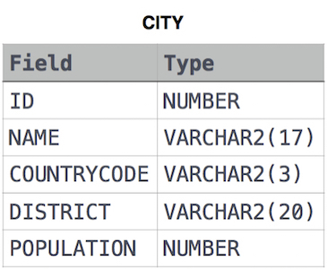

**Ans:**

Select * from CITY;