ASSIGNMENT-V

**Question 1**

Convert 1D Array Into 2D Array

You are given a **0-indexed** 1-dimensional (1D) integer array original, and two integers, m and n. You are tasked with creating a 2-dimensional (2D) array with  m rows and n columns using **all** the elements from original.

The elements from indices 0 to n - 1 (**inclusive**) of original should form the first row of the constructed 2D array, the elements from indices n to 2 * n - 1 (**inclusive**) should form the second row of the constructed 2D array, and so on.

Return an m x n 2D array constructed according to the above procedure, or an empty 2D array if it is impossible.

**Example 1:**

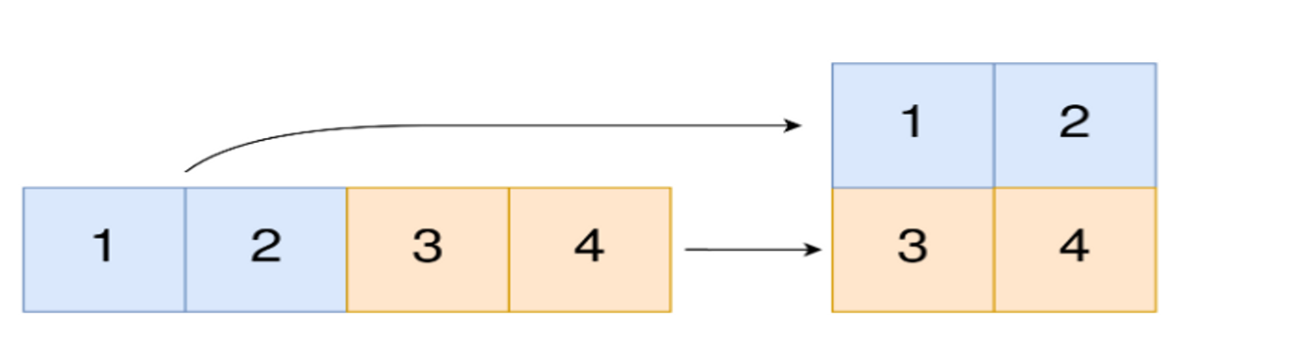

**Input:** original = [1,2,3,4], m = 2, n = 2

**Output:** [[1,2],[3,4]]

**Explanation:** The constructed 2D array should contain 2 rows and 2 columns.

The first group of n=2 elements in original, [1,2], becomes the first row in the constructed 2D array.

The second group of n=2 elements in original, [3,4], becomes the second row in the constructed 2D array.

**Ans:** def convert_to_2d_array(original, m, n):

if len(original) != m * n:

return []

result = [[0] * n for _ in range(m)]

for i in range(len(original)):

row = i // n

col = i % n

result[row][col] = original[i]

return result

**Question 2**

You have n coins and you want to build a staircase with these coins. The staircase consists of k rows where the ith row has exactly i coins. The last row of the staircase **may be** incomplete.

Given the integer n, return the number of ***complete rows*** of the staircase you will build.

**Example 1:**

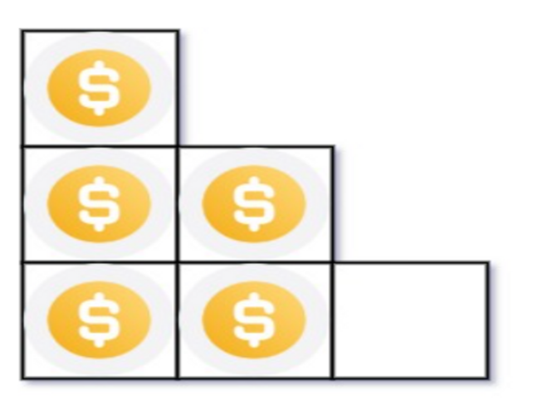

**Input:** n = 5

**Output:** 2

**Explanation:** Because the 3rd row is incomplete, we return 2

**Ans**: def arrange_coins(n):

left = 0

right = n

while left <= right:

k = (left + right) // 2

coins_needed = k * (k + 1) // 2

if coins_needed == n:

return k

if coins_needed > n:

right = k - 1

else:

left = k + 1

return right

**Question 3**

Given an integer array nums sorted in **non-decreasing** order, return an array of ***the squares of each number*** sorted in non-decreasing order.

**Example 1:**

**Input:** nums = [-4,-1,0,3,10]

**Output:** [0,1,9,16,100]

**Explanation:** After squaring, the array becomes [16,1,0,9,100].

After sorting, it becomes [0,1,9,16,100].

**Ans**: def sorted_squares(nums):

n = len(nums)

result = [0] * n

left = 0

right = n - 1

index = n - 1

while left <= right:

if abs(nums[left]) > abs(nums[right]):

result[index] = nums[left] ** 2

left += 1

else:

result[index] = nums[right] ** 2

right -= 1

index -= 1

return result

**Question 4**

Given two **0-indexed** integer arrays nums1 and nums2, return *a list* answer *of size* 2 *where:*

* answer[0] *is a list of all* ***distinct*** *integers in* nums1 *which are* ***not*** *present in* nums2*.*
* answer[1] *is a list of all* ***distinct*** *integers in* nums2 *which are* ***not*** *present in* nums1.

**Note** that the integers in the lists may be returned in **any** order.

**Example 1:**

**Input:** nums1 = [1,2,3], nums2 = [2,4,6]

**Output:** [[1,3],[4,6]]

**Explanation:**

For nums1, nums1[1] = 2 is present at index 0 of nums2, whereas nums1[0] = 1 and nums1[2] = 3 are not present in nums2. Therefore, answer[0] = [1,3].

For nums2, nums2[0] = 2 is present at index 1 of nums1, whereas nums2[1] = 4 and nums2[2] = 6 are not present in nums2. Therefore, answer[1] = [4,6].

**Ans:** def find_disjoint(nums1, nums2):

set1 = set(nums1)

set2 = set(nums2)

result = []

result.append(list(set1 - set2))

result.append(list(set2 - set1))

return result

**Question 5**

Given two integer arrays arr1 and arr2, and the integer d, return the distance value between the two arrays.

The distance value is defined as the number of elements arr1[i] such that there is not any element arr2[j] where |arr1[i]-arr2[j]| <= d.

**Example 1:**

**Input:** arr1 = [4,5,8], arr2 = [10,9,1,8], d = 2

**Output:** 2

**Explanation:**

For arr1[0]=4 we have:

|4-10|=6 > d=2

|4-9|=5 > d=2

|4-1|=3 > d=2

|4-8|=4 > d=2

For arr1[1]=5 we have:

|5-10|=5 > d=2

|5-9|=4 > d=2

|5-1|=4 > d=2

|5-8|=3 > d=2

For arr1[2]=8 we have:

**|8-10|=2 <= d=2**

**|8-9|=1 <= d=2**

|8-1|=7 > d=2

**|8-8|=0 <= d=2**

**Ans:** def distance_value(arr1, arr2, d):

count = 0

for num1 in arr1:

found = False

for num2 in arr2:

if abs(num1 - num2) <= d:

found = True

break

if not found:

count += 1

return count

**Question 6**

Given an integer array nums of length n where all the integers of nums are in the range [1, n] and each integer appears **once** or **twice**, return an array of all the integers that appears ***twice***.

You must write an algorithm that runs in O(n) time and uses only constant extra space.

**Example 1:**

**Input:** nums = [4,3,2,7,8,2,3,1]

**Output:**

[2,3]

**Ans:** def find_duplicates(nums):

result = []

for num in nums:

index = abs(num) - 1

if nums[index] < 0:

result.append(index + 1)

else:

nums[index] *= -1

return result

**Question 7**

Suppose an array of length n sorted in ascending order is **rotated** between 1 and n times. For example, the array nums = [0,1,2,4,5,6,7] might become:

* [4,5,6,7,0,1,2] if it was rotated 4 times.
* [0,1,2,4,5,6,7] if it was rotated 7 times.

Notice that **rotating** an array [a[0], a[1], a[2], ..., a[n-1]] 1 time results in the array [a[n-1], a[0], a[1], a[2], ..., a[n-2]].

Given the sorted rotated array nums of **unique** elements, return *the minimum element of this array*.

You must write an algorithm that runs in O(log n) time.

**Example 1:**

**Input:** nums = [3,4,5,1,2]

**Output:** 1

**Explanation:**

The original array was [1,2,3,4,5] rotated 3 times.

**Ans**: def find_minimum(nums):

left = 0

right = len(nums) - 1

while left < right:

mid = left + (right - left) // 2

if nums[mid] > nums[right]:

left = mid + 1

else:

right = mid

return nums[left]

**Question 8**

An integer array original is transformed into a **doubled** array changed by appending **twice the value** of every element in original, and then randomly **shuffling** the resulting array.

Given an array changed, return original *if* changed *is a* ***doubled*** *array. If* changed *is not a* ***doubled*** *array, return an empty array. The elements in* original *may be returned in* ***any*** *order*.

**Example 1:**

**Input:** changed = [1,3,4,2,6,8]

**Output:** [1,3,4]

**Explanation:** One possible original array could be [1,3,4]:

* Twice the value of 1 is 1 * 2 = 2.
* Twice the value of 3 is 3 * 2 = 6.
* Twice the value of 4 is 4 * 2 = 8.

Other original arrays could be [4,3,1] or [3,1,4].

**Ans**: def find_original_array(changed):

frequency_map = {}

for num in changed:

frequency_map[num] = frequency_map.get(num, 0) + 1

original = []

for num, freq in frequency_map.items():

if freq == 0:

continue

double_value = num * 2

if double_value not in frequency_map or frequency_map[double_value] == 0:

return []

frequency_map[num] -= 1

frequency_map[double_value] -= 1

original.append(num)

return original