Mod 4 Project Presentations
- Profile

- Search

Mod 4 Project Presentations
- ⏱ 3 hours

Project Presentations
After all of your hard work implementing your first portfolio project, you'll have the opportunity to present your results to your peers! This should be an exciting time to share what you have been able to accomplish and what you learned throughout the experience.

When are presentations?
Project presentations will take place at the very beginning of the first day of Module 5. You should come into the day ready to present your deployed project and discuss your experience.

How long are presentations?
These are not intended to be long presentations. Everyone will take five minutes to discuss their project and experience. These shouldn't be anything to be nervous about!

How should I prepare for the presentation?
Since many students will be implementing similar APIs, the focus of your presentation should be on what you are particularly proud of.
- Prepare Postman requests for 1-3 endpoints to your deployed application to demonstrate

From Albums:

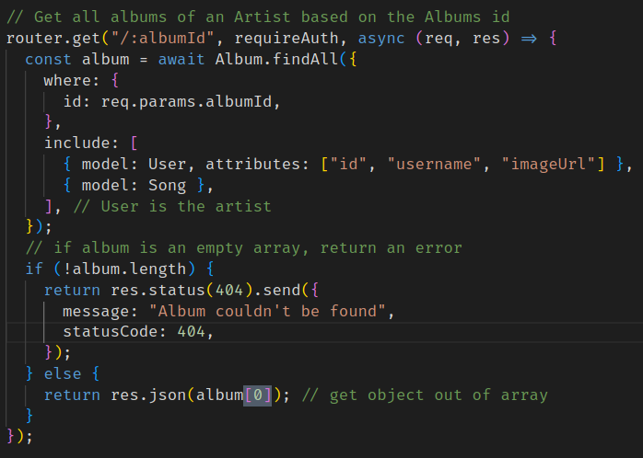

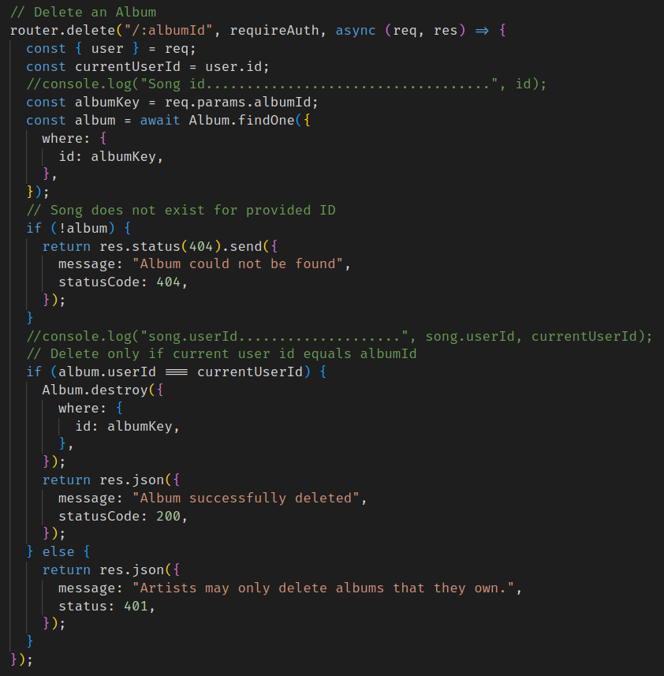
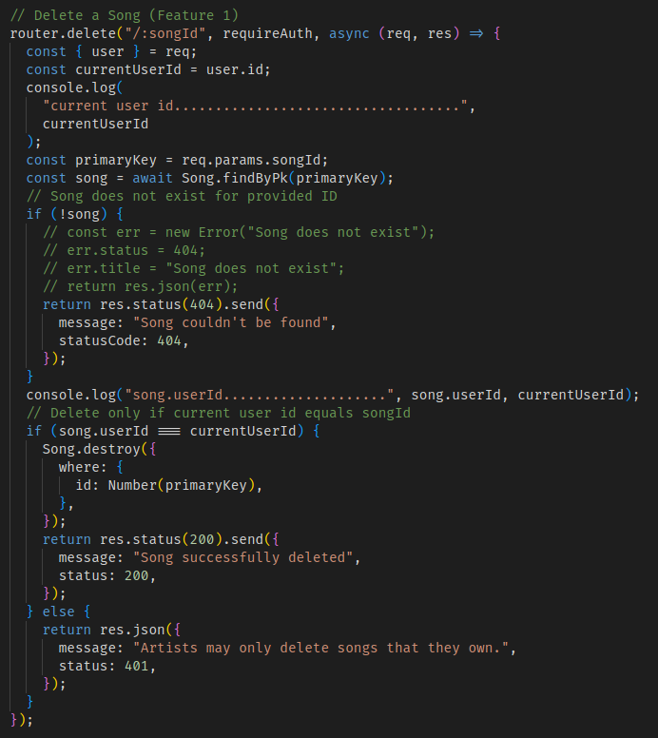
  - Have the code for these endpoints opened up in VSCode
  - Here are possible topics to talk about or demonstrate for an endpoint:
    - What you struggled with most when implementing the endpoint
    - Was there something that you really struggled with and had to come up with a creative solution for?
    - Is there something that you're excited about working on more in the future?
    - Is there any code logic or syntax that you're proud of?
    - Is there any section of code that you think is particularly clean/maintainable?
    - Was there anything you did to make the code DRYer?
- Prepare to talk about and navigate through your code when asked a random technical question asked by your Project Advisor
- Optional topics:
  - What you struggled with most during the project
  - What you learned about yourself as a solo programmer
  - Any tools that you used improve your workflow
  - Anything that you're excited to work on in the future

How does the presentation affect project grading?
The presentation should not be a stressful part of the project. The main goal is to share what you learned and celebrate everyone's accomplishments. The only requirements for the presentation are:
- You must present your project, and
- You must demonstrate your features on the deployed application (no localhost presentations!)
Think about your growth during this project week and celebrate the work that you and your cohortmates have completed!
No
Yes
Finished with this task? Click Mark as Complete to continue to the next page!

