Deanna M. Presswood

SDEV 300 Section 6380

October 1, 2017

**Lab 3 Web Page Foundations**

Introductory Heading of Webpage

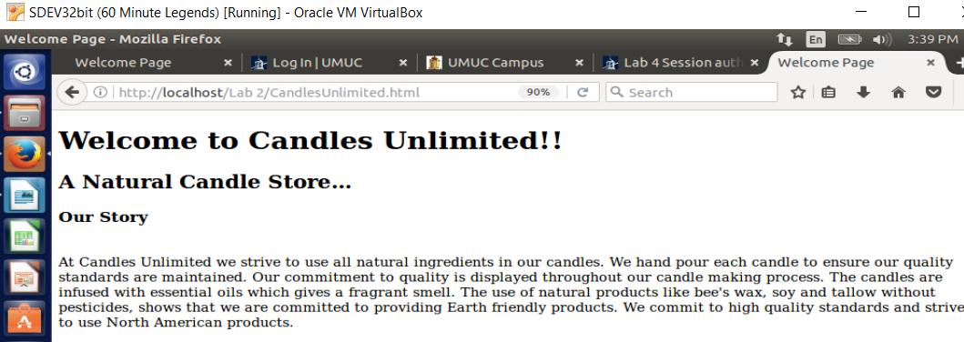

This screen shot displays a welcome message, an introductory heading and a brief description for an e-commerce Website. The description is the company story which gives a brief overview of products on the Candles Unlimited Webpage.

Products with photos, description and prices are displayed below:

Products

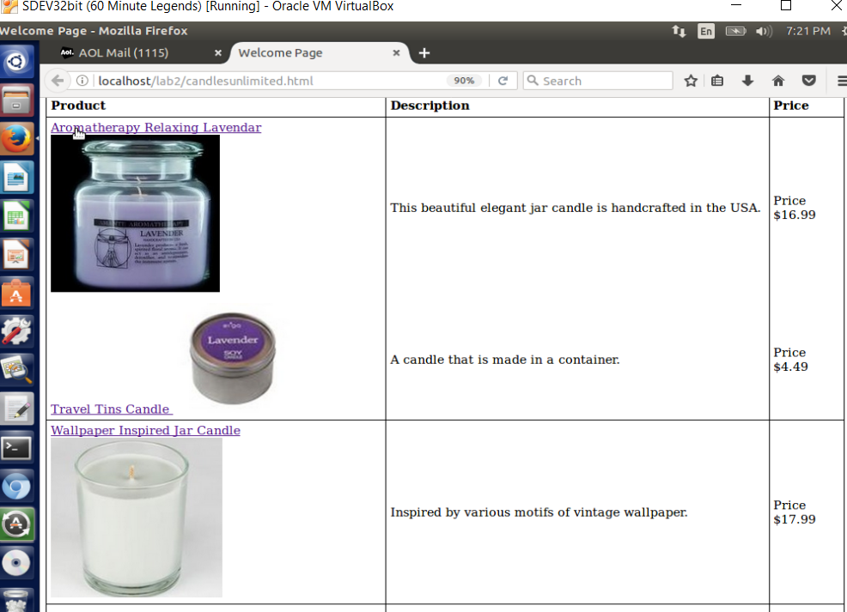

The above screen shots displays the several products on the Candles Unlimited Webpage.

Products

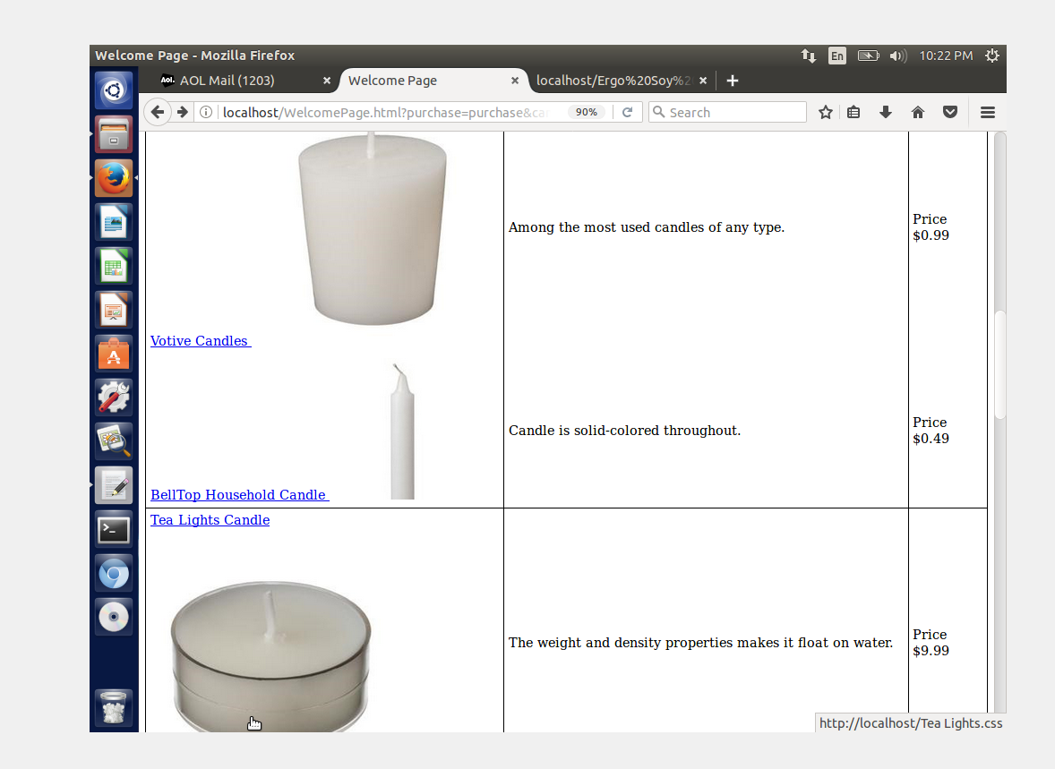

The above screen shot is displaying several products on the Candles Unlimited Webpage.

The following screenshots displays the progression of the site with the images, the product links and description being added to the Candles Unlimited Webpage.

3 More Products

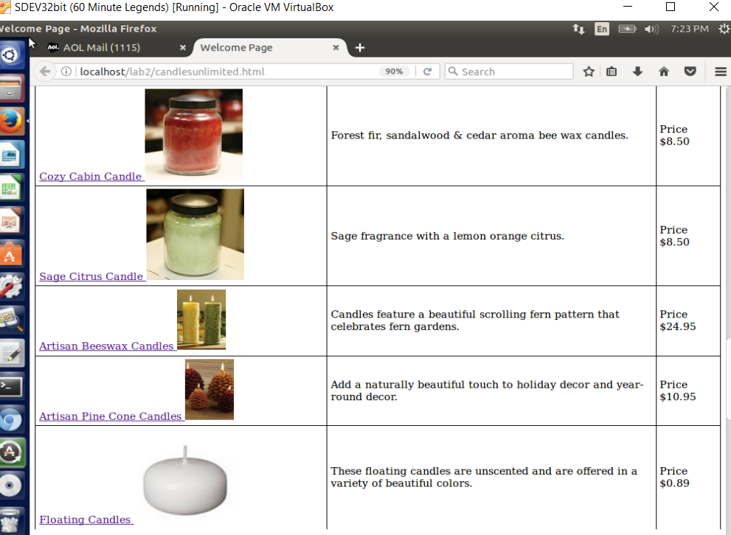

Shopping Cart

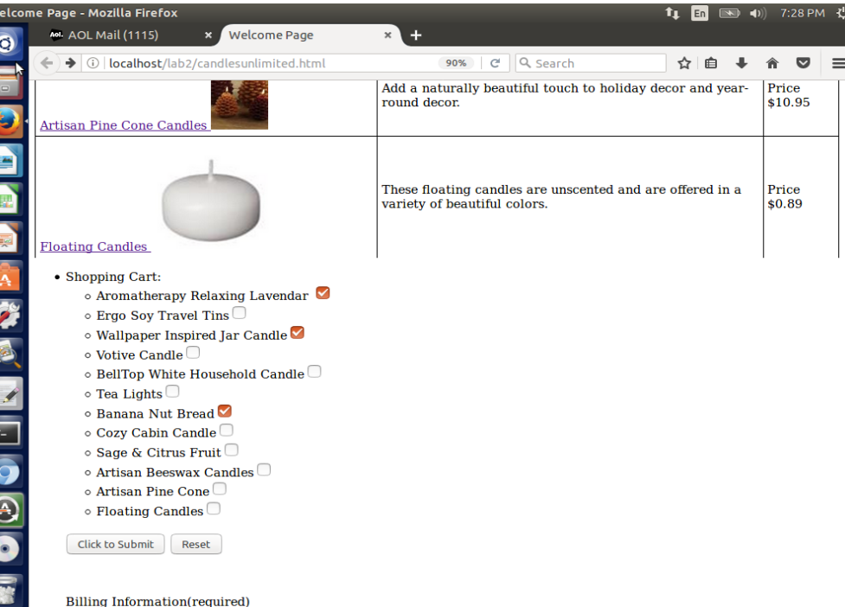

Shopping cart showing several items being purchased.

User-Friendly Billing Form

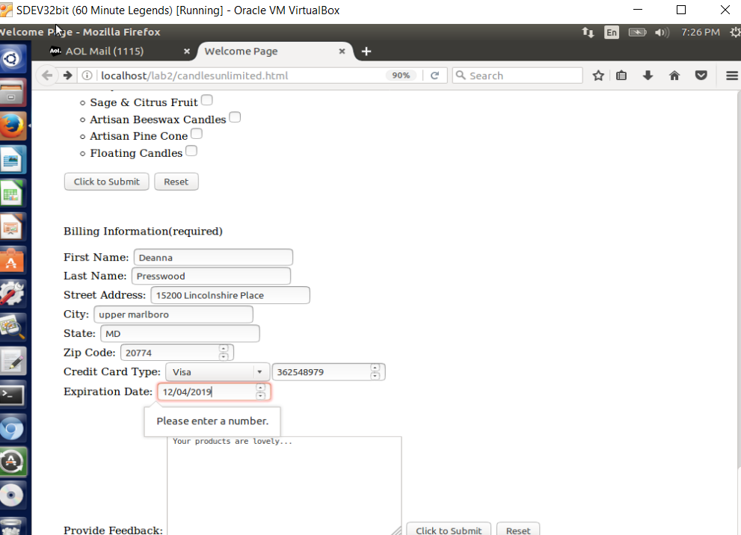

The last screenshot displays a user-friendly Billing Form where users provide contact information, credit card data and provide customer feedback.