
VGSync – Documentation

VGSync stands for “Kinomap Video Route Suite” — an open-source tool to synchronize videos with GPX/FIT data (officially supported by Kinomap).

Introduction
VGSync aligns your video with GPX/FIT data so each frame corresponds precisely to its position on the map, making uploads to Kinomap seamless.
When the video and GPX/FIT file are imported the application asks if the video start is already synchronized with gpx start. If it’s not the case it is advised to start by finding a matching gpx and video location. It can be anywhere in the video, not especially at the start. Until this synchronization is not done, video and gpx edit and playback are not synchronized.
Modes
The program can be used in three different modes:
GPX Mode
This is the default setting, where a pre-cut video (edited outside of VGSync) and its corresponding GPX file are loaded. In this mode, only the GPX file is modified.
- The start of the GPX can be synchronized, and pauses can be cut.
- Various manipulations of individual points or sections are possible, such as modifying time, altitude, or gradient.
- Errors in waypoints or timestamps are detected upon loading and marked in the diagram. These can be removed via the "More (…)" menu.
- Multiple GPX files can be loaded and appended with a 1-second gap (e.g., multiple GoPro GPX files).
- It is also possible to edit a GPX file without a video if needed, for example, to merge multiple GoPro files. However, GoPro files should be recorded with a 1Hz resolution.
- There are various tools available to extract data from GoPro metadata and prepare it accordingly, such as:
https://goprotelemetryextractor.com/free/#
In this tool, select:
  - Frequency: 1Hz
  - Altitude: corrected
  - Save as: GPX or Virb

Video Mode
If you only need to merge multiple video files (e.g., from a GoPro) and optionally cut them, you can select “Edit Video” from the menu.
Copy Mode:
The video is not re-encoded,
but instead handled by LossLessCut – meaning it is simply copied.
This may result in slightly abrupt transitions at cut points. However, these are negligible compared to the overall uncut video or, for example, waiting at a traffic light.
Encoder Mode:
The video is re-encoded using the settings from the Encoder Setup!
Options configured in the Encoder Setup, such as GPU usage, will be applied.
Cuts will also be transitioned smoothly using a crossfade (xfade) effect.
When you open a video, you are prompted to select a mode. You can change it later.

AutoCut Video + GPX Mode
This setting, also found in the "Config" menu, trims the video and simultaneously removes the corresponding sections from the GPX file (traffic lights, breaks, etc.). The video is then already synchronized.

Edit view
This mode is convenient if you edit only the gpx file or your gpx files are longer than video.
To clarify the layout:
- At the top, as usual, there is the menu bar with options like File, Playlist, Config, etc., and their submenus.
- Between the video and the map, the video control buttons are located.
- In the map, the map control buttons are at the top right, and the switch for toggling between satellite view and terrain view is at the bottom left.
- Between the diagram and the GPX list, the GPX control buttons are placed.
- In the list, the time associated to gpx points can be edited by double click. This changes only a single point. If you need to shift all next points, see “chT” button (explained later).
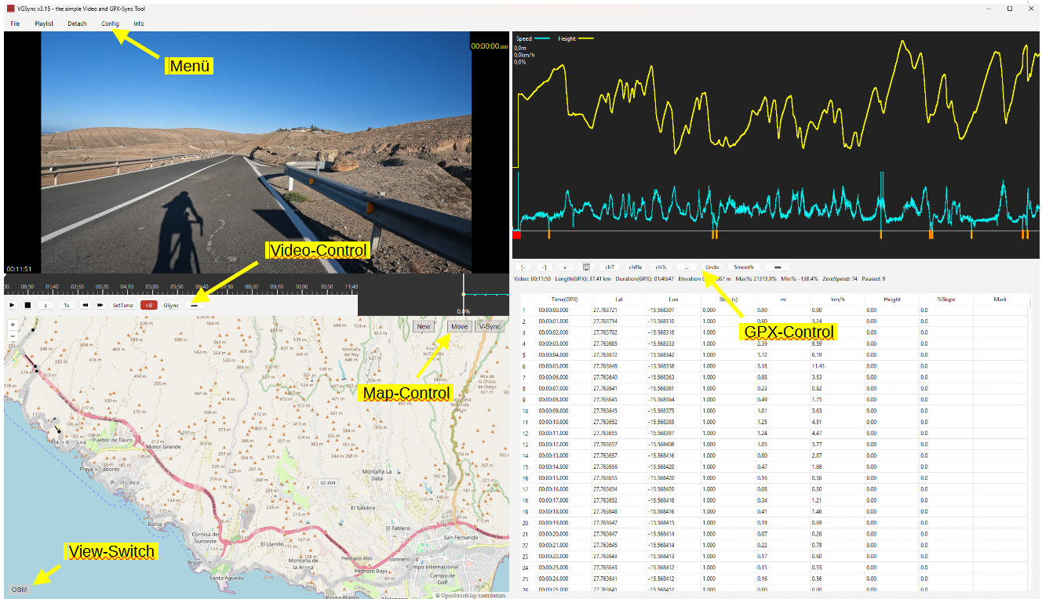

Menu File
New Project
Start a new Project, all loaded files and edits will be deleted and you start from new.
Load Project
Load an already saved Project, all files and edits will be reloaded
Open Recent
Choose one of the last loaded projects/files
Import GPX/FIT
Attention: GPX/FIT Files will be loaded in Slot 1 (read Slot description)
Loads a GPX or a FIT file.
It will then be displayed on the map, in the diagram, the mini-diagram, and the GPX list.
If a file is already loaded and "Open GPX" is selected again, you will be given the choice to append it or load it as a new file.
If you choose to append it (which is useful for GoPro GPX files), the new file will be added to the previous one with a 1-second gap. This makes it easy to merge multiple GPX files of a route seamlessly.
If you choose "New," the old GPX file will be removed from the tool, and the new one will be loaded.
Import Video
Loads one or more video files.
If multiple videos are loaded, they will be played sequentially in the player, and a blue marker will be placed between them in the timeline to indicate separation visually.
The total duration of all loaded videos is displayed at the bottom left of the player, while the current video time is shown in the top right during playback.
Gopro-Extractor
Attention: Gopro – GPX will be loaded in Slot 2 ( read Slot description=
**Experimental Feature** - This feature is currently in testing and may not work with all GoPro models or firmware versions.
### Requirements:
- GoPro videos with embedded GPS data (typically Hero 5 and newer)
- Videos must contain GPS signals (recorded outdoors with GPS reception)
### Usage
1. Load your GoPro videos via **File → Import Video**
2. Select **File → Import Video → Extract Gopo-GPS**
3. Read the experimental warning and click **Yes** to continue
4. Choose Files for extraction:
- All - will be load all files
- Selected – only selected files will be loaded
- Ony First – only the first will be loaded ( for sync Slot1 ypu need ony the first one)
5. The extraction process will start automatically for all loaded videos
6. After completion, you'll see an elevation data quality notice
### Important Notes
- Raw GoPro elevation data is often inaccurate due to barometric sensor limitations
- For accurate elevation data:
- Use **Update Elevation** in the GPX Control panel (requires Mapbox key)
- Apply **smoothing** with the smoothing tool
- If GPX data is already loaded, you'll be prompted to clear it before extraction
- Only works with GoPro files containing valid GPS metadata
### Troubleshooting
- If extraction fails, ensure your GoPro has GPS reception during recording
- Check that the video files contain GPS metadata (use GoPro Player to verify)
- Some GoPro models/firmware may not be fully supported

Save Project
safe the actual loaded files and edits in a project file, you can work later on it, but you cant undo any edits!
Export GPX
Saves the GPX file with all applied changes.
Export Video
Saves the video with all cuts applied using the LossLessCut method (Copy-Mode) or the Encoder method (Encode-Mode)
Hint: You choose Copy-Mode or Encode-Mode in Menu “Config” -> “Edit Video”

Menu Edit
In this Menu you get the Undo action and the information about the available Shortcuts
Undo – Shortcut: STRG +Z
Reverts the last action. You can always choose STRG+Z
Show Shortcuts
List the available Shortcuts:
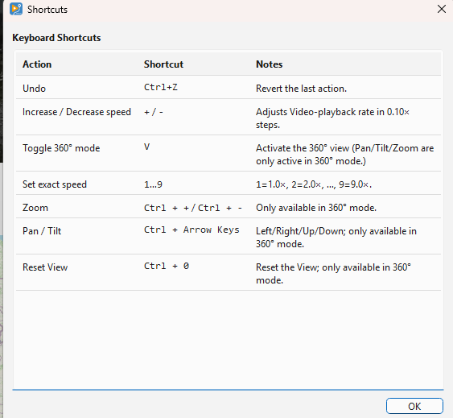
Menu Playlist
Displays the loaded videos.
Videos can be removed by clicking on them,
The "Reorder" menu item opens a pop-up window where you can change the order of the videos if you loaded them incorrectly. But be careful: Don't use this menu item if you already have synced, edited, or overlays!

Menu View
Edit mode
Switch to the “classic” edit view composed of video, map, chart and gpx list (see before).
Create mode
Switch to the gpx creation mode with a view composed of video, map and street view (see before). “Sync all with video” option is then activated.
Video (detach)
The video window is detached from the tool and can be enlarged.
This is useful for comparing the exact gradient progression with the displayed video, as the mini chart (bottom right) always shows the elevation profile section corresponding to the current video position.
It is especially recommended to check hilltops to ensure that the gradient change in the profile matches the video.
Detach (map)
The map can also be expanded!

360° Video – Shortcut: V
Activate the view for 360° Videos and the Pant/Tilt/Zoom Buttons
if activated you can use CTRL+ + / CTRL + - / CTRL+ ArrowKeys for PAN/TILT/ZOOM

Menu Config
Edit Video
If you want to cut the video, you need to activate one of the two modes (see below). This will enable additional buttons in the video control section.
On first activation, you'll be asked whether to index keyframes or not.
Indexing allows you to cut exactly at keyframe positions. While this is not mandatory, it can help produce cleaner cuts.
Once editing is activated, you’ll see the overlay Edit: On in the video window.
Edit Video / Copy Mode:
As mentioned earlier, this uses LossLessCut.
The advantage: The video is not re-encoded – it is built using the copy function only.
The downside: Transitions at cut points may be abrupt or hard cuts.

Edit Video / Encode Mode:
The entire video is re-encoded using the settings from the Encoder Setup.
Crossfades (xfades) – smooth transitions between clips – are applied.
You can also choose the video resolution, quality, and frame rate (FPS) during encoding.
⚠️ Important:
Cuts and overlays must be at least 2 seconds apart – ideally 4 seconds.
This ensures proper transitions and prevents rendering issues.
Example: Cut 1: from second 10 to 22 - Overlay start: at second 24

Encoder Setup (Only active in Encoder Mode)
This is where you configure the encoder:
- Resolution: Sets the output video resolution (16:9)
- Container: e.g., x265 (Recommended: x265 – fewer issues with crossfades)
- Hardware: Select the hardware (e.g., Nvidia or CPU ) to be used for encoding
- Quality (CFR): The lower the value, the higher the quality
(Tip: the value of 20 results in almost no visible quality loss)
- Preset: Controls compression and encoding speed – the faster the preset, the larger the file
- FPS: Frames per second
- XFade: e.g., 2s – sets the duration of the crossfade between clips
- Detect HW: Automatically detects your encoding-capable hardware.
After detection, only the supported hardware will be selectable – not "everything".
Tip: Try encoding a short 1-minute video with different settings to see what works best for you.
Overlay Setup
First of all: What are overlays?
An overlay is an image that is displayed on top of the video at a specific time and for a set duration.
For example, you can show a short logo at the beginning of the video, or a quick intro screen.
Recommended: Use .jpg images for overlays.
Within the menu, you can preconfigure up to three overlays, so you don’t have to reconfigure them every time.
This makes it easy to automatically show your logo at the beginning and/or end of a video.
You need to set the image path, and optionally scale it if the image is very large (e.g., choose 0.5 or 0.1 to reduce its size).
You can also choose the corner in which the overlay should appear, and use dx and dy to shift it slightly inward from the edge, so it doesn’t appear “crammed” into the corner.

How to insert an overlay:
Use the Ovl button in the Video Editor Control panel.
When pressed, it inserts the overlay at the currently selected point in the timeline.
In the menu, you can:
- Choose one of the predefined overlays
- Load a custom overlay ad hoc
- Set display duration
- Optionally set fade-in and fade-out times (if the overlay supports transparency)

⚠️ Important: Overlays can be shown for a maximum of 30 seconds.
Note: Platforms like Kinomap generally discourage the use of overlays – so it’s best to limit them to a brief logo only.

AutoCutVideo+GPX
To activate this option, Edit Video must be enabled first.
This is one of the most important features of the program!
- When this option is activated, selecting a section of the video for cutting (e.g., a stop at a traffic light or the start of the video) will automatically cut the GPX file as well!
- This allows you to remove breaks from both the video and GPX with minimal effort, ensuring the project remains synchronized.

Player Setup
- Show Endcut Warning
shows a pop-up when the player reached a Endcut ( you set a cut on the end of the video)

- Time: Global/Final
The timer at the top right of the video, which shows the current video time, can be switched between Global and Final mode.
What is the difference?
- Global time: The total duration of all videos before editing.
- Final time: The total duration after cuts have been applied.
For example, if a video originally lasts 10 minutes and you cut out 2 minutes, then:
- Global = 10 min
- Final = 8 min
Why is this useful?
If you're editing a long route with multiple stops and breaks, it's best to review all videos quickly in an external player and note down break times.
Example:
- The first video has a break at 4:31
- The second at 2:20 and 4:40
- The fifth at 7:10
When you load all videos and cut the first break, it becomes difficult to calculate the exact position of the next break.
Using Global time, the second break remains at (length of video 1) + 2:20, making it easier to locate without extra calculations.
This is especially useful for GoPro files, which usually have the same length (unless manually stopped).

Player-Setup
- Show Endcut
ON: Player shows the Final-End of the Video ( shows last Frame of Final Video)
OFF: Player jump to the Global-End of the Video ( ignore cuts)
- Show Endcut Warning
ON: You get a warning or OFF:not

FFMPEG / libmpv
These two menu options ensure compliance with the GPL license requirements for FFmpeg and libmpv.
- Here, users can specify their own FFmpeg or libmpv files by entering the file paths.
- If the entered files are incorrect, the default LGPL-compliant version included with the software will be used automatically.
Temp Directory
The Encode-Mode need a lot of HD Space and imn case you haven’t enough on the actually Partition, you can choose another Directory!

Chart Settings
Limit Speed
Adjusts the maximum peak in the speed curve.
It is not uncommon for a GPX point to show an unrealistic speed (e.g., 240 km/h) due to recording errors, signal loss, or faulty cuts. If the speed limit is not set (e.g., to 70 km/h), the curve would be flattened by extreme peaks. This setting ensures that speeds above the limit (e.g., 240 km/h) are capped at 70 km/h (or your chosen value).
Mark ZeroSpeed
Marks GPX points with a downward orange line in the diagram when the speed drops below a set threshold. The default threshold is 1 km/h. If a GPX point falls below this speed, an orange marker is displayed. This helps quickly identify pauses in the GPX file.
Mark TimeGaps
Another function for identifying breaks. GPX points with a time gap greater than the specified value (e.g., >1s) will be marked in the diagram with blue

Map Setup
Directions:
If you have a Mapbox key/token set up, you can use the Directions function to draw a route that follows known roads and paths, just like a route planner. Two new buttons will be added to the map, allowing you to choose whether the route should be drawn for cars, bicycles, or pedestrians. Additionally, the "Close Gaps" function (see below) will also change accordingly.
Map Keys
You can enter API keys for different tile providers (terrain maps).
Without a valid key, terrain maps cannot be displayed.
Most providers offer a large number of free tiles per month. At the time of this software's release, Mapbox provided 50,000 free tiles per month—a limit that most users will never exceed.
Points Size:
The size of GPX points on the map can be adjusted.
This is useful when points are closely clustered together.

Sync all with video
When activated, many actions are synchronized with video:
- New points inserted at current video time. If Directions is activated and Mapbox provided, a route is created to the new point (after ask transport mode).
- When we select a point the video and street view (if visible) jump to the corresponding time

Reset Config
Resets all settings to factory defaults. App restart required!

Menu GPX-INFO
GPX-Summary
Shows the summary or the loaded GPX File, like length height …
Check the following values to ensure your GPX file has no unusual peaks:
Show max Slope: Displays the GPX point with the highest slope.
Show min Slope : Displays the GPX point with the lowest slope.
Show max Speed: Displays the GPX point with the highest speed.
Show min Speed: Displays the GPX point with the lowest speed.

Average Speed
Show the average Speed of a selected range

Menu Help
Show documentation
Displays this document
Youtube tutorials
Opens Youtube channel in browser
Copyright
Displays copyright information and the installed version.

Video Control Buttons
Note: Depending on the mode, not all buttons are visible.
Some buttons only appear after Video Edit is enabled, while others change functionality when AutoCutVideo+GPX is activated.
Here are the two different views:
Edit Off:
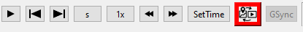
Edit On:

Video Control Buttons
The buttons from left to right:
Play/Pause – Go to start – Go to end – Step-Value – Multiplier Stepper – Step Left – Step Right – SetTime – MarkB – MarkE – Deselect [x] – Cut – CutBegin – CutEnd – GSync – Overlay [Ovl] – AutoCutVideo+GPX [VG]
Play/Pause
Starts and pauses the video.
Go to start
Resets video position to the beginning.
Go to end
Sets video position to the last frame.
*hidden feature: Right-click to navigate through all cuts and video merges
Stepper
The stepper consists of the following buttons: Step-Value – Multiplier – Step Left – Step Right


Stepper
With Step-Value, you can select the type of step: seconds (s), minutes (m), keyframes (k), or frames (f). Important: Keyframes can only be used if you selected "Yes" when asked about Indexing Keyframes.
The Multiplier determines the size of each step, e.g., 1 second (s 1x) or 8 minutes (m 8x).
Left (←) and Right (→) indicate the direction in which the step should move (forward or backward).
Important Note:
Jumping backward is often slightly less accurate than jumping forward.
When synchronizing and moving to an exact point, it is recommended to first jump a bit further back and then use the forward step button to fine-tune the position.

SetTime
Manually enter the exact time the player should display.

MarkB [-
Only available when Video Edit is ON!
Marks the beginning of a cut point in the video.
If AutoCutVideo+GPX is also activated:
Marks the beginning of a cut point in both the video and the GPX file.

MarkE -]
Only available when Video Edit is ON!
Marks the end of a cut point in the video.
If AutoCutVideo+GPX is also activated:
Marks the end of a cut point in both the video and the GPX file.

Deselect [x]
Clears the selection for MarkB and MarkE.

Cut
Deletes the marked section.
If Video Edit is ON: Only the selected section in the video is removed.
If AutoCutVideo+GPX is ON: The selected section in both the video and the GPX file is removed.
Note:
In the video, the removed section is black-marked and will be skipped during playback.
In the GPX file, the section is completely removed and no longer visible.

CutBegin
Only available when Video Edit is ON!
We synchronize the start of the video with the GPX file.
Both the video and the GPX file will be trimmed at the exact point. In the example, the first 10 seconds of the video would also be cut, and the GPX file would now start exactly at the marked point.

CutEnd
Only available when Video Edit is ON!
The GPX file is also trimmed at the same point.

Define GPX/Video sync point
Allows to calculate the shift between video and gpx start. Find the matching gpx point corresponding to a video frame and click this button. Once set, the video and gpx edit (if video in edit mode) and selections are synchronized. New created points are inserted at time corresponding to current video time.
You can click this button again to edit the shift between gpx and video.
GSync
Active only when gpx/video sync point is defined.
Displays the corresponding GPX point for the current video position. This is useful for checking synchronization after making a cut. Set the video to a distinctive point (e.g., after a cut) and press GSync. The matching GPX point will be highlighted, allowing you to compare them. Recommendation:
Check multiple points throughout the video to ensure that no pauses were missed during synchronization.
Ovl:
Add an Overlay on the marked Timeline-Position. A Window will open and ask which Overlay you want to add from the pre-configured one ( you can add a new one too).
Set the Duration (max 30s) and the fade-in and fade-out time.
Please use jpg-files only.
VG✓/x
Same as Confif Menu AutoCutVideo&GPX On and Off

Map Control Buttons
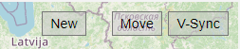
New point now can be in 2 modes:
: icon in edit mode
Adds a new GPX point on the map, either at the beginning or end of a route. Alternatively, you can place it precisely on the line between two existing points.
- The route will automatically be extended by 1 second.
- Before adding the new point, you must select the point where it should be connected.
: icon when “Sync all with video” activated
Adds a new GPX point on the map synchronized with the video
- With timestamp corresponding to the current video position.
- Inserted in the list in the according position, based on its time
Move
Activates the "Move GPX Point" mode. This allows you to freely move a GPX point on the map. Useful for adjusting the route to align with roads if the recorded path is incorrect.

V-Sync
Displays the video frame corresponding to the selected GPX point. For example, if the GPX position is at 10 seconds, pressing V-Sync will show the frame at 10 seconds in the video. It is recommended to press the button multiple times to ensure the correct frame is displayed, as system performance may cause delays. Keep in mind that not every exact frame can be displayed—only the nearest displayable frame. There might be a slight millisecond discrepancy, as some frames are not directly accessible due to GOP (Group of Pictures) encoding.
In “Sync all with video” mode this button is visually activated and triggered at any point selection.
View-Switch
Toggles between different map display modes: OSM (OpenStreetMap) - Various satellite views
Note: If no API key is entered for services like MapBox, only OSM will be displayed. To access terrain maps, you must request an API key from the respective service provider.
Directions-Control-Buttons:
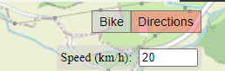

For Experts ONLY!
The "Bike" button toggles between Bike, Car, and Foot. Depending on the selected mode, the route will be requested and calculated accordingly via Mapbox.
Function:
First, you need to select either the first or the last point of the route by clicking on it. Then, activate the Directions function (its color will change). Using "Speed," you can define the spacing between points, and with the crosshair, you can set the target point where the route should lead. This can only be done at the beginning or end of a route!
It is crucial not to select excessively large "steps" but to create the new route in small increments instead. Additionally, always verify the connection to the existing route, as the "old" point often needs to.
If you want to recalculate a section of an existing route—for example, if your GPS device did not record anything due to a lost signal or any other reason—you can use the Close Gaps function while Directions is active.
The functionality is the same as Close Gaps, but instead of drawing a direct path, the route will be adjusted to follow the road.

GPX Control Buttons
The buttons from left to right:
markB – markE – Deselect [x] – Delete – chTime – chElevation – chSlope – More (…) – Smooth

markB
Marks the beginning of a cut in the GPX list. The marked section will be highlighted in red in both the GPX list and the map. The button turns red when activated.To delete a single point, simply mark it with markB.
markE
Marks the end of a cut in the GPX list. The entire section between markB and markE will be highlighted in red in both the GPX list and the map.

Deselect [x]
Deselects a marked section or a single selection.

Cut (scissors)
Deletes an entire marked section. To prevent a gap, the time between the two surrounding points is adjusted to 1 second. Points next to deleted section will have their time shifted back by the amount corresponding to the deleted section length.
Remove (minus button)
Also deletes the marked section, but the next points time will not be shifted. We can see this as a route simplification, with less points. ( needed for rebuilding a route with Close Gaps or by hand)

chT (chTime)
Modifies the time or step of a single point or all points in a marked section. Useful for fine-tuning synchronization. This button allows to edit the step of the selected points in the list. Note that next points will be shifted by the time difference. For example if you set 2s instead of 1s on a single point all the next points will be shifted to +1s. If you don’t want the following points to change edit the time value directly in the list (by double click).

chEle (chElevation) Changes the elevation of a single point or an entire marked section. This is useful when there is a sudden elevation shift due to a GPS restart after a break. If the GPS records a different elevation after restarting, the entire section can be shifted so that: The first point after the restart has the same elevation as the last point before the restart.

%↗ (chSlope)
Adjusts the slope (gradient) of a single point or a marked section. Used to correct elevation recording errors or smooth transitions after a cut.

Undo
Reverts the last action.

Smooth
Opens a smoothing settings window, where adjustments can be made to smooth the elevation profile. Default settings usually provide a good result.If the result is not satisfactory, the options can be adjusted: Box-Smoothing: Number of GPX points included in the smoothing process. Flatten-Value: Maximum slope difference between points.
Slot 1/2
switch between Slot 1 and Slot 2
Read more in the Section Slots
Slot Sync
See chapter Slots

More-Menü […]:
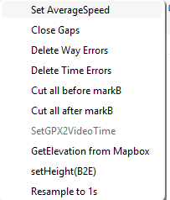
Set Average Speed
Calculates the average speed of a selected section. This can be helpful if a speed peak cannot be corrected in another way.
Close Gaps / Close Gaps (Directions)
Fills in missing GPX points. Example: You drive through a tunnel or an area without GPS coverage.The GPX file shows an unusually large time step, and the chart displays it as a pause (since the step is greater than 1s). Cause: GPS signal failure. Solution: Using Close Gaps, the missing section is filled with GPX points at 1-second intervals. No changes are made to time or distance—it simply looks better in the visualization. If necessary, the new points can be adjusted to match the road.
Important: markB must be set before the gap. markE must be set after the gap.
Close Gaps (Directions):
When Directions is activated, GPX points are no longer simply connected in a straight line from markB to markE. Instead, you can let Mapbox draw the route along the road.

Delete WayErrors
When loading a GPX file, you will receive a warning if WayErrors are found. These errors are also highlighted in red in the chart. This button fixes these errors automatically. What are WayErrors? These are GPX points that have identical latitude/longitude but a 1s time step—a recording error. Fixing the error recalculates the second point: It is moved to the middle between the previous and next point while keeping the same latitude/longitude.
This should always be executed!

Delete Time Errors
This issue is rare, but some GPX points might have a 0s time step.These points are simply deleted.
This should always be executed!

Cut all before markB
Deletes all GPX points before and including the markB point.
Cut all after markB
Deletes all GPX points after and including the markB point.

SetGPX2VideoTime
For Experts Only!
Synchronizes the GPX time (range) with the video time (range).
This function aligns a marked time range in the GPX list with the corresponding marked time in the video editor.
Requirements:
- Video Edit = ON
- AutoCutVideo & GPX = OFF
Instructions:
- Set the start point markB in Video_Control using markB.
- Use GSync to select the corresponding GPX point with markB in GPX_Control.
- Navigate the video to a second clearly identifiable point and mark it with markE.
  - This range will now be highlighted in yellow.
- Find the corresponding point on the map and mark it with markE.
  - Now, both the video and the GPX list have a marked range.
- Click SetGPX2VideoTime to adjust the GPX time range to match the video time range.
  - Every point in the GPX section will be recalculated.
  - The marked section in the video will now have the same duration as the marked section in the GPX list.

GetElevation from Mapbox
Retrieves elevation data from Mapbox for the selected area and stores it.
Note: You need a Mapbox Key/Token

Set Height(B2E)
Change the final height ( markE) in a selected area.
We select an area, markB and markE, and now we can change the final height, markE.
All points are increased evenly, and the subsequent points are adjusted accordingly.
Resample to 1s
In case your Steps between the GPX-Points are not in 1s Steps you can resample it.
Please notice that this change the distance / height and maybe a sync.
Please check after resample ( it is recommend to this first and that’s why we check it at every load of a gpx file)
If a range is marked, we only resample the marked range, otherwise the complete track!
Flatten
Flattens a local elevation anomaly (e.g. bridge or cuvette) between two marked points.
- Select the start of the problematic section with MarkB and the end with MarkE.
- Open the More (...) menu and choose Flatten.
- The tool takes the elevation of the point just before the selected range and the point just after the range, then linearly interpolates the elevations inside the range so that the profile transitions smoothly between those two outer points.
- This is useful to remove short false “hills” (e.g. GPS signal jumping to a bridge deck) or “holes” while preserving the surrounding elevation trend.
After applying Flatten, the GPX data, elevation stats, and charts are updated, and the selection is cleared.

The Chart:

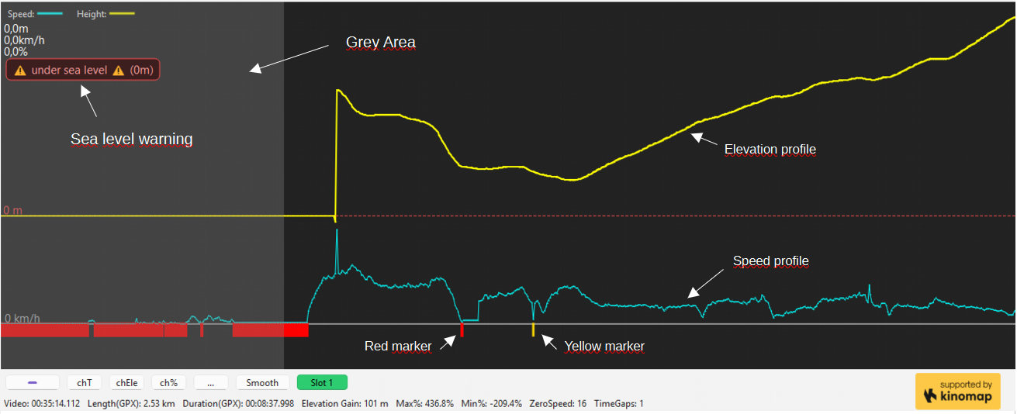
you will see:
- The elevation profile at the top
show the elevation Profile of the Route
- The speed profile at the bottom.
show the speed profile
- Sea level warning
if there is a point under sea level ( under 0m) we show this warning,
you shouldn’t upload a route with a sea level warning
Right Click on the warning: we show step by step every point under sea level
Left Click on the Warning:
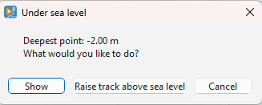
You get a information which is the deepest point and you can choose between:
- Show ( will show the point)
- Raise track above sea level – we move all points over the sea level with exact the shown
value and the warning should be gone, the profile will be the same but now over 0m
- Red Marker
this will show the ZeroSpeed Points and it’s a clear marker that you are stopping here and have 0km/h speed ( you can setup the value in the Setup Menu). This Points must be cutted!
We don’t want ZeroSpeed Points. If you take a look at the info line directly under the buttons you can see how many ZeroSpeed or TimeGaps you have
- Yelllow Marker
this shown points with higher Steps than 1s ( you can change the value in the Setup Menu)
Check this points if there is something wrong, but sometimes there isn’t nothing really wrong, because you was riding through a tunnel and lost the signal, than the first point after the tunnel have a TimeGaps. If yu play the Video at this point and your are moving and the point has a Speed value all is ok. Of course we can fix that with our tool ( Close Gaps and some points more, but for that: follow the Tutorials.
- Grey Area
If you have uses the sync button and the first part of the gpx-list, this area is grayed too and this mean it will not be written to the exported gpx file, all red and yellow markers are not shown in the info-list and you can ignore them. You see o sea level warning if a point is in the grey area and under sea level!

Navigation Controls:
- Zoom: Use CTRL + Mouse Wheel.
- Pan: Hold the right mouse button and drag to move the chart.

Timeline:
Visual Representation of Video Time
- Blue Marker: Indicates the separation between two videos.
- Black Area: Represents an already deleted section.
- Blue Area: Marks a Overlay ( with right click into the blue Area you can delete the overlay)
- Yellow Area: Marks a selected section.
Controls:
- Zooming: Use CTRL + Mouse Wheel.
- Panning: Hold the right mouse button and drag to move the timeline.
- Clicking on the timeline: Moves the white marker (which indicates the current time) to that position and updates the video accordingly.
- Scrubbing: The white marker can also be dragged to scrub through the video.

Mini-Chart:
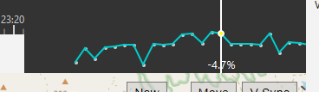
The mini-chart, located at the bottom right under the video, is used to check the gradient at locations such as hilltops.
After smoothing, this chart provides a clear visualization of whether the video aligns correctly with the gradient changes.
This helps ensure that elevation changes in the GPX file match what is visible in the video.
Slots
We have now two different Slots: Slot 1 and Slot 2
if you load a GPX od FIT the files will automatically loaded in Slot 1
if you extract a GPX from a Gopro it will be loaded in Slot 2
you can work in each Slot like you want it make no changes in the other Slot.
If you prefer to work with GPX from a Wahoo/Garmin/Strava/whatever ( what I recommended) you can worl like before.
but if you only have a Gopro with GPS, you had in the back to extract the gpx with a extern tool to load it into the App, now ypu can do it directly in the App
But why Slots?
for a maximum easy syncing.
Gopro-GPX are always perfect synced to the Video!
How ?
If you have a Gopro File with GPX and want sync your extern GPX loaded in Slot 1:
1. Load the GPX
2. Load the Video / Videos
3. Extract the first Video
4. You are in Slot 2 now
5. Search a point you can simple identify in the Video and in the GPX ( corner/ roundabout… )
6. The magic starts now with: click on the Slot Sync - Button
7. The app search the nearest GPX Point in Slot 1 ( Lat/Lon) and will show you this point
8. The Video is still on the same point
9. If the point is the same ( and it is)-> press the Sync-Button
10. Synced !
Background- Information to point 9:
You have two different GPX records, sometimes the GPX we show in Slot 1 match perfectly.
Sometimes there are some meters difference, than you can simple move the Video a little bit
forward or backward to the point we shown ( only some 1x frames click) and it will match

© Kinomap – 2026 – All rights reserved.
email: d.prikhodko@kinomap.net
Github: https://github.com/dprh-kinomap/VGSync
Legal Notes
VGSync is an independent open-source project officially supported by Kinomap. “Kinomap” is a trademark or registered trademark of its owner and is used here with permission. Other brands mentioned are trademarks of their respective owners; no affiliation or endorsement by them is implied.

