Table of contents
FEMNET 1
*.don file 3
-The first part: 3
- the second part of *.don file: 14
phobos 16
- The first way: 16
- The second way: 18
Unix_2004 ./4ch19 19
Batz 21
Hector 23
Automatic creation of links 27
Refining the calculation 30
Symmetry 33
Bottom trawl 38
Catch 45
Flexion 59
Stiff netting example. 59
Polyamide cylinder example 61
Gravity catch 65
FAD 72
Mussels longline 75
Netting boom 81
Fish cage 87
Bottom seine 93
Symmetry plane 99
Index 101
Annex 1: Stiffness of cables 105
Annex 2: Volumic mass of cables 106

FEMNET
FEMNET is a numerical modelling dedicated to mechanical assessment of flexible structures such as fishing gear and fish cage. This numerical modelling is based on the finite element method with a specific emphasis on netting structures. Netting is a main component of fish cage and fishing gear. This numerical modelling using the finite element method also takes into account cables, bars, floats and netting. FEMNET has been used in several scientific papers: [1], [2], [3] and book: [4].

FEMNET runs on linux.
- Download the source code from https://gitlab.ifremer.fr/dp00644/femnet
In the following these files are placed in ~/hexa.
- Libsx is the graphics library. FEMNET requires the file libsx.a. 2 possibilities to get it: a) use ~/hexa/libsx/src/libsx.a hoping that it is usable on your computer; b) find libsx on internet, compile it to get a libsx.a adapted to your computer.
- Edit makefile of ~/hexa/phobos_2005, ~/hexa/batz and ~/hexa/hector and modify the path of libsx.a in order to indicate the path of your libsx.a.
- Do make in ~/hexa/lib_dp, in ~/hexa/unix_2004, in ~/hexa/dyna2, in ~/hexa/phobos_2005, in ~/hexa/batz and in ~/hexa/hector.

To use FEMNET a main file is required: *.don. *.don file has to be write by the user. This file describe the structure and its environment.
5 tools are also required:
phobos in ~/hexa/phobos_2005 to transform *.don file in *.mdg file which is compatible with calculation of equilibrium by Finite Element Method.
4ch19 in ~/hexa/unix_2004 which calculated the equilibrium in static conditions from *.don file and *.mdg file and records the equilibrium in *.sta file.
4ch19 in ~/hexa/dyna2 which calculate the equilibrium in dynamic conditions from *.don file, *.mdg file and *.sta file and records the dynamic equilibrium in *.dyn file.
batz in ~/hexa/batz which display the equilibrium of the structure. It uses mainly *.sta file and *.dyn file if any.
hector in ~/hexa/hector which is an help for the construction of *.don file. It uses *.don file and records the result in a specific file.

*.don file

*.don file has two parts:
- the first part follows a strict template.
- the second part is a succession of commands which don’t need to follow a specific order.
These two parts are described in the following.

In the following s1.don file (in ~/hexa/data_2001/readme/1pelagic_trawl) is displayed in blue, a tentative of explanation is given in green and with figures. This file describes a pelagic trawl. In this file the boat is fixed and a current represents the towing speed. The file begins with the first part which follows a strict template:

-The first part:
In this first part, the order of the commands must be respected.

design in the plane normal to axis: 2
The design of the structure is done in the plane normal to axis 2 (y) that means in the plane X,Z.
This is used by phobos. The Figure 1 gives the view of phobos of this file. That shows panels of netting in blue, cables or bars in red. The design is in the plane XZ. To get the view of Figure 1 do cd ~/hexa/phobos_2005, ./phobos, File, load_don_file, choose s1.don, Visualisation, contour_diamond, Visualisation, contour_cable_bar, Visualisation, axes.
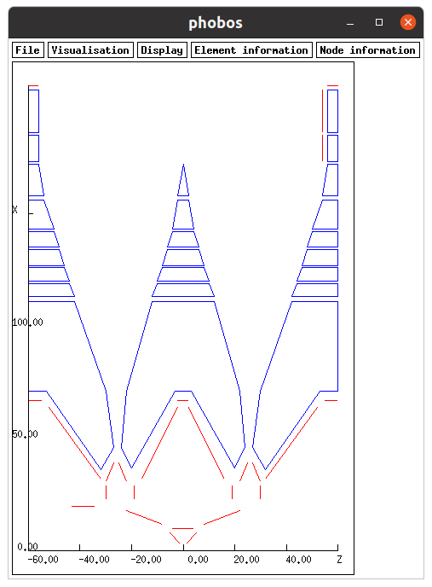Figure 1: Design of a pelagic trawl ~/hexa/data_2001/readme/1pelagic_trawl/s1 displayed with phobos tool.

panels number: 25
There are 25 panels of netting of diamond meshes, which can be seen in blue on Figure 1.
Panel: 1
The value 1 is not used. In fact the panel 1 is the first of this list of panels, panel 2 is the second and so on.
number of nodes around: 10
The panel 1 is a polygon made of 10 nodes around (see Figure 1).
nodes of the contour no x y z U V type and following type:
1 37.000000 0.000000 20.000000 0.000000 27.500000 2 2
This list of number are described in the following: The corner 1 is the first of this list of corners, the corner 2 the second and so on. The corner 1 has a position X,Y and Z of 37m, 0m and 20m. The user defines an origin for counting the number of meshes for each corner. The origin is constant for all the corners of a panel. The corner 1 is at 0 mesh along U meshes and is at 27.5 mesh along V meshes. The Figure 2 displays the number of meshes for the corners of panel 1. The type of corner 1 is 2 and the type of nodes, if any, between corner 1 and corner 2 is 2. This point will be discussed later (p11).
2 46.000000 0.000000 24.000000 7.000000 37.500000 2 2
3 71.000000 0.000000 22.000000 25.000000 32.500000 2 2
4 111.000000 0.000000 12.000000 55.000000 17.500000 2 2
5 111.000000 0.000000 -12.000000 55.000000 -17.500000 2 2
6 71.000000 0.000000 -22.000000 25.000000 -32.500000 2 2
7 46.000000 0.000000 -24.000000 7.000000 -37.500000 2 2
8 37.000000 0.000000 -20.000000 0.000000 -27.500000 2 2
9 71.000000 0.000000 -3.000000 25.000000 -2.500000 2 2
10 71.000000 0.000000 3.000000 25.000000 2.500000 2 2
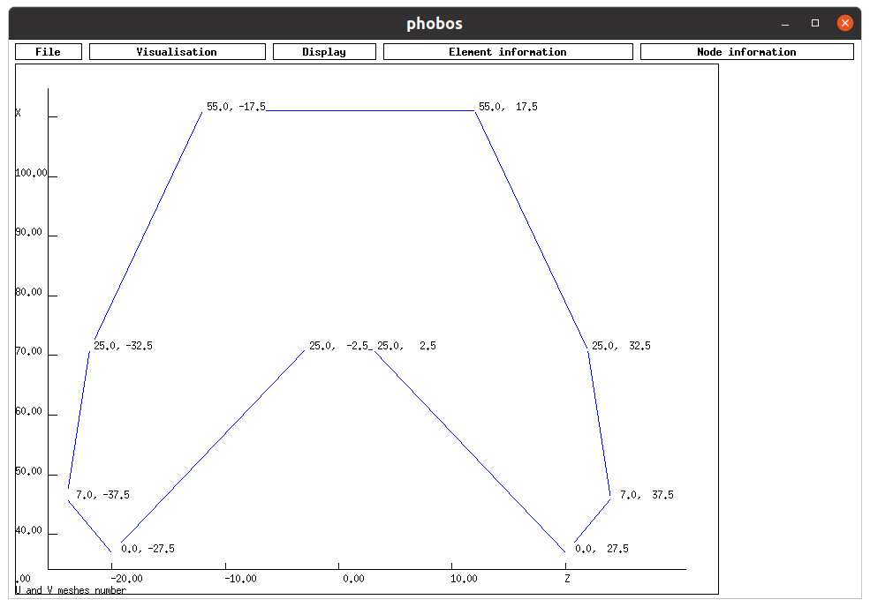Figure 2: Mesh coordinates of the corners of the panel 1 of netting, displayed with phobos using ~/hexa/data_2001/readme/1pelagic_trawl/s1.
Traction stiffness (N): 25000.000000
The traction stiffness, more exactly the force required to double the length of the twine, is 25000N. This value is E.A. E is the Young modulus of the material and A (N/m²) is the section of the twine (m², p105).
Compression stiffness (N): 1.000000
The compression stiffness is 1N. That means that there is more or less no force required to compressed the twine.
Mesh opening stiffness (N.m/rad): 0.000000
The mesh opening stiffness is the couple required to open the mesh of 1 Rad. Generally speaking, use 0N.m/Rad. For stiff netting see p59.
Unstretched length (m): 0.400000
The unstretched length is the length of the mesh side from a middle of a knot to the middle of a knot.
Volumic mass (kg/m3): 1025.000000
The volumic mass of the netting (material and sea water inside the hydrodynamic diameter, see p106 a method of assessment). Note that the default volumic mass of sea water used here is 1025kg/m³.
Hydrodynamic diameter (m): 0.002800
The diameter of the twine. This diameter is used for the calculation of the drag, the mass and the floatability.
Knot size (m): 0.005600
In case of the meshes are closed, the closing could be limited by the size of the knot. A default value is twice the twine diameter. 0.0 is also used.
Normal Cd: 1.200000
Normal Cd for the calculation of the drag. 1.2 is an usual value.
Tangential Cd: 0.080000
Tangential coefficient for the calculation of the drag. 0.08 is an usual value.
Meshing step (m): 27.000000
The distance between the numerical nodes created by phobos. Here the value is quite large, for finer calculations in following files this meshing step will decrease.
Type of internal nodes: 2
Type of the numeric nodes created by phobos. This point will be discussed later (p11).
Meshing type: 2
When the meshing type is 1 there is no constraint on the creation of the nodes by phobos. If the meshing type is 2, phobos tries to create the numeric node on a knot. It is preferable to use meshing type 2.

Panel: 2
Continue the same for all the panels. Here the panels 3 to 24 have been hidden.
number of nodes around: 7
nodes of the contour no x y z U V type and following type:
1 36.000000 0.000000 32.000000 0.000000 -32.500000 2 2
2 71.000000 0.000000 53.000000 25.000000 -7.500000 2 2
3 71.000000 0.000000 60.000000 25.000000 0.000000 3 3
4 111.000000 0.000000 60.000000 55.000000 0.000000 3 2
5 111.000000 0.000000 42.000000 55.000000 -24.500000 2 2
6 71.000000 0.000000 30.000000 25.000000 -42.500000 2 2
7 46.000000 0.000000 27.000000 7.000000 -39.500000 2 2
Traction stiffness (N): 25000.000000
Compression stiffness (N): 1.000000
Mesh opening stiffness (N.m/rad): 0.000000
Unstretched length (m): 0.400000
Volumic mass (kg/m3): 1025.000000
Hydrodynamic diameter (m): 0.002800
Knot size (m): 0.005600
Normal Cd: 1.200000
Tangential Cd: 0.080000
Meshing step (m): 27.000000
Type of internal nodes: 2
Meshing type: 2
.
.
.

Panel: 25
number of nodes around: 4
nodes of the contour no x y z U V type and following type:
1 186.000000 0.000000 -60.000000 0.000000 0.000000 3 3
2 205.000000 0.000000 -60.000000 450.000000 0.000000 3 2
3 205.000000 0.000000 -56.000000 450.000000 62.500000 2 2
4 186.000000 0.000000 -56.000000 0.000000 62.500000 2 2
Traction stiffness (N): 25000.000000
Compression stiffness (N): 1.000000
Mesh opening stiffness (N.m/rad): 0.000000
Unstretched length (m): 0.025000
Volumic mass (kg/m3): 1025.000000
Hydrodynamic diameter (m): 0.002800
Knot size (m): 0.005600
Normal Cd: 1.200000
Tangential Cd: 0.080000
Meshing step (m): 27.000000
Type of internal nodes: 2
Meshing type: 2

hexagonal panels number: 0
Number of panels of hexagonal meshes. Use 0, as the hexagonal meshes are not explained in this document.

Cables number: 26
There are 26 cables or bars.

Cable: 1
The value 1 is not used. In fact the cable (or bar) 1 is the first of this list of cables, cable 2 is the second and so on.
Extremities no x y z type:
1 0.000000 0.000000 0.000000 1
2 2.000000 0.000000 0.000000 4
There are 2 extremities (corners) for each cable or bar. The extremity 1 is the first, extremity 2 is the second. The coordinates X,Y,Z of extremity 1 are 0m, 0m, 0m and 2m, 0m, 0m for extremity 2. The type of node of extremity 1 is 1 and 4 for extremity 2 (p11).
Traction stiffness (N): 62000000.000000
This characteristics are the same as the one uses for twines previously described.
Compression stiffness (N): 1.000000
Unstretched length (m): 200.000000
Volumic mass (kg/m3): 4800.000000
Hydrodynamic diameter (m): 0.026000
Normal Cd: 1.800000
Tangential Cd: 0.080000
Bars number: 9
This cable will be discretized by 9 bars. For finer calculations in following files this number will decrease.
Type of internal nodes: 2
The nodes created by the 9 bars are of type 2 (p11).

Cable: 2
Continue the same for all the cables and bars. In this document, only few cables/bars are shown.
Extremities no x y z type:
1 3.000000 0.000000 1.000000 4
2 8.000000 0.000000 5.000000 2
Traction stiffness (N): 200000000.000000
Compression stiffness (N): 200000000.000000
Unstretched length (m): 3.000000
Volumic mass (kg/m3): 1025.000000
Hydrodynamic diameter (m): 0.010000
Normal Cd: 1.800000
Tangential Cd: 0.080000
Bars number: 1
Type of internal nodes: 2
.
.
.
Cable: 18
Extremities no x y z type:
1 32.000000 0.000000 -16.000000 2
2 64.000000 0.000000 -2.000000 2
Traction stiffness (N): 20000000.000000
Compression stiffness (N): 1.000000
Unstretched length (m): 20.000000
Volumic mass (kg/m3): 4800.000000
Hydrodynamic diameter (m): 0.012500
Normal Cd: 1.800000
Tangential Cd: 0.080000
Bars number: 1
Type of internal nodes: 2

Sliding cables number: 0
This number must be always 0. There is a new method for the sliding ropes which will be described later.

Links number: 52
The panels and cables/bars have to be linked together. Here there are 52 links. The Figure 3 shows few links. The four corners (panels corners and cables extremities) noted 6 on Figure 3 are linked together, that means that they are represented by only one numeric node in the numerical model. The two corners noted 52 are linked. Be careful to the following rule: if two components are linked together by consecutive corners it is equivalent to a sewing of the two components. For example, on the Figure 3, the panel side between links 7 and 14 of panel 1 and the cable 18 with links 7 and 14 are sown. The Figure 4 shows that the nodes which are created on the panel side and the cable are linked (links 122 to 127). The tool hector (hector in ~/hexa/hector) is specifically designed for creating the links between components.
nb_pt: 3 el: 3 nd: 1 el: 2 nd: 1 el: 1 nd: 2
This link relies 3 corners: extremity (nd) 1 of cable (el) 3, extremity (nd) 1 of cable (el) 2 and extremity (nd) 2 of cable (el) 1.
nb_pt: 3 el: 6 nd: 1 el: 4 nd: 2 el: 3 nd: 2
.
.
.
nb_pt: 2 pa: 1 nd: 6 pa: 3 nd: 6
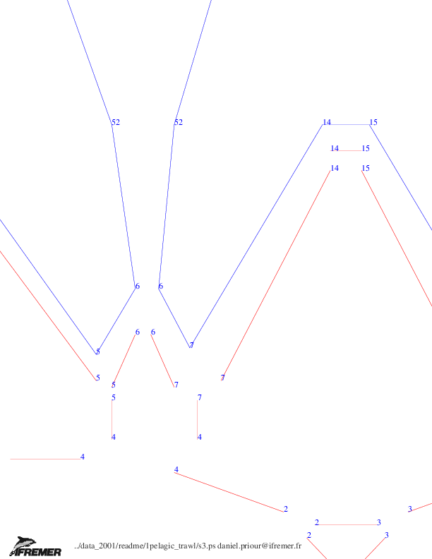Figure 3: Links between components. The two corners noted 52 are linked and this link is the 52. View of phobos using ~/hexa/data_2001/readme/1pelagic_trawl/s1.
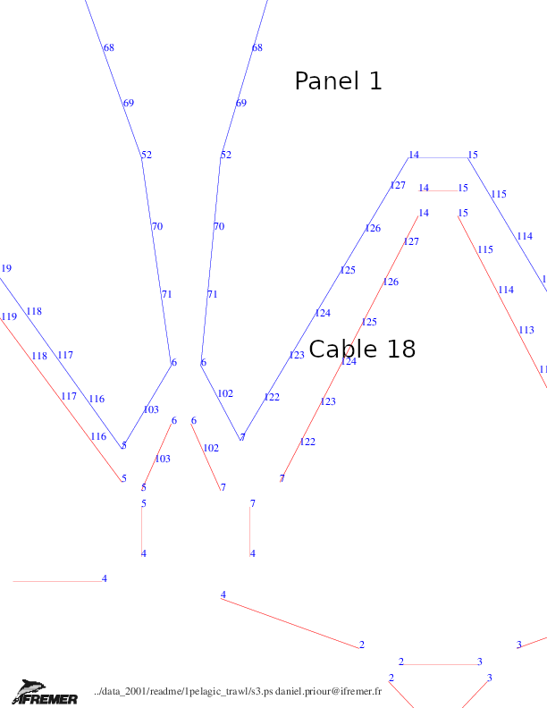Figure 4: The cable 18 is sown to a side of panel 1. There are 8 common nodes which are linked (links 7, 122, 123, 124, 125, 126, 127, 14). Here panel 1 is discretized before cable 18 (this point is discussed later). View of phobos using ~/hexa/data_2001/readme/1pelagic_trawl/s1.
Meshing order:
el: 23 el: 24 pa: 24 pa: 25 pa: 22 pa: 23 pa: 1 pa: 2 pa: 3 pa: 4
pa: 5 pa: 6 pa: 7 pa: 8 pa: 9 pa: 10 pa: 11 pa: 12 pa: 13 pa: 14
pa: 15 pa: 16 pa: 17 pa: 18 pa: 19 pa: 20 pa: 21 el: 1 el: 2 el: 3
el: 4 el: 5 el: 6 el: 7 el: 8 el: 9 el: 10 el: 11 el: 12 el: 13
el: 14 el: 15 el: 16 el: 17 el: 18 el: 19 el: 20 el: 21 el: 22 el: 25
el: 26
The meshing order defined the order by which each component is discretized by phobos. This is in relation with the previous point: the links between components. In the list above the panel 1 (pa: 1) is listed before cable 18 (el: 18), that means that the panel 1 is discretized before cable 18, the numeric nodes inside and around panel 1 are created before those of cable 18. In this example the discretization step of panel 1 is 3 m, that gives 6 new numeric nodes (links 122, 123, 124, 125, 126, 127 on Figure 4) on the panel side as visible on Figure 4. If cable 18 (el: 18) is before panel 1 (pa: 1) in the meshing order the result could be different: because the number of bars in cable 18 is 3 (see ~/hexa/data_2001/readme/1pelagic_trawl/s1.don) that leads to create on this cable 2 new numeric nodes, and because panel 1 is sown to cable 18, consequently, on the side of panel 1 there are 2 new numeric nodes (links 58, 59) also, as visible on the Figure 5.
If the meshing order does not matter which is quite often the case, the list Meshing order: el: 23 .. .. .. .. el: 26 could be replaced by Meshing order: all, in this case cables are meshed before diamond netting panels, and cable n before cable n+1 (idem for panels.)
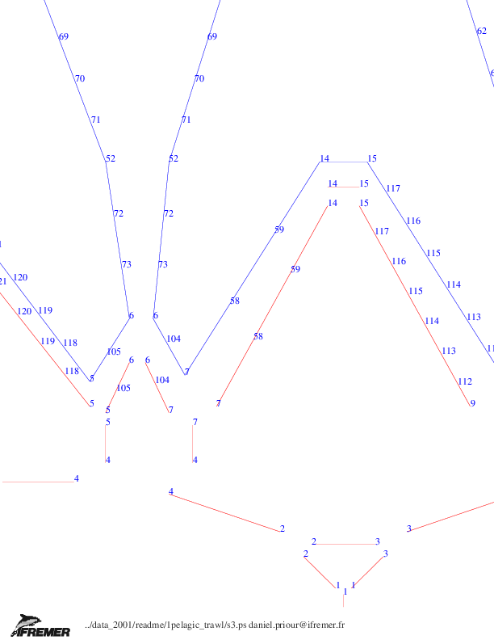Figure 5: The cable 18 is sown to a side of panel 1. There are 4 common nodes which are linked (links 7, 58, 59, 14). Here the cable 18 is discretized before panel 1. View of phobos using ~/hexa/data_2001/readme/1pelagic_trawl/s1.
Number of types of nodes: 4
There are 4 types of nodes
No du type : 1
The type 1. Be careful this value 1 is not used: The type 1 is the first of this list, the type 2 is the second and so on.
Mass X,Y,Z (kg): 0.000000 0.000000 0.000000
The node mass. The mass along X, Y and Z could be different. Generally these 3 masses are equal.
Added mass X,Y,Z (kg): 0.000000 0.000000 0.000000
The added mass in case of dynamic.
Length X,Y,Z (m): 0.000000 0.000000 0.000000
The length of the node along X, Y and Z axis. These lengths could lead to floatability due to the volume and drag due to sections.
Drag coefficient X,Y,Z: 1.200000 1.200000 1.200000
The drag coefficient applied on sections.
External forces X,Y,Z (N): 0.000000 0.000000 0.000000
External constant forces along X, Y and Z axis.
Displacement X,Y,Z: 1 1 1
if 0 the displacement of the nodes with this type is possible. If 1 the node is fixed. The displacement is along X, Y and Z.
Limits X,Y,Z (m): 0.000000 0.000000 0.000000
In case of bottom sea the limit along Z is minus the depth. The limits could be also along X and Y axis.
Limits sense X,Y,Z: 0 0 0
If limits sense is 0 there is no limit. If limits sense is 1, the limit previously defined is a floor. If limits sense is -1, the limit is a ceiling.
Symmetry X,Y,Z: 0 0 0
In case of symmetry relatively to the plane Y,Z (Z,X and X,Y) use 1 0 0 (0 1 0 and 0 0 1). In case of no symmetry use 0 0 0.

No du type : 2
Mass X,Y,Z (kg): 0.000000 0.000000 0.000000
Added mass X,Y,Z (kg): 0.000000 0.000000 0.000000
Length X,Y,Z (m): 0.000000 0.000000 0.000000
Drag coefficient X,Y,Z: 1.200000 1.200000 1.200000
External forces X,Y,Z (N): 0.000000 0.000000 0.000000
Displacement X,Y,Z: 0 0 0
if 0 the displacement of the nodes with this type is possible. If 1 the node is fixed. The displacement is along X, Y and Z.
Limits X,Y,Z (m): 0.000000 0.000000 0.000000
Limits sens X,Y,Z: 0 0 0
Symmetry X,Y,Z: 0 0 0

No du type : 3
Mass X,Y,Z (kg): 0.000000 0.000000 0.000000
Added mass X,Y,Z (kg): 0.000000 0.000000 0.000000
Length X,Y,Z (m): 0.000000 0.000000 0.000000
Drag coefficient X,Y,Z: 1.200000 1.200000 1.200000
External forces X,Y,Z (N): 0.000000 0.000000 0.000000
Displacement X,Y,Z: 0 0 0
Limits X,Y,Z (m): 0.000000 0.000000 0.000000
Limits sens X,Y,Z: 0 0 0
Symmetry X,Y,Z: 0 1 0

No du type : 4
Mass X,Y,Z (kg): 0.000000 0.000000 0.000000
Added mass X,Y,Z (kg): 0.000000 0.000000 0.000000
Length X,Y,Z (m): 0.000000 0.000000 0.000000
Drag coefficient X,Y,Z: 1.200000 1.200000 1.200000
External forces X,Y,Z (N): 5600.000000 13000.000000 -15000.000000
Displacement X,Y,Z: 0 0 0
Limits X,Y,Z (m): 0.000000 0.000000 0.000000
Limits sens X,Y,Z: 0 0 0
Symmetry X,Y,Z: 0 0 0

These 4 types of node show that nodes could be fixed (type 1), free to move (type 2), free to move and on symmetry plane (type 3) and free to move with external forces (5600.000000 13000.000000 -15000.000000, type 4). This last type (type 4) is dedicated to trawl door. To assess the hydrodynamic forces on trawl doors, use their hydrodynamic characteristics (drag coefficient, lift coefficient,as it is defined for example in [5]), their surface and the water speed. For the vertical force use the weight of the trawl door.

NUMERIC ENVIRONMENT
Divisor (s): 0.000050
Not used.
Convergence threshold (N): 0.100000
The equilibrium is reached when the mean disequilibrium force per node is smaller than the convergence threshold (N).
Displacement limit for each iteration (m): 10.000000
Maximal displacement at each iteration per node (m).
Maximal number of iterations: 10000
If the convergence is not reached, the calculation stops when the number of iterations reaches this value.
Dynamic: Time step (s): 0.100000
In case of dynamic, calculation time step (s).
Dynamic: Record time step (s): 0.200000
In case of dynamic, time step for recording the shape of the structure (s). Record time step is equal or larger than time step.
Dynamic: Beginning time of record (s): 0.000000
In case of dynamic, beginning time for recording the shape of the structure (s).
Dynamic: End time of record and calculation (s): 0.000000
In case of dynamic, end time for calculation and recording the shape of the structure (s).
METEO/OCEANIC ENVIRONMENT
Current direction (deg): 0.000000
Direction of the current (deg.). When 0, the current is along X axis; when 90, the current is along Y axis; when 180, the current is opposite X axis; when 270 the current is opposite Y axis. As said previously, the boat is, in this model, fixed and the towing speed is represented by a current.
Current speed (m/s): 2.058000
Current amplitude (m/s).
Wave period (s): 10.000000
Wave period, only in case of dynamic (s). The default model is Airy intermediate depth. For the other models (Stokes 2d intermediate depth, Stokes 3d deep waters) see later “input wave_model”.
Wave height (m): 0.000000
Wave height only in case of dynamic (m). Wave height is the double of wave amplitude.
Wave direction relatively X (deg): 0.000000
Wave direction only in case of dynamic (deg.).
Depth (m): 2000.000000
Depth used for wave calculation in case of dynamic (m). This depth is also used for visualisation with batz. Be careful, this depth is not used as limit of vertical position of nodes. For such limit see type of node previously described.
CATCH DESCRIPTION
Volume (m3): 0.000000
The catch in the netting (m³). In fact, it is a volume behind a vertical front (a plane) and the netting. This volume is the fish catch but also water. The catch applies a pressure on the netting, be careful that the pressure occurs on the inner side of the netting. The inner side of the netting could be seen with phobos (Visualisation, orientation_xy), and with batz (Visualisation, orientation_xy).See [6]. In case the inner side of a netting panel is not appropriate, to change it, replace the V coordinates of the panel by their opposite (or the U coordinates by their opposite). For example, in the *.don file, if a V coordinate of a corner of the panel is 10.0 replace it by -10.0.
Accuracy on this volume: 0.000010
The position of the front of the catch is calculated by dichotomy using this accuracy on the volume (m³).
Drag coefficient on this volume: 1.000000
Drag coefficient on the catch. 1.40 is an usual value.
BOTTOM SEA ENVIRONMENT
Wearing coefficient on the bottom: 0.500000
In case of contact on the bottom and movement of the structure on the bottom, the wearing force is proportional to this wearing coefficient and vertical force on the bottom. There is a contact with the bottom if the position of the node is under the limit defined in type of nodes as seen above.
Stiffness of the insertion in the sea bottom (N/m): 5000000.000000
In case of contact with the bottom, the vertical force on the node is proportional to its sinking into the ground and the stiffness of the insertion in the sea bottom (N/m).
TEXT OUTPUT
The following lines are used to gives specific result of the calculation
Distances number : 2
Here two distances (m) are displayed.
Distance: 1 comment: #PELAGIC TRAWL # no global 1: 1 no global 2: 1 decimal nb: 0
The distance 1. The comment is written between # #. The distance is calculated between the node 1 and 1 (and is zero m because the two nodes are the same). This distance is written with 0 decimal.
Distance: 2 comment: #Boat to door distance # no global 1: 48 no global 2: 49 decimal nb: 2
The distance 2. The comment is written between # #. The distance is calculated between the node 48 and 49. This distance is written with 2 decimal. For choosing the nodes use phobos (node information, node_global), or add output no_visible_symmetry at the end of *.don file, and use batz (Node information, number).

Forces number : 2
Here there are 2 forces (N) displayed
Force: 1 comment: #Boat Z force (N)# no global: 48 axe: 3 decimal nb: 0
The comment is between # #. The force applied on 48 along axis 3 (Z) is displayed with 0 decimal.
Force: 2 comment: #Boat X force (N)# no global: 48 axe: 1 decimal nb: 0

Tensions number : 3
Here there are 3 tensions (N) displayed.
Tension: 1 comment: #Warp tension (N)# cable: 1 extremity node: 49 decimal nb: 0
The comment is between # #. The tension is in cable 1 at the node 49 is displayed with 0 decimal. The cable number is visible in phobos (display, cable_number) and in batz (Element information, cable_type). The node number is visible in phobos (Node information, node_global) and in batz (node information, number). Be careful, in case of symmetry, in batz the symmetric of a node covers the number of node on the symmetry plane. In this case add at the end of the *.don file “output no_visible_symmetry”. Prefer phobos view.
Tension: 2 comment: #Bottom bridle tension (N)# cable: 5 extremity node: 50 decimal nb: 0
Tension: 3 comment: #Top bridle tension (N)# cable: 6 extremity node: 51 decimal nb: 0

Sliding tensions number : 0
Remains at 0.

Positions number : 3
Here there are 3 positions (m) of nodes
Position: 1 comment: #Head line immersion (m)# no global: 13 axe: 3 decimal nb: 1
The comment is between # #. The position of node 13 along axis 3 (Z) is displayed with 1 decimal.
Position: 2 comment: #Bottom line immersion (m)# no global: 17 axe: 3 decimal nb: 1
Position: 3 comment: #Door immersion (m)# no global: 49 axe: 3 decimal nb: 1

Structure forces display : 1
If 1, the forces (N, along X, Y and Z) applied on the structure is displayed at the end of calculation on the terminal, recorded in sta file, recorded in detail in efg file, and visible by batz (Visualisation, comment). If 0, not.
Catch diameter display : 1
If 1, the diameter of the catch (m) is displayed at the end of calculation on the terminal and recorded in sta. If 0 not.
Catch thickness display : 1
If 1, the thickness of the catch (m) is displayed at the end of calculation on the terminal and recorded in sta. If 0 not.
Catch volume display : 1
If 1, the volume of the catch (m³) is displayed at the end of calculation on the terminal and recorded in sta. If 0 not.
Filtrated surface display : 1
If 1, the surface filtrated (m²) by the structure is displayed at the end of calculation on the terminal and recorded in sta. If 0 not.
Speed display : 1
If 1, the speed (current amplitude m/s) is displayed at the end of calculation on the terminal and recorded in sta. If 0 not.

- the second part of *.don file:
In this second part there are a succession of commands (if any) which don’t need to follow a specific order.

output catch_drag
The drag on the catch (N) is displayed at the end of calculation on the terminal and recorded in *.sta file.
output bottom_drag
The drag on the bottom (N) is displayed at the end of calculation on the terminal and recorded in *.sta file.
output element_drag
The drag on the cables and bars (N) is displayed at the end of calculation on the terminal and recorded in *.sta filr.
output surface_drag
The drag on the netting (N) is displayed at the end of calculation on the terminal and recorded in *.sta file.
input Auto_convergence
Use a specific function for increasing the speed of convergence, by modifying the added stiffness added on the diagonal of the stiffness matrix [4].
#output no_visible_symmetry
#indicates that this line is a comment
input convergence_parameters 1 10 100000000000
The 3 convergence parameters are (1) the relaxation, (10) the print period, and (100000000000) the added stiffness (N).
- The relaxation is the proportion of calculated displacement at each iteration which is effectively used for the calculation of the position of nodes, it is recommended to use 1.
- The print period is the iteration period at which informations are displayed on the terminal during the calculation (see the first column of Figure 9).
- The added stiffness is used to avoid singular matrix in the Newton-Raphson scheme [4]. In this scheme at each iteration the nodes displacement is calculated using f/f’, with f the vector of force disequilibrium and f’ the stiffness matrix (df/dx). To avoid a division by 0 the added stiffness is added to the diagonal of the matrix df/dx. See input Auto_convergence above to complete the information. If the line (input convergence_parameters 1 10 100000000000) don’t exist in *.don file, the convergence parameters of the file ~/hexa/unix_2004/param.txt are used. During the calculation, the user could change the value of *.par file if any or of ~/hexa/unix_2004/param.txt.
In case the convergence is difficult to reach, it could be useful to comment input Auto_convergence, by replacing it by #input Auto_convergence or removing the line. Then the *.par file is opened if any (if not, open ~/hexa/unix_2004/param.txt), and the user could change, during calculation, the value of the added stiffness. A decrease of the added stiffness could accelerate the convergence with a risk of divergence.

phobos
2 ways to use phobos:

- The first way:
In a terminal run the commands :
cd ~/hexa/phobos_2005
./phobos
You get the Figure 7.
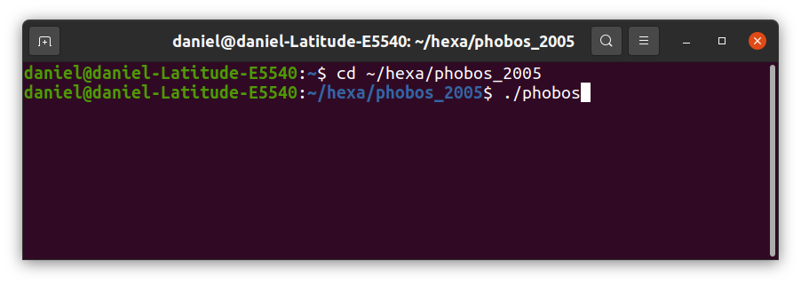Figure 6: Commands for phobos.
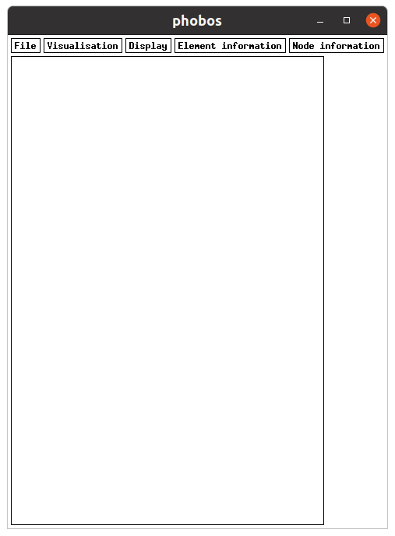Figure 7: Window of phobos.
The main commands are the following:
To load a *.don file, do: File, load_don_file.
To make *.mdg file compatible with the Finite Element Method calculation, do: File, Create_mdg_file and choose a *.don file.
To display the diamond mesh panels, do: Vizualisation, contour_diamond.
To display the cables and bars, do: Vizualisation, contour_cable_bar.
To display the twines in the panels, do: Vizualisation, twines_contour.
If the number of twines is too large and you want to display 1 twine on 10, do: Vizualisation, twines_periods, 10.
To displayed the inner and outer side of the netting, do Vizualisation, orientation_xy.
This last point is in relation with a catch in the netting. The catch creates a pressure on the inner side of the netting. To change the orientation of the netting (inner in place of the outer side), the V coordinates in *.don file are replaced with their opposites (for example replace 10 by -10).
To display the links between components, do: Display, link_number.
To display the type of the nodes, do: Node information, node_type,.

- The second way:
In a terminal run the commands :
cd ~/hexa/phobos_2005
./phobos ~/hexa/data_2001/readme/1pelagic_trawl/s1
This command creates directly the s1.mdg file from s1.don file, without using the graphical tool.

Unix_2004 ./4ch19
The equilibrium could be calculated when *.don file and *.mdg file exist. For calculating the equilibrium of s1, use the commands:
cd ~/hexa/unix_2004
./4ch19 ~/hexa/data_2001/readme/1pelagic_trawl/s1
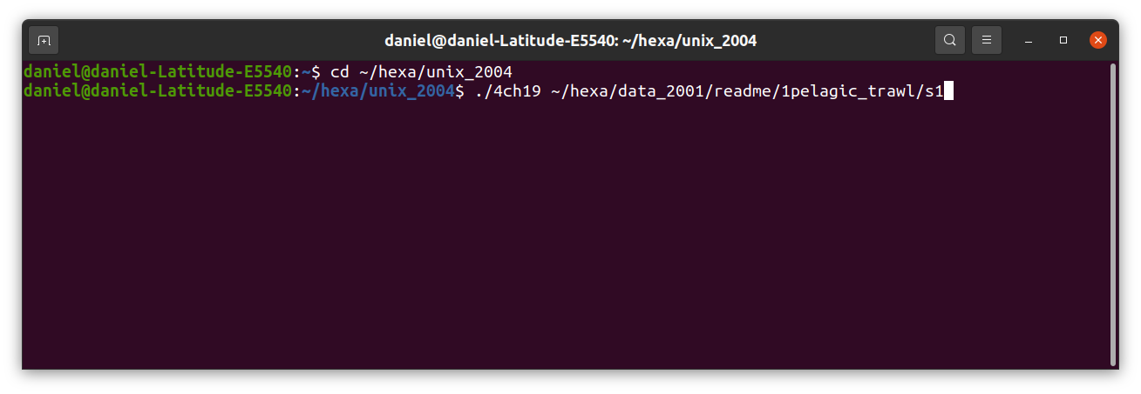Figure 8: Commands for calculating the equilibrium of s1, when s1.don and s1.mdg exist.
The result is displayed on the Figure 9 and Figure 10:
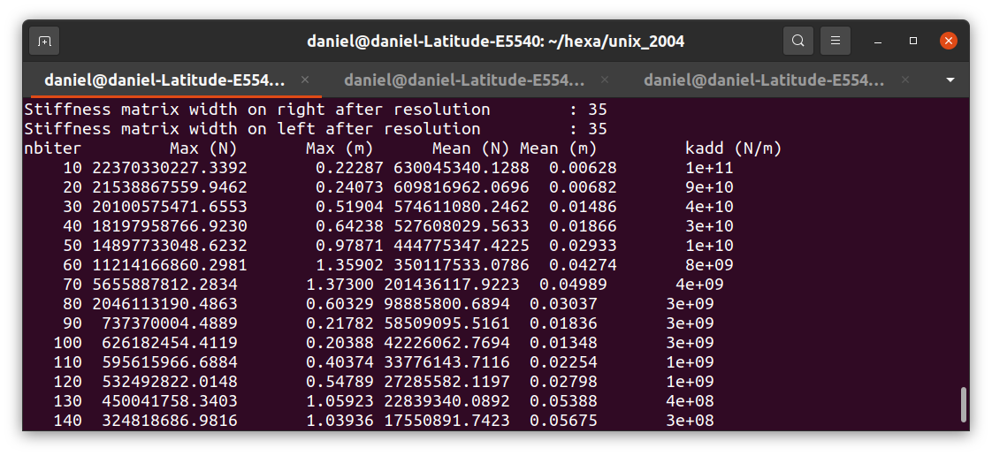Figure 9: Iterations due to the calculation of the equilibrium of s1.
In Figure 9:
- the first column gives the iteration number,
- the second the maximal disequilibrium (N) per coordinate,
- the third the maximal displacement per coordinate (m),
- the fourth the mean disequilibrium (N) per node,
- the sixth the mean displacement (m) per node,
- the seventh the additional stiffness (N).
In the line of s1.don input convergence_parameters 1 10 100000000000 the period of display is 10, as visible on the first column of Figure 9. This line indicates also that the added stiffness is initiated at 100000000000, as visible on the sixth column of Figure 9. This added stiffness varies on Figure 9 due to the line input Auto_convergence of s1.don.
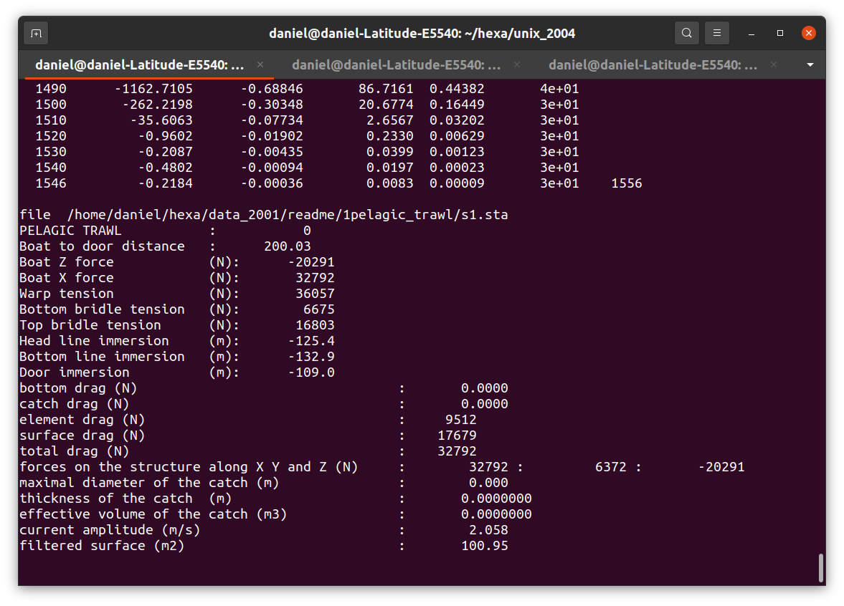Figure 10: End of iterations for the calculation of the equilibrium of s1. In this case, it requires 1546 iterations.
This Figure 10 shows that the equilibrium has been reached in 1546 iterations (This number of iterations in very dependant of the added stiffness of the line input convergence_parameters 1 10 100000000000 of s1.don and of the line input Auto_convergence. The equilibrium is reached when the mean disequilibrium (fourth column) is less than 0.1N (the convergence threshold defined in the *.don file). The result is stored in the *.sta file.

Batz
To display the result use the commands:
cd ~/hexa/batz
./batz
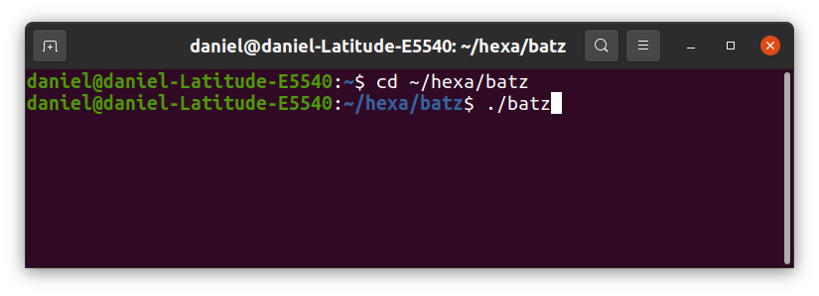Figure 11: Commands for batz. The tool used for displaying the result of calculation when *.don file, *.mdg file and *.sta file exist.
In the Figure 12 the structure is displayed. To display the structure, do:
a) File, load_final_file, that loads the equilibrium shape of the structure.
b) Vizualisation, cable/bar_contour, u_twines, v_twines, that displays the cables and the twines of the netting.
c) File, twine_period, 10, that displays only one twine on 10, in case of too many twines.
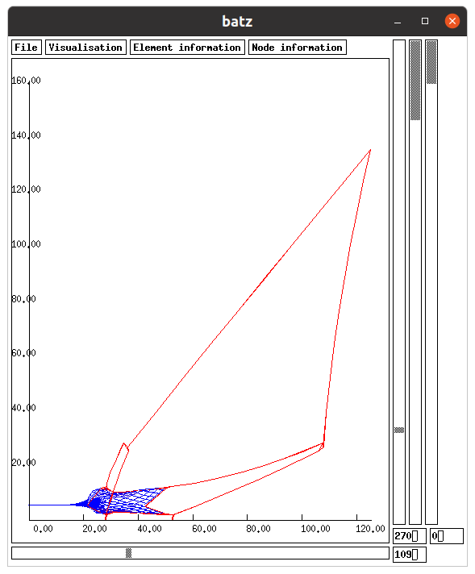Figure 12: The pelagic trawl ~/hexa/data_2001/readme/1pelagic_trawl/s1 displayed with batz.
In Figure 12, the horizontal cursor and the left vertical cursor are for turning the structure.
The second vertical cursor defines a plane in front of which the netting is hidden. This works only when Vizualisation, triangle_contour is selected.
The right vertical cursor is used for displaying dynamic calculation, if any.

Hector
In order to ease the creations of links between components, the following commands (Figure 13) could be used:
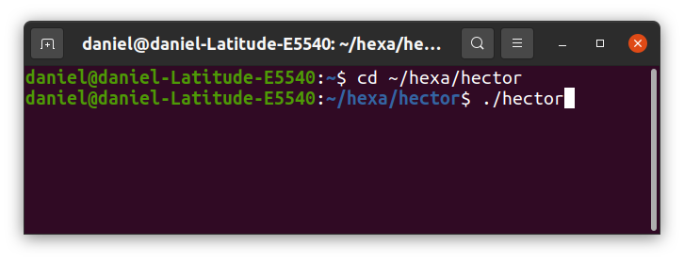Figure 13: Commands to run hector.
With hector do: file, open *.don file, display, links numbering. It leads to the Figure 14 with s1.don. Note that, the number of links has been reduced of one to show how to create new links.
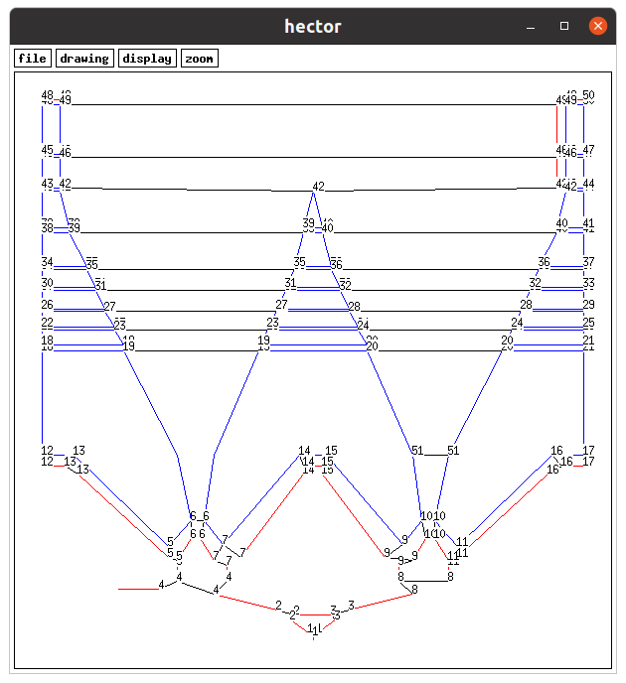Figure 14: ~/hexa/data_2001/readme/1pelagic_trawl/s1.don with hector. The links number are displayed. The link in the ellipse has been cancelled in order to show how to add a link with hector.
To add a link, do: drawing, create link, click close to one node to link, click close to another node to link, drawing, close link. The result is shown on the Figure 15. It is possible to links more than 2 nodes together.
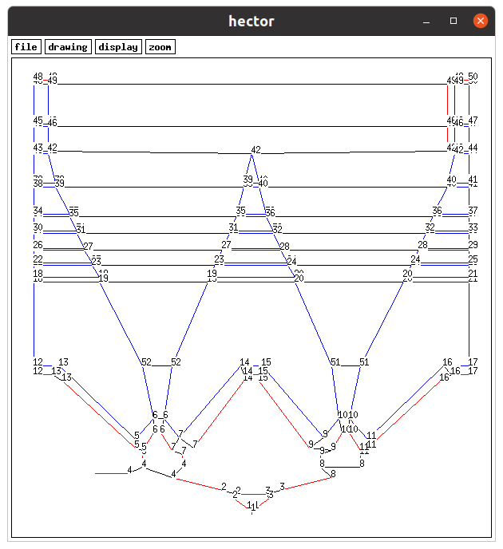Figure 15: The link 52 has been created. View of hector using ~/hexa/data_2001/readme/1pelagic_trawl/s1.
Once the links have been created, do: file, create .don file, okay, file, quit. Open the text file ~/hexa/hector/new_file.don. It defines 52 links:

links number: 52
nb_pt :3 el: 3 nd: 1 el: 2 nd: 1 el: 1 nd: 2
nb_pt :3 el: 6 nd: 1 el: 4 nd: 2 el: 3 nd: 2
.
.
.
nb_pt :2 pa: 1 nd: 3 pa: 2 nd: 6
nb_pt :2 pa: 3 nd: 6 pa: 1 nd: 6

Copy all this text and replace the links definition in s1.don to take into account these 52 links.
If a zoom is required, do: zoom, click on a point, keep the click on, drag the mouse to another point, release the mouse button. To see the whole image, do: zoom, click on and release the mouse button on the same point.

Automatic creation of links
An another way to create links between points, is to place points in *.don file which have to be linked at the same position (X, Y and Z m). If they are at a distance (m) below a certain value, the points are automatically linked. To do that use at the end of the *.don file:
input link 0.01
In the previous line, all the points closer than 0.01m are automatically linked.
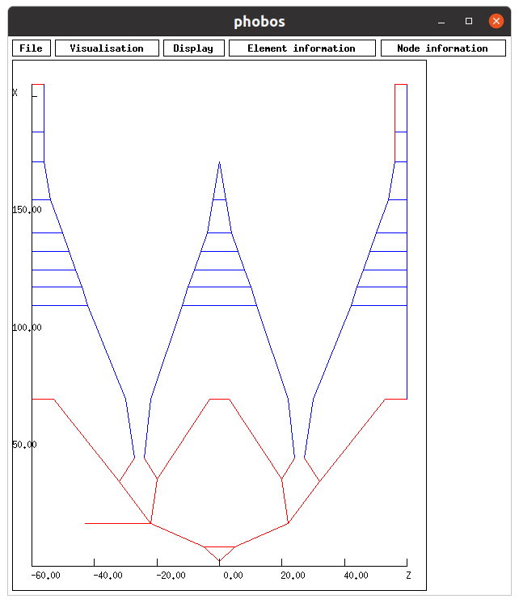Figure 16: This design (~/hexa/data_2001/readme/1pelagic_trawl/u1.don) is identical to the one of figure 1. Here part of the links are automatically carried out using input link 0.01 at the end of u1.don.
To add the remaining links, hector could be used:
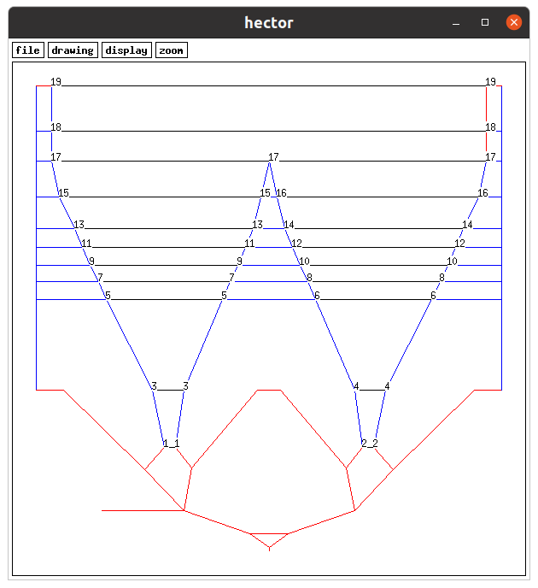Figure 17: The remaining links could be created with hector. Only 19 links are required in place of the 52 links when the automatic creation of links is not used (Figure 15).View of hector using ~/hexa/data_2001/readme/1pelagic_trawl/u1.

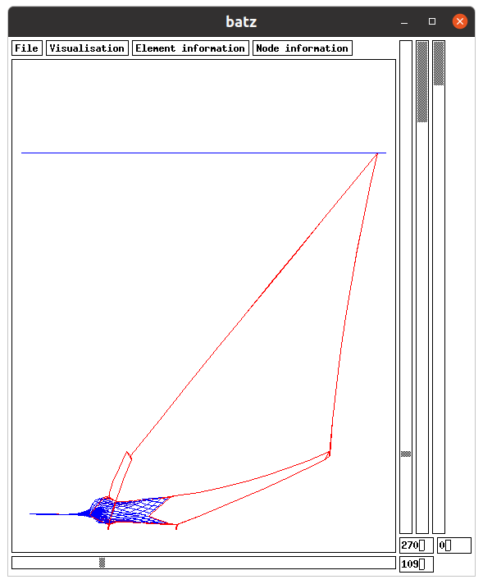Figure 18: Shape of the pelagic trawl ~/hexa/data_2001/readme/1pelagic_trawl/u1. It is very similar to s1 trawl (Figure 12).

Refining the calculation
In order to refine the calculation of the equilibrium of the structure:
- Copy s1.don in s2.don,
- Replace in s2.don Meshing step (m): 27.000000 by Meshing step (m): 9.000000.
That leads to reduce the distance between numeric nodes created on netting panels. The user could also increase the number of bar per cable (see in *.don file Bars number: 9 for example, not done here).
It is worth to approximate the equilibrium of s2 using the equilibrium of s1. To do this, do:
cd ~/hexa/phobos_2005
./phobos ~/hexa/data_2001/readme/1pelagic_trawl/s2 ~/hexa/data_2001/readme/1pelagic_trawl/s1
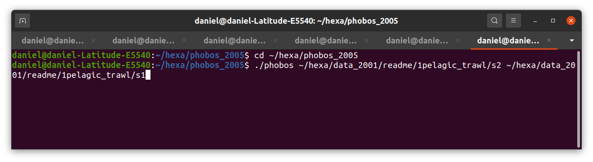Figure 19: Phobos commands to generate s2.mdg and s2.sta from s2.don and s1.sta.
This command creates the file s2.mdg but also s2.sta which is an approximation of the equilibrium of the structure by using the equilibrium recorded in s1.sta. This approximation of s2.sta is done in order to accelerate the calculation of the equilibrium of s2.
cd ~/hexa/unix_2004
./4ch19 ~/hexa/data_2001/readme/1pelagic_trawl/s2
This command calculates the shape of the refined structure, and records the result is s2.sta.
The structure can be again refined. For that, the file s3.don is a copy of s2.don except that the meshing step of panels is reduced to 3m. Once s3.don is created. The command to create the s3.mdg and s3.sta is the following:
cd ~/hexa/phobos_2005
./phobos ~/hexa/data_2001/readme/1pelagic_trawl/s3 ~/hexa/data_2001/readme/1pelagic_trawl/s2

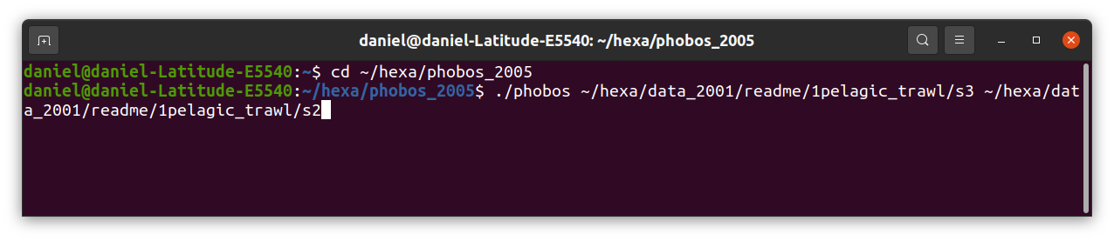Figure 20: Phobos commands to generate s3.mdg and s3.sta from s2.don and s2.sta.
To calculate the equilibrium of the refined structure and record the shape in s3.sta do:
cd ~/hexa/unix_2004
./4ch19 ~/hexa/data_2001/readme/1pelagic_trawl/s3

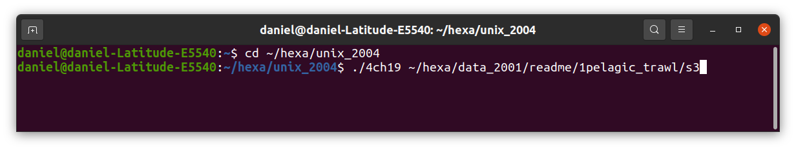Figure 21: Commands for calculating the equilibrium of s3.
This command gives:
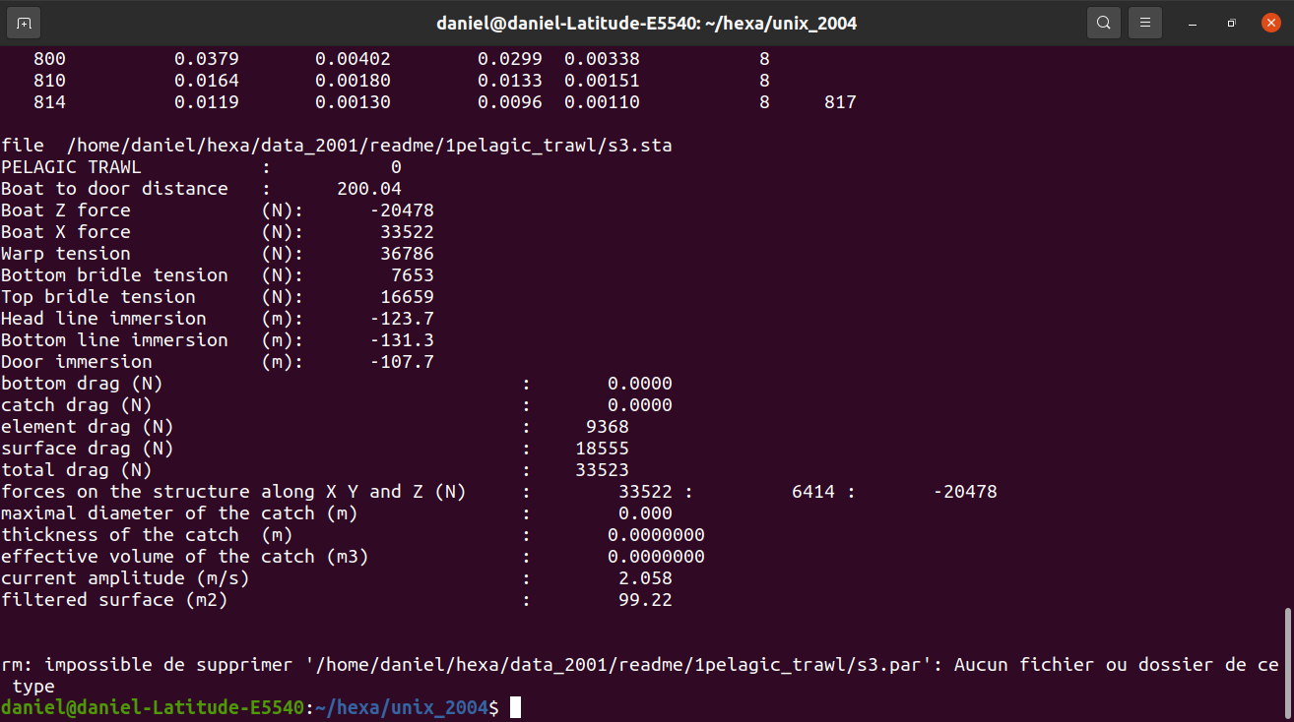Figure 22: End of iterations for the calculation of the equilibrium of s3. It requires 814 iterations. The figures are very comparable to those of s1 (Figure 10).
That means that the calculation is done in 814 iterations.
The result can be displayed with batz:
cd ~/hexa/batz
./batz
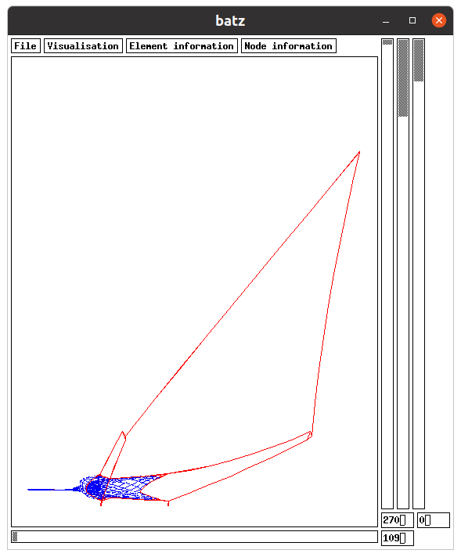Figure 23: The pelagic trawl ~/hexa/data_2001/readme/1pelagic_trawl/s3 displayed with batz. This figure is very similar to Figure 12 (s1).

Symmetry
A structure and its environment could be symmetric. In the following figure, the structure presents a vertical plane of symmetry.
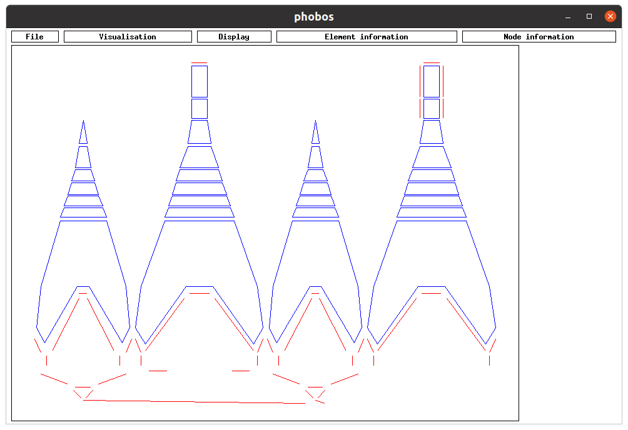Figure 24: Design of the pelagic trawl ~/hexa/data_2001/readme/1pelagic_trawl/t1. It is the same as s1 (figure 1) except that here the symmetry plane is not used: the whole trawl is designed.
If there is a symmetry plane only half structure could be designed, as s1.
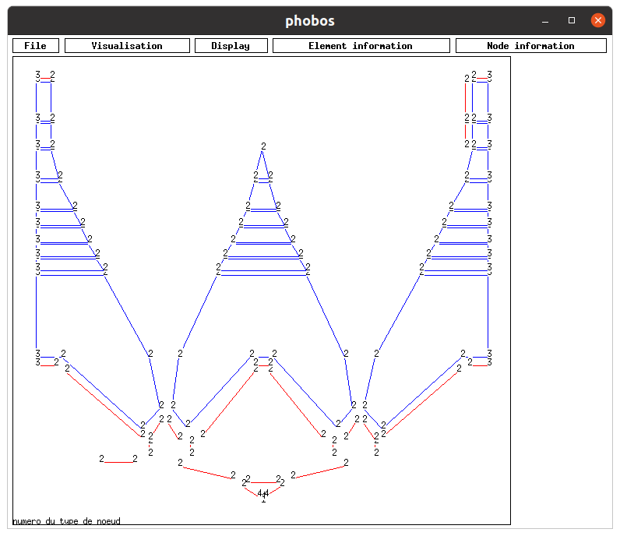Figure 25: Design of ~/hexa/data_2001/readme/1pelagic_trawl/s1 with one symmetry plane. The nodes type are displayed. The nodes on the symmetry plane have a type 3.
To introduce a symmetry plane the nodes on the symmetry plane must have a type which define the symmetry, for example in s1.don the node type 3 has the following characteristics:

No du type : 3
Mass X,Y,Z (kg): 0.000000 0.000000 0.000000
Added mass X,Y,Z (kg): 0.000000 0.000000 0.000000
Length X,Y,Z (m): 0.000000 0.000000 0.000000
Drag coefficient X,Y,Z: 1.200000 1.200000 1.200000
External forces X,Y,Z (N): 0.000000 0.000000 0.000000
Displacement X,Y,Z: 0 0 0
Limits X,Y,Z (m): 0.000000 0.000000 0.000000
Limits sens X,Y,Z: 0 0 0
Symmetry X,Y,Z: 0 1 0

It can be seen (last line) that there is a symmetry normal to axe Y, and the nodes with type 3, as visible on Figure 25, are on this symmetry plane.
The calculation of equilibrium of t1 (design on Figure 24 without using symmecty) is done with the following commands:
cd ~/hexa/phobos_2005
./phobos ~/hexa/data_2001/readme/1pelagic_trawl/t1
This first part for calculated t1.mdg compatible with the calculation of equilibrium.
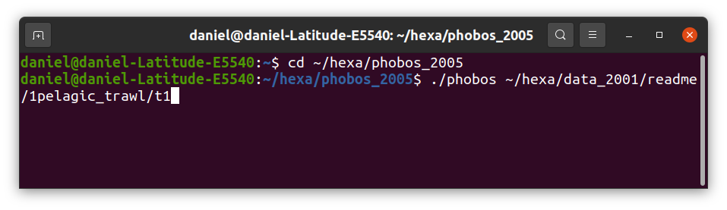Figure 26: Calculation of t1.mdg with phobos.
cd ~/hexa/unix_2004
./4ch19 ~/hexa/data_2001/readme/1pelagic_trawl/t1
This second part for the calculation of the equilibrium of t1.
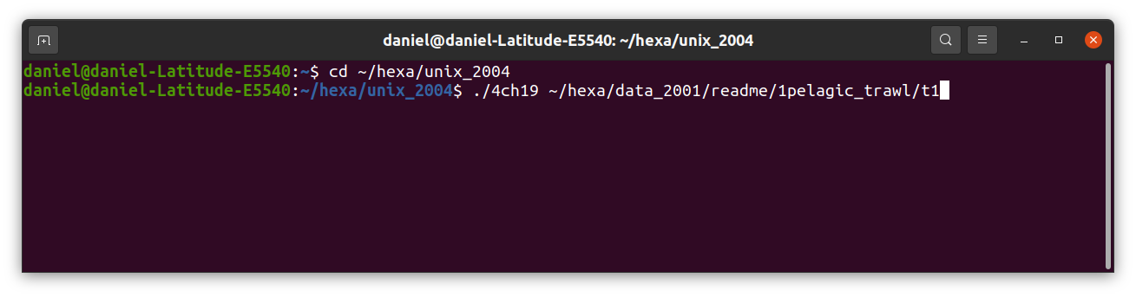Figure 27: Calculation of the equilibrium of t1.
The result is partly shown on Figure 28. It can be compared to those displayed on Figure 10 and Figure 22. Due to the symmetry, some figures are around the double on Figure 28 of those of Figure 10 and Figure 22 (boat Z force, Boat X force, bottom drag, catch drag, element drag, surface drag, total drag, forces on the structure, filtered surface).

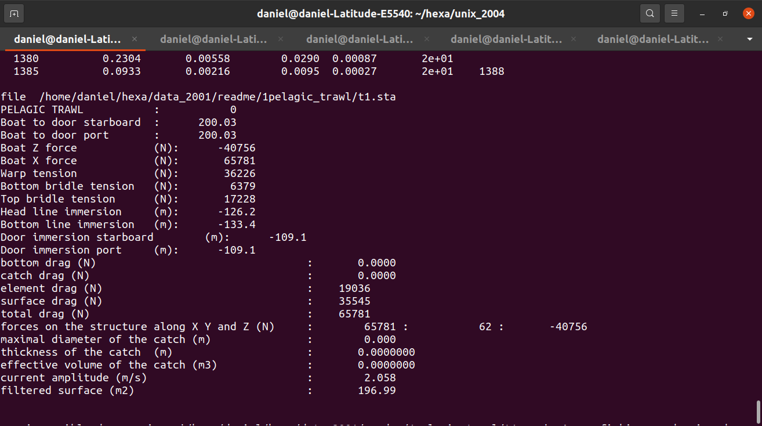Figure 28: The calculation is carried out in 1385 iterations. The figures are comparable to those of s1 (Figure 10 and Figure 22).
The shape of the trawl is displayed on Figure 29.
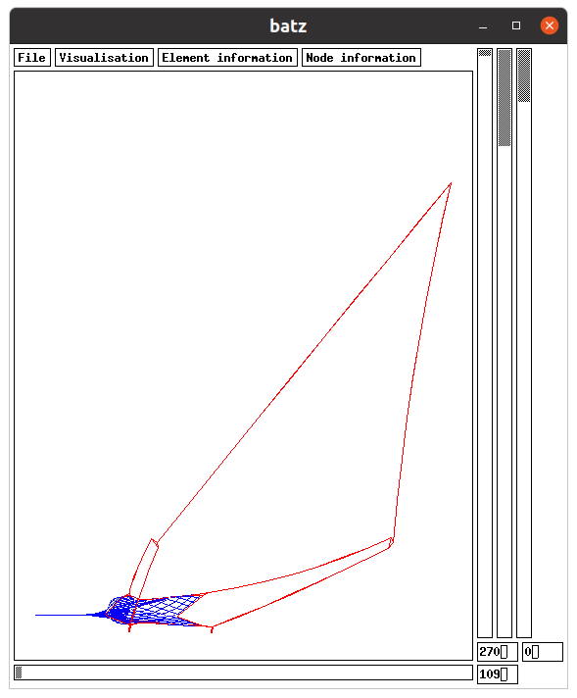Figure 29: Shape of ~/hexa/data_2001/readme/1pelagic_trawl/t1. The design of this trawl don’t use the symmetry plane as s1 (Figure 12).

Bottom trawl
A structure which has a contact with the sea bottom has to be defined using specific types of nodes. For example a node which could be in contact with a bottom sea at -56 has a type such as the following (defined in *.don file):
No du type : 2
Mass X,Y,Z (kg): 0.000000 0.000000 0.000000
Added mass X,Y,Z (kg): 0.000000 0.000000 0.000000
Length X,Y,Z (m): 0.000000 0.000000 0.000000
Drag coefficient X,Y,Z: 1.200000 1.200000 1.200000
External forces X,Y,Z (N): 0.000000 0.000000 0.000000
Displacement X,Y,Z: 0 0 0
Limits X,Y,Z (m): 0.000000 0.000000 -56.000000
The z limit is -56m
Limits sense X,Y,Z: 0 0 1
The z limit is a minimum (it is a floor not a ceiling)
Symmetry X,Y,Z: 0 0 0
.
.
.
BOTTOM SEA ENVIRONMENT
Wearing coefficient on the bottom: 1.000000
Stiffness of the insertion in the sea bottom (N/m): 5000000.000000

In this type of node, it can be seen that the limit along z axis is -56m and that the sense is positive (1). That means that if the node is above -56m there is no contact with the sea bottom and if the node is below -56m the node is in contact with the sea bottom.
If a node is below the sea bottom, there is a a reaction of the bottom due to the elasticity of the bottom, as previously defined in *.don file (Stiffness of the insertion in the sea bottom (N/m): 5000000.000000). In case of wearing, there is consequently a friction force due to the wearing coefficient on the bottom, as previously defined in *.don file (Wearing coefficient on the bottom: 1.000000).
Such bottom trawl could be seen on Figure 30 .
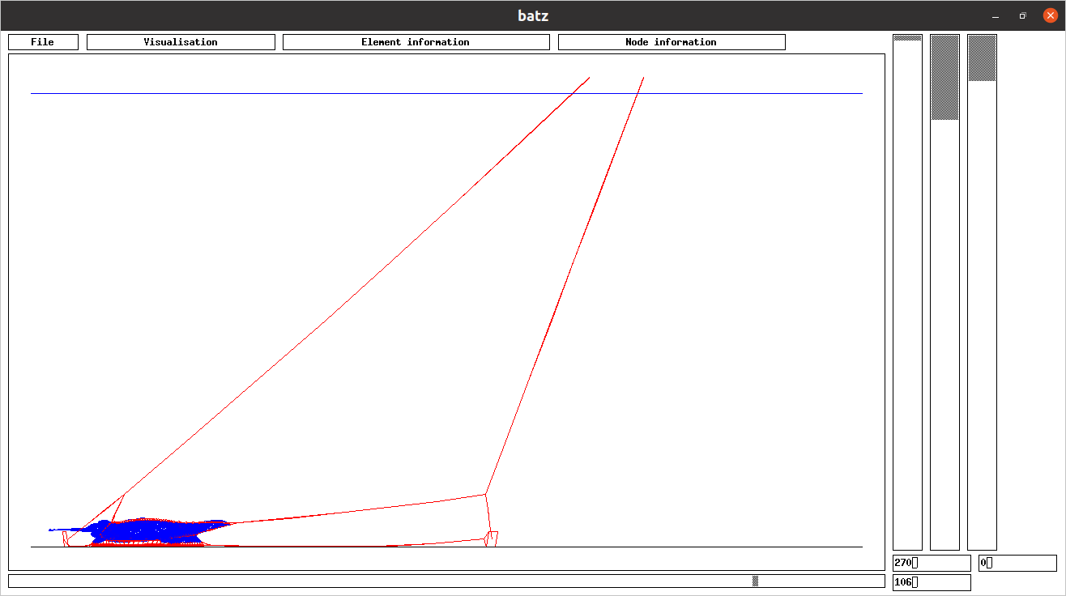Figure 30: Bottom trawl ~/hexa/data_2001/readme/3bottom_trawl/b3.
The design of this bottom trawl could be seen on Figure 31 .
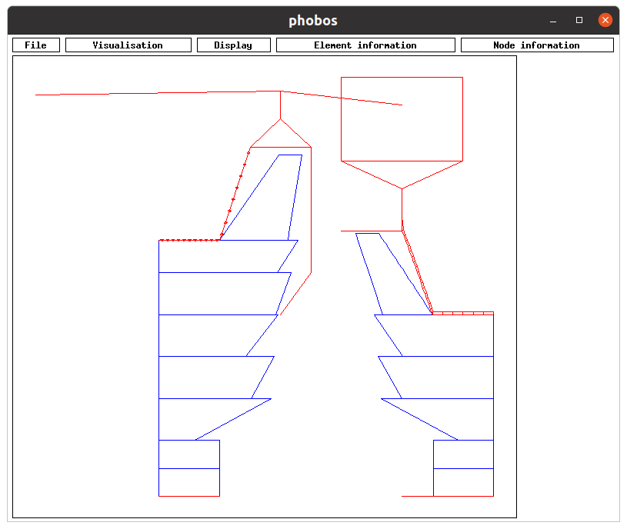Figure 31: Design of the bottom trawl b3.
To reach this result, a first trawl defined in b1.don with a Meshing step (m): 3.000000 per panel is used, followed by b2.don with a Meshing step (m): 1.000000 per panel, and finally b3.don with a Meshing step (m): 0.500000 per panel.
The following commands are used to reach this result:
cd ~/hexa/phobos_2005
./phobos ~/hexa/data_2001/readme/3bottom_trawl/b1
cd ~/hexa/unix_2004
./4ch19 ~/hexa/data_2001/readme/3bottom_trawl/b1

cd ~/hexa/phobos_2005
./phobos ~/hexa/data_2001/readme/3bottom_trawl/b2 ~/hexa/data_2001/readme/3bottom_trawl/b1
cd ~/hexa/unix_2004
./4ch19 ~/hexa/data_2001/readme/3bottom_trawl/b2

cd ~/hexa/phobos_2005
./phobos ~/hexa/data_2001/readme/3bottom_trawl/b3 ~/hexa/data_2001/readme/3bottom_trawl/b2
cd ~/hexa/unix_2004
./4ch19 ~/hexa/data_2001/readme/3bottom_trawl/b3

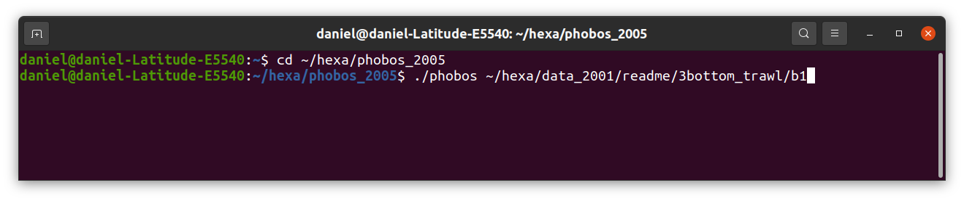Figure 32: Command to create b1.mdg from b1.don.
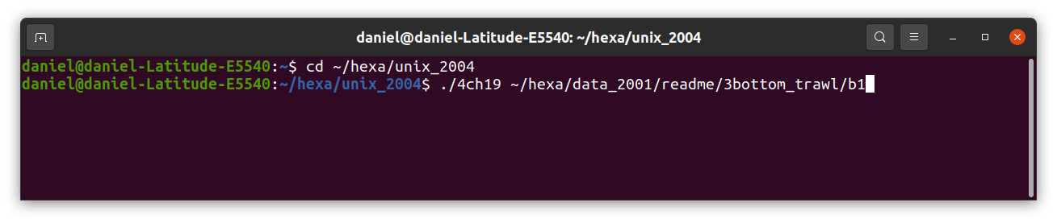Figure 33: Command to calculate the equilibrium of b1, and consequently create b1.sta.

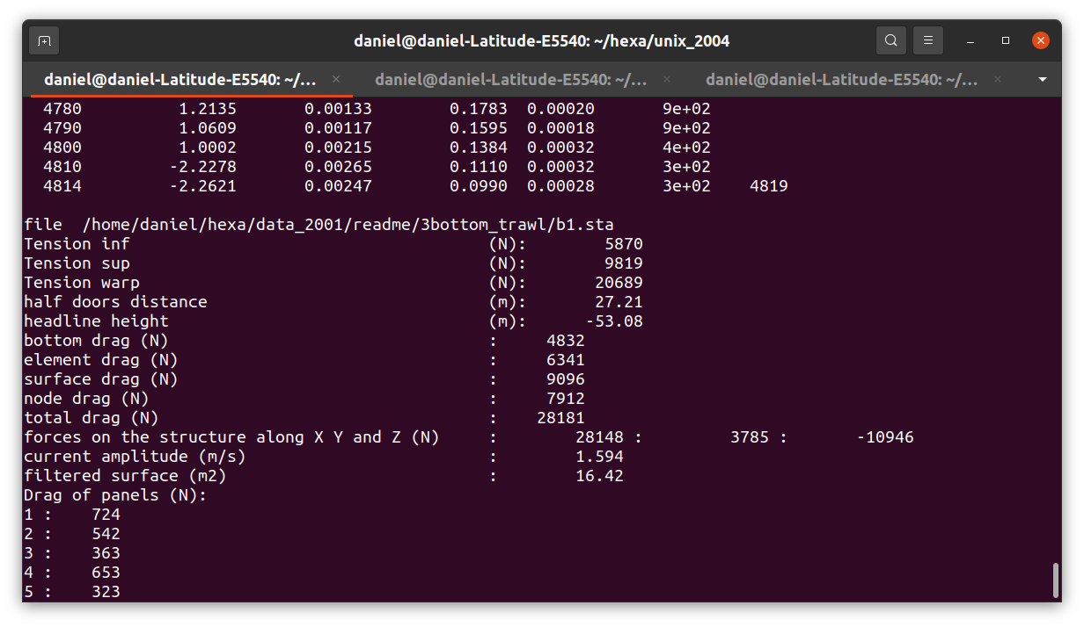Figure 34. The calculation of equilibrium of bottom trawl b1, converges in 4814 iterations.

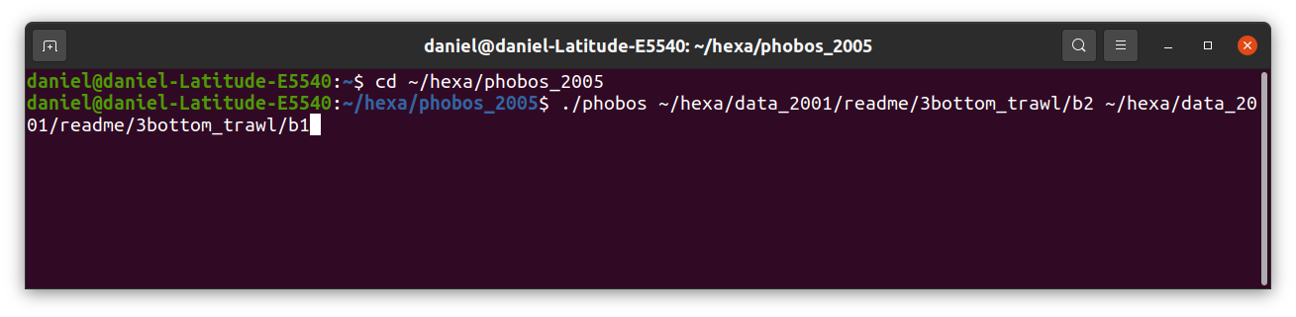Figure 35: Command to create b2.mdg and calculate an approximation of equilibrium of b2 (recorded in b2.sta) by using b1.sta.

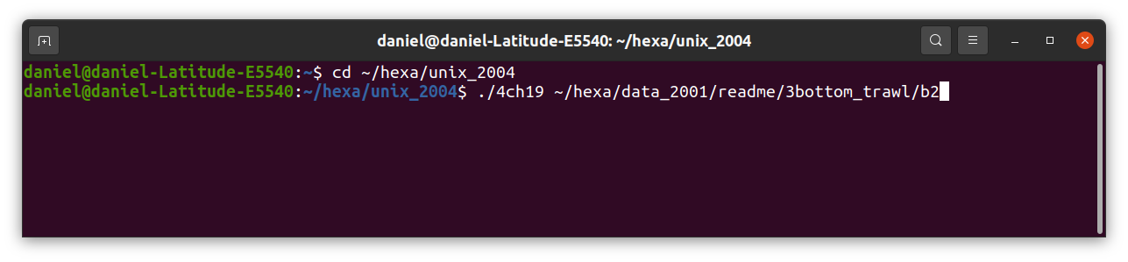Figure 36: Command to calculate the equilibrium of b2, and consequently create b2.sta.

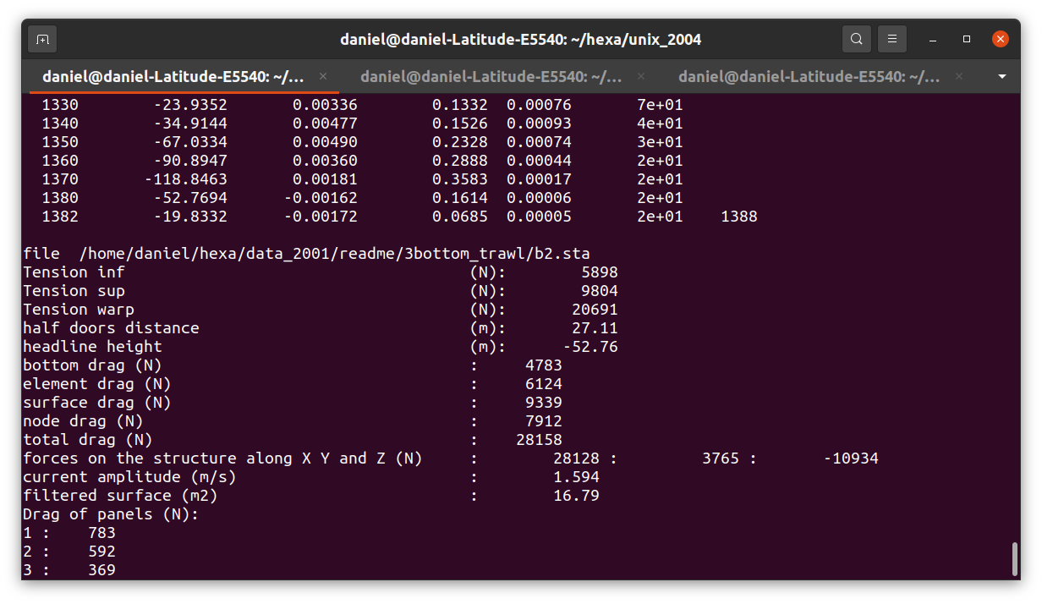Figure 37: The calculation of equilibrium of bottom trawl b2, converges in 1382 iterations.

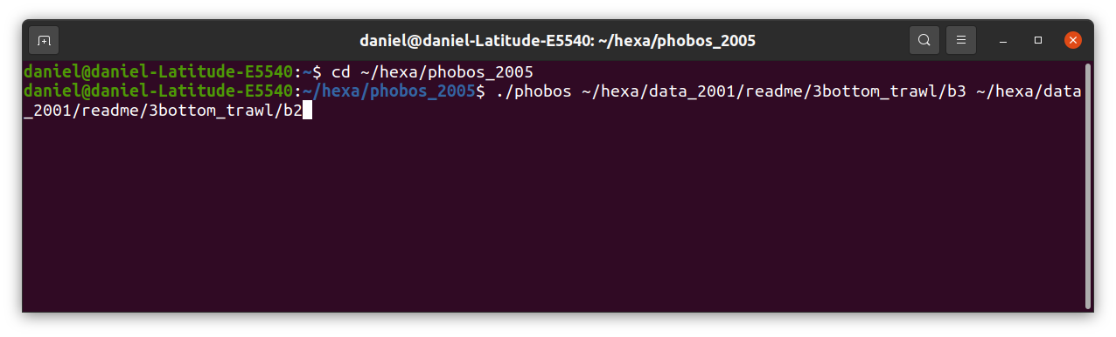Figure 38: Command to create b3.mdg and calculate a approximation of equilibrium of b3 (recorded in b3.sta) by using b2.sta.

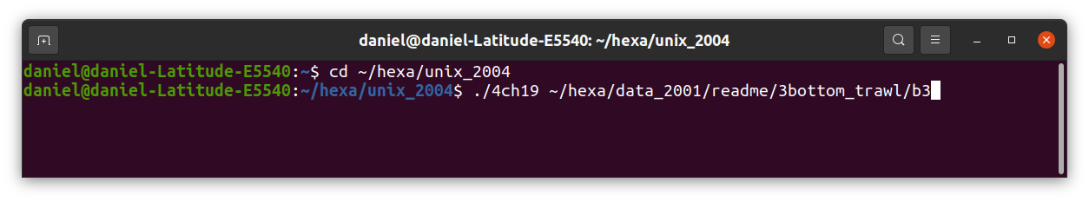Figure 39: Command to calculate the equilibrium of b3, and consequently create b3.sta.

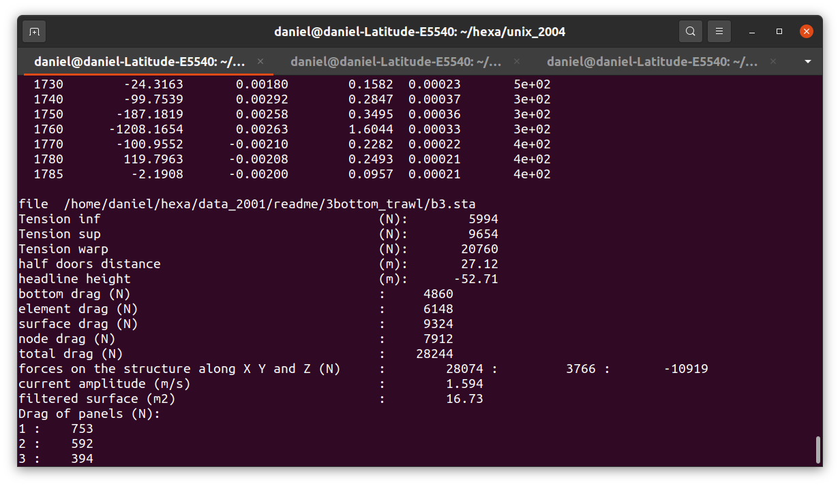Figure 40: The calculation of equilibrium of bottom trawl b3, converges in 1785 iterations.
Several scientific papers used this possibility of FEMNET: [7], [8], [9], [10].

Catch
A catch in a netting, such as an amount of fish in a trawl cod-end, creates a pressure on the netting.
The catch is limited by a a surface normal to the current (the front). All the catch is after this front. The volume behind this front is the fish catch but also water. This volume is used in *.don file. The volume is between the front and the netting.
In the following example (c2.don) the cod-end is made of 4 panels of netting which are closed by 4 ropes. Due to the symmetry only one panel and one rope are discretized (Figure 42). In order to see in ./batz only the discretized components add output no_visible_symmetry at the end of the *.don file (Figure 42).
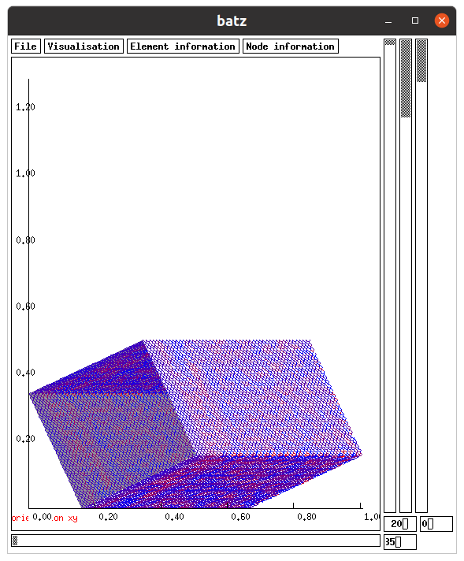Figure 41: Initial position of the cod-end. To get this view do in ./batz File, load_initial_file. Here output no_visible_symmetry is not used in ~/hexa/data_2001/readme/5catch/c2.don.
The nodes at the entry are fixed along X axis, the nodes on the symmetry panels have to be declared as symmetric, as shown on Figure 42.
The pressure of the catch occurs on one side of the netting, the inner one. To verify that the inner and outer sides are well defined, it can be shown in ./batz using vizualisation, orientation_xy. The grey surface is the inner side of the netting. If the orientation of a panel is not appropriated, replace V coordinates (V1, V2 …) of the panel by the opposite (-V1, -V2 …). It could be done also by replacing U coordinates par their opposite.
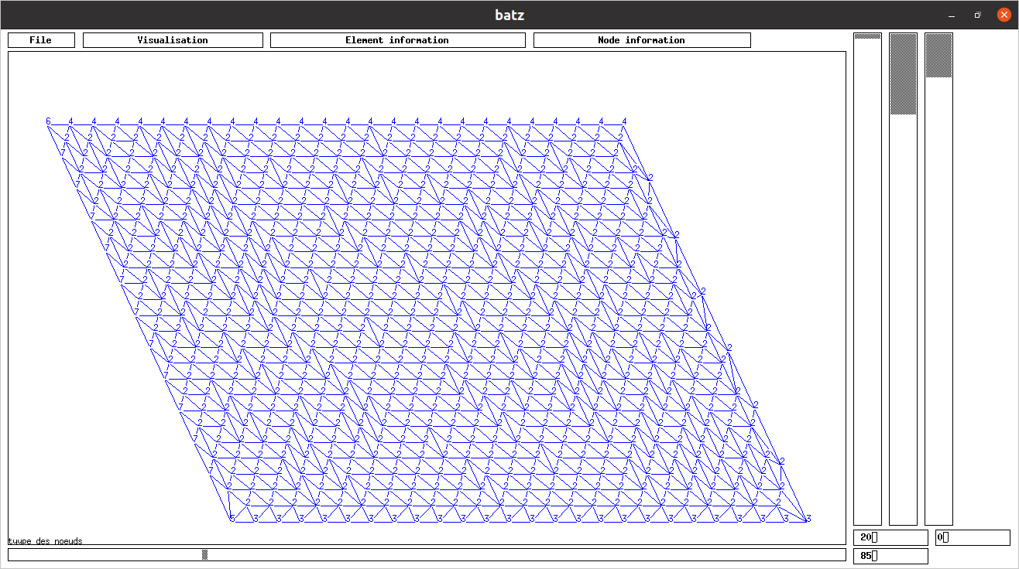Figure 42: The discretized panel in triangular elements. The node types are displayed. The type 1 is not used. The type 2 refers to no constraint on node displacement. The type 3: symmetry along axe Y. The type 4: symmetry along axe Z. Type 5: constraint along axe X and symmetry along axe Y. Type 6: constraint along axe X and symmetry along axe Z. Type 7: constraint along axe X. Here output no_visible_symmetry is used in ~/hexa/data_2001/readme/5catch/c2.don.
The commands to create the c2.mdg file are (Figure 43) :
cd ~/hexa/phobos_2005
./phobos ~/hexa/data_2001/readme/5catch/c2
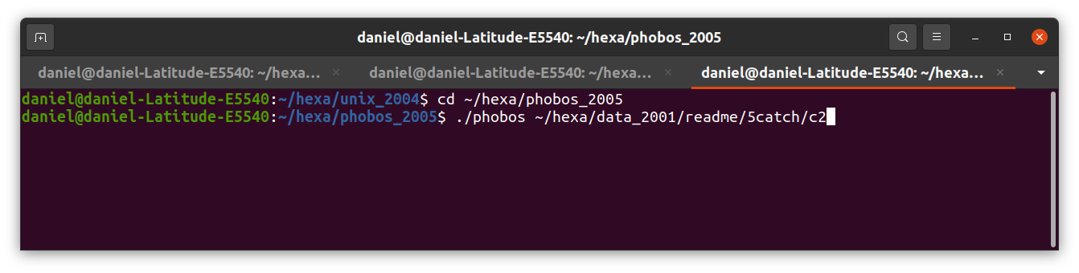Figure 43: Commands to create the file c2.mdg.
The commands to calculate the equilibrium of c2 and record the result in c2.sta are:
cd ~/hexa/unix_2004
./4ch19 ~/hexa/data_2001/readme/5catch/c2
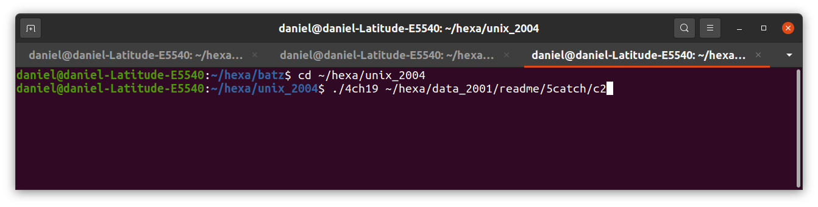Figure 44: Commands for the equilibrium calculation of c2.

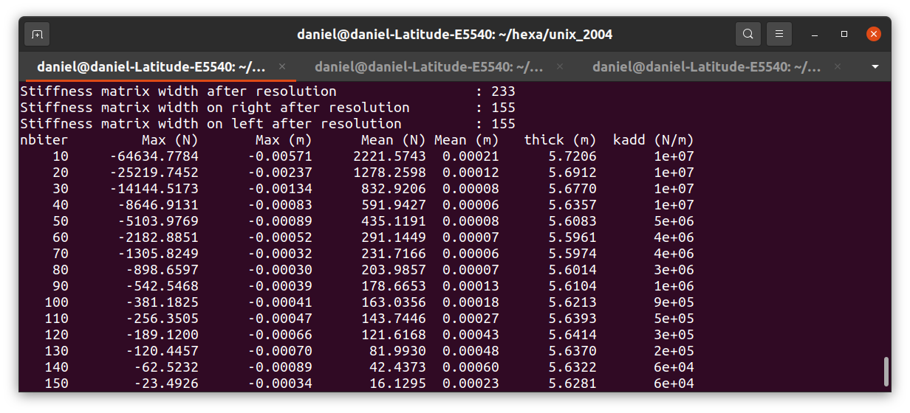Figure 45: Beginning of the iterations of the calculation of the equilibrium of c2. The first column is the iteration, the second is the maximal disequilibrium (N) per coordinate, the third the maximal displacement (m) per coordinate, the fourth the mean disequilibrium (N) per node, the fifth the mean displacement (m) per node, the sixth the thickness of the catch (m, distance between the front of the catch and the rearrest part of the structure), the seventh the added stiffness (N/m) to the stiffness matrix in order to avoid singular stiffness matrix.
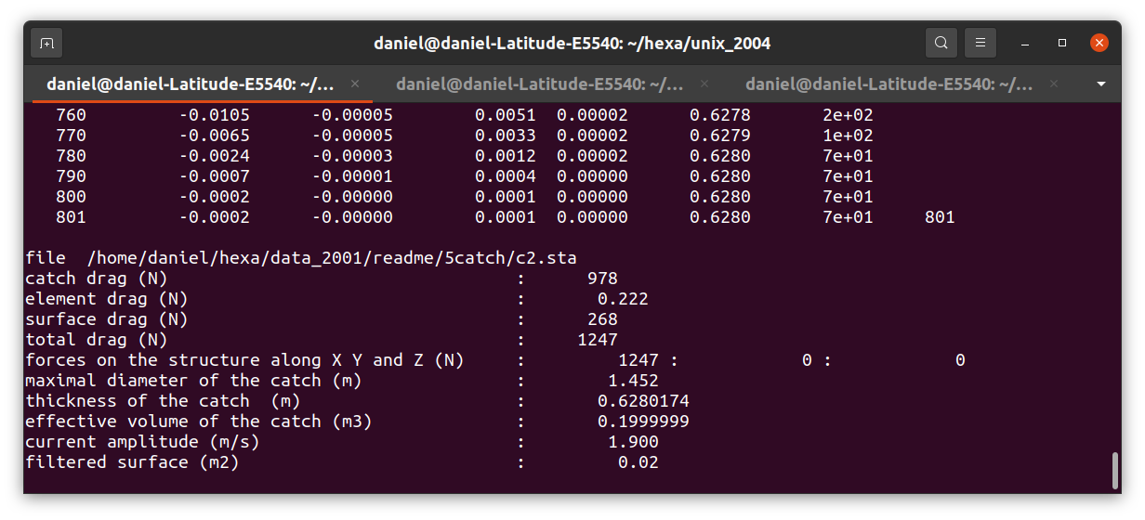Figure 46: End of iteration. The calculation converges in 801 iteration, when the fourth column is less the convergence threshold (N). The thickness of the catch is 0.628m (sixth column).
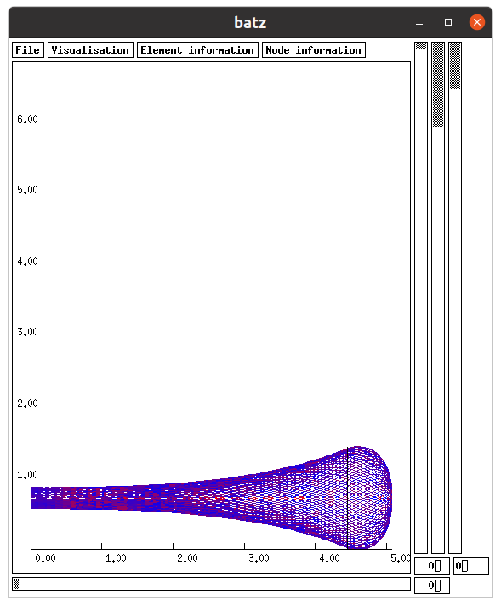Figure 47: Equilibrium of the cod-end. The limit of the catch is visible (vertical black line): the catch is on the right of this limit. View of batz using ~/hexa/data_2001/readme/5catch/c2.
If the catch is too small, there is a possibility of contact between knots of the netting in areas the meshes are very closed and if the size of the knots are large enough (Figure 48).
To display the contact do in batz: Element information, twines contact.
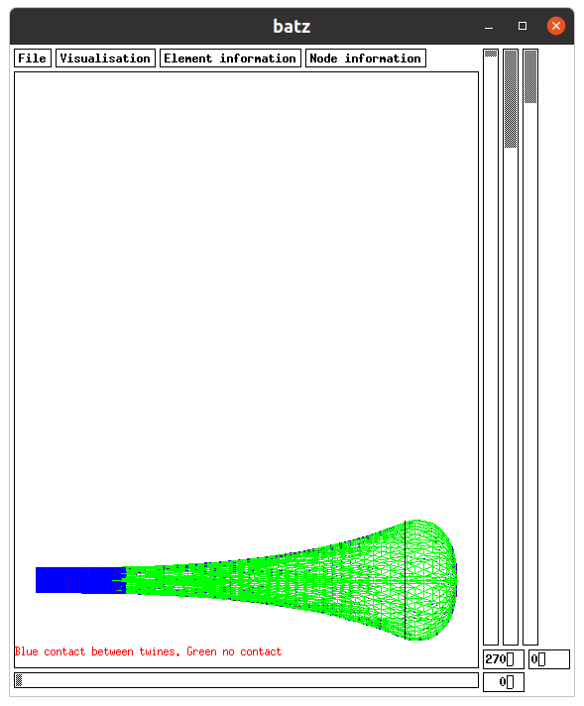Figure 48: There is a contact between knots in the blue zone. This contact is due to the meshes which are closed and to the size of the knots of the netting. View of ~/hexa/data_2001/readme/5catch/c2.
In case of small catch volume, there could be an unrealistic behaviour of the calculated netting. In the following example, the initial shape of the codend (Figure 49) has a width smaller than the previous one (Figure 41).

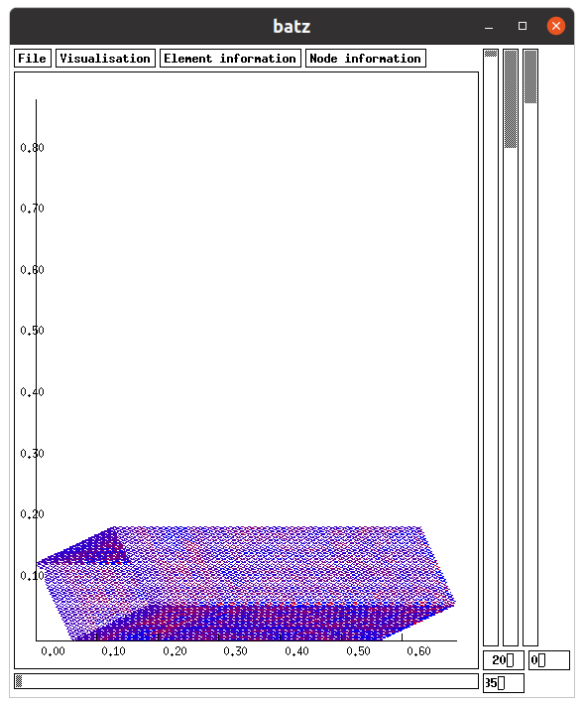Figure 49: This codend (~/hexa/data_2001/readme/5catch/d2) is exactly the same as the previous, except its initial shape has a smaller width (see Figure 41).
The commands to get the equilibrium are:
cd ~/hexa/phobos_2005
./phobos ~/hexa/data_2001/readme/5catch/d2
cd ~/hexa/unix_2004
./4ch19 ~/hexa/data_2001/readme/5catch/d2
The twines of the structure is displayed on Figure 50. It can been seen the result is not as expected: the calculated shape is unrealistic.
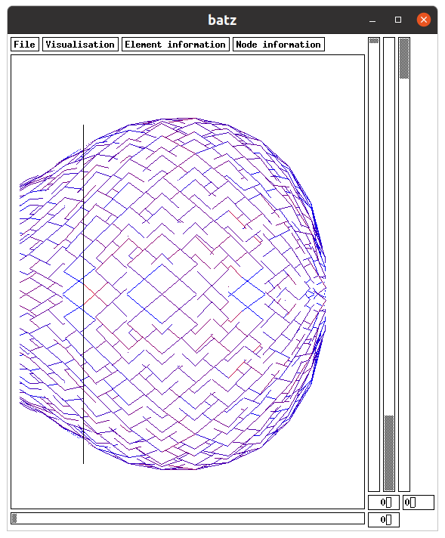Figure 50: The calculated shape is unrealistic: the twines, which are displayed, are not as expected. The catch volume is 0.2m³. This unrealistic calculated shape is got probably because the initial shape of the codend is too far the equilibrium shape. View of ~/hexa/data_2001/readme/5catch/d2.
In such cases, a solution is to momently increase a lot the catch. Generally speaking, larger is the catch volume easier is to reach a realistic calculated shape.
In the following example the volume has been increased from 0.2m² to 1m³ (Figure 50 for d2.don and Figure 51 for d3.don). It can be seen on Figure 51 that a volume of 1m³ gives a realistic calculated shape. The commands for carrying out the equilibrium of d3 are:
cd ~/hexa/phobos_2005
./phobos ~/hexa/data_2001/readme/5catch/d3
cd ~/hexa/unix_2004
./4ch19 ~/hexa/data_2001/readme/5catch/d3
The next steps are to decrease slowly the catch in order to get at each steps realistic calculated shapes. These following steps are here, first a catch volume of 0.4m³. The calculation starts with the shape got with the previous catch volume (1m³). This calculation with 0.4m³ gives a realistic calculated shape (Figure 53). The commands to get the equilibrium at 0.4m³ (d4) are:
cd ~/hexa/phobos_2005
./phobos ~/hexa/data_2001/readme/5catch/d4 ~/hexa/data_2001/readme/5catch/d3
cd ~/hexa/unix_2004
./4ch19 ~/hexa/data_2001/readme/5catch/d4

The following step is to reduce the catch volume to 0.2m³. This calculation starts from the previous shape (Figure 53) and reach a realistic calculated shape (Figure 55) which is similar to the one got an another initial shape (Figure 47). The commands to get the equilibrium at 0.2m³ (d5) are:
cd ~/hexa/phobos_2005
./phobos ~/hexa/data_2001/readme/5catch/d5 ~/hexa/data_2001/readme/5catch/d4
cd ~/hexa/unix_2004
./4ch19 ~/hexa/data_2001/readme/5catch/d5
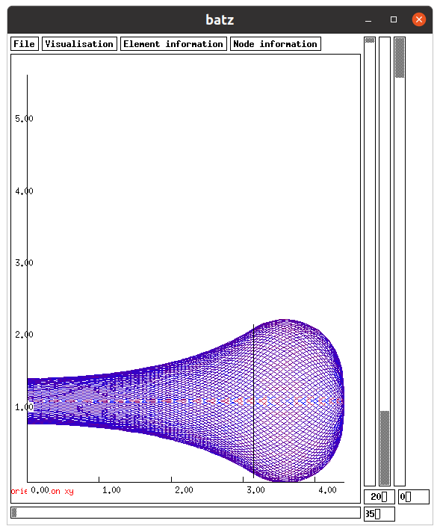Figure 51: The volume of the catch is 1m³ (~/hexa/data_2001/readme/5catch/d3). The calculated shape is realistic.

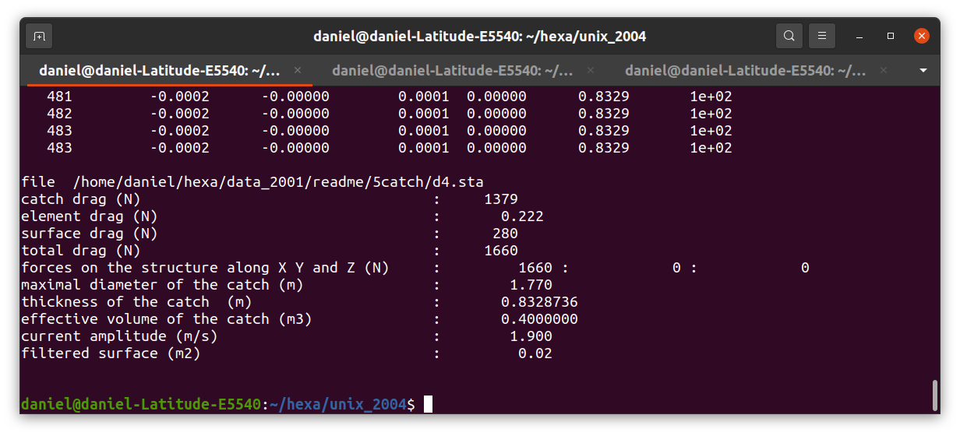Figure 52: The volume of the catch is 0.4m³. The calculation converges in 483 iterations. The thickness of the catch is 0.8329m.

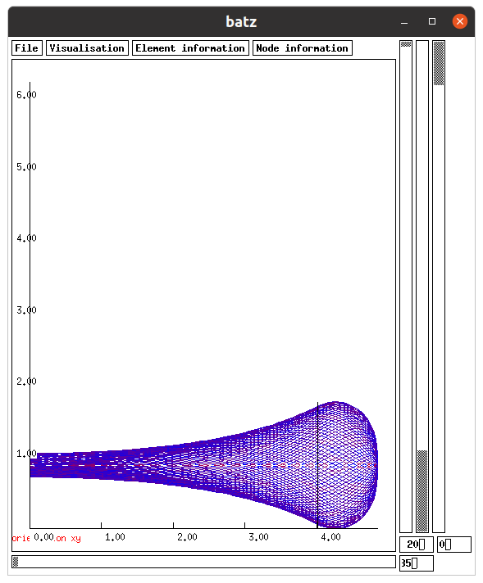Figure 53: The calculated shape of the codend with a volume catch of 0.4m³ is realistic (~/hexa/data_2001/readme/5catch/d4 file).

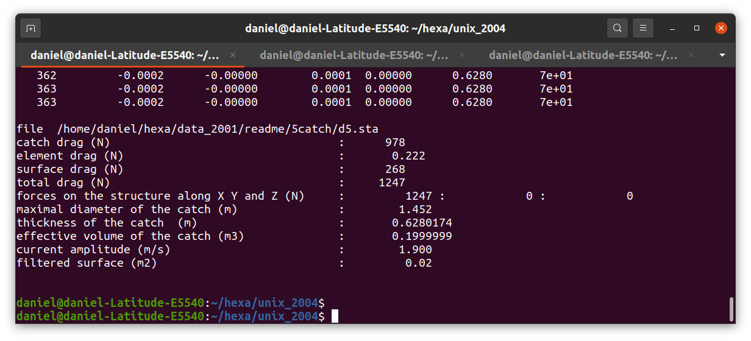Figure 54: The calculation for a catch of 0.2m³ (d5) is done in 363 iterations. The catch thickness is 0.6280m (sixth column) , as it is on Figure 46.

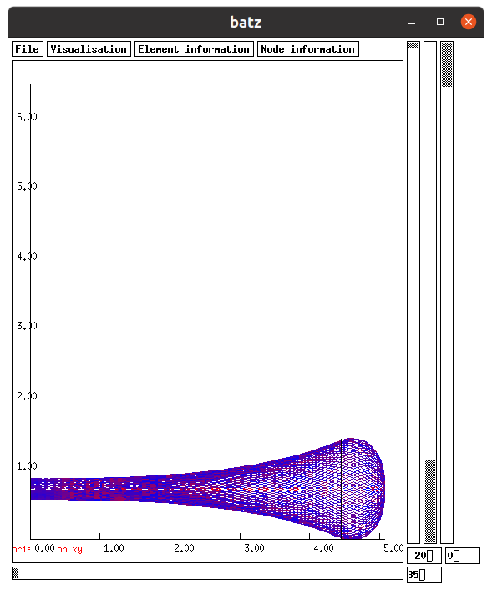Figure 55: The calculation gives a realistic calculated shape (~/hexa/data_2001/readme/5catch/d5) and very similar to the one calculated with an another initial shape (Figure 47).
Several scientific papers used this possibility of FEMNET: [11], [12], [13].

Flexion
In case of flexion resistance in cables (twines, beams), this flexion resistance can be introduced.

Stiff netting example.
In the example of Figure 56, the twines of the netting have been discretized as cable with a flexion resistance. This flexion resistance is the product of Young modulus (E, N/m²) by the moment of inertia of the section (I, m⁴). This ability of FEMNET has been described in [14].
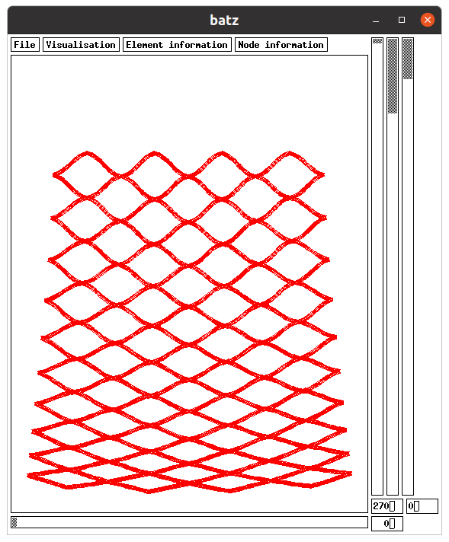Figure 56: Small panel of suspended netting by its top boundary. The twines are modelled as cables with flexion resistance. View of batz using ~/hexa/data_2001/readme/6flexion/f1.
The initial position of this panel of netting is visible in Figure 57. An another parameter has to be introduced, the neutral angle between the twines. This angle corresponds to the angle between twines when there is no couple between twines.
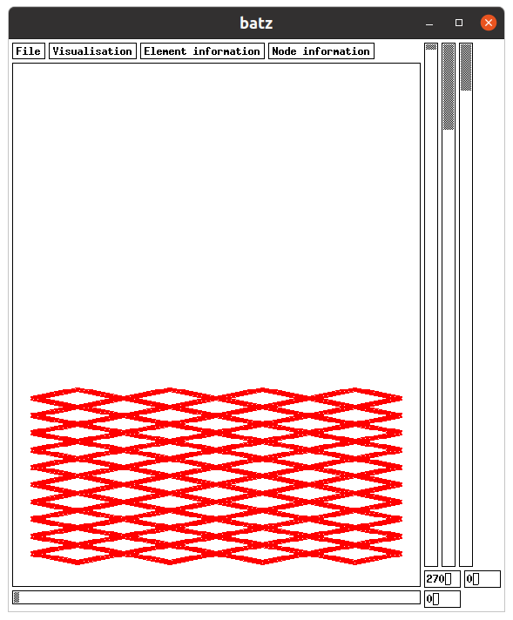
Figure 57: Initial position of the panel of netting. View of batz using ~/hexa/data_2001/readme/6flexion/f1.
The flexion resistance is introduced in *.don file such as following in case of cable 9 (EI = 0.00000269 N.m²):
input EI_flexion_cable 9 0.00000269
The neutral angle between cables 9 and 10 is introduced as following (neutral angle = 21.155158 deg.):
input link_flexion_elem2 9 10 21.155128
The command to get the f1.mdg file is (Figure 58):
cd ~/hexa/phobos_2005
./phobos ~/hexa/data_2001/readme/6flexion/f1
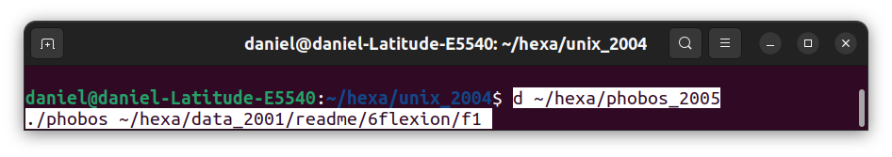Figure 58: Commands to get the f1.mdg.
The commands to reach the equilibrium are (Figure 59):
cd ~/hexa/unix_2004
./4ch19 ~/hexa/data_2001/readme/6flexion/f1
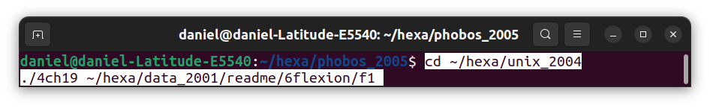Figure 59: Commands to calculate the equilibrium.

Polyamide cylinder example
A second example of flexion resistance is given, it is made of 4 cables (bars) with a flexion resistance (EI = 300000 N.m², equivalent of resistance of cylinder of polyamide of 0.2m in diameter). This resistance is given in *.don file by:
input EI_flexion_cable 1 300000
input EI_flexion_cable 2 300000
input EI_flexion_cable 3 300000
input EI_flexion_cable 4 300000
The cables are aligned. This is given by:
input link_flexion_elem2 1 2 180.0
input link_flexion_elem2 2 3 180.0
input link_flexion_elem2 3 4 180.0
input link_flexion_elem2 4 1 180.0
That means that the cables 1 and 2 have an angle between them (without stress) of 180.0 deg.
The initial position of the 4 cables is given in Figure 60.
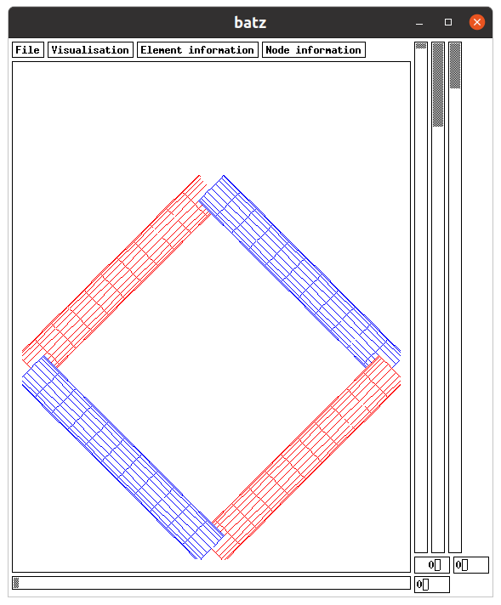Figure 60: Initial position of 4 cables with a flexion resistance. View of batz using ~/hexa/data_2001/readme/6flexion/c1.
The equilibrium if displayed in Figure 61.
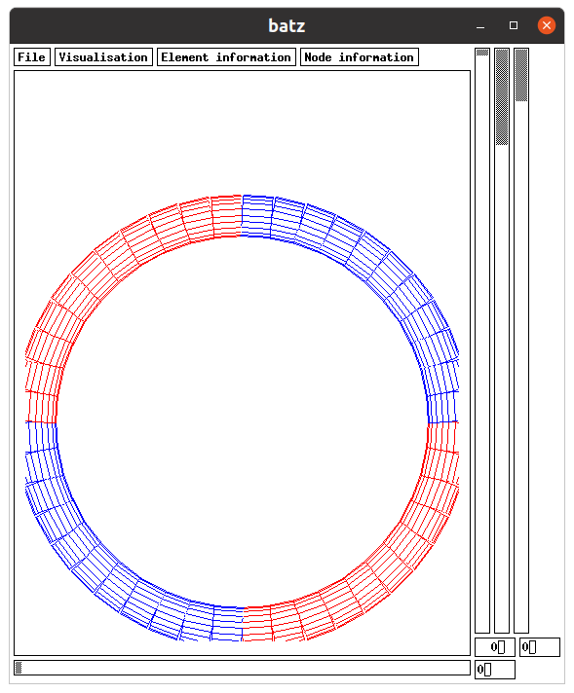Figure 61: Final position (equilibrium) of the 4 cables with a flexion resistance. View of batz using ~/hexa/data_2001/readme/6flexion/c1.
The command to get the c1.mdg file is:
cd ~/hexa/phobos_2005
./phobos ~/hexa/data_2001/readme/6flexion/c1
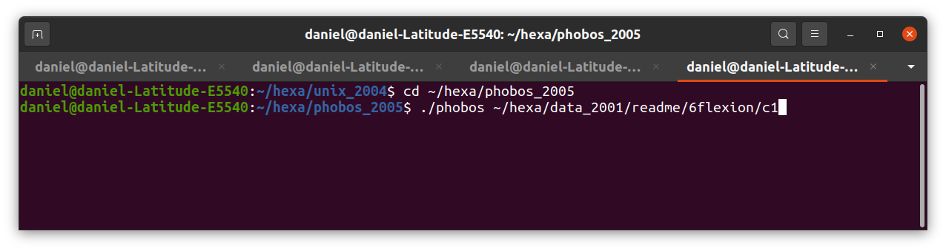Figure 62: Commands to get c1.mdg.
The commands to reach the equilibrium are:
cd ~/hexa/unix_2004
./4ch19 ~/hexa/data_2001/readme/6flexion/c1
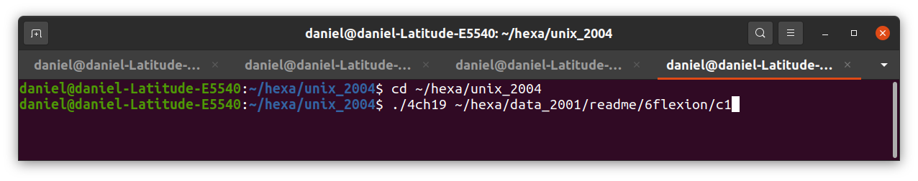Figure 63: Commands to reach the equilibrium (c1.sta).
The result of these commands is shown in Figure 64. That shows that the equilibrium is reached in 1396 iterations.

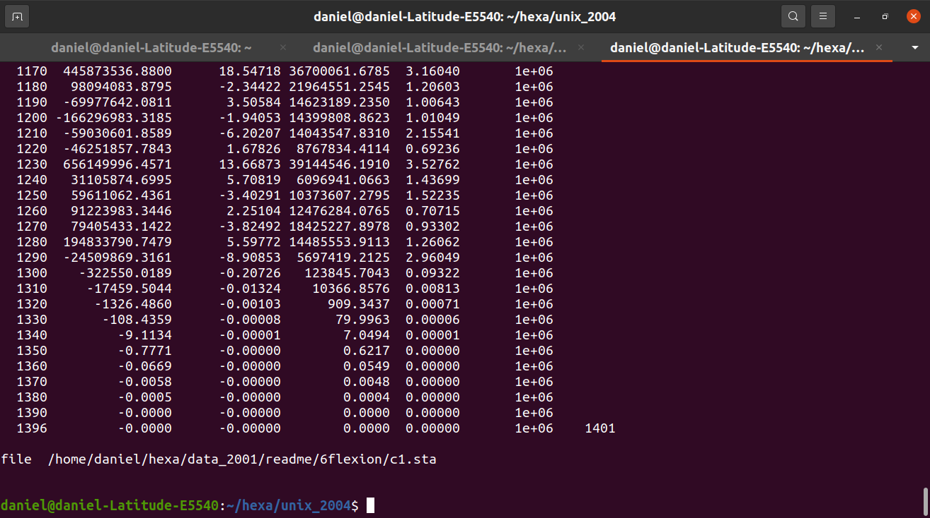Figure 64: The equilibrium is reached in 1396 iterations.

Gravity catch
A gravity catch is a catch which presses on the netting bag by its own weight. It is expected that the netting is not in water. The “catch” could be an amount of fish but also bags of water such as it is in [15].
The catch is limited by a horizontal surface. All the catch volume is below this surface. This volume is determined in *.don file.
In the following example (~/hexa/data_2001/readme/13gravity_catch/g1.don) the netting bag is made of 2 panels of netting which are closed at the bottom by 4 ropes and hold at the top by 4 rigid cables.
The view of the initial shape of the netting bag is on Figure 66 and Figure 65.
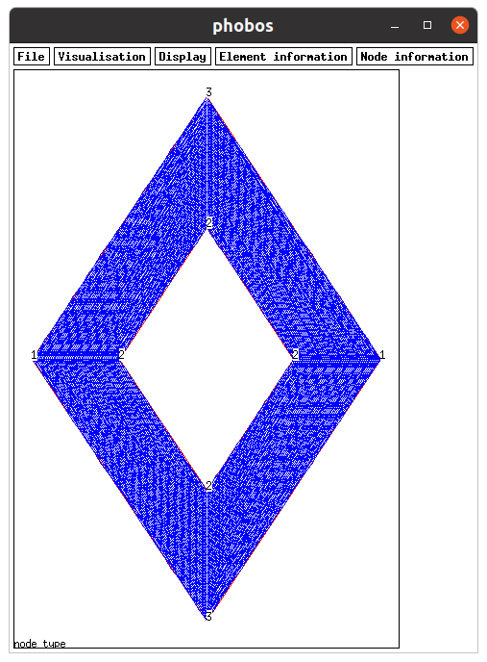Figure 65: Top view of the initial shape of the netting bag. The nodes type are shown. View of phobos using ~/hexa/data_2001/readme/13gravity_catch/g1.
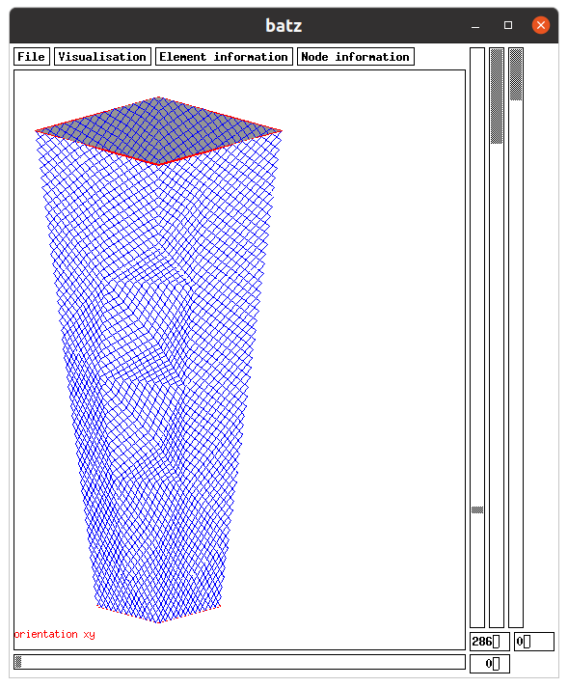Figure 66: 3D view of the initial shape of the netting bag. The bag is closed at the bottom by 4 ropes and it is hold at the top by 4 rigid cables. View of batz using ~/hexa/data_2001/readme/13gravity_catch/g1.
The nodes at the top are fixed along Z axis. The nodes of type 3 (Figure 65) are also fixed along X axis when the nodes of type 1 are also fixed along Y axis. The 4 cables at the top have a flexion rigidity of 1127 N.m². This rigidity is equivalent of a rigidity of a iron bar of 18mm of diameter.
The pressure of the catch occurs on one side of the netting, the inner one. To verify that the inner and outer sides are well defined, it can be shown in ./batz using vizualisation, orientation_xy (Figure 66). The grey surface is the inner side of the netting. If the orientation of a panel is not appropriate, replace V coordinates (V1, V2 …) of the panel by the opposite (-V1, -V2 …). It could be done also by replacing U coordinates par their opposite.
The volume of the catch is determined in g1.don:
CATCH DESCRIPTION
Volume (m3): 0.026500
Accuracy on this volume (m3): 1e-07
The catch is subject to the gravity and not to the drag by (in g1.don):
input catch_gravity 1000
The four bars at the entry of the cod-end are subject to flexion rigidity (EI = N.m²) by (in g1.don):
input EI_flexion_cable 5 1127
input EI_flexion_cable 6 1127
input EI_flexion_cable 7 1127
input EI_flexion_cable 8 1127
The four bars at the entry of the cod-end are welded together (the angle between them is 180deg.) by (in g1.don):
input link_flexion_elem2 5 6 180
input link_flexion_elem2 6 7 180
input link_flexion_elem2 7 8 180
input link_flexion_elem2 8 5 180
The commands to create the g1.mdg file are (Figure 67) :
cd ~/hexa/phobos_2005
./phobos ~/hexa/data_2001/readme/13gravity_catch/g1
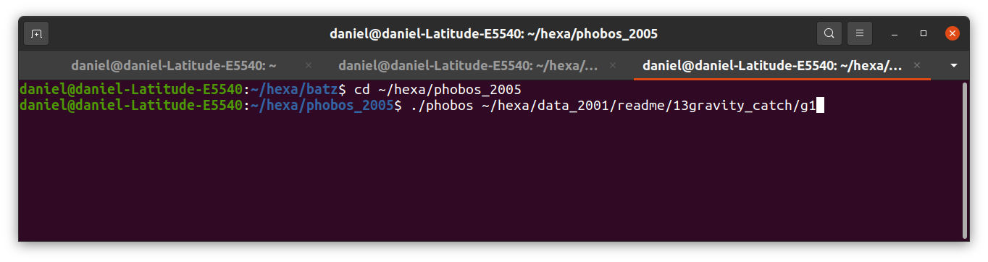Figure 67: Commands to create the file g1.mdg.
The commands to calculate the equilibrium of g1 and record the result in g1.sta are (Figure 68):
cd ~/hexa/unix_2004
./4ch19 ~/hexa/data_2001/readme/13gravity_catch/g1
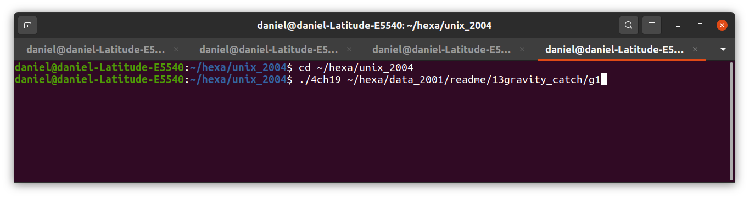Figure 68: Commands for the equilibrium calculation of g1.

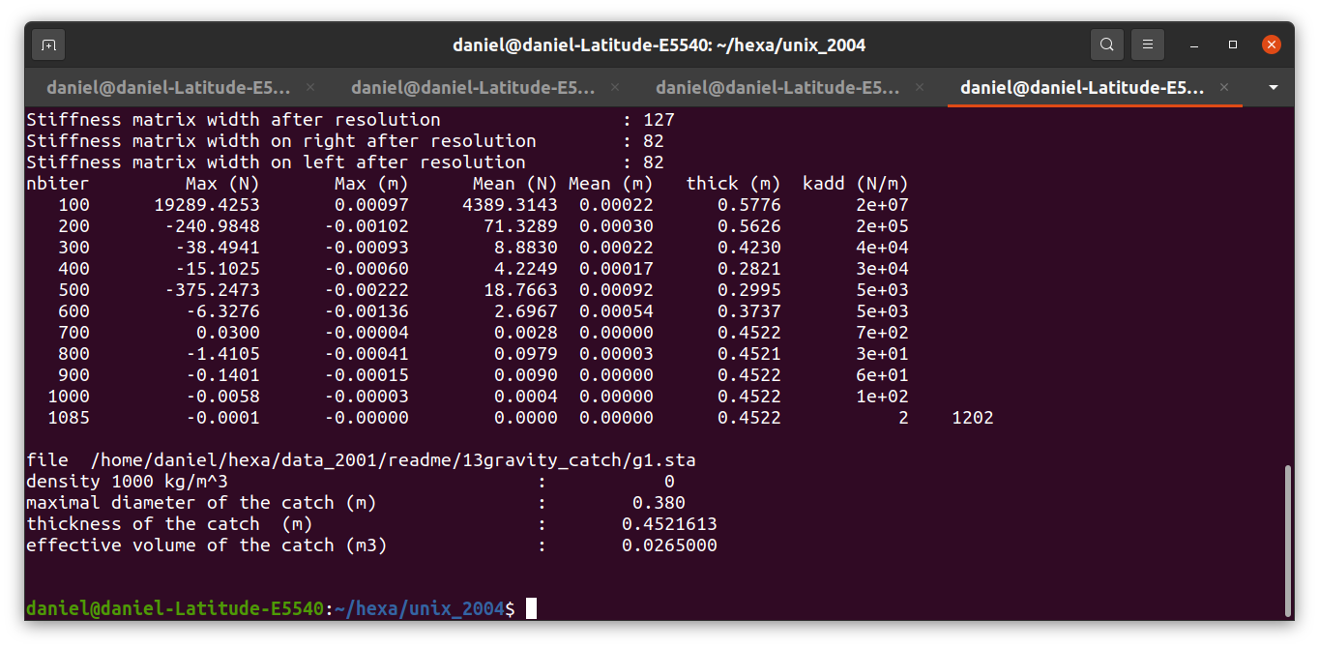Figure 69: Iterations of the calculation of the equilibrium of g1. The first column is the iteration, the second is the maximal disequilibrium (N) per coordinate, the third the maximal displacement (m) per coordinate, the fourth the mean disequilibrium (N) per node, the fifth the mean displacement (m) per node, the sixth the thickness of the catch (m, distance between the front of the catch and the rearrest part of the netting), the seventh the added stiffness (N/m) to the stiffness matrix in order to avoid singular stiffness matrix. The calculation converges in 1085 iteration, when the fourth column is less the convergence threshold (N). The thickness of the catch is 0.4522m (sixth column)
In order to have a finer discretization, the meshing step of netting panels is decreased to 0.0465m in g2.don in place of 0.186m in g1.don:
Meshing step (m): 0.0465
To get the equilibrium of g2, do (Figure 70):
cd ~/hexa/phobos_2005
./phobos ~/hexa/data_2001/readme/13gravity_catch/g2 ~/hexa/data_2001/readme/13gravity_catch/g1
and (Figure 71, Figure 72)
cd ~/hexa/unix_2004
./4ch19 ~/hexa/data_2001/readme/13gravity_catch/g2
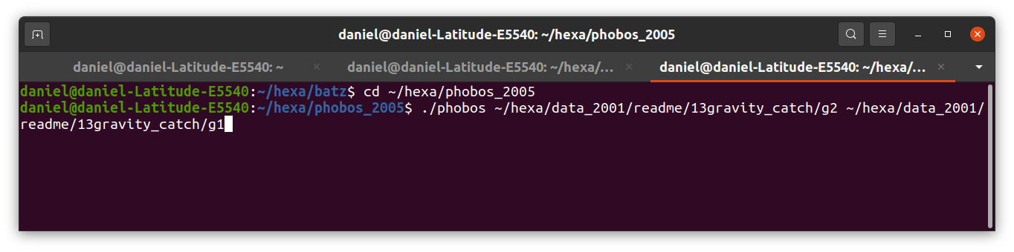Figure 70: Command to create g2.mdg and a first evaluation of g2.sta from g1.
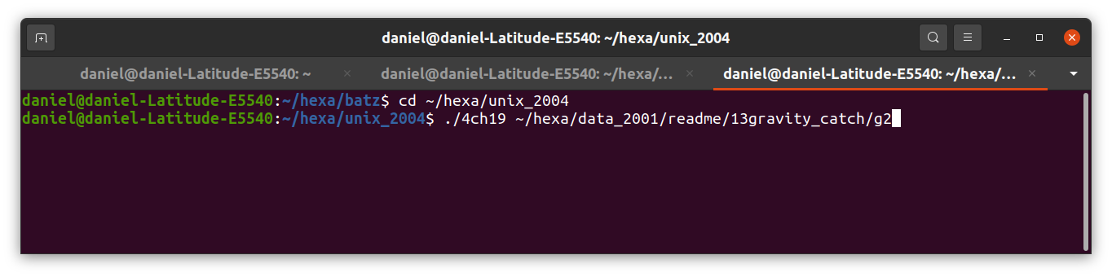Figure 71: Command for the calculation of the equilibrium of g2.
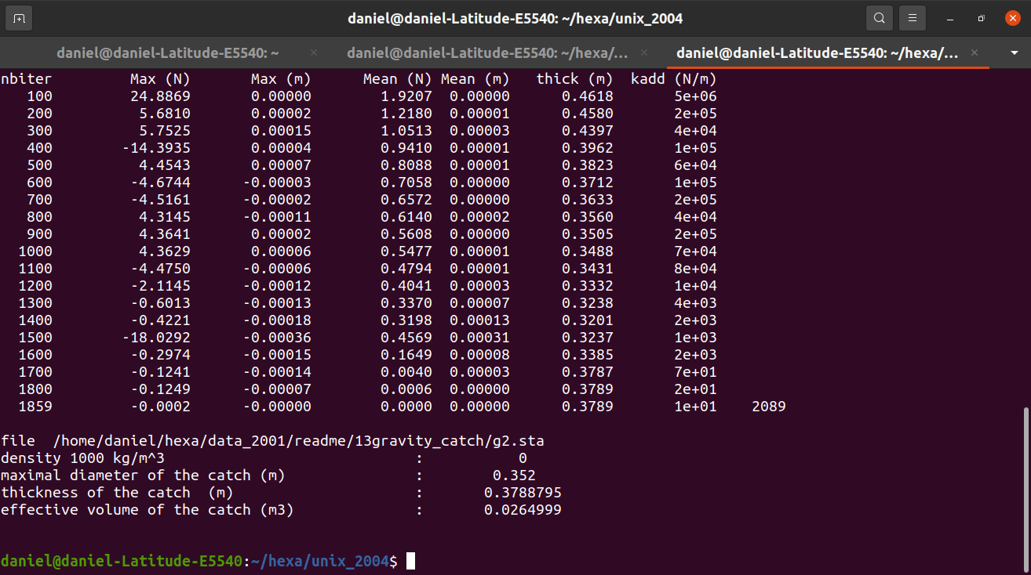Figure 72: Calculation of the equilibrium of g2 in 1859 iterations stored in g2.sta.
The equilibrium is reached in 1859 iterations (Figure 72). The shape is displayed on Figure 73 using the command:
cd ~/hexa/batz
./batz
And doing:
a) File, load_final_file, that loads the equilibrium shape of the structure.
b) Vizualisation, u_twines, v_twines, that displays the twines of the netting.
c) Vizualisation, catch_front_surface, that displays the limit of the catch
the netting.
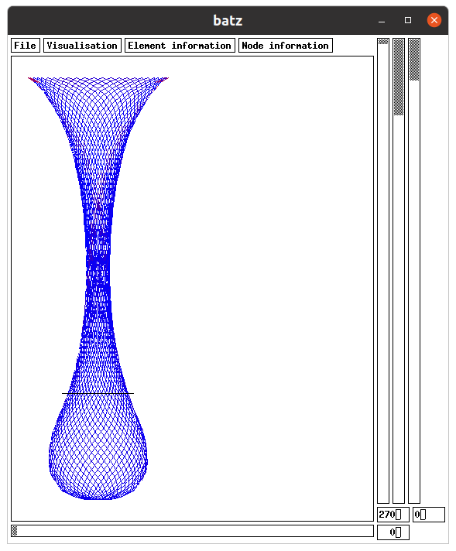Figure 73: Equilibrium of the netting bag. The catch is below the horizontal line. View of batz using ~/hexa/data_2001/readme/13gravity_catch/g2.

FAD
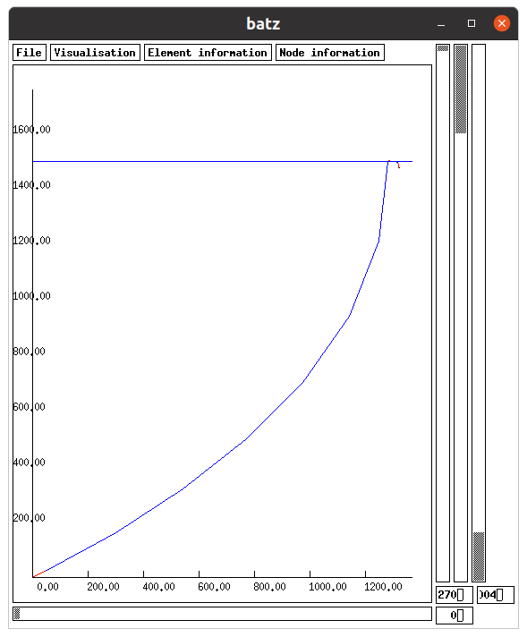Figure 74: The FAD moored by 1500m deep waters and in current of 1.5m/s. View of batz using ~/hexa/data_2001/readme/7fad/g3.
The wave conditions are:
Wave period = 14s,
Wave height = 10 m,
Depth = 1500 m.
These conditions are displayed on Figure 75. It can be seen that the wave model of Stokes 2d order is adapted. To choose this wave model use in *.don file:
input wave_model 2
The Airy wave model (input wave_model 1) and wave model of Stokes 3d order in deep waters (input wave_model 3) can also be used.
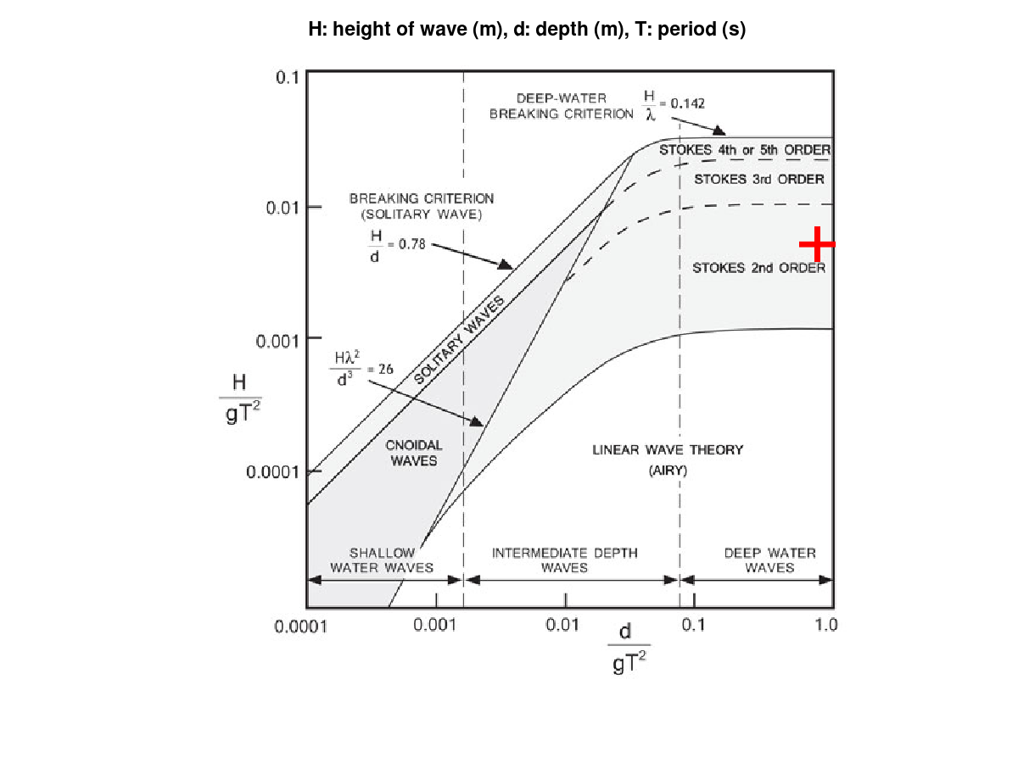Figure 75: The wave conditions of the FAD are shown with the red cross. The wave model of Stokes 2d order is adapted to such wave conditions.
The result of calculation is shown on Figure 74 and Figure 76. On Figure 76 a zoom on the top is displayed. It can be seen the static position (mostly on the left) and the trajectories of nodes in wave (mostly on the right due to the drift).

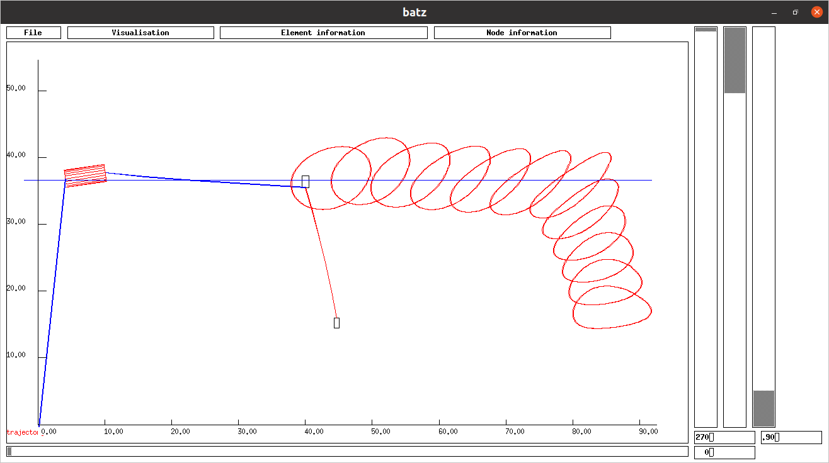Figure 76: Static position (on the left) and nodes trajectories (on the right due to the wave drift) of the top of the FAD assessed with the Stokes 2d order wave model. View of batz using ~/hexa/data_2001/readme/7fad/g3.
The commands to create mdg file are:
cd ~/hexa/phobos_2005
./phobos ~/hexa/data_2001/readme/7fad/g3
The commands to calculate the equilibrium in static conditions and to record this equilibrium in sta file are:
cd ~/hexa/unix_2004
./4ch19 ~/hexa/data_2001/readme/7fad/g3
The commands to calculate the equilibrium in dynamic conditions and to record this equilibrium in dyn file are:
cd ~/hexa/dyna2
./4ch19 ~/hexa/data_2001/readme/7fad/g3

Mussels longline
In the following example of mussels longline (8long_line/m1) there are 11 buoys (3 m³ at the extremities and 1.3m³ for the others) and 41 mussels lines (7m long and 0.29m width, Figure 77). The environmental conditions are a depth of 15m, a current of 0.5m/s and a wave of 9s for 4m high. The mooring lines are made of 2 ropes with an intermediate float. The fixations to the bottom sea are escaped of 210m.
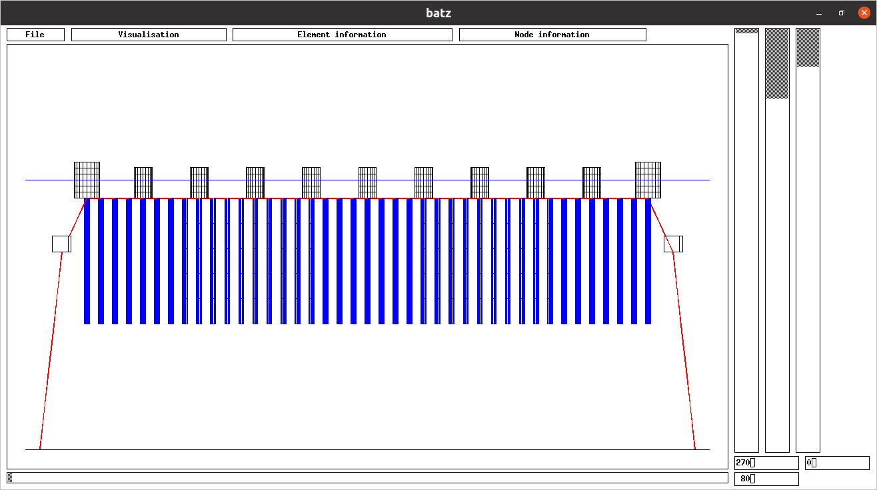Figure 77: The longline is made of 11 floats (black), 41 mussels lines (blue), one headline (red) and 2 mooring lines at each extremity (red). For getting this view do cd ~/hexa/batz, ./batz, File, load_initial_file, Visualisation, Cable/bar_contour, Visualisation, node_contour, Visualisation, free_surface, turn the view of 270 degrees in the left vertical cursor and turn of 80 degrees in the horizontal cursor. View of batz using ~/hexa/data_2001/readme/8long_line/m1.
The intermediate floats on the mooring line are defined as a specific type of node:
No du type : 3
Mass X,Y,Z (kg): 1.140000 1.140000 1.140000
Added mass X,Y,Z (kg): 1.140000 1.140000 1.140000
Length X,Y,Z (m): 0.900000 0.900000 0.900000
Drag coefficient X,Y,Z: 1.200000 1.200000 1.200000
External forces X,Y,Z (N): 0.000000 0.000000 0.000000
Displacement X,Y,Z: 0 0 0
Limits X,Y,Z (m): 0.000000 0.000000 0.000000
Limits sense X,Y,Z: 0 0 0
Symmetry X,Y,Z: 0 0 0
It can be seen that the mass of this node is 1.14Kg and this size is 0.900000m by 0.900000m by 0.900000m.

In order to ease to modelling of the structure in relation with the free surface (buoyancy, hydrodynamic drag which are dependant of the immersion in the water) the volume of the elements (bar element for cables and triangular element for nettings), is split between extremities of these elements. It can be seen on the left of Figure 78, a float modelled in 6 bar elements. The volume of the float is split between the 7 nodes and modelled by cubes (on the right of Figure 78).
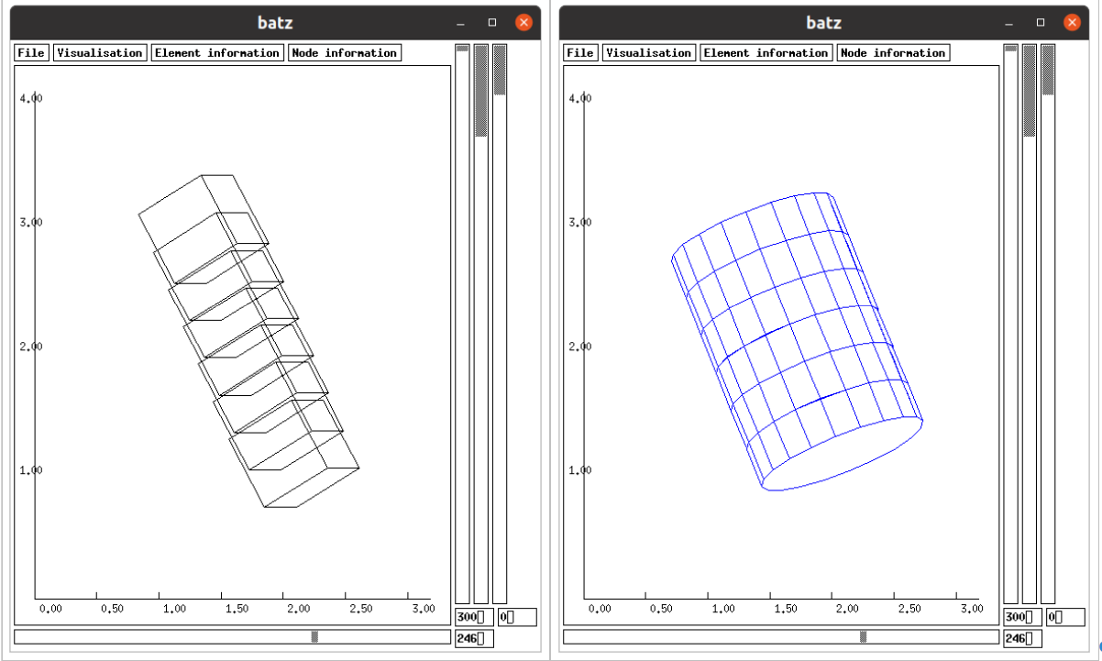Figure 78: A float is modelled by 6 bar elements (on the right). The volumes of bar elements are split in cubes on bar element extremities (on the left). View of batz using ~/hexa/data_2001/readme/8long_line/m1.

If the float is modelled in 1 bar element (left of Figure 79). The volume of the float is split between the 2 cubes (on the right of Figure 79). In this case, because the modelling is coarser than on Figure 78, the modelling is also coarser.
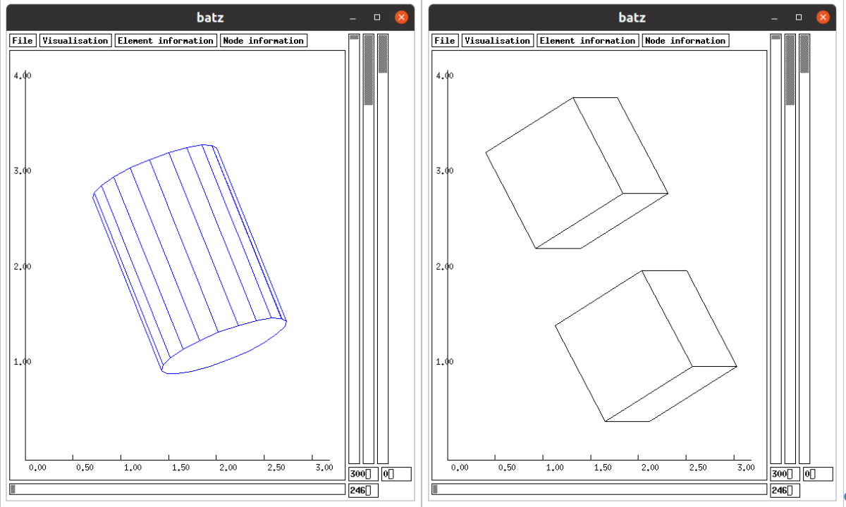Figure 79: A float is modelled by 1 bar element (on the left). The volume of bar element is split in cubes on bar element extremities (on the right). This modelling is coarser than on Figure 78. View of batz using ~/hexa/data_2001/readme/8long_line/m2.

Once the float is modelled in several bar elements (Figure 78), it must be introduced a resistance in flexion between these bar elements to avoid articulations between these bar elements. This resistance in introduced using the following line (in the case of cable/float 82) in the *.don file:
input EI_flexion_cable 82 10000
This line means that the cable (float) 82 has a flexion resistance (EI) of 10000N.m².

The m1.mdg file is got using:
cd ~/hexa/phobos_2005
./phobos ~/hexa/data_2001/readme/8long_line/m1
The static position (8long_line/m1.sta, without wave) is got using:
cd ~/hexa/unix_2004
./4ch19 ~/hexa/data_2001/readme/8long_line/m1

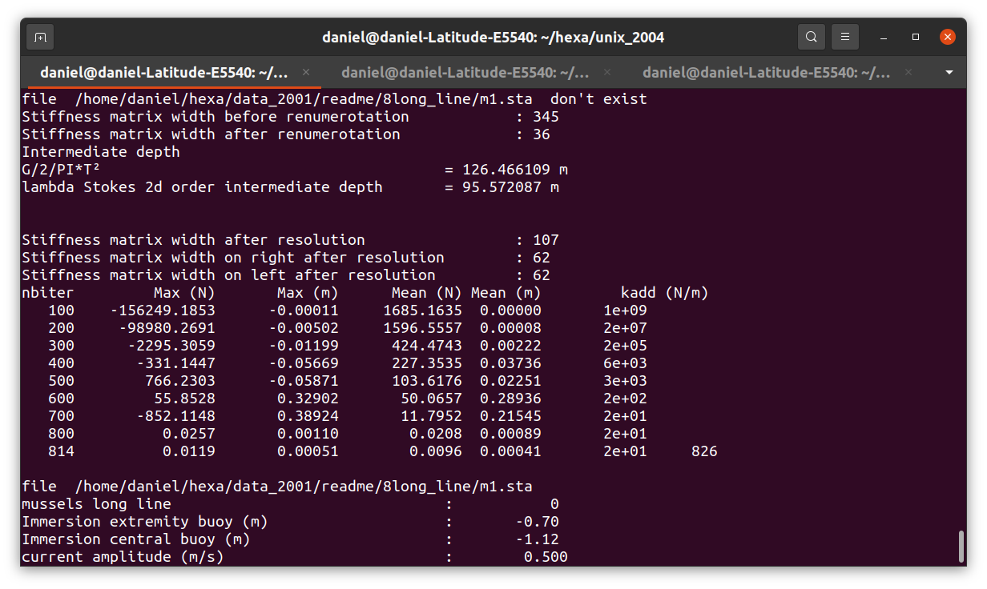Figure 80: The static equilibrium of the mussels long line is reach in 814 iterations.
The shape of the long line in static conditions is displayed on Figure 81.
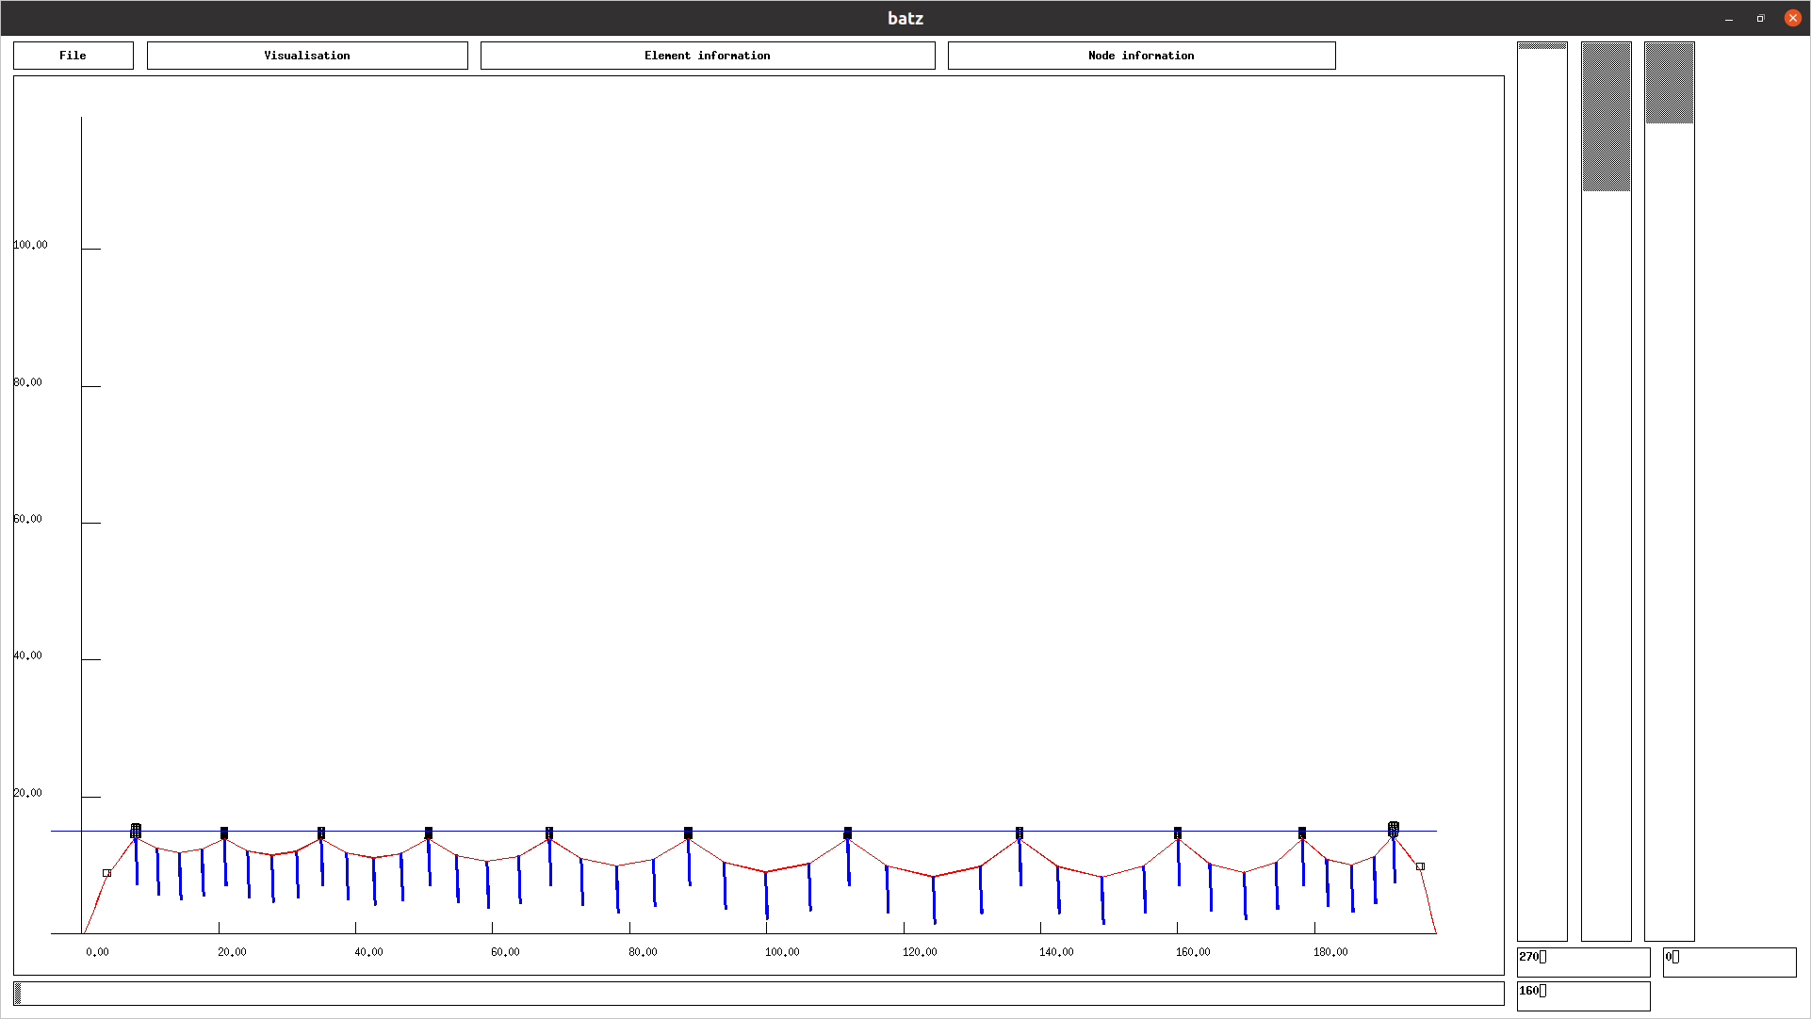Figure 81: Static position of the mussels long line m1. View of batz using ~/hexa/data_2001/readme/8long_line/m1.
The wave conditions and the depth lead to use the Stokes 2d order wave model as it can be seen on Figure 82.
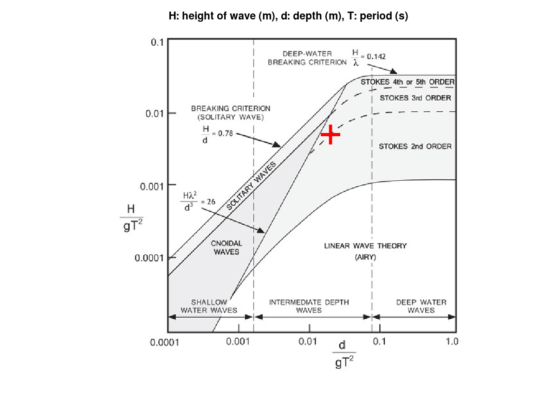Figure 82: The wave conditions of the mussels long line are shown with the red cross. The wave model of Stokes 2d order is adapted to such wave conditions and depth.
The dynamic equilibrium is got using in a terminal:
cd ~/hexa/dyna2
./4ch19 ~/hexa/data_2001/readme/8long_line/m1
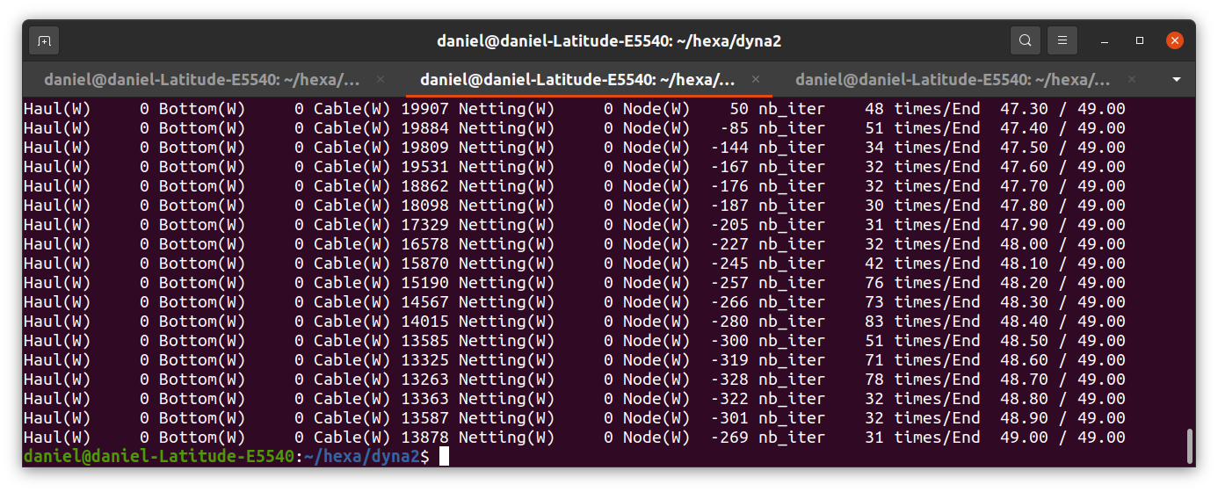Figure 83: Dynamic calculation of the mussels line on 49s. The columns give the sum of scalar product of drag (N) by displacement (m). The unit of this scalar product is the Watt. Column Haul is used when hauling cables are used (it is not the case here). Bottom when there is a friction with the sea bottom (not the case here). Cable (Netting, Node) in case of drag and displacement of cables (nettings, nodes). Here the scalar product for node is not null due to the intermediate float on the 2 mooring lines. This float is described as a node with a lengths (m) along X, Y and Z which give sections (m²) and consequently a drag (N).

A dynamic position is got using,
a) in a terminal cd ~/hexa/batz and ./batz;
b) File, load_final_file, choose ~/hexa/data_2001/readme/8long_line/m1, Visualisation, cable/bar_contour, Visualisation, node_contour, Visualisation, free_surface, Visualisation, axes, choose view angles (bottom cursor and left vertical cursor), and drag the right vertical cursor to display the dynamic position (Figure 84).
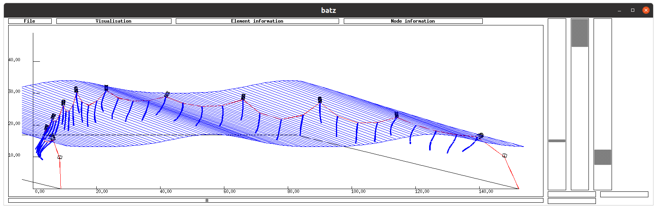Figure 84: The dynamic position of the mussels long line in waves. View of batz using ~/hexa/data_2001/readme/8long_line/m1.

Netting boom
Netting booms or gill nets are structures which are very long relatively to their width. In the case the variation of behaviour along the length is much smaller than along the width and to avoid to have too much numeric nodes issuing the discretisation process, it could be used a specific function in order to reduce the number of numeric nodes along, while the number of numeric nodes along the width remain large enough.
in order to create nodes along the diagonals of meshes and not along twines, in the following command, panel 1 is discretized each 200 meshes along U diagonal and each 3 meshes along V diagonal (h1.don). The best is to have ropes (cables) around the panel of netting with the same step of meshing along ropes as the panel and to begin the discretisation by the ropes. This following command is only available for panel with 4 corners.
input Meshing_UV 1 200 3
To verify the position of U diagonal and the V diagonal, do in a terminal:
cd ~/hexa/phobos_2005
./phobos
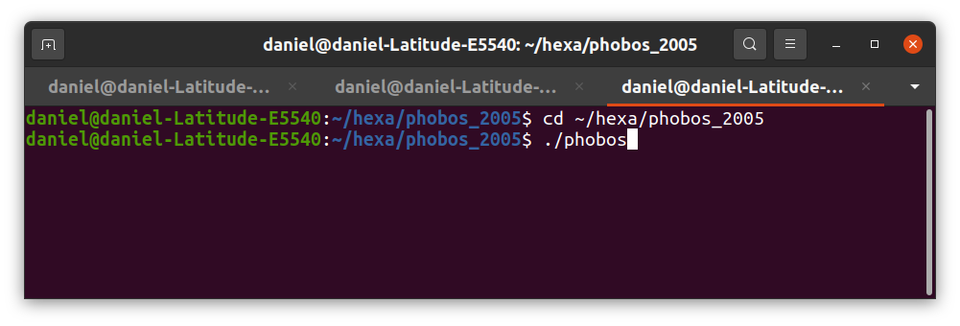Figure 85: Command for graphic phobos.
In phobos, do: File, create_mdg_file. Choose ~/hexa/data_2001/readme/9gill_net/h1. Do: Visualisation, contour_diamond, Visualisation, UV_vectors, Visualisation, axes, Visualisation, twines_period, introduce 20. It can be seen that the V diagonal of meshes is along the width of the panel and the U diagonal is along the length of the panel. The command input Meshing_UV 1 200 3 creates numeric nodes each 200 U diagonals and each 3 V diagonals.
To verify it can be done:
Firstly, Node information, node_global, Visualisation, twines_period, introduce 200. It can be seen that the length of 200 U diagonals is the distance between numeric nodes along axe Y.
And secondly, Node information, node_global, Visualisation, twines_period, introduce 3. It can be seen that the length of 3 V diagonals is the distance between numeric nodes along axe Z (Figure 86).
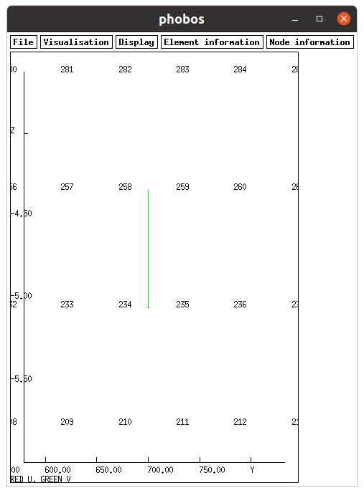Figure 86: Phobos on ~/hexa/data_2001/readme/9gill_net/h1 file. The 3 V diagonals have the length identical as the distance between numeric nodes along Z axe.
Spheric floats are added on the head line with the following command:
input sphere_element 3 500 0.23 60.0
This command leads that these floats are uniformly added on cable 3. There are 500 floats. The diameter of spheric floats is 0.23m and the buoyancy of each float is 60N. These floats are visible on the headline on Figure 87.
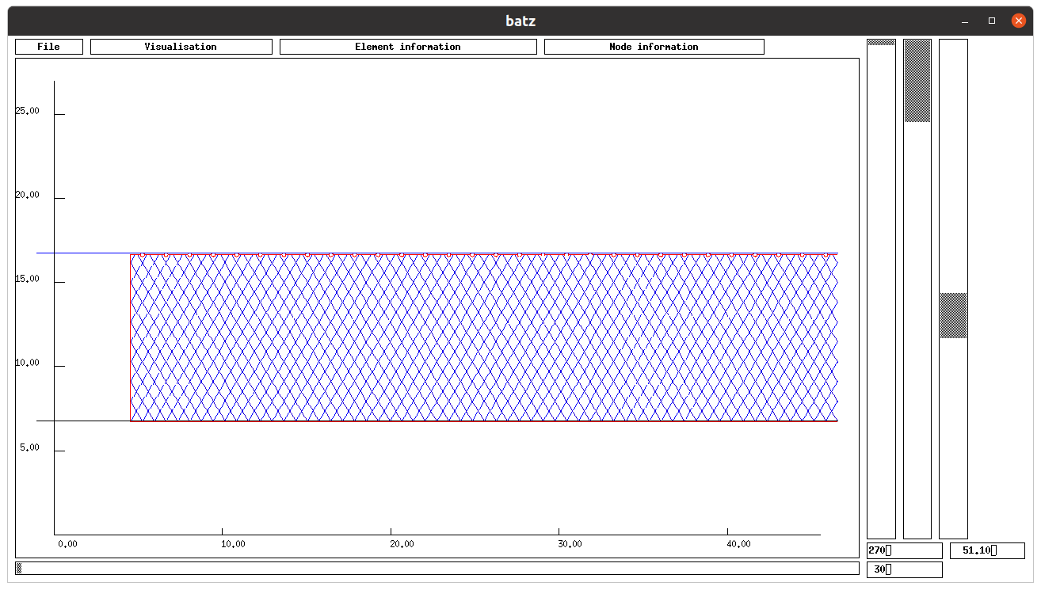Figure 87: A zoom on an extremity of the boom. The twines are shown. The spheric floats are visible. View of batz using ~/hexa/data_2001/readme/9gill_net/h1.
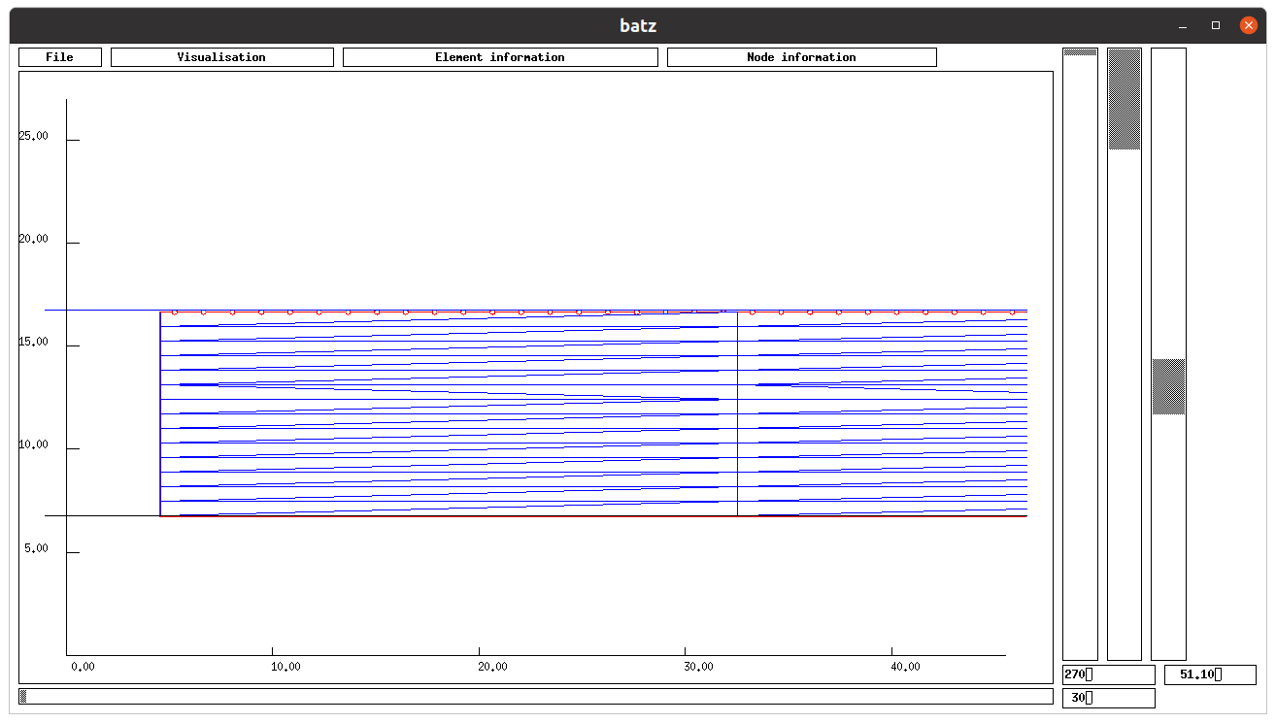Figure 88: The same zoom on the boom as Figure 87, the twines are hidden, the triangular elements of netting are shown. These triangular elements are very long relatively to their width. View of batz using ~/hexa/data_2001/readme/9gill_net/h1.
The calculation of the static equilibrium of h1 is got with the command:
cd ~/hexa/unix_2004
./4ch19 ~/hexa/data_2001/readme/9gill_net/h1
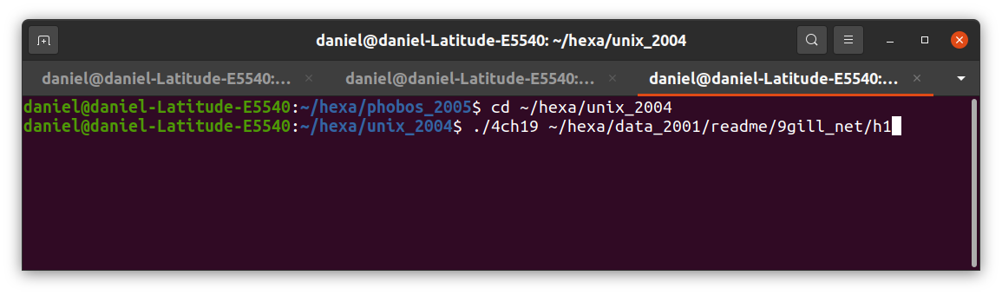Figure 89: Commands to calculate the static equilibrium of h1.

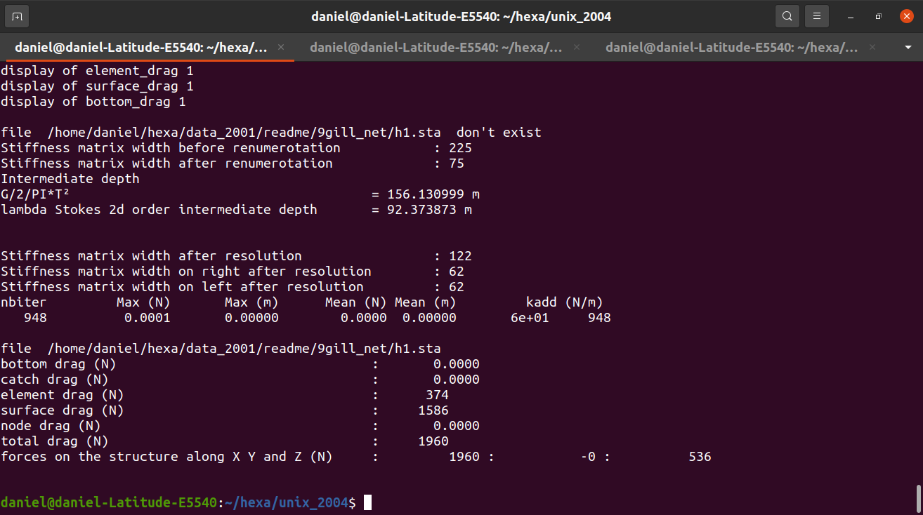Figure 90: The static equilibrium of h1 is reached in 948 iterations.
The static position is displayed on Figure 91.
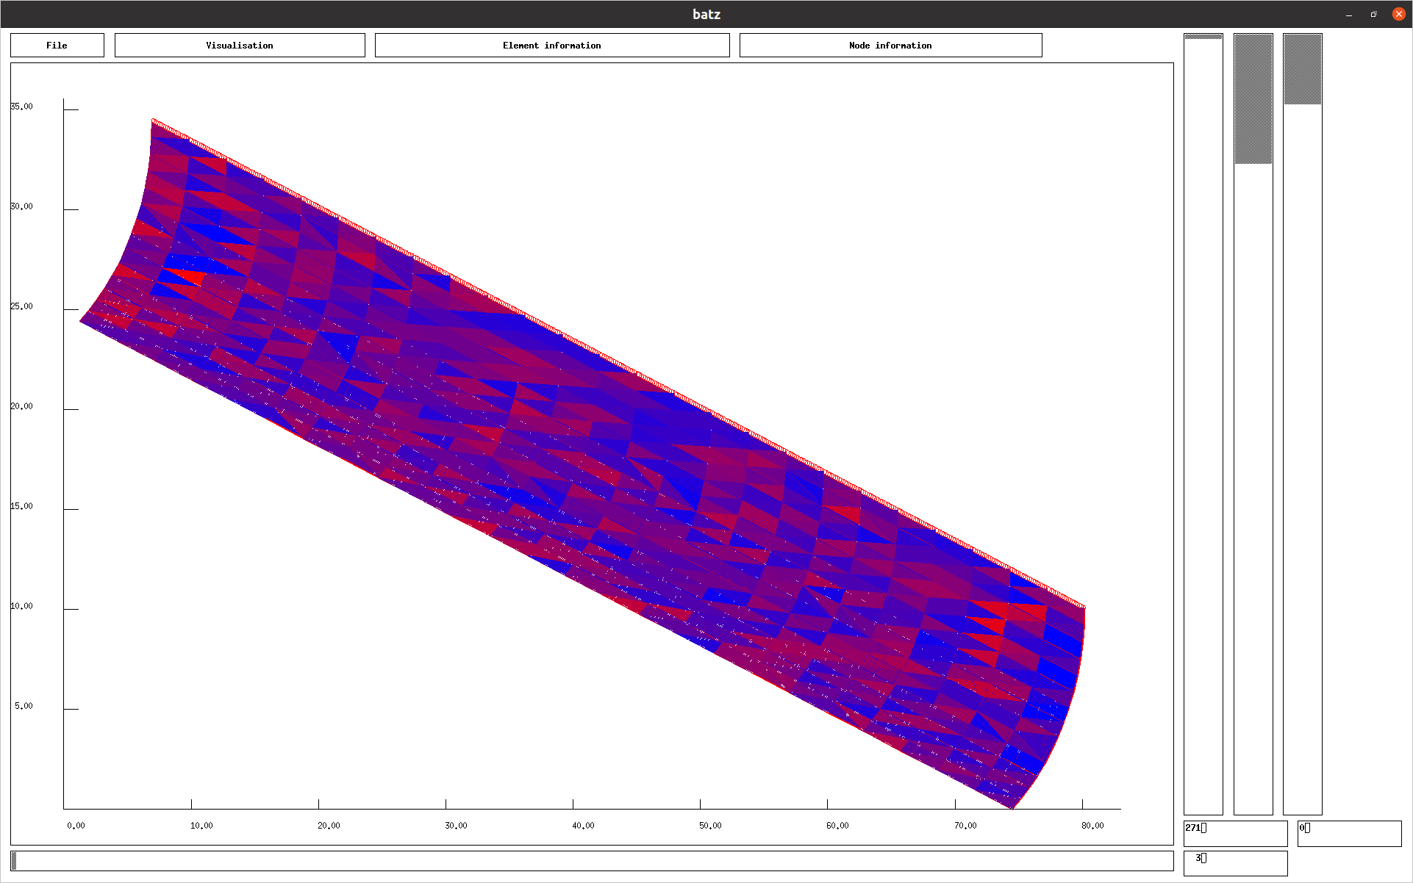Figure 91: Static position of the boom in the current. View of batz using ~/hexa/data_2001/readme/9gill_net/h1.
The dynamic position of the boom is got using the commands (Figure 92):
cd ~/hexa/dyna2
./4ch19 ~/hexa/data_2001/readme/9gill_net/h1
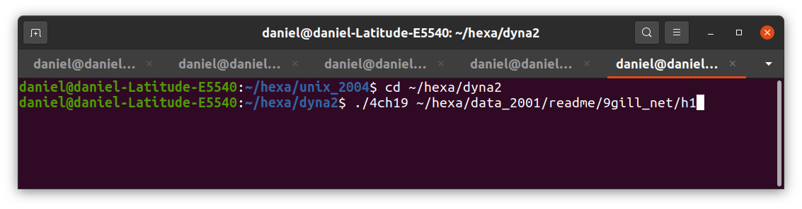Figure 92: Commands to get the dynamic equilibrium of h1.

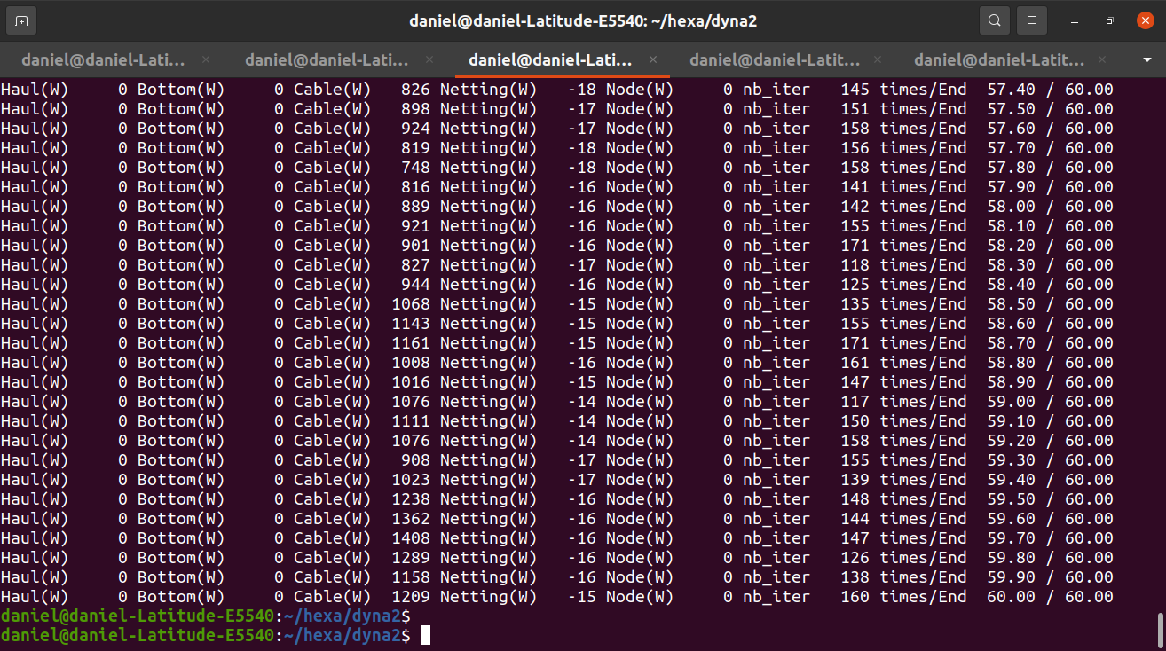Figure 93: Dynamic calculation of the boom on 60s. The columns give the sum of scalar product of drag (N) by displacement (m). The unit of this scalar product is the Watt. Column Haul is used when hauling cables are used (it is not the case here). Bottom when there is a friction with the sea bottom (not the case here). Cable (Netting, Node) in case of drag and displacement of cables (nettings, nodes).
A Shape of the boom in wave is shown on Figure 94. This shape is got using the tool batz and the commands: File, load_final_file, Visualisation, Cable/bar_contour, Visualisation, u_twines, Visualisation, v_twines, , Visualisation, free_surface, Visualisation, axes. Finally the right vertical cursor is used to adjust the time step required.
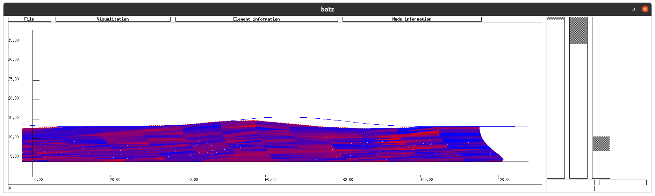Figure 94: A dynamic position of the boom in wave. It can be seen that the headline don’t always stay on the free surface (blue line). View of batz using ~/hexa/data_2001/readme/9gill_net/h1.

Fish cage
A fish cage using flexible polyethylene pipes as float, and moored with 3 lines ended by chains is described (Figure 95).
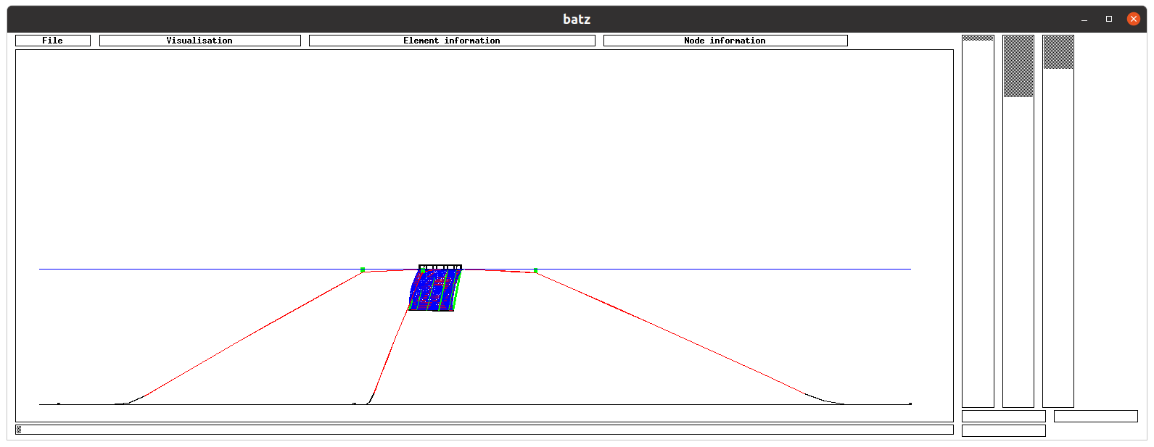Figure 95: Fish cage. PE pipes are used as floats at the free surface. The mooring lines ends with chains. View of batz using ~/hexa/data_2001/readme/10fish_cage/f1.
The *.don file is quite complex: it is made of 14 panels of netting, and 114 cables/bars. The netting here is divided in 12 lateral panels (Figure 96) and a top and bottom netting (Figure 97). The circular floating collar consists of two concentric PE pipes (Figure 98). The netting is taut with a circular dead weight (Figure 98). The dead weight is fixed to the floating collar by 12 ropes and fixed to the bottom of netting by 12 ropes (Figure 98).
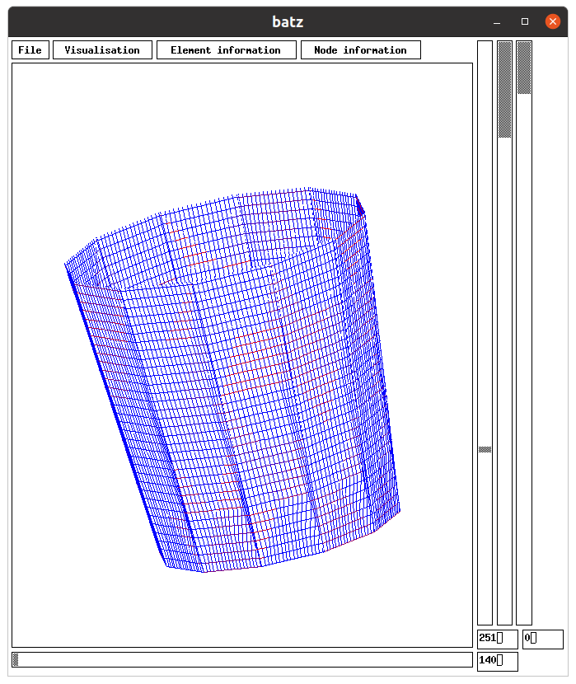
Figure 96: 12 lateral panels of netting. View of batz using ~/hexa/data_2001/readme/10fish_cage/f1.
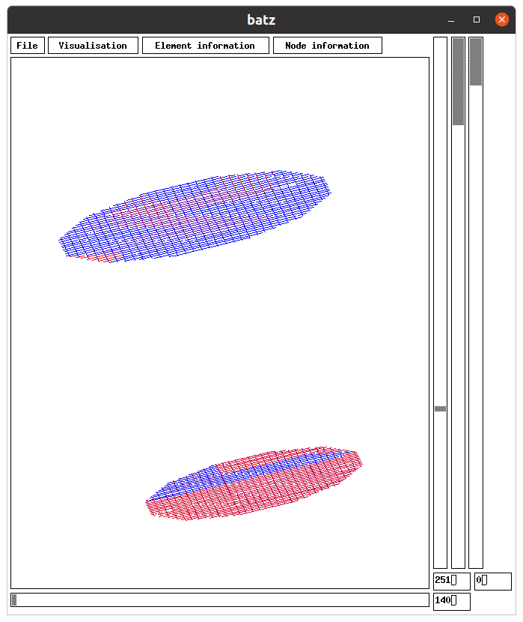
Figure 97: The top and bottom panel of netting. View of batz using ~/hexa/data_2001/readme/10fish_cage/f1.
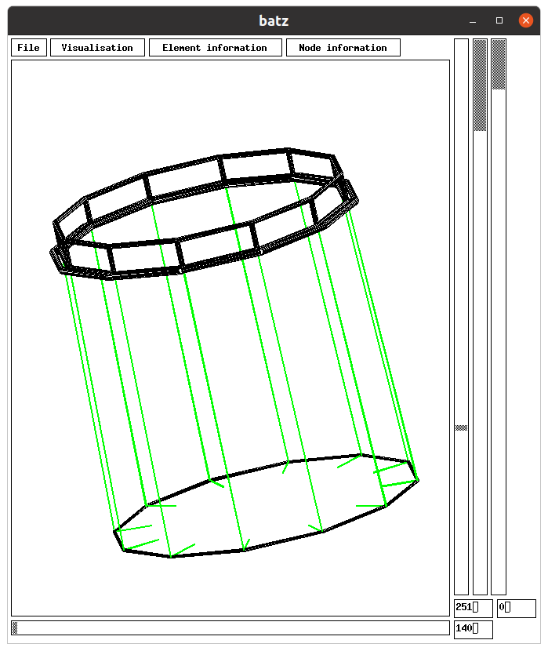
Figure 98: The float pipes (top) and the dead weight (bottom) are shown in black, when ropes of fixation of the dead weight and of the bottom of netting are in green. View of batz using ~/hexa/data_2001/readme/10fish_cage/f1.
The fish cage is moored using 3 mooring lines (Figure 99) made of, from the sea bottom to the cage, a chain, a sub-surface rope, a buoy, a surface rope and 2 bridles. The bridles are fixed to the floating collar of the cage.
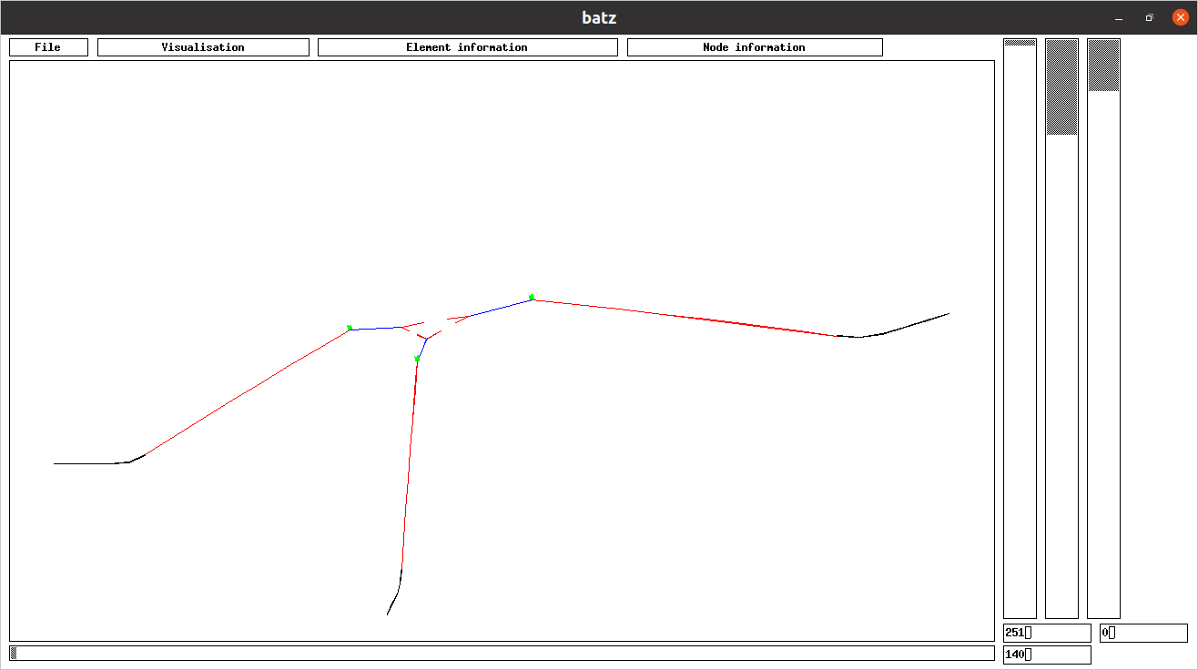Figure 99: Each of the 3 mooring lines is made, from the bottom, of chain (black), sub-surface rope (red), buoy (green), surface rope (blue) and 2 bridles (red). View of batz using ~/hexa/data_2001/readme/10fish_cage/f1.
It is recommanded to use an help to create the *.don file (f1.don) due to the large number of components. It is proposed a spreadsheet in which each component are defined in a specific worksheet. Have a look at ~/hexa/data_2001/readme/10fish_cage/help_don.ods: the gray zones of each worksheet are copied in the don file.
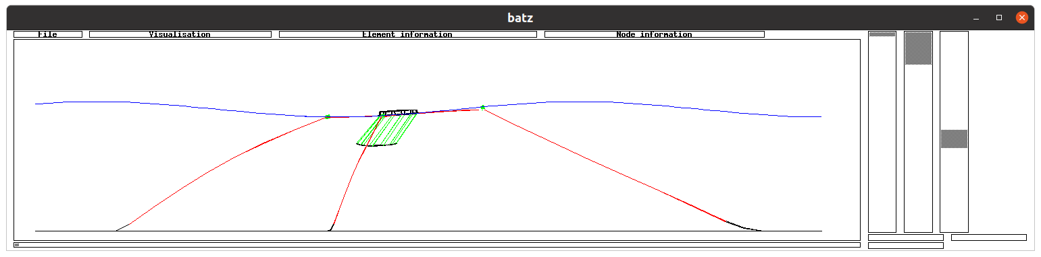Figure 100: Fish cage in waves. View of batz using ~/hexa/data_2001/readme/10fish_cage/f1.
Once f1.don is created, doing f1.mdg with the commands (Figure 101):
cd ~/hexa/phobos_2005
./phobos ~/hexa/data_2001/readme/10fish_cage/f1
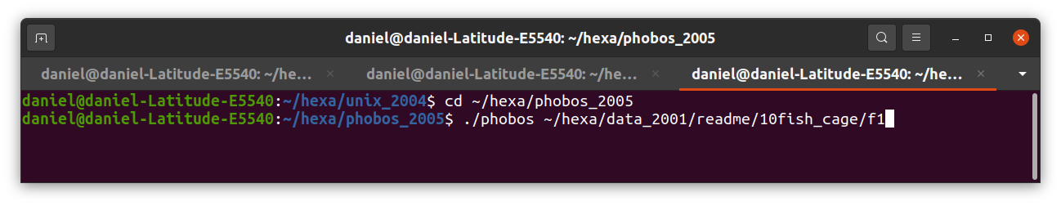Figure 101: Creation of f1.mdg using phobos.
The calculation of the static equilibrium of the cage described by f1.don is done using the commands (Figure 102):
cd ~/hexa/unix_2004
./4ch19 ~/hexa/data_2001/readme/10fish_cage/f1
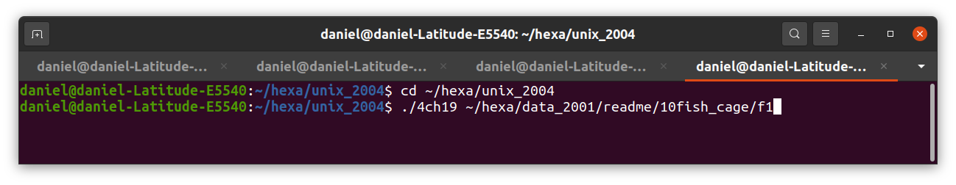Figure 102: Commands used for the calculation of f1.sta.
In order to have a more detailed fish cage, f2.don is created. It is a copy of f1.don except that for each panel of netting the line:
Meshing step (m): 4
is replaced by:
Meshing step (m): 2
This replacement leads to create numeric nodes each 2m in place of each 4m.
In the description of cables 67 to 78, the number of bars is increases from 1 (in f1.don) to 3, 7 or 5 (in f2.don).
E : 67 ….Cd : 1.2 F : 0.08 Nb : 1 Ty : 2 in f1.don
E : 67 ….Cd : 1.2 F : 0.08 Nb : 3 Ty : 2 in f2.don
Once f2.don is created, doing f2.mdg with the commands (Figure 101):
cd ~/hexa/phobos_2005
./phobos ~/hexa/data_2001/readme/10fish_cage/f2 ~/hexa/data_2001/readme/10fish_cage/f1
This commands also creates an estimation of the static equilibrium of f2 (f2.sta) based on equilibrium of f1 (f1.sta).
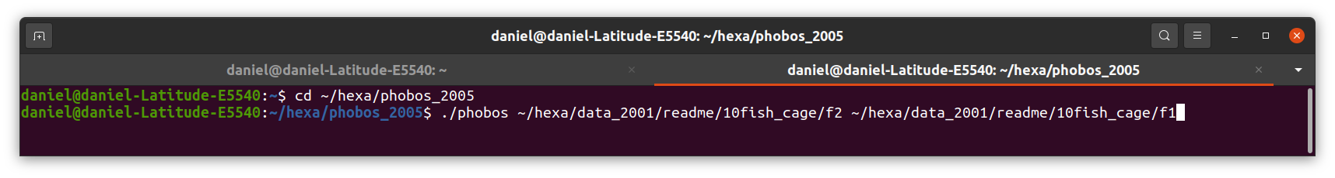Figure 103: Creation of f2.mdg using phobos. This commands estimates also f2.sta using f1.sta.
The commands to calculate the equilibrium in static conditions of f2 are (Figure 104):
cd ~/hexa/unix_2004
./4ch19 ~/hexa/data_2001/readme/10fish_cage/f2
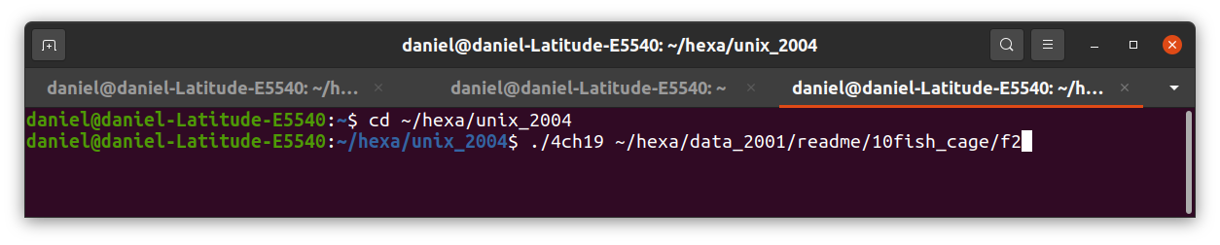Figure 104: Commands for the calculation of the equilibrium in static conditions of f2.
The commands to calculate the equilibrium in dynamic conditions of f2 are (Figure 105):
cd ~/hexa/dyna2
./4ch19 ~/hexa/data_2001/readme/10fish_cage/f2
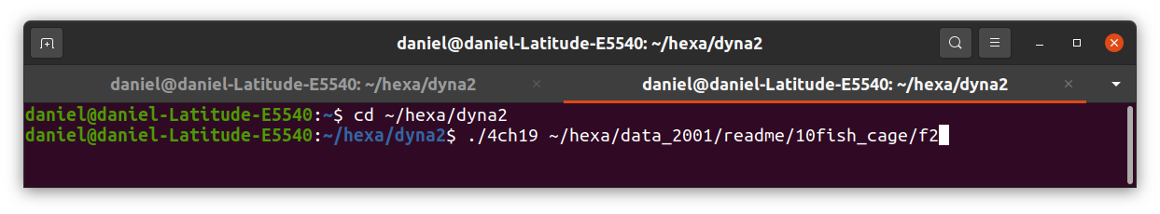Figure 105: Commands for the calculation of the equilibrium in dynamic conditions of f2.
A view of the cage (f2) in the wave is given Figure 106.
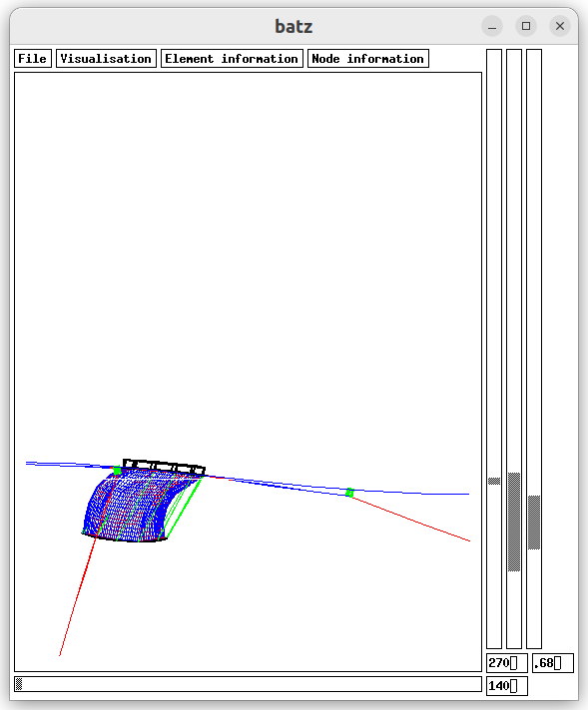Figure 106: View of the cage in wave. View of batz using ~/hexa/data_2001/readme/10fish_cage/f2. The vertical cursor is tuned at 270deg in order to have a side view. The horizontal cursor is tuned at 140deg in order to a view normal to wave propagation: 140deg is the complement of wave direction (40deg) to 180deg.

Bottom seine
The hauling back process of a bottom seine could be assessed with FEMNET [16].
The initial shape of the seine cables is almost square. One corner of the square is the boat, the opposite corner is the trawl, and the two other corners are the middle of the two cables (Figure 107). Note that the symmetry plane is taken into account (vertical plane passing by the boat and the trawl).
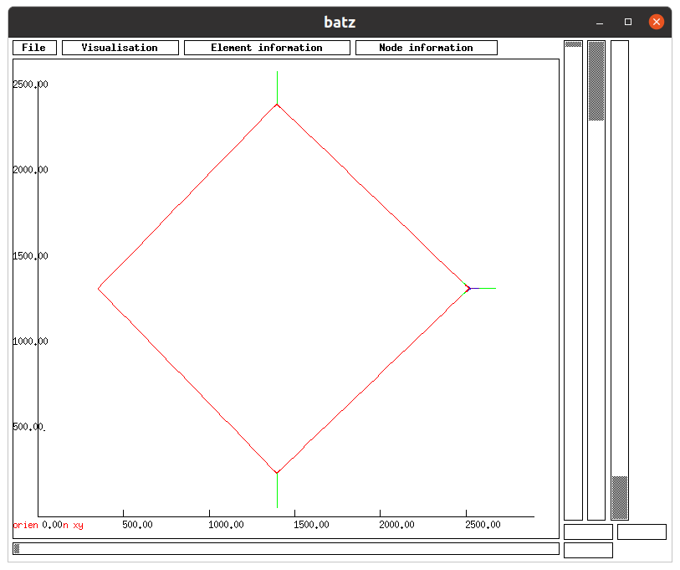Figure 107: Initial shape of the seine (top view). It is almost square with one corner the boat (on the left) and the trawl at the opposite corner (on the right). The structure is symmetric around a vertical plane. The square is got using external forces (green lines). View of batz using ~/hexa/data_2001/readme/11bottom_seine/s1.
Because the cable is defined as a line (Figure 108) in s1.don, it is necessary to deform this line in order to get a square.
To get this initial shape, this shape is calculated in static conditions applying forces on the middle of the 2 cables and on the trawl in order to reach an almost square shape. To apply these forces, 2 types of node are created in s1.don: a first for the middle of the cables (type 4) and a second for the rear part of the trawl (type 5). These forces appear in green on Figure 107.
To create the type of node in the middle of the cable the following command is used in s1.don:
input type_noeud_XYZ_SUPINF 13 53.25 53.35 0.5 1.5 67.5 67.7 4
This command (the 13th of type_noeud_XYZ_SUPINF) affects the type 4 at any numeric node in the window of coordinates x> 53.25m, x <53.35, y>0.5m, y<1.5m, z>67.5, z<67.7m. This type 4 of node can be seen on Figure 108 inside the red circle. The type 5 is also visible in two places.
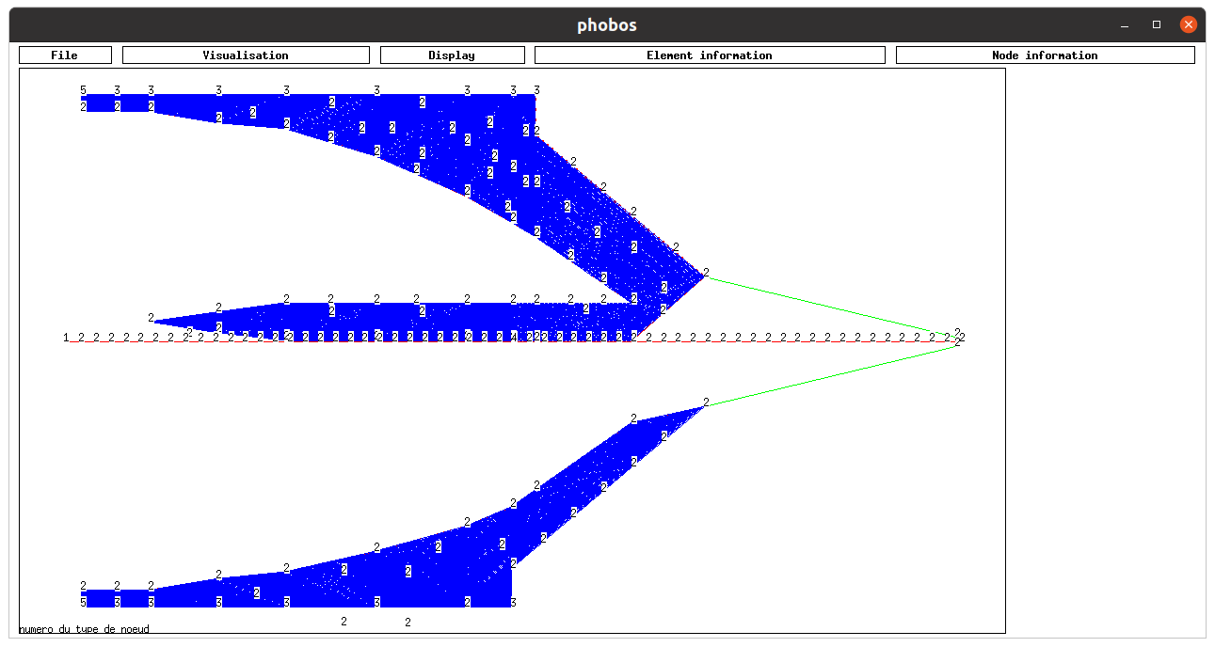Figure 108: The creation of s1.mdg with phobos. The type of the nodes is displayed: it can be seen type 4 in the middle of the cable and two types 5 at the rear part of the trawl (inside the red circles). View of phobos using ~/hexa/data_2001/readme/11bottom_seine/s1.
The external force on type 5 is 10000N and 20000N along axe Y on type 4 (middle of the cable):
No du type : 4
Mass X,Y,Z (kg): 0.000000 0.000000 0.000000
Added mass X,Y,Z (kg): 0.000000 0.000000 0.000000
Length X,Y,Z (m): 0.000000 0.000000 0.000000
Drag coefficient X,Y,Z: 1.200000 1.200000 1.200000
External forces X,Y,Z (N): 0.000000 20000.000000 0.000000
Displacement X,Y,Z: 0 0 0
Limits X,Y,Z (m): 0.000000 0.000000 -30.000000
Limits sense X,Y,Z: 0 0 1
Symmetry X,Y,Z: 0 0 0

No du type : 5
Mass X,Y,Z (kg): 0.000000 0.000000 0.000000
Added mass X,Y,Z (kg): 0.000000 0.000000 0.000000
Length X,Y,Z (m): 0.000000 0.000000 0.000000
Drag coefficient X,Y,Z: 1.200000 1.200000 1.200000
External forces X,Y,Z (N): 10000.000000 0.000000 0.000000
Displacement X,Y,Z: 0 0 0
Limits X,Y,Z (m): 0.000000 0.000000 -30.000000
Limits sense X,Y,Z: 0 0 1
Symmetry X,Y,Z: 0 1 0

The initial shape of the seine s1 is calculated using:
cd ~/hexa/phobos_2005
./phobos ~/hexa/data_2001/readme/11bottom_seine/s1
cd ~/hexa/unix_2004
./4ch19 ~/hexa/data_2001/readme/11bottom_seine/s1

Once s1.sta is calculated, copy s1.don in s2.don and decrease by 10 the external forces on type 4 and type 5 (2000N and 1000N). Theses types are:
No du type : 4
Mass X,Y,Z (kg): 0.000000 0.000000 0.000000
Added mass X,Y,Z (kg): 0.000000 0.000000 0.000000
Length X,Y,Z (m): 0.000000 0.000000 0.000000
Drag coefficient X,Y,Z: 1.200000 1.200000 1.200000
External forces X,Y,Z (N): 0.000000 2000.000000 0.000000
Displacement X,Y,Z: 0 0 0
Limits X,Y,Z (m): 0.000000 0.000000 -30.000000
Limits sense X,Y,Z: 0 0 1
Symmetry X,Y,Z: 0 0 0

No du type : 5
Mass X,Y,Z (kg): 0.000000 0.000000 0.000000
Added mass X,Y,Z (kg): 0.000000 0.000000 0.000000
Length X,Y,Z (m): 0.000000 0.000000 0.000000
Drag coefficient X,Y,Z: 1.200000 1.200000 1.200000
External forces X,Y,Z (N): 1000.000000 0.000000 0.000000
Displacement X,Y,Z: 0 0 0
Limits X,Y,Z (m): 0.000000 0.000000 -30.000000
Limits sense X,Y,Z: 0 0 1
Symmetry X,Y,Z: 0 1 0

The initial shape of the seine s2 is calculated using:
cd ~/hexa/phobos_2005
./phobos ~/hexa/data_2001/readme/11bottom_seine/s2 ~/hexa/data_2001/readme/11bottom_seine/s1
cd ~/hexa/unix_2004
./4ch19 ~/hexa/data_2001/readme/11bottom_seine/s2
Once again, copy s2.don in s3.don and decrease the forces by 10 on type 4 and type 5 (200N and 100N).
The initial shape of s3 is calculated using:
cd ~/hexa/phobos_2005
./phobos ~/hexa/data_2001/readme/11bottom_seine/s3 ~/hexa/data_2001/readme/11bottom_seine/s2
cd ~/hexa/unix_2004
./4ch19 ~/hexa/data_2001/readme/11bottom_seine/s3
Finally, copy s3.don in s4.don and decrease the forces to 0.0N on type 4 and type 5 (0.0N and 0.0N)
The initial shape of s4 is calculated using:
cd ~/hexa/phobos_2005
./phobos ~/hexa/data_2001/readme/11bottom_seine/s4 ~/hexa/data_2001/readme/11bottom_seine/s3
cd ~/hexa/unix_2004
./4ch19 ~/hexa/data_2001/readme/11bottom_seine/s4
At this step, s4.sta is static position of the seine just before the hauling back process: there are no remaining external forces on the cables and on the trawl, as expected. This static position is almost a square.
The hauling back of cables is defined using the command in s4.don:
input hauling_cable4 14 0.010 50.0 2
10 3010
1.0 1.0
2 2
That means that the cable which is hauled is the 14, the bar elements which discretize the cable have length which could vary between 0.010m and 50.0m. The time table has 2 components: The hauling back starts at 10s and ends at 3010s; the hauling speed varies between 1.0m/s at 10s and 1.0m/s at 3010s; the extremity by which the cable is hauled is 2 between 10s and 3010s and 2 at 3010s. To determine by which extremity the cable is hauled, do ./phobos, File, twines_surface, Node information, node_corner (Figure 109). The hauling speed varies linearly between times.

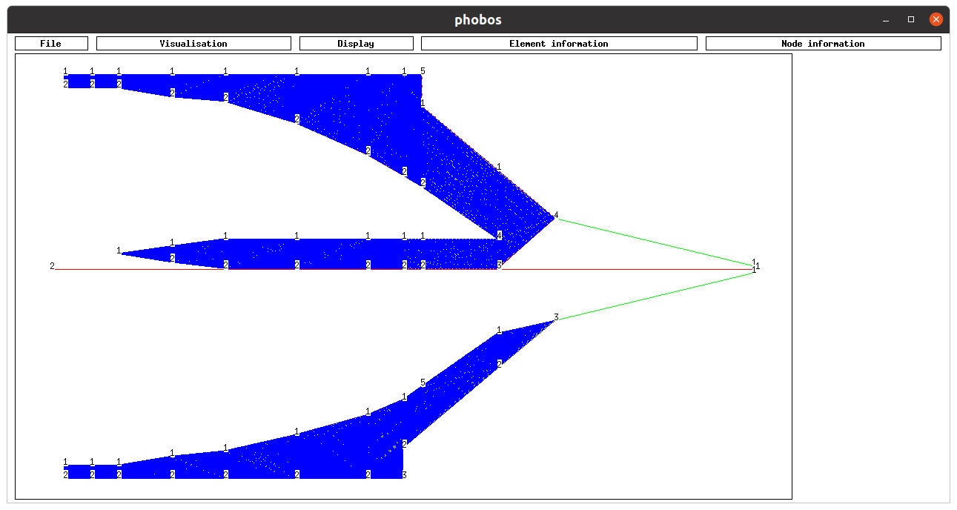Figure 109: The cable is hauled back by extremity 2 (red circle). To get this view, do in a terminal cd ~/hexa/phobos_2005, ./phobos, File, triangle_contour, choose ~/hexa/data_2001/readme/11bottom_seine/s4, Visualisation, contour_cable_bar, Visualisation, twines_contour, Node_information, node_corner.

In this example, the boat tows the seine. To introduce this towing use the following command in s4.don:
input speed_type_node2 1 2
1500 3020
0 -1
0 0
0 0
That means that the nodes of type 1 are affected by a towing speed. The speed is defined in a time table with 2 components: The towing starts at 1500s and ends at 3020s, the speed along X axis is 0m/s at 1500s and -1m/s at 3020s; the speed along Y axis is 0m/s at 1500s and 0m/s at 3020s; the speed along Z axis is 0m/s at 1500s and 0m/s at 3020s. The speeds vary linearly between times.
Be sure that the type (here 1) where the speed is affected has no limit. The type of node must have:
Limits sens X,Y,Z: 0 0 0

The dynamic positions of the seine (s4.dyn, Figure 110) is calculated using:
cd ~/hexa/dyna2
./4ch19 ~/hexa/data_2001/readme/11bottom_seine/s4
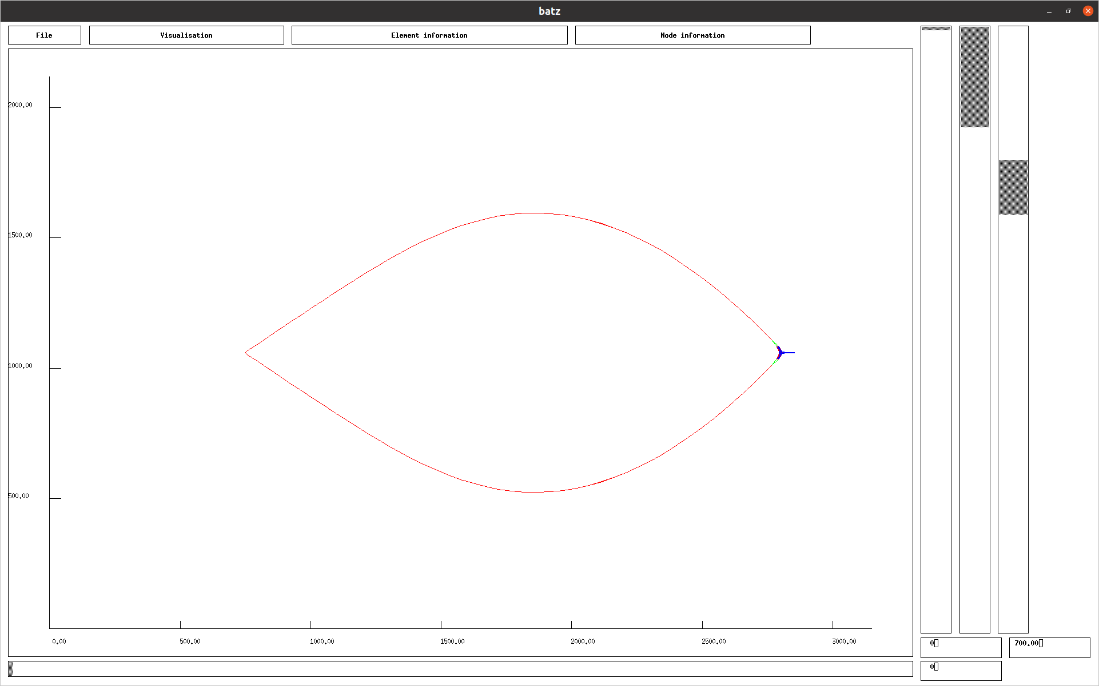Figure 110: Shape of the bottom seine at 700s. View of batz using ~/hexa/data_2001/readme/11bottom_seine/s4.

Symmetry plane
The symmetry planes are defined using type of node.
The following type of node defines a symmetry plane (YOZ) normal to X axis, see the last line (Symmetry X,Y,Z: 1 0 0):
No du type : 2
Mass X,Y,Z (kg): 0.000000 0.000000 0.000000
Added mass X,Y,Z (kg): 0.000000 0.000000 0.000000
Length X,Y,Z (m): 0.000000 0.000000 0.000000
Drag coefficient X,Y,Z: 1.200000 1.200000 1.200000
External forces X,Y,Z (N): 0.000000 0.000000 0.000000
Displacement X,Y,Z: 0 0 0
Limits X,Y,Z (m): 0.000000 0.000000 0.000000
Limits sens X,Y,Z: 0 0 0
Symmetry X,Y,Z: 1 0 0

The following type of node defines a symmetry plane (ZOX) normal to Y axis, see the last line (Symmetry X,Y,Z: 0 1 0):
No du type : 2
Mass X,Y,Z (kg): 0.000000 0.000000 0.000000
Added mass X,Y,Z (kg): 0.000000 0.000000 0.000000
Length X,Y,Z (m): 0.000000 0.000000 0.000000
Drag coefficient X,Y,Z: 1.200000 1.200000 1.200000
External forces X,Y,Z (N): 0.000000 0.000000 0.000000
Displacement X,Y,Z: 0 0 0
Limits X,Y,Z (m): 0.000000 0.000000 0.000000
Limits sens X,Y,Z: 0 0 0
Symmetry X,Y,Z: 0 1 0

The following type of node defines a symmetry plane (XOY) normal to Z axis, see the last line (Symmetry X,Y,Z: 0 0 1):
No du type : 2
Mass X,Y,Z (kg): 0.000000 0.000000 0.000000
Added mass X,Y,Z (kg): 0.000000 0.000000 0.000000
Length X,Y,Z (m): 0.000000 0.000000 0.000000
Drag coefficient X,Y,Z: 1.200000 1.200000 1.200000
External forces X,Y,Z (N): 0.000000 0.000000 0.000000
Displacement X,Y,Z: 0 0 0
Limits X,Y,Z (m): 0.000000 0.000000 0.000000
Limits sens X,Y,Z: 0 0 0
Symmetry X,Y,Z: 0 0 1

The rule used here is that the Mass, the Added mass, the Length and External force are defined for the whole structure, not only for the symmetric part of the structure. If the mass in the type of node is 10Kg, and there is one symmetry plane, the part of the mass of the whole structure is 10Kg that means that the part of this mass for the symmetric part is the half (5Kg).

References
1 Priour D., 1999, Calculation of net shapes by the finite element method with triangular elements, Commun. Numer. Meth. Engng, 15, 757-765.
2 D.Priour, 2001, Introduction of mesh resistance to opening in a triangular element for calculation of nets by the finite element method, , 17, 229-237.
3 D.Priour, 2003, Analysis of nets with hexagonal mesh using triangular elements, , 56, 1721-1733.
4 D.Priour, 2013, A Finite Element Method for Netting, Application to fish cages and fishing gear, Springer
5 , 2004, Les panneaux de chalut, Caractéristiques et mise en oeuvre, Quae
6 Priour D. & Herrmann B., Catch shape in codend, 2005
7 R.Khaled, D.Priour & JY.Billard, 2012, Numerical optimization of trawl energy efficiency taking into account fish distribution, , 54, 34-45.
8 R.Khaled, D.Priour & JY.Billard, 2012, Cable length optimization for trawl fuel consumption reduction, , 58, 167-179.
9 A.de la Prada & D.Priour, 2014, The effect of the bottom boundary layer on trawl behaviour, , 101, 142-151.
10 D.Priour & A.de la Prada, 2015, An experimental/numerical study of the catch weight influence on trawl behavior, , 94, 94-102.
11 A.Sala, D. Priour, B. Herrmann, 2006, Experimental and theoretical study of red mullet (Mullus barbatus)selectivity in codends of Mediterranean bottom trawls, , 19, 317-327.
12 B. Herrmann, D. Priour, L. A. Krag, 2006, Theoretical study of the effect of round straps on the selectivity in a diamond mesh cod-end, , 80, 148-157.
13 B. Herrmann, D. Priour, L. A. Krag, 2007, Simulation-based study of the combined effect on cod-end size selection of turning meshes by 90◦ and reducing the number of meshes in the circumference for round fish, , 84, 222-232.
14 B.Morvan, D.Priour, Z.Guédé, G.Bles, 2016, Finite element model for the assessment of the mesh resistance to opening of fishing nets, , 123, 303-313.
15 FG.O’Neill FG & T.O’Donogue, 1997, The fluid dynamic on catch and the geometry of trawl cod-ends, , 453, 1631-1648.
16 Priour D., Billard J.-Y, 2019, Measurements and numerical modelling of the towing and hauling back phases of a bottom seine

Index
input add_z_ele 180.0 79 152: In case cables/bars are translated in the design. In this command the cables/bars are translated along z axis of 180.0m. This translation is applied to cables/bars 79 to 152. The same commands exist for translation along x and y axis (input add_x_ele 180.0 79 152, input add_y_ele 180.0 79 152).

input add_z_pan 180.0 79 152: In case netting panels are translated in the design. In this command the panels are translated along z axis of 180.0m. This translation is applied to cables/bars 79 to 152. The same commands exist for translation along x and y axis (input add_x_pan 180.0 79 152, input add_y_pan 180.0 79 152)

input Auto_convergence: In order to accelerate the convergence, by modifying the added stiffness. The added stiffness is initiated by a command such as input convergence_parameters 1 10 100000000000 in *.don file; or, if this command is not defined, by the value in the file ~/hexa/unix_2004/param.txt for static calculations or defined by the value in the file ~/hexa/dyna2/param.txt for dynamic calculations.

input convergence_parameters 1 10 100000000000: In order to have convergence parameters specifically for a file, add the previous command to have a relaxation of 1 a period display on the terminal of 10 and an added stiffness of 100000000000 N/m.

input current_reduction 7 0.65: This command reduces on netting panel 7 the current by 0.65.

input EI_flexion_cable 9 0.00000269: The cable 9 has a flexion rigidity (EI) of 0.00000269 N.m²

input hauling_cable4 14 0.010 50.0 2
10 3010
1.0 1.0
2 2
: In order to haul or shoot a cable. For example the previous command reduce the length of cable 14. The bar elements vary between 0.010m and 50.0m long. There are 2 time steps in the following table. The second line indicates the times (10s and 3010s), the third the speed of reduction (1.0m/s and 1.0m/s, to shoot the speed is < 0.0), the fourth line indicate the extremity by which the cable is reduced (2 and 2).

input link 0.01: Automatic creation of link between nodes if they are at a distance < a certain value. In the previous command all nodes with a distance < 0.01m are linked.

input link_flexion_elem2 9 10 21.155128: The two cable 9 and 10 has a welding angle of 21.155128 degrees. If they are aligned the angle is 180 degrees. If they are perpendicular the angle is 90 degrees. EI of welding is the mean value of EI of cable 1 and EI of cable 2

input Meshing_UV 1 200 3: In order to create nodes along the diagonals of meshes and not along twines. In the previous command panel 1 is discretised each 200 meshes along U diagonal and each 3 meshes along V diagonal. The best is to have ropes around the panel of netting with the same step of meshing along ropes as the panel and to begin the meshing by the ropes. It is only available for panel with only 4 corners. The meshing step (m) of panel 1 is, in this case, not used

input moving_bottom: In case of towing structures, such as bottom trawl, they are modelled in current and the boat is fixed. If there is a wearing on the bottom, the bottom has the same speed of the current.

input rot_z_ele 1.0 2.0 4.0 11 17: In case cables/bars are turned in the design. In this command the cables/bars are turned around z axis and the centre of position x 1.0m and y 2.0m. The rotation is of pi/4.0 and is applied on cables/bars 11 to 17. The same commands exist for rotation around x and y axis (input rot_x_ele 1.0 2.0 4.0 11 17, input rot_y_ele 1.0 2.0 4.0 11 17).

input rot_z_pan 3.0 2.0 2.0 3 8: In case netting panels are turned. In this command the netting panels are turned around z axis and the centre of position x 3.0m and y 2.0m. The rotation is of pi/2.0 and is applied on panels 3 to 8. The same commands exist for rotation around x and y axis (input rot_x_pan 3.0 2.0 2.0 3 8, input rot_y_pan 3.0 2.0 2.0 3 8).

input speed_type_node2 1 2
1500 3020
0 -1
0 0
0 0
: In case of a movement speed is imposed to a node. Introduce a specific type to the node. In the previous command the speed of the node of type 1 is imposed using a time table. This table has 2 components: the times are 1500s and 3020s, with a speed along X axis of 0m/s and -1m/s, with a speed along Y axis of 0m/s and 0m/s, with a speed along Z axis of 0m/s and 0m/s. The speed varies linearly between time steps.

input sphere_element 3 500 0.23 60.0: Add sphere floats along a cable element, the drag coefficient of sphere is expected to be 0.6. The previous command add on element 3, 500 sphere floats of 0.23m of diameter and 60.0N of buoyancy. It is expected that, following the Archimedes' principle, the upward buoyant force due to the volume of the sphere (4/3πR³) is less than the buoyancy (60.0N).

input type_noeud_XYZ_SUPINF 1 14.0 1: In order to change the type of nodes depending on their position: in the previous command, nodes with X value > 14.0m has the type 1.

input type_noeud_XYZ_SUPINF 2 14.0 1: In order to change the type of nodes depending on their position: in the previous command, nodes with X value < 14.0m has the type 1.

input type_noeud_XYZ_SUPINF 3 14.0 1: In order to change the type of nodes depending on their position: in the previous command, nodes with Y value > 14.0m has the type 1.

input type_noeud_XYZ_SUPINF 4 14.0 1: In order to change the type of nodes depending on their position: in the previous command, nodes with Y value < 14.0m has the type 1.

input type_noeud_XYZ_SUPINF 5 14.0 1: In order to change the type of nodes depending on their position: in the previous command, nodes with Z value > 14.0m has the type 1.

input type_noeud_XYZ_SUPINF 6 14.0 1: In order to change the type of nodes depending on their position: in the previous command, nodes with Z value < 14.0m has the type 1.

input type_noeud_XYZ_SUPINF 7 14.0 15.0 1: In order to change the type of nodes depending on their position: in the previous command, nodes with X value > 14.0m and < 15.0m has the type 1.

input type_noeud_XYZ_SUPINF 8 14.0 15.0 1: In order to change the type of nodes depending on their position: in the previous command, nodes with Y value > 14.0m and < 15.0m has the type 1.

input type_noeud_XYZ_SUPINF 9 14.0 15.0 1: In order to change the type of nodes depending on their position: in the previous command, nodes with Z value > 14.0m and < 15.0m has the type 1.

input type_noeud_XYZ_SUPINF 10 14.0 15.0 16.0 17.0 1: In order to change the type of nodes depending on their position: in the previous command, nodes with X value > 14.0m and < 15.0m and Y value > 16.0m and < 17.0m has the type 1.

input type_noeud_XYZ_SUPINF 11 14.0 15.0 16.0 17.0 1: In order to change the type of nodes depending on their position: in the previous command, nodes with Y value > 14.0m and < 15.0m and Z value > 16.0m and < 17.0m has the type 1.

input type_noeud_XYZ_SUPINF 12 14.0 15.0 16.0 17.0 1: In order to change the type of nodes depending on their position: in the previous command, nodes with Z value > 14.0m and < 15.0m and X value > 16.0m and < 17.0m has the type 1.

input type_noeud_XYZ_SUPINF 13 53.25 53.35 0.5 1.5 67.5 67.7 4: In order to change the type of nodes depending on their position: in the previous command, nodes with X value > 53.25m and < 53.35m and Y value > 0.5m and < 1.5m and Z value > 67.5m and < 67.7m has the type 4.

input water_density 1000: The default water density is 1025Kg/m³. This command change this density to 1000Kg/m³.

output no_visible_symmetry: in case of symmetry, batz don't display the symmetric parts.

input wave_model 1: for using Airy intermediate depth.

input wave_model 2: for using Stokes 2d intermediate depth.

input wave_model 3: for using use Stokes 3d deep waters.

output bottom_drag: Display on the terminal and record in *.sta file the wearing on the bottom.

output catch_drag: Display on the terminal and record in *.sta file the drag of the catch.

output color_element 8 4: In order to have specific colour for element 8 in batz and phobos. 4 is for green. The other colours are :
0 : invisible
1 : black
2 : blue
3 : red
4 : green
5 : yellow

output color_surface 8 4: In order to have specific colour for diamond mesh panel 8 in batz and phobos. 4 is for green. The colour is applied when using Visualisation, triangle_contour in batz and Visualisation, contour-diamond in phobos. The other colours are :
0 : invisible
1 : black
2 : blue
3 : red
4 : green
5 : yellow

output element_drag: Display on the terminal and record in *.sta file the drag of the cables/bars.

output hydro_forces: In order to create the file *.hyd file which contains the nodes positions along x y z and the hydrodynamic forces on these points along x y and z.

output node_drag: Display on the terminal and record in *.sta file the drag of the nodes. A drag on nodes appear only if the size of the node is not null.

output no_visible_element 4 9 10 11 12: This command leads to hide the 4 cables/bars 9, 10, 11 and 12.

output no_visible_surface 4 9 10 11 12: This command leads to hide the 4 netting panels 9, 10, 11 and 12.

output surface_drag: Display on the terminal and record in *.sta file the drag of the netting.

Annex 1: Stiffness of cables
Du to the braid, the nominal diameter of the cable is not fully made of the material: an usual ratio between mechanical diameter and nominal diameter is 0.66. The following table displays the stiffness of cables using a mean ratio between mechanical diameter and nominal diameter of 0.66.
 | PA | PP | PE | Aramide | Iron XC18 | Dyneema | carbon | glass
Young modulus GPa | 6.00 | 6.00 | 14.00 | 60.00 | 200.00 | 90.00 | 300.00 | 80.00
Nominal diameter mm | Stiffness kN | Stiffness kN | Stiffness kN | Stiffness kN | Stiffness kN | Stiffness kN | Stiffness kN | Stiffness kN
0.52 | 0.548 | 0.548 | 1.28 | 5.48 | 18.3 | 8.2 | 27.4 | 7.3
1.00 | 2.03 | 2.03 | 4.73 | 20.3 | 68 | 30.4 | 101 | 27.0
1.20 | 2.92 | 2.92 | 6.8 | 29.2 | 97 | 43.8 | 146 | 38.9
1.40 | 3.97 | 3.97 | 9.3 | 39.7 | 132 | 59.6 | 199 | 53.0
1.60 | 5.19 | 5.19 | 12.1 | 51.9 | 173 | 78 | 259 | 69
1.80 | 6.6 | 6.6 | 15.3 | 66 | 219 | 98 | 328 | 88
2.00 | 8.1 | 8.1 | 18.9 | 81 | 270 | 122 | 405 | 108
2.20 | 9.8 | 9.8 | 22.9 | 98 | 327 | 147 | 490 | 131
2.40 | 11.7 | 11.7 | 27.2 | 117 | 389 | 175 | 584 | 156
2.60 | 13.7 | 13.7 | 32.0 | 137 | 457 | 205 | 685 | 183
2.80 | 15.9 | 15.9 | 37.1 | 159 | 530 | 238 | 794 | 212
3.00 | 18.2 | 18.2 | 42.6 | 182 | 608 | 274 | 912 | 243
3.20 | 20.7 | 20.7 | 48.4 | 207 | 692 | 311 | 1,037 | 277
3.60 | 26.3 | 26.3 | 61.3 | 263 | 875 | 394 | 1,313 | 350
4.00 | 32.4 | 32.4 | 76 | 324 | 1,081 | 486 | 1,621 | 432
5.00 | 50.7 | 50.7 | 118 | 507 | 1,689 | 760 | 2,533 | 675
6.00 | 73 | 73 | 170 | 729 | 2,432 | 1,094 | 3,647 | 973
7.00 | 99 | 99 | 232 | 993 | 3,310 | 1,489 | 4,965 | 1,324
8.00 | 130 | 130 | 303 | 1,297 | 4,323 | 1,945 | 6,484 | 1,729
10.00 | 203 | 203 | 473 | 2,026 | 6,754 | 3,039 | 10,132 | 2,702
12.00 | 292 | 292 | 681 | 2,918 | 9,726 | 4,377 | 14,590 | 3,891
14.00 | 397 | 397 | 927 | 3,972 | 13,239 | 5,957 | 19,858 | 5,295
16.00 | 519 | 519 | 1,210 | 5,187 | 17,291 | 7,781 | 25,937 | 6,917
18.00 | 657 | 657 | 1,532 | 6,565 | 21,884 | 9,848 | 32,827 | 8,754
20.00 | 811 | 811 | 1,891 | 8,105 | 27,018 | 12,158 | 40,527 | 10,807
22.00 | 981 | 981 | 2,288 | 9,807 | 32,691 | 14,711 | 49,037 | 13,077
24.00 | 1,167 | 1,167 | 2,723 | 11,672 | 38,905 | 17,507 | 58,358 | 15,562
26.00 | 1,370 | 1,370 | 3,196 | 13,698 | 45,660 | 20,547 | 68,490 | 18,264
28.00 | 1,589 | 1,589 | 3,707 | 15,886 | 52,955 | 23,830 | 79,432 | 21,182
30.00 | 1,824 | 1,824 | 4,255 | 18,237 | 60,790 | 27,355 | 91,185 | 24,316
32.00 | 2,075 | 2,075 | 4,842 | 20,750 | 69,165 | 31,124 | 103,748 | 27,666
36.00 | 2,626 | 2,626 | 6,128 | 26,261 | 87,537 | 39,392 | 131,306 | 35,015
40.00 | 3,242 | 3,242 | 7,565 | 32,421 | 108,071 | 48,632 | 162,106 | 43,228

Annex 2: Volumic mass of cables
The volumic mass of cables when under water, could be assessed using the diameter (D,m) and linear mass (k, kg/m) of the cable and volumic mass (ρ_{m}) of the cable material.
The total volume of 1 m of cable (material and sea water):
V_{t} = π D²/4 (m³)
The volume of cable material in 1m of cable:
V_{m} = k/ρ_{m} (m³)
The volume of sea water in 1m of cable:
V_{w} = Vt – Vm (m³)
The mass of sea water inside 1m of cable (using 1025kg/m³ for the sea water density):
M_{w} = V_{w}/1025 (kg)
The total mass of 1m of cable (material and sea water):
M_{t} = k + M_{w} (kg)
The volumic mass of cables when under water:
ρ_{c} = M_{t}/V_{t} (kg/m₃)

