

**Product Dissection for Airbnb :**

### ****Company Overview:****

Airbnb is a global online marketplace that connects people looking for accommodation with hosts offering short-term lodging. Founded in 2008 by Brian Chesky, Joe Gebbia, and Nathan Blecharczyk, Airbnb started with the idea of renting out air mattresses in their apartment to cover rent. It quickly grew into a global platform, allowing individuals to list, discover, and book unique accommodations, including apartments, houses, villas, and even more unconventional spaces like treehouses and castles. Airbnb operates in over 190 countries and offers millions of listings worldwide, catering to both leisure and business travelers.

**Product Dissection and Real-World Problems Solved by Airbnb:Real-World Problems and Airbnb's Solutions:**

1. **Affordability of Travel:**
   * **Challenge:** Traditional hotels are expensive, especially in tourist-heavy locations.
   * **Solution:** A wide range of pricing options and budget-friendly alternatives.
2. **Standardized Hotel Experience:**
   * **Challenge:** Travelers seek unique, personalized, and immersive experiences.
   * **Solution:** Airbnb offers diverse accommodations and cultural experiences via "Airbnb Experiences."
3. **Monetizing Extra Space:**
   * **Challenge:** Property owners struggle to generate income from unused spaces.
   * **Solution:** Easy-to-use listing platform with secure payment and support.
4. **Limited Accommodation in Remote Areas:**
   * **Challenge:** Lack of lodging in rural or less touristy regions.
   * **Solution:** Hosts in remote areas can attract tourists, expanding the reach of tourism.

**Top Features of Airbnb:**

1. **Search and Filters**:
   * Airbnb offers powerful search functionality that allows users to filter results by location, price, amenities, type of accommodation, and more. This makes it easy for users to find the perfect property that meets their specific needs.
2. **Host Profiles**:
   * Hosts can create detailed profiles with information about their properties, personal details, and previous guest reviews. This fosters trust between hosts and guests, making it easier for guests to choose a host they feel comfortable with.
3. **Guest Reviews and Ratings**:
   * After staying at a property, guests can leave reviews and rate their experience, giving future guests valuable insights into the quality of the accommodation and the host's hospitality.
4. **Instant Book**:
   * The Instant Book feature allows guests to book properties immediately without having to wait for host approval. This feature streamlines the booking process and reduces the waiting time for users.
5. **Airbnb Experiences**:
   * In addition to accommodation, Airbnb offers users the opportunity to book "Experiences" – activities hosted by locals, such as cooking classes, guided city tours, and outdoor adventures. This feature enhances the overall travel experience by allowing users to immerse themselves in local culture.
6. **Payment Protection and Security**:
   * Airbnb provides payment protection for both hosts and guests, ensuring that the booking process is secure. Guests pay upfront, and hosts receive payment after the stay. Airbnb also provides 24/7 customer support in case of issues.
7. **Superhost Program**:
   * Airbnb recognizes exceptional hosts with the "Superhost" badge, which highlights hosts with consistently high ratings, responsiveness, and hospitality. This helps guests identify trusted and reliable hosts.
8. **Flexible Cancellation Policies**:
   * Airbnb offers several cancellation policies for hosts, from flexible to strict. This provides both hosts and guests with flexibility depending on the situation, enhancing the overall user experience.
9. **Messages and Communication**:
   * The messaging feature allows hosts and guests to communicate directly through the platform, ensuring clear communication and a seamless experience for both parties.
10. **Map View**:
    * Airbnb’s map view feature allows users to visually browse properties based on their desired location, helping travelers find the perfect accommodation near landmarks or points of interest.

**Schema Description:**

The schema for Airbnb involves multiple entities that represent the various aspects of the platform. These entities include Users, Hosts, Locations, Amenities, Payments, Listings, Bookings, Reviews, and Experiences. Each entity contains specific attributes that describe its properties and relationships with other entities.

**User Entity:** Users represent the guests who book listings on Airbnb:

* **UserID (Primary Key)**: A unique identifier for each user.
* **Username**: The chosen username for the user's account.
* **Email**: The user's email address.
* **Full_Name**: The user's full name as displayed on their profile.
* **Bio**: A brief description that users can use to express themselves.
* **Registration_Date**: The date when the user joined Airbnb.

**Host Entity:** Hosts are individuals who offer properties or experiences on Airbnb:

* **HostID (Primary Key)**: A unique identifier for each host.
* **HostName**: The host's name.
* **VerificationStatus**: The status indicating whether the host's profile is verified or not.

**Location Entity:** Locations describe where listings or experiences are situated:

* **LocationID (Primary Key)**: A unique identifier for each location.
* **City**: The city where the property or experience is located.
* **State**: The state where the property or experience is located.
* **Country**: The country where the property or experience is located.

**Amenity Entity:** Amenities are features available with listings or experiences:

* **AmenityID (Primary Key)**: A unique identifier for each amenity.
* **AmenityName**: The name of the amenity (e.g., Wi-Fi, Air Conditioning).

**Payment Entity:** Payments track the payment transactions for bookings:

* **PaymentID (Primary Key)**: A unique identifier for each payment.
* **PaymentMethod**: The method of payment (e.g., Credit Card, PayPal).
* **Amount**: The total amount paid for the booking.
* **Payment_Date**: The date when the payment was made.

**Dependent Tables:**

**Listing Entity:** Listings represent the properties available for booking by users:

* **ListingID (Primary Key)**: A unique identifier for each listing.
* **HostID (Foreign Key referencing Host Entity)**: The host offering the listing.
* **LocationID (Foreign Key referencing Location Entity)**: The location of the listing.
* **PropertyType**: The type of property (e.g., Apartment, House, Villa).
* **PricePerNight**: The price per night to stay at the listing.

**Booking Entity:** Bookings represent the reservations made by users for listings:

* **BookingID (Primary Key)**: A unique identifier for each booking.
* **UserID (Foreign Key referencing User Entity)**: The user making the booking.
* **ListingID (Foreign Key referencing Listing Entity)**: The listing that has been booked.
* **PaymentID (Foreign Key referencing Payment Entity)**: The payment associated with the booking.
* **Booking_Date**: The date when the booking was made.
* **Total_Price**: The total price for the booking.

**Review Entity:** Reviews represent the feedback given by users after staying at a listing:

* **ReviewID (Primary Key)**: A unique identifier for each review.
* **BookingID (Foreign Key referencing Booking Entity)**: The booking associated with the review.
* **Rating**: The rating given by the user (e.g., 1 to 5 stars).
* **ReviewText**: The content of the review.
* **ReviewDate**: The date when the review was written.

**Listing_Amenity Entity:** This entity associates amenities with listings:

* **ListingID (Foreign Key referencing Listing Entity)**: The listing that has the amenity.
* **AmenityID (Foreign Key referencing Amenity Entity)**: The amenity associated with the listing.
* **PRIMARY KEY (ListingID, AmenityID)**: The combination of ListingID and AmenityID serves as the primary key.

**Experience Entity:** Experiences represent the activities or tours offered by hosts:

* **ExperienceID (Primary Key)**: A unique identifier for each experience.
* **HostID (Foreign Key referencing Host Entity)**: The host offering the experience.
* **ExperienceName**: The name of the experience (e.g., City Tour, Cooking Class).
* **PricePerPerson**: The price per person for the experience.

**Relationships:**

* **Users book Listings**: Each user can book multiple listings, and each listing can have multiple bookings.
* **Users write Reviews for Bookings**: Each user can write one review for each booking they made, and each booking can have one review.
* **Listings have Amenities**: Each listing can have multiple amenities, and each amenity can be associated with multiple listings.
* **Hosts offer Listings and Experiences**: Each host can offer multiple listings and experiences.
* **Listings have Locations**: Each listing is associated with a specific location.
* **Bookings involve Payments**: Each booking is associated with one payment.

**ER Diagram:**

Let's construct an ER diagram that vividly portrays the relationships and attributes of the entities within the Airbnb schema. This diagram will visually represent how users, hosts, listings, bookings, reviews, and other components interact with each other.

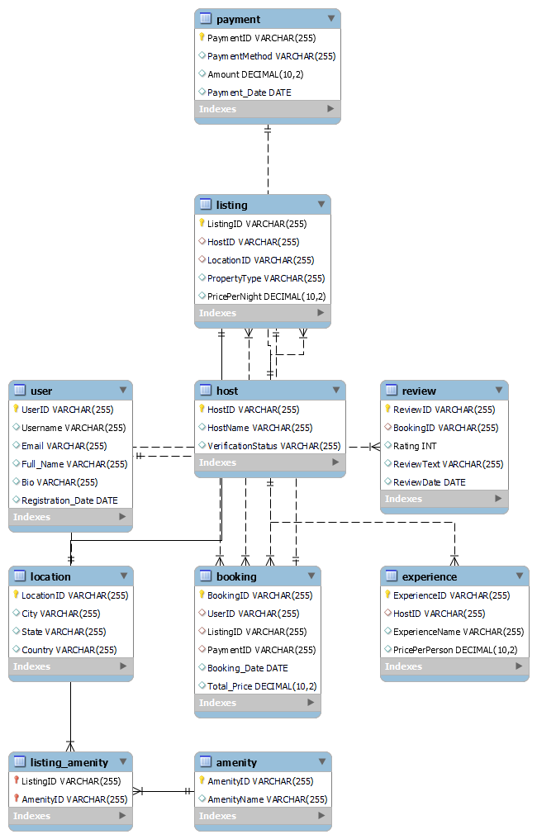

**Conclusion:**

In this case study, we explored the design of Airbnb's schema and Entity-Relationship diagram. Airbnb connects hosts offering properties and experiences with users seeking accommodations or activities, facilitating seamless transactions and feedback. The platform’s intricate data model, consisting of entities like users, hosts, listings, bookings, reviews, and amenities, ensures efficient management of these interactions. Understanding this schema provides valuable insight into how Airbnb operates, fostering both user and host engagement on a global scale.