Germanium strip detector operating manual
firmware version : 17, 9-7-21

Table of Contents
1.0 Introduction 2
2. Readout electronics 3
2.1 Detector Module 3
2.2 Readout and Processing Module 3
3. Data retrieval 4
3.1 Register Reads/Writes 4
3.2 UDP data stream 4
3.3 Data format 4
4.0 FPGA Interface Registers 5
5.0 High Speed Event Data Interface 7
6. System 9
6.1 EPICS IOC 9
7. Powering the system 10
8. Starting up from atmospheric pressure and room temperature 10
9. Shutting down from vacuum and 105K 12
Appendix 1. PV list 12

1.0 Introduction

The germanium microstrip detector consists of a monolithic multi-element germanium detector providing 192 sensors formed from a hyper-pure germanium single crystal 12mm x 50mm x 3mm. It is mounted on a closed-cycle cryostat in a custom vacuum chamber, and connected via wire bonds to a set of 6 custom integrated circuits which provide amplification and pulse-shaping. The chamber has ports for an ionization pump, vacuum gauge and a multi-conductor feedthrough, which carries the signals to the external electronics.
The GeRM Electronics is comprised of 2 printed circuit boards as shown below in figure 1. The bottom board is the detector module and goes in-vacuum. This board has 12 custom ASIC chips, named MARS, that are wire-bonded to the Germanium strip detector. The upper board is the Readout and Processing Module, which hosts an FPGA with an ARM processor running Linux and provides interfaces such as Gigabit Ethernet and SFP modules for high throughput data. The two boards are interconnected via a pair of rigid flex printed circuit boards and a vacuum tight feedthrough board, which for simplicity is not shown in figure 1.

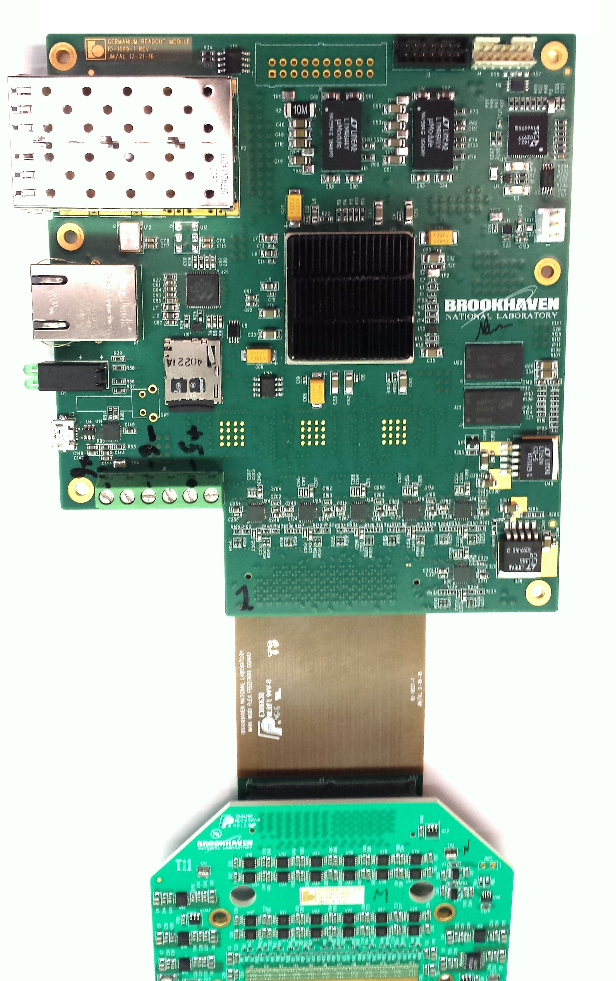

1Gbps UDP Event
Data Port
Readout and
Processing
Module
Embedded Event
Receiver Port

1Gb Ethernet

Detector
Module

Figure 1. GeRM Electronics

2. Readout electronics

2.1 Detector Module

The detector module electronics board contains up to 12 custom ASICs developed by the BNL]s Instrumentation Division, named the Multi-element Amplifier and Readout System (MARS). These chips are comprised of 32 front-end channels with low noise charge preamplifier, fifth order shaping amplifier, peak amplitude detector, threshold discriminator and time detector. The ASICS are wire-bonded directly to the Germanium Strip Detector and also the printed circuit board. When charge collected by the detector exceeds the programmable threshold the ASIC outputs a flag and a digital word containing the address. It also outputs an analog output (PD), which contains the energy information and also an analog Time Detector output (TD), which contains fine timing information. The PD and TD signals are then buffered and delivered to the Readout and Processing Module for digitization.

2.2 Readout and Processing Module

The main component on the Readout and Processing Module is a Xilinx Zynq FPGA. This FPGA contains a hard dual-core ARM A9 processor which runs Debian Linux. The non-volatile memory for the fpga bit file, linux kernel, and root-file system is contained on an SDCARD. The user can login to the sytem via ethernet connection using ssh. A micro-usb serial port connector is also provided for a console login. The other interfaces available are via the SFP (Small Form Pluggable) connectors. The top-most SFP slot is a high speed Gigabit Ethernet connection running UDP which provides the list mode event data from the detector. The bottom-most SFP slot is for an embedded event receiver, compatible with the NSLSII timing system.
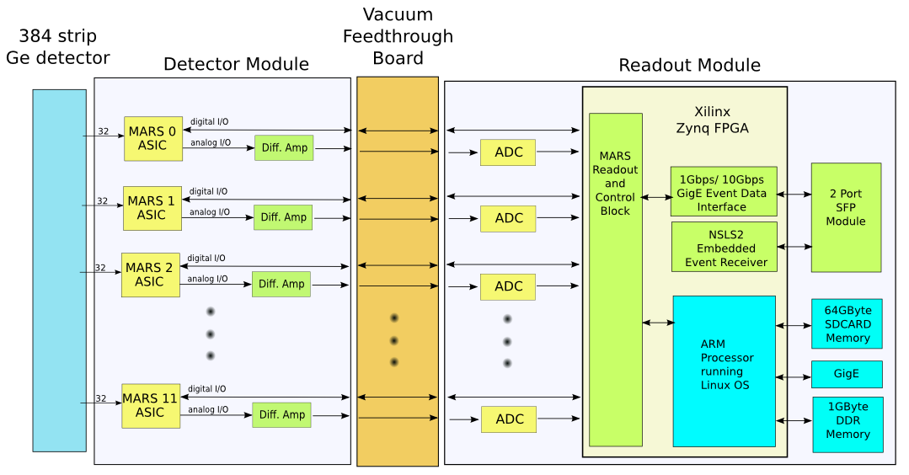
figure 2. GeRM Electronics Block Diagram

3. Data retrieval

The system has two separate and independent data streams. One is used by the on-board EPICS IOC to display raw spectral data in real time for the user to assess experiment progress. The second is a streaming interface using the UDP protocol, which provides the highest throughput, but requires off-board processing.

3.1 Register Reads/Writes

The FPGA code provides a FIFO buffer into which it places data for every event. The IOC code reads that buffer and assembles the events into energy and time histograms. These histograms are presented to the user as a false-color image, with a row for every detector (192 rows) and a column for every ADC value (4096 columns). This provides rapid feedback to the user, but has limited throughput.

3.2 UDP data stream

One of the two high-speed serial links is dedicated to providing a stream of events without any processor intervention. The rate capability of this interface is dominated by the Ethernet speed. Currently, that is 1 GB/s. Since a data event occupies 8 bytes, the event rate is limited to 12.5 Mevents/s. This stream must be accepted by a server on a host capable of handling this rate. We will soon upgrade the FPGA code to provide a 10GB link, which will increase the usable throughput.

3.3 Data format

For each event, two 32 bit words are transmitted which have the format shown in table 1. The first 32 bit word contains the strip address of the photon event, along with the energy and fine resolution timestamp. The second 32 bit word contains the coarse 29 bit timestamp, which has a resolution of 40ns. When a frame starts, this timestamp is reset. It will roll-over after about 42 seconds. At the completion of each frame, a special packet is transmitted which contains a single 32 bit word which has the current frame number,. This allows the client to separate the incoming data stream based on frame number.
The MSB of the first word is always 0. The MSB of the second word is 1. The remaining bits are encoded as in table 1. Bits 29 and 30 are reserved in case other types of record need to be transmitted, but at the moment there are only the two types.

Word 1 (Photon Time/Energy)
31 | 30 | 29 | 28 | 27 | 26 | 25 | 24 | 23 | 22 | 21 | 20 | 19 | 18 | 17 | 16 | 15 | 14 | 13 | 12 | 11 | 10 | 9 | 8 | 7 | 6 | 5 | 4 | 3 | 2 | 1 | 0
0 | Address |  |  |  |  |  |  |  |  | Time (TD) |  |  |  |  |  |  |  |  |  | Energy (PD)

Word 2 (Time Stamp)
31 | 30 | 29 | 28 | 27 | 26 | 25 | 24 | 23 | 22 | 21 | 20 | 19 | 18 | 17 | 16 | 15 | 14 | 13 | 12 | 11 | 10 | 9 | 8 | 7 | 6 | 5 | 4 | 3 | 2 | 1 | 0
1 | 0 | 0 | Time Stamp
Table 1. Event Data Format

A program is supplied which can read this format and accumulate histograms off-line.

4.0 FPGA Interface Registers

The FPGA registers are accessible to Linux via a provided kernel driver or using a simple mmap command from userspace. The physical address of the registers and their definitions are shown below.

Register Map
Base Address 0x43C00000

Address (hex) | Register Name | Function
00 | MARS_CONFIG_LOAD | Used for configuring the MARS internal registers  bit 1 : Config Load  bit 2 : Config FIFO reset  bits 27-16: Config ASIC (sends MARS serial data stream)
04 | FP_LEDS | Controls the LED's on the front panel of the Readout Module  bit 1 : Top Right LED  bit 2 : Bottom left LED  bit 3 : Bottom Right LED
08 | MARS_CONFIG | Data Word Register to load MARS internal registers, written 32 bits at a time.
0C | FPGAVER | Readback of FPGA firmware version
10 | MARS_CALPULSE | Each bit connects to a MARS asic tpck input
14 | MARS_PIPE_DLY | Aligns MARS digital data with digitized PD and TD signals (Expert Use Only)
18 | DET_CONFIG | Current Detector configuration  0 = 192 pixels using ASIC locations 1,3,5,7,9,11  1 = 384 pixels using all ASIC locations.  2-7 = Reserved
20 | MARS_RDOUT_ENB | Enables the Readout of MARS ASIC.  Bit 11:0. One bit for each of the 12 MARS chips
24 | EVENT_TIME_CNTR | Resets the event time counter. The event time counter is a 29 bit counter which is free running at 25MHz. The count value is latched and recorded with each event.
28 | SIM_EVT_SEL | For testing the readout when real events are not available, this will generate simulated events at a rate set by the SIM_EVENT_THROTTLE register  0 = real events  1 = simulated events
2C | SIM_EVT_RATE | Sets the event rate when the SIM_EVENT_SEL register is set to 1
30 | ADC_SPI | Connects to the PD & TD ADC SPI port  bit 0 : sda  bit1 : sck  bit2 : csb
40 | CALPULSE_CNT | Number of calpulses to generate. Changing CALPULSE_MODE register from a 0 to 1 will initiate the generating of calpulses.
44 | CALPULSE_RATE | Number of 40ns clock ticks between calpulses. Note: Calpulse rate is the sum of RATE and WIDTH.
48 | CALPULSE_WIDTH | Number of 40ns clock ticks of calpulse signal being high.
4C | CALPULSE_MODE | 0 = bit bang mode, register 0x10 is used to generate calpulses.  1 = fpga state machine controls calpulses, via registers 0x40, 0x44, 0x48. Register 0x10 is used to select which asic's are selected.
50 | TD_CAL | Used for calibrating the TD ramp time. Adds n clock ticks to asserting MARS enable pin.
60 | EVENT_FIFO_DATA | Reads the Event Data
64 | EVENT_FIFO_CNT | Number of events currently queued up to be read from the EVENT_FIFO_DATA register
68 | EVENT_FIFO_CNTRL | Control Register for Event Data  bit 0 : fifo enable  bit 1 : testmode. Sends test count pattern for data  bit 2 : fifo reset
A0 | UDP_IP_ADDRESS | Sets the IP address for the SFP UDP Interface.
B0 | UDP_CNTRL_REG | Reserved
B4 | UDP_STATUS_REG | Bit 31: Auto Neg. Complete (Should readback high)  Bit15:0 : GigE status vector (defined in table 2-41 of Xilinx PG047) For a working link, should read back 0x8000d80b
B8 | UDP_PACKETS_RCVD | Count of packets that have been received by the interface.
BC | UDP_PACKETS_SENT | Count of packets that have been transmitted by the interface.
D0 | FRAME_SOFTTRIG | 1 = Start a new event frame. Readback reports if current frame is acitve
D4 | FRAME_TIME | Sets the frame length.  Resolution is 1us.  Max frame time is 2^31*1us ~ 35min.  Interrupt is generated when the frame time expires. (IRQ # 61)
D8 | FRAME_NUM | Sets the frame number on write. Read returns the current active frame number. Increments when frame completes
DC | FRAME_MODE | Sets the frame mode  0 = normal mode. Frame starts on FRAME_SOFTTRIG and completes after FRAME_TIME  1 = debug mode. Frame length is set to infinite.
F4 | TS_FAST | Slow part of the timestamp from EVR in seconds
F8 | TS_SLOW | Fast part of the timestamp from EVR in nanoseconds
100 | FRAME_ COUNT | Number of Frames since the beginning
104 | FLAG_CNT_ASIC_0 | Number of Events from MARS ASIC #0 for the last frame
108 | FLAG_CNT_ASIC_1 | Number of Events from MARS ASIC #1 for the last frame
10C | FLAG_CNT_ASIC_2 | Number of Events from MARS ASIC #2 for the last frame
110 | FLAG_CNT_ASIC_3 | Number of Events from MARS ASIC #3 for the last frame
114 | FLAG_CNT_ASIC_4 | Number of Events from MARS ASIC #4 for the last frame
118 | FLAG_CNT_ASIC_5 | Number of Events from MARS ASIC #5 for the last frame
11C | FLAG_CNT_ASIC_6 | Number of Events from MARS ASIC #6 for the last frame
120 | FLAG_CNT_ASIC_7 | Number of Events from MARS ASIC #7 for the last frame
124 | FLAG_CNT_ASIC_8 | Number of Events from MARS ASIC #8 for the last frame
128 | FLAG_CNT_ASIC_9 | Number of Events from MARS ASIC #9 for the last frame
12C | FLAG_CNT_ASIC_10 | Number of Events from MARS ASIC #10 for the last frame
130 | FLAG_CNT_ASIC_11 | Number of Events from MARS ASIC #11 for the last frame

5.0 High Speed Event Data Interface

Detector Event Data is also transmitted via the bottom SFP slot using a UDP protocol. This interface provides a higher bandwidth interface which can accommodate event rates up to 12 Mevents/sec. The IP address for this interface is set through the IOC. The MAC address of this interface is hardwired to 00:01:02:03:04:05. The interface supports ARP requests, but not ping requests. A status register provides debug information to see if the interface is currently working via registers 0xB4. Before event data will be transmitted, the interface needs to be enabled by sending a simple 3 word UDP enable packet to the device with the format shown in Table 2. The device will send an acknowledge packet with the same information.

Lword Number | Function | Value
0 | Key | 0xdeadbeef
1 | Address | 0x1
2 | Data | Bit 0:  0 = transmit events via UDP disabled.  1 = transmit events via UDP enabled.  Bit 1:  0 = transmit real event data  1 = transmit test data (count pattern)
Table 2. UDP Enable Packet Format

After the host successfully sends this packet, event data will be transmitted to the host, using as its destination IP address and destination MAC address the values it received from the enable packet. The format of the event packet(s) are shown in Tables 3-5. Event data will begin streaming at the beginning of the next frame and will be packaged into UDP packets having a payload size of 1024 bytes. Each packet will have as its first 32 bit word a packet counter, which can be used to determine if any packets were lost in transmission. At the start of a new frame, a unique 32 bit word will be sent in words 2 and 3 to mark the beginning of a frame (Table 3). Packets will continue to be sent with event data, always having a packet counter attached at the beginning (Table 4). Finally when the end of a frame is reached, the last 2 words in the packet will have a unique format as shown in Table 5. This packet will have a variable length depending on the number of events in a frame.

32 bit Word Number | Function | Value
0 | Packet Counter | Running counter
1 | Padding | 0
2 | Start of Frame Marker | 0xfeedface
3 | Frame Number | Running counter
4...1023 | Event Data | See Table 1.
Table 3. 1st UDP packet at Start of Frame

32 bit Word Number | Function | Value
0 | Packet Counter | Running counter
1 | Padding | 0
2..1023 | Event Data | See Table 1.
Table 4. 2nd – (n-1) UDP packet

32 bit Word Number | Function | Value
0 | Packet Counter | Running counter
1 | Padding | 0
2..(n-2) | Event Data | See Table 1.
n-1 | Events lost to overflow | count
n | End of Frame Marker Low | 0xdecafbad
Table 5. 1st UDP packet at End of Frame

A C program is provided (germ_getudpevents.c) which sends the enable packet and then receives the event data. When an end of frame marker is received, the received data for that frame is saved to disk. The file format of the data is shown below in Table 6.

32 bit Word Number | Function | Value
0 | Start of frame marker | 0xfeedface
1 | Frame Number | # of frame in run
2..(n-2) | Event Data | See Table 1.
n-1 | Events lost to overflow | # of overflows
n | End of Frame Marker Low | 0xdecafbad
Table 6. Binary file format of raw event data

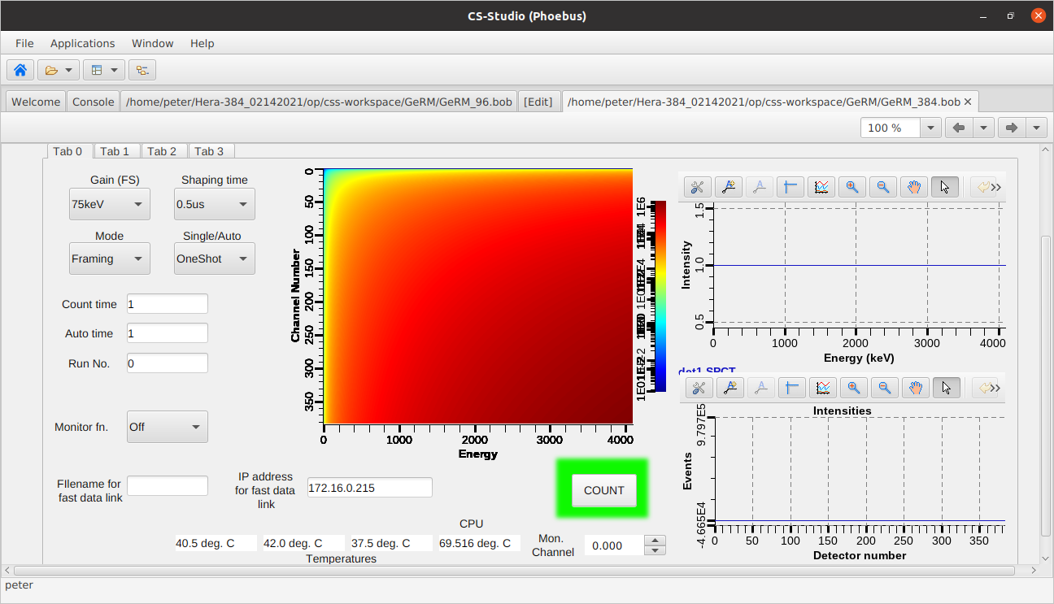
6. System

The unit runs a Debian Linux operating system on its dual-core ARM processor, and is configured using standard Linux commands. It runs an IOC on an embedded EPICS server to provide access to all of the detector functionality. By default it finds a network address using DHCP, but if desired a fixed IP can be implemented. The environment must provide an NTP server so the system is synchronized with at least local network time. This is usually provided by DHCP, but for a fixed-IP setup, it must be explicitly configured.

The EPICS configuration is typically set up to automatically run the IOC on startup, but can be configured to suit the local EPICS setup.

A serial debug port is provided through a microUSB connector. This provides text-mode communications with the system for troubleshooting and initial setup.

6.1 EPICS IOC

The embedded EPICS IOC provides full control of all the parameters of the detector. A set of CSS screens is provided for user interaction. The following shows the screens and explains their functions.

The first tab provides the most-used controls: gain, shaping time, frame or count time, filename for fast data, IP address for the fast data link, Start Frame (CNT), plus controls for various signals which can be monitored, and the various count modes implemented. This interface was modeled on the EPICs Scaler record, and shares many of its features. The large image shows the channel raw energy spectra in false-color, 384 x 4096 pixels. It is complicated to calibrate this image in real time and the processor is already quite loaded. The graphs beside it show the spectrum of a selected channel as a histogram, which can be calibrated to give true energy. The channel is selected by the Mon Channel entry. The lower graph shows the event rate in all strips as a histogram.

The second tab has some more expert-level controls. These include calibration file name and several controls for ASIC functions.

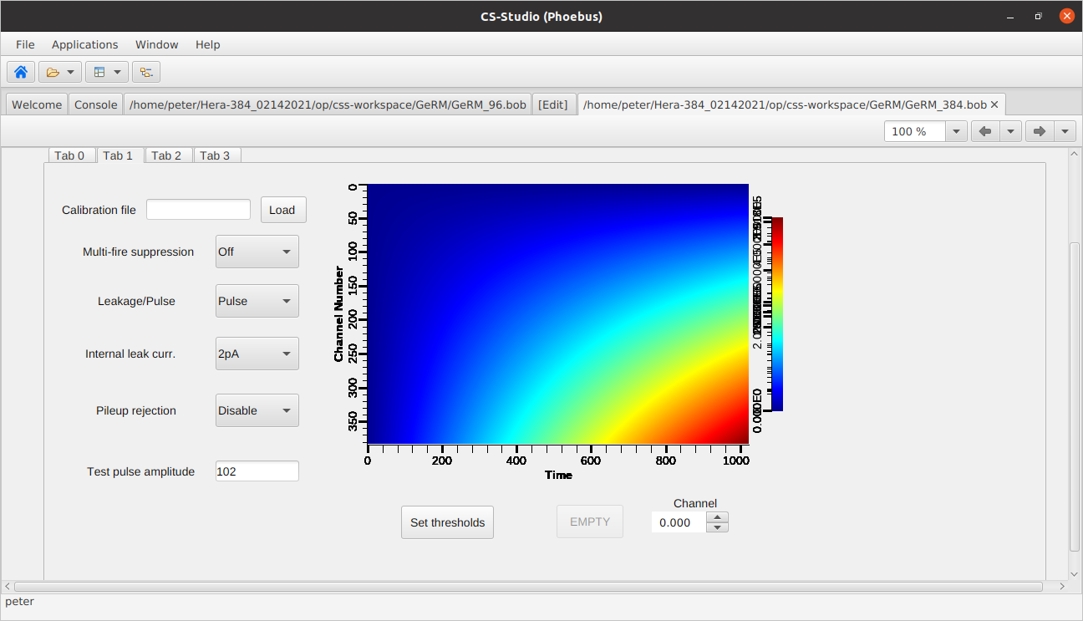

The third tab has controls for test-pulse generation, TDC functions and enabling channels and enabling test pulses to channels. Some of this CSS functionality is implemented as external C language programs which run on the host, called as actions of the CSS buttons.

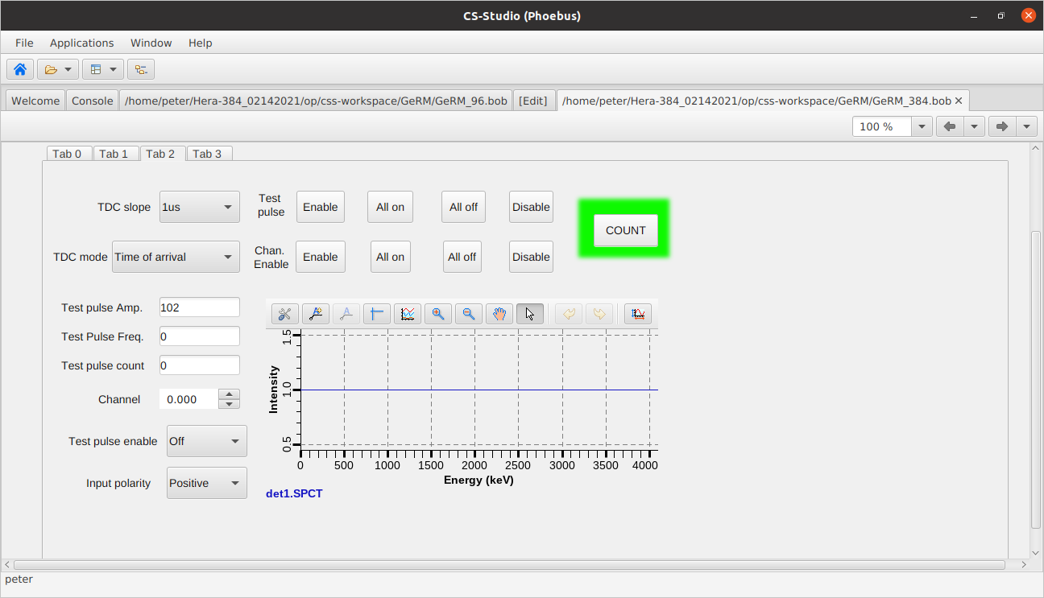

The fourth tab has the control and readout of the detector bias supply.

7. Powering the system

The system requires 3 voltages (+5v digital and +/-6v analog) which are supplied using the included power supply. Both the detector module and the readout module are powered using these supplies. Since the detector module is in vacuum it is important to not to power the system while it is warm as the electronics may overheat. It is also important to power the electronics before the cryostat becomes too cold, as it will prevent the electronics from operating below their minimum operating temperature for commercial grade components (-40 degrees C) The procedure for system power-up and power-down are outlined below. The detector module includes three temperature sensors (TMP100) for monitoring the on-board temperature of the detector module. The temperatures are displayed on the first tab of the CSS screen.

The cooling plate temperature is monitored with an RTD, and can be controlled by a heater if required. We recommend using a temperature controller such as a Lakeshore and set it up to maintain a constant sensor temperature.

8. Starting up from atmospheric pressure and room temperature
Connect the turbo vacuum pump to the vacuum port on the detector.
Open the vacuum valve and start the pump
When the vacuum reaches <10^-6, try to start the ion pump
When the ion pump is operating stably, valve off the turbo station and disconnect it from the detector. The detector can operate on the ion pump indefinitely. The turbo station is only needed for startup, and for shutdown. A stable operation typically shows an ion current of 100-300 uA.
Connect the gas hoses from the cryo compressor to the cryostat head. Check that the gas pressure is within specifications. If not, add gas according to the manufacturer’s instructions.
Connect all of the electrical equipment to the detector (readout electronics power, temperature readout / conroller )
Do not turn on the electronics at this time. The power dissipation from the electronics inside the vacuum chamber will cause overheating, since it has no convection cooling. The cryostat needs to be operating before power is applied.
Start the compressor. Monitor the temperature as it falls. When it reaches ~220 deg. K, turn on the detector electronics supply. It is important that the electronics power be turned on before the temperature gets too low. The power from the electronics serves to keep the components at a temperature where they can operate.
The temperature should reach <105K. When this is achieved, engage the temperature controller to control at 105K.
The detector is now ready for operation.

9. Shutting down from vacuum and 105K
Set the detector bias to zero
Connect the turbo pump to the detector pump-out port and begin pumping. When the turbo vacuum is< 10^-7, open the vacuum valve so that the detector is being pumped by the turbo. Turn off the ion pump HV and disable the temperature control. When the cryostat warms up it will outgas significantly, so the turbo is needed to maintain vacuum until the detector reaches room temperature, so that no condensation forms on the sensor.
Turn off the cryo compressor
Monitor the temperature until it is >220K
Restart the ion pump
Turn off the detector readout electronics
When the ion pump is operating reliably, valve off and disconnect the turbo station.
The detector should be maintained under vacuum at all times if possible. Using the ion pump with a UPS backup should allow that, even allowing the unit to be temporarily disconnected from house power for several hours.

Appendix 1. PV list

$(P)$®.CALF: Name of file containing calibration constants
.CHEN: Array of flags to enable or disable any channel
.CNT: 1= start count frame
.CONT: Select one-shot or auto-count
.DESC: Description of detector
.DLY: Pre-count delay (single-shot mode)
.DLY1: Pre-count delay (auto-count mode)
.EBLK: Enable internal current source to bias amplifier
.EXSIZE: X-axis size for energy spectra plot
.EYSIZE: Y-axis size for energy spectra plot
.FNAM: Filename for fast data storage
.FREQ: Clock frequency for frame timer
.FVER: Firmware version
.GAIN: Gain
.GMON: Selector for various debug monitors
.INTENS: Total intensity in each channel, i.e. events.
.IPADDR: IP address of fast data interface (set by user).
.LOAO: Chose to monitor analog pulse or value of detector leakage
.MCA: Array of spectra for each channel
.MFS: Multi-fire suppression enable and time choice
.MODE: Either time framed or continuous counting.
.MONCH: Channel to be monitored
.NAME: Record name
.NCH: Number of channels
.NCHIPS: Number of chips which supply those channels
.NELM: Same as NCH
.OFFS: Array of energy offsets after calibration
.POL: Input signal polarity
.PUEN: Pileup detector enable
.PUTR: Pileup detector threshold trim
.RAT1: Update frequency of display, one-shot
.RATE: Update frequency of display, auto-count
.RUNNO: count of number of frames acquired.
.SHPT: Shaping time of amplifier
.SLP: Array of energy calibration slope values
.SPCT: Single spectrum data
.SPCTX: X-values for single spectrum data
.TDC: Time-to-digital converter data array
.TDM: TDC mode, time-of-arrival or time-over-threshold.
.TDS: TDC ramp time.
.THRSH: Array of pulse-height threshold values, one for each chip.
.THTR: Array of threshold trim values, one for each channel
.TP: Time per count frame (in seconds) for one-shot mode
.TP1: Time per count frame (in seconds) for auto-count mode
.TPAMP: Amplitude of test pulses
.TPCNT: Number of test pulses to deliver
.TPENB: Internal test pulse generator enable.
.TPFRQ: Test pulse frequency.
.TSEN: Array of enable flags for test pulses (one per chanel)
.TXSIZE: X-axis size for ToT / ToA spectra plot
.TYSIZE: Y-axis size for ToT / ToA spectra plot
.VERS: IOC code version

$(P)$®:HV Set bias voltage (0-200V)
:HV_RB Bias readback
:HV_CUR Bias supply current
:Temp1 Temperature sensor 1 on detector board
:Temp2 Temperature sensor 2 on detector board
:Temp3 Temperature sensor 3 on detector board
:ztmp Temperature of Zynq processor cores

