BridgeHammock2 (Bic’s Life – aka Hiking Dad)

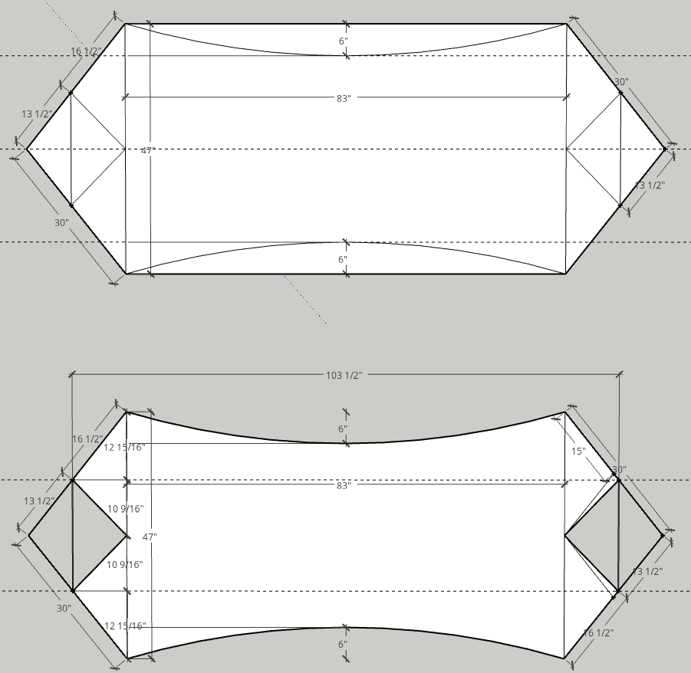

3 yds material (1.9oz ripstop nylon) [Weight Limits: 1.1oz 200 lbs; 1.6 300 lbs; 1.9 350 lbs]

½” webbing – 18 feet ***Purchase***

Thread (Gutterman 50)

Spreader bars (.625)

Spreader bar tips – 4

7/64 Amsteel – 25’

Dutchware gear – aluminum bride hammock end ($12 for 4) ***Purchase***

Instructions

½” webbing sewn to the edges one inch from the end. Sewn once to attach, then double wrap and sew again. Do a double seem on the webbing after wrapped. This edge should be on the inside of the hammock.

Sew the center triangles together about ¼” seam. Flip inside out, sew that the edges are inside the seam (not showing). Then open up and sew the flap flat to outside of material. This length should be 29” for 28” spreader bars.

Layout the hammock and draw straight line to remove excess at the top. Cut this and do a rolled hem.

4 pieces of ½” webbing 11” long. Sew to hammock ends. This is then sewn to the sides with the webbing.

Suspension dogbones are made of 7/64 Amsteel. Cut 4 pieces at 52”. Make a mark on each end at 6” and 10”. Uses yarn needle for splicing and knitting needle or small paint brush. Pule through 10” mark pulling 6” mark through. Then pull long end through the 6” mark making a locked Brummel. Last burry the tail. Do the same to the other end. Use the knitting needle to open the hole at the 6” mark to pull through the long end. Larks head dogbone to suspension clip.

Use whoopie sling to hang the hammock.

Build fast shackle to connect both dogbones to UCR or whoopie sling. <https://www.youtube.com/watch?v=QYZ3ZL1Mhao>

BridgeHammock (Grizz Ariel Bridge Hammock))

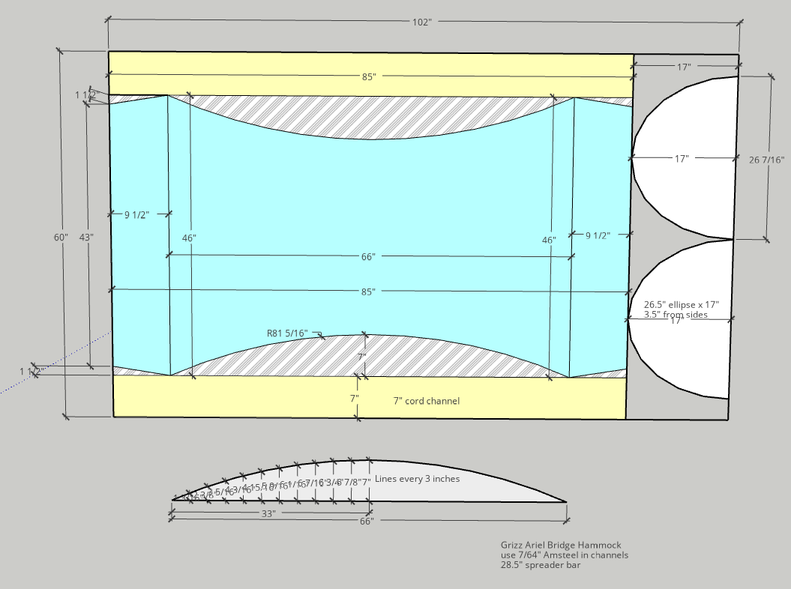

Uses 7/64 amsteel in side channels