Organic Gardening
Contents
Plants 3
Plants to consider growing 3
Other plants no longer marketed 3
9 Vines that feed you for life 4
My Planting List 4
Soil Mixes 6
Potting Soil mix 6
See Starter mix 6
General potting mix 6
Composting 6
Fertilizers 7
Biochar 7
Liquid fertilizer 8
Cow Manure Tea 8
Yeast Fertilizer 8
JADAM Liquid fertilizer – plant material 9
Crop Wast Fertilizer 9
JADAM Liquid fertilizer – manure & plant material 9
JADAM Serum (JAS) 9
Mid season plant boost 10
Lactic Acid Bacteria (LAB) Serum 10
Liquid Nitrogen Fertilizer (3-6 months fermentation) 10
Fish Fertilizer 10
Wood Ash Fertilizer 11
Chicken Manure Fertilizer 11
Pre Spring Planting 11
Fall Soil boost 12
Rice 12
Calcium Acetate 12
When to fertilizer 12
Plant Rooting 14
Sites 15
Seed Starting and Planting Times 16
Cold Frame 17
Pest Control 18
Companion plants 18
Victory Garden Plants 19
Hoop house design 19
Small Greenhouse design 19
Notes 20

Plants

Plants to consider growing
- *Rugosa rose - Rosa Rugosa (Rose hips)
- *Saskatoon berry - Service berry
- *Goji Berry
- *Black berries
- Honey Berry - Haskap Berry
- Sea Buckthorn
- *Stevia
- *Echinacea
- *Chamomile
- *Peppermint (in buried bucket with edge above ground)
* Grow

Other plants no longer marketed
- *Hazelnut bush
- *Chicago Hardy Fig
- *Persimmon
- *Paw-Paw (5-7 years to produce)
- *Mulberry (end of yard on Tex's property)
- *Autumn Olive
- Goumi berry (Goomy?)
- Tamarillo - tree tomato
- Sun chokes - Jerusalem artichoke
- Perilla seeds - high omega 3
- rutabaga
- Nanking cherry
- Cornellian cherry
- Amaranth - grain
- Aronia berries - high anti-oxident
- Josta berry
- Currants
- Goose berries
- June berry
- beach plum
- hardy orange
- medlar
* Grow

9 Vines that feed you for life
- Cucamelon
- Tromboncino squash
- *Malabar spinach
- *Scarlet runner bean
- chayote
- Hycinth bean
- ground nut view
- Passion flower
- Akebia - chocolate vine
- *Hardy Kiwi (not included in the 9 from the video)
* Grow

My Planting List
- Onions
- Garlic
- Bell peppers (6-12)
- Jalapeno peppers (3)
- Cayenne peppers (3)
- Habanero peppers (1-2)
- Roma tomatoes (6-12)
- Grape tomatoes (1)
- Zucchini (2-4)
- Butternut squash (2-4)
- Spaghetti squash (2-4)
- Cucumber (2-4)
- Watermelon (2-4)
- Cantaloupe (2-4)
- Black Raspberries (planted 35’ row)
- Strawberries (planted 2 35’ rows)
- Black berries (start with 2 and root cuttings)
- Spinach
- Romaine
- Kale
- Radish
- Turnips
- Dill
- Parsley
- Cilantro
- Basil
- Peppermint

Soil Mixes
Potting Soil mix
My first attempt spring 2026.
- 3 parts Peat Moss
- 2 parts Compost (Black Kow)
- 1 part vermiculite/perlite
lime (to bring up ph of peat moss)

See Starter mix
- 2-galllons peat moss
- 2-galllons vermiculite
- 1 gal compost (Black Kow)
- 3 T lime
- 2 T blood meal (10-10-10)

General potting mix
- 6-gallon Peat Moss 3 gal
- 6-gallon Compost 3 gal
- 2-gallon vermiculite 1 gal
- 1/4 cup lime 1/8 c
- 1 1/2 cups of blood meal 3/4 c

Composting
Browns: leaves, sawdust, wood chips
Greens: grass clippings, weeds, plant materials
Add charcoal to compost pile to inoculate biochar.
Piles should be 4 feet high, and temperature should be 120 to 150 F.
Add bloodmeal to add nitrogen (or fermented urine – urea).

Fertilizers
Alfalfa powder is a great fertilizer
Leaf mold. in the woods find large old trees. scrape away the leaves. get the dirt and items with stringy mold. Do this from several trees. Cover area with leaves so you leave no trace.
Grow comfrey for compost (chickens love this)
Place chopped comfrey in container of rainwater with leaf mold and let ferment. The longer it ferments the richer the nutrients in the liquid fertilizer. Dilute 1:15 for watering. 8.5 oz to 1 gallon rainwater.
Comfrey can be dried, then ground. This can be put at the base of plants.
Cayenne and Cinnamon help deter bugs and rodents. Refer to list of plants that deter pest under the pest control section.

Biochar
inoculate by placing in the compost pile
inoculate with manure, compost, leaf mold, rainwater, urine 3+ days fermentation
inoculate with rainwater and urine (1 qt) 3+ days fermentation
inoculate with liquid fertilizer
inoculate with:
- 3 handfuls of compost
- 2 handfuls of leaf mold
- 1 cup of urine
- JAS
- Fish fertilizer
- Blackstrap molasses (unsulfured)
Other inoculant to Test
- Whey
- Rice water
- Blackstrap molasses
- Yeast
- Scoby
- Water
Let ferment 48 hours before adding to biochar.

Liquid fertilizer
- 1 gallon rainwater
- 1 T wood ash
- 1 t Epsom salt
- 1 T Blackstrap molasses (unsulfured)
- 2-3 cups Black Kow compost (in mesh bag)
- 1 t yeast
Add a handful of leaf mold. Ferment 3 days using fish aeration pump.
Add 1 part to 5 parts rainwater ( 3 cups to 1 gallon)

Cow Manure Tea
- 4 cups cow manure (Black Kow) or compost
- ¼ c Blackstrap molasses (unsulfured)
- 2 T Wood Ash
- 1 T Epsom salt
- 1 T Yeast
- 5 gallons rainwater
Add manure/compost to a paint strainer bag and tie shut. Add Dunk in rainwater like a tea bag. Leave bag in water and use an aerator for four days with the bag in the rainwater.
Dilute 1:5 ( rainwater to water plants. Dilute 1:50 (2.5 oz per gallon) for a foliar spray.

Yeast Fertilizer
- 1 liter of rainwater
- 2 T sugar or blackstrap molasses (unsulfured)
- 2 t yeast
Let it ferment for 24 hours
Mix 1 part to 5 parts of rainwater. ½ gallon to 2.5 gallons rainwater.

JADAM Liquid fertilizer – plant material
- rainwater
- wild grass (comfrey, alfalfa powder, clover, greens) chopped
- leaf mold
Ferment for several months to a year

Crop Wast Fertilizer
Fill container half full with garden waste/weeds/comfrey. Add a handful of leaf mold. Fill container with rainwater. Cover container with lid. Let ferment in hot weather 3 weeks.
Dilute 1:50, 2.5 oz per gallon.

JADAM Liquid fertilizer – manure & plant material
Place 2.5 gallons of rainwater in 5-gallon bucket.
- 2.2 pounds of plant material
- 4.4 pounds manure
- Handful of leaf mold
Place lid on bucket and let sit 2 weeks. Stir daily.
Dilute 1 part to 10 parts water. 12 oz to 1 gallon of water.

JADAM Serum (JAS)
2 potatoes boiled 20 minutes and cooled. Blend with 1 T sea salt and rainwater.
Place in paint strainer bag with 2 handfuls of leaf mold. Tie the strainer to close it.
Place in 5 gallon bucket with 4 gallons of rainwater.
Cover with lid and let ferment 24-26 hours until it is bubbly and has white foam.
To use dilute 1 part to 20 parts rainwater. 6 oz per gallon of rainwater.
Use weekly in the garden

Mid season plant boost
- use organic bananas. Place it in blender with water.
- Pour in 5-gallon bucket
- 1 cup Blackstrap molasses (unsulfured)
- 3 cups of lactic acid serum
Let ferment for 2 weeks or until everything is dissolved, then use.

Lactic Acid Bacteria (LAB) Serum
- fermented rice water and milk – OR – Whey from Milk kefir.
cover rice with water and let sit. drain rice water. Make 1 quart.
Ferment the rice water 3-5 days. Will have bubbles and a film on top with a smell of yeast.
Add 1 gallon of whole milk and let sit 3-5 days.
strain off the liquid
eat the solids (cheese)
Dilute 1 oz to 1 gallon of rainwater

Liquid Nitrogen Fertilizer (3-6 months fermentation)
- 5-gallon bucket with lid
- leaf mold
- urine
The longer the fermentation the better the fertilizer. This becomes urea.
Dilute 1 oz to 1 gallon of rainwater before adding to garden

Fish Fertilizer
- 5-gallon bucket
- water
- fish – No more than half of the bucket
- 2 handfuls of leaf mold
inoculant - leaf mold (use soil from the base of a large tree in the woods.
Keep fermenting until fish is gone. Take some out and add more water and more leaf mold.
Dilute 1 oz to 1 gallon of rainwater before adding to garden

Wood Ash Fertilizer
1 gallon wood ash
5 gallons of rainwater
16 T per cup; 16 cups per gallon
Mix well and strain with paint strainer.
Dilute 1 cup to 1 gallon of rainwater. This equates to 1 T wood ash to 1 gallon of rainwater.

Chicken Manure Fertilizer
Add 1 gallon chicken manure and 2 handfuls of leaf mold toa 5-gallon bucket and fill with rainwater.
Diluter 1:50 (2.5 oz per gallon) as a start. Can go to 1:20 (6.4 oz per gallon), if plants can tolerate this ratio.

Pre Spring Planting
potatoes, water 1 T sea salt blended
use paint strainer bag and add leaf mold plus potato mixture
place this in a 5-gallon bucket filled with rainwater.
Use when bubbles are at the maximum.
Use straight in the garden before planting.
When used on plants, dilute 1 part to 20 parts. 6 oz per gallon.

Fall Soil boost
1 gallon rainwater
10 T hydrogen Peroxide
Dig trench and bury dead plants. Add some compost. Add some of the peroxide mixture. This boosts oxygen and aids in decomposition

Rice
raw - grind into powder - long term
cooked - place small amount buried in 3 holes around the plant
- can be added to compost pile
rice water - Ferment for 3-5 days
- dilute 1 part rice water into 5 parts rainwater. 25 oz to 1 gallon of water.
- if not fermented, it can be mixed 1 to 1 ration with rainwater.
- used to water plants (diluted)

Calcium Acetate
Dry egg shells in oven at 250 degrees F for 2 hours. Let cool, crush, and blend into a powder. Mic 1 part egg shell powder to 10 parts vinegar. (1 oz egg shell powder to 10 oz vinegar)
Let sit for 7 to 10 days for full conversion from calcium carbonate to calcium acetate.
Add 1 oz calcium acetate to 1 gallon of rainwater. Use for direct watering of foliar feeding.
Can be added to compost pile.

When to fertilizer
Fall - Base fertilizer
- crop residue
- manure - cow, horse, chicken
- compost
Do once a year

Plant Rooting

Sites
Garden like a Viking (YouTube)
Zen Garden Oasis (YouTube)
Epic Gardening (YouTube)
The Growing Channel with James Prigioni (YouTube)
GrowVeg (YouTube)
Homesteading Family (YouTube)
Sidney Explains (YouTube) [Questionable] – links to self sufficient backyard site.
Book: Selfsufficientbackyard.com $37
Courtneygrowsfood.com
Ruth Stout Gardening – classics series, 3 books
Square foot gardening by Mel Bartholomew
No dig gardening

Seed Starting and Planting Times
When to Plant Vegetables in Zone 7
Zone 7 Last Frost Date: May 2 - Zone 7 First Frost Date: October 15
 | Start Seeds Indoors | Direct Sow/ Transplant
Artichoke | 3/7/2014 | 5/2/2014
Beans |  | 5/2/2014
Beets | 3/7/2014 | 4/18/2014
Broccoli | 3/7/2014 | 4/18/2014
Brussel Sprouts | 3/7/2014 | 4/18/2014
Cabbage | 2/21/2014 | 4/4/2014
Carrots |  | 4/11/2014
Cauliflower | 3/7/2014 | 4/18/2014
Celery | 2/14/2014 | 5/9/2014
Chard | 3/7/2014 | 4/18/2014
Collards | 2/28/2014 | 4/4/2014
Corn |  | 5/9/2014
Cucumbers |  | 5/2/2014
Eggplant | 3/21/2014 | 5/16/2014
Gourds |  | 5/16/2014
Kale | 2/21/2014 | 4/4/2014
Kohlrabi | 2/21/2014 | 4/4/2014
Leek | 2/7/2014 | 4/18/2014
Lettuce | 2/9/2014 | 4/4/2014
Melons |  | 5/16/2014
Okra | 3/21/2014 | 5/16/2014
Onions | 1/24/2014 | 4/4/2014
Peas |  | 3/7/2014
Peppers | 3/7/2014 | 5/9/2014
Pumpkins |  | 5/16/2014
Radish |  | 3/28/2014
Spinach | 2/14/2014 | 3/21/2014
Squash | 4/18/2014 | 5/16/2014
Tomatoes | 3/14/2014 | 5/9/2014
Turnips |  | 3/28/2014
Watermelons | 4/18/2014 | 5/16/2014

Use your last and first frost dates to calculate your planting schedules.
Zone 7 Planting Schedule
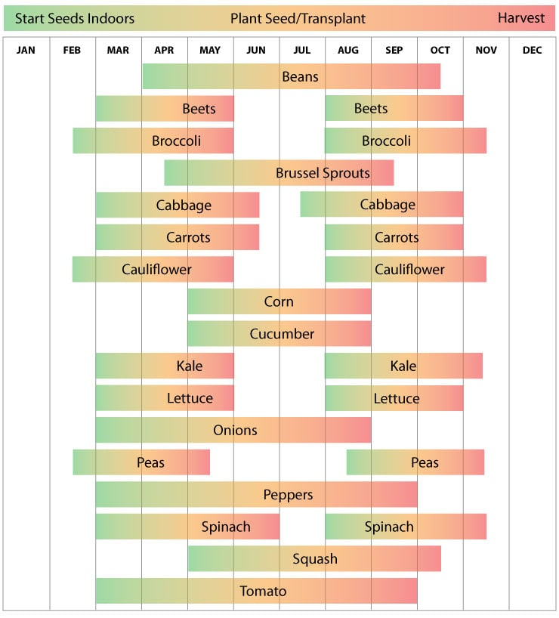

Cold Frame
Use Glass, Polycarbonate panels, Polyethylene panels, or plastic sheeting.
Front to back angle 15 degrees.
If using plastic sheet, make it a hoop frame. This will help shed water.

Pest Control
These plants will help deter pests.
Marigold
Lavender (mosquito)
Basil – between tomatoes (mosquito)
Rosemary
Mint
Chives – plant near tomatoes, fruit trees, roses, carrots
Dill – plant near cabbage, lettuce, cucumbers, tomatoes
Garlic – plant on borders. Plant near roses, tomatoes, lettuce, strawberries
Steep garlic in water overnight and use it as foliar spray
Nasturtiums – plant neat peppers, cucumbers, beans, squash (ground vine)
Thyme
Sag, Bee balm, catnip repels mosquitos

Companion plants
Corn, beans, squash
Cucumbers, dill
Carrots, onions
Peppers, basil; peppers, marigolds; peppers, onions; peppers, oregano
Tomatoes, basil
Spinach, strawberries
Lettuce, radish
Zucchini, nasturtiums

Victory Garden Plants

Hoop house design
https://ourstoneyacres.com/simple-hoop-house
https://www.instructables.com/Simple-Hoop-Houses-for-Raised-Beds/
https://www.betterfarm.org/blog/2016/4/1/extending-your-growing-season-hoop-houses-row-covers-and-cold-frames

Small Greenhouse design
Building an 8’ x 12’ hoop house from pvc and 2x4s (YouTube)
https://www.youtube.com/watch?v=4RScZ2JlUhE
Green house pvc pipe and pallet lumber (YouTube)
https://www.youtube.com/watch?v=RJwxkKcSJCA
Build a winter Greenhouse in 1 day for $150!! (Youtube)
https://www.youtube.com/watch?v=_UxCZaWX5s8

Notes
Purchase
- Measuring cups (dollar store)
- Measuring spoons (dollar store)
- Plastic pitchers (dollar store)
- Scissors (dollar store)
- Fish tank air pump (for aeration)
- Pitchfork (5 or 8 tines)
- Mushroom soil
- Cow manure (bags) (Will’s)
- Plastic barrel with screw lid
Make
- Barrel with lid. Cut top off barrel and flip over, weight on lid
- Cedar planter near house for herbs
- Large claw
- Small claw
- Broad fork
- Planting shovel (forged steel)
- Small worktable for garden with small weather proof storage. (cedar planks)
Broad Fork Ideas
5-7 rebar tines, welded to 2” square tubing, with 2 wood or metal handles.
Add slight curve to the rebar tines.
7 tines spaced 3” (18”) welded to 2’ angle or square tube
27” wide base; 57” handles 1” tubing; rebar ½” to ¾” pointed 10” long spaced 3-4”; 2” square tubing; add 2” to rebar to weld in holes in square tubing and add 2” to handles to weld inside 2” square tubing.
Make handles from 2”x2” wood and round the top part. Weld 2” square tube to base to insert handles.
Materials: 3’ 2” square tube (24” base, 2@6” handles; ¾” rebar 12” each tine; 2 @ 2”x2” wood for handles)

