Top Quilt
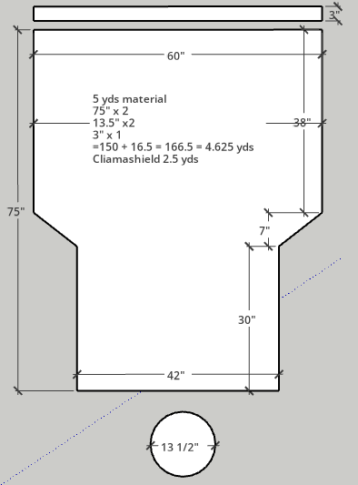

Top Quilt
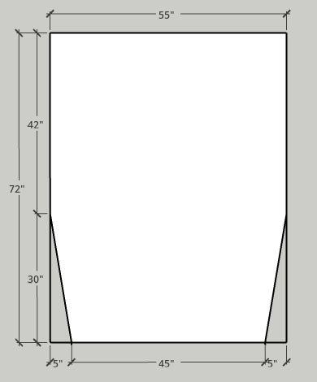

Under Quilt
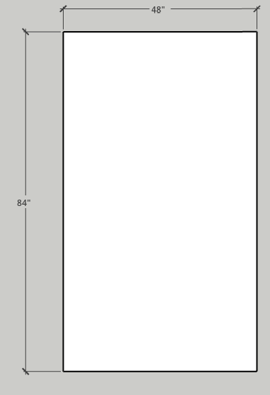
Current under quilt is 44” x 88” with Climashield 5.0 oz good down to 30 F

