**5 Essential Tablesaw Jigs**

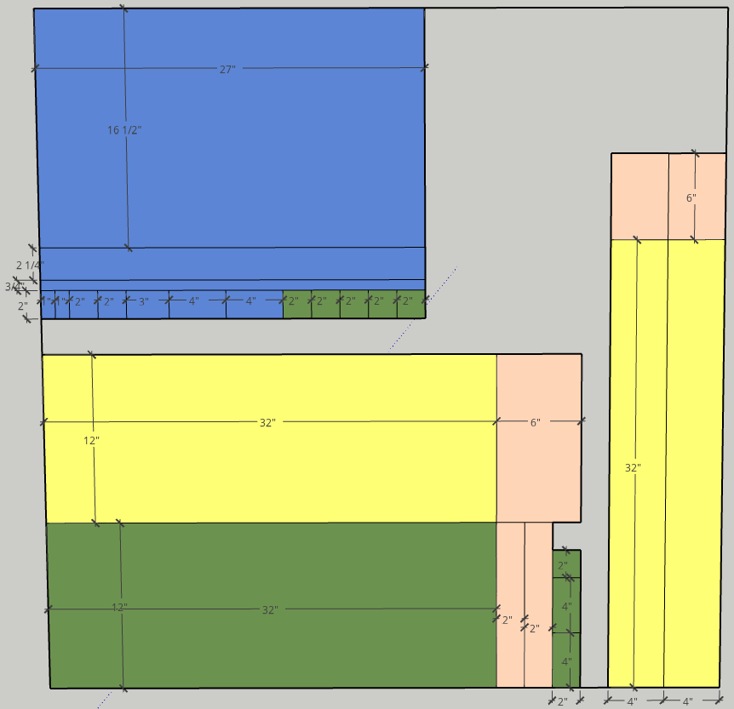

Refer to PDF in OneDrive Shared\Wood