**Angle of right triangle**

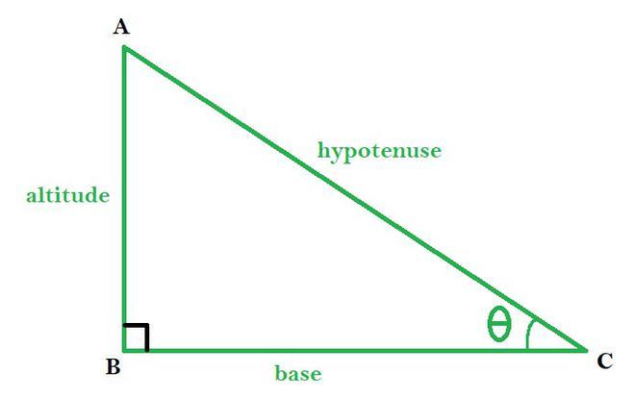***cosθ = base / hypotenuse***

***sinθ = altitude / hypotenuse***

***tanθ = altitude / base***

***A2 + B2 = C2 (hypotenuse)***

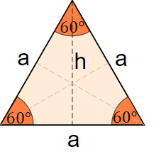**Area of equilateral triangle**

area = (a² × √3)/ 4

**Height of equilateral triangle**

h = a × √3 / 2

where a is a side of the triangle.

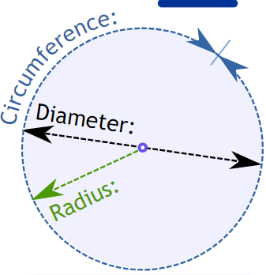

Area = **π** r2 Circumference = 2 r  **π π = 3.14159265**

Volume of cylinder = **π r2 h**  outside area of cylinder = **π 2r h**

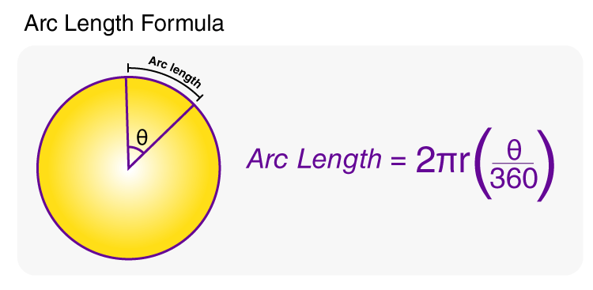

* r is the radius of the circle
* θ is the central angle of the arc

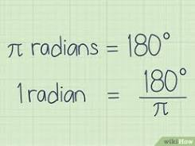**Degrees to radians:**

**radians = degrees * (π / 180)**

**Radians to degrees:**

**degrees = radians * 180 / π**

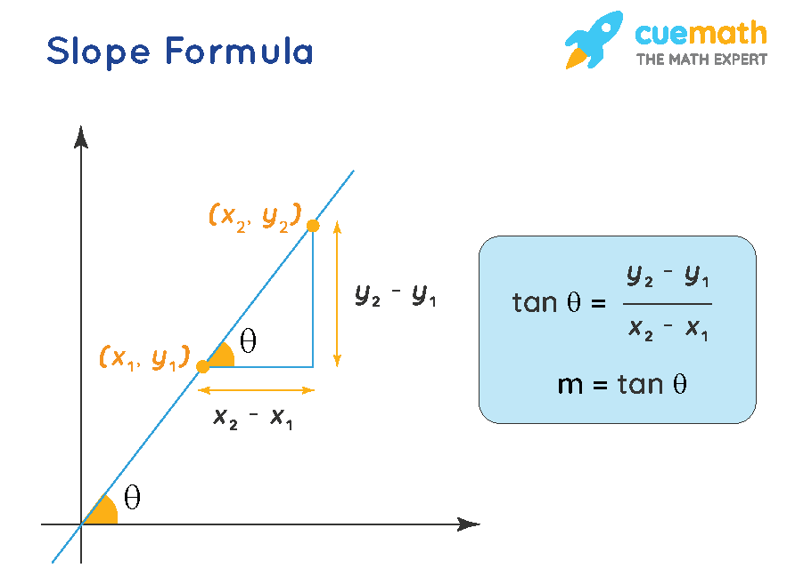 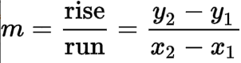

m = (y2 - y1)/(x2 - x1) = Δy/Δx

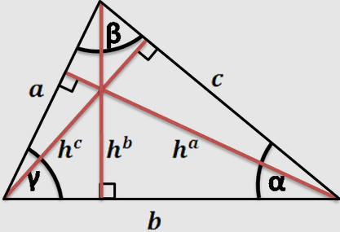

* area=*b*×*h*/2, where *b* is a base, *h* – height;
* ℎ=2×area/*h*=2×area/*b*.

using all side lengths 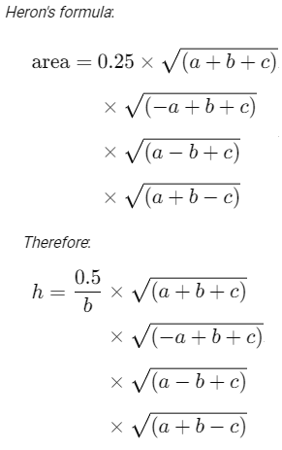

Using 2 sides and angle 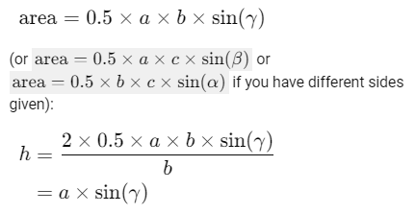

**Area of an Ellipse**

Area= π ab

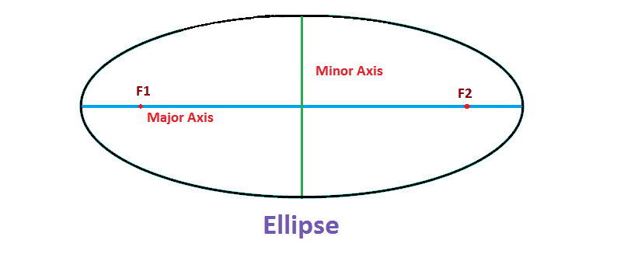

**Ellipse router jig**

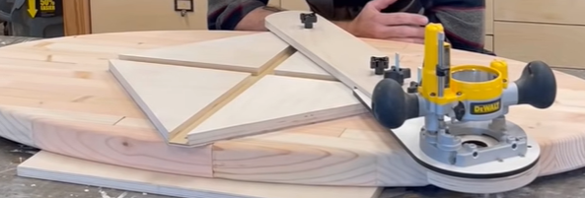

<https://www.youtube.com/watch?v=PCsmw07sSZg>