**Headboard**

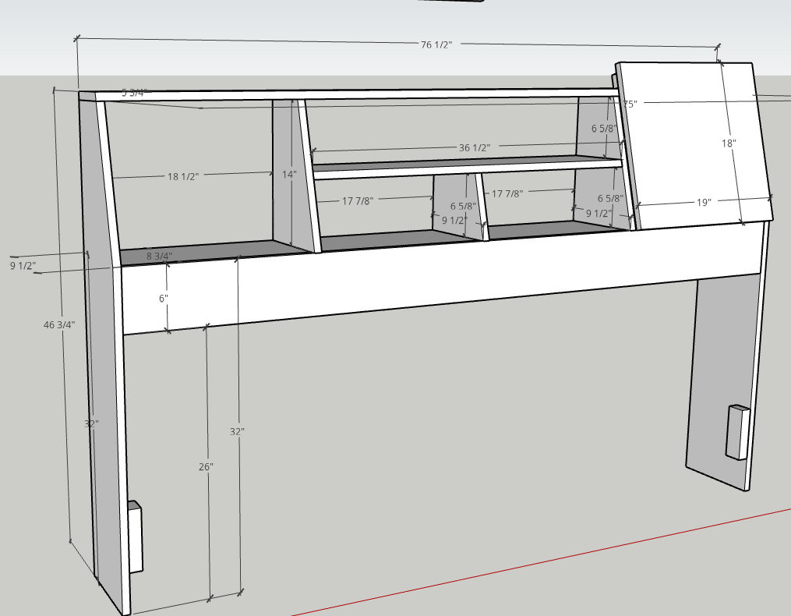

Block on inside support is 4” from the bottom. 6” tall x 2” deep x 1 ¼” wide.

Sliding doors / Back rest 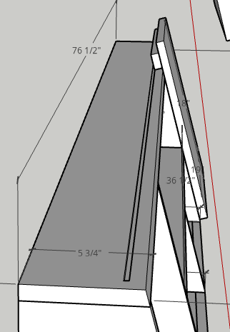

2” aluminum bar on ¾ x 1 ½ x 19 support. Rides in channel on headboard

