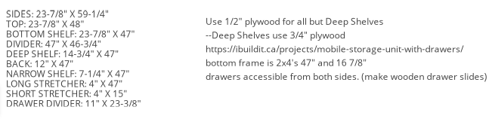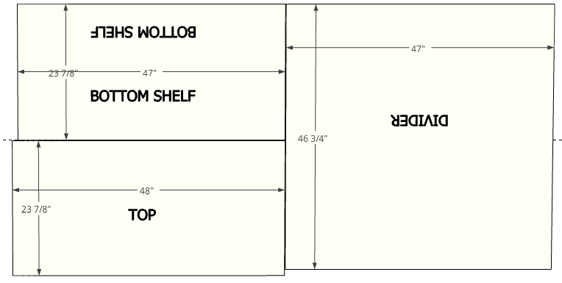

Divider 46 ¾” x 47” Top 23 7/8” x 48” Bottom Shelf 23 7/8” x 47”

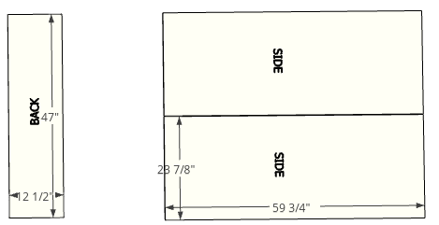

Back 12 ½” x 47” Sides 23 7/8” x 59 ¾” (added ½” to account for 2x4’s used for the base)

(1/2“ plywood)

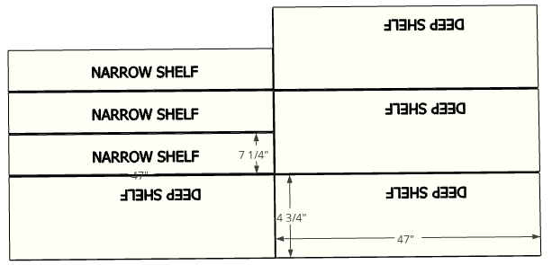

Narrows shelf 7 ¼” x 47” (3/4” plywood) Deep Shelf 14 ¾” x 47”